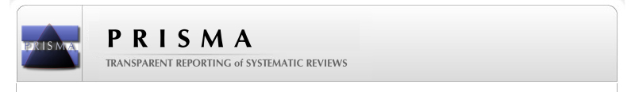**PRISMA 2009 Flow Diagram**

## Identification

## Eligibility

## Included

## Screening

Full-text articles assessed for eligibility (N = 66).

Full-text articles excluded (N = 45).

* Did not evaluate diabetes as an outcome (N = 37).
* Studied pregnancy-induced hypertension rather than pre-eclampsia (N = 5).
* No control group (N = 2).
* No diabetes events in study (N = 1).

Records excluded which did not meet the inclusion criteria on reviewing the titles and abstracts (N = 10,658).

Records identified through EMBASE and MEDLINE database searching between 2005 to August 2015

(N = 10,724).

Total number of studies included in systematic review after full review of studies (N = 21).

Title and abstract screened for potential inclusion (N = 10,724).