Figure 2. Research processes in the PAR framework
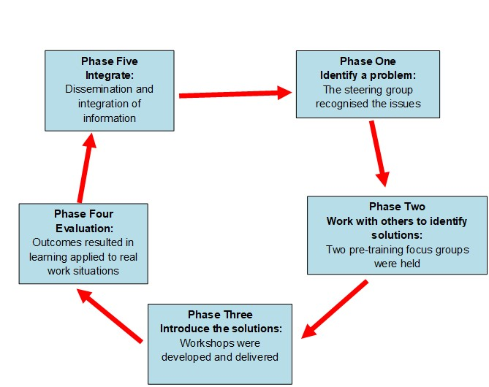

| FINAL NOVEMBER 2019

