Figure 1. PRISMA Flow diagram of the selected studies in the updated review.
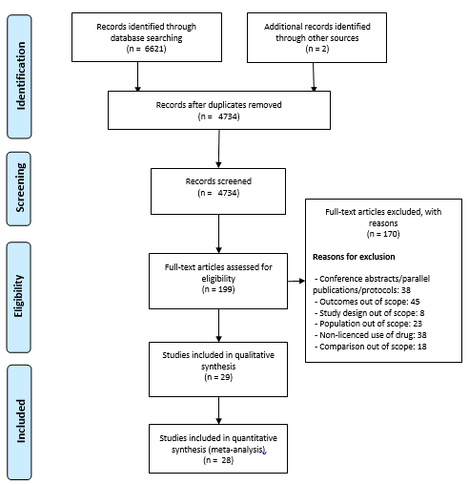

Table 1. League table presenting network meta-analysis estimates (lower triangle) and direct estimates (upper triangle) of efficacy of bisphosphonates. From the left to the right: i) % BMD change at femoral neck, ii) vertebral fractures, and iii) non-vertebral fractures. Posterior mean differences (95%CrI) are presented for percentage BMD change at femoral neck and posterior median hazard ratios (95%CrI) for vertebral and non-vertebral fractures.
ZOL |  |  |  | 3.8(2.7, 4.8) |  | ZOL |  |  |  | 0.33(0.23, 0.43) |  | RIS |  |  |  | -
1.15(.24, 2.08) | ALN |  |  | 3.1(2.4, 3.8) |  | 0.88(0.58, 1.21) | ALN |  |  | 0.43(0.33, 0.53) |  | 0.98(0.82, 1.35) | ZOL |  |  | -
1.31 (-0.08, 2.73) | .15 (-1, 1.32) | IBNor |  | 2.3(.21, 4.3) |  | 0.87(0.37, 1.82) | 0.99(0.47, 2.18) | IBNor |  | - |  | 0.95(0.5, 1.33) | 0.98(0.55, 1.36) | IBNor |  | -
1.76(0.82, 2.74) | .6(-.09, 1.31 | .45(-0.8, 1.72) | RIS | 2.4(1.5, 3.3) |  | 0.76(0.5, 1.07) | 0.88(0.6, 1.22) | 0.91(0.37, 1.82) | RIS | 0.54(0.39, 0.69) |  | 0.92(0.65, 1.11) | 0.93(0.74, 1.11) | 0.99(0.63. 1.5) | ALN | -
4.02(3.2, 4.84) | 2.86(2.37, 3.36) | 2.7(1.56, 3.86) | 2.25(1.61, 2.87) | PLB |  | 0.38(0.28, 0.49) | 0.44(0.33, 0.57) | 0.43(0.2, 0.94) | 0.5(0.37, 0.66) | PLB |  | 0.70(0.53, 0.84) | 0.71(0.61, 0.81) | 0.75(0.51, 1.26) | 0.77(0.63, 0.91) | PLB
Note. ALN = Alendronate; IBN-oral: Ibandronate 150mg; PLB: Placebo; RIS: Risedronate; ZOL: Zoledronate.
Treatments are reported in order of relative ranking for efficacy. Comparisons between treatments should be read from left to right, and their hazard ratio is in the cell in common between the column-defining treatment and the row-defining treatment. Hazard ratios (HR) < 1 favour the column-defining treatment for the network estimates and the row-defining treatment for the direct estimates

