Surgical and percutaneous management of post-infarction ventricular septal defects in the era of primary percutaneous coronary intervention: The United Kingdom National Registry.

Supplementary information

Supplementary Figure 1 – Flowchart showing multiple attempts at PIVSD repair

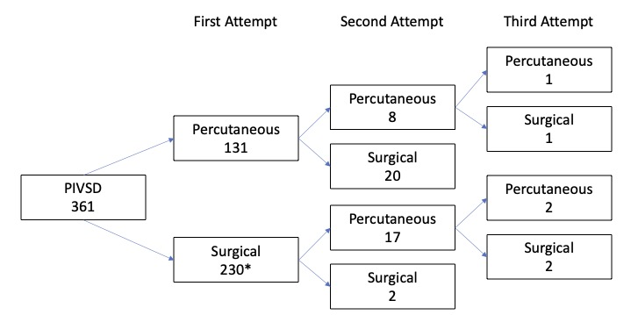
Abbreviations: PIVSD – postinfarction ventricular septal defect.

Supplementary Table 1 – Participating Centres

Hospital centre (number of patients) | City | Initial percutaneous management (N=131; 36.2%) | Initial surgical management (N=231; 63.8%)
University Hospital Bristol | Bristol | 23 | 1
Freeman Hospital | Newcastle-upon-Tyne | 3 | 13
Guys and St. Thomas’ Hospital | London | 2 | 27
Kings College Hospital | London | 5 | 20
Leeds General Infirmary | Leeds | 16 | 12
Liverpool Heart and Chest Hospital | Liverpool | 5 | 36
Morriston Hospital | Swansea | 0 | 14
Nottingham University Hospital | Nottingham | 11 | 13
Queen Elizabeth Hospital | Birmingham | 13 | 13
Royal Infirmary of Edinburgh | Edinburgh | 21 | 11
Royal Papworth Hospital | Cambridge | 4 | 46
Royal Surrey County Hospital | Brighton | 14 | 7
University Hospital Southampton | Southampton | 2 | 1
Royal Stoke University Hospital | Stoke-on-Trent | 9 | 7
University Hospital of Wales | Cardiff | 1 | 2
Whytheshawe Hospital | Manchester | 2 | 8

Supplementary Table 2 - Different predictors of post-discharge mortality* (patients who survived to hospital discharge – landmark analysis)

Variables | Univariate Cox analysis* |  | Multivariate Cox analysis*
 | HR (95% CI) | P-value | aHR (95% CI) | P-value
Percutaneous management¹ | 0.83 (0.37, 1.86) | 0.647 | 1.00 (0.30, 3.31) | 0.999
Centre volume | 1.01 (0.98, 1.04) | 0.580 | 1.01 (0.97, 1.05) | 0.621
Patients with multiple procedures | 0.33 (0.08, 1.37) | 0.125 | 0.39 (0.08, 1.87) | 0.238
Time from AMI to VSD repair | 1.00 (0.99, 1.01) | 0.547 | 1.00 (0.98, 1.01) | 0.622
Age | 1.03 (0.99, 1.06) | 0.175 | 1.03 (0.98, 1.08) | 0.196
Female sex | 0.86 (0.39, 1.88) | 0.707 | 0.50 (0.19, 1.32) | 0.162
Diabetes Mellitus | 2.21 (1.01, 4.82) | 0.048 | 3.49 (1.39, 8.77) | 0.008
Hypertension | 1.36 (0.66, 2.81) | 0.400 | 1.17 (0.50, 2.74) | 0.723
Creatinine | 1.00 (1.00, 1.01) | 0.668 | 1.00 (0.99, 1.01) | 0.949
PCI to IRA | 0.36 (0.14, 0.94) | 0.038 | 0.22 (0.07, 0.77) | 0.018
Number of vessels with coronary artery disease | 1.14 (0.71, 1.84) | 0.589 | 1.18 (0.68, 2.04) | 0.559
NYHA class | 0.97 (0.64, 1.46) | 0.884 | 1.04 (0.62, 1.76) | 0.877
Cardiogenic shock | 0.98 (0.47, 2.01) | 0.946 | 1.15 (0.45, 2.92) | 0.775
RV dysfunction² | 0.96 (0.39, 3.38) | 0.933 | 1.06 (0.36, 3.10) | 0.912
¹Reference group is surgical management.
²Reference group is normal RV function (EF>50%).
*Censored at 5 years.
Note: Enter algorithm was used. HR value corresponds to 1 unit increase/decrease for continuous variables.
Abbreviations: aHR – adjusted hazard ratios; AMI – acute myocardial infarction; EF – ejection fraction; HR – hazard ratios; IRA – infarct-related artery; NYHA – New York Heart Association classification; PCI – percutaneous coronary intervention; RV – right ventricle; VSD – ventricular septal defect.

Supplementary Table 3 –Different predictors of percutaneous interventional management as initial management strategy

Variables | Multivariate analysis
 | aOR (95% CI) | P-value
Overall Centre volume | 0.94 (0.91, 0.97) | <0.001
Time from AMI to VSD repair | 1.00 (0.99, 1.01) | 0.845
Age | 1.06 (1.03, 1.10) | 0.001
Female sex | 0.78 (0.41, 1.50) | 0.459
Diabetes Mellitus | 2.22 (0.97, 5.09) | 0.059
Hypertension | 0.55 (0.30, 0.99) | 0.047
Creatinine | 1.00 (0.99, 1.01) | 0.301
PCI to IRA | 1.47 (0.81, 2.66) | 0.208
Cardiogenic shock | 0.65 (0.33, 1.30) | 0.225
Defect size | 0.94 (0.91, 0.98) | 0.004
Number of vessels with coronary artery disease | 0.95 (0.65, 1.38) | 0.790
NYHA class | 0.99 (0.67, 1.48) | 0.977
RV dysfunction¹ | 0.74 (0.36, 1.51) | 0.403
¹Reference group is normal RV size and function (EF>50%).
Note: Enter algorithm was used. aOR value corresponds to 1 unit increase/decrease for continuous variables.
Abbreviations: aOR – adjusted odds ratios; AMI – acute myocardial infarction; EF – ejection fraction; IRA – infarct-related artery; NYHA – New York Heart Association classification; PCI – percutaneous coronary intervention; RV – right ventricle; VSD – ventricular septal defect.

