Chronic Cough in Children
Gilchrist FJ & Carroll WD

Introduction
Cough is a protective physiological reflex that aids the clearance of airway secretions and aspirated material. As such, it is normal to cough. Coughing becomes abnormal when the frequency or severity impacts on the child’s ability to eat, sleep, play or learn. Cough is a non-specific symptom and a detailed history and examination is therefore vital when trying to elucidate the cause. Most episodes of cough in children are acute (<3 weeks) and secondary to a lower respiratory infection . A cough that persists beyond three weeks can be classified as prolonged acute (3-8 weeks) or chronic (>8 weeks). The exact prevalence of chronic cough is unknown but may be as high as 10%. It is a frequent reason for the use of over the counter remedies, appointments in primary care and referral to secondary or tertiary services. The impact of chronic cough should not be underestimated; it can have a profound adverse effect on the quality of life of both the affected child and their family. The causes of chronic cough in children are different to those in adults and adult cough protocols are therefore of no use in children.

Defining Chronic Cough
Character
Knowing what a cough sounds like is an extremely important diagnostic clue. The terminology used by parents to describe the character of their child’s cough is variable and the use of local dialect may add to the confusion. You should therefore listen to the child cough yourself which thankfully, is likely to occur spontaneously in clinic. If this does not occur you can ask the child to cough on command or ask if the parent has a video recording of the cough. The character of the cough should guide you as to whether it is caused by a suppurative or non-suppurative process. The former usually results in a wet cough (also described as moist, chesty, rattly or a smokers cough) and the later a dry cough (also described as tickly, croupy or barking).
Onset
The onset of chronic cough can also give valuable diagnostic clues. If it has been present since birth then airway malacia or another congenital anomaly should be considered. If the cough was preceded by a choking episode, inhalation of a foreign body should be considered. The parent should be asked about this specifically when taking the history.
Chronic Wet Cough
Protracted Bacterial Bronchitis (PBB)
PBB is a common cause of chronic wet cough in children. It is caused by bacterial infection of the conducting airways (endobronchial) in children who are otherwise healthy. The causative organisms are the same as those responsible for community acquired pneumonia (Haemophilus influenza, Morexella catarrhalis and Staphylococcus aureus). The diagnosis of PBB is based on the presence of an isolated wet cough for >4 weeks, resolution of cough with appropriate antibiotics and the absence of an alternative cause. Some centres choose to confirm the diagnosis microbiologically by undertaking a flexible bronchoscopy with broncho-alveolar lavage. The cornerstone of treatment is oral antibiotics but there is variation in practice regarding the optimum duration.
Bronchiectasis
Bronchiectasis refers to abnormal widening of the airway accompanied by destruction of the bronchial and peri-bronchial tissue. It is therefore a radiological diagnosis. Although severe bronchiectasis can be seen on a chest radiograph it does not reliable detect mild to moderate bronchiectasis. A CT scan is therefore the imaging modality of choice. Although previously thought to be irreversible, there is now evidence that early bronchiectasis can resolve. Major causes include: post infectious, cystic fibrosis (CF), primary ciliary dyskinesia (PCD), immunodeficiency, post-obstructive and chronic aspiration. Respiratory symptoms include productive cough, wheeze, chest pain, shortness of breath and haemoptysis. Examination findings include inspiratory crackles and finger clubbing.. Other associated symptoms depend on the underlying cause but include failure to thrive in CF and recurrent otitis media in PCD.

Chronic Dry Cough

Pertussis
Whooping cough is a common cause of prolonged cough in children. Even in children with a ‘full set’ of suggestive symptoms, doctors often miss the diagnosis. It should be considered in any child presenting with paroxysms of cough particularly if they are associated with vomiting (tussive vomiting), regardless of immunisation status. Vaccination offers some protection and may shorten the duration of symptoms but it does not prevent the disease wholly. 2013 saw an increase in cases and one of the authors [WDC] was unlucky enough to contract whooping cough himself. In common with many patients he coughed for just over 100 days. Approximately 20% of full immunised individuals with confirmed Pertussis infection will cough for this long.
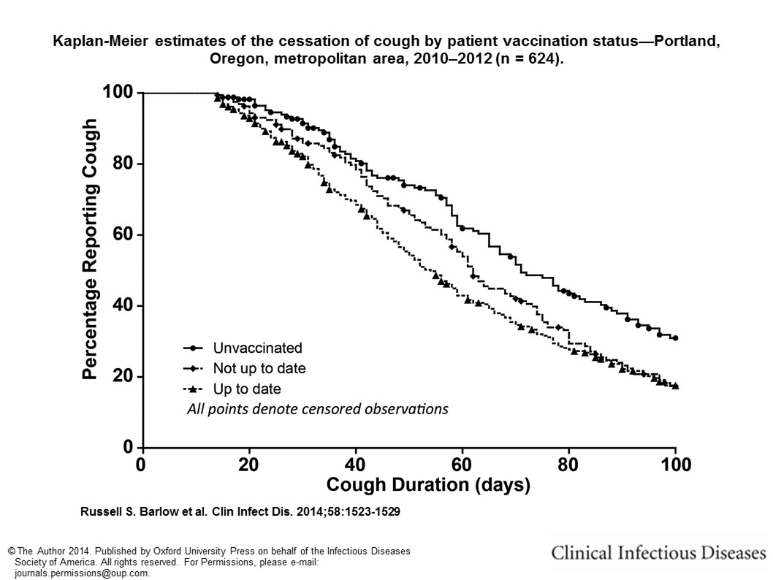

As treatment after the first 2 weeks of symptoms is of little value then it is not particularly helpful to offer testing. Simple reassurance is required providing there is no wet element to the cough. A small proportion of children will develop bronchiectasis as a result of infection. In clinical practice it is helpful to treat any moist cough after 8 weeks as possible PBB (see above).

Cough-variant asthma
Although cough is a common symptom in asthmatic children, in our opinion cough is very rarely the only symptom. Even in the adult populations, where cough is a more common symptom, a vanishingly small percentage (<2%) of individuals with asthma report cough without wheeze or breathlessness. In fact, cough without wheezing is reported much more commonly in apparently healthy adult controls (8%). In children, the diagnosis of cough variant asthma was discredited by studies showing that very few children with non-specific isolated children have eosinophilic airway inflammation or bronchial hyper-responsiveness. It is therefore not surprising that the overwhelming majority of children who have persistent dry cough do not benefit from asthma therapies including inhaled corticosteroids. In children who are old enough to perform lung function measurements (spirometry with reversibility testing) and exhaled nitric oxide measurements these should be undertaken to exclude asthma but a trial of speculative asthma treatment is not warranted in children with isolated dry cough without wheeze.

Malacia / Tracheoesophageal Fistula (TOF)
The cough associated with tracheomalacia or TOF has a characteristic ‘brassy’ sound. This is likely to be present since birth and may be associated with stridor.

Non-specific isolated cough
This is a label given to children who have a persistent dry cough but a complete absence of respiratory signs and symptoms and a normal chest radiograph. This “diagnosis” should only be made as a last resort and such children should be followed-up until the cough resolves or a more satisfactory diagnosis reveals itself.
Non-organic cough
It is common for children to have a repetitive, habitual dry cough that can persist for some time after an upper respiratory infection has cleared. This cough can be troublesome during the day but is rarely present during sleep. Psychogenic cough is a well-recognised clinical syndrome exemplified by a bizarre, explosive cough that is often described as ‘honking’ or ‘seal-like’. As with habit cough, it is rarely present at night but may become more prominent in the presence of parents, doctors or teachers. The diagnosis of non-organic cough is usually made clinically and any investigations undertaken are helpful only insomuch as they provide reassurance for the child and family. Children with non-organic cough often have very significantly impaired quality of life and we have encountered cases where children have been excluded from school or received long courses of oral and inhaled steroids with no effect. The key to successful treatment lies in recognising that the lower airway is healthy and that almost every therapy tried can be successful providing that the patient (and parents) share the optimism of the health care professional treating them. Our own centre has had considerable success using combinations of reassurance, hypnotherapy and inhaled ipratropium bromide (as a plausible placebo) tailored to the individual family.

Dispelling Adult Myths
Most adult chronic cough protocols revolve around three main diagnoses: cough variant asthma, gastro-oesophageal reflux (GOR) and post nasal drip. As mentioned above, cough variant asthma has largely been dismissed as a clinical entity in children. Similarly, there is little evidence to show that GOR causes cough in otherwise healthy children. Indeed a study in which GOR and cough were monitored simultaneously (using a pH probe and a cough recorder) demonstrated that whilst both coughing and GOR occurred, the relationship was not causal. There is a paucity of evidence that post nasal drip (PND) causes cough in children. The authors agree with the suggestion that cough in the presence of posterior pharyngeal secretions is more likely to suggest co-existing airway pathology than PND causing cough. The lack of evidence for these three diagnoses in paediatric practice emphasise that adult cough protocols have no role in the diagnosis or management of children with chronic cough.

Referral to secondary care / tertiary respiratory paediatrics
It may be appropriate to refer any child with a chronic cough to secondary or tertiary paediatrics although that may not always be necessary. Some causes such as PBB and pertussis can be managed in primary care where as others, such as a child with suspected bronchiectasis must be referred to a Tertiary Paediatric Respiratory Team. This is because the child is likely to need a number of investigations and if the diagnosis is confirmed will require input from an expert multi-disciplinary team.

