Figure 1: Sample size for analysis and sensitivity analysis
588,639 participants in the BCIS dataset in England and Wales between 2006 to 2013.

312,247 excluded for missing:
- Diabetes (n=36,279)
- Left ventricular ejection fraction (n=275,968)

15,666 excluded for missing:
- 30-day mortality (n=5,290)
- In-hospital major adverse cardiovascular events (n=0)
- In-hospital bleeding (n=10,376)

260,726 participants in primary analysis.
276,392 participants considered for primary analysis prior to consideration of outcomes.
Figure 2: Left ventricular function in non-diabetes and diabetes patients according to year
A) Poor LV function

B) Good LV function

Figure 3: Adjusted risk of adverse outcomes by diabetes status and left ventricular ejection fraction
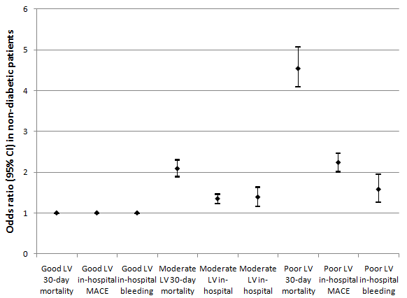
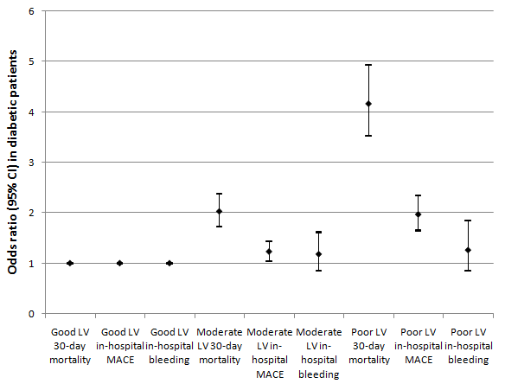
Figure 4: Adjusted risk of adverse outcomes according to left ventricular ejection fraction within subgroups of types of diabetes
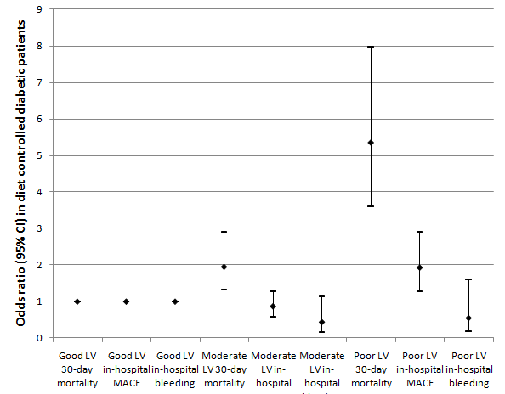
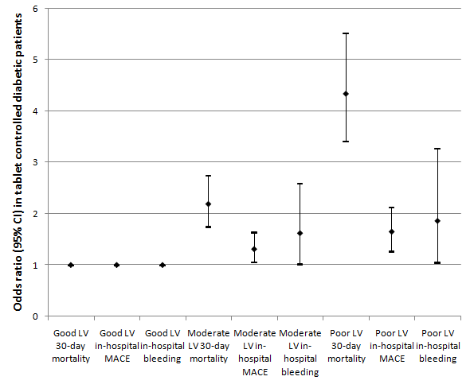
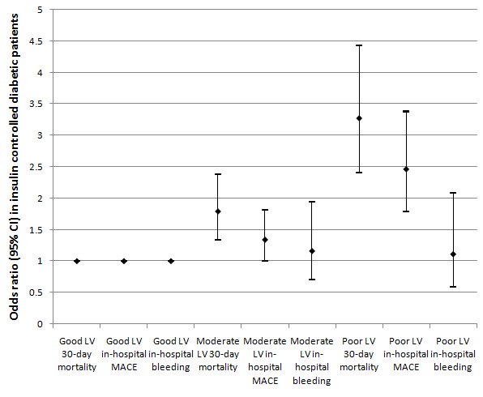

Figure 5: Adjusted Risk of adverse outcomes by type of diabetes within left ventricular ejection fraction groups
