Supplementary appendix
Table 1 Knee injury codes (ICD-10)
Knee injury description | Knee injury code
Knee contusion | S80.0
Fracture of patellae | S82.0
Fracture of the upper end of tibia | S82.1
Dislocation of patellae | S83.0
Dislocation of knee | S83.1
Meniscal tear | S83.2
Articular cartilage tear | S83.3
Collateral ligament sprain/strain | S83.4
Cruciate ligament sprain/strain | S83.5
Other/unspecified sprain/strain | S83.6
Injury to multiple structures | S83.7

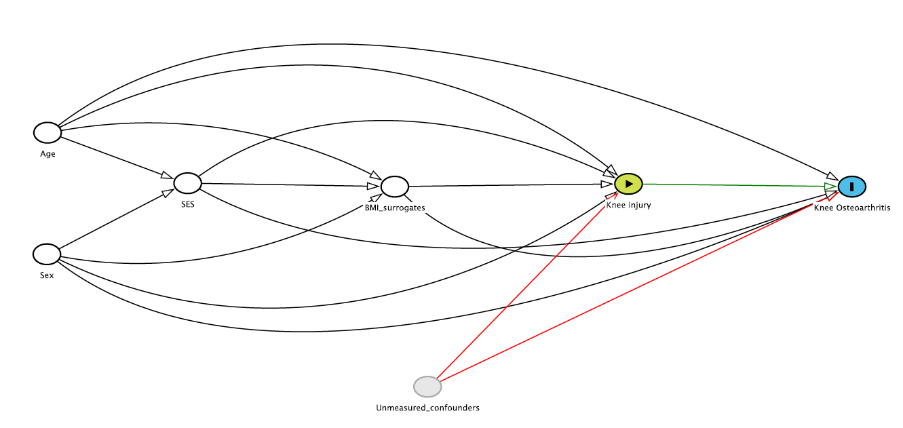
Figure 1 Directed Acyclic Graph to illustrate the confounders that were adjusted for in the analysis, and unmeasured confounders, both associated with knee injury and knee osteoarthritis

* SES= social economic status, which contains the variables income, educational attainment, and residential area.
† BMI surrogates contain the variables hypertension, diagnosis of diabetes, and obesity.
To support the relationships within this graph, we included the following references:

Zheng H, Chen C. Body mass index and risk of knee osteoarthritis: systematic review and meta-analysis of prospective studies. BMJ Open 2015;5(12). doi:10.1136/bmjopen-2014-007568
Silverwood V, Blagojevic-Bucknall M, Jinks C, et al. Current evidence on risk factors for knee osteoarthritis in older adults: a systematic review and meta-analysis. Osteoarthritis Cartilage 2015;23(4):507-515
Srikanth VK, Fryer JL, Zhai G, et al. A meta-analysis of sex differences prevalence, incidence and severity of osteoarthritis. Osteoarthritis Cartilage 2005;13(9):769-781
Van Tunen JAC, Peat G, Bricca A, et al. Association of osteoarthritis risk factors with knee and hip pain in a population-based sample of 25-59 year olds in Denmark: a cross-sectional analysis. BMC Musculoskelet Disord 2018;19(1):300. doi: 10.1186/s12891-018-2183-7
Kiadaliri AA, Gerhardsson de Verdier M, Turkiewicz A, Lohmander LS, Englund M. Socioeconomic inequalities in knee pain, knee osteoarthritis, and health-related quality of life: a population-based cohort study in southern Sweden. Scand J Rheumatol 2017;46(2):143-151. doi: 10.1080/03009742.2016.1181203
Jayanthi NA, Holt DB Jr. LaBella CR, Dugas LR. Socioeconomic factors for sports specialization and injury in youth athletes. Sports Health 2018;10(4):303-310. doi: 10.1177/1941738118778510
Figure 2 Log-log survival plot to assess the assumption of proportionality of hazards for the Cox regression model
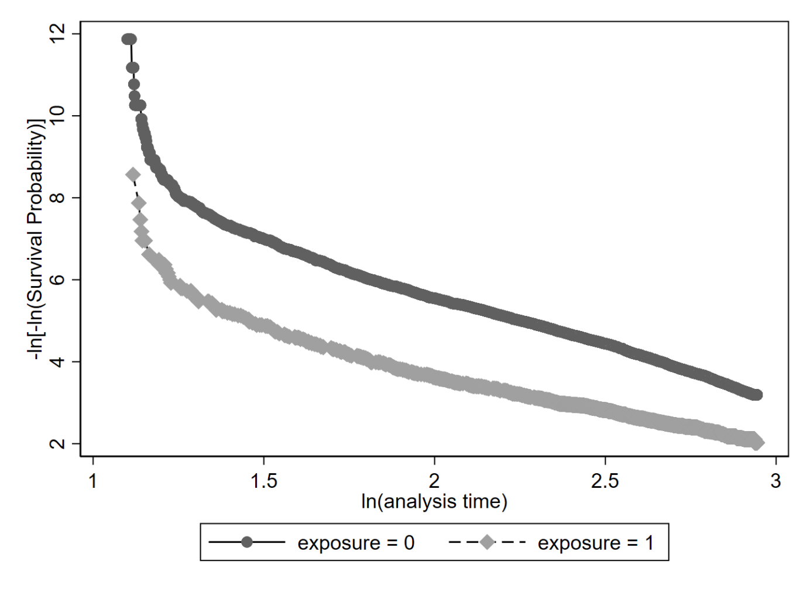
Figure 3 Frequency of main type of injury in injured persons

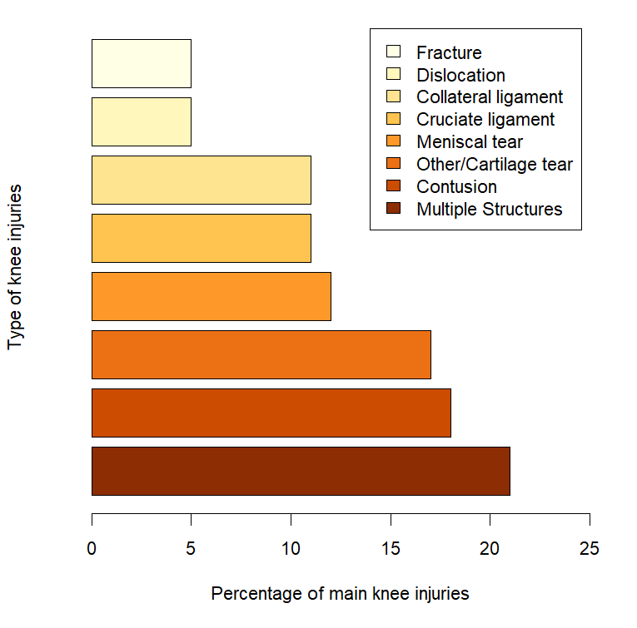
Table 2 Absolute frequencies and cumulative incidence of OA development at different follow-up times for persons with and without knee injury exposure
 | Knee OA  up to 5 years | Knee OA  up to 10 years | Knee OA  up to 15 years | Knee OA  up to 19 years
No knee injury, n (%)*  N=142,825 | 186 (0.1) | 1045 (0.7) | 2253 (2.1) | 2854 (4.0)
Knee injury, n (%)*  N=5,247 | 55 (1.1) | 225 (4.4) | 376 (8.3) | 422 (11.3)
Specific knee injuries, n (%)*
Cruciate ligament tear  N=571 | 10 (1.8) | 35 (6.2) | 68 (13.2) | 80 (18.3)
Meniscal tear  N=610 | 10 (1.6) | 35 (5.8) | 57 (10.0) | 65 (13.2)
Contusion  N=955 | 5 (0.5) | 22 (2.3) | 45 (5.7) | 49 (7.1)
Intra-articular fracture  N=250 | 4 (1.6) | 12 (4.9) | 18 (8.2) | 19 (10.4)
Dislocation  N=284 | 5 (1.8) | 11 (4.0) | 20 (9.1) | 21 (10.5)
Collateral ligament  N=564 | 2 (0.4) | 23 (4.1) | 34 (6.7) | 37 (8.1)
Multiple structures  N=1,096 | 10 (0.9) | 48 (4.4) | 81 (8.3) | 91 (10.9)
Cartilage tear/other injury  N=917 | 9 (1.0) | 39 (4.4) | 53 (6.9) | 60 (11.9)
OA=Osteoarthritis
*%=cumulative incidence

