A Data-Pooling Laboratory Activity to Investigate the Influence of Ionic Strength on the Solubility of CaSO₄·2H₂O (s)
David J McGarvey
School of Chemical and Physical Sciences, Lennard-Jones Laboratories, Keele University, Keele, Staffordshire, UK

Abstract
A laboratory experiment characterized by a whole class data-pooling approach to generate a dataset that can be used to test a model of the influence of ionic strength on electrolyte solubility is described and discussed. The design of the experiment makes efficient use of the laboratory period and releases time for instructional and dialogic exchanges surrounding the theoretical background to ionic strength effects on ionic equilibria and the use of advanced features of Excel to analyse the data based on a model derived from Debye-Hückel theory. The activity is assessed via a pre-laboratory exercise and an Excel workbook, for which a typical dataset with full analysis and results is provided.

Graphical Abstract
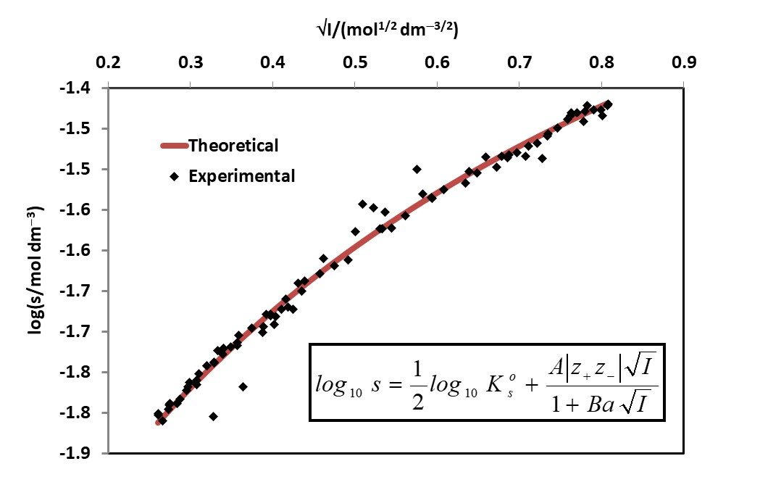

Keywords
Second-year undergraduate; physical chemistry; analytical chemistry; laboratory instruction; hands-on learning; aqueous solution chemistry; equilibrium; precipitation/solubility; quantitative analysis.

INTRODUCTION

This experiment forms part of the laboratory programme associated with a 2nd year undergraduate module (15 credits out of a total of 120 credits for the whole 2nd year programme) in ‘Spectroscopy and Analytical Chemistry’, of which lectures, workshops and laboratory classes on ‘Electrolyte Solutions’ comprises about one third of the module content.
The relevant learning outcomes for the electrolyte solutions component of the module state that students will be able to:
- Use advanced features of Excel in the analysis of experimental data.
- Describe, apply and evaluate theories of electrolyte solutions through experiment and problem solving.
- Apply principles of analytical chemistry to quantify analytes and associated errors.
- Communicate the analysis, interpretation and significance of experimental results in compliance with scientific writing conventions and standards.
- Locate, analyse and apply information from literature, chemical databases, and scientific journal articles.

A key feature of this laboratory experiment is the efficient use of laboratory instruction time and resources through the use of a whole class data-pooling approach. The data-pooling approach facilitates acquisition of a large experimental dataset in a relatively short time by distributing the experimental work amongst the class, such that the data is acquired in parallel rather than in series. This strategy releases class time for students to focus on the more challenging aspect of the activity, which in this case is data analysis involving the use of Excel solver and nonlinear least-squares regression to model the influence of ionic strength on the solubility of an electrolyte. The use of data pooling to support learning activities in chemistry has a number of advantages and several examples have featured in articles in this journal ¹⁻⁸. Data-pooling is particularly advantageous in aspects of physical and analytical chemistry, which can require students to carry out highly repetitive tasks in order to acquire a meaningful dataset to investigate the influence of a variable on a physical or chemical property. The learning benefits individual students (or pairs of students) derive from carrying out repetitive tasks clearly decline after the task has been performed a few times, and it therefore makes logistical sense to distribute the workload amongst the whole class, allowing acquisition of a larger (whole class) dataset in a fraction of the time and freeing up class time for other learning activities associated with the practical. An additional advantage of the data-pooling approach is afforded if the laboratory environment supports the display, in real-time, of the pooled data (e.g. via projection screens in the laboratory), such that students can see the data evolve as it is acquired, thus facilitating instructional and dialogic interventions as the practical proceeds. In the teaching laboratories at Keele large projection screens permit the data to be displayed as it is acquired and entered into the shared spreadsheet by students. This laboratory experiment has been used successfully with 2nd year undergraduate cohorts of up to ~100 students for more than five years.

theory

The influence of ionic strength on electrolyte solubility

In this experiment the influence of ionic strength (I) on the solubility of the sparingly soluble salt calcium sulfate dihydrate, CaSO₄·2H₂O (s), was examined using a complexometric (EDTA) titration to determine the concentration of Ca²⁺ ions in solutions in which the equilibrium represented by equation 1 is established. The ionic strength was varied by allowing the equilibrium to become established in a series of solutions containing different concentrations of the inert electrolyte, KNO₃.
$CaSO_{4}·2H_{2}O(s)⇌Ca^{2+}\left(aq\right)+SO_{4}^{2-}(aq)$ (1)
The thermodynamic equilibrium constant (solubility product), K_{s}°, is given by equation 2, where a is activity and γ± is the mean ion activity coefficient. The molar concentration terms [Ca²⁺] and [SO₄²⁻] are referenced to the standard state (c_{o} = 1 mol dm⁻³, not shown explicitly) and are therefore dimensionless.
(2)
The solubility (s) is the number of moles of CaSO₄·2H₂O (s) that dissolve per dm³ of solution, and therefore equation 2 may be re-written in terms of s (equation 3).
(3)
The Debye-Hückel Extended Law (DHEL, equation 4) is a theoretical expression for the ionic strength dependence of γ±, and is generally applicable up to ionic strengths of approximately 0.1 mol dm⁻³. In equation 4, A is the Debye-Hückel constant (0.509 dm^{3/2} mol^{−1/2} for aqueous solutions at 298 K), |z₊z₋| is the magnitude of the product of the ion charges (equal to 4 for CaSO₄), I is the ionic strength, B is a constant (3.286 × 10⁹ dm^{3/2} mol^{−1/2} m⁻¹ at 298 K in water⁹) and a is an ion size parameter; the product Ba is around 1 – 2 dm^{3/2} mol^{−1/2} for many electrolytes in water.
(4)
Combining equation 3 with equation 4 leads to equation 5, which predicts how the solubility (s) should vary with I, assuming the DHEL is valid.
(5)
Analysis of solubility (s) data as a function of ionic strength (I) was performed by modelling the experimental data based on equation 5, allowing determination of K_{s}°, Ba and |z₊ z₋| and an assessment of the validity of the DHEL. Using the determined value of K_{s}°, equation 3 was then used to determine experimental γ± values from the experimentally determined solubility (s) data.

Thus the objectives of the laboratory activity are to:
- Model the experimental data using the Debye-Hückel extended law (DHEL) and hence determine |z₊ z₋|, Ba and K_{s}° for CaSO₄·2H₂O (s).
- Determine γ± values over a range of ionic strengths.
- Compare findings with literature data.

HAZARDS
Instructors and students should wear appropriate personal safety protection (laboratory coat, eye protection, gloves) when handling the chemicals (see Supporting Information) used in this experiment. Storage and transfer of the buffer should be conducted in a fume hood. Chemical waste should be disposed of in accordance with local regulations and protocols.

THe laboratory session, pre- and post-laboratory activities

The duration of the laboratory session for this experiment was three hours and the total number of students was approximately 90. Students worked individually and contributed their raw data to a whole-class dataset within a spreadsheet, subsequently shared with the class via the VLE (Virtual Learning Environment). Prior to the laboratory session students were required to complete a COSHH (Control of Substances Hazardous to Health, a UK statutory instrument) risk assessment and a short pre-laboratory exercise (see Supporting Information), which was designed to seed students’ minds with knowledge and understanding of some of the fundamental concepts and calculations. Students received feedback on the pre-laboratory exercise approximately one week before the laboratory session using a whole-class tutor-led dialogic self-assessment approach during which students take responsibility for writing their own feedback and marking their own work using a distinctly colored pen under controlled conditions. Risk assessments were signed off prior to commencement of experimental work.
At the beginning of the laboratory session the students received an introductory briefing recalling the aims and objectives of the experiment and explaining the rationale behind the data-pooling approach and the allocation of experimental work amongst the class. Each student¹⁰ then prepared the KNO₃ solution allocated to them (each student typed their name against an indicative concentration in the approximate range 5.0 × 10⁻⁴ – 0.5 mol dm⁻³), to which they added sufficient CaSO₄·2H₂O (s) to allow establishment of the equilibrium shown in equation 1. Thus a series of ~90 solutions was prepared across the whole class in which the equilibrium was established in environments of widely differing ionic strengths. Students then analysed the equilibrated supernatant liquid for Ca²⁺(aq) using an EDTA titration (see Results and Data Analysis below and Supporting Information) and recorded their exact KNO₃ concentration and titre volume information on the class spreadsheet against their respective names. The stock EDTA solution was provided such that all students used the same EDTA solution for analysis. During data collection a living plot of the raw data (titre volume versus [KNO₃]) was displayed via a projection screen in the laboratory, which very effectively illustrated the influence of the ionic strength on the titre volume, and hence the solubility. Further details of the experimental procedure are provided in the Supporting Information.
Once data collection was complete (generally this was within 2 hours, including the briefing session at the beginning of the session), the remainder of the session was used to explain the principles and key steps of the data analysis using Excel solver, with ample time for discussion and questions and making links to theoretical concepts discussed in lectures. Post-laboratory, the students accessed the data spreadsheet (via the VLE) and were required to make an initial attempt at the data analysis prior to a data analysis workshop in a computer laboratory the following week (typically), during which students refined and improved their work, drawing on formative face-to-face feedback from instructors.

Results AND DATA ANALYSIS

Solubility and Ionic Strength Calculations
The number of moles of EDTA in the corrected titre volume is equivalent to the number of moles of Ca²⁺(aq) at equilibrium. Hence the solubility (s) is conveniently calculated using equation 6, where [EDTA] is the molar concentration of the standard EDTA solution and V_{titre} and V_{sample} are respectively the blank-corrected titre volume and the volume of sample analysed (10.0 mL in this case).
$s=\frac{\left[EDTA\right]V_{titre}}{V_{sample}}$ (6)
The ionic strength (I) is given by equation 7, where c_{i} is the concentration of ion i and z_{i} is its charge number.
$I=\frac{1}{2}\sum{c_{i}z_{i}^{2}}$ (7)
Applying equation 7 to the equilibrated samples, and noting that [K⁺] = [NO₃⁻] = [KNO₃] and [Ca²⁺] = [SO₄²⁻] = s, leads to the following expression for I (equation 8).
$I=4s+[KNO_{3}]$ (8)
The raw pooled data (see Supporting Information) consisted of spreadsheet columns containing the KNO₃ concentrations and the V_{titre} values. Students created subsequent columns containing s and I for all samples and calculated these quantities using equations 6 and 8 with appropriate cell addressing and drag-down formula entries. With the range of KNO₃ concentrations employed, the range of s values was 0.014-0.038 mol dm⁻³ and the range of I values was 0.068 – 0.65 mol dm⁻³. Willey¹¹ has previously reported a related experiment involving CaSO₄·2H₂O (s), but a slightly different theoretical model was invoked (involving ion-pairs) and data was only reported for two different ionic strengths.

Nonlinear regression analysis using Excel Solver
A detailed description of the application of Excel Solver to problems in chemistry is provided by Billo¹², so only a brief description is provided here (the Supporting Information consists of a set of fully analysed student data). Solver is an Excel add-in, accessible via file/options in the Excel toolbar. Equation 5 is the theoretical equation that describes the variation of s with I (specifically how log s depends on √I) and predicts a non-linear relationship between log s and √I.
The use of Excel solver enables students to determine the values of K_{s}°, Ba and |z₊ z₋|that best fit the experimental data. Thus within their spreadsheets, students created columns containing log s and √I values from the experimental data. Next students created a column for theoretical log s values (log s (theoretical)) with values being calculated using equation 5, the √I values and starting values for the three adjustable parameters (K_{s}°, Ba and |z₊ z₋|), which were placed in adjacent separate cells (see Supporting Information)). Students determined an appropriate starting value for K_{s}° by using equation 3 and taking γ± = 1 for the sample with the lowest ionic strength (alternatively a literature value^{11, 13} could be used). Students were advised that starting values of 1 and 4 were appropriate for Ba and |z₊ z₋|. Students then created two plots of log s and log s (theoretical) versus √I on a single plot area, in order to visualize the difference between the two; students should observe that the general form of the experimental data and the theoretical curve are similar. Students are taught that solver needs to be able to compare the log s (theoretical) with the log s data and that this is done using the sum of squares of the differences between these two sets of values. Thus students created a column for (log s – log s (theoretical))² and the sum of these values was calculated in a suitable cell. Students then loaded the solver add-in (through the ‘data’ tab), selected the sum of squares cell as the ‘objective’ cell, selected ‘min’ (to minimize the sum of squares) and selected the three cells containing the values of the adjustable parameters for the ‘by changing variable cells’ field. GRG nonlinear (default) was then selected as the solving method, ticking ‘make constrained variable non-negative’ (as none of the parameters are theoretically negative). Under ‘options’ for GRG nonlinear, students ticked ‘Use Automatic Scaling’ which they have learned alerts solver to the fact that the adjustable parameter values will vary by orders of magnitude. Students then click on ‘solve’ and very quickly a solution is found. In the instruction of students on the use of solver, it is important to explain that running solver several times and from different starting values of K_{s}°, Ba and |z₊ z₋|is good practice so as to have confidence the global minimum has been reached (of course students should be made aware that there is no guarantee a global minimum is reached without additional information). The actual iterative process can be observed in steps by ticking ‘show iteration results’ under the options tab next to GRG nonlinear.
Billo¹² describes how the standard deviations for the determined values of the adjustable parameters can be obtained, but advises that it is a cumbersome process and hence provides a macro (solver statistics) for this purpose on the CD rom accompanying the hardcopy of the book, the operation of which is clearly explained in chapter 15 of reference 12. For this experiment students used the solver statistics macro to obtain the standard deviations of the adjustable parameters.
Figure 1 shows a set of typical student data for a class of ~90 students with the corresponding determined values of K_{s}°, Ba and |z₊ z₋|, their standard deviations and literature data shown in table 1. Similar results have been obtained for successive student cohorts over a period exceeding five years.
Figure 1. Plots of log s and log s (theoretical) versus √I for CaSO₄·2H₂O (s). The theoretical curve is calculated from equation 5 using the values (see table 1) of K_{s}°, Ba and |z₊ z₋| determined using Excel solver.

Table 1. Determined values of the adjustable parameters (eq 5) and literature data for comparison.
K_{s}°/10⁻⁵ | |z₊z₋| | Ba/(mol^{–1/2} dm^{−3/2})
3.7 ± 0.8ª | 4.1 ± 0.6ª | 1.4 ± 0.3ª
4.2^{b} | - | 1.5^{b}
2.63^{c} | - | -
ªThis work; ^{b}Ref 13; ^{c}Ref 11

An alternative approach to the data analysis, suggested by a reviewer, is to express equation 5 in terms of ps (i.e. –log₁₀ s) and pK_{s}° and to set pK_{s}°, Ba and |z₊ z₋| as adjustable parameters. This approach has the advantage of reducing scaling issues, but otherwise yields parameter values that are almost identical to those presented in table 1.

Activity coefficients
Students then determined values of γ± across the whole range of ionic strengths by using equation 3 (rearranged), the value of K_{s}° obtained from the nonlinear regression analysis using Excel solver, and the experimental s values. Figure 2 shows a plot of log γ± versus √I alongside the theoretical plot predicted by the Debye-Hückel limiting law (equation 4 with Ba = 0, |z₊ z₋|= 4), where it is evident that the two curves are converging at lower ionic strengths (achievement of lower ionic strengths is limited to ~ 0.06 mol dm⁻³ by the inherent solubility of CaSO₄·2H₂O (s)). Values of γ± for the full range of ionic strengths are provided in the analysed student dataset in the Supporting Information.
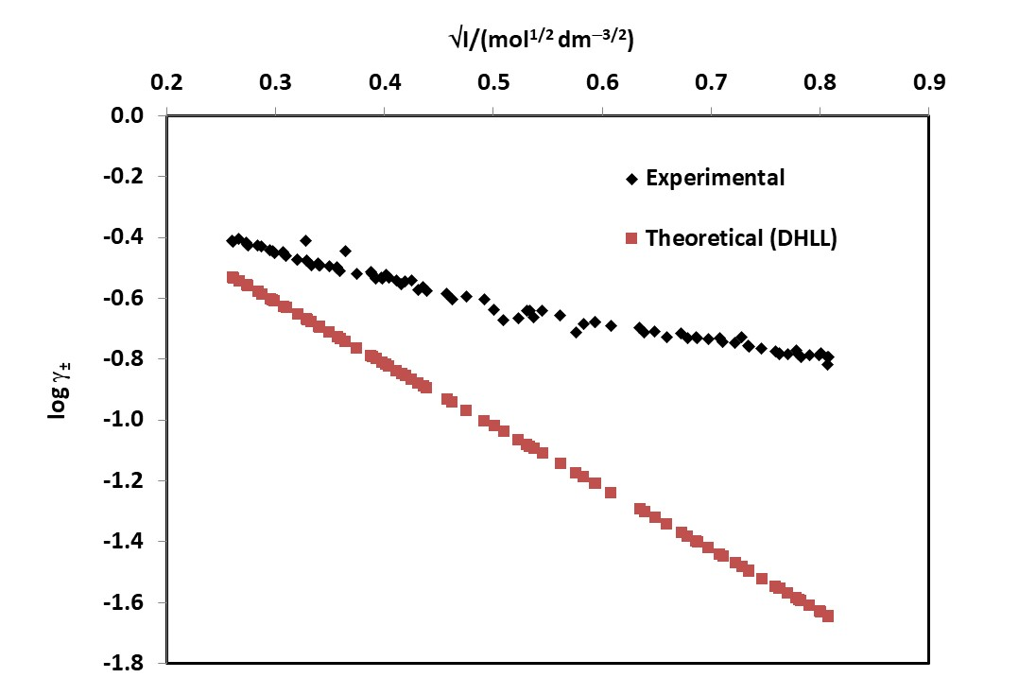
Figure 2. Plots of log γ± and log γ± (theoretical) versus √I for CaSO₄·2H₂O. The log γ± (theoretical) values are calculated using the Debye-Hückel limiting law (equation 4 with Ba = 0, |z₊ z₋| =4).

Willey¹¹ reports γ± values for two different ionic strengths (using NaCl as the inert electrolyte), however the model invoked by Willey includes ion-pair formation which affects the calculation of γ± from s data (see eq 12 of reference 11). In respect of competing processes such as ion-pair formation, Clark and Bonicamp¹⁴ argue that the extent of agreement between experimentally measured solubilities and solubilities calculated from K_{s}° (with calculation of activity coefficients where necessary) can be used to judge whether the operation of such competing processes is significant. It is clear from their analysis that it is reasonable to neglect ion-pairing for CaSO₄, which is the assumption in the work reported here. However, Willey’s use of NaCl as the inert electrolyte could lead to ion-pair formation due to the higher charge density on the Na⁺ and Cl⁻ ions in comparison with K⁺ and NO₃⁻ from KNO₃ used in this work. Table 2 shows γ± values from reference 11 alongside values for comparable ionic strengths obtained in the work reported here. The ionic strengths for Willey’s γ± values were calculated using equation 8 with [NaCl] replacing [KNO₃] and Willey’s reported s values from EDTA titrimetric analysis.

Table 2. Literature comparison for selected γ± values
s/mol dm⁻³ | I/mol dm⁻³ | γ± | s/mol dm⁻³ | I/mol dm⁻³ | γ±
0.015ª | 0.060ª | 0.53 (0.41)ª | 0.016^{b} | 0.068^{b} | 0.39^{b}
0.022ª | 0.34ª | 0.30 (0.28)ª | 0.029^{b} | 0.34^{b} | 0.21^{b}
ªRef 11 (values in parentheses calculated from reported s and the value of K_{s}° from this work (see Table 1)); ^{b}This work (see Supporting Information dataset).

ASSESSMENT OF ACHIEVEMENT OF THE LEARNING OUTCOMES

This laboratory experiment is one of four experiments associated with ‘electrolytes and solution chemistry’ within a 2nd year chemistry module at Keele University. The principal assessment for the laboratory practicals is an Excel spreadsheet comprising comprehensive data analysis, interpretation of results and evidence of engagement with relevant peer-reviewed journal articles. Students ‘report’ each practical via separate worksheets within a single Excel workbook. The laboratory programme is designed to enable students to gain experience with and acquire skills in more advanced aspects of data analysis and presentation using Excel and has a strong formative element in which students learn by doing and get face-to-face feedback in the laboratory and workshops as they work through their data processing and analysis. The Excel skills developed include data manipulation and calculations using formula entries with appropriate cell addressing strategies, use of statistical functions, use of LINEST for returning linear regression statistics, use of Solver for nonlinear regression, XY scatter plots with multiple datasets on one plot area and for displaying multiple spectra on one plot. Presentation quality also forms part of the assessment criteria such that students are expected to observe professional standards of presentation and adherence to professional conventions in chemistry (e.g. graphs, tables, equations, referencing). Year on year the vast majority of students produce work of a high to very high standard and show strong evidence of achievement of the learning outcomes as well as creativity in their execution of the assessment tasks; this is also evident in their use of the acquired skills in different contexts in 3rd and 4th year research projects. Assessment details and marking criteria are provided in the Supporting Information, whilst a summary of student performance data is provided in the ‘Instructor notes’.

Associated content

Supporting Information
The Supporting Information is available on the ACS Publications website at DOI: 10.1021/acs.jchemed.XXXXXXX.
Typical Analysed Dataset (.xlsx)
Student handout (.docx)
Instructor notes (.docx)
Assessment details (.docx)
Pre-laboratory exercise (.docx)

AUTHOR INFORMATION

Corresponding Author
*E-mail: d.j.mcgarvey@keele.ac.uk

Acknowledgments
The author acknowledges the technical support of Nicola Jervis of Keele University. The author also acknowledges the insightful comments and suggestions of two reviewers, which have resulted in significant improvements to the manuscript.

REFERENCES

1. Ricci, R.W.; Ditzler, M. A. A Laboratory-Centered Approach to Teaching General Chemistry. J. Chem. Educ., 1991, 68(3), 228-231. DOI: 10.1021/ed068p228
2. Ricci, R. W.; Ditzler, M. A.; Jarret, R.; McMaster, P.; Herrick, R. The Holy Cross Discovery Chemistry Program. J. Chem. Educ., 1994, 71 (5), 404-405. DOI: 10.1021/ed071p404
3. Ditzler, M. A.; Ricci, R. W. Discovery Chemistry: Balancing Creativity and Structure. J. Chem. Educ., 1994, 71 (8), 685-688. DOI: 10.1021/ed071p685
4. Herrick, R.S.; Nestor, L. P.; Benedetto, D. A. Using Data Pooling to Measure the Density of Sodas. J. Chem. Educ., 1999, 76(10), 1411-1413. DOI: 10.1021/ed076p1411
5. Shipp, D.; Durham, B.; Sadoski, R. C. Metal Complexes of Trifluoropentanedione. An Experiment for the General Chemistry Laboratory. J. Chem. Educ., 2001, 78 (5), 665-666. DOI: 10.1021/ed078p665
6. Cornely, K; Moss, D. B. Determination of the Universal Gas Constant, R. A Discovery Laboratory. J. Chem. Educ., 2001, 78 (9), 1260-1262. DOI: 10.1021/ed078p1260
7. Herrick, R.S.; Mills, K. V.; Nestor, L. P. Data Pooling in a Chemical Kinetics Experiment: The Aquation of a Series of Cobalt(III) Complexes. J. Chem. Educ., 2008, 85(8), 1120-1122. DOI: 10.1021/ed085p1120
8. Olsen, R. J. Using Pooled Data and Data Visualization To Introduce Statistical Concepts in the General Chemistry Laboratory. J. Chem. Educ., 2008, 85 (4), 544-545. DOI: 10.1021/ed085p544
9. Manov, G.G; Bates, R.G.; Hamer, W.J.; and Acree, S.F. Values of the Constants in the Debye-Hückel Equation for Activity Coefficients. J. Am. Chem. Soc. 1943, 65 (9), 1765-1767, DOI: 10.1021/ja01249a028
10. This is of course flexible and for smaller class sizes it may be more appropriate for each student to prepare and analyse two (or more) samples.
11. Willey J. D. The Effect of Ionic Strength on the Solubility of an Electrolyte. J. Chem. Educ., 2004, 81(11), 1644-1646. DOI: 10.1021/ed081p1644
12. Billo, E. J. Excel for Chemists; a Comprehensive Guide. 3rd ed. Hoboken ed.; Wiley: N. J., 2011.
13. Marshall, W. L.; Slusher, R. Thermodynamics of Calcium Sulfate Dihydrate in Aqueous Sodium Chloride Solutions, 0-110°. J. Phys. Chem. 1966, 70 (12), 4015-4027, DOI: 10.1021/j100884a044
14. Clark R. W.; Bonicamp J. M. The K_{sp}-Solubility Conundrum. J. Chem. Educ., 1998, 75(9), 1182-1185. DOI: 10.1021/ed075p1182

