**Comparing the Management of Constipation and Distal Intestinal Obstruction Syndrome between Paediatricians and Adult Physicians.**

Green J1, Carroll WD1,2, Gilchrist FJ1,2

Running title: Management of constipation and DIOS in the UK.

Institutions: 1Institute of Applied Clinical Science, Keele University, ST4 7QB, UK; 2University Hospitals of North Staffordshire NHS Trust, Stoke on Trent, ST4 6QG, UK.

Correspondence: Dr Francis J Gilchrist, Department of Paediatric Respiratory Medicine, Royal Stoke University Hospital, University Hospitals of North Staffordshire NHS Trust, Stoke on Trent, ST4 6QG. Tel: 01782 675289. Fax: 0843 6365389. [f.j.gilchrist@keele.ac.uk](mailto:f.j.gilchrist@keele.ac.uk) [francis.gilchrist@uhnm.nhs.uk](mailto:francis.gilchrist@uhnm.nhs.uk)

**Key Words:** Constipation, cystic fibrosis, distal intestinal obstruction syndrome, laxatives.

**Word count:** 795

**Funding source:** No funding was secured for this study.

**Financial Disclosure:** The authors have no financial relationships relevant to this article to disclose.

**Conflict of interest:** The other authors have no conflicts of interest to disclose.

Intestinal complications are common in children and adults with cystic fibrosis (CF). Constipation affects up to half of all patients and DIOS affects around 5% of patients in any one year.[1] Although these two conditions share symptomatology and treatments, the pathogenesis is different. DIOS is acute complete or incomplete faecal obstruction in the ileocaecum whereas constipation is gradual faecal impaction of the total colon.[2] We wanted to assess and compare the treatment regimens used by paediatricians and adult physicians for the management of constipation, incomplete DIOS and complete DIOS.

Separate electronic surveys were devised for paediatricians and adult physicians to clarify treatment regimens for constipation, partial DIOS and complete DIOS. These were based around case vignettes of patients meeting the relevant diagnostic criteria.[2] An electronic link to the appropriate survey was sent to each consultants listed on the UK CF Trust directory (2013). Consultants not listed on this directory were identified using CF Centre’s own websites. Links were sent to 82 paediatricians and 65 adult physicians. If responses were not received within one week a single reminder email was sent out. The Chi-squared test was used to compare paediatrician and adult physician responses. A p value <0.05 was deemed significant. The UK NHS Health Research Authority ethics tool confirmed that ethical approval was not required (http://www.hra.nhs.uk/resources/before-you-apply/is-nhs-rec-review-required/).

We received responses from 51% (42/82) paediatricians and 60% (39/65) adult physicians giving an overall response rate of 55% (81/147). For constipation, adult physicians used a higher median (range) number of interventions per patient than paediatricians; 2 (1-3) vs 1 (1-2), p=0.006. Sachets of Macrogol 3350 (Movicol®) and lifestyle modifications were the most frequently used interventions for constipation accounting for >70% of the responses from both paediatricians and adult physicians. Responses included under lifestyle modification were: increased fluid or salt intake, assessing adherence or pancreatic enzyme replacement and modifications to physical activity levels. The lack of variation seen in the management of constipation is likely to be influenced by the available national guidance which is informed by randomised controlled trials. Although the NICE guideline is not specific to cystic fibrosis, there is no reason to think that this guidance cannot be extrapolated to CF. Lactulose was the only intervention other than Movivol® and lifestyle modification used by paediatricians whereas the adult physicians also documented the use of sodium docusate, senna, N-acetylcysteine and Gastrografin®. Adult physicians were more likely than paediatricians to recommend lifestyle modification for constipation (p=0.006). The reasons for this are unclear but may reflect adult patients being more willing or able to make such changes.

For incomplete DIOS, nine interventions were combined into 22 different regimens by the paediatricians and 23 by the adult physicians. The three most commonly used interventions were Movicol®, Gastrografin® and lifestyle modification. Gastrografin® was used to treat incomplete DIOS by 20/37 (54%) adult physicians compared to 10/39 (26%) paediatricians (p=0.01). There was a non-significant trend for paediatricians to use more lactulose than adult physicians (p=0.051). See Figure 1.

The four most common interventions for complete DIOS were surgical review, Gastrografin®, KleanPrep® and non-surgical management of bowel obstruction (intravenous fluids, nasogastric aspiration and nil by mouth). The use of Gastrografin® and KleanPrep® as first-line medical management for complete DIOS is in keeping with published guidelines.[3,4] There was a non-significant trend for adult physicians to use more Gastrografin® (p=0.08) and Klean-Prep® (p=0.06) than paediatricians. Surgical review was part of the initial management plan for complete DIOS for 26/38 (68%) paediatricians compared to 14/36 (39%) adult physicians (p=0.01). If bilious vomiting was present 36/38 (95%) paediatricians would request a surgical review compared to 12/36 (33%) adult physicians (p=0.0001). Surgical intervention is generally accepted as a last resort.[5] The different thresholds for surgical intervention between paediatricians and adult physicians may relate to the increased prevalence of DIOS in adults resulting in greater confidence in the likely success of conservative management.

All adult physicians and all but one of the paediatricians identified a lack of good quality evidence on which to base their management decisions for all three conditions.

In summary, this survey found relatively little variation in the management of constipation. There were, however, differences amongst and between paediatricians and adult physicians regarding the management of DIOS. This was most noticeable for incomplete DIOS with a large number of therapies being combined into multiple different regimens. The listed medical therapies for incomplete DIOS included both laxatives used for constipation and the bowel cleansing agents used to treat complete DIOS. The variation in practice for the management of DIOS is likely to be influenced by the lack of good quality evidence. Given this lack of evidence, clinicians can use the available guidelines[3,4] and management algorithms (http://cfmedicine.com/htmldocs/CFText/dios.htm) to aid their clinician decisions regarding DIOS. Review by the multi-disciplinary team enables individualised treatment plans and promotion of prevention strategies.

## Figure 1: First line management for incomplete DIOS.

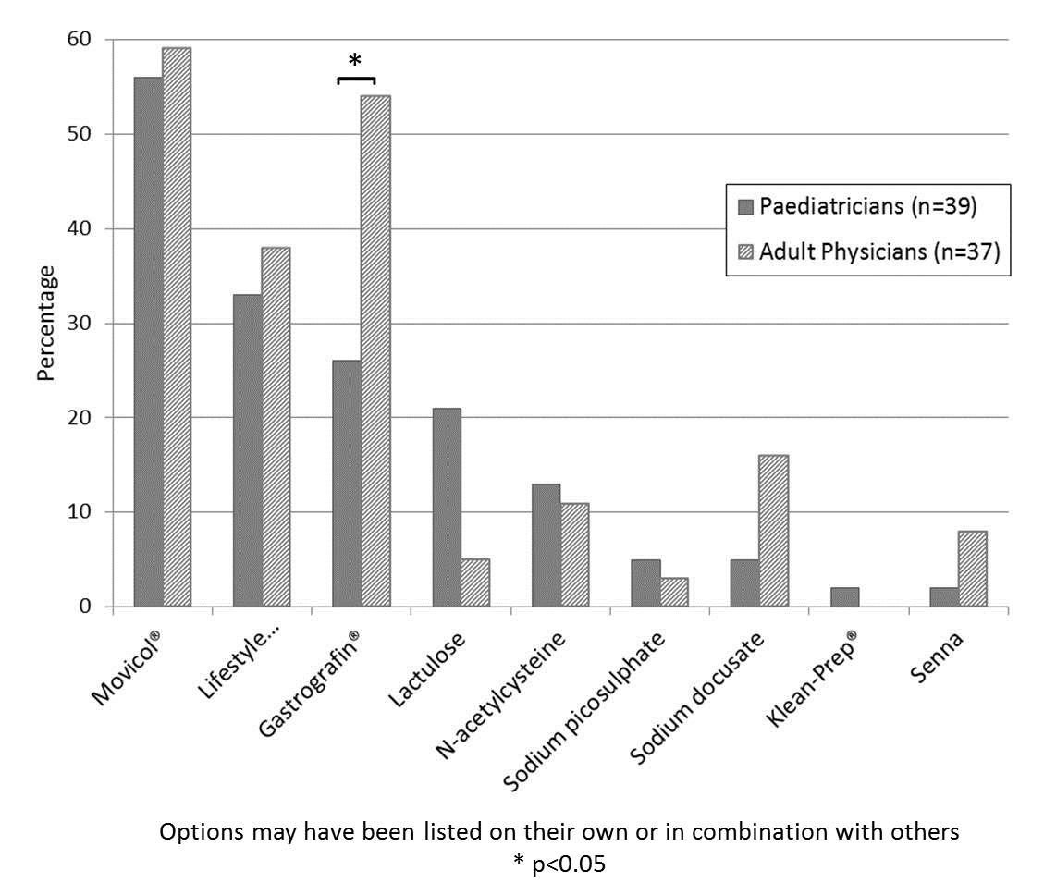

# References

[1] van der Doef HPJ, Kokke FTM, van der Ent CK, Houwen RHJ. Intestinal Obstruction Syndromes in Cystic Fibrosis: Meconium Ileus, Distal Intestinal Obstruction Syndrome, and Constipation. Curr Gastroenterol Rep 2011;13:265–70. doi:10.1007/s11894-011-0185-9.

[2] Houwen RH, van der Doef HP, Sermet I, Munck A, Hauser B, Walkowiak J, et al. Defining DIOS and constipation in cystic fibrosis with a multicentre study on the incidence, characteristics, and treatment of DIOS. J Pediatr Gastroenterol Nutr 2010;50:38–42. doi:10.1097/MPG.0b013e3181a6e01d.

[3] Colombo C, Ellemunter H, Houwen R, Munck A, Taylor C, Wilschanski M, et al. Guidelines for the diagnosis and management of distal intestinal obstruction syndrome in cystic fibrosis patients. J Cyst Fibros Off J Eur Cyst Fibros Soc 2011;10 Suppl 2:S24-28. doi:10.1016/S1569-1993(11)60005-2.

[4] Groves T, Kench A, Dutt S, Gaskin K, Fitzgerald DA. Question 8: How should distal intestinal obstruction syndrome [DIOS] be managed? Paediatr Respir Rev 2017;21:68–71. doi:10.1016/j.prrv.2016.04.001.

[5] Farrelly PJ, Charlesworth C, Lee S, Southern KW, Baillie CT. Gastrointestinal surgery in cystic fibrosis: a 20-year review. J Pediatr Surg 2014;49:280–3. doi:10.1016/j.jpedsurg.2013.11.038.