Factors influencing family burden of paediatric atopic dermatitis patients: a cross-sectional study
Running title: Family impact of childhood AD: a cross-sectional analysis

Xiaomeng Xu¹, Louise Sandra van Galen^{1,2}, Ram Bajpai^{1,3}, Mark Jean-Aan Koh⁴, Steven Thng^{5,6}, Yik Weng Yew^{5,6}, Krister Järbrink¹, Josip Car¹*

1 Centre for Population Health Sciences (CePHaS), Lee Kong Chian School of Medicine, Nanyang Technological University Singapore, Singapore [josip.car@ntu.edu.sg]
2 Section of Acute Medicine, Department of Internal Medicine, VU University Medical Centre, the Netherlands
3 School of Primary Community and Social Care, Keele University, Staffordshire, UK
4 Dermatology Service, KK Women's and Children's Hospital, Singapore
5 National Skin Centre, 1 Mandalay Road, Singapore 308205
6 Skin Research Institute of Singapore, 8A Biomedical Grove, Immunos, Singapore 138648
*Corresponding author

MESH term: Dermatitis, Atopic, Family, Quality of Life
Funding statement: This research was supported through the Skin Research Grant by the Skin Research Institute of Singapore (SRIS: SRG/15022), a tripartite partnership between the Agency for Science, Technology, and Research (A*STAR), National Healthcare Group through its National Skin Centre (NHG) and the Nanyang Technological University (NTU).
Disclosures: Nothing to disclose.

Introduction
Atopic dermatitis (AD) is a chronic, recurrent inflammatory skin condition that affects about 10–20% of children and 2-15% of adults in developed countries (1). In Singapore, the prevalence among children and adolescents is 20.8% (2). Itchiness, the most common complaint, results in behavioural and social impairments among paediatric AD patients, which in turn impacts on the wellbeing of caregivers, particularly family members (3, 4). A sick child can markedly affect normal family life and the mental and social wellbeing of other family members (5). Their family members, namely parents, may experience feelings of helplessness and stress as they struggle to treat their child’s symptoms, and this can lead to feelings of guilt as they feel they are failing in their duty to care for their offspring (6). In return, family quality of life can greatly influence patient-related outcomes. Previous studies have demonstrated that paediatric atopic eczema can significantly affect family life; however, they provide limited quantitative data on the factors influencing family life and functions (6). Therefore, we conducted this study in an effort to gain in-depth insights into the family burden caused by paediatric AD, and to explore the social and clinical factors potentially impacting family life and function.

Methods
A cross-sectional survey was conducted during the years 2016 and 2017 at two paediatric dermatology clinics in Singapore. Families were recruited if the patient was (i) aged from 0 to 16 years and (ii) fulfilling the Hanifin and Raijka criteria (1980) for AD (7).
The following information and instruments were included in the study: (1) The Dermatitis Family Impact (DFI) questionnaire, which assesses the impact of AD on family life and function. The DFI questionnaire consists of 10 questions which are based on a four-point Likert scale ranging from 0 (“not at all”) to 3 (“very much”), and so the total DFI score ranges from 0 to 30 (8); (2) RAND-36, which assesses the physical and mental health of caregivers, whereby a lower score indicates poorer health or functioning (9); and, (3) Infants’ Dermatitis Quality of Life Index (IDQOL) in infants (0-3 years) and Children’s Dermatology Life Quality Index (CDLQI) in children (4-16 years) were merged into the health related quality of life (HRQoL) score in order to evaluate AD-related quality of life among paediatric patients; with this instrument, a higher score indicates a greater degree of QoL impairment (10, 11).
Eczema severity data was extracted from electronic medical records (EMR). For patients whose severity of symptoms was not explicitly reported in the EMR, symptoms and information on affected areas were extracted from EMR and assessed by the researcher (XX) using the Eczema Area and Severity Index (EASI) method. There are four categories of EASI scores: mild (EASI score 1.1-7.0), moderate (EASI score 7.1–21.0) and severe (EASI score 21.1–50.0), very severe (EASI score 50.1-72) (12).
Statistical analysis was carried out using Stata software package (version 14.2) (StataCorp, College Station, TX, USA). The Wilcoxon rank-sum (or Mann–Whitney) test for two groups and the Kruskal Wallis test for more than two groups were used to determine the statistical association between socio-demographic characteristics and DFI scores along with their subdomains. Subsequently, a negative binomial regression model was used to demonstrate the relationship between socio-demographic variables and DFI measures. Univariable and multivariable incidence rate ratios (IRR) were calculated and reported with 95% confidence intervals (CIs). A two-sided p-value of less than 0.05 is assumed to be statistically significant, and the 95% confidence intervals (CIs) are presented below.

Results
In total, 559 families participated in the study. The ages of paediatric patients in the families ranged from 1 month to 16 years, with a mean 6.6±4.6 years. Disease severity was mild in 56% of the cases, moderate in 24%, and severe in 11% of cases. Seventy-two per cent of the participants were Chinese, and Indian and Malay participants accounted for 16% and 6%, respectively. A great majority of caregivers (81%) were educated to at least tertiary-level educational attainment. The majority were employed (81%), and 19% were unemployed or retired.
More than 94% of families reported that their family life and function (DFI) were affected by their child’s AD (DFI > 0). The mean score for DFI in affected families was 9.19±7.28. Sleep disturbance, emotional distress and tiredness/exhaustion were the subscales with the largest impacts. Significant differences among different disease severity groups was observed in terms of overall DFI score. In nine out of ten subdomains, there were indications that families with children with more severe AD had poorer DFI scores than those families with children with mild AD.
Univariate model and multivariate models were employed to analyse the factors influencing DFI; the results are presented in Table 1. Families with younger children were less affected by their child’s AD (IRR: 0.97, 95%CI: [0.96, 0.99], P=0.002). Disease duration and severity also significantly affect DFI: Families with children suffering from longer disease duration exhibited poorer DFI scores compared to families with children having AD for a shorter period (IRR: 1.02, 95%CI: [1.00, 1.04], P=0.019). Families with children with moderate and severe AD had poorer DFI scores than those with children with mild AD (moderate: IRR: 1.23, 95%CI: [1.09, 1.40], P=0.001; severe: IRR: 1.26, 95%CI: [1.06, 1.49], P=0.008). Family members’ QoL also affects DFI score. As for the caregivers’ QoL, both the mental and physical health of caregivers can affect DFI. Better mental and physical health among caregivers is associated with a better DFI (physical health: IRR: 0.99, 95%CI: [0.98, 0.99], P<0.001; mental health: IRR: 0.99, 95%CI: [0.99, 0.99], P<0.001). A family whose child has a poorer HRQoL had a poorer DFI score (IRR: 1.04, 95%CI: [1.03, 1.05], P<0.001).

Discussion
Ninety-four per cent of the families included in our study reported their DFI to be affected by their children’s AD, with the most commonly affected domains being sleep disturbance, emotional distress, and tiredness/exhaustion. In addition, the severity of the child’s AD was found to be significantly associated with DFI and its subdomains, indicating that severe AD causes more severe impairment of family functioning. The univariate and multivariate models showed that the patient’s age and disease severity influence DFI. This study also found that the self-reported QoL in paediatric patients and the mental and physical health of the caregivers contribute to impaired family life and function. The impact of childhood AD on DFI can be substantial. It has been reported that the QoL of families with children with AD are more impaired than that of families with psoriasis patients, and is comparable to that of families with congenital ichthyosis patients (13, 14).
Family support plays a significant role in the treatment of AD, and this study provides a unique perspective into the family burden of paediatric patients with AD. Following a review of previous works (3, 6), we used statistical models to identify the influencing factors on family life, which could generate meaningful data for informing treatment decisions in clinical practice. Our sample size is large enough to be generalized to Singapore and to other multi-ethnic countries. However, there are also a number of limitations to this study which merit attention. First, the family impact data is based on parents’ self-reporting, and might not represent all family members’ points of view. Secondly, there is no healthy control group included in this study, and this precludes us from calculating comparisons with healthy families.
In conclusion, this study was conducted in order to provide a more in-depth insight into the impact of paediatric AD on families. In our sample, in more than 94% of the families, family life and function were significantly affected by their children’s AD. Thus, in order to improve overall family QoL, AD treatment should not be limited to the patients; rather, the approach should be broadened to involve their family members.

Acknowledgments
This research was supported through the Skin Research Grant by the Skin Research Institute of Singapore (SRIS: SRG/15022), a tripartite partnership between the Agency for Science, Technology, and Research (A*STAR), National Healthcare Group through its National Skin Centre (NHG) and the Nanyang Technological University (NTU). The present study was approved by the Institutional Review Board of National Healthcare Group (NHG-DSRB: 2015/01228) and Nanyang Technological University (NTU IRB: IRB-2016-10-059-01).

Author contributions statement
All authors have contributed substantially to the study, approved the final version of the manuscript and share responsibility for the results. JC and KJ conceptualised the project. XM conceptualised and wrote the manuscript. XM and RB designed analysis plan and XM undertook the formal analyses and prepared the tables. LVG reviewed and revised the manuscript. all authors reviewed the analyses. All authors critically reviewed and approved the final manuscript.
Information
Conflict of interest: None

Figure 1 Association between mean score of dermatitis family impact reported subdomains and children’s disease severity
X-axis: DFI subdomains; Y-axis: Mean score of dermatitis family impact
* Significant differences in dermatitis family impact between different severity groups
~missing data: n=46
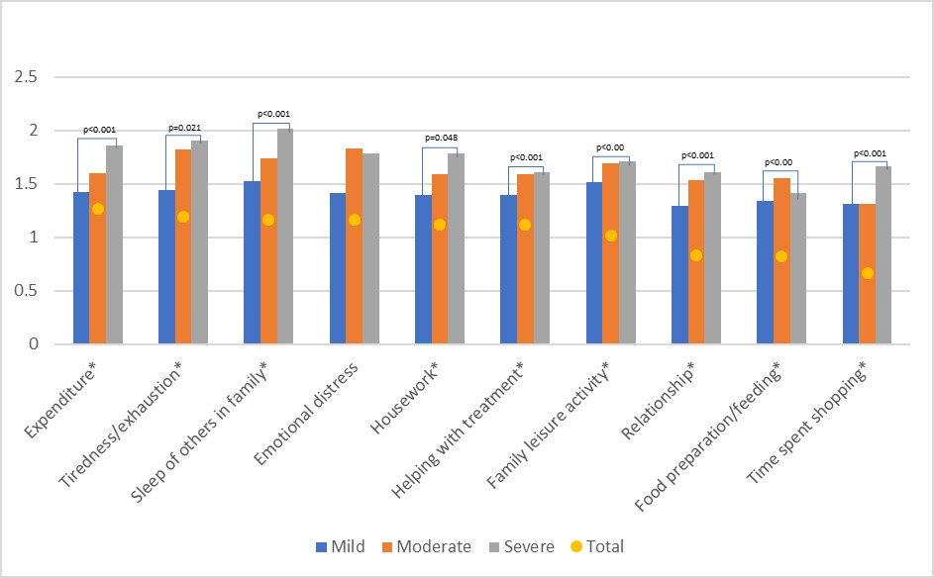

Table 1. Relation between Dermatitis family overall impact and demographic characteristics, HRQOL and RAND36 in univariate and multivariate models
Variables | Dermatitis Family Impact
 | Univariate model |  |  | Multivariate model
 | IRR | 95% CI | p-value | IRR | 95% CI | P-value
Age of child (years) | 0.99 | [0.97, 1.00] | 0.038 | 0.97 | [0.96, 0.99] | 0.002
Gender of child
Male | 1(Ref)
Female | 0.95 | [0.84, 1.07] | 0.386 | 0.93 | [0.83, 1.05] | 0.236
Ethnicity
Chinese | 1(Ref)
Indian | 1.24 | [1.05, 1.45] | 0.009 | 1.13 | [0.96, 1.31] | 0.133
Malay | 1.15 | [0.86, 1.55] | 0.349 | 1.02 | [0.80, 1.30] | 0.865
Caucasian and others | 1.43 | [1.17, 1.75] | p<0.001 | 1.33 | [1.10, 1.60] | 0.003
Qualification
Polytechnic and professional | 1(Ref)
Primary and secondary | 1.01 | [0.85, 1.20] | 0.896 | 0.88 | [0.76, 1.02] | 0.099
University | 0.87 | [0.76, 1.00] | 0.053 | 0.99 | [0.87, 1.14] | 0.93
Number of children in family | 1.02 | [0.94, 1.11] | 0.679 | 0.99 | [0.91, 1.06] | 0.712
Accommodation
Government flat 1-3 rooms | 1(Ref)
Government flat 4-5 rooms | 0.81 | [0.69, 0.95] | 0.011 | 0.91 | [0.78, 1.06] | 0.235
Private housing (condo, landlord) | 0.68 | [0.56, 0.83] | p<0.001 | 0.81 | [0.66, 0.99] | 0.04
Disease duration (years) | 1.00 | [0.99, 1.02] | p<0.001 | 1.02 | [1.00, 1.04] | 0.019
Severity
Mild | 1(Ref)
Moderate | 1.38 | [1.20, 1.59] | p<0.001 | 1.23 | [1.09, 1.40] | 0.001
Severe | 1.50 | [1.26, 1.79] | p<0.001 | 1.26 | [1.06, 1.49] | 0.008
HRQOL | 1.06 | [1.05, 1.07] | p<0.001 | 1.04 | [1.03, 1.05] | p<0.001
RAND 36
Physical health | 0.98 | [0.97, 0.98] | p<0.001 | 0.99 | [0.98, 0.99] | p<0.001
Mental health | 0.98 | [0.98, 0.99] | p<0.001 | 0.99 | [0.99, 0.99] | p<0.001
* Missing data: Disease severity, n=46; Living accommodation, n=2
IRR: incidence rate ratio; CI: confidence interval
~DFI: The score ranges from 0 to 30. A higher score indicates a greater degree of QOL impairment.
~HRQOL: Disease-specific HRQOL of patients with AD was measured using IDQOL and CLDQI

Reference
1. Vartiainen E, Petays T, Haahtela T, Jousilahti P, Pekkanen J. Allergic diseases, skin prick test responses, and IgE levels in North Karelia, Finland, and the Republic of Karelia, Russia. The Journal of allergy and clinical immunology 2002; 109: 643-648.
2. Tay YK, Kong KH, Khoo L, Goh CL, Giam YC. The prevalence and descriptive epidemiology of atopic dermatitis in Singapore school children. The British journal of dermatology 2002; 146: 101-106.
3. Jang HJ, Hwang S, Ahn Y, Lim DH, Sohn M, Kim JH. Family quality of life among families of children with atopic dermatitis. Asia Pacific allergy 2016; 6: 213-219.
4. Xiaomeng Xu LSvG, Mark Koh Jean Aan, Ram Bajpai, Steven Thng, Yik Weng YEW, Valerie Pui Yoong Ho, Uma Alagappan, Krister Sven Ake Järbrink, Josip car. Factors influencing quality of life in children with atopic dermatitis and their caregivers: a cross-sectional study. Scientific Reports 2019.
5. Sun F. Caregiving stress and coping: a thematic analysis of Chinese family caregivers of persons with dementia. Dementia (London, England) 2014; 13: 803-818.
6. Al Shobaili HA. The impact of childhood atopic dermatitis on the patients' family. Pediatric dermatology 2010; 27: 618-623.
7. Anderson RT, Rajagopalan R, Asher MI, Montefort S Fau - Bjorksten B, Bjorksten B Fau - Lai CKW, Lai Ck Fau - Strachan DP, et al. Effects of allergic dermatosis on health-related quality of life.
8. Higaki Y KK, Kamo T, Ueda S, Arikawa J, Kawashima M. Measurement of the impact of atopic dermatitis on patients' quality of life: a cross-sectional and longitudinal questionnaire study using the Japanese version of Skindex-16. The Journal of dermatology 2004; 31: 5.
9. Mortimer D, Segal L. Comparing the incomparable? A systematic review of competing techniques for converting descriptive measures of health status into QALY-weights. Medical decision making : an international journal of the Society for Medical Decision Making 2008; 28: 66-89.
10. Lewis-Jones MS, Finlay AY, Dykes PJ. The Infants' Dermatitis Quality of Life Index. The British journal of dermatology 2001; 144: 104-110.
11. Lewis-Jones MS, Finlay AY. The Children's Dermatology Life Quality Index (CDLQI): initial validation and practical use. The British journal of dermatology 1995; 132: 942-949.
12. Hanifin JM, Thurston M, Omoto M, Cherill R, Tofte SJ, Graeber M. The eczema area and severity index (EASI): assessment of reliability in atopic dermatitis. EASI Evaluator Group. Experimental dermatology 2001; 10: 11-18.
13. Ganemo A, Wahlgren CF, Svensson A. Quality of life and clinical features in Swedish children with psoriasis. Pediatric dermatology 2011; 28: 375-379.
14. Ganemo A. Quality of life in Swedish children with congenital ichthyosis. Dermatology reports 2010; 2: e7.

