Trump Study: Longitudinal examination of Imagistic ritual events and Fusion.

Time 1. ~1 week before the Inauguration
N = 1500. Estimated Time: < 10 minutes
Measures:
- PANAS (emotional experience)
- Consequentiality of Experience
- Identity Fusion
- Behavioral Endorsements / Extreme action (aka., Fight and Die).
- Demographics
- Voting Behavior
- Combined Open-ended response (narrative and affective experience)

Time 2. Immediately after the Inauguration; to open within 48 hours
N = (assuming 50% attrition) ~ 750. Estimated time: ~10 minutes
Measures (italics denote repeated measures):
- PANAS (emotional experience)
- Consequentiality of Experience
- Identity Fusion
- Behavioral Endorsements / Extreme action (aka., Fight and Die).
- Combined Open-ended response (narrative and affective experience)
- Self-reflection and self-shapingness
- Inauguration Experience
- Inauguration reflection

Time 3. Several weeks after the inauguration; to open at 6 weeks

N = (assuming 50% attrition) ~350. Estimated time: ~15 minutes

Measures (italics denote repeated measures):
- PANAS (emotional experience)
- Consequentiality of Experience
- Identity Fusion
- Behavioral Endorsements / Extreme action (aka., Fight and Die).
- Combined Open-ended response (narrative and affective experience)
- Self-reflection and self-shapingness.
- Inauguration Experience
- Inaugruation reflection
- Healthcare questions

Predictions across all three time points
- Past research shows that identity fusion predicts willingness to fight and die for one’s group. Thus, we predict that fusion to the U.S. (people who share one’s political views) at each time point will predict willingness to fight/die for the U.S. (people who share one’s political views) also at each time point.

Predictions at Time 2
- We anticipate that the Inauguration will be experienced as an imagistic event for some people (see Whitehouse & Lanman, 2014 for an overview of the imagistic mode). One key feature of an imagistic event is that it produces an intense affective response. Thus, we predict that reports of affective intensity at T2 will be higher overall compared to T1.
- If this assumption is incorrect and the inauguration does not serve as an appropriate imagistic event then we will not collect data at T3 as specified.
- Increases in fusion are most likely to occur after a period of reflection and meaning-making, a process that can take weeks or months. Thus, we predict that fusion is unlikely to change from T1 to T2.

Predictions at Time 3
- Affective intensity (T2) will predict change in fusion (T2-T3). These effects will be mediated by measures of self-reflection and self-shapingness (T3).
- We intend to explore the relationship between Consequentiality and other DVs, but make no specific or direction predictions.

The following predictions relate to those who experience the Trump presidency as a negative/dysphoric event
- The relationship between Affective Intensity and Fusion at T2 and T3 (H3) will be mediated by Self-Reflection.
- Given that fusion is a consequence of self-reflection and requires considerably time, we do not anticipate a difference in fusion between T1 and T2 for any population of participants.
- Self-reflection will increase between T2 and T3.
- At T2 and T3 we predict that Fusion will be positively related with behavioral Endorsement of Extreme Action. Each fusion target within each time-point (T1, T2, and T3) will strongly predict the corresponding target on Behavior Endorsement of Extreme Action.

- We tentatively predict that all the above relationships will hold for those who experience the Trump presidency as positive/euphoric.
- We intend to explore the relationship between Consequentiality and other DVs, but make no specific or direction predictions.

Demographics and Voting Behavior

Age
Gender
Relationship Status
Sexual Orientation
Children
Employment Status
In which country do you currently reside
What is your nationality
What is your ethnicity
What best describes your religious affiliation
Manipulation Check
Is English your first language
What best describes your political affiliation
Where would you place yourself on a liberal-conservative political spectrum?

Which Political Party do you most strongly support?
Who did you vote for in the 2016 U.S. election?
Regardless of voting behavior/preferred candidates, if forced to choose between Donald Trump and Hillary Clinton who would you say you supported more?
How many presidential elections have you voted in?
Which statement best describes you? [Never-, Rarely-, Usually-, Always Vote]

Consequentiality of Experience
We will quantify consequentiality via two questions with Likert Scale response options.

- How far do you agree that Trump's presidency will have an impact on your life?
(9 point scale from strongly disagree to strongly agree with neither agree nor disagree as midpoint)
- How much will Trump positively vs. negatively impact your life?
(9 point scale from extremely negatively to extremely positively with neither positively nor negatively as the midpoint),
- How much will Trump’s victory hurt you personally vs. help you personally?
(9 point scale from extremely hurtful to extremely helpful, neither hurtful nor helpful as the midpoint).

(Present in T1)
We will also code responses for personal consequentiality dimensions to be determined by an open coding process. Participants will be instructed:
Please take the next 2 minutes to write about the following: How will Trump's victory in the presidential election affect your life? **Please note to insure consistency you will be unable to move on to the next screen until at least 30 seconds have passed on the timer.**

PANAS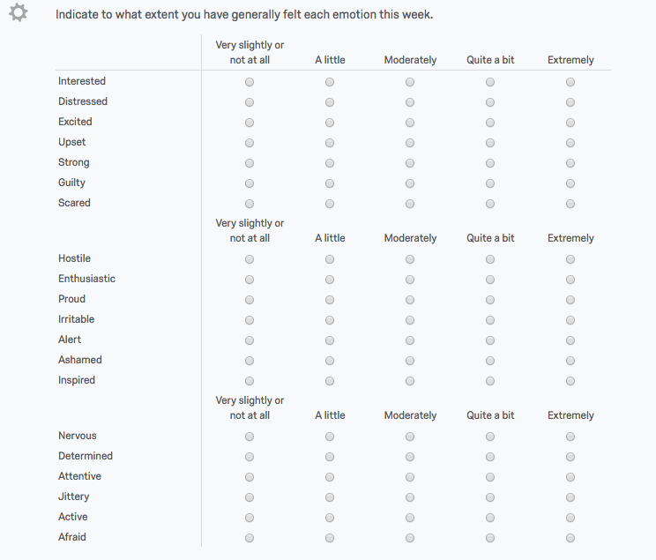
Identity Fusion (Dynamic Identity Fusion Index- short form)
- Fusion to the United States
- Fusion to all Americans who share your political views
- Fusion to your political party
- Fusion to people in your social network that share your political views
- Fusion to family
- Fusion to Trump

Endorsement of Extreme Behavior
Where … denotes, first, “the U.S.A.” and, second, “someone I know who shares my core political views.”
- I would help others get revenge on...
- I would fight someone who sought to harm...
- I would do anything if it helped to protect...
- Hurting other people is acceptable if it means protecting...
- I would fight someone insulting or making fun of...
- I would sacrifice my life if it helped to save … from harm

Open-ended Experience Question We will code responses along lines of affective intensity, consequentiality, and narrative experience as determined by an open coding process. Coding schema to be determined after collection at T2 based on group discussions. This schema will be developed before examining data collected at T3. The developed schema will be uploaded to OSF. Participants will be asked, T1 and T3. “Please take the next 3 minutes to write about the following: As if you were chatting with a friend, please describe how you think and feel about a Trump presidency this week. Please don’t worry about punctuation or grammar – just write as much as you can.”
At T2: Please describe your experience and how you felt in reaction to the official start of Donald Trump's Presidency on Inauguration Day, January 20th. Please write about how it made you feel, what you thought, or anything else that comes to mind.

Inauguration Experience
What best describes your experience of the inauguration event?
- I watched it live on TV/online
- I saw clips of the event later on TV/online
- I read descriptions of the event in articles
- I did not watch or read about the inauguration
- I did not know about the inauguration
How would you describe your reaction to the inauguration event?
Regardless of whether your response was positive or negative how consequential did you find Trump's inauguration to be for you personally?
How important do you think the inauguration event was?
How memorable do you think the inauguration event was?

Inauguration Reflection
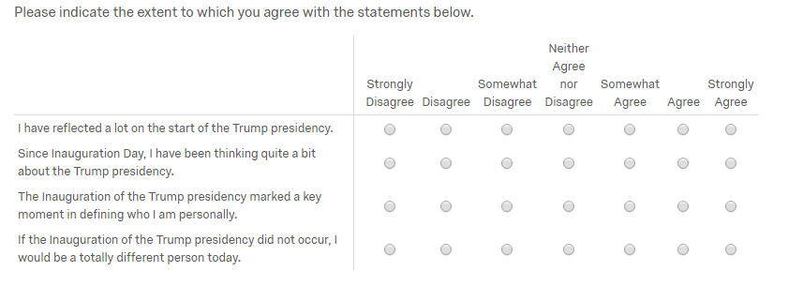
Since the inauguration have you taken part in any rallies, meetings or marches to show your support of Donald Trump’s presidency? [If yes] Please briefly describe what events you have participated in.
Since the inauguration have you taken part in any rallies, meetings or marches to show your opposition of Donald Trump’s presidency? [If yes] Please briefly describe what events you have participated in.
Healthcare questions
How do you feel that Trump's presidency will impact your healthcare coverage? It will be...
(9 point: 1- much worse, 2- moderately worse, 3- slightly worse, 4- the same, 5- slightly better, 6- moderately better, 7- much better)

To what extent are you concerned about the implications for your welfare if President Trump repeals the Affordable Healthcare Act (aka Obamacare)
(5 point: 1 – not concerned at all, 2 – concerned a little, 3 –concerned, 4 – moderately concerned, 5 – extremely concerned)
(Potential extra healthcare questions in T3)
Have you lost medical coverage as a result of President Trump repealing the Affordable Healthcare Act (aka 'Obamacare')? Yes/No
Have any of your friends or family lost medical coverage as a result of President Trump repealing the Affordable Healthcare Act (aka 'Obamacare')? Yes/No
To what extent are you concerned about the implications for the welfare of your friends or family as a result of President Trump repealing the Affordable Healthcare Act
(5 point: 1 – not concerned at all, 2 – concerned a little, 3 – moderately concerned, 4 – very concerned, 5 – extremely concerned)

