Supplementary figure 1: Cohort selection from MINAP registry
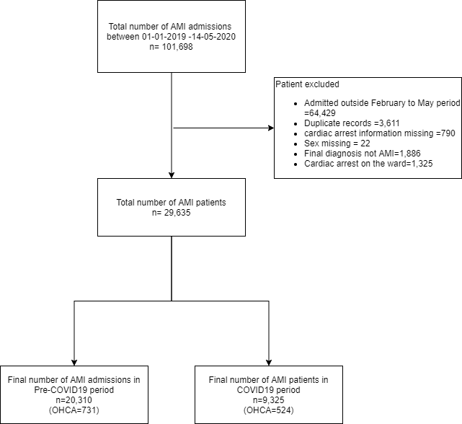

Supplementary Figure 2: Cohort selection from BCIS registry
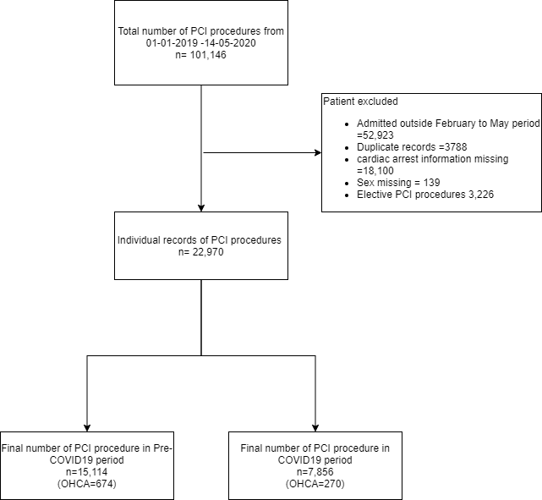

Supplementary Figure 3: Temporal trends of monthly proportions of OHCA patients presenting with STEMI before and during COVID19 period

OHCA= out of hospital cardiac arrest, UK lockdown= 22nd March 2020, COVID19 = Corona virus infection. Pre-COVID19 period= 1st February 2019 to 14th May 2019, COVID19 period= 1st February 2020 to 14th May 2020, STEMI= st elevation acute myocardial infarction
Supplementary Figure 4: Temporal trends of monthly proportion of patients presenting with OHCA before and during the COVID-19 pandemic amongst the rapid reporting hospitals.

OHCA= out of hospital cardiac arrest, UK lockdown= 22nd March 2020, COVID19 = Corona virus infection. Pre-COVID19 period= 1st February 2019 to 14th May 2019, COVID19 period= 1st February 2020 to 14th May 2020
Supplementary figure 5: Incidence rate ratio of OHCA during COVID-19 pandemic amongst the rapid response hospitals
OHCA= out of hospital cardiac arrest, UK lockdown= 22nd March 2020, COVID19 = Corona virus infection. Pre-COVID19 period= 1st February 2019 to 14th May 2019, COVID19 period= 1st February 2020 to 14th May 2020
Supplementary Figure 6: Temporal trends of use of percutaneous coronary intervention before and during COVID19 period in England

OHCA= out of hospital cardiac arrest, UK lockdown= 22nd March 2020, COVID19 = Corona virus infection. Pre-COVID19 period= 1st February 2019 to 14th May 2019, COVID19 period= 1st February 2020 to 14th May 2020
Supplementary Figure 7: Monthly adjusted probability of mortality between pre-COVID-19 and COVID-19 OHCA groups in England

OHCA= out of hospital cardiac arrest, UK lockdown= 22nd March 2020, COVID19 = Corona virus infection. Pre-COVID19 period= 1st February 2019 to 14th May 2019, COVID19 period= 1st February 2020 to 14th May 2020

Supplementary Table 1: Percentage of missing information for each variable from MINAP registry
Variables | Number (percentage)
Age | 0
Sex | 0
Race | 5,500 (18.5%)
BMI | 0
Heart rate | 0
Systolic blood pressure | 0
Clinical syndrome | 0
Creatinine | 0
Kilip Class | 2,604 (8.8%)
LV systolic function | 5,638 (19.0%)
Percutaneous coronary intervention | 3,702 (12.5%)
Coronary artery bypass graft | 3,705 (12.5%)
Heart failure | 3,568 (12.0%)
Hypercholesterolemia | 3,574 (12.0%)
Angina | 3,641 (12.3%)
Cerebrovascular disease | 3,643 (12.3%)
Myocardial infarction | 3,333 (11.3%)
Peripheral vascular disease | 3,692 (12.5%)
Chronic kidney disease | 3,204 (10.8%)
Diabetes | 917 (3.0%)
Hypertension | 3,168 (10.7%)
Smoking status | 5,534 (18.7%)
Asthma / COPD | 3,557 (12.0%)
Family history of CHD | 7,462 (25.2%)
Low molecular weight heparin | 7,177 (24.2%)
Unfractionated heparin | 7,045 (23.8%)
Warfarin | 7,270 (24.5%)
Loop Diuretic | 7,085 (23.9%)
Glycoprotein use | 6,891 (23.2%)
Seen by cardiologist | 381 (1.3%)
Coronary angiography | 3,523 (11.9%)
Percutaneous coronary intervention | 9,677 (32.6%)
P2Y12 use | 0
Dual antiplatelet therapy | 0
ACE inhibitors | 6,480 (21.9%)
In-hospital mortality | 0
CHD= coronary heart disease, COPD= chronic obstructive pulmonary disease, LV= left ventricle, bpm= beats per minute, BMI= body mass index, OHCA= out of hospital cardiac arrest, UK lockdown= 22nd March 2020, COVID19 = Corona virus infection. Pre-COVID19 period= 1st February 2019 to 14th May 2019, COVID19 period= 1st February 2020 to 14th May 2020
Supplementary Table 2: Procedural characteristic of patients presenting with OHCA undergoing PCI before and during COVID-19 pandemic
Variables | Total AMI patients  N=22,026 |  |  |  | Pre-COVID-19 OHCA  N= 674 | COVID-19 OHCA  N=270 |  | P value*
Lesion attempted |  |  |  |  |  |  |  | 0.26
1 | 14,965(68.9%) |  |  | 480 (71.8%) |  | 216 (81.2%)
2 | 4171 (19.2%) |  |  | 129 (19.3%) |  | 31 (11.6%)
3 or more | 1442 (6.6%) |  |  | 50 (7.5%) |  | 16 (6.2%)
Call to Balloon time | 8.8 (18.9) |  |  | 2.5 (4.5) |  | 3.2 (5.9) |  | 0.12
Vessel attempted |  |  |  |  |  |  |  | 0.05
Grafts | 357 (1.7%) |  |  | 7 (1.1%) |  | 2 (0.8%)
LMS | 485 (2.3%) |  |  | 8 (1.2%) |  | 10 (3.8%)
RCA | 9314 (45.0%) |  |  | 367 (55.8%) |  | 145 (54.5%)
LAD | 3925 (19.0%) |  |  | 113 (17.2%) |  | 35 (13.2%)
LCX | 6608 (31.9%) |  |  | 163 (24.8%) |  | 74 (27.8%)
Multi-vessel PCI | 4200 (19.1%) |  |  | 85 (12.6%) |  | 44 (21.2%) |  | <0.001
Number of stents |  |  |  |  |  |  |  | 0.26
0 | 3221 (14.9%) |  |  | 72 (10.8%) |  | 37 (14.1%)
1 | 11301 (52.4%) |  |  | 376 (56.6%) |  | 153 (58.4%)
2 | 4755 (22.1%) |  |  | 138 (20.8%) |  | 50 (19.1%)
3 or more | 2278 (10.6%) |  |  | 78 (11.7%) |  | 22 (8.4%)
Inotropic support | 334 (1.6%) |  |  | 113 (17.4%) |  | 37 (14.2%) |  | 0.23
Intra-aortic balloon pump | 127 (0.6%) |  |  | 49 (7.6%) |  | 16 (6.1%) |  | 0.45
Impella | 16 (0.1%) |  |  | 1 (0.2%) |  | 1 (0.4%) |  | 0.50
Glyoprotein IIb/IIIa inhibitor use | 3075 (16.2%) |  |  | 243 (40.7%) |  | 99 (42.1%) |  | 0.71
TIMI flow post PCI |  |  |  |  |  |  |  | 0.64
0 | 431 (3.0%) |  |  | 34 (6.5%) |  | 15 (7.3%)
1 | 120 (0.8%) |  |  | 5 (1.0%) |  | 3 (1.5%)
2 | 419 (2.9%) |  |  | 25 (4.8%) |  | 6 (2.9%)
3 | 13529 (93.3%) |  |  | 460 (87.8%) |  | 182 (88.3%)
IVUS use | 1946 (9.8%) |  |  | 44 (7.4%) |  | 24 (10.0%) |  | 0.22
OCT use | 726 (3.7%) |  |  | 21 (3.5%) |  | 11 (4.6%) |  | 0.48
FFR/iFR use | 2236 (11.3%) |  |  | 15 (2.5%) |  | 5 (2.1%) |  | 0.71
Aspirin | 17585 (93.6%) |  |  | 442 (78.4%) |  | 175 (76.4%) |  | 0.55
Clopidogrel | 7451 (40.9%) |  |  | 130 (24.2%) |  | 47 (21.2%) |  | 0.37
Ticagrelor | 8079 (44.3%) |  |  | 186 (34.6%) |  | 80 (36.0%) |  | 0.70
Heparin | 4502 (24.7%) |  |  | 142 (26.4%) |  | 64 (28.8%) |  | 0.49
Procedural outcomes
MACCE |  | 615 (2.9%) | 151 (23.2%) |  |  |  | 42 (17.0%) | <0.001
In-hospital bleeding |  | 92 (0.4%) | 10 (2.0%) |  |  |  | 2 (1.0%) | 0.34
In-hospital death |  | 316(1.4%) | 136 (20.2%) |  |  |  | 40 (14.8%) | 0.05
*All statistical comparisons were made between pre-COVID19 and COVID-19 period group only, LMS= left main stem, RCA= Right coronary artery, LAD= left anterior descending artery, LCX= left circumflex artery, IVUS= intravascular ultrasound, OCT= optical coherence tomography, FFR= fractional flow reserve, iFR= instantaneous flow reserve, MACCE= major adverse cerebrovascular events.

