Radiation risk from digital breast tomosynthesis screening – a comparison with full field digital mammography
Abstract
Objectives: To compare the radiation risk from digital breast tomosynthesis (DBT) screening with that from full field digital mammography (FFDM) screening.
Method: To simulate compressed breasts, two Perspex-polyethylene breast phantoms were used, one phantom for compressed breast in craniocaudal and the other for compressed breast in mediolateral oblique. An adult ATOM dosimetry phantom was loaded with high sensitivity thermoluminescence dosimeters; the phantom was then positioned on Hologic Selenia Dimensions mammographic machine to imitate DBT and 4-view FFDM screening. Organ radiation doses were measured from 4-view DBT and 4-view FFDM (craniocaudal and mediolateral oblique views for each breast). Organ radiation doses were used to calculate effective dose from one screening session.
Results: Mean glandular dose (MGD) for DBT was 3.6 mGy; MGD for FFDM was 2.8 mGy. For DBT, other organs (e.g. thymus, lungs, salivary glands, thyroid, contralateral breast and bone marrow) radiation dose was also higher than for FFDM. The use of DBT for breast cancer screening increases the effective dose (E) of one screening session by 22%. E for DBT was 0.44 mSv; E for FFDM was 0.34 mSv.
Conclusion: The use of DBT for breast cancer screening increases the radiation dose to screening clients.
Keywords
Tomography, dosimetry, organ dose, breast cancer
Introduction
Digital breast tomosynthesis (DBT) involves relative motion between the X-ray source, image receptor and patient [1]. DBT images were firstly produced on 1997 by Niklason, Christian [2], who used a movable X-ray tube and fixed image receptor to image the American College of Radiology (ACR) breast phantom and several mastectomy samples. DBT involves multiple exposures of the breast from different angles [1] and its image acquisition geometry is comparable to that of full field digital mammography (FFDM). The only difference between DBT and FFDM is, in DBT the X-ray tube moves at specific angular intervals around the compressed breast which rests on the static image receptor [3]. The range of X-ray tube movement is different for each DBT manufacturer. For instance, the range of X-ray tube movement in Hologic Selenia Dimensions is 15 degrees, -7.5 to +7.5 degrees, and produces 15 images per view [4]. Overall DBT is used to produce several high spatial resolution, cross-sectional and low dose images of breast tissue for each mammographic projection. Consequently, DBT helps to minimise breast tissue superimposition resulting in more clearly defined tumours [5].
The clinical performance of DBT, for both screening and diagnostic purposes, was evaluated in many studies [6]. For screening, the majority of these studies reported that integrated DBT with 2D FFDM may increase breast cancer detectability [7, 8] and reduce the recall rate [8, 9]. This came at a cost – it increased examination and interpretation time [10]. However, Lang, Andersson [11] reported that one-view DBT screening significantly increases breast cancer detectability and recall rate. For diagnostic purposes, DBT has been reported to have a comparable diagnostic accuracy to spot-view mammography [12] and significantly better accuracy than supplemental diagnostic mammograms [13].
Similar to other breast imaging modalities, mean glandular dose (MGD) is used as a radiation risk indicator in DBT. For single view DBT, the MGD is the total MGDs of all projections in the tomographic scan [14]. In the early stage of DBT development, Niklason, Christian [2] reported that DBT MGD is comparable to that from single view screen-film mammography. MGD from DBT is currently reported to be one to two times more than that from single view FFDM [15]. Feng and Sechopoulos [4] estimated the MGD resulted from single craniocaudal view acquired by FFDM and DBT. They concluded that DBT resulted in higher MGD than FFDM and this difference increases as the breast thickness increase.
Other organs radiation dose, excluding exposed breast tissue, from DBT was assessed by Baptista, Di Maria [15]. They used Monte Carlo simulation software to estimate the radiation dose received by several radiosensitive organs within the female reference voxel Laura phantom from DBT exposure. In order to simulate different breast thickness, the organ radiation doses were estimated using different tube potentials, 24-34 kVp, and 100 mAs. They found that the highest radiation dose was received by ipsilateral lung, thyroid and contralateral lung. Presently there is limited published literature that considers the radiation dose to other organs from DBT. Accordingly, the aim of this work was to measure, experimentally, the other organs radiation dose from DBT and compare these data with organs radiation dose from FFDM.
Materials and Method
For organs dose measurement, a dual function (FFDM and DBT) Hologic Selenia Dimension machine was used. This machine was operating within the acceptable quality control criteria recommended by National Health Services Breast Screening Programme (NHSBSP). For both FFDM and DBT, automatic exposure control (AEC) was used to expose a breast phantom. Thermoluminescent dosimeters (TLDs) loaded within an adult human ATOM dosimetry phantom were used to measure the radiation dose received by radiosensitive organs determined by the International Commission on Radiological Protection (ICRP) [16].

Breast Phantom and MGD Calculation
A polymethyl methacrylate-polyethylene (PMMA-PE) breast phantom, as suggested by Bouwman, Diaz [17], was used to simulate the compressed breast. This was 53 mm thick and comprised 32.5 mm PMMA and 20.5 mm PE slabs. Two breast phantoms were used: semicircular with 95mm radius to simulate the compressed breast in CC view; 100mm x 150mm rectangular to mimic the breast in MLO view.
For FFDM, the MGD was calculated using the equation described by Dance, Skinner [18]:
MGD=K.g₅₃.c₅₃.s
Where K is the incident air kerma for the phantom measured at midpoint in the lower surface of the compression paddle about 4cm from the chest wall using solid-state dosimeter (Unfors Multi-O-Meter dosimeter, Billdal, Sweden); g₅₃ is a factor to convert the incident air kerma to MGD for a 53mm thick standard breast; c₅₃ is a conversion factor which allows for the glandularity of 53mm thick standard breast; s is the spectral correction factor.
For DBT, the incident air kerma was measured using three TLDs, to obtain an average reading minimizing random error. TLDs were utilised instead of the Unfors solid state dosimeter because the solid state dosimeter cannot measure the total air kerma for a pulsing X-ray beam. These three TLDs were fixed at the midpoint 4 cm from the chest wall side on the lower surface of the compression paddle through which the X-rays enter to the breast. Then the MGD was calculated using the equation described by Dance, Young [19]:
MGD=K_{T}.g₅₃.c₅₃.s T
Where K_{T} and T are the total incident air kerma and total ‘tomo’ factor for complete scan, respectively. The values for T factor are tabulated by Dance, Young [19] for Hologic Selenia Dimension system for each breast thickness.
Organs Dose Measurement
Using the method described by M. Ali, England [20], organ doses were measured by TLDs loaded within ATOM dosimetry phantom. 280 TLDs were used to measure the radiation dose received by 20 radiosensitive organs and tissues. These organs included adrenals, brain, bone marrow, contralateral breast, gall bladder, heart, intestine, kidneys, liver, lungs, oesophagus, ovaries, pancreas, salivary glands, spleen, stomach, thymus, thyroid, urinary bladder and uterus. In order to minimise random error, the breast phantom was exposed three times for each mammographic view then the dose data was divided by three to obtain the organ doses from a complete screening session (CC and MLO for each breast). This procedure was conducted for both FFDM and DBT (Figure 1).
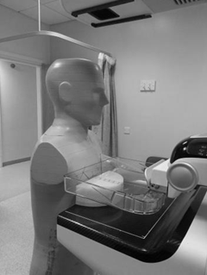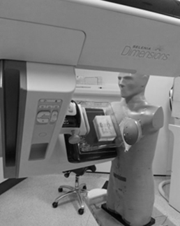
(a) (b)
(Figure 1) Shows the adult human ATOM dosimetry and breast phantom positioned on Hologic Selenia Dimensions mammography machine (a) in cranio-caudal position (b) in medio-lateral oblique position.
Radiation Risk Estimation
In this study effective dose was used to compare the radiation risk from DBT screening with that from FFDM screening. The effective dose was calculated using the tissue weighting factors published by the ICRP [16] as follow:
E= Σw_{T} H_{T}
Where E is the effective dose, w_{T} is the tissue weighting factor and H_{T} is the radiation received dose by tissue T.
Results
For 4-view DBT screening, MGD was increased from 2.81 mGy, for FFDM, to 3.58 mGy. Similarly, effective dose was increased from 0.34 mSv to 0.44 mSv, when changing from FFDM to DBT screening (Figure 2).
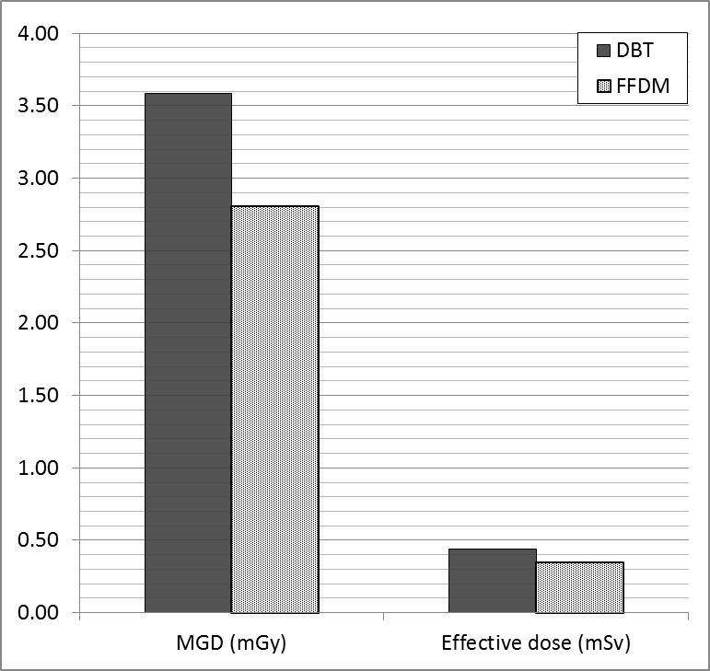
(Figure 2) Shows the MGD and effective dose of one screening session when using DBT as compared to FFDM.
The radiation dose received by other tissues, other than the exposed breast, was also increased when using DBT for screening as compared to FFDM. For both FFDM and DBT the highest radiation dose was received by contralateral breast tissue. Oesophagus, spleen, kidneys, pancreas and intestine do not receive radiation dose with the use of FFDM. However, they received a measurable radiation dose (≤ 1µGy) when using DBT (Figure 3).
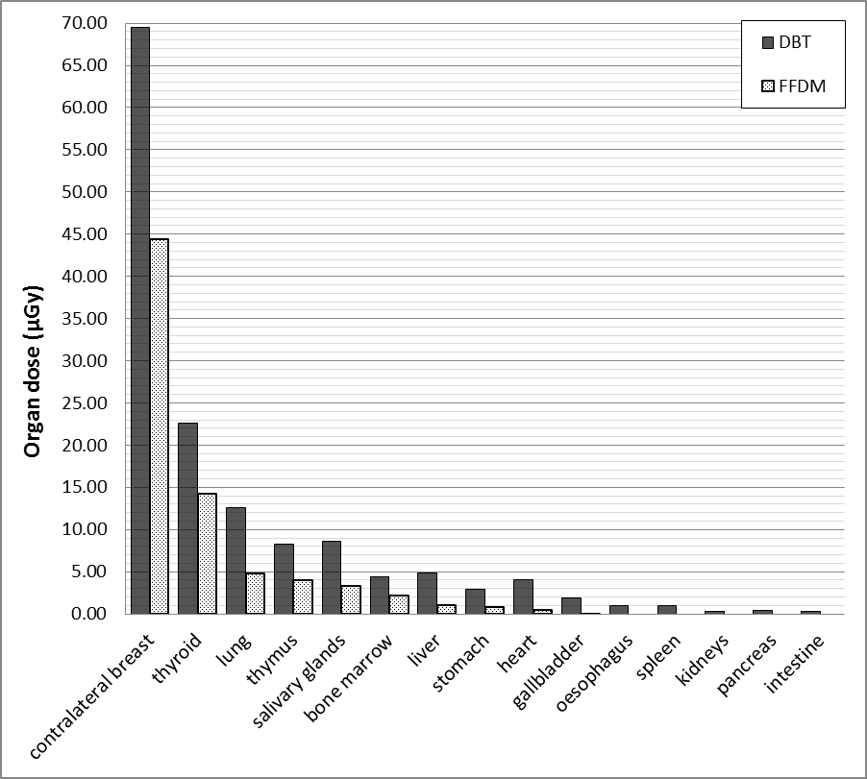
(Figure 3) Demonstrates the radiation dose received by body tissues from one screening session by DBT compared with that by FFDM.
Discussion
Several studies considered the MGD arising from DBT, however, a limited number of studies have considered the radiation dose to other body tissues, other than exposed breast. Undoubtedly, the use of DBT for 4-view breast cancer screening results in higher MGD than that when FFDM is used but DBT has better breast cancer detectability than FFDM. In our current study the MGD from DBT was 3.58 mGy and this was more than that from FFDM (Figure 2). This DBT MGD is slightly more than the acceptable mammographic MGD range recommended by the European Commotion [21].
Regarding the radiation dose to other organs, no research has been identified which measuredorgan dose in vivo using DBT and this is a novel point within our work. The mathematical simulation by Monte Carlo software has previously used to estimate organ dose from DBT. Baptista, Di Maria [15] estimated the radiation dose received by seven radiosensitive organs from a craniocaudal view DBT, using the Siemens MAMMOMAT Inspiration. Baptista, Di Maria [15] and his colleague published the radiation dose from each X-ray tube rotation angle from 0 to +24 degree in 2 degree steps and then they duplicated their data to obtain the radiation dose for a complete DBT scan. However, this is not the exact case in DBT wherein the X-ray tube moves in both directions resulting in different radiation exposures in each direction. Their results are similar to ours in that the DBT generated more organ radiation dose than FFDM. However, they found that the highest radiation dose, after the exposed breast, was received by left lung and thyroid but we found that the highest dose received by contralateral breast and thyroid making the lung dose ranks third as seen in (Figure 3).
The use of DBT increases the effective dose of one screening session by 22% compared to FFDM; the figures were 0.44 mSv and 0.34 mSv, respectively (Figure 2).
Since DBT from different manufacturers has different design, further work is required to include more mammographic machines from different manufacturers to investigate the effect of machine design on radiation risk.
Conclusion
The use of DBT for breast cancer screening increases the radiation dose received by body tissues and organs. Consequently, it increases the effective dose of 4-view screening session but this increment tended to be within the acceptable range. From a dosimetric view, the 4-view DBT can be used for breast cancer screening especially for high breast density women in spite of its higher radiation risk when compared to FFDM.
Footnotes
Contributors: All authors contributed to the conception or design of the work, the acquisition, analysis, or interpretation of the data. All authors were involved in drafting and commenting on the paper and have approved the final version.
Funding: This study did not receive any specific grant from funding agencies in the public, commercial, or not-for-profit sectors.
Ethical approval: Not required.
References
1. Thomassin-Naggara, I., Perrot, N., Dechoux, S., et al. (2015). Added value of one-view breast tomosynthesis combined with digital mammography according to reader experience. Eur J Radiol 84(2), 235-41.
2. Niklason, L.T., Christian, B.T., Niklason, L.E., et al. (1997). Digital tomosynthesis in breast imaging. Radiology 205(2), 399-406.
3. Palazuelos, G., Trujillo, S., and Romero, J. (2014). Breast tomosynthesis : the new age of mammography. Rev. Colomb. Radiol 25(2), 3926-33.
4. Feng, S.S.J., and Sechopoulos, I. (2012). Clinical digital breast tomosynthesis system : dosimetric characterization. Radiology 263(1).
5. Destounis, S., and Gruttadauria, J.L. (2015). An Overview of Digital Breast Tomosynthesis. Journal of Radiology Nursing 34(3), 131-136.
6. Skaane, P. (2012). Tomosynthesis in X-ray: proven additional value? European Journal of Radiology 81, S156-S157.
7. Gilbert, F.J., Tucker, L., Gillan, M.G., et al. (2015). The TOMMY trial: a comparison of TOMosynthesis with digital MammographY in the UK NHS Breast Screening Programme--a multicentre retrospective reading study comparing the diagnostic performance of digital breast tomosynthesis and digital mammography with digital mammography alone. Health Technol Assess 19(4), i-xxv, 1-136.
8. Haas, B.M., Kalra, V., Geisel, J., et al. (2013). Comparison of tomosynthesis plus digital mammography and digital mammography alone for breast cancer screening. Radiology 269(3), 694-700.
9. Friedewald, S.M., Rafferty, E.A., Rose, S.L., et al. (2014). Breast cancer screening using tomosynthesis in combination with digital mammography. JAMA 311(24), 2499-507.
10. Bernardi, D., Ciatto, S., Pellegrini, M., et al. (2012). Application of breast tomosynthesis in screening: incremental effect on mammography acquisition and reading time. The British Journal of Radiology 85(1020), e1174-e1178.
11. Lang, K., Andersson, I., Rosso, A., et al. (2016). Performance of one-view breast tomosynthesis as a stand-alone breast cancer screening modality: results from the Malmo Breast Tomosynthesis Screening Trial, a population-based study. Eur Radiol 26(1), 184-90.
12. Noroozian, M., Hadjiiski, L., Rahnama-Moghadam, S., et al. (2012). Digital breast tomosynthesis is comparable to mammographic spot views for mass characterization. Radiology 262(1), 61-8.
13. Zuley, M.L., Bandos, A.I., Ganott, M.A., et al. (2013). Digital breast tomosynthesis versus supplemental diagnostic mammographic views for evaluation of noncalcified breast lesions. Radiology 266(1), 89-95.
14. Baptista, M., Di Maria, S., Oliveira, N., et al. (2014). Image quality and dose assessment in digital breast tomosynthesis: A Monte Carlo study. Radiation Physics and Chemistry 104, 158-162.
15. Baptista, M., Di Maria, S., Barros, S., et al. (2015). Dosimetric characterization and organ dose assessment in digital breast tomosynthesis: Measurements and Monte Carlo simulations using voxel phantoms. Med Phys 42(7), 3788-800.
16. ICRP (2007).The 2007 Recommendations of the International Commission on Radiological Protection (Publication 103). Annals of the ICRP 37(2-4), 1-332.
17. Bouwman, R.W., Diaz, O., van Engen, R.E., et al. (2013). Phantoms for quality control procedures in digital breast tomosynthesis: dose assessment. Phys Med Biol 58(13), 4423-38.
18. Dance, D.R., Skinner, C.L., Young, K.C., et al. (2000). Additional factors for the estimation of mean glandular breast dose using the UK mammography dosimetry protocol. Physics in medicine and biology 45, 3225–3240.
19. Dance, D.R., Young, K.C., and van Engen, R.E. (2011). Estimation of mean glandular dose for breast tomosynthesis: factors for use with the UK, European and IAEA breast dosimetry protocols. Phys Med Biol 56(2), 453-71.
20. M.Ali, R., England, A., McEntee, M.F., et al. (2015). A method for calculating effective lifetime risk of radiation-induced cancer from screening mammography. Radiography 21(4), 298-303.
21. European Commission (2013). European guidline for quality assurance in breast cancer screening and diagnosis. Fourth edition supplements: Belgium.

