The patient, clinician and healthcare perspectives in evaluating care pathways for stable chest pain
Short running title: Care pathways for stable chest pain
Chun Shing Kwok MBBS PhD,^{1,2} Simon Duckett MD,¹ Duwarakan Satchithananda MBChB,¹ Rahul Potluri MBChB,³ Dot Morgan-Smith MSc,¹ Nick Bellenger MD,³ Mark Gunning MD,¹ Christian Mallen PhD²
Affiliation
- Department of Cardiology, Royal Stoke University Hospital, Stoke-on-Trent, UK
- School of Medicine, Keele University, Stoke-on-Trent, UK
- Department of Cardiology, Royal Devon and Exeter NHS Trust, Exeter, UK

Corresponding author
Chun Shing Kwok
Royal Stoke University Hospital, Newcastle Rd, Stoke-on-Trent, UK, ST4 6QC
Email: shingkwok@doctors.org.uk
Tel: +44 1782 671654 Fax: +44 1782 674467
Funding: None
Disclosures/conflicts of interest: The authors have no conflicts of interest to declare. CDM has received funds from Bristol Myer Squibb for academic support for a non-pharmacological atrial fibrillation screening trial but this is not related to this work.
Word count: 4,766

Abstract
Chest pain is one of the most common reasons for patients to present to healthcare professionals. One of the main challenges with the management of chest pain is the wide differential diagnosis, ranging from minor chest trauma to potentially life threatening acute myocardial infarction. In a patient-centered health service pathway, the aim is to assess, investigate, diagnose and treat patients in the safest and most accurate, time and cost-efficient manner. This report describes the concept of clinical pathways and their importance. It iterates different perspectives of the investigation of chest pain and the barriers to understanding the clinical sequence of events. By considering the patient, clinician and healthcare service perspective it is possible to critically evaluate the current stable chest pain pathway. This exercise gives consideration into the way in which patient care could be improved.

Keywords: clinical pathways; investigation; diagnosis; management; chest pain

Introduction
Chest pain is one of the most common reasons for patients to present to healthcare professionals. In the United States, between 2006 and 2016, there were an estimated 42.48 million visits to hospital for chest pain, which is equivalent to just under 4 million visits on average each year.¹ It has been suggested that 1 in 10 patients with visits to the emergency department are prompted by chest pain.² Patients can also present with chest pain to primary care with an evaluation of 118 general practitioners in the Netherlands and Belgium over a two-week period reporting that 1.26% of all consultations were for chest pain. From the clinician and the patient’s perspective, clarification of etiology is important. One key objective is the identification of prognostically significant disease states. A further objective is the alleviation of symptoms where the cause is deemed to be benign, there is much to be offered to the patient by a clear identification of the cause for their symptoms. Arriving at this end point in a timely fashion satisfies a further need.
The patient can engage in the pathway in primary care or secondary care and they are influenced by the severity of symptoms. First of all, the patient needs to recognize the significance of their symptoms in order to avail themselves of medical care. Secondly, the course of investigation thereafter is influenced by whether this takes place in primary or secondary care. There may also be significant variation brought to bear by availability of services and geography. In a patient-centered health service pathway, the aim is to assess, investigate, diagnose and treat patients in the safest and most accurate, time and cost-efficient manner.
The objective of this report is to critically evaluate: what pathways are, why they are important, the perspectives of those involved in the chest pain pathway and barriers to understanding pathways and how understanding pathways can improve patient care.

What are pathways?
There is no formal definition of a clinical pathway. They are often perceived as a linear sequence of events (Figure 1). The point to which they present to healthcare professionals is often the starting point. From there patients, may be referred to a specialist, undergo investigations and receive treatment. However, there is more warranting investigation here. Clinical pathways are actually complex variables which can be treated as both exposure and outcome variables (Figure 2). The clinical sequence of events may also predict a certain outcome. For example, a patient with chest pain may see the GP, be referred to cardiology, have test to confirm coronary artery disease and undergo percutaneous coronary intervention. This clinical sequence of events may be predictive of fewer admissions to hospital or healthcare contacts for chest pain. On the other hand, exposure variable may also be predictive of a particular clinical course such as a patient who is elderly with comorbidities may be predictive of a course of medical management of their coronary artery disease and they may have admissions to hospital for acute myocardial infarction, cardiac arrest or heart failure from ischemic cardiomyopathy. In the context of chest pain, one of the most relevant collection of pathways is the one where a diagnosis is reached for the patient. It can be a frightening experience for patients with symptoms to go through the healthcare process and the practice of potentially outlining and explaining the pathway may alleviate some stress and avoid problems related to patient expectations. The exact pathway, however, for a patient is complex and a framework for considering the pathways as well as the different perspectives of those involved is needed.

Importance of considering pathways
Some understanding of the concept of pathway his is important for the patient because patients with the same condition may have very different experiences depending on the journey they take. Considering that path a patient takes can be a patient-centered approach where they are followed across the healthcare system as opposed to just collecting data from one setting such as hospitals or primary care practices without considering them together. However, some pathways can be rigid particularly in the case where it is designed by doctors and practitioners who may not treat people as they expect. The knowledge about the sequence of clinical events has the advantage that resource utilization can be considered and the most cost-effective sequence can be promoted. It may be argued that there are too many courses that patients may take before arriving at a diagnosis as well as clinical trajectories that patients follow after treatment. However, some courses will be more common than others. The differences in the events and the patient experience are of interest because it captures the real-world heterogeneity. A person living in an urban city that is short distance from a specialist center with the very same symptoms as someone living in a rural area where the main healthcare provider is the primary care physicians may have different experience to arrive at a diagnosis and their long-term outcome. To explore pathways further we will describe the example for patients who present with stable chest pain.
Applying a systematic framework for evaluation of pathways for stable chest pain
This systematic framework for stable chest pain begins with the individuals involved which include the patients, family members and healthcare professionals (such as GPs and hospital clinicians). These individuals then interact depending on what setting the patient may be in whether it is the community, general practice, hospital outpatient space and hospital emergency and inpatient ward areas. For stable chest pain, the pathway typically begins with the GP. At this starting point, an evaluation of the patient is made. The patient can be discharged with no further care, treated or monitored in the community with the general practitioner overseeing the care, investigated further before making a decision or the patient may be referred to secondary care for evaluation. Similar options are present when patients present to secondary care in the outpatient settings for evaluation except that there is more access to diagnostic testing. Using these concepts for a patient pathway, a framework more detailed consideration of the different perspectives is required needed (Figure 3).

Perspectives in the diagnostic pathway of chest pain
The patient
From a patient’s perspective, chest pain can be disabling and these symptoms can result in patients not being able to return to previous levels of activity.³ In addition, they may be anxious that the symptoms may worsen or cause a heart attack or death. This creates psychological distress knowing that something is wrong, but not knowing what it is. Therefore, it makes sense that the priority of most patients would be early diagnosis and treatment as it may affect their employment and ability to work.
However, the ability of clinicians to help patients actually depends on patient starting the process. While it is clear that no patient wants to be suffering, they may not recognize that what they are experiencing needs medical attention, and this is particularly the case of mild or atypical symptoms that reverse easily or do not last long. This can contribute to delayed diagnosis which is undesirable. This is particularly important in the context of potential external factors such as the current settings of COVID-19 pandemic where some patients may be afraid to see healthcare professionals because they are afraid of being exposed to the virus. Furthermore, willingness to seek help may be influenced by a variety of factors such as education, understanding of health and level of health literacy, previous experience with others who may have health problems, support from family and friends to encourage health seeking behavior, convenience of access to healthcare appointments, ability to take time off work. There can also be challenges related to ability to communicate to patients from learning disability to language barriers because of different ethnic groups. Public health campaigns are specifically designed to influence presentation to healthcare professionals. For example, the FAST campaign for stroke (running between 2009 to 2013) resulted in a 54% rise in stroke related 999 calls and 4,337 fewer people that were left disabled.⁴ Therefore, the designated starting point for a pathway is important as assigning onset of symptoms for patient in the community may be different from considering the starting point as when a patient presents to healthcare professionals.
The delay in diagnosis is undesirable for many patients. While patients may appreciate that clinicians are investigating them with multiple tests, it is frustrating for patients to undergo multiple tests without a payoff of a definitive diagnosis. This potentially breaches the trust between patients and healthcare workers. Some patients may accept that they have symptoms but life-threatening causes such as coronary artery disease (CAD) are not responsible for them. The aim in this case is to treat the symptoms to reduce their impact. Nevertheless, there are cases where delays are unavoidable. Sometimes the symptoms and signs that patients initially present with lead to investigations which fail to diagnose the patient but only through time do the patients clinical presentation change which enable the workup to confirm the diagnosis.
The clinicians
The clinical perspective on chest pain has three overarching objectives which relies on reaching the correct diagnosis. In terms of diagnosis, the majority of patients that present with chest pain to general practitioners do not have serious pathology and acutely dangerous causes for chest pain are rare.⁵ The first objective is symptomatic relief so that patients can be independent and symptom free as long as possible. The second major objective is to identify the cause for chest pain. The third objective is to reduce the risk of patients having a potentially life-threatening diagnosis with a consequence of significant complications such as critical coronary disease that may lead to an acute coronary syndrome or sudden death. These are important both from a perspective of the personal desire of clinicians to help those who are sick as well as from the medicolegal view as missing a serious problem when there are obvious signs can raise concerns about fitness to practice and potential malpractice. The key to achieving both objectives is the correct diagnosis.
Diagnosis is established based on the evaluating clinician’s history taking and clinical reasoning which draws on their knowledge and experience, augmented by investigations.⁶ High body of experience on the part of the clinician will favorably affect the quality of the clinical assessment. From primary care practitioners, chest pain is an uncommon presentation and access to tests which exclude serious causes such as acute myocardial infarction or aortic dissection in-house may be limited. While some surgeries may have facilities to do an electrocardiogram and radiograph, others would be required to send patients to nearby hospitals. Even if electrocardiograms could be performed by GPs, they may not be able to interpret them. This is different again the secondary care outpatient setting where medical practitioners or cardiologists have to access a plethora of tests which could be utilized to confirm or refute suspected diagnoses.
An alternative way approach is for primary care clinicians to offer treatment that is available to them and refer to secondary care if this fails to resolve the symptoms. For stable patients with chest pain especially those who have symptoms related to food, a common cause for chest pain is dyspepsia or gastro-esophageal reflux disease. While treatment with a proton-pump inhibitor may alleviate symptoms, the potential issue may be if there is underlying coronary heart disease this could delay the diagnosis which could affect patient outcomes if they have an acute myocardial infarction or cause patient distress with misdiagnosis. Clinicians do however often safety net to say if the symptoms do not get better or get worse to go to hospital.
From the clinician’s perspective the priorities of a pathway may be different to that of the patient. Whilst the patient may wish the pathway to determine the diagnosis, the clinician may design pathway to rule out a specific important cause of chest pain, rather than to find a specific diagnosis. For example, many chest pain pathways used in clinical practice are used to rule out CAD related pain. An example of this may be the real-world data on pathways related to the use of computed tomography coronary angiogram for chest pain.⁷ The reason for this is that coronary heart disease is a common cause for chest pain, it can have potentially serious consequences if it is not identified, and treatment specifically alters the prognosis and symptomatic burden of patients. Identification of this life-threatening disease process may also reduce the risk of malpractice claims. However, such pathways may misdiagnose or delay the diagnosis of other serious problems such as lung malignancy or pulmonary embolism.
A further consideration is about individual patients and their baseline health status, which affect whether later treatments are appropriate. GPs and emergency care doctors have a broad training and experience to deal with a wide variety of medical problems, but they may not have the expertise to know whether invasive coronary revascularization or medical therapy is most appropriate for individual patients. In the European Society of Cardiology guidelines for chronic coronary syndrome there is an important step after initial consideration of symptoms and signs to consider the patient’s general health, comorbidities and quality of life.⁸ There is a growing population who are elderly, comorbid, frail with dementia. Often the ceiling of treatment is considered in these circumstances. For some of these patients, it would not be inappropriate or distressing to undergo investigations which may place them at risk of complications only to decide after diagnosis is confirmed that a specific treatment would not be offered. In particular coronary revascularization procedures such as invasive coronary angiogram, percutaneous coronary intervention and coronary artery bypass grafting can carry serious complications such as bleeding, stroke, life threatening infections and death.

The health service perspective
The healthcare service perspective is far more complex. The care components of the health service are divided into those in the community (such as primary care services) and secondary/tertiary care hospitals where there is specialist input and where procedures are carried out. For patients with stable chest pain, primary care or family doctors may be where patients first present or the first place where their chest pain is formally assessed. The community clinician has a key role as a gatekeeper to either manage or refer patients for further evaluation. Based on the clinical acumen of the primary care clinician they may be able to identify patients who are more likely to have cardiac symptoms due to stable angina over other common causes such gastrointestinal, infectious, musculoskeletal or venous thromboembolism related causes for chest pain. They may be able to investigate the chest pain with tests such as electrocardiogram, bloods, exercise tests and echocardiogram depending on the availability in their area. Experienced primary care physicians or those with specialist interest in cardiology may also feel comfortable prescribing initial treatment such as antiplatelet, cholesterol lowering and antianginals and manage patients in the community, especially when they are in rural settings with no nearby hospital. This approach of treating coronary artery disease without a definitive diagnosis does however risk patients inappropriately taking medication if there is no CAD, and will deny patients with significant proximal coronary artery disease from being offered revascularization shown to improve prognosis
After the initial community assessment, patients are referred to cardiology services for outpatient assessment which may be delivered via nurse or consultant led clinics. Once under the care of cardiology services, patients are often clinically assessed and may receive one or more of a variety of tests including exercise test, computed coronary angiography, stress echocardiogram, myocardial perfusion scan, cardiac magnetic resonance imaging and invasive coronary angiography. Each test has advantages and disadvantages and the challenge often in public healthcare systems is balancing finite healthcare resources. In cases where there is a strong suspicion that the chest pain is related to CAD, the situation is complicated by options of trying medical therapy or sending patients for evaluation for coronary revascularization. The consideration of available resources and direct cost may be greater in the secondary care setting as appointments, medications, tests and procedures can be expensive and patients can have very different care paths in terms of assessments, investigations and management. The aim is to provide safe care that is cost-effective without wasting unnecessary resources. Unlike the patient’s perspective, the time frame for when all this takes place for healthcare services may not be a priority and delays may be acceptable because of limited resources.
Challenges in real-world practice and clinical pathways
Variation in available local resources
In the ideal situation, all patients would have equitable access to general practice/family medicine and specialist cardiology input, investigations and management. Unfortunately, the reality is that some patients do not live near a hospital providing all these services which makes delivering standardized and high-quality care challenging. In addition, even if a patient resides near a hospital with all these services there may be delays in appointments, investigations and treatment because of limited resources as outpatient services are balanced against the need to care for urgent or emergency care for inpatients. As chest pain due to stable angina is a frequent reason to visit healthcare professionals, local pathways should be explored and made known to relevant clinicians in the area. However, there will be places especially rural areas where we may have to accept that they cannot deliver the same level of care as those areas near larger tertiary hospitals. Nevertheless, this should not mean that there cannot be pathways in place to deliver the best possible care for patients in the local areas with mechanisms to obtain expert input or refer patients to specialist centers for care. It is therefore important that this heterogeneity in services availability be represented and accounted for in research about stable coronary disease.
Primary care and secondary care divide
The divide between primary and secondary care can also introduce difficulties in understanding the paths patients take. While specialist input from secondary care clinicians is helpful in the management of chest pain and stable coronary disease, primary care or family medicine in the community is really important to coordinate the initial referral to specialist and to monitor patients should they be discharged from cardiology. In the perfect system both primary care and secondary care have access to the same health records and effective mechanisms for communications so that management plans can be quickly formulated agreed plans for patients where there is clear definition of responsibility. However, this is not available in many countries. In addition, all secondary care cardiologists will have achieved a similar recognized specialist qualification that includes the diagnosis and treatment of cardiac chest pain, primary care clinicians often have very different backgrounds which may not include exposure to cardiology. Some primary care doctors are comfortable making a clinical diagnosis, starting treatment and monitoring patient response while others feel that chest pain is something that should be dealt by specialists. This is influenced by the ability of primary care to arrange test, interpret results and discuss results with specialists. In order to understand the true impact of CAD on patients capturing the paths patients take in both in community settings and hospital is necessary particularly when it comes to the patient experience as well as the true demands on healthcare for this problem.
Healthcare system
Another important consideration is the type of healthcare system in the country where a patient resides. For examples, in public healthcare systems where care is free at the point of delivery, such as the National Health Service in the United Kingdom and the Swedish Healthcare system, there are limited resources so management may be based on local/national guidelines and clinical practice is often driven by available funding to deliver care. In the UK, for example, there is National Institute for Clinical Excellence. In these settings, financial incentives in the form of quality and outcomes framework may be a way to motivate clinicians to refer patients for specialist care and provide good care to patients. In such settings, pathways are easier to understand because there is no cost disadvantage for patients in seeking care. However, in other countries where there are private healthcare insurance or fee-for-service and different tiers of care there may be complex factors influencing the paths patients take. Patients for example may delay seeking help because of the cost of healthcare and even when they present, they may not be able to afford recommended treatments and therefore choose the care which is within their budget. At the same time, clinicians may have other factors that bias the care they deliver, such as a pecuniary interest to perform a certain number of profit-making procedures or investigations.

What can be done about clinical pathways to improve patient care
A key to the improvement of patient care with chest pain and stable CAD is clinical audit and service evaluation to define and evolve the course patients take. Strategies to improve the development of clinical pathways include co-designing them with patients, using robust evidence to support the development and inclusion of all stakeholders in the development process. Clinicians and hospital managers may have certain expectations based on clinical guidelines, regional practices and scientific literature for the care of patients with chest pain and stable CAD and these expectations may for the basis of standards to be audited. The service can also be evaluated in terms of the demands with regards to patient volume, investigations used and managements instigated in relation to patient outcomes and cost. The journeys that patients follow can then be formed to provide a good understanding of what happens on a local level for clinical practice. This real-world data is helpful to inform clinicians about best practices in the area as well as to inform patients about what patients in their similar situation may encounter in the future. This knowledge can further help support patients in adhering to prescribed medications and follow advice about lifestyle changes such as weight loss, exercise or smoking cessation. In addition, research is needed to define what patient perceives about the quality of their care and if any improvements to the delivery of care can be made. This is particularly important where there may be delays to diagnosis, misdiagnosis and any untoward events. Clinicians may then aim to identify patients who are on less favorable paths and take measures to try to move them onto more favorable paths. For example, if a patient continues to smoke or do not want to take medications despite having stable angina may be likely to go down the path of worsening symptoms and having a heart attack or cardiac arrest. The knowledge accrued about paths will help health services understand the resources required to deliver care as well as the financial impact of delivering care. Cost reduction while improving care or not compromising care may be motivations to improve clinical practice for patient with chest pain and CAD.
As briefly described earlier the current pathways for chest pain appear to focus resources on excluding ischemic cardiac pain which can raise some issues as this is a pathology driven approach rather than a patient centered approach. Such pathways focused on ischemic chest pain raises the question whether it is satisfactory for a patient to have a diagnosis of non-cardiac chest pain. It may not be clear for patients who enter the pathway that non-cardiac chest pain is a potential outcome and whether they would be happy for this outcome of cardiac versus non-cardiac chest pain. Clinicians and patients may have to complete one pathway to exclude significant CAD but then enter another pathway to investigate the wide differential of non-cardiac chest pain, none branch of which may be to accept that important life-threatening causes are excluded but a definitive diagnosis is not sought. This become challenging when a patient may not have cardiac pain at the time of assessment but their future risk may be high because of risk factors. There are also issues related to diagnoses based on symptoms only such as syndrome X or Prinzmetal’s angina which lack definitive evidence from tests. Also, clinical pathways have different meaning for patients, clinicians and the health economy. There are complex considerations as chest pain which turns out to be esophageal dysmotility may be less likely to result in legal action compared to missing CAD and sudden cardiac death. Furthermore, in this model for chest pain where the central tenet for defining CAD is the coronary angiogram. Whether performed non-invasively or invasively, there is the potential for false positives or negatives as atherosclerotic disease may not cause luminal stenosis and patients can still have acute myocardial infarction from plaque rupture.

Conclusions
Clinical pathways in chest pain are important as they have the potential to improve patient experience and outcomes and reduce cost of delivering care. Understanding the perceived aim and outcome of the pathway (e.g. diagnosis of coronary artery disease) is essential to allow the pathway to achieve the desired goals, and for clinical and patient satisfaction. Whilst pathways should aim to follow nationally approved guidance, any pathway needs to accommodate local healthcare and resource and ongoing evaluation with clinical audit, service evaluation and research is essential to ensure optimization of the pathway.

Acknowledgement: None
Acknowledgements: None
Contributorship: CSK designed the study, concept and wrote the first draft of the manuscript. All authors contributed to the writing of the paper.
Figure 1: Pathway as a linear sequence of events
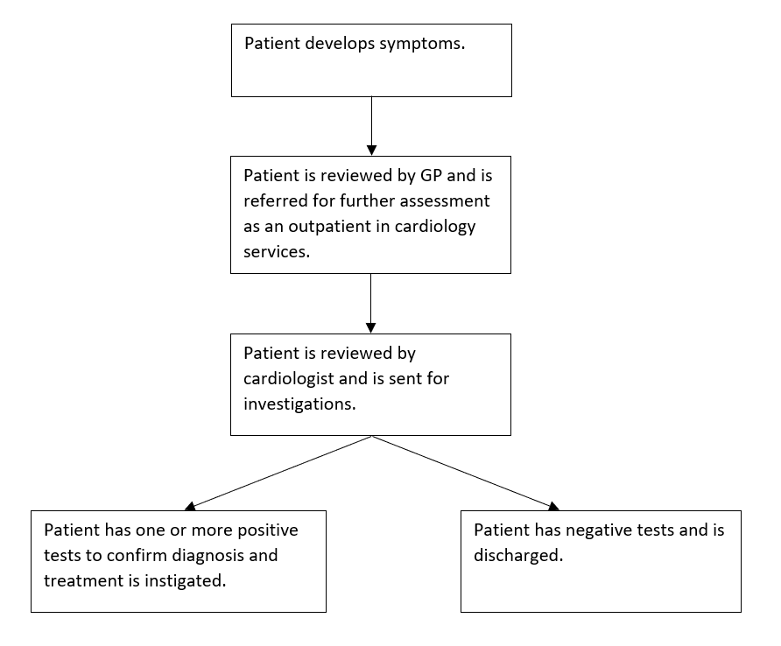

Figure 2: Clinical pathway as an exposure and outcome variable
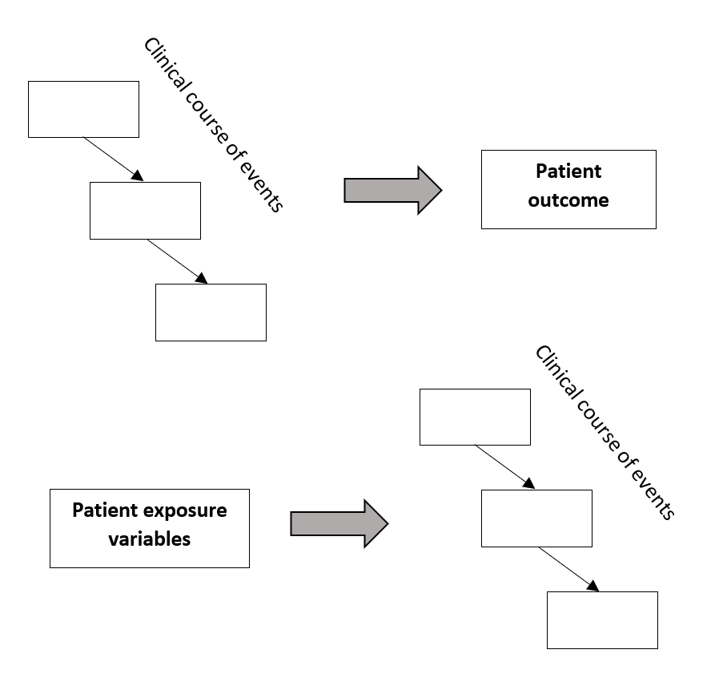

Figure 3: Framework for rationalizing events in a clinical pathway
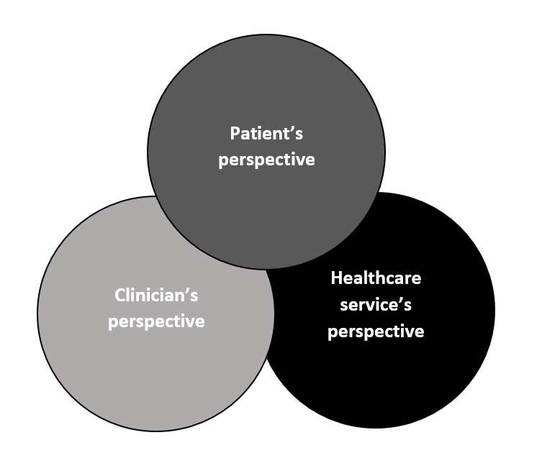

References
- Aalam AA, Alsabban A, Pines JM. National trends in chest pain visits in US emergency departments (2006-2016). Emerg Med J 2020;37:696-699.
- Emergency department visits for chest pain and abdominal pain: United States, 1999-2008. NCHS Data Brief. 2010;43:1-8.
- Chernen L, Friedman S, Goldberg N, Feit A, Kwan T, Stein R. Cardiac disease and nonorganic chest pain: factors leading to disability. Cardiology 1995;86:15-21.
- Stroke Association. Together we can conquer stroke. Stroke Association Strategy 2015 to 2018. Available at: https://www.stroke.org.uk/sites/default/files/stroke_association_strategy_2015-2018.pdf. Last accessed 15 Feb 2021.
- Frese T, Mahlmeister J, Heitzer M, Sandholzer H. Chest pain in general practice: frequency, management, and results of encounter. J Family Med Prim Care 2016;5:61-66.
- Kendall JM, Hancock I. Ed. Hassan T. Chest pain syndromes. RCEM Learning. Available at: https://www.rcemlearning.co.uk/reference/chest-pain-syndromes/
- Morgan-Hughes G, Williams MC, Loudon M, Roobottom CA, Veitch A, van Lingen R, Holloway B, Bellenger N, Schmitt M, Bull R. Downstream testing after CT coronary angiography: time for rethink? Open Heart 2021;8:e001597.
- Knuuti J, Wijns W, Saraste A, Capodanno D, Barbato E, Funck-Brentano C, Prescott E, Storey RF, Deaton C, Cuisett T, Agewall S, Dickstein K, Edvardsen T, Escaned J, Gersh BJ, Svitil P, Gilard M, Hasdai D, Hatala R, Mahfoud F, Masip J, Muneretto C, Valgimigli M, Achenbach S, Bax JJ. 2019 ESC guidelines for the diagnosis and management of chronic coronary syndromes: The Task Force for the diagnosis and management of chronic coronary syndromes of the European Society of Cardiology (ESC). Eur Heart J 2020;41:407-477.

