An exploration into the impact of clinical simulation on the development of advanced practice skills and knowledge: a qualitative study

Abstract
Background
COVID-19 has had an impact on teaching and learning, requiring education providers to seek innovative ways to adapt to such challenges. Lectures have been adjusted for online delivery, with technology, assessment and curriculum all requiring modification to address the developing situation. One such area that has grown in popularity during these challenging times is simulation (Hays et al. 2020). This paper considers the findings of a qualitative research study into the impact of simulation on the development of advanced clinical practitioners’ skills and knowledge.
Study Aim
The aim of the study was to explore simulated learning through the eyes of trainee and trained advanced clinical practitioners and consider its potential in supporting their development and continued development towards advanced clinical practice.
Methods
This qualitative research study utilised trained and trainee advanced clinical practitioner volunteers, undertaking a structured simulated event provided by a local Acute Hospital Trust simulation team. A Questionnaire (n=10) and a focus group (n=4) acted as the data gathering tools.
Results
Although simulation can be daunting for the participants, the overwhelming outcome was positive. The participants stated that they gained confidence and suggested that simulation offered a safe place to practice the challenges of the clinical environment. Additionally, they emphasised that simulation provided a place to network, receive constructive feedback that was non-judgemental, which helped the participants to develop clinical knowledge and appreciate their limitations.
Conclusion
Simulation is a valuable addition to the education and development of advanced clinical practitioners. It should be considered for inclusion within the educational curriculum as a supplement to theoretical knowledge and the structured clinical supervision provided within the clinical environment.
Key words
Simulation, advanced practice, advanced clinical practice, education, technology.
Introduction
Simulation offers a safe environment to practice, learn and discuss clinical practice without the threat of catastrophic consequences (Yu So et al. 2019). Simulation based education must focus on the safety of patients and therefore provide effective educational outcomes for those taking part (HEE, 2020). The development of competency frameworks that recognise nationally agreed key abilities and knowledge required for the delivery of safe advanced clinical practice is essential. Several authors have referred to the necessities for competent advanced clinical practice and therefore the need for supporting competency frameworks. (Furlong and Smith, 2005; Bench, et al. 2018; Dover, et al. 2019). The required capabilities and competencies, aimed directly at advanced clinical practice, have subsequently been provided via such structures (DH, 2010; HEE, 2017; IFA, 2018). Competency frameworks to address generalist capabilities have been developed by Health Education England (HEE, 2017), with the addition of specialist competencies provided by the Royal College of Emergency Medicine (RCEM, 2017), the Faculty of Intensive Care Medicine (FICM, 2015) and the Royal College of General Practitioners (RCGP, 2015). Collaboration and adoption of these capabilities into advanced clinical practice curricula is therefore advantageous and may support the development of knowledge and skill (Dover, et al. 2019). However, HEE (2020) have outlined the role that simulation can play in supporting national policies and strategic developments in ensuring that health care practitioners are supported, adaptable and capable of delivering safe and effective care. What simulation provides is a rehearsal of the clinical encounter, an opportunity for the exploration of clinical reasoning and the development of a modern workforce capable, resilient, and able to work seamlessly in a multi-professional environment, ensuring the optimisation of patient safety (HEE, 2020).
Advanced Clinical Practitioners are required to have a high degree of autonomy with the ability to make complex decisions, for which they are ultimately responsible (HEE, 2017). To support the development of such practitioners it is not just the curriculum that impacts upon the students’ educational and clinical need, but a complex interwoven merger of clinical, academic/educational, emotional and reflective experiences that shape their world (Reynolds and Mortimore, 2021). Therefore, a curriculum designed to support the development of trainee advanced clinical practitioners and other professions employed to practice at such a level, must provide not simply the required capabilities and competencies, but a structured and supported fusion of both academic and clinical education to offer a meaningful experience. Simulation is one way to help achieve such an ambition.
What is Simulation?
Simulation has been used in medical, nursing and dental education over the last 60 years (DoH, 2011). Simulation is defined as ‘a technique to replace or amplify real experiences with guided experiences, often immersive in nature, that evoke or replicate substantial aspects of the real world in a fully safe, instructive and interactive fashion’ (Gaba, 2007, page 126). Simulation is acknowledged as an important element in healthcare education programs (Warren et al., 2016), with HEE (2020) supporting the use of simulation and immersive learning technologies for training the current and future NHS workforce.
The versatility of simulation allows for a variety of practical scenarios to be considered and developed into a potential learning experience. Simulation can vary from complex software that can detect variables that alter the response, to simulations that explore emotion and relationships and their impact on patients and clients (HEE 2020; Fry, Ketteridge and Marshall, 2003). The ability of simulation to allow for ethical, professional and legal debates related to complex scenarios, away from the practice area is advantageous. In such situations students are supported with debriefs following emotionally charged simulations that can be facilitated away from the pressures of the real clinical environment (So et al., 2019; Warren et al., 2016; Fry, Ketteridge and Marshall, 2003). The scope of simulation ranges from a static model to a fully automated skills suite or simulation booth. The experience for the learner can be solitary or in groups. The main features being that simulated practice can take place without the potential risk of harm to patients/clients, whilst supporting the development of good performance in stressful situations (Hubert et al., 2014). Moreover, simulation provides a safe environment where students can reflect on good areas of practice as well as learn from mistakes without compromising their professional integrity (So et al., 2019; Rudolph, Raemer, and Simon, 2014).
This safe practical environment is attractive to professional education and health providers, who actively endorse the use of quality simulation to develop competent practice in their workforce and professional members (DoH, 2011; NMC, 2018 pg. 23-24). It is suggested that simulation offers the learner the opportunity to develop skills in the rapid processing of information, which is highly desirable in a fast and changeable clinical environment (Satish and Streufert, 2002). This structure for implementing simulation into a curriculum is described by Platt, Unsworth and Tuffnell (2010) who argue that the integration of simulation can be staged in consideration of the students learning needs and the curriculum's learning objectives, whilst utilising a mixed modality approach.
Although the issue of a simulated environment may appear at odds with the real-world experience, simulation is required to fill the void of reduced clinical opportunities, reduced hours dedicated to training and competition for clinical opportunity in an increasing multi-disciplinary healthcare environment (Moran and Glavin, 2003). That said, simulation is not designed to replace the real-life experience, it is there to help facilitate the acquisition of skills and boost student confidence. It offers a practical solution to re-constructing environments that by their very nature are constantly in a state of change, thus helping to prepare the student for modern day healthcare clinical practice (Issenberg et al., 2005). It is these relationships between the increased service requirements and the need to develop advanced clinical practitioners with the appropriate skills and knowledge, that this collaborative research study sought to explore.

Background to the study
The study emerged as a biproduct of a doctoral thesis aimed at considering the impact of a master’s degree in advanced clinical practice on the educational, clinical, and professional development of advanced nurse practitioners. The use of simulation to support advanced clinical practice education was referred to by the research participants but infrequently. Therefore, whilst useful, it did not appear to be the most influential in the development of advanced clinical practitioners. However, this was not in keeping with the anecdotal feedback from advanced clinical practitioners, who had engaged with a well-structured simulation provided by a local hospital Trust simulation team, which they felt was instrumental in their learning. Thus, a collaborative qualitative research study was proposed.
The notion of collaboration between academia and clinical practice is not new and is supported by Fitzgerald et al. (2013) in their article related to sustainable and flexible learning in a master’s programme designed to support advanced clinical practitioners. The authors describe development of modules that help link theory with practice and do so by using action research incorporating, interviews, focus groups and journal reflections, although there is no mention of the use of simulation. Whilst focus groups and journal reflections are helpful, there is still a requirement to cement knowledge in real time. This is supported further by the views of the student advanced nurse practitioner participants taken from the doctoral thesis. One participant discusses points they feel are important in advanced practice curriculum design as follows:
“Good links with the university I think is really, really important, having that deep understanding of investigations and disease process… things like ‘OK your bleep goes off and you’ve been called to a patient who is hypotensive, that’s real life, what would you do, what are the questions you are going to ask? Having some simulation like that would be brilliant” (NI7)
This type of response in addition to the anecdotal feedback from advanced clinical practitioners engaging with the simulation sessions prompted further investigation.
Methodology
This qualitative study was developed in collaboration with a local acute hospital Trust, to consider the experiences of advanced clinical practitioners undertaking a simulated scenario. The scenarios, which were designed by the simulation team within the Trust and led by an experienced consultant from the emergency department, related to complex clinical events within primary and secondary care, which were enhanced using actors (Pascucci et al, 2014).
Ethical approval from the Higher Education Institution (HEI), the Health Research Agency and the Research and Development department at the local hospital Trust was sought and obtained. The qualitative study proposed the use of a questionnaire consisting of five questions and an additional Likert scale in questions 1-3 (Table 1) a focus group (Table 2) as the data collection tools. A participant information leaflet (Table 3) and a consent form (Table 4) were also utilised.
A purposive sample was voluntarily acquired via the simulation events held at the Acute Hospital Trust. Those wishing to take part, voluntarily submitted their completed questionnaire. Those wishing to take part in the focus group, submitted their contact details to be recruited at a later point. The simulation sessions were based on four scenarios which were adapted to mirror the candidate’s workplace. Those working outside of the Acute Trust undertook the simulation in a clinical room which offered a non-ward environment. For maximum impact, recruitment was permitted of up to ten participants per simulation event, however on all four occasions the number of attendees did not exceed eight. Evidence for such a number is supported by Yu,So et al. (2019) who suggests that small group teaching allows for ‘ stop and pause’ moments, offering greater time to discuss clinical decisions, outcomes, team interaction and feedback delivery. The simulation took place over a seven-month period, with between 4 to 8 trainee and qualified ACPs taking part (Table 5).
DATE (2019) | NUMBER OF ATTENDEES
17th June | 8
9th Sept | 8
14th Oct | 8
9th Dec | 4
Simulation sessions delivered over a 7-month period. | Total number of attendees= 28,  (3 trained ACPs, 25 trainees)
Table 5: number of ACP attendees and simulation sessions over a 7-month period
Findings
Likert Scales – taken from the questionnaires
Of the twenty-eight attendees, ten questionnaires were completed (Table 5). As the questionnaires were anonymised it was not possible to identify trainee from qualified thereby maintaining confidentiality. Questions 1-3 offered a Likert scale, the response to which is demonstrated on the bar charts (Tables 6,7,8), with an additional free text box provided to capture the participants personal experiences. Questions 4 and 5 offered free text boxes only. All participants who completed the questionnaire were anonymised using letters and numbers (P1-10).
Question 1 asked.
‘How effective do you feel this form of simulation is in relation to the education and development of practitioner’s clinical skills and knowledge’?
The bar chart below (Table 6) suggests the simulation offered was very helpful in 90% of the students who volunteered a response.

Table 6: responses to question 1
Question 2 asked.
‘Did the scenarios help you explore your clinical reasoning and decision making’?
The response to question 2 suggests that simulation events facilitate the advanced clinical practitioner to explore and develop their clinical reasoning and decision-making capability (Table 7).
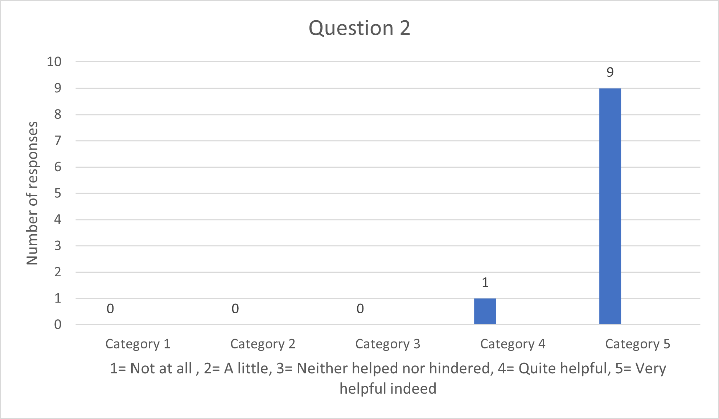
Table 7: responses to question 2
Question 3 asked,
‘Do you feel that this approach has helped you feel better prepared and more confident in your clinical practice’?
Again, the participants offered a positive response in relation to the development of their confidence following simulation, this is depicted in Table 8.
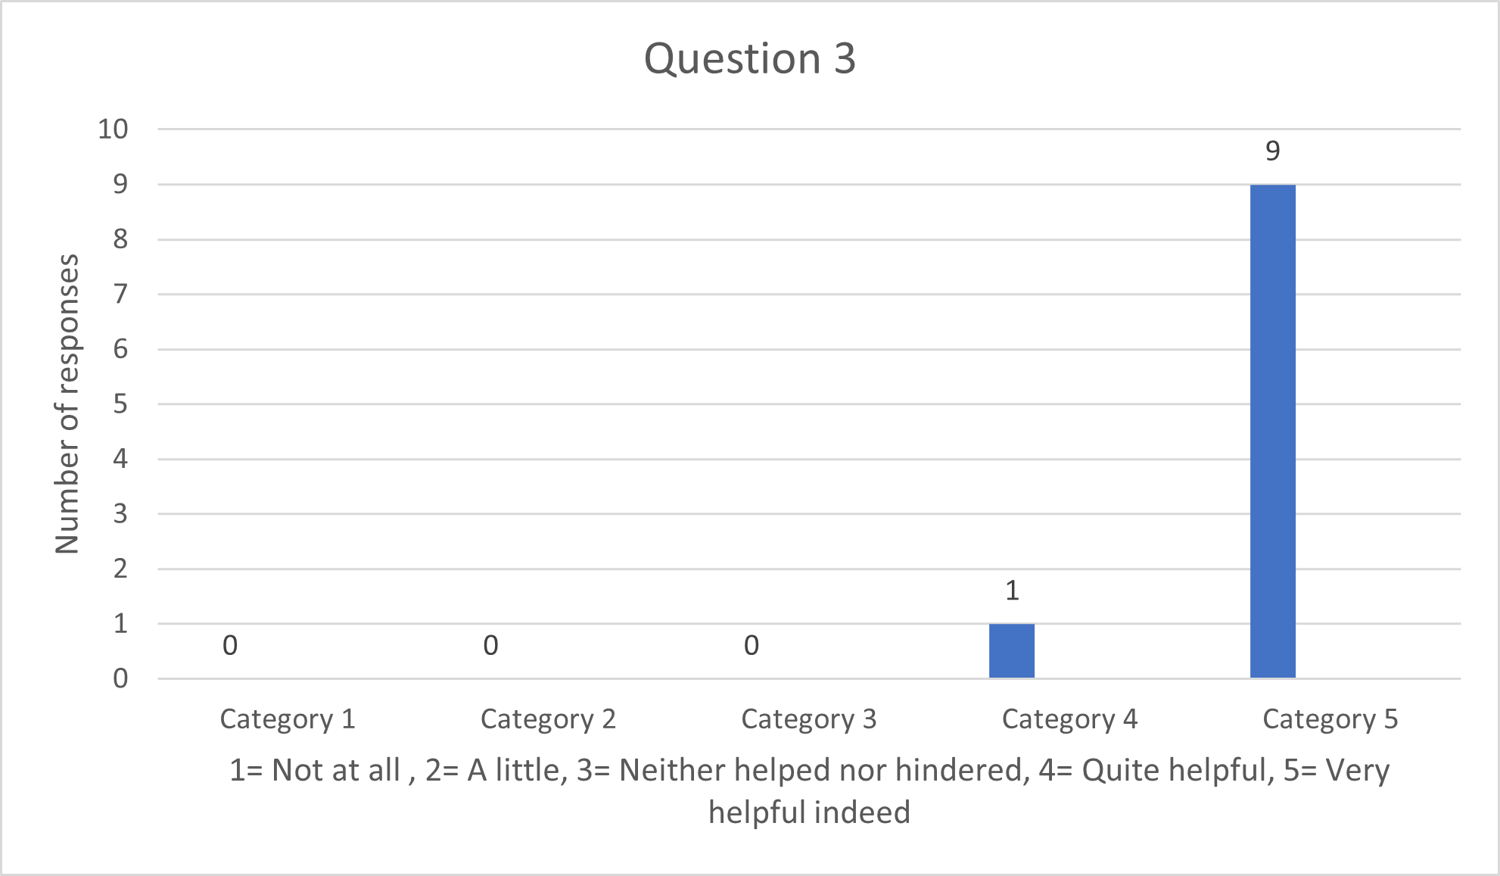
Table 8: responses to question 3
Findings from the Free text responses
Question 1
The free text offered additional feedback from the participants and captured their personal responses and their individual experience of the simulation event. A selection of responses to question 1, which explores if the scenarios help with developing clinical reasoning and decision making, is offered below with the participant code indicated (P1-4). The responses are extremely positive and help endorse the use of simulation as part of the educational development of advanced clinical practitioners.
“Safe learning environment, to practice before seeing real patients. An opportunity to network and share experiences” P1.
“There is currently no other education sessions available to trainee ACP’s working within the community setting. Whilst some elements of the training are not relevant to primary care practice, the recognition of poorly patients is vital in any setting” P5.
“Being able to practice scenarios in real- life allows learning that would not happen from just discussing or learning about this in theory” P2.
The suggestion of a safe environment where one can practise, discuss cases, and practise case scenarios based on real life is supported by the work of So et al., (2019), DoH, (2011) Issenberg and Scalese (2008). These authors propose that simulation can be created at any time to mimic a variety of situations and ethical dilemmas. What simulation provides is a safe space in which mistakes can be made and recognised and from which learning how to manage them can be discussed and developed (Issenberg and Scalese, 2008). This suggestion is reflected in the data extracts below taken from the free text within the questionnaires and supports the assertion that simulation offers vitally important learning, debrief and feedback to advanced clinical practitioners in the development of their skills and confidence.
“Good to discuss cases and what you would actually do in practice. Gives you confidence in your ability to recognise and request appropriate treatment” P3.
“I find simulation is the best form of learning for me. It helps to develop clinical knowledge and ability, but also to change attitudes and culture to giving supportive feedback” P4.
“Enables confidential discussions and constructive feedback in non-judgment environment” P10.

Question 2
When the participants considered if the simulation helped them explore their clinical reasoning and decision-making abilities, again the feedback received from the questionnaires was positive.
“Yes- it made me realise that I have relevant skills, but also highlighted my gaps” P3.
“Yes- group discussion and reflection/feedback allows for the identification of strengths/weaknesses and areas for development” P5.
“Excellent way of delving into thought processes and why we do the things we do” P8.
Question 3,4 and 5
This positive feedback continued with Question 3 when asked if simulation helped them feel more prepared and more confident in their clinical practice. Extracts related to this question are offered below.
“Yes- it has improved my confidence as I suffer with imposter syndrome” P4.
“It helps build confidence and reinforces existing knowledge. Also providing new knowledge” P7
“Helped with my confidence and acknowledging my own limitations” P8.
When the participants were asked was there anything that would enhance the simulation and debrief event (question 4) or things they would like to comment on regarding the experience (question 5) they appeared to want more scenarios related to general practice, the acutely unwell patient, prescribing, feedback from the actors playing the patient relating to how they felt and definitely more opportunities to engage with simulation and debrief. This is supported by the extracts below.
“Cases more specific to general practice may be more useful” P1.
“May be a little session on assessment of the acutely unwell,…. as a refresher” P2.
“Feedback from the patient, how did they feel?” P4.
“Regular sessions to provide skills/knowledge or revisit previously taught sessions. relative to community primary care” P5.
“More Sim Sessions! I find it really valuable” P8.
Opportunities to engage with simulated activity more frequently are supported by Issenberg and Scalese (2005) as part of a structured approach to its delivery. These authors indicate that simulation should encourage active participation by the student and should reflect reality as much as possible. Simulation needs to be conducted in a controlled educational environment, utilising various scenarios which are related to clear outcomes and goals and supported by feedback (So et al., 2019; DoH, 2011; Issenberg and Scalese, 2008). Issenberg and Scalese (2008) also refer to the need for repetition, which Harder (2018) suggests helps improve team performance. This idea of reiteration is acknowledged by Warren et al. (2016) who speak of repetition supporting the development of greater longevity of skills, which is not necessarily as apparent with a ‘one off’ exposure.
In relation to the comments and thoughts provided by the participants of this study, they wished for ‘more opportunities to engage with simulation’, ‘to network’, and although ‘stressful’ they indicated that it was ‘fun’ and a ‘crucial part of learning’.
“I thoroughly enjoyed the day and learnt a lot about my own clinical expertise and knowledge base. Also, from a networking perspective it was a valuable experience” P3.
“We need as many opportunities of this training as possible” P4.
“Stressful but fun” P7.
“Crucial part of learning” P9.
The findings from this qualitative study are supported by Parry and Fey (2018) who state that simulation improved confidence, knowledge, and satisfaction, but that more research was required on evaluating the theory practice gap, the effect of simulation on patient outcomes and its effect on postgraduate education.
Findings from the Focus Group
The focus group offered further insight into the potential impact of simulation on the development of advanced clinical practitioners, from both primary and secondary care. When the focus group (n=4) were asked about their experience of simulation it was suggested by one that they had been ‘terrified’, because by having a primary care background it had left the participant feeling ‘daunted’ by the acute ACP’s who they felt had more knowledge. This had affected the participant’s confidence. The participant stated that ‘acutely ill patients were often not seen in primary care’ and that they had ‘always worked within a primary care setting, so had limited exposure’ to this which ‘left them feeling vulnerable’.
Other participants from the acute Trust empathised with this feeling offered by the advanced nurse practitioner from primary care. They spoke of previously undertaking simulation, but also felt they had less confidence relating to clinical skills. However, all participants felt that simulation was very beneficial, and that they learnt more from simulation than in the classroom. However, some commented that they were not yet comfortable within the ACP role as they were still trainees. Another participant spoke of ‘expectations’ on the ACP, ‘that you could learn a lot and enjoy the simulation’, but there was ‘performance anxiety’. Generally, the focus group felt that simulation ‘exposed them’ and could leave them feeling ‘vulnerable and open’, but once it was over the ‘feedback was always supportive’ and therefore on ‘leaving the simulation’ the participants ‘felt more confident’.
Limitations of the simulation study
There were limitations related to the study, notably only 10 people out of 28 participants completed the questionnaires and only 4 took part in the focus group. This was due to the limited number of simulations available and the allowed maximum of 10 participants per simulation event (Table 1), to ensure the simulated learning was of maximum benefit (So et al., 2019; Lateef, 2010). Moreover, the questionnaire completion was purely voluntary and in addition COVID-19 impacted upon the clinical setting and further simulation was discontinued. Further restrictions existed due to workloads and availability of the simulation team to provide a structured and well-run simulated experience. Unfortunately, the effects of COVID-19 also played a part and impacted on the focus group, which eventually took place virtually with only 4 participants able to join. Despite the limitations, the participants experiences help to provide rich data from which further studies may be developed.
Discussion
Simulation is there to present the situation and a patient authentically (So et al., 2019; DoH, 2011; Issenberg and Scalese, 2008), it offers an opportunity to experience safe real-world experiences that are guided, interactive and instructive (HEE, 2020). However, simulation is costly and labour intensive in relation to the human resources required to provide it and the technology associated with high fidelity simulation (So et al., 2019; Issenberg and Scalese, 2008). For this reason, the researchers asked the question of the focus group.
‘Where do you think your knowledge and skill development really takes place?’
The response from the primary care participant was ‘ward rounds’. The participant said that this was where ‘cases could be discussed’. The point was made that ‘you can learn from textbooks’, but ‘patients don’t present like that’. Other participants suggested that ‘academic modules designed to support history taking and patient examination skills helped with skills and knowledge in how to examine’ a patient. These skills could then be ‘built on’ in a ‘self-directed way’. Interestingly one participant spoke of knowledge and skills developing a form of ‘triangulation’ and described the experience which is translated using the model indicated below (Fig. 1)
Classroom
(academic)

Clinical
(supported by supervision)
Simulation (combines classroom and clinical ‘safely’)

Figure 1. Knowledge and skills created from ‘triangulation’ of classroom, supported clinical learning and simulation.
Clearly there is a suggestion that simulation has an impact on the development of advanced practitioners and that they gain personally and professionally from the experience. Indeed, participants of the focus group suggested that simulation offered an opportunity ‘to adapt practice’ and whilst doing this ‘no harm’ came to the patient. There was also the suggestion that undertaking simulation outside of your team offered the participant the knowledge of the other team members strengths, therefore simulation outside of established teams may be beneficial. Certainly, one participant made the point that when you are outside your team in a simulation ‘you can look at your own role and see what you are as an ACP’. This allowed for ‘shared learning’, the difference between primary and secondary care and an appreciation of how people handle situations in different ways, which may help with learning and understanding.
One participant suggested that ‘consolidation’ of knowledge and skills is helped through the use of simulation. This prompted a question by the researchers which asked.
‘Could/should simulation be used in ever increasing complexity through a master’s program of study or be run as a joint simulation session with doctors?
The participants agreed that it could be helpful to do this and ‘develop the simulation to become more challenging as knowledge accumulated as the program developed’. The ACPs acknowledged that as they progressed, they wanted simulation to provide an opportunity to practice leadership but stated that they experienced ‘when doctors were involved, they have a tendency to take over’.
The structured approach to simulated learning as indicated by Issenberge and Scalese (2008) can also be enhanced through the use of Simulation using Team Deliberate Practice (Sim-TDP). Platt, McMeekin and Prescott-Clements (2020) explored this suggestion with undergraduate student nurses. They indicated that Simulation using Team Deliberate Practice helped avoid variation on simulated learning, by offering simulation that embraced an arrangement of clearly identified goals, underpinned by reflection on enactment and feedback from experienced clinicians. The outcome of the study was encouraging and indicated that Sim-TDP could help enhance the participants performance. This form of structured simulation was utilised by the simulation team within this study and therefore provides evidence of its impact in the development of advanced clinical practitioners.
Conclusion
The participants within this qualitative study, found simulation extremely beneficial and wanted the opportunity to participate in further simulations, offering various scenarios, with differing levels of complexity and involving multi-professional teams. The value of a structured, safe and supportive simulated activity proved a positive experience which enhanced their learning. Therefore, simulation is a valuable addition to advance clinical practice education. However, there is also a suggestion that simulation should not be undertaken in isolation but should form part of a comprehensive and structured approach to the education of advanced clinical practitioners. This approach includes consideration for the formal theoretical and clinical education provided by HEIs and the importance of the clinical environment, and the support offered by clinical supervisors (see Fig. 1). The suggestion that simulation seeks to mimic, not replace clinical skill and knowledge is highlighted by Harder (2018), who identifies that as simulation replicates the clinical environment, then the impact and worth of the true clinical environment should not be underestimated as a place to learn. Figure 1 depicts such a collaboration between the classroom, clinical environment and simulation and offers a suggested model for the inclusion of simulated practice in ACP education.
Words 3,935 (excluding abstract, but including table and figures)

References
Bench, S., Baker, E., Dover, N., Gary, B., Nwosu, W., Peacock, S., Trenchard-Turner, N., Whaley, S., Worth, T., Lee, G.A. (2018) The education and training needs of advanced clinical practitioners: An exploratory qualitative study, Journal of Nursing Education and Practice, Vol 8, No 8, pp. 66-74.
Department of Health (2010) Advanced Level Nursing: A Position Statement. Available at: www.dh.gov.uk (Accessed: November 17th 2010).
Department of Health (2011) A Framework for Technology Enhanced Learning Available at assets.publishing.service.gov.uk/government/uploads/system/uploads/attachment_data/file/215316/dh_131061.pdf (Accessed; 10/10/21).
Dover, N., Lee, G.A., Raleigh, M., Baker, E.J., Starodub, R., Bench, S., Garry B (2019) A rapid review of educational preparedness of advanced clinical practitioners, Journal of Advanced Nursing, Available at: doi.org/10.1111/jan.14105.
Fitzgerald, L., Wong, P., Hannon, J., Solberg Tokerad, M., Lyons, J. (2013) Curriculum learning designs: Teaching health assessment for advanced nursing practitioners through sustainable, flexible learning, Nurse Education Today, 33. pp. 1230-1236.
Fry H. Ketteridge S. Marshall S. (2003) A Handbook For Teaching and Learning in Higher Education Enhancing Academic Practice, Kogan Page, London

Furlong, E., Smith, R. (2005) Advanced Nursing Practice: policy, education and role development, Journal of Clinical Nursing, Vol 14, pp. 1059-1066.
Gaba DM. (2007) The future vision of simulation in healthcare. Simulation in Healthcare; 2:126-135
Harder, N. (2018) The Value of Simulation in Health Care: The Obvious, the Tangential and the Obscure, Clinical Simulation Nursing, 15, pg. 73-74, DOI https://doi.org/10:1016/j.ecns.2017.12.004 .
Hays, R., Jennings, B., Gibbs, T., Hunt, J., McKay, K. (2020) Impact on COVID-19 pandemic: The perceptions of health professions educators, MedEdPublish Journal, (Accessed on: 15th June 2021) (Available at: medpublish.org/manuscripts/3406, DOI https://doi.org/10.15694/mep.2020.0001421.1.
Health Education England (2020) Enhancing educations, clinical practice and staff wellbeing. A national vision for the role of simulation and immersive learning technologies in health care. Available at www.hee.nhs.uk (Accessed: June 16th 2021).
Health Education England (2017) Multi-professional framework for advanced clinical practice in England. Available at www.hee.nhs.uk (Accessed: November 17th, 2017).
Hubert, V., Duwat, A., Deransy, R., Mahjoub, Y., Dupont, H. (2014) Effect of Simulation Training on Compliance with Difficult Airway Management Algorithms, technical Ability, and Skills Retention for Emergency Cricothyrotomy, Anesthesiology, Vol. 120, pg. 999-1008. Available at www.pubs.asahq.org/anesthesiology/article/120/4/999/11809/Effect-of-Simulation-Training-on-Compliance-with (Accessed June 30th 2021).
Institute for Apprenticeships and Technical Education (2018) Advanced Clinical Practitioner (degree). Available at: www.instituteforapprenticeships-org/apprenticeship-standards/advanced-clinical-practice-degree/ (Accessed: March 2018).
Issenberg, S.B., McGaghie, W. C., Petrusa, E.R., Gordon, D. L., Scalese, R.J. (2005) Features and uses of high-fidelity medical simulations that lead to effective learning: a BEME systematic review, Medical Teacher, Vol. 27, No. 1, pg. 10-28. (Available at: reserachgate.net/publication/7613777_Features_and_uses_of_high-fidelity_medical_simulation_that_lead_to_effective_learning_A_BEME_systematic_review.
Issenberg, S.B., Scalese, R.J. (2008) Simulation in perspective in Biology and Medicine, Vol. 1, No1, pg. 31-46.
Lateef F. (2010). Simulation-based learning: Just like the real thing. Journal of emergencies, trauma, and shock, 3(4), 348–352. https://doi.org/10.4103/0974-2700.70743
Moran, N.J., Glavin, R.J. (2003) Low-to high-fidelity simulation- a continuum of medical education, Medical Education, Nov;37, Available at: www.pubmed.ncbi.nlm.nih.gov/14641635, (Accessed: June 10th 2021) DOI: 10.1046/j.1365-2923.37.s1.9.x
Nursing and Midwifery Council (2018) Education standards consultation response, Available at www.nmc.org.uk/globalassets/sitedocuments/education-standards/education-standards-consultataion-response-may-2018.pdf (Accessed: July 2021).
Parry, H., Fey, M.K. (2018) Simulation in advanced practice, International Nursing Association of Clinical Simulation, Elsevier.
Pascucci, R.C., Weinstock, P.H., O’Connor, B.E., Fancy, K.M., Meyer, E.C. (2014) Integrating Actors Into a Simulation Program, Simulation in Healthcare: The Journal of the Society for Simulation in Healthcare: April 2014 - Volume 9 - Issue 2 - p 120-126 doi: 10.1097/SIH.0b013e3182a3ded7 Available at: Integrating Actors Into a Simulation Program: A Primer : Simulation in Healthcare (lww.com) (Accessed: 28/10/21).
Platt, A., Unsworth, J., Tuffnell, C. (2010) Delivering manikin-based simulation in an undergraduate curriculum, Paper presented at HPSN Europe 2010, 1/11/10.
Platt, A., McMeekin, P., Prescott-Clements, L. (2020) Effects of the Simulation Using Team Deliberate Practice (Sim-TDP) model on the performance of undergraduate nursing students, British Medical Journal Simulation Technology Enhanced Learning, 7, pg. 66-74, DOI, doi:10.1136/bmjstel-2019-000520.
Reynolds, J., Mortimore, G. (2021) Clinical supervision: its influence in supporting the development of advanced clinical practitioners, British Journal of Nursing, Vol. 30, pg. 422-424.
Royal College of Emergency Medicine (2015) Emergency Care Advanced Clinical Practitioner Curriculum and Assessment, Version 1, London, Royal College of Emergency Medicine, Available at: www.rcem.ac.uk (Accessed: May 2017).
Royal College of General Practitioners (2015) General Practice Advanced Nurse Practitioner Competencies, Available at: www.rcgp.org.uk (Accessed: May 2017).
Establishing a safe container for learning in simulation: the role of the presimulation briefing. Simul Healthc 2014; 9: 339–49
Rudolph JW, Raemer DB, Simon R. (2014) Establishing a Safe Container for Learning in Simulation, Simulation in Healthcare: Journal of the Society for Simulation in Healthcare: December - Volume 9 - Issue 6 - p 339-349
doi: 10.1097/SIH.0000000000000047
Satish, U. Streufert, S. (2002) Value of a cognitive simulation in medicine: towards optimising decision-making performance of healthcare personnel, Quality of Healthcare, 11, pg. 163-167 (Available at: ncbi.nlm.nih.gov/pmc/articles/PMC1743599/pdf/v011p00163.pdf (Accessed 28/10/2021).
So HY, Chen PP, Wong GKC, Chan TTN. (2019) Simulation in medical education. Journal of the Royal College of Physicians Edinburgh. Mar;49(1):52-57. doi: 10.4997/JRCPE.2019.112. PMID: 30838994. Available at: Simulation in medical education - PubMed (nih.gov) (Accessed: 28/10/2021).

The Faculty of Intensive Care Medicine (2015) Curriculum for Training Advanced Critical Care Practitioners, (Available from: ficm.ac.uk/sites/default/files/acp_curriculum_part_i_”_handbook_v1.1_2019_revision.pdf
Warren, J.N., Luctkar-Flude, M., Godfrey, C., Lukewich, J. (2016) A systematic review of the effectiveness of simulation-based education on satisfaction and learning outcomes in nurse practitioner programs, Nurse Education Today, 46. Pg. 99-108. DOI http://dx.doi.org/10.1016/j.nedt2016.08

