Design Thinking pedagogy and enterprise education
Peter McLuskie and Sunita Dewitt

Abstract
Design Thinking features increasingly within Enterprise and Management education programmes. Its adoption is piece meal led by what could be described as champions and evangelists. There are nevertheless critics and detractors with accusations that the Design Thinking discipline is not robust and is a ‘simplified’ version of the design discipline. There exists a growing body of resources and how-to guides on what Design Thinking is and how to mobilise it in the classroom. However, despite these resources it is still unclear how Design Thinking is being delivered in the classroom. A number of studies have recognised this gap and have sought to begin formalising knowledge and understanding of Design Thinking pedagogy for non-designers.

This study aims to contribute to this research by exploring key questions:
- What tools, methods and models do Design Thinking educators use: existing resources, do they create their own or do they adapt existing resources?
- Do Design Thinking educators present their students with a variety of methods/models or do they focus on just one or two?
- Do educators ask students to engage critically with Design Thinking and its limitations or is there a taken for granted assumption about its efficacy?

The aim is to map the range of Design Thinking methods and pedagogies
The first part of the study involved surveying thirty-nine Design Thinking educators and this paper presents the results of this study.

Key findings:
- Design Thinking is ubiquitous: it is cited in an extensive range of contexts and applications
- While there are several Design Thinking models available to educators, they nevertheless tend to create their own model rather than follow existing models
- There is a high number of pedagogies which do not engage critically with Design Thinking
- Design Thinking can serve other agendas

This paper will offer a fuller account of these findings and offer conclusions relating to the research questions.

Key words: Design Thinking, enterprise education, pedagogy, entrepreneurship

Introduction
This paper is concerned with Design Thinking pedagogy and enterprise education: how the discipline of Design Thinking is delivered in the classroom, the range of tools and models used, the underlying ideologies and agendas driving its use and the expected outcomes for learners and the wider society.

This builds on an earlier work in progress paper looking at Design Thinking and its promise of utopia (McLuskie: 2017). The current paper extends this perspective and includes primary sources derived from Design Thinking educators to focus on a range of Design Thinking models and attitudes.

While Design Thinking has acquired a great deal of currency in teaching and learning and indeed within the wider society, there nevertheless remains important pedagogical questions about how it can be delivered effectively, what are the current examples of good practice, what are the range of tools and models available and what are the potential learning and personal development outcomes.

This paper adopts a mixed research methodology. It firstly conducts a review of the literature to identify common themes and concerns. This then led into the primary research study surveying thirty-nine Design Thinking educators. The aim here is to extend understanding of Design Thinking pedagogy in the context of enterprise education.

The assumptions that drive this study are:
- That Design Thinking is ubiquitous in terms of discipline and faculty, level of study and type of study
- That Design Thinking is an underlying pedagogic principle, philosophy or belief system which is not subject to sufficient critique or scrutiny by teachers and students
- That there is a diverse range of models and tools and at the same time a tendency for educators to devise their own models
- That Design Thinking pedagogy can lead to a diverse range of expected learning outcomes

What is Design Thinking?
There are several threads of Design Thinking literature that should be acknowledged in order to understand the evolution of the term and its current usage. Key figures in the early Design Thinking literature are Simon (1969) who, while not using the term Design Thinking, is seen as key in linking design to a cognitive process. Other writings, particularly Cross (1982), explore design in the context of knowledge rather than simply practice. Rowe (1987) is the first to use the term ‘Design Thinking’ in a substantive way, but here it is limited to the practice of architecture. In these discourses, the focus is on the notion of the designer and the practice of designing. However, a substantial addition to these discourses begins to appear in the early part of the 21st C, which links design to management and innovation practice.

Johansson-Sköldberg et.al (2013) explores the evolution of Design Thinking and identifies and labels two discourses: Designerly Thinking, which is concerned with the practice and theory of design and designing, and ‘Design Thinking’, which refers to a wider context where design is used by non-designers in disciplines, particular Business Management, where design has not traditional featured. Significant here is the authors’ reference to Design Thinking as a ‘simplified version’ of Designerly Thinking implying a less robust and sophisticated adoption of design (2013: 123)

This combination of Designerly Thinking and Design Thinking is perhaps best summed up by Tim Brown who is a key figure in linking design to innovation and management practice. He defines Design Thinking:

Put simply, it is a discipline that uses the designer’s sensibility and methods to match people’s needs to what is technologically feasible and what a viable business strategy can convert into customer value and market opportunity (2008: 86)

Other writers have extended these categories of discourse to identify other ways of talking about Design Thinking. Kimbell identifies three discourses: Design Thinking as cognitive style, as a general theory of design and design as an organisational resource (2011: 297).

The linkage between Design Thinking and Management and Business Management education is consolidated and championed by Dunne and Martin (2006) who demonstrate a need for more of a designer’s sensibility in business and business education. In additional, there are other key actors and agencies building a case for design in management, notably the design agency IDEO (n.d) who have produced a range of supporting texts and tools to help embed Design Thinking into a wider range of disciplines and contexts.

There is also a popular discourse around Design Thinking which features prominently and frequently in the media, the popular press and less scholarly publishing outlets. It is not always clear where the boundary lies but for many writers, the Management discourse is very much related to the less rigorous and scholarly popular discourse (Johansson-Sköldberg 2013) (McLuskie 2017))

While the literature often simplifies Design Thinking by suggesting it brings a design sensibility to management, there are nevertheless distinctive elements of the new discipline. First, there is a shift from thinking about design as the sole preserve of the designer to recognising non-designers and even users as instrumental in the process of design. Secondly, the corresponding shift away from the centrality of the designer to the user and the notion of ‘empathy’ becomes a recurring motif and tenet in Design Thinking. Lastly, the emphasis on prototyping and getting the ideas out into the world as viable enterprises rather than simply experiments is key to Design Thinking (Liedtka; 2015 922)

However, several accounts of the literature on Design Thinking have pointed to its lack of robustness and indeed the need for more, and more scholarly, research in the field (Kimbell, 2011) (Johansson-Sköldberg 2013). Furthermore, it is acknowledged that Design Thinking is not well understood and much of the literature has been focussed on defining and refining it in order to move to greater clarity (Kimbell, 2011) (Johansson-Sköldberg 2013) (Lindgaard & Wesselius 2017)

In moving away from the centrality of the designer and design practice, Design Thinking has opened up to being adapted to a plethora of disciplines, contexts and outcomes. Indeed, another characteristic of Design Thinking is both its flexibility – its adaption to any discipline and outcomes – and its pervasiveness – its tendency to be foundational, providing underpinning philosophies across programmes rather than as a stand-alone experience. For example, in Design Thinking Research (Plattner et.al 2016,) although focusing mainly on engineers, notes how they are working with researchers across a range of disciplines to generate creative confidence:

And that’s what design thinking is all about: it’s a framework and method that fosters creative confidence which is foundational for innovation and can ultimately enable everyone to be innovative (2016: vi)

Other examples of Design Thinking pedagogy discuss it in terms of its underpinning, cross-curricular role (Cara (Wrigley & Kara Straker 2015). However, while the aspiration is there for making Design Thinking foundational in pedagogical terms, there are still questions about how to deliver Design Thinking outside of the discipline of design.

Design Thinking & Pedagogy
One of the first attempts to theorise a pedagogy within the management discipline is provided by Welsh and Dehler (2012). Their pedagogy aims to produce integrative thinkers across multiple disciplines and specifies innovative teaching methods to accomplish this. A key outcome is also around ‘reinvigorating faculty’ and to ‘reenvision and invigorate the potential of management education’ (2012: 798). The authors therefore see Design Thinking as contributing to a wider agenda than stand-alone classes and programmes: there is also the opportunity to transform faculty and education. It is worth noting that, for these authors, their pedagogy and the presence of Design Thinking is claimed to have ‘transformative’ and potentially ‘life altering’ powers (2012:797), which perhaps hints at the hyperbole that is claimed to be characteristic of the Design Thinking discourse (Johansson & Woodilla 2009) (McLuskie 2017). One further issue that is addressed by these authors is the question of how to bring students from non-design disciplines into the design studio learning environment. They note that students needed to transcend their disciplinary boundaries in order to work effectively, and it is here the authors recognise the difficulty of simply grafting one discipline onto another (Welsh and Dehler 2012).

More recent accounts of teaching Design Thinking to non-designers continue to pose the question of the rigour of current pedagogy and the lack of knowledge that exists regarding classroom practice and pedagogy. Royalty (2018) attempts to compare Design Thinking teaching against establish theoretical perspectives, including Constructivist learning environments. The aim here is to test the learning environment of Design Thinking which is proven to be robust, but not the strategy, which is not explored in this research and is recognised as a limitation and a gap in knowledge (2018: 143).

However, while Royalty’s study is a serious and grounded attempt to integrate design and management pedagogy, several writers and educators have extended the discussions to connect Design Thinking to enterprise education, recognising the synergies that exist between the designer and the entrepreneurial mind-set (Penaluna et.al 2010). A number of these accounts have attempted to combine theoretical underpinnings along with pedagogic programmes and models to help ground Design Thinking within enterprise education.

Design Thinking and enterprise education
There are several case studies exploring Design Thinking and enterprise education. Daniel (2016) considers the synergies between Design Thinking and enterprise education and adopts the Stanford D and Hasso Plattner Institute model, which is based around a six-stage process: understand, observe, define, ideate, prototype and test. The author also references other key figures and agencies, IDEO and Tim Brown as providing touchpoints for delivering Design Thinking in the classroom. The author compares this process against ten principles of enterprise education proposed by Löbler (2006). The author goes onto demonstrate synergies and concludes that Design Thinking is a useful addition to enterprise education. It should be noted that while the author discusses and evaluates enterprise education pedagogy and explores its theoretical underpinnings Design Thinking is not subjected to the same scrutiny.

There are further examples and case studies which attempt to align Design Thinking processes with enterprise education. For example, Huber et.al (2016) identify nine elements of Design Thinking which have been synthesised from a range of sources, including Tim Brown (2008 & 2009), The Design Council, Jeanne Liedtka and Tim Ogilvie (2011) Kelley & Kelley (2013). The authors map these nine concepts onto enterprise education pedagogies and learning outcomes (2016: 2). There are further elaborations on the pedagogy, in particular the importance of the studio based learning context, something which is referenced by other authors, in particular Welsh and Dehler (2012)

The final case study comes from Huq and Gilbert (2017). The authors utilise the Design Council’s ‘Double Diamond’ model which specifies four stages: Discover, Define, Develop and Deliver (2017: 9). The authors also reference IDEO and Tim Brown (2009) in their construction of a Design Thinking Model. However, they also go onto to map the process against five key questions that are synthesised from their literature review: why (purpose and objectives of the course), for whom (the students and their profiles), for what results (the relevant evaluation criteria), the what (what is the content) and the how (methods employed) (2017: 8). In addition, the authors identify and cite other principles underpinning an effective enterprise and entrepreneurship pedagogy: justice and equity, humour, role-play and constructivism (2017: 11).

It is again, worth noting that this programme and the Design Thinking pedagogy was partly adopted in response to low student satisfaction and engagement ratings. The result of the programme has led to increases in these ratings (2017: 10). Furthermore, as stated in the title of their paper, the authors are promising to ‘transform entrepreneurship education through Design Thinking’.

To summarise the literature review, several issues can be noted. First, there is a range of approaches and models adopted by educators. Secondly, there are other agendas to be served by Design Thinking: increased student satisfaction, regeneration of faculty. Third, there is evidence of hyperbole in judging the potential impact of Design Thinking and this has been noted elsewhere (Johansson & Woodilla 2009). Fourth, while there are positive accounts of the powers of Design Thinking, there are critical voices as well. Fifth, there is a tendency to see Design Thinking as a foundational pedagogy, underpinning all programmes. Sixth, while there is a good deal of critical reflection around enterprise pedagogy, often, it seems, Design Thinking is taken at face value. Seventh, there are a range of outcomes leading from Design Thinking pedagogy, including creative confidence (Huber 2016) (Plattner et.al. 2016), integrative learners (Welsh and Dehler 2012) and fostering an entrepreneurial mind-set (Daniel 2016)

In order to explore these insights and issues further, a two-part primary research project was designed. The first stage was to survey Design Thinking educators.

Methodology
An online survey was initially distributed via Bristol Online Survey to 50 Design Thinking Educators. Respondents were identified as Enterprise Educators interested in Design Thinking. This resulted in thirty-nine completed surveys. Respondents were selected from colleagues and contacts collected at Design Thinking and Enterprise Education events between 2015 and 2018. Colleagues and contacts were invited to pass on the survey to their relevant network using a snowballing methodology. Some respondents were familiar with my research agenda, which may have led to some bias; however, given the anonymity of the survey this would be unlikely to affect responses. The survey was distributed exclusively to Higher Education institutions without geographic restrictions.

The survey consisted of six questions designed to establish insights into key questions around Design Thinking pedagogy and the attitudes of educators. The questions asked respondents to identify the subject area(s), the intended outcomes and educational levels for teaching Design Thinking. Here the aim was to identify the range of contexts in which Design Thinking is delivered and the diversity of contexts and levels that individual educators operate within and across. Respondents were invited to select from a pre-defined list but also to add their own categories. Questions were also asked regarding the range of tools and models that respondents were familiar with and whether they were referenced or adopted in their pedagogy. Importantly, a binary question was asked about whether respondents created their own Design Thinking models. Again, these questions were designed to help identify the extent of the diversity in Design Thinking pedagogy and indeed the extent to which that pedagogy might be hidden. Questions were also asked about the level of critical engagement with Design Thinking and whether students look at theories behind Design Thinking. In addition, questions were asked regarding the respondents perceived value of Design Thinking asking them to describe their attitude as ranging from evangelical to sceptics. The intention here is to generate insight into the range of attitudes towards Design Thinking and the robustness of the pedagogy that is being delivered. The survey did not capture other data, the aim was to design a short, simple survey that would maximise responses and at the same time generate insights relating to the key research questions. The next stage of the research will interview Design Thinking educators to elaborate on responses from the survey and build a more detailed picture of current Design Thinking pedagogy.

Results
Respondents were asked about the context for teaching Design Thinking. The results (Table 1) show that Creativity and Innovation along with Enterprise and Entrepreneurship are the most common contexts. However, conducting a deeper analysis it can be seen that 15% chose all five listed topics land all of the respondents listed more than one context. In the ‘Other’ section, 5% of the respondents listed seven additional contexts including what might be understood as Design Thinking as an umbrella or an underpinning method: for example ‘Life Design, using the design approach in life’ and ‘we are a design school. Everything we do is Design Thinking’. Also listed were ‘personal development’ and professional development contexts and ‘situating learning with careers opportunities as freelancers and entrepreneurs’.

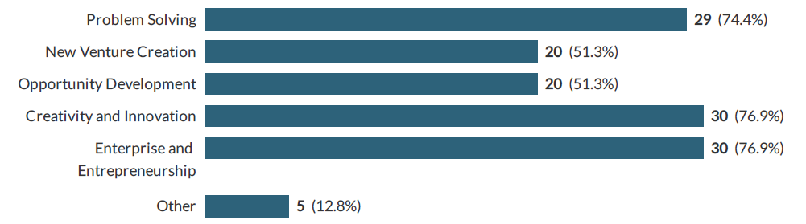

Table 1: Context for Teaching Design Thinking

In a related question, respondents were asked for which disciplines they use Design Thinking. Again, out of the six listed disciplines Enterprise and Entrepreneurship is the most common followed by Business and management (Table 2). However, respondents listed several disciplines and only nine respondents listed only one discipline. 33% of respondents listed an additional sixteen disciplines. Several responses referred to disciplines which were unrelated to Enterprise, Entrepreneurship, Design or Business; the topics listed, included ‘Health’ ‘Law’ and ‘Engineering’. Several responses again referred to the umbrella role of Design Thinking as in having a ‘university-wide remit’ or ‘other interdisciplinary humanistic courses’, again suggested the boundary spanning nature of their pedagogy.

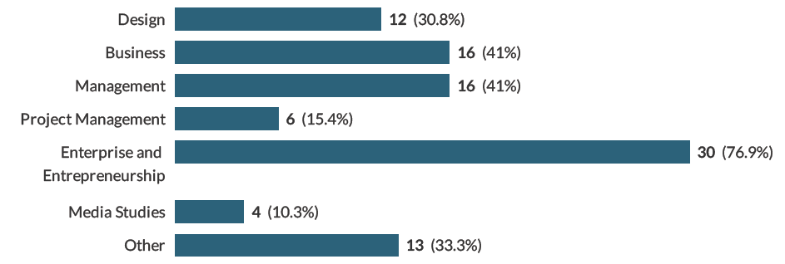
Table 2: Which disciplines do you use Design Thinking in?

Respondents were asked which level(s) they taught (table 3). The most common being undergraduate, followed by Postgraduate and then extra-curricular. Two additional categories were added in ‘other’ by respondents: elementary schools and business owners. Looking deeper into the data, it can be seen that 61% of respondents taught multiple levels; 8% taught all five levels and 31% of respondents taught at only one level. Noteworthy is the fact that 11% of the single level ticked extracurricular only. Extra-curricular would seem to be very distinctive as a separate group who do not overlap, however, 23% of respondents who ticked several levels also included extra-curricular.

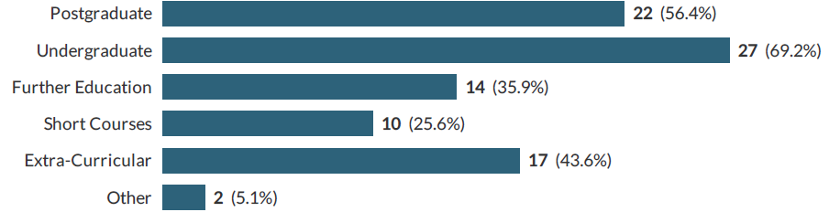
Table 3: Which levels do you teach?

Respondents were asked to identify the models and resources they use drawing from a pre-set list of 10 options with the opportunity to add their own in the ‘other’ section (Table 4). IDEO was the most visible and well referenced with 64% claiming to use it in their teaching. The Design Council’s Double Diamond at 59% and The Art of Innovation Tom Kelley with 44% closely followed this. However, 36% of respondents referenced all three of these in their teaching. In addition to the ten models cited, 33% respondents cited an additional thirty-six resources that had not been listed in the survey. However, a striking 26% of respondents claimed not to use any of the listed models and resources.

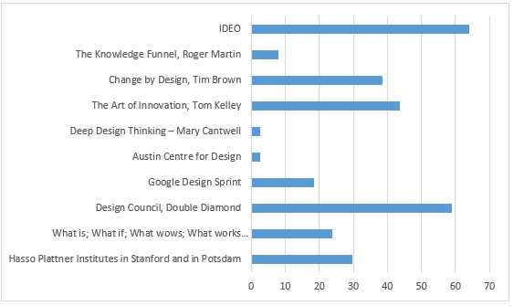
Table 4: Which models and resources do you reference?

Related to this question, respondents were asked if they created their own model of Design Thinking. In answer to this question, 58% stated that they created their own model. Following further analysis of the data, 50% of the respondents who create their own model do not use any of the 10 models or resources listed by the survey.
Table 5: I create my own model

Respondents were asked does your use or teaching include a critical reflection on the theories behind Design Thinking (Table 6). 26% of respondents explicitly address this and see it as a key part of their pedagogy; 54% do not address it explicitly while 20% state it is not addressed.
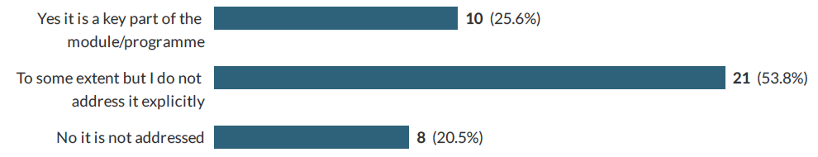
Table 6: does your use or teaching include a critical reflection on the theories behind Design Thinking?

Finally, respondents were asked to rate their attitude to Design Thinking and how they value it ranging from ‘I am evangelical’ to ‘I am sceptical’ (Table 7). 15% were evangelical; 36% thought it was an excellent tool; 38% thought it had a role to play in education; 4% said useful but can be over rated. No respondents stated that they were sceptical about Design Thinking.
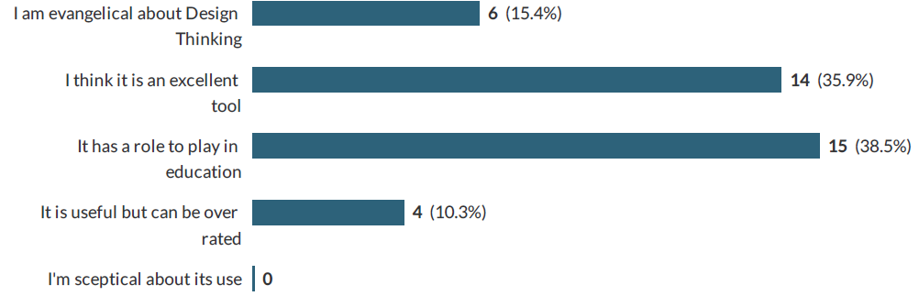

Table 7: Are you an advocate or sceptic of Design Thinking?

Discussion
The online survey is the first stage of the research process and will be followed by more in depth one-to-one interviews. However, there are interesting and insightful findings from this initial round which does extend knowledge around Design Thinking pedagogy for non-designer and enterprise education.

Firstly, the data shows that there is a wide context for teaching Design Thinking, in terms of discipline, level and outcomes. For example in addition to the listed six disciplines in the survey, 33% of respondents identified a further sixteen categories. Furthermore, many of the respondents claimed to work across disciplines, levels and outcomes suggesting a very diverse application for Design Thinking. There is also the suggestion that, and in line with the secondary research case studies, Design Thinking is foundational rather than a stand-alone offering with many respondents suggesting a university wide, embedded role.

Secondly, the survey listed ten different models and resources that might be used in Design Thinking pedagogy. All were included in some degree. However, the most popular was IDEO, The Design Council’s Double Diamond and The Art of Innovation by Tom Kelley. The data suggests that there may be a pick and mix approach with 36% respondents claiming to use all three of these models and resources. However, 26% of respondents did not reference any of the ten models and resources, which suggests that other resources are being adopted that are not accounted for by the survey. Indeed, in addition to the models and resources listed, 33% of respondents cited an additional thirty-six resources that had not been listed in the survey. Furthermore, most respondents (58%) claim to create their own model. This data suggests that there are a diverse range of pedagogies and practices that are being pursued and adopted by Design Thinking educators. Issues around what is good and robust pedagogy and transparency of practice are raised by these findings.

The survey also aimed to identify the extent to which current pedagogy includes a critical and reflective perspective on the theories behind Design Thinking and whether or not students are expected to engage in critical dialogue with Design Thinking. Only 26% of respondents claimed that critical reflection was a key part of their pedagogy. The other 74% were split between those that did not address it explicitly and those that did not address it at all. This perhaps confirms assumptions in the secondary research that more needs to be done to engage critically with Design Thinking within the non-design community.

In terms of attitudes towards Design Thinking, there was a range of responses. While there were no out an out sceptics, there were nevertheless 10% who thought it can be over-rated. Opposed to this, 15% were evangelical about Design Thinking. This suggests a diverse and conflicted community of practitioners.

Limitations and further research
The research is limited by the small sample of thirty-nine respondents. The survey is also attempting to identify complex results and insights from survey questions which offer limited opportunities for response. While the survey was designed to be simple and quick in order to ensure completions, nevertheless this is at the expense of more open-ended questions which could yield greater and more concrete insights. The next stage of this research will include one-to-one interviews and will attempt to address these limitations.

Conclusions
This research has reviewed the current literature on Design Thinking and enterprise education. It has also looked more broadly at Design Thinking education for non-designers in general. This research was extended and complimented by a primary research project which surveyed thirty-nine Design Thinking educators who were involved in enterprise education.

Design Thinking (as opposed to Designerly Thinking) has received criticism for its lack of pedagogical and theoretical rigour and several accounts of Design Thinking have noted the need for more research and discussion on these topics. This study has begun exploring these claims focusing on a range of questions and issues. First, we can see that Design Thinking educators are working across a number of disciplinary boundaries and academic levels and that there is evidence of Design Thinking functioning as a foundational or underpinning concept. If this is the case, academic and theoretical rigour is crucial. At the same time, several case studies have focused narrowly on Design Thinking and enterprise education. Here, we can observe that while enterprise education might be heavily theorised, Design Thinking is not always – the exception being Penaluna who takes a deep dive into theories of creativity and design pedagogy (Penaluna et.al 2010). In addition, Welsh and Dehler (2012) noted that teaching Design to non-designers brings challenges and that there is not an easy translation from design into other disciplines.

It was also noted that Design Thinking serves other agendas, particularly the crises in Management education: here Design Thinking has the potential to not only transform students but Faculty as well (Welsh and Dehler 2012).

This research has demonstrated that with regards to Design Thinking, there exists a wide and diverse range of pedagogies. The research revealed that while there exists a number of ‘off the shelf’ Design Thinking models, most educators create their own teaching models and resources. The reasons for this are unclear and further research is necessary; however, it does suggest that Design Thinking pedagogy lacks coherence and consistency. The survey results also confirmed this fragmented and incoherent position amongst the community by suggesting a range of attitudes ranging from evangelical to feeling that Design Thinking can be over-rated.

The study has confirmed the need for more transparency, greater coherence and critical engagement with Design Thinking pedagogy within non-design disciplines. The next stage of the research will be to bring more detail to the topic through one-to-one interviews with Design Thinking educators.

References
Austin Centre for Design (n.d) Austin Centre for Design [online] http://www.ac4d.com/
Brown, T. (2008) Design Thinking, Harvard Business Review, June 2008, 85-92
Brown, T. (2009) Change by design: How design thinking transforms organizations and inspires innovation, HarperCollins, New York
Cantwell, M. (n.d.) Deep Design Thinking, [online] https://www.deepdesignthinking.com/
Cross, N. (1982) Designerly ways of knowing Design Studies, 3(4), 221-227
Daniel, A. (2016) Fostering an entrepreneurial mind-set by using a design thinking approach in
entrepreneurship education, Industry and Higher Education, 2016, Vol. 30(3) 215–223
Dunne D, Martin RL (2006) Design thinking and how it will change management education: an interview and discussion, Academy of Management Learning & Education, 5:512–23
Huber, F. Peisl, T. Gedeon, S. Brodie, J. Sailer, K. (2016) Design Thinking-Based Entrepreneurship Education: How to Incorporate Design Thinking Principles into an Entrepreneurship Course, Paper delivered at 3E Conference, Leeds, 13 May
Huq, A and Gilbert, D (2017) All the world's a stage: transforming entrepreneurship education through design thinking, Education and Training, vol. 59, no. 2, pp. 155-170
IDEO (n.d) Work, Blog, Tools [online] https://www.ideo.com/eu accessed 10/04/2019
IDEO (2012) Design Thinking for Educators, [online] https://designthinkingforeducators.com/design-thinking/
Johansson, U. & Woodilla, J. (2009) Towards an epistemological merger of design thinking, strategy, and innovation, 8th European Academy of Design Conference: April 1-3, 2009, Aberdeen, Scotland
Johansson-Sköldberg, U. Woodilla, J. & Cetinkaya, M. (2013) Design Thinking: Past, Present and Possible Futures, Creativity and Innovation Management, Volume 22 number 2, pp.121 – 146
Kelley, T. & Kelley, D. (2013), Creative confidence: Unleashing the creative potential within us all, Crown Business
Kelley, T. (2016) The art of innovation: lessons in creativity from IDEO, America's leading design firm, London, Profile Books
Kimbell, L (2011) Rethinking Design Thinking, Design & Culture, vol 3 issue 3 pp.285-306
Knapp, J (n.d) The Design Sprint [online] https://www.gv.com/sprint/
Liedtka, J., & Ogilvie, T. (2011) Designing for growth: A design thinking tool kit for managers (1st ed.). New York, NY & Chichester, West Sussex: Columbia University Press.
Liedtka, J. (2015) Perspective: Linking Design Thinking with Innovation Outcomes through Cognitive Bias Reduction, Journal of Product Innovation Management; 32(6): 925–938
Lindgaard, K. & Wesselius, H. (2017) Once More, with Feeling: Design Thinking and Embodied Cognition, She Ji: The Journal of Design, Economics, and Innovation, Volume 3, Issue 2, summer, Pages 83-92
Löbler, H. (2006) Learning entrepreneurship from a constructivist perspective, Technology Analysis & Strategic Management 18(1): 19–38
McLuskie, P. (2017) Design Thinking: Pedagogy and the promise of utopia, 6 Sep 2017, European Conference on Innovation & Entrepreneurship, p. 819-822
Nielsen, S. & Stovang, P. (2015), DesUni: university entrepreneurship education through design thinking, Education + Training, Vol. 57 Iss 8/9 pp. 977 – 991
Penaluna, A. Coates, J. Penaluna, K. (2010) Creativity-based assessment and neural understandings, Education + Training, Vol. 52 Iss 8/9 pp. 660 – 678
Plattner, H. Meinel, C. Leifer, L. eds (2016) Making Design Thinking Foundational, Springer, Cham Heidelberg, New York
Rowe , P (1987) Design thinking. Cambridge, MA: The MIT Press
Royalty, A. (2018) Design-based Pedagogy: Investigating an emerging approach to teaching design to non-designers, Mechanism and Machine Theory, Volume 125, July, Pages 137-145
Simon, H.A. (1969) The Sciences of the Artificial, Cambridge, Massachusetts: MIT Press
Welsh, M. A., & Dehler, G. E. (2012) Combining critical reflection and design thinking to develop integrative learners, Journal of Management Education, 37(6), 771-802.
Wrigley, C & Straker, K (2015): Design Thinking pedagogy: the Educational Design Ladder, Innovations in Education and Teaching International, 54:4, 374-385

