Is integrated information management a core clinical skill required for the doctor-patient encounter?
Running head:- Information management: a core clinical skill
Robert K McKinley MD and Simon P Gay MB
Keele University School of Medicine

Address for correspondence:
Robert K McKinley
Keele University School of Medicine
Keele, ST5 5BG, UK.
r.k.mckinley@keele.ac.uk
00 44 1782 734667

Declaration of Competing Interests
Both authors declare that there are no competing interests.

Funding/Support
"This research received no specific grant from any funding agency in the public, commercial, or not-for-profit sectors."

Ethical approval
Not applicable.

Guarantor
RK McKinley.

Contributions
RK McKinley developed the conceptual model and wrote the first draft of the paper. SP Gay extensively revised this and both have contributed equally to subsequent drafts and approve the final version.

Acknowledgment
We would like to thank Dr M. H. Bartlett for her contribution to the development of the teaching on which this paper is based.
Introduction
The most important context in which a medical doctor works is in the consultation or doctor-patient encounter, in which a complex blend of cognitive, psychomotor and interpersonal skills are deployed. Many of these are well established, such as the skills required to elicit findings on physical examination. Others such as establishing and maintaining a relationship with the patient are more recently recognised but an emerging evidence base supports their learning.[1]
Good clinical outcomes requite good clinical care which in turn requires good clinical skills. Clinical skills are interdependent and context dependent. Those required to gather information, build relationships, structure the encounter and give information are formally integrated in the Calgary Cambridge Framework;[1] the skills required to elicit the history, elicit appropriate findings on physical examination, and clinical reasoning skills are intimately related and have been formally integrated in newer doctor-patient encounter models.[2] Even competent performance of clinical procedures requires interpersonal and team skills[3] as well as ‘pure’ psychomotor skills.
We use a unified skills model to support clinical skills tuition which recognises this interdependence of clinical skills (fig.1).[2]This blend of overlapping skills also includes integrated information management as a component doctor-patient encounter skill. This stance is supported by Outcomes for Graduates[4] which requires medical students to “use information effectively in a medical context”.
This paper describes how we conceptualise integrated information management skills, why and how we teach them.

What is integrated information management within the doctor-patient encounter?
In the doctor-patient encounter, doctors manage six major information streams in an information dense environment; four input and two output (fig.2). Consider them in order of maximal flow:

Information about the patient: The doctor has this information before the encounter starts. It may be in the patient’s clinical record, referral letters, letters from professionals to whom the patient has been referred, or in the doctor’s memory. Classically this information is accessed before seeing the patient but alternative strategies have been proposed such as waiting until the patient has described why she has attended then reviewing her record.[5]
Information from the patient: This is the information the patient brings to the encounter. It usually encapsulates the reason for attendance. However, patients sometimes bring other information with them: in the past these were often newspaper or magazine cuttings; it now includes printouts from, or links to, websites of varying quality.
Information for the doctor: Information the doctor uses to assist decision making. Historically this has been printed material available the office: drug formularies, clinical guidelines or protocols and textbooks. This is now delivered electronically through local intranets or the global internet and is disparate in quality and content. When just a few printed sources, the doctor could be familiar with the content and have some confidence in the quality. Now she is unfamiliar with much of what is available and is uncertain of its quality. This requires that the doctor has the skills to rapidly evaluate this information within the encounter.
Information for the patient: Historically, information available for the patient in the encounter was usually limited to a restricted range of printed patient information leaflets with which the doctor was familiar and had pre-appraised. The doctor’s decision-making was restricted to what and how much information to give the patient and to what end.[6] Now that the doctor can source patient information from the internet, this challenge is compounded by the need to evaluate the information found because the doctor retains responsibility for the quality of information given to a patient.[6][7]
Information to the patient: The four outputs of the doctor-patient encounter are management of the presented problem, modification of health seeking behaviour, management of continuing problems and health promotion.[8] Each task is critically dependent on patient engagement with healthcare. While many patients actively engage with their healthcare, many don’t.[9] Information is key[9] and can be used to support biomedical compliance or an exchange of understanding thus achieving concordance.[6] We adopt no particular stance in this debate but invoke it to illustrate the complexity of information use.
Information for the future: In today’s increasingly fragmented health system, personal continuity of care being replaced by informational continuity. This depends on the patient’s record bridging the past, the current consultation and future care. The final task in any consultation is to ensure informational continuity by recording the information used in the consultation, any decisions made and why they were made.(Table 1)

Is integrated information management part of the clinical skill set?
Clinical skills are critical to good clinical care and outcomes. While this is dependent on the traditional clinical skills described above, on their own they are insufficient without integrating the various information flows within the consultation. To ignore what is already known about the patient is self-evidently foolhardy. UK doctors are charged to ‘make good use of the resources’, which include information, to ‘keep clear, accurate and legible records’, to ‘encourage patients…to take an interest in their health and to take action to improve and maintain it’.[7] The ‘informed patient’ rhetoric is complex and contested[6][9] but ultimately few doctors would advocate withholding information from our patients. Furthermore, doctors’ frequency of information needs are between ‘four times a half day’ and ‘five times per patient’ and are likely to affect the care of 40% of patients from whose care the information needs arose.[10] Sackett described evidence-based medicine as ‘the integration of best (current) research evidence with clinical expertise and patient values”;[11] a definition which imbeds evidence based medicine and its attendant information management skills in the doctor-patient encounter. Therefore, provision of good clinical care requires doctors to manage information while consulting with their patient: information management is self-evidently a clinical skill.

Isn’t promoting integrated information management as a clinical skill glorifying the trivial?
Integrated information management in a consultation is difficult for a number of reasons:
Patient record volume: Patient care and patient records are becoming increasingly complex and multiprofessional as medical knowledge advances. While the electronic patient record facilitates the ‘multiuser record’, it is harder for the practitioner to identify her last entry and all other entries relevant to today’s attendance.
Information paradox: Doctors are ‘overwhelmed with information but unable to find the knowledge they need when they need it’,[12] largely because of the growth in medical literature. Nevertheless, tools exist to support doctor access to quality assured biomedical information, for example the McMaster Health Knowledge Refinery (http://hiru.mcmaster.ca/hiru/HIRU_McMaster_HKR.aspx). However, there are no equivalent tools to sift information resources for patients. This highlights the third problem…
Information quality: Not all information sources are equally trustworthy. While the issues are complex, reflecting differing perspectives of the functions of patient leaflets,[6] they are not trivial and need consideration.
Information purpose: Information is not neutral but is deployed strategically by healthcare systems, the medical profession,[6] interest groups and industry to achieve desired outcomes, manage demand or enhance uptake of goods and services. Nevertheless, there is increasing evidence of how information can be presented in ways which enable genuine patient choices.[13]

We already know how to do it?
At the individual doctor level this is patently not the case. Doctors still make choices contrary to best evidence, advice and practice.[14] Routine clinical practice generates many questions yet most are never answered and, when they are, the sources consulted and information gained is often poor or outdated.[15] Knowledge of available information sources is patchy, skills required to efficiently use information found within the doctor-patient encounter are weak, teaching of these skills is still in its infancy and, until recently, the technology available inadequate. We need to nurture these skills for doctors of all ages and experiences and a good place to start is with medical students.

How can we support development of integrated information management skills?

- Curriculum
Curriculum architecture is beyond the scope of this paper but some suggestions are included in Table 2 and the following issues are relevant:
  - Components: Identify and develop key attitudes and skills first. These might include generation of awareness of need, opportunity, value and consequence amongst learners, critical appraisal of evidence skills, use of information sources and concepts such as “patient-oriented evidence that matters” (POEMs)[16] Much of this is already part of many curricula.
  - Integration into real time patient encounters: Having developed key attitudes and skills, the learner then integrates them and rehearses them in real time alongside conventional skills (Table 3).
- Culture change
Much of the required IT infrastructure is in place: Virtually all UK family practitioners have used sophisticated electronic patient records since 2004. High speed internet access has been commonplace for over ten years. Adoption of electronic patient records has been slower in hospitals and only recently has medical student access been raised and addressed.[17] What is now needed is a cultural change so that IT policies, strategies and training better enable practitioners to implement evidence-based practice.[18]
- Assessment
Many medical schools assess components of an information management skills curriculum but they are assessed individually. Critical appraisal of publications, for example, has been a core activity for many years. Clinical reasoning skills are now also attracting assessment.[18] Why should integrated information management be any different?

Discussion
We have argued that integrated information management is essential to modern doctor-patient encounters and good patient care. Effective integration of information management during the doctor-patient encounter is demanding and the demands are increasing. We assert that it is not currently conceptualised or taught as a clinical skill set and propose an approach to doing so.
Although we believe we are the first to assemble this argument we are building on the ideas of others. Sackett’s conceptualisation of evidence based medicine is an important precursor although information systems then available could not fully support evidence based practice. Information systems have now matured to the point where Sackett’s vision can be realised in real-time. Clinical information systems and electronic patient records are now starting to deliver better care but are not uniformly safe and reliable in the work place.[19] Although further refinement of clinical information systems is needed, further development of doctors’ information management skills and their teaching is also required. We build on Slawson and Shaughnessy’s innovation of the POEM[16] by setting information for the doctor in the broader context of all information streams in the encounter.
We also contend that undergraduate medical education and postgraduate training must evolve from a ‘knowledge economy’, in which the doctor’s role is rooted in privileged professional knowledge, to a ‘cognitive skills economy’. With the increasing democratisation of information, powerful search engines which enable anyone with some IT skill to find information pertinent to their needs, and the internet as the delivery mechanism, the doctor’s role as an information source will be increasingly challenged. However, the doctors’ role in helping patients to make judgements about complex, contradictory and contextually dependent information will continue. This role is rooted in cognitive skills, one of which will be integrated information management. Integrated information management skills will accentuate the clinician’s capability and enhance patient experience.
This presents a radical change for medical education from curriculum, instructional and assessment design to IT infrastructure available in medical schools and the clinical environment, and the culture of using IT. It will have enormous impacts on doctor-patient relationships, doctor-patient encounters and healthcare. Patients will move from being passive consumers of information to active explorers of the information mountain. Integration of information management skills into doctor-patient encounters will improve the encounter, its efficacy, patient safety, and patient and doctor satisfaction, as well as drive continuing lifetime professional development of doctors through learning tailored to practice context and patient needs.
If the centrality of integrated information management skills is accepted, our profession will need to ensure that they are represented in curricula and learners will need support to acquire them. This is not a trivial change for medical education and training but it will be necessary to ensure that healthcare practitioners can respond to the potential of the ever-growing medical information mountain.

Notes on contributors
XXXX MD is the Professor of Education in General Practice at XXXX. His research focuses on the development and assessment of clinical skills.
XXXX MB BS is a Lecturer in Medical Education at XXXX. His major interest is the teaching of cognitive skills in clinical settings.
List of tables and figures
Table 1: Illustration of the six information streams in a doctor-patient encounter
Table 2: Suggestions for an Information Management Educational Programme
Table 3: Integration of the information management skill set into the simulated or real doctor-patient encounter.
Figure 1: The relationship between skills required for the doctor-patient encounter.[14]¹⁴
Figure 2: Information streams in the doctor-patient encounter.
Table 1: Illustration of the six information streams in a doctor-patient encounter
Information about the patient: TS is a 73 year old man with well controlled diabetes mellitus, hypertension and Stage 2 chronic kidney disease who, at a routine vascular risk management clinic, was noted to have atrial fibrillation with a resting pulse rate of 72. He was asked to attend his family practitioner for consideration of anticoagulation.
Information from the patient: TS drinks 10 units of alcohol per week and is a non-smoker. His father died of a gastrointestinal haemorrhage 25 years ago while on anti-coagulation therapy for a prosthetic mitral valve.
Information for the doctor: The CHA2DS2-VASc Score is 3 for TS which corresponds to a high risk of stroke in atrial fibrillation. Yearly risk of stroke without warfarin treatment is estimated at 3.2%.^{i} His HAS-BLED Score is 3. Patients with this score are considered to have a HIGH risk of major bleeding (associated with intracranial, hospitalization, haemoglobin decrease > 2 g/L, and/or transfusion). The 1 year estimated risk of bleeding on oral anticoagulants is 4.9 - 19.6%.^{i}
Information for the patient: Atrial fibrillation patient decision aid: Antithrombotic therapy.^{ii}
Information to the patient: 32 of 1000 patients like you would have a stroke each year, 49 to 196 of 1000 patients like you would have a bleed which would require hospitalisation.
Information about the encounter for the future: CHA2DS2-VASc Score 3, HAS-BLED Score 3. TS is concerned about the risk of haemorrhage because of his family history and has taken the decision aids and his personalised risk scores away. He will discuss it with his family and will return next week to discuss this further with the doctor.
^{ii} https://www.qxmd.com/calculate-online/calculate
i^{i} https://www.nice.org.uk/news/article/helping-people-with-af-make-informed-choices-about-their-treatment

Table 2: Suggestions for an Information Management Educational Programme
Years 1 and 2
Basic Communication Skills Learning
For example, using the Calgary Cambridge Framework: Clarification of patient agenda, sign posting, chunking and checking of information and use of summaries of particular relevance for information management.

Basic Information Management Learning
Keeping up to date
Just in time learning
The Information Gap
Definitions within evidence based practice.
Useful tools such as PICO or POEMs.
Searching skills including the use of Boolean Operators.
Information governance - the law and best practice.

Year 3
Acquisition of Basic Clinical Skills
History taking, examination, reporting and interpreting skills.
Acquisition of Core Information Management Skills
Quality assurance of information sources such as websites.
Hierarchy of sources.
Using information management to solve clinical problems e.g. use of PICO.
Use of patient records and relevant clinical information systems.

Year 4
Integrated clinical practice
Use of information management skills in real or simulated patient encounters with feedback and opportunities to practice the skills set without undue time pressure.
(See Table 3)

Year 5
Preparation for practice
Assimilation of the information management skill set into real time doctor-patient encounters through supervised “assistantships” and other experiences designed to aid preparation for qualified clinical practice.

Table 3: Integration of the information management skill set into the simulated or real doctor patient encounter.
Points to consider:

Particular aspects benefitting from tutor focus
Clarification of the patient’s agenda.
Sign posting to patient that doctor’s focus is shifting to information sources.
Sign posting to the patient the doctor’s focus is returning to the patient.
Real time formulation and answering of PICO questions.
Where to go for information and why.
Rapid critical appraisal of information.
Communication of risk.
Chunking and checking of information.
Using information to help inform explanation and planning.
Use of summaries.
Record keeping and identification of information sources.

Time
Efficient use of consultation time.
Time for relatively unpressurised practise for example, parallel consulting with a series of patients under supervision.

Maintenance of other communication skills learning
Maintenance of all other communication skills learning whilst dealing with the distraction of learning to use information management skills within the doctor patient encounter.

Figure 1: The relationship between skills required for the doctor-patient encounter.[2]

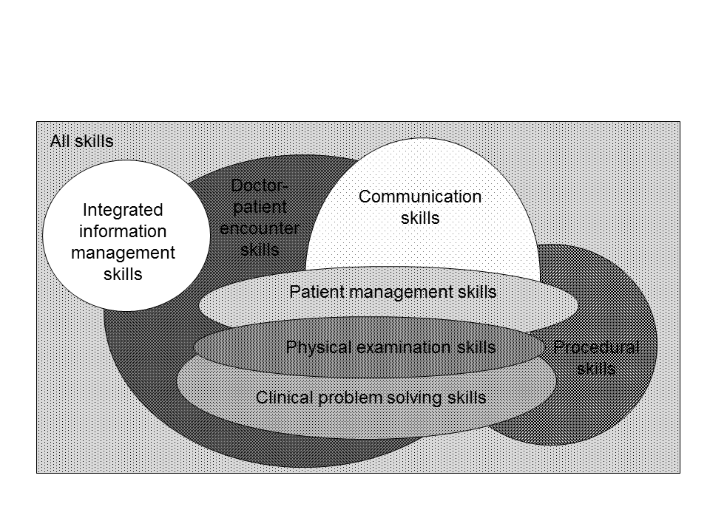
Figure 2: Information streams in the doctor-patient encounter.
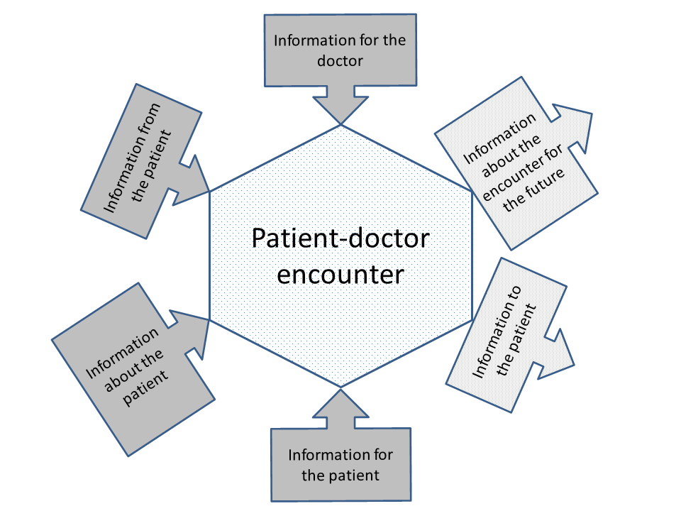

Reference List
1 Kurtz SM, Silverman D, Draper J, et al. Teaching and Learning Communication Skills in Medicine. Oxford: : Radcliffe 2005.
2 Lefroy J, Gay SP, Gibson S, et al. Development and face validation of an instrument to assess and improve clinical consultation skills. Int J Clin Ski 2011;5:115–25.http://scholar.google.com/scholar?hl=en&btnG=Search&q=intitle:Development+and+face+validation+of+an+instrument+to+assess+and+improve+clinical+consultation+skills.#0 (accessed 16 Oct2014).
3 McKinley RK, Strand J, Gray T, et al. Development of a tool to support holistic generic assessment of clinical procedure skills. Med Educ 2008;42:619–27.
4 GMC. Outcomes for graduates. London: 1015. http://www.gmc-uk.org/Outcomes_for_graduates_Jul_15.pdf_61408029.pdf (accessed 13 Feb2017).
5 Heath C. Participation in the medical consultation: the co-ordination of verbal and nonverbal behaviour between the doctor and patient. Sociol Heal Illn 1984;6:311–38. doi:10.1111/1467-9566.ep10491964
6 Dixon-Woods M. Writing wrongs? An analysis of published discourses about the use of patient information leaflets. Soc Sci Med 2001;52:1417–32. doi:10.1016/S0277-9536(00)00247-1
7 GMC. Good medical practice the General Medical Council. 2013;:13–4, 21.
8 Stott NCH, Davis RH. The exceptional potential in each primary care consultation. Br J Gen Pract 1979;29.
9 Henwood F, Wyatt S, Hart A, et al. ‘Ignorance is bliss sometimes’: constraints on the emergence of the ‘informed patient’ in the changing landscapes of health information. Sociol Health Illn 2003;25:589–607.http://onlinelibrary.wiley.com/doi/10.1111/1467-9566.00360/pdf
10 Smith R. What clinical information do doctors need? Br Med J 1996;313:1062–8.
11 Sackett DL, Rosenberg WM, Gray JA, et al. Evidence based medicine: what it is and what it isn’t. Br Med J 1996;312:71–2.
12 Gray JA. Where’s the chief knowledge officer? To manage the most precious resource of all. Br Med J 1998;317:832.
13 Edwards A, Elwyn G, Mulley A. Explaining risks: turning numerical data into meaningful pictures. Br Med J 2002;324:827–30.http://www.bmj.com/content/324/7341/827.1.short
14 McGlynn EA, Asch SM, Adams J, et al. The quality of health care delivered to adults in the United States. N Engl J Med 2003;348:2635–45.
15 Green ML, Ciampi MA, Ellis PJ. Residents’ medical information needs in clinic: are they being met? Am J Med 2000;109:218–23.
16 Slawson DC, Shaughnessy AF. Becoming an information master: using POEMs to change practice with confidence. Patient-Oriented Evidence that Matters. J Fam Pract 2000;49:63–7.http://europepmc.org/abstract/MED/10678341
17 Jones R, Mehta M, McKinley RK. Medical student access to electronic medical records in UK primary care. Educ Prim Care 2011;22:4–6.
18 Green ML, Ruff TR. Why do residents fail to answer their clinical questions? A qualitative study of barriers to practicing evidence-based medicine. Acad Med 2005;80:176–82.
19 Burnett S, Franklin BD, Moorthy K, et al. How reliable are clinical systems in the UK NHS? A study of seven NHS organisations. BMJQualSaf 2012.

