**Abstract Title**

The co-administration of anticancer and pro-apoptotic agents as novel approach in liver cancer therapy

**Abstract (main text)**

**INTRODUCTION**

Malignant hepatoma, also known as Hepatocellular carcinoma accounts 85% for liver cancers that originate in liver cells, this type of tumour is characterised by defective or ineffective apoptosis which is considered to be the main cause of cancer progression. Cytochrome-C (heme protein) triggers mitochondrial apoptosis and is responsible to activate the downstream caspase apoptosis pathway during cell death in the tumour cells. However, there is a significant difficulty in the delivery of proteins through the cell membrane. Iron-gold hybrid nanoparticles (HNP-C) application offers a promising tool for cytochrome-c delivery into tumour cells and enhances the specific targeting of therapeutic particles to their site of action.

**METHODS**

DNA damage drugs (doxorubicin, oxaliplatin) and anti-microtubule drugs (paclitaxel, vinblastine and vincristine) with different mechanisms of action were used to treat HepG2 cell line at specific concentrations to assess their IC50 values as single drug treatment , subsequently the cells were treated with combination of these drugs with HNP-Cytochrome C showing a 10% growth inhibition alone in HepG2 cells. Cell viability tests were performed by (MTT, cell counting (trypan blue)) accompanied by caspase -3 colorimetric method and western blot for apoptosis detection steps.

**RESULTS**

The results of MTT assay showed a significant decrease in cell viability with combination therapy comparing to each drugs alone.as illustrated in Figure1.

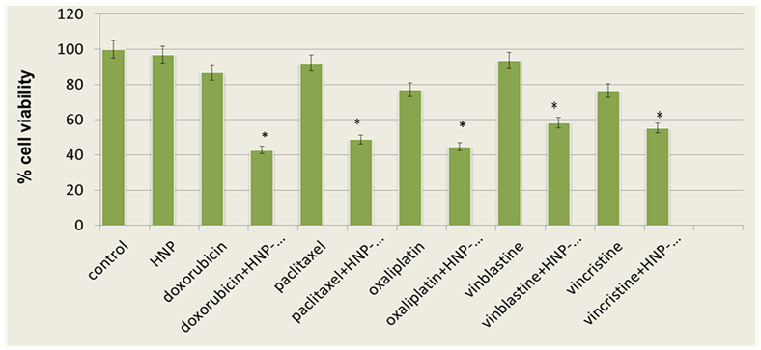

**Figure 1: MTT viability results in HepG2**

The trypan blue method is also used to detect the effect of our combination by targeting the other way of counting dead cells and detect the viability as the percentage of control. The numbers of the dead staining cells are remarkably increase with HNP-C and chemotherapeutic treated cells after 48 and 72hr incubation period and statically significant results were resulted comparing to single drug treatment.

Apoptosis assays are used to detect the different stages of apoptosis as well as the percentage of killing cells by measuring the caspase enzyme as the early detection of programmed cell death using abcam colorimetric method and detecting the enzyme colouring reaction at 405nm by microplate reader. And the following steps of apoptosis detection is the protein immunoblot method (western blot) to identify the bands of cleavage PARP-1 protein as the main marker of apoptosis in treated cells. As shown in figure 2 detective mark bands were noticed with combination therapy treatment with no noticeable band under the single drugs treatment.

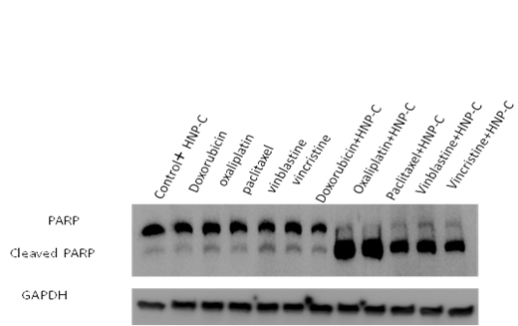

**Figure 2: cleavage PARP-1 bands in HepG2 cell line by western blot.**

**CONCLUSION**

The successful delivery of pro-apoptotic protein (cytochrome-C) using hybrid iron-oxide gold nanoparticles can be considered as a promising step in the liver cancer treatment by working in synergism pattern with anticancer drugs and targeting the apoptotic signal in each drug mechanism pathway.