Acute phase response signalling is altered following cartilage harvest in non-responders to Autologous Chondrocyte Implantation
Charlotte H Hulme^{1,2}, Emma Wilson^{2,3}, Heidi R Fuller¹, Sally Roberts^{1,2}, James B. Richardson^{1,2}, Pete Gallacher^{1,2}, Mandy J. Peffers⁴, Sally L Shirran⁵, Catherine H. Botting⁵, Karina T Wright^{1,2}
1. Institute of Science and Technology in Medicine, Keele University, Keele, Staffordshire, UK; 2. Robert Jones and Agnes Hunt Orthopaedic Hospital, Oswestry, Shropshire, UK; 3. Chester Medical School, Chester University, Chester, UK; 4. Institute of Ageing and Chronic Disease, University of Liverpool, Liverpool, UK; 5. BSRC Mass Spectrometry and Proteomics Facility, University of St Andrews, North Haugh, Fife, KY16 9ST, UK
Purpose (the aim of the study)
Autologous Chondrocyte Implantation (ACI) has recently been recommended by the National Institute for health and Care Excellence (NICE) as a treatment for knee chondral/osteochondral defects in a specific subset of UK National Health Service patients. For ACI to be recommended on a wider scale, a better understanding of the biological mechanisms underlying ACI success/failure is needed, so as to improve the success rate further.
ACI is a two stage procedure. During initial surgery (Stage I) healthy cartilage is harvested from the joint. Chondrocytes are then extracted and culture expanded for 3-4 weeks in a GMP laboratory before being implanted into the defect site under a periosteal patch or commercial collagen membrane in a second surgery (Stage II). We have previously highlighted that there is a marked response to the cartilage harvest procedure in individuals who do not respond well post-operatively. In this study we have aimed to elucidate the biological pathways that are altered in this response.
Methods
Isobaric tag for relative and absolute quantitation (iTRAQ)-LC-MS/MS was used to assess the proteome of high abundance proteins in pooled synovial fluid (SF) samples from the knees of 14 ACI responders (Stage I, n=8; Stage II, n=12) and 13 ACI non-responders (Stage I, n=7; Stage II, n=12) collected immediately prior to both Stages I and II. ACI response was determined by change in Lysholm score at 12 months (the Lysholm is a scale of 0-100; 100 represents a ‘perfect’ functioning knee); mean improvement was 33 points (range 17-54) and mean worsening was 14 points (range 4-46). This dataset was then combined with our published label-free quantitation (LF) proteomic dataset (1), in which the same SF samples were dynamically compressed to measure low abundance proteins. The combined proteomic profile was assessed using IngenuityTM Pathway Analysis (IPA) software (Qiagen) to identify functional pathways which are associated with the differentially abundant proteins. IPA was used to predict the abundance of proteins in the bodily fluids (plasma is referred to as the ‘standard’ fluid with this tool) when acute phase response signalling is activated.
Results
Assessment of the differential proteome shift identified using IPA in response to cartilage harvest in non-responders showed altered acute phase response signalling when the iTRAQ (p=2.93 x10⁻¹; Fisher’s Exact test) and LF (p= 1.69× 10^{–6}; Fisher’s Exact test) datasets were considered independently. When the proteomic datasets were combined, acute phase response signalling was again significant (p=1.10x10⁻⁹; Fisher’s Exact test), indicating this pathway likely contributes to the non-responder phenotype. Twenty-two of the 39 proteins that were bioinformatically predicted to be increased in the plasma during the acute phase response were more abundant (≥+1.2 fold change (FC)) in the SF at Stage II compared to Stage I (Figure 1). Further, two of the ten proteins that were predicted to be downregulated demonstrated decreased abundance in the SF at Stage II compared to Stage I. Interestingly, only 3 of these proteins (fibrinogen alpha-chain; fibrinogen beta-chain and fibrinogen gamma-chain) were identified by both proteomic techniques, with iTRAQ and LF proteomics highlighting a total of 18 and 6 differentially abundant proteins within the acute phase response signalling pathway, respectively.
Conclusions
Acute phase response signalling has been identified as a functional pathway which is associated with the marked proteome shift that exists in response to cartilage harvest in patients who do not respond well to ACI. Using two independent proteomic techniques has provided a more comprehensive assessment of the proteins within this pathway. The acute phase response is the body’s first systemic reaction to surgery or trauma indicating that clinical non-responders may have a greater/abnormal innate response to cartilage biopsy or cartilage injury initial surgery. In addition, this pathway has been associated with the SF proteome in patients with OA, perhaps suggesting that these patients who do not respond well to ACI have already developed a more ‘OA-like’ phenotype meaning a therapy to repair cartilage injury may be insufficient to treat whole joint disease/failure.

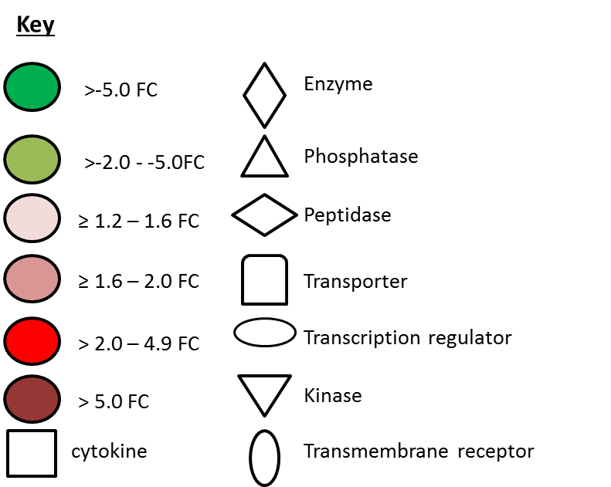
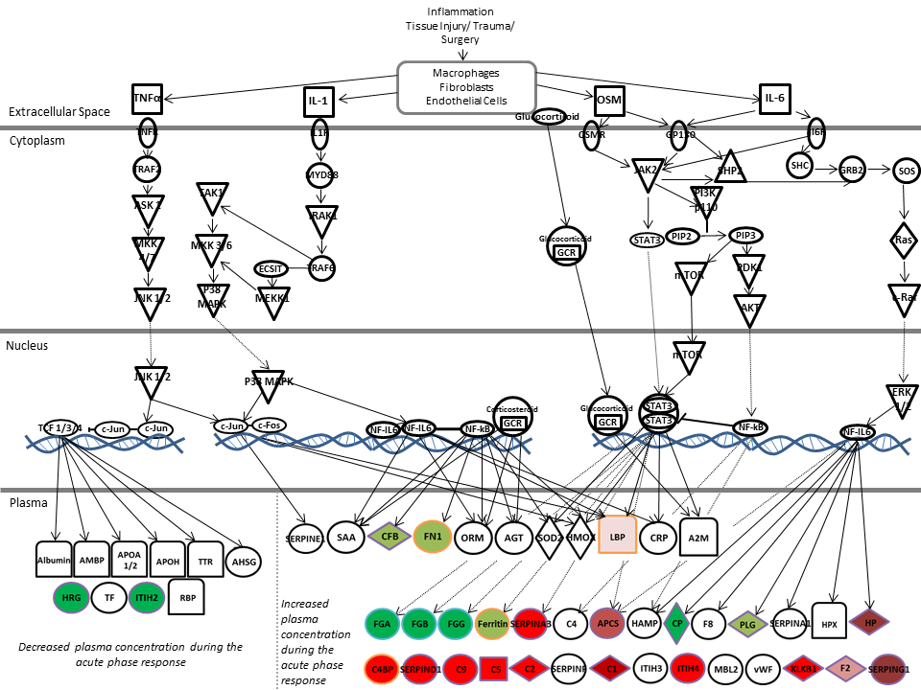

Figure 1: Proteins of Acute Phase Signalling at Stage II compared to Stage I in non-responders to Autologous Chondrocyte Implantation (ACI). Several synovial fluid proteins that are downstream of acute phase response signalling were differentially abundant between Stages I and II of ACI. Proteins edged in purple, orange and blue were identified using iTRAQ LC-MS/MS, LF LC-MS/MS or by both techniques, respectively. (Adapted from Ingenuity).

