Title Page
Title: Factors influencing the implementation of evidence-based guidelines for osteoarthritis in primary care: a systematic review and thematic synthesis
Short running title: Implementation for osteoarthritis
Article type: Systematic review
Order of authors: Laura Swaithes, MA; Zoe Paskins, PhD; Krysia Dziedzic, PhD; Andrew Finney, PhD.
Corresponding Author: Mrs Laura Swaithes, MA
Impact Accelerator Unit, Versus Arthritis Primary Care Centre, School of Primary, Community and Social Care, Keele University, Staffordshire, United Kingdom, ST5 5BG. Tel: 01782 734889
PROSPERO (reference CRD42017079289)
Word count: 3496

Acknowledgements
LS was funded by KD’s National Institute for Health Research fellowship, the NIHR Collaborations for Leadership in Applied Health Research and Care West Midlands, and the European Institute for Innovation and Technology Health. LS is funded by an NIHR School for Primary Care Research (SPCR) Launching Fellowship.
ZP is funded by the NIHR Clinician Scientist Award (CS-2018-18-ST2-010)/NIHR Academy.
KD was part funded by the NIHR Collaborations for Leadership in Applied Health Research and Care West Midlands and by an NIHR Knowledge Mobilisation Research Fellowship (KMRF-2014-03-002). KD is an NIHR Senior Investigator.
The views expressed are those of the authors and not necessarily those of the NHS, the NIHR or the Department of Health and Social Care, European Institute for Innovation and Technology Health.

Source of funding
This work was supported by the National Institute for Health Research, Knowledge Mobilisation Fellowship [KMRF-2014-03-002].

Conflict of interest
The authors declare no conflicts of interest

Contributions
All authors contributed to the conception, design, drafting and final approval of this article. ZP contributed to the data analysis and interpretation.

Accepted for publication on 28th November 2019

Abstract

Objective
Implementation of evidence-based guidelines in primary care is challenging. This systematic review aimed to synthesise qualitative evidence that investigates the factors influencing the implementation of evidence-based guidelines for osteoarthritis in primary care.

Methods
A systematic review of qualitative studies. MEDLINE, EMBASE, CINAHL, HMIC, PsychINFO, Web of Science and Assia were searched (from 2000 to March 2019). The methodological quality of the included studies was assessed by two independent reviewers. Data were analysed and synthesised using thematic synthesis.

Results
1612 articles were screened and four articles with a total of 87 participants (46 patients, 28 GPs, 13 practice nurses) were included. Three of the studies were conducted in England within the context of an implementation trial and one was conducted in the Netherlands. The thematic synthesis revealed three overarching themes. Best practice was not enough to achieve ‘buy-in’ to implementation but a range of tacit motivators to implementation were identified. Healthcare professionals used patient reasons to justify engaging or not engaging with implementation. Engaging with the whole practice was important in achieving implementation. A disconnect between research and ‘real-world’ primary care practice influenced long-term implementation.

Conclusions
Despite the relative paucity of current evidence, this systematic review has identified a series of possible disconnects may impact uptake of interventions to improve osteoarthritis care, existing between clinicians and patients, researchers and clinicians, clinicians and guidelines and within general practice itself. There remains a need to further explore the experiences of key stakeholders, including patients involved in implementation for osteoarthritis in primary care.

Keywords
Implementation, osteoarthritis, OA, guidelines, systematic review, primary care, qualitative

Introduction
An array of international guidelines and recommendations that reflect the consistent body of evidence for best practice and the recommended management of osteoarthritis (OA) exist (1-6). Despite the publication of such guidelines, evidence suggests that the core approaches for managing OA are underutilised and that the quality of care for adults with OA is inconsistent (7, 8). This is compounded by the fact that the implementation of guidelines in a complex setting such as primary care, is challenging for researchers, clinicians, patients and the public, commissioners and managers.
The underutilisation of recommended strategies to prevent and treat OA has resulted in international efforts to develop and implement models of care that focus on non-surgical, evidence-based management of OA (9). These models of OA care are, by nature, complex interventions which require change at multiple levels including individual, organisational and systems level (10). The complexity associated with implementation of research evidence in the form of complex interventions in clinical practice is well recognised (11, 12). Uncertainty exists regarding the factors influencing the implementation and the practical application of these models of care in clinical settings.
Research exploring the process of implementing evidence-based guidelines is required to provide insights into the practical, real-world issues encountered and to develop targeted implementation strategies (9). Previous evidence syntheses have described clinicians’ views of the barriers and enablers of the management of OA (13) and factors affecting implementation more broadly across a range of conditions in primary care (12). The perceived barriers to implementation of best practice guidelines for OA across hospital and community settings have also been explored (14), however, to date, no study has synthesised the experiences of implementing evidence-based guidelines for OA in primary care. A comprehensive understanding of the experienced barriers and enablers to guideline implementation for OA in primary care is therefore required. This review aims to identify, appraise and synthesise available qualitative evidence that investigates the implementation of evidence-based guidelines for OA in primary care.

Method
This systematic review used a thematic synthesis approach based on the principles of Thomas and Harden (2008). No a priori theoretical assumptions were made prior to the conduct of this work because firstly, thematic synthesis typically adopts an inductive approach whereby data extraction and analysis are data-driven, and secondly, it was decided that this may be too restrictive for the exploratory and interpretative nature of the work (15). The review was registered with PROSPERO (reference CRD42017079289, October 2017). Reporting for this systematic review is guided by the Preferred Reporting Items for Systematic Reviews and Meta-Analysis (PRISMA) checklist (16).

Search strategy
Seven electronic bibliographic databases (MEDLINE, EMBASE, CINAHL, HMIC, PsychINFO, Web of Science and Assia) were searched using a structured search strategy to identify articles published between 2000 and March 2019 (see Additional file 1 for the MEDLINE search strategy). All reference lists of included articles were checked.

Study selection
Table 1 describes the eligibility criteria for this review which were defined prior to undertaking the search (17). One author conducted title screening (LS) and two authors conducted abstract screening (LS and ZP). An overly inclusive approach until progression to the full-text screening stage was adopted in light of the challenges in identifying qualitative data in implementation studies (18). Each of the full text articles were screened by two reviewers (LS and ZP or AF). Any discrepancies were resolved with a fourth reviewer (KD). This process yielded a final set of articles for quality assessment and thematic synthesis phases.

Quality assessment
Articles were not excluded or weighted based on quality due to the risk of losing insightful findings or concepts (19, 20). An 11-point list of quality assessment criteria was used, derived and informed by the Critical Appraisal Skills Programme (CASP) checklist (21), with one additional question from Harden et al (2009) to evaluate description of contextual factors (22). Two reviewers (LS and AF) independently assessed the methodological quality of the selected studies. Discrepancies were resolved with a third reviewer (ZP).

Data analysis and synthesis
All text labelled as ‘results’ or ‘findings’ were imported into NVivo. Data analysis and synthesis were conducted according to the three-stage thematic synthesis approach advocated by Thomas and Harden (15). The three stages were overlapping and iterative and not distinct, linear phases. First, inductive line by line coding was undertaken (LS) to gain insight into the underpinning meaning and concepts within the data. Independent coding was undertaken for two of the studies by the second reviewer (ZP). All text and codes were reviewed with the whole study team to examine interpretations and check for consistency. Second, descriptive codes were reviewed for similarities and differences and organised into similar descriptive themes. An iterative process of refining emerging ideas and expanding on developing concepts took place. Codes were renamed, merged, and removed to capture the meaning of each potential theme and a draft narrative summary produced. Due to the descriptive nature of this stage, the descriptive themes remained close to the results of the primary studies. Third, analytic themes were generated. The implications of each descriptive theme were considered and discussed iteratively and conceptually similar themes were associated with one another (23). By comparing and contrasting the descriptive themes, more analytic themes were developed. A cyclical, iterative process took place, considering the analytic themes in light of the review objective, until the analytic themes were found to describe and/or explain the descriptive themes. An agreement was gained on the final ‘analytical’ themes for inclusion in the synthesis.

Results

Included studies
The searches identified 1612 titles, leaving 1175 after de-duplication. Four articles that were eligible for inclusion in the review (24-27). The review process is demonstrated in Figure 1.

Study characteristics
The characteristics of the included studies are shown in Table 2. The included studies were conducted as part of larger implementation research studies. Three of the four studies were conducted in England (24, 25, 27) as part of the Managing OA in Consultations (MOSAICS) study (28). The fourth study (26), from the Netherlands, explored the implementation of an OA self-management booklet as part of the Beating OA (BART) study.
The studies used semi-structured interviews, (24, 26, 27), group interviews (25), and observations of meetings between researchers and general practices (24, 25) to explore the experiences of implementation. Participants in the included studies were patients (n=46), GPs (n=28) and practice nurses (n=13).

Quality appraisal
The results from the quality appraisal are presented in Table 3. In terms of context, each article referred to a separate publication for details of the research context as they were all conducted as part of larger implementation research trials. It was unclear if the same sample was used in two of the included studies (24, 27). Frequently, studies were considered to have insufficient detail regarding researcher reflexivity and to establish if data saturation was reached (24, 25, 27). In three studies characteristics of non-responders were not discussed. In the one study that did describe characteristics of non-responders, there was limited discussion of the effect of any differences on the findings (26). With regards to data collection, it was unclear in two of the studies how the interview guide or observation schedule were developed (25, 27).

Thematic synthesis
Three overarching themes were identified from 7 descriptive themes: alignment between best practice, healthcare professional views and patient views; the importance of implementation researchers engaging with the whole practice; and, a disconnect between research and the ‘real-world’. An overview of the thematic synthesis process is shown in Figure 2.

Alignment between best practice, healthcare professional views, and patient views
The findings illustrate best practice was not enough to ensure buy-in to implementation. The studies that explored the experiences of HCPs (24, 25, 27) reported engagement with implementation to enhance the consistency and provision of quality care by offering healthcare professionals (HCPs) more treatment options for managing people with OA. Despite innovations being grounded in evidence-based guidelines, this was rarely the reason stated for HCP or patient engagement.
Tacit or more personalised motivators that optimised HCPs’ engagement with implementation were implied by GPs. For example, patient ‘disposal’ in the consultation, by way of referring to a practice nurse or placing the responsibility of self-management with the patient to inadvertently free up consultation time.
Being able to offer the guidebook and refer on to see the nurse was seen as a “natural” way of ending the consultation smoothly and minimising the risk of aggravating patients who may feel that they should get more from the GP. (24)
Whereas practice nurses saw the implementation of the evidence-based innovation as a foundation for future consultations and a platform for discussing treatment options, which aligned with their desire to increase professional autonomy (24, 27). The following quote illustrates the notion of shifting responsibility.
GPs also thought that consultations could ‘empower’ patients to look after their own condition. The guidebook was depicted as a tool to help this process: ‘Your book, your thing, I want you to read it all. I want you to bring any questions.’ (GP 4), (24)
HCP and patient preferences (or perceived patient preferences) for self-management also influenced implementation. Despite self-management being aligned with best practice, barriers to achieving ‘buy-in’ of implementation were related to the fundamental differences in how HCPs define their role in patient self-management. For example, some HCPs questioned whether self-management was of value for OA, and, whether it was their role to advocate and implement it. If the HCP had little interest in the value of the innovation, then they were less likely to prioritise it within their practice, endorse it to patients or attempt to try and convince or ‘sell’ the importance of active self-management (24, 25, 27).
Two of the studies investigated patient experiences of implementation (26, 27). A range of values, beliefs, and expectations of OA management were highlighted and patient preferences for participation in the consultation and role in supporting their self-management influenced the process (26). The ‘encouragement’ of health care providers with self-management approaches was reportedly a facilitator in one study (26). The extent to which the patient preferences inferred by HCPs were based on experience or beliefs and whether HCPs views were concordant with their patients’ views was not evaluated.
HCPs used patient reasons to justify positive and negative patient preferences for implementing the interventions. For example, in the study by Morden et al (24) (that did not include patient data) HCPs discuss patients whom they perceive to have a ‘fixed agenda' and show how HCPs believed that by offering a self-management approach, patients would feel as though they were ‘being delayed in their quest to see a specialist’. In contrast, in the same study, participants reported the opposite view that the intervention would put an end to the feeling of being ‘fobbed off’:
A third way in which GPs thought patients gained was from a sense of being taken seriously, or being made a “special” case by being referred to the nurse clinic and were not being “fobbed off” as one GP put it (24)
There was no patient data from the study by Morden et al (24) to examine patient preferences. However, in the study by Cuperus et al, where patients were also given a guide book as part of the intervention (26) there was no evidence to support the fact that patients either felt ‘special’ or ‘fobbed off’ as a result of implementing the intervention. Several patients in the study did however report feeling that their OA would deteriorate because they believed that OA was not a treatable condition. This facilitated engagement with implementation for some patients and impeded it for others.

The importance of implementation researchers engaging with the whole practice
Engagement between implementation researchers and the whole general practice organisation was important as it enabled implementers to be cognisant of potential drivers and motivators for implementation in primary care and to provide ‘ongoing support’ to practices (25). For example, the way in which practices were rewarded and incentivised for meeting Quality and Outcomes Framework (QOF) targets, significantly affected their prioritisation of workload and desire to implement best practice for a condition that produced no financial gain.
GP2: I think that would be the case really because of the QOF work load and the way in which GPs are rewarded for monitoring chronic disease and also the importance of trying to get tight glycemic control and monitoring in place for diabetics I think that we would prioritise diabetic care and try and get that optimised before we would cast our gaze towards osteoarthritis. (24)
Furthermore, whole practice engagement appeared to enable a detailed understanding of the practice context including power relations and decision makers within a practice which had the potential to impact the long-term implementation of an innovation (24, 25).
Nurses thought that they had little say in the decision whether to continue with the clinics beyond the study. As one nurse put it “the GPs are in charge” (24)
The interpretation of the roles within the practice became clear in this meeting in which the GPs controlled the decision that the content of the intervention fitted with their current approach; the lead nurse followed the GPs' lead and took charge of sorting the nurse clinics and indemnity, while the practice manager took responsibility for the financial aspects (25)
Practice nurse attendance and engagement in meetings and training was considered sub-optimal in one paper (25) and it was unclear whether this was due to patient demand and pressures on staffing and clinics or due to the potential hierarchy within the practice in terms of power and leadership. Subsequently, the input required from the nurses for implementation was reported to ‘come as a shock’ because the nurses were not in the initial planning meeting even though they would be expected to implement the innovation.

A disconnect between research and the ‘real-world'
Participants in one study were engaged in the trial but reported unlikely to adopt the innovation long-term due to the reality of ‘what was practical and acceptable to take forward within the broader context of Primary Care’ (24). One explanation for this was that the long-term routinisation and sustainability of implementation were impacted if relevant outcome measures were not captured and communicated to stakeholders.
In the intervention practices no formal, structured collective process for collecting information, reviewing or reflecting on the intervention appeared to exist (24)
This resulted in some individuals and practices reporting limited motivators to continue implementing the innovation. Hence, a barrier to implementation for OA was the prioritisation of other policy drivers, for example, the QOF. Participants described the scenario of sustained implementation of the innovation by accident, whereby they had absorbed elements of the training implicitly (24).
In the studies that were conducted during a trial (24, 25, 27), it was evident that systems-level evaluation could not take place before completion of the trial due to the protocolised nature. Therefore, the researchers were bound by a requirement to evaluate the trial before the ‘next-step’ of real-world implementation could be addressed. Despite this, individual level evaluation was ongoing throughout the whole process.

Discussion
This systematic review addressed an important area of implementation research to synthesise qualitative evidence that investigates the factors influencing the implementation of evidence-based guidelines for OA in primary care. Whilst there was a paucity of studies that met the inclusion criteria of this review, four studies were included in the synthesis and highlighted three overarching themes. These were: the alignment between best practice, HCP views and patient views; the importance of implementation researchers engaging with the whole practice, and, a disconnect between research and the real-world.
The findings of this review highlights that, within primary care, a series of possible disconnects may impact uptake of interventions to improve OA care; these disconnects exist between HCPs views and what is recommended best-practice, HCPs and patients, researchers and clinicians and within general practice itself. Tacit, or more personalised motivators for implementation were identified which illustrate the importance of understanding personal and practice-based drivers.
It is not surprising that best practice was considered insufficient in driving implementation. Egerton et al (2016) (13) and many others have reported the perception that ‘OA is not that serious’ and that ‘personal beliefs are at odds with providing recommended practice’. A body of literature suggests that OA is a low priority to both HCPs and patients, and, that HCPs’ personal beliefs do not always align with recommended guidelines (13, 29-32). In addition, findings illustrated how self-management was not viewed as core business by some GPs and because the condition didn’t align to pay-for-performance targets, and implementation was reported not to provide any benefits to the practice.
The findings suggest there may be a discordance between provider and patient perceptions and preferences for OA care, although more patient evidence to confirm or refute this is needed. Whilst within this review there were no data to support or refute the idea that patients either felt ‘special’ or ‘fobbed off’ by way of referral to a self-management intervention, a narrative review by Paskins et al (32) found that patients reported feeling like they have ‘not been taken seriously’ when consulting for OA and a questionnaire survey by Cotterell et al (33) found that 36% of GPs (n=291) reported the perception that patients prefer alternative treatment options to exercise. More patient-related evidence demonstrating a need for self-management support, may be needed to achieve successful ‘buy-in’ of the intended users of research and potentially challenge HCP perceptions of patient preferences.
In this review, whole practice involvement was shown to impact implementation, in order to understand the context within an organisation and to be cognisant of factors that influence implementation. The prioritisation of other policy drivers has been reported as barriers to implementation in a process evaluation of implementing a self-management support approach by Kennedy al (34). Identifying potential barriers early in the process may enable implementers to circumnavigate such barriers to optimise implementation. Furthermore, a large systematic review of systematic reviews exploring the barriers and facilitators to implementation across a range of conditions in primary care (12) identified the importance of understanding contextual organisational drivers but that research in this area was lacking. This review demonstrates that in OA management, important contextual factors are practice priorities and hierarchy, including practice-decision makers and communication between researchers and practice staff. Similarly, in a study evaluating clinical practice guideline uptake in OA and RA, Linekar et al (2009) (35) found interprofessional learning and networking were beneficial for successful implementation in primary care. This was due to the opportunities associated with team learning and linking with peers and specialists to discuss resources and guidelines and improve collaborative care.
The findings of this review illustrate the challenges of researching implementation in trial conditions whereby the relevance and reality of what happens in practice may not be captured (36). Kennedy et al (2014) (37) also reported that engagement from the trial did not translate into everyday practice when participants in one study were engaged in the trial but reported unlikely to adopt the innovation long-term (24). Tooth et al (1998) (38) in a study for low back pain, reported that participants may view research as peripheral to their current practice and lack motivation towards engaging in implementation. Findings suggest that some practices involved in two of the studies (24, 25) could not or did not evaluate implementation and there was some suggestion the intervention did not fully work for their context. Co-production and early engagement between implementation researchers and clinical practice (including HCPs, patients, managers and commissioners) may be a strategy to overcome these issues by transcending organisational and professional boundaries to illuminate insights and maximise the potential for successful implementation through collaborative partnerships (39).
This review employed rigorous methods that included following published guidance on the conduct of thematic synthesis (15). Two reviewers undertook quality assessment and the thematic synthesis which enabled inter-researcher differences to be examined, yielded new insights, made connections between data clearer, and increased the transparency and trustworthiness of the synthesis. A limitation of this systematic review is the paucity of qualitative studies directly examining the implementation of evidence-based guidelines for OA in primary care. The search identified conference abstracts of relevance which suggests that more evidence will be emerging and reported from other evaluations. Three of the four studies included in this review were conducted in the context of the MOSAICS study, of which KD led and AF and ZP contributed to. However, analysis was primarily conducted by LS (not part of the MOSAICS team) to mediate this. Furthermore, an inherent limitation of this type of synthesis is that themes are dependent on the primary data and research questions. As two of the four studies utilised normalisation process theory and were considering how the intervention was embedded (24, 25), this will have influenced the sustainability of the intervention emerging as an analytical theme (disconnect between research and the ‘real-world').
Despite the relative paucity of current evidence, this systematic review has identified a number of factors that influence implementation of OA guidelines, related to a series of possible discordant views between HCPs, guidelines, patients and researchers. The findings suggest that uptake of interventions might be enhanced by appealing to tacit motivators, by ensuring whole practice engagement in implementation activity, and reinforce the notion that co-production of interventions is important to ensure relevance and promote sustainability. The findings highlight the importance of ensuring that evaluations of implementation activity involve patient and HCPs together; further research is needed to explore the potential discordance between patient and practitioner views of interventions to optimise OA care, and strategies to best overcome this discordance to promote implementation.

References
1. NICE. Osteoarthritis care and management in adults. London: National Institute for Health & Clinical Excellence 2014.
2. Hochberg MC, Altman RD, April KT, Benkhalti M, Guyatt G, McGowan J, et al. American College of Rheumatology 2012 recommendations for the use of nonpharmacologic and pharmacologic therapies in osteoarthritis of the hand, hip, and knee. Arthritis care & research. 2012;64(4):465-74.
3. Jordan K, Arden N, Doherty M, Bannwarth B, Bijlsma J, Dieppe P, et al. EULAR Recommendations 2003: an evidence based approach to the management of knee osteoarthritis: Report of a Task Force of the Standing Committee for International Clinical Studies Including Therapeutic Trials (ESCISIT). Annals of the rheumatic diseases. 2003;62(12):1145-55.
4. Zhang W, Doherty M, Arden N, Bannwarth B, Bijlsma J, Gunther K-P, et al. EULAR evidence based recommendations for the management of hip osteoarthritis: report of a task force of the EULAR Standing Committee for International Clinical Studies Including Therapeutics (ESCISIT). Annals of the rheumatic diseases. 2005;64(5):669-81.
5. Zhang W, Doherty M, Leeb B, Alekseeva L, Arden N, Bijlsma J, et al. EULAR evidence based recommendations for the management of hand osteoarthritis: report of a Task Force of the EULAR Standing Committee for International Clinical Studies Including Therapeutics (ESCISIT). Annals of the rheumatic diseases. 2007;66(3):377-88.
6. Zhang W, Moskowitz R, Nuki G, Abramson S, Altman R, Arden N, et al. OARSI recommendations for the management of hip and knee osteoarthritis, Part II: OARSI evidence-based, expert consensus guidelines. Osteoarthritis and cartilage. 2008;16(2):137-62.
7. Porcheret M, Jordan K, Croft P. Treatment of knee pain in older adults in primary care: development of an evidence-based model of care. Rheumatology. 2006;46(4):638-48.
8. Porcheret M, Jordan K, Jinks C. Primary care treatment of knee pain—a survey in older adults. Rheumatology. 2007;46(11):1694-700.
9. Allen KD, Choong PF, Davis AM, Dowsey MM, Dziedzic KS, Emery C, et al. Osteoarthritis: models for appropriate care across the disease continuum. Best practice & research Clinical rheumatology. 2016;30(3):503-35.
10. Craig P, Dieppe P, Macintyre S, Michie S, Nazareth I, Petticrew M. Developing and evaluating complex interventions: the new Medical Research Council guidance. BMJ: British Medical Journal. 2008;337.
11. Morris ZS, Wooding S, Grant J. The answer is 17 years, what is the question: understanding time lags in translational research. Journal of the Royal Society of Medicine. 2011;104(12):510-20.
12. Lau R, Stevenson F, Ong BN, Dziedzic K, Treweek S, Eldridge S, et al. Achieving change in primary care—causes of the evidence to practice gap: systematic reviews of reviews. Implementation Science. 2016;11(1):1.
13. Egerton T, Diamond L, Buchbinder R, Bennell K, Slade S. A systematic review and evidence synthesis of qualitative studies to identify primary care clinicians’ barriers and enablers to the management of osteoarthritis. Osteoarthritis and Cartilage. 2016.
14. Brand C, Cox S. Systems for implementing best practice for a chronic disease: management of osteoarthritis of the hip and knee. Internal medicine journal. 2006;36(3):170-9.
15. Thomas J, Harden A. Methods for the thematic synthesis of qualitative research in systematic reviews. BMC medical research methodology. 2008;8(1):45.
16. Moher D, Liberati A, Tetzlaff J, Altman DG. Preferred reporting items for systematic reviews and meta-analyses: the PRISMA statement. Annals of internal medicine. 2009;151(4):264-9.
17. Higgins JP, Green S. Cochrane handbook for systematic reviews of interventions: Wiley Online Library; 2008.
18. Popay J, Roberts H, Sowden A, Petticrew M, Arai L, Rodgers M, et al. Guidance on the conduct of narrative synthesis in systematic reviews. A product from the ESRC methods programme Version. 2006;1:b92.
19. Dixon-Woods M, Agarwal S, Jones D, Young B, Sutton A. Synthesising qualitative and quantitative evidence: a review of possible methods. Journal of health services research & policy. 2005;10(1):45-53B.
20. Gough D, Oliver S, Thomas J. An introduction to systematic reviews: Sage; 2017.
21. CASP. 10 questions to help you make sense of qualitative research. In: Unit PhR, editor. England2006.
22. Harden A, Brunton G, Fletcher A, Oakley A. Teenage pregnancy and social disadvantage: systematic review integrating controlled trials and qualitative studies. Bmj. 2009;339:b4254.
23. Gough D, Thomas J, Oliver S. Clarifying differences between review designs and methods. Systematic reviews. 2012;1(1):28.
24. Morden A, Brooks L, Jinks C, Porcheret M, Ong BN, Dziedzic K. Research “push”, long term-change, and general practice. Journal of health organization and management. 2015;29(7):798-821.
25. Ong BN, Morden A, Brooks L, Porcheret M, Edwards JJ, Sanders T, et al. Changing policy and practice: making sense of national guidelines for osteoarthritis. Social Science & Medicine. 2014;106:101-9.
26. Cuperus N, Smink AJ, Bierma-Zeinstra SM, Dekker J, Schers HJ, de Boer F, et al. Patient reported barriers and facilitators to using a self-management booklet for hip and knee osteoarthritis in primary care: results of a qualitative interview study. BMC family practice. 2013;14(1):181.
27. Morden A, Jinks C, Ong BN, Porcheret M, Dziedzic KS. Acceptability of a ‘guidebook’for the management of Osteoarthritis: a qualitative study of patient and clinician’s perspectives. BMC musculoskeletal disorders. 2014;15(1):1.
28. Dziedzic KS, Healey EL, Porcheret M, Ong BN, Main CJ, Jordan KP, et al. Implementing the NICE osteoarthritis guidelines: a mixed methods study and cluster randomised trial of a model osteoarthritis consultation in primary care-the Management of OsteoArthritis In Consultations (MOSAICS) study protocol. Implementation Science. 2014;9(1):1.
29. Thomas MJ, Moore A, Roddy E, Peat G. “Somebody to say ‘come on we can sort this’”: a qualitative study of primary care consultation among older adults with symptomatic foot osteoarthritis. Arthritis care & research. 2013;65(12):2051-5.
30. Jinks C, Ong BN, Richardson J. A mixed methods study to investigate needs assessment for knee pain and disability: population and individual perspectives. BMC musculoskeletal disorders. 2007;8:59.
31. Paskins Z, Sanders T, Hassell AB. What influences patients with osteoarthritis to consult their GP about their symptoms? A narrative review. BMC family practice. 2013;14:195.
32. Paskins Z, Sanders T, Hassell AB. Comparison of patient experiences of the osteoarthritis consultation with GP attitudes and beliefs to OA: a narrative review. BMC family practice. 2014;15:46.
33. Cottrell E, Foster NE, Porcheret M, Rathod T, Roddy E. GPs' attitudes, beliefs and behaviours regarding exercise for chronic knee pain: a questionnaire survey. BMJ open. 2017;7(6):e014999.
34. Kennedy A, Chew-Graham C, Blakeman T, Bowen A, Gardner C, Protheroe J, et al. Delivering the WISE (Whole Systems Informing Self-Management Engagement) training package in primary care: learning from formative evaluation. Implementation Science. 2010;5(1):7.
35. Lineker SC, Bell MJ, Boyle J, Badley EM, Flakstad L, Fleming J, et al. Implementing arthritis clinical practice guidelines in primary care. Medical teacher. 2009;31(3):230-7.
36. Proctor EK, Rosen A. From knowledge production to implementation: Research challenges and imperatives. Research on Social Work Practice. 2008;18(4):285-91.
37. Kennedy A, Rogers A, Chew-Graham C, Blakeman T, Bowen R, Gardner C, et al. Implementation of a self-management support approach (WISE) across a health system: a process evaluation explaining what did and did not work for organisations, clinicians and patients. Implementation Science. 2014;9(1):129.
38. Tooth S, Ong B, Foster N, editors. Using a conceptual framework to study the introduction of a new approach to the assessment and treatment of low back pain in primary care. International Forum X for Low Back Pain Research in Primary Care 0606 09; Boston, USA; 1998.
39. Martin S. Co-production of social research: strategies for engaged scholarship. Public Money & Management. 2010;30(4):211-8.

Tables and figures
Table 1 Criteria for including studies in the review
 | Inclusions
Population | Primary care clinicians applying, or primary care patients receiving osteoarthritis guidelines, recommendations, or evidence-based practice
Experience | The context of implementation (from the patient or healthcare professional perspective) of established evidence-based intervention  Studies published in the English language
Outcome of interest | Actual or experienced barriers, facilitators, influential factors
Setting | Primary care/general practice
Study design | Qualitative empirical studies
 | Exclusions
Population | Patients with low back pain, arthritis of the spine
Experience | Management or treatment of osteoarthritis  Development of an intervention  Intervention/innovation not informed by evidence-based guidelines or recommendations  Studies not published in the English language
Outcome of interest | Anticipated, perceived, predicted or expected barriers, facilitators, influential factors
Setting | Secondary care
Study design | Qualitative component included as an appendix or additional file, as such that qualitative methods and reporting are NOT the primary focus  Quantitative reporting of findings  Systematic reviews  Abstracts or conference proceedings

Table 2 Study characteristics
 | Morden et al (24) | Ong et al (25) | Cuperus et al (26) | Morden et al (27)
Country | England | England | Netherlands | England
Participants | 9 GPs  4 practice nurses | 10 GPs  5 practice nurses | 17 patients | 29 patients  9 GPs  4 Practice nurses
Research Question/aim | To explore clinicians’ experiences and perceptions of the MOSIACS trial and to explicate how and why they selectively continued with components of a new model of care beyond the trial’s lifespan | How do English General Practitioners and practice nurses make sense of a complex intervention for the management of osteoarthritis | To evaluate the implementation of a booklet (Care for Osteoarthritis) | To evaluate the acceptability and usefulness of an OA guidebook as part of a complex intervention to deliver NICE OA guidelines in General Practice
Methods | Semi-structured interviews and observations | Group interviews and observations | Semi-structured interviews | Semi-structured interviews
Underpinning theory | Normalisation Process Theory (NPT) | Normalisation Process Theory (NPT)  Macro- meso-micro approach | Integrated Change Model | Principles of Grounded Theory

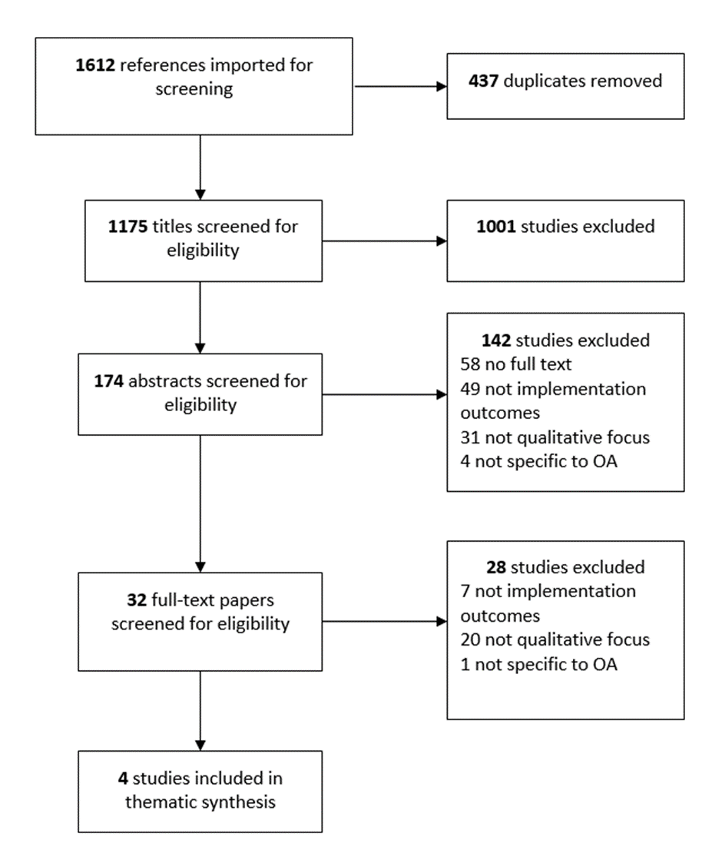
Figure 1 Flowchart documenting the study selection process for the review

Table 3 Quality appraisal of the four included studies
 | Cuperus  2013 | Morden  2014 | Ong  2014 | Morden  2015 | Areas of  uncertainty
1. Was there a clear statement of the aims and objectives of the research? | Y | Y | ?³ | Y | ³Aims and objectives not explicitly stated
2. Was there an adequate description of the context in which the research was conducted? | ?¹ | Y | Y | Y | ¹Limited description of the context of research
3. Is a qualitative methodology appropriate to address the aims and objectives of the research? | Y | Y | Y | Y
4. Was the research design clearly described? | Y | ?² | ?³ | Y | ²Unclear how observation schedule derived  ³No description of interview questions and how derived
5. Was the recruitment strategy and sample clearly described? | ?¹ | ?² | ?³ | ?⁴ | ^{1, 3}Limited information about the sample characteristics  ^{2,4}Small sample of nurses
6. Were the data collection methods clearly described? | Y | ?² | ?³ | ?⁴ | ^{2,3,4}No mention of steps taken to confirm data saturation  ²Unclear how observation schedule derived  ³Limited information about data collection methods
7. Has researcher reflexivity been adequately considered? | Y | ?² | ?³ | ?⁴ | ^{2,3,4}No mention of researcher reflexivity
8. Have ethical issues been taken into consideration? | Y | Y | Y | Y
9. Was the data analysis sufficiently rigorous? | Y | Y | ?³ | Y | ³Little information provided on data analysis methods
10. Is there a clear statement of findings? | Y | Y | Y | Y
11. How valuable is the research? | Y | Y | Y | Y

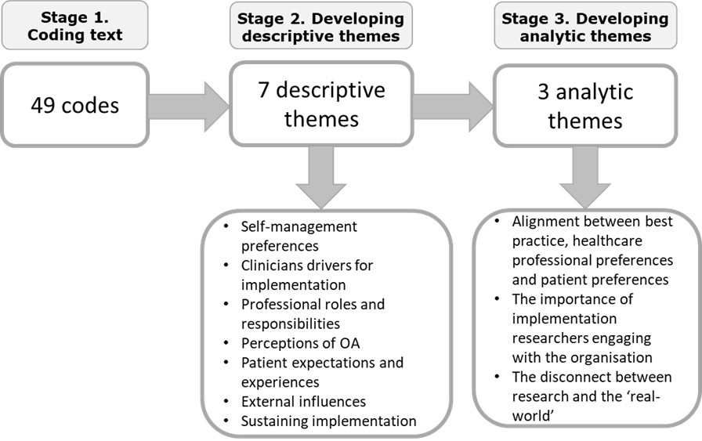
Figure 2 Thematic synthesis process flowchart

