Title: Incidence and mortality due to thromboembolic events during the COVID-19 pandemic: Multi-sourced population-based health records cohort study.

Authors:
Suleman Aktaa, Jianhua Wu, Ramesh Nadarajah, Muhammad Rashid, Mark de Belder, John Deanfield, Mamas A Mamas, Chris P Gale

Supplement Table 1. ICD-10 codes for thromboembolic events.
Arterial TE | Venous TE | DVT | PE
- I63.0 Cerebral infarction due to thrombosis of precerebral arteries  - I63.1 Cerebral infarction due to embolism of precerebral arteries  - I63.2 Cerebral infarction due to unspecified occlusion or stenosis of precerebral arteries  - I63.3 Cerebral infarction due to thrombosis of cerebral arteries  - I63.4 Cerebral infarction due to embolism of cerebral arteries  - I63.5 Cerebral infarction due to unspecified occlusion or stenosis of cerebral arteries  - I63.6 Cerebral infarction due to cerebral venous thrombosis, nonpyogenic  - I63.8 Other cerebral infarction  - I63.9 Cerebral infarction, unspecified  - I64 Stroke, not specified as haemorrhage or infarction  - I65.1 Occlusion and stenosis of basilar artery  - I65.2 Occlusion and stenosis of carotid artery  - I65.8 Occlusion and stenosis of other precerebral arteries  - I66.1 Occlusion and stenosis of anterior cerebral artery  - I66.8 Occlusion and stenosis of other cerebral arteries  - I66.9 Occlusion and stenosis of unspecified cerebral artery  - I74 Arterial embolism and thrombosis  - I74.01 Saddle embolus of abdominal aorta  - I74.09 Other arterial embolism and thrombosis of abdominal aorta  - I74.10 Embolism and thrombosis of unspecified parts of aorta  - I76 Septic arterial embolism  - G459 Transient cerebral ischemic attack, unspecified  - K55.059 Acute (reversible) ischemia of intestine, part and extent unspecified  - N28.0 Ischemia and infarction of kidney  - K55.039 Acute (reversible) ischemia of large intestine, extent unspecified  - H34.9 Unspecified retinal vascular occlusion | - I81 Portal vein thrombosis  - I82 Other venous embolism and thrombosis  - I82.2 Embolism and thrombosis of vena cava  - I82.3 Embolism and thrombosis of renal vein  - I82.8 Embolism and thrombosis of other specified veins  - I82.9 Embolism and thrombosis of unspecified vein  - I82.0 Budd-Chiari syndrome  - O082 Embolism following abortion and ectopic and molar pregnancy  - O882 Obstetric blood-clot embolism  - O88.21 Thromboembolism in pregnancy  - O88.23 Thromboembolism in the puerperium  - O88.22 Thromboembolism in childbirth  - G08 Intracranial and intraspinal phlebitis and thrombophlebitis  - G95.19 Other vascular myelopathies | - I80.1 Phlebitis and thrombophlebitis of femoral vein  - I80.2 Phlebitis and thrombophlebitis of other deep vessels of lower extremities  - I80.3 Phlebitis and thrombophlebitis of lower extremities, unspecific  - I80.8 Phlebitis and thrombophlebitis of other sites  - I80.9 Phlebitis and thrombophlebitis of unspecified site  - I82.1 Thrombophlebitis migrans  - I82.4 Acute embolism and thrombosis of deep veins of lower extremity  - I82.5 Chronic embolism and thrombosis of deep veins of lower extremity  - I82.6 Acute embolism and thrombosis of veins of upper extremity  - I82.7 Chronic embolism and thrombosis of veins of upper extremity  - O223 Deep phlebothrombosis in pregnancy  - O871 Deep phlebothrombosis in the puerperium | - I26 Pulmonary embolism  - I26.0 Pulmonary embolism with acute cor pulmonale  - I26.9 Pulmonary embolism without acute cor pulmonale  - I27.82 Chronic pulmonary embolism
DVT; deep venous thrombosis, PE; pulmonary embolism, TE; thrombo-embolic events

Supplement Figure 1. Incidence rates of thromboembolic events, by the type of thromboembolic event and atrial fibrillation status.
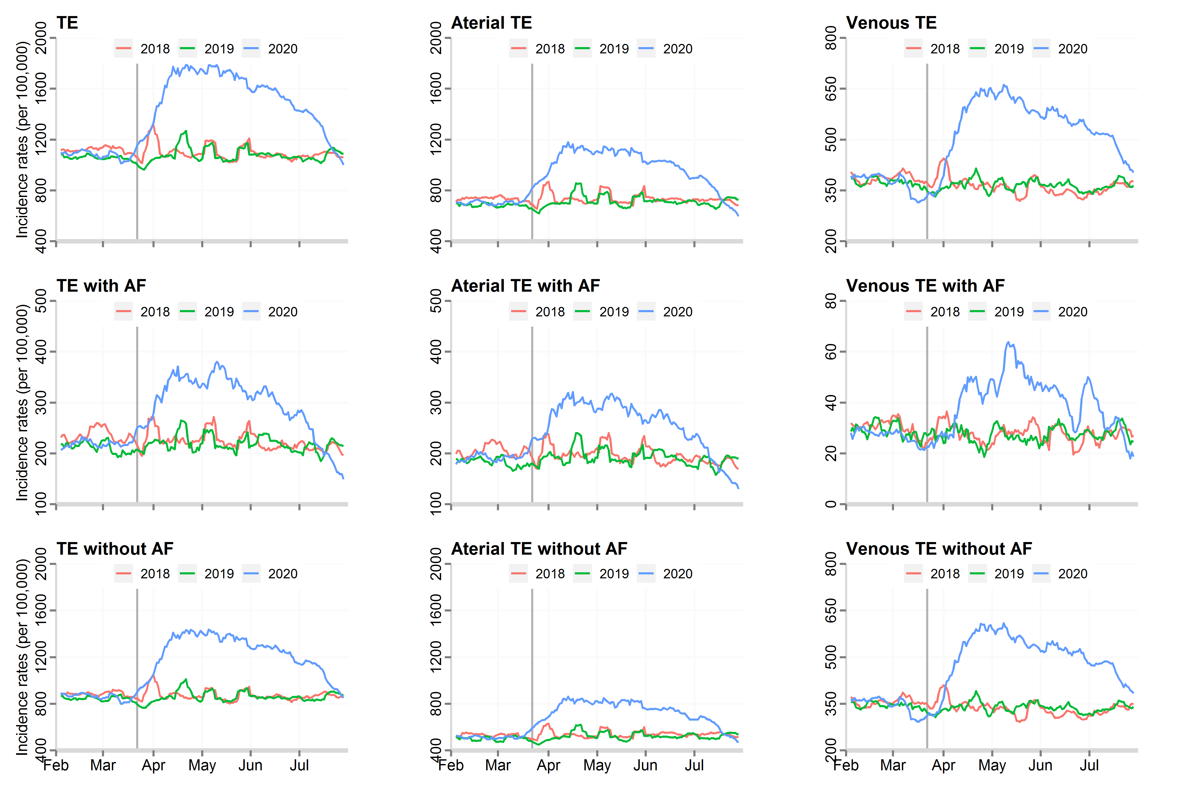
AF, atrial fibrillation, TE, thrombo-embolic events
Supplement Table 2. Incidence rates, absolute risk change and unadjusted risk between COVID-19 -ve and +ve patients.
 | Incidence rate (per 100,000) |  |  | Absolute risk change |  | Unadjusted relative risk* | Adjusted relative risk**
Conditions | COVID-19 -ve | COVID-19 +ve |  | Percentage (95% CI) |  | RR (95% CI) | RR (95% CI)
All patients
TE | 1597 | 1943 |  | 21.7% (21.0-22.4%) |  | 1.22 (1.21-1.23) | 1.20 (1.18-1.22)
Arterial TE | 1044 | 1171 |  | 12.2% (11.4-13.0%) |  | 1.13 (1.12-1.14) | 1.14 (1.12-1.16)
Venous TE | 553 | 972 |  | 76.0% (74.3-77.6%) |  | 1.89 (1.88-1.91) | 1.87 (1.85-1.89)
DVT | 237 | 288 |  | 21.6% (19.5-23.8%) |  | 1.46 (1.43-1.49) | 1.43 (1.39-1.47)
PE | 322 | 886 |  | 174.9% (171.7-178.1%) |  | 3.01 (2.98-3.05) | 2.96 (2.91-3.00)
* A Poisson regression model was used to calculate the relative risk.
**A Poisson regression model was used to calculate the relative risk, adjusted for age, sex, and Charlson Comorbidity Index. TE, thrombo-embolic events; DVT, deep vein thrombosis; PE, pulmonary embolism.

