**Introduction**

Radiography education is the cornerstone to the profession and an essential element in helping generate competent radiographers who can practise safely and effectively. Training curricula are generally guided by national regulatory requirements and service needs. These dynamic drivers, are every changing, as a result of developments in healthcare and imaging equipment. Radiography educators, typically universities, technical institutes and vocational colleges, are responsible for providing training.1

In their 2015 surveys, the European Federation of Radiographer Societies (EFRS) reported that 90% of European programmes at are Bachelors level.2 Despite this, the EFRS reported significant variations in the duration, format and curricula. Similar differences have also been highlighted outside of Europe. Cowling in 20123, on behalf of the International Society of Radiographers and Radiologic Technologists (ISRRT), indicated that radiographers in 94% of responding institutions (Europe, Africa, Americas and Asia/Oceania) were also educated at Bachelors level. Cowling further confirmed that programme duration varied significantly (1.5 to 5 years) as did scope of practice.

Although training differences are evidence many similarities will exist. Clinical placements remain a core component of radiography education.1, 4 However, again significant variations have been reported in clinical placement time, inclusion of skills labs and simulators, clinical supervision and methods of quality assurance.1 With greater emphasis on digital technologies and virtual environments within education, there are reports of the use of digital teaching libraries,5 and a range of computer-based and virtual reality simulations embedded within curriculum.6-11 Such pedagogical practises are likely to be based on a multitude of factors. In addition to publications from the EFRS1, 12, 13, a number of institutions have documented their own practices around radiography education.14-20

With radiographic practices changes, when combined with developments in imaging technology and education it is important to understand the key components of radiography training programmes worldwide. The last global survey was undertaken in 20123and the radiographic profession has changed significantly during this time. Demand for imaging is higher, recruitment and retention of radiographers is variable and the scope of practise is continuing to broaden. Improved understanding on radiography curricula and pedagogical techniques would be highly advantageous for the profession. The aim of this study was to undertake a global survey of radiography educators to look for similarities and differences in training curricula.

**Methods**

Prior to the start of the study ethics approval was attained from Human Research Ethics Committee of the University of Canberra (2019-1924).

*Design*

The research design was an online survey using QualtricsTM platform (Qualtrics, Drive Provo, UT). Participants were provided an information statement that outlined the aims, requirements, and confidentiality of the study. The initial question to the survey was an informed consent agreement that required the participant to complete before access to the questionnaire was granted. The questionnaire was based on two previous questionnaires developed by the EFRS Educational Wing focussing on key issues relating to radiography education.1, 13 The survey was presented to participants in English language only as this was the approach previously adopted. The questionnaire comprised of open and closed questions and consisted of sections designed to ascertain data on: type, level and duration of education programmes leading to an initial or pre-registration qualification in medical radiation practice; pre-clinical skill development and clinical placement within programmes. The survey was open to participants 17 May 2019 and closed 31 October 2019.

The questionnaire focused on the amount and types of practical training within a programme (*two questions*), supervisory arrangements (*ten questions*), placement logistics (*two questions*), quality assurance processes (*one question*) and the assessment of clinical competencies (*two questions*). All respondents consented to data being identifiable in terms of educational institution and country. Backtracking was not permitted between sections of the survey.

*Participants*

To obtain an international perspective a link to the survey with the participant information form was distributed via social media channels and the network of professional societies, including the EFRS. Direct email contact with programme leaders, known to the authors or via names on university web sites, was also made.

*Data analysis*

Data were uploaded to IBM SPSS Version 23 (IBM, Armonk, NY). Descriptive statistics are reported for most analyses while open questions were examined thematically to provide a more nuanced understanding of education programmes.

Results

Responses were received from 79 individuals. Of the 75 (95%) respondents who chose to identify the country in which initial or pre-registration programme(s) were offered, 28 different countries were represented (**Figure 1**).

*Types of programme*

Respondents were asked to identify the type of programmes offered (**Figure 2**). As educational institutions could offer one or more programmes of study leading to an initial or pre-registration qualification in an area of medical radiation practice, the number of educational programmes (n=121) exceeds the number of respondents (n=79). The majority of programmes for initial or pre-registration qualification in medical radiation practice are for a single area of specialisation (79 out of 121 programmes). Almost one-third of programmes (40/121) offered two or more areas of specialisation within the curriculum. Diagnostic radiography is present in the majority of individual (42/121) and combined (40/121) areas of specialisation within programmes. Not all combined programmes of study afford the graduate the ability to immediately undertake independent practice in their area or areas of specialisation. Graduates from combined programmes require additional compulsory clinical placement (16/40), satisfactorily complete an external examination (7/40), and/or undertake compulsory additional formal education (11/40). Of the 121 educational programmes, the primary professional areas that graduates from the programme are reported to be fully qualified to safely perform were provided for 102 programmes (**Table 1**).

*Level of qualification*

A broad range of level of qualifications are currently utilised internationally for entry into the medical radiation profession (**Figure 3**). The majority of programmes are offered at the undergraduate level, with Bachelor’s degrees accounting for 84% (73/87) of undergraduate entry qualifications. Entry into the profession by postgraduate qualification (graduate entry initial or preregistration qualification) varied from postgraduate certificate to doctoral level. Postgraduate certificate and Master’s were the most frequently reported graduate entry level qualifications for initial entry into the medical radiation professions.

*Duration of initial qualification*

The total duration of the undergraduate and graduate entry programmes providing an initial or preregistration qualification in medical radiation practice is shown in **Figure 4**. For undergraduate entry programmes total duration varied between 1.5 - 4 years, with the majority of programmes (67/75) at least 3 years in total duration. Total duration of postgraduate entry initial or preregistration programmes varied between 1 and 4 years with the majority of programmes (31/35) at least 2 years in total duration.

*Skill development*

The number of hours per year students undertake pre-clinical skills development and clinical placement as part of their programme of study for six different programme types is presented in **Figure 5**. Across the different types of undergraduate programmes of study, the average of total hours for clinical placement and pre-clinical skill development were: *diagnostic radiography only* 1397, 262 hours; *radiation therapy only* 1300, 250 hours; *nuclear medicine only* 1025, 224 hours; and *combined specialisation programmes* 1134, 497 hours, respectively. For postgraduate (graduate entry) qualifications (**Figure 5**) clinical placement and pre-clinical skill development were: *diagnostic radiography only* 886, 120 hours and *sonography only* 334, 28 hours, respectively. Programme types with less than five responses were not reported for total hours for clinical placement and pre-clinical skill development.

University programmes provide a range of functioning physical and virtual systems to support pre-clinical skills development (**Figure 6**). The most commonly provided physical systems were digital radiography and ultrasound. Virtual simulation was adopted but less frequently than physical systems by programmes to support pre-clinical skill development. The most commonly provided virtual simulation systems were radiography and Virtual Environments for Radiotherapy (VERT).

Pre-clinical skill development included use of clinical systems in a university laboratory, computer simulation and a range of other learning opportunities (**Figure 7**). Other learning opportunities as stated by participants in open text responses included, for example, imaging of anthropomorphic phantoms and cadavers, image evaluation and image interpretation, roleplays with students, use of actors for communication training and patient care workshops, practicals in the mould room, access to datasets and imaging processing, dosimetry and dose management, venepuncture, radio-pharmacy, pathology case studies and interprofessional learning workshops.

Sixty percent (36/60) institutions using simulation reported that they did not intend to change the current amount of simulation time within their programme of study. Only one institution reported that they intended to decrease the amount of simulation time, whereas 38% (23/60) intended to increase the amount to time used in simulation. The focus for increasing the time for simulation, as stated by participants in open text responses, included the increased availability of a range of simulation systems, increasing communication and interprofessional activities, increasing radiation therapy planning, increased student numbers with limitation on clinical placements. Seventy percent (42/60) of participants reported that they did not intend changing the total number of clinical hours in their programme. Twenty percent (12/60) reported that they intended to increase the number of clinical hours in their programme. The reasons provided included to increase the nuclear medicine component, to get hours closer to the European average for clinical hours, and to improve student and programme quality. Ten percent (10/60) reported that they intended to decrease the number of clinical hours in their programme; no reason was provided.

*Student numbers, job vacancies for recent graduates and programme staffing*

Fifty-four respondents reported both first-year intake and graduating number of students for their initial or pre-registration medical radiation practice programmes. Half of the programmes, 27 (50%) had less than 50 students in the first year, 18 (33.3%) had between 50 and 100 students, six (11.1%) had between 100 and 150 students, and three (5.6%) had more than 150 students. The number of students (mean ± SD) in the first year of study was 60.1 ± 44.2, with a reported graduating number of 44.6 ± 32.9. For this set of paired data, the percent difference between first year student intake and graduating number of students was -21.4 ± 19.2. The majority of programmes, 32 (59.3%) had 20% or lower reported graduating number of student than first year intake, and of these programmes 20 (37.0%) had less than a 10% lower graduating number than first year intake. Seven (13.0%) programmes reported higher than 40% difference between first year intake and graduating student number. These programmes included both relatively small first year intakes (n= 35, 40, 45) as well as larger intakes (n= 80, 115, 120, 125). The two programmes with the highest percent difference between first year intake and graduating student number (-78.2% and -84.1%) both reported that their students included full-time and distance learning students.

*Job vacancies for recent graduates*

The job vacancy situation for recent graduates of initial or pre-registration medical radiation practice programmes, as reported by survey respondents, is presented in **Figure 8**. Job vacancies on graduation vary across areas of specialisation. 53 (86.9%) programmes offering diagnostic radiography initial or preregistration qualification reporting jobs for most or all of their graduates. Uncertainty regarding job vacancies for recent graduates was more common from respondents offering programmes specialising in nuclear medicine (n=6, 21%) and sonography (n=3, 27%).

*Programme staff*

Survey respondents were asked to report the student /staff (per full-time equivalent (FTE)) ratio of their programme(s). The calculated student /staff ratio (mean ± SD) was 16.6 ± 9.8. Reported staff/student ratios for entry level programmes were less than 10:1 (x%; n=13), 10:1 to 14.5:1 (x%; n=12), 15:1 to 19.5:1 (x%; n=9), 20:1 to 25:1 (x%; n=13), and greater than 25:1 (x%; n=9). Where respondents reported multiple medical radiation practice programmes at their institution, the student / staff ratio was higher for diagnostic radiography than was reported for radiation therapy, sonography or nuclear medicine. For example, one respondent reported diagnostic radiography 50:1, radiation therapy 10:1, sonography 10:1, and nuclear medicine 5:1, and another reported diagnostic radiography 21:1, radiation therapy 14:1.

**Discussion**

Research exploring radiography education, has in the past, primarily focussed on Europe.13, 19, 21, 22 This study sought to provide a more global perspective on trends in radiography education. The European model of radiography education typically offers a qualification with multiple areas of specialisation13, 21 including two or more of the following specialisms, namely diagnostic radiography, radiation therapy and/or nuclear medicine. This current study demonstrates that from an international perspective, the most common model of radiography education, with approximately two-thirds of programmes (79/121) is to provide a qualification with a single area of specialisation (**Figure 1**). Diagnostic radiography was the most common single area of study for specialisation (42/79). Of these 42 programmes that provide a qualification in diagnostic radiography, graduates from the majority of programmes (**Table 2**) are fully qualified to safely perform generally radiography (42/42), fluoroscopy (40/42) and computed tomography (32/42) examinations. Overall, a wide variation in professional practice areas that graduates from single and combined programmes of study are reported to be fully qualified to safely perform on graduation, was apparent. Identification of key professional areas of practice that graduates are qualified to safely perform from single and combined area of specialisation degrees has, to the authors’ knowledge, not been previously reported. The inclusion of practice areas in radiography education research is an important addition to the knowledge base of the profession as it is these area of professional practice that form professional competencies that regulate professions23

The European qualification in radiography is typically three years in duration13, 19, 21 and results in a Bachelor degree.21, 22 This current study similarly reports that a three year Bachelor (40/87) degree is the most common undergraduate qualification for entry into the radiography profession. As previously reported21 there continues to exist a broad range in undergraduate qualifications currently adopted for entry into radiography profession from certificate (3/87) to Bachelor with honours (33/87). In addition, this study identifies entry into the profession now also occurs at a post-graduate level, varying from postgraduate certificate (8/22) to Master’s (9/22) level qualifications. The offering of post-graduate entry qualification for students who already hold a Bachelor degree, typically shortens the duration of the entry qualification to the profession to two (15/35) or three years (11/35) duration. With such diversity in training duration, academic level and professional practice capabilities upon graduation remains across radiography education global transportability of radiography qualification will not be realised.

Clinical education is a core component of European radiography education programmes.1, 19 This current study identifies that clinical placement occurs across all years of study, with average total hours of clinical placement typically higher for single specialisation than combined degrees. In contrast pre-clinical skill development hours is higher in combined programmes of study than for those with a single area of specialisation. For single area of specialisation qualifications, the ratio of pre-clinical to clinical placement hours approximates 1:5, whilst combined programmes of study approximates 2:5. In a study examining clinical education in Europe programmes, England et al.,1 reported average pre-clinical to clinical placement ratio of 1:4. The findings of this current study, suggests that there has been little change in ratio since that reported by England et al.,1 As the global pandemic has impacted clinical practice of radiography,24-26 it would be beneficial to investigate if pre-clinical and clinical education hours or use of simulation resources changed during and / or after the COVID-19 pandemic.

Limitations

There were a number of limitations evident within our study. Gaining a snapshot of global radiography education is a challenge and it is possible that a greater number of respondents could have been recruited if the survey was deployed in languages in addition to English. It might also have received a greater response rate if a greater number of national and international societies were used to advertise the questionnaire. It should be noted that no responses were received from South American radiography training institutions and responses from Asia were also low. A further limitation is that no information was collected on the educational institution. This means that two or more people from the same educational institution may have responded independently to the survey. While no set of responses from the same country were identical, we cannot exclude this occurring. Study findings and conclusions must, therefore, be interpreted with these points in mind. Deployment of the questionnaire was during 2019; it is highly likely that the provision of radiography education in many jurisdictions would have undergone significant changes as a result of the COVID-19 pandemic in 2020. There are potentially improvements that could have been made to the questionnaire, more extensive piloting and validation could have assisted. The deployed survey was, however, adapted from a previously successful international survey. Improvements in response rates may also have been achieved if further reminders had been issues and if respondents were given longer to complete the questionnaire. Online questionnaires are notoriously difficult to achieve huge response rates and we should accept that this study has provided a snapshot of global radiography education.

Conclusion

Results presented in this publication represent the most recent evaluation of global radiography education with data obtained from 28 countries (4 continents). Globally the majority of education institutions support the delivery of a single programme. Such programmes can contain multiple areas of specialisation (medical imaging/nuclear medicine/radiotherapy), but diagnostic radiography dominates. Variations in professional qualifications are evident and have started to include Level 7 and 8 qualifications in some jurisdictions. Skill development, included the split of time between clinical and academic practice and the inclusion of different learning opportunities varies between providers. Some changes around the utilisation of simulation are evident, staff ratios are variable and global job markets for radiographers appear favourable.

**Table 1.** Primary area of professional practice that graduates from programmes are fully qualified to safely perform



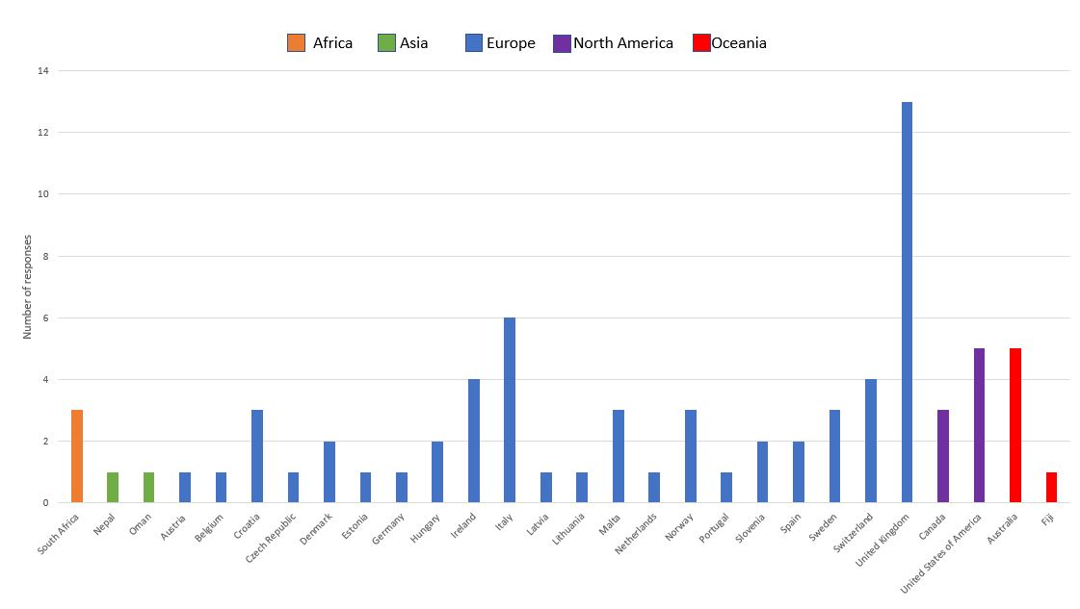

**Figure 1**. Programme information illustrating the breakdown of respondents by country / continent.

­­

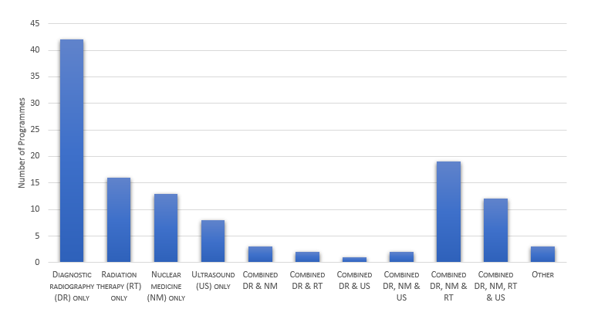

**Figure 2.** Programme types and areas of specialisation of new graduates

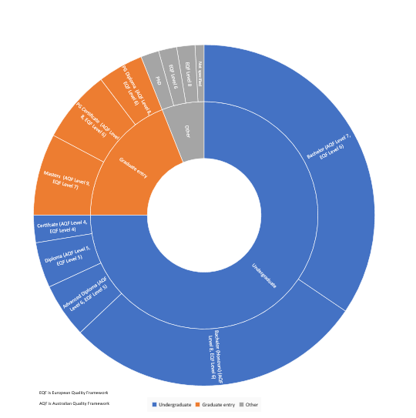

**Figure 3**. Type (Undergraduate or Postgraduate (Graduate Entry), name, and level (EQF and AQF) of qualification for entry into profession

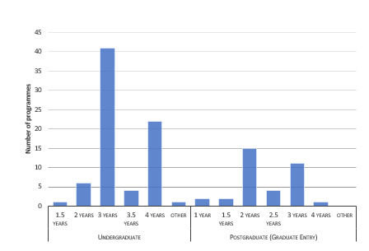

**Figure 4**. Type and duration of programme leading to an initial qualification for entry into the profession

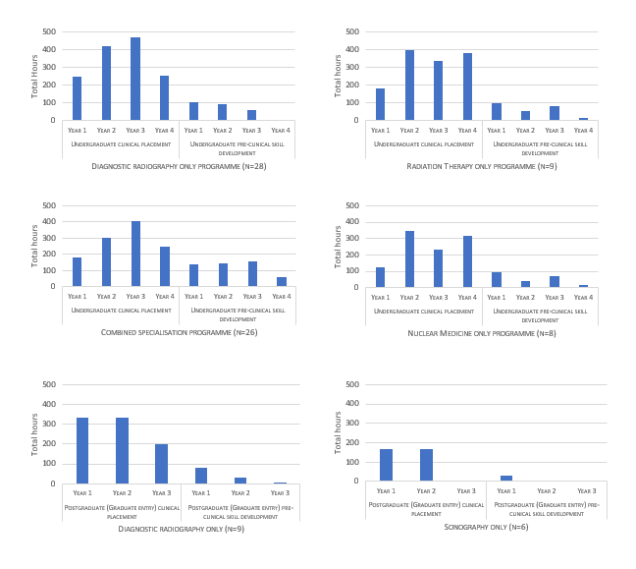

**Figure 5**. Reported average number of clinical and pre-clinical placement hours each year for six programme types leading to entry /initial qualification into the medical radiation profession

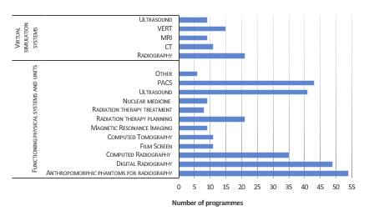

**Figure 6**. On-campus (university) physical and simulation systems for pre-clinical learning

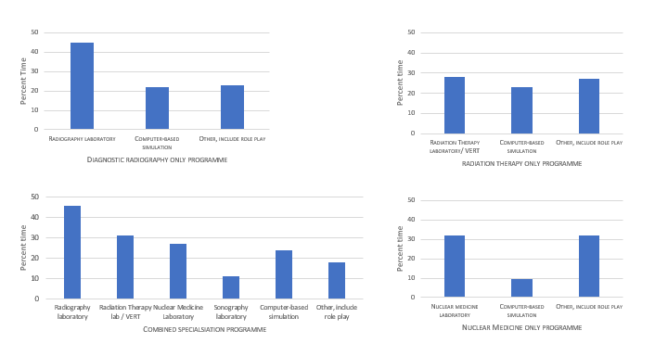

**Figure 7**. Components of pre-clinical skill development as percent of total time for four programme types.

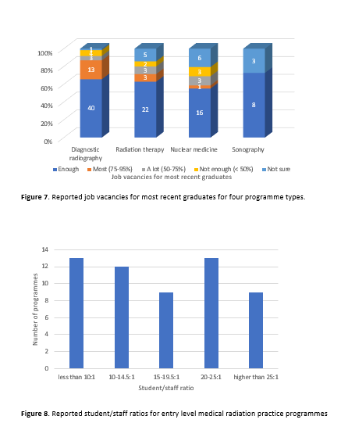

**Figure 8**. Reported job vacancies for most recent graduates for four programme types.

1. England A, Geers-van Gemeren S, Henner A, et al. Clinical radiography education across Europe. *Radiography* 2017; 23: S7-S15.

2. European Federation of Radiographer Societies. EFRS Education Survey, <http://www.efrs.eu/publications> (2010, accessed 24.09.2020).

3. Cowling C. Education preliminary report. International Society of Radiologic Technologists <http://www.isrrt.org/isrrt/ISRRT_Education_Preliminary_Report.asp> (accessed 24.09.2020).

4. Cunningham J, Wright C and Baird M. Managing Clinical Education Through Understanding Key Principles. *Radiologic Technology* 2015; 86: 257-273.

5. Cosson P and Willis N. Digital teaching library (DTL) development for radiography education. *Radiography* 2012; 18: 112-116.

6. Shanahan M. Student perspective on using a virtual radiography simulation. *Radiography* 2016; 22: 217-222.

7. Elshami W and Abuzaid M. Transforming Magnetic Resonance Imaging Education through Simulation-Based Training. *Journal of Medical Imaging and Radiation Sciences* 2017; 48: 151-158. DOI: <https://doi.org/10.1016/j.jmir.2017.01.002>.

8. O'Connor M, Stowe J, Potocnik J, et al. 3D virtual reality simulation in radiography education: The students' experience. *Radiography (Lond)* 2020: S1078-8174(1020)30141-30143. DOI: 10.1016/j.radi.2020.07.017.

9. Bridge P, Crowe SB, Gibson G, et al. A virtual radiation therapy workflow training simulation. *Radiography* 2016; 22: e59-e63. DOI: <https://doi.org/10.1016/j.radi.2015.08.001>.

10. Gunn T, Jones L, Bridge P, et al. The use of virtual reality simulation to improve technical skill in the undergraduate medical imaging student. *Interactive Learning Environments* 2018; 26: 613-620. DOI: 10.1080/10494820.2017.1374981.

11. Shiner N. Is there a role for simulation based education within conventional diagnostic radiography? A literature review. *Radiography* 2018; 24: 262-271. DOI: <https://doi.org/10.1016/j.radi.2018.01.006>.

12. England A, Azevedo KB, Bezzina P, et al. Patient safety in undergraduate radiography curricula: A European perspective. *Radiography* 2016; 22: S12-S19. DOI: <https://doi.org/10.1016/j.radi.2016.10.004>.

13. McNulty JP, Rainford L, Bezzina P, et al. A picture of radiography education across Europe. *Radiography* 2016; 22: 5-11. DOI: <https://doi.org/10.1016/j.radi.2015.09.007>.

14. Abuzaid MM, Elshami W, McConnell J, et al. Changing the model of radiography practice in the UAE: A snapshot of a profession in transition. *Radiography* 2020. DOI: <https://doi.org/10.1016/j.radi.2020.05.014>.

15. Akimoto T, Caruana CJ and Shimosegawa M. A qualitative comparative survey of First Cycle radiography programmes in Europe and Japan. *Radiography* 2009; 15: 333-340. DOI: <https://doi.org/10.1016/j.radi.2009.04.002>.

16. Andersson BT, Lundgren SM and Lundén M. Trends that have influenced the Swedish radiography profession over the last four decades. *Radiography* 2017; 23: 292-297. DOI: <https://doi.org/10.1016/j.radi.2017.07.012>.

17. Elshami W, McConnell J, Abuzaid M, et al. Radiography doctorates in Arabia: Current position and opportunities to transform research practice in the Middle East. *Radiography* 2020. DOI: <https://doi.org/10.1016/j.radi.2020.07.008>.

18. Keogh J, Keogh M and Bezzina P. Nursing, radiography and primary health care within healthcare education in Malta. *Radiography* 2000; 6: 273-282. DOI: <https://doi.org/10.1053/radi.2000.0279>.

19. Sá dos Reis C, Pires-Jorge JA, York H, et al. Curricula, attributes and clinical experiences of radiography programs in four European educational institutions. *Radiography* 2018; 24: e61-e68. DOI: <https://doi.org/10.1016/j.radi.2018.03.002>.

20. Baird M. Evolution of a degree program: the Australian example. *Radiologic Technology* 1992; 63: 406-409.

21. Couto JG, McFadden S, Bezzina P, et al. An evaluation of the educational requirements to practise radiography in the European Union. *Radiography* 2018; 24: 64-71. DOI: <https://doi.org/10.1016/j.radi.2017.07.009>.

22. Prentakis AG, Stefanoyiannis AP, Georgiadis K, et al. Education, training, and professional issues of radiographers in six European countries: a comparative review. *Journal of European CME* 2016; 5: 31092. DOI: 10.3402/jecme.v5.31092.

23. Medical Radiation Practice Board of Australia (MRPBA). Professional capabilities for medical radiation practitioners, effective 1 March, 2020, Available from: <https://www.medicalradiationpracticeboard.gov.au/About/Statistics.aspx> (2020).