Characterisation of the natural history of peritoneal dialysis prior to encapsulating peritoneal sclerosis
Mark Lambie, Biju John, Lily Mushahar, Kit Huckvale, Simon J. Davies

Department of Nephrology, University Hospital of North Staffordshire, Stoke on Trent and Institute of Science and Technology in Medicine, Keele University, Stoke on Trent, United Kingdom

Correspondence address:
Professor Simon Davies
Department of Nephrology, University Hospital of North Staffordshire,
Royal Infirmary, Princess Road, Stoke on Trent, Staffordshire, ST4 7LN
United Kingdom
Email: simondavies1@compuserve.com
This study had no external or internal source of income
Running Headline
Characteristics of EPS patients pre-diagnosis
Word Count 3961
Abstract
Encapsulating peritoneal sclerosis (EPS) is a serious condition occurring with increasing frequency the longer the duration of peritoneal dialysis. We report the longitudinal changes in peritoneal membrane function of patients who develop EPS compared with controls who had completed their dialysis episode. All patients starting peritoneal dialysis since 1990 with an unequivocal diagnosis of EPS in our unit were identified, and each matched for dialysis duration and age with four controls. All prospectively collected clinical measures were retrieved and compared. The dialysate/plasma creatinine ratio increased with time in both groups but was only significantly higher in EPS patients at the time of stopping dialysis (0.89 vs 0.78, p=0.007), whereas the ultrafiltration capacity was significantly worse from at least 2 years prior to stopping dialysis, diverging further till dialysis finished (345mls vs 137mls, p=0.006) suggesting reduced osmotic conductance. Both the glucose exposure rate for the 5 years preceding stopping dialysis and the Icodextrin exposure was significantly higher, with a worse residual renal function, in the EPS group, but there was no significant difference in peritonitis rates. 24 hour peritoneal protein clearance was not significantly different in EPS cases, possibly due to a greater fibrous matrix. This study shows that regular peritoneal membrane function tests can identify most patients at high risk of developing EPS.

Keywords
Peritoneal dialysis, peritoneal membrane, ultrafiltration, fibrosis, life-threatening dialysis complications
Introduction
Encapsulating peritoneal sclerosis (EPS) is an increasingly recognised complication of peritoneal dialysis(PD), characterised by development of a diffuse ‘cocoon’ over the small bowel causing gastrointestinal symptoms and bowel obstruction, leading to weight loss, under-nutrition and in some cases death. The incidence increases with time on PD, ranging from 0% during the first 3 years to 5.9% for patients on PD between 8 and 10 years in Japan [1], and from 0% during the first year to 8% for patients on PD for 5 or more years in Scotland [2]. Several treatment-related risk factors have been suggested including severe peritonitis, glucose exposure, lack of residual renal function and the development of ultrafiltration failure associated with high rates of membrane solute transport. Paradoxically, discontinuation of PD appears to be a trigger factor for developing the condition resulting in a therapeutic dilemma for the clinician as to when and if patients should be switched to haemodialysis (HD). Although EPS is rarely seen in patients not exposed to PD, other precipitants such as cirrhosis with ascites, post surgical, peritoneal shunts, autoimmune conditions and intraperitoneal chemotherapy [3, 4] are described and the underlying pathophysiology remains obscure. This is compounded by the lack of a good animal model, the rarity of the disease and the lack of stringent diagnostic criteria.
The ability to identify patients at high risk, thereby prompting consideration of switching to HD or transplantation might be facilitated by identifying changes in peritoneal membrane function that precede or predispose to the development of EPS. It is well established that time on PD is associated with increases in peritoneal solute transport rate (PSTR) associated with a fall in the ultrafiltration (UF) capacity of the membrane. In a proportion of patients there is uncoupling of these two processes due to a decrease in the osmotic conductance of the membrane that may well reflect the progressive fibrosis associated with longer time on treatment. These changes in membrane function are associated with more rapid loss in residual renal function and higher glucose exposure, which may contribute to further fibrosis and subsequent EPS. To date, most studies of EPS patients have reported only the results of the most recent peritoneal membrane function tests prior to diagnosis. We report the first controlled longitudinal cohort study of peritoneal membrane function with associated detailed clinical measurement including RRF and peritoneal glucose exposure in patients who subsequently develop definite EPS.
Results
9 patients with definite EPS were identified from a total cohort of 692 patients treated with peritoneal dialysis since 1990. The diagnosis of EPS was confirmed surgically in 5 out of 9 patients, and radiologically in 7 out of 9, (Table 1). 3 patients were on PD at the time of diagnosis, while the other 6 were on haemodialysis, a mean of 7.3 months after stopping PD (range 1-18 months). Constipation was unusual, while diarrhoea occurred in only 3 out of 9. Frank obstruction was only diagnosed formally in 4 out of 9 although vomiting occurred in 6 out of 9.
EPS free survival is demonstrated in Figure 1. The 2 early cases of EPS (6 and 23 months) were both related to severe, prolonged peritonitis episodes. Of the EPS not associated with severe and prolonged peritonitis, there were no early cases, with the first case occurring at 32 months. The risk rose substantially after five years such that the probability of EPS free survival after 93 months on PD was 0.85. The confidence intervals for this are wide with small numbers of patients at risk but they follow a pattern of an increasing gradient with time in the Kaplan-Meier plot.
The demographics of the cases and 36 matched controls are shown in table 2 with no significant difference between the groups. One EPS case had 2 significant sessions of PD which, whilst separated by a 9 year period, were combined into one for the analysis. The cohorts were reasonably matched in time with a median date of stopping PD of 26/3/04 in EPS cases and 9/4/02 in the controls. Predictably, the outcome of the two groups was significantly different.
The mean number of peritonitis episodes was greater in the control group, although this did not reach statistical significance (1.78 vs 4.19, p=0.061). 2 EPS cases had no peritonitis at all, only one EPS case had their catheter temporarily removed for peritonitis and only 2 of the EPS cases had peritonitis within the 6 months preceding stopping PD
Both EPS and control groups demonstrated a gradual rise in solute transport rate with time on treatment (p=0.003 and 0.001 respectively), (figure 2). The change with time of UF capacity in the EPS group (figure 3) was significant (p=0.02) but not in the control group (p=0.34). Only 2 of the control group of patients had a consistently low UF capacity suggestive of UF failure.
When D/P Cr and UF capacity are plotted together (figure 4), the decline in UF capacity with increasing D/P Cr is disproportionately worse for the EPS group such that, for the same D/P Cr ratio in both groups, there is a statistically significant difference in UF (345mls at 0.781 for control group vs 194mls at 0.784 for EPS group, p=0.015).
5 EPS cases had been on APD, giving a mean duration on APD usage of 20.2 months within EPS cases, and 19 controls had been on APD, giving a mean duration of 13.1 months within controls. This difference was not significant (p=0.35). The mean annual glucose exposure rates (figure 5) were not statistically significantly different for the last 3 readings due to an increase in variance but the mean values still showed a clear difference. The last year’s glucose exposure was 66,494 and 96,241 grammes per year in control and EPS groups respectively; 4 two litre 1.36% or 2.27% exchanges per day correspond to a yearly glucose exposure of 39,712 or 66,284 grammes per year respectively. Icodextrin use was greater in the EPS cases, but the difference was only significant for between 1 and 2 years prior to stopping PD (7/9 vs 12/36, p=0.016).
Over the first 4 years of PD residual renal function was significantly better preserved in controls with a mean urine volume for EPS 339.6mls vs controls 572mls, p=0.001 (Figure 6). Peritoneal protein clearances (PCl) were not significantly lower in the EPS cases than the controls by independent samples t-test (figure 7). The EPS group did have a lower PCl than controls in a linear mixed model with EPS/controls and time to PD finish as predictor variables using fixed effects but the model improved and the difference became insignificant when a random effect was added for EPS/controls or intercept. Although there were insufficient samples to make meaningful comparisons on a time matched basis, there was no significant longitudinal change from the last year of PD to between 3 and 4 years before stopping PD (94.50 vs 84.99 mls plasma per day, p=0.46).
Discussion
This is the first controlled analysis describing the longitudinal changes of a number of treatment related measures of PD patients developing EPS. The characteristics of patients destined to develop EPS were early loss of residual renal function, and increased glucose exposure associated with reduced ultrafiltration capacity of the peritoneal membrane. In contrast baseline characteristics such as age, gender and comorbidity or subsequent frequency of peritonitis were not different. These observations have important implications for the longitudinal monitoring, prevention and risk assessment of patients on long-term PD.
A higher risk of EPS has consistently been associated with a longer duration of PD [1, 5]. The incidence in this study is in line with this, with a lifetime risk of 8.75% for patients on PD for more than 5 years, a finding in keeping with the incidence reported by the Scottish Renal Registry [2]. One of the strengths of this study is follow up data over a long period of time (19 years) allowing us to examine EPS risk after long periods on PD, and the Kaplan Meier gradient continues to worsen with longer PD exposure, a similar pattern to that published by Kawaguchi et al [6] although in our centre the decline in EPS free survival is shorter.
It has been suggested that transplantation is a particular risk for the development of EPS [7, 8], although this does not seem to be the case for our cohort (12 out of 36 controls vs 0 out of 9 EPS cases had a transplant) nor was it the case in the Pan-Thames EPS study where 14 out of 65 patients had a transplant [9]. The majority of our patients developed the condition after stopping PD (6 out of 9) suggesting that, as has been documented previously [1, 10], cessation of PD may be the main trigger.
The original reports of EPS linked it with an increased rate and/or severity of peritonitis [5, 11-13], although this is not the case in our study. This might be explained by case selection as, to ensure there was uniformity in the diagnosis of EPS, we excluded 2 cases characterised by an early diagnosis after severe and prolonged peritonitis. However, there have also been other recent case series where the rate of peritonitis was unremarkable such as that from Kawanishi et al [10] where 16 of 50 cases of EPS had no peritonitis, and Summers et al [14] and Hendriks et al [15] where the rate of peritonitis was no different to the entire PD population and control group respectively. These case series suggest infectious peritonitis is no longer such an important feature. Changes in PSTR and UF capacity have been documented with peritonitis, particularly multiple and severe episodes [16], so there may be a subset of patients in whom severe, non-resolving or recurrent peritonitis is still important in the development of EPS [17] such as the 2 patients we excluded from this analysis.
The PSTR might reflect intraperitoneal inflammation through its association with local IL-6 levels [18] and previous studies have demonstrated a faster PSTR in most patients who develop EPS [15, 19, 20]. This association with EPS is usually reported in the context of a single measurement at differing time points on dialysis so how this related to the evolution of EPS was unclear until now. Our study confirms previous observations that PSTR tends to increase with time on treatment and shows this was not obviously different between EPS patients and controls, with the exception of the last measurements taken within a year of diagnosis. This is in keeping with previous observations suggesting that the early stages of EPS are inflammatory in nature with evidence of local inflammatory changes in biopsies compared with samples taken from patients with simple peritoneal sclerosis [21].
Whilst a previous uncontrolled study failed to show an increase in PSTR measured in 4 Standardised Permeability Analyses’ prior to the development of peritoneal sclerosis, our controlled study of EPS included measurements from within the final year of PD, the only time point at which there was a significant difference in PSTR [22]. The only previous report of peritoneal protein loss (albumin and IgG) in EPS was in 4 patients with no control group [19], where 3 had an increase over time and one a decrease. By using a case control design with more cases we have demonstrated that EPS patients actually have a slightly smaller peritoneal protein clearance than time matched controls.
UF failure at the time of PD cessation has been documented as a risk factor for the development of EPS [15, 23], including the same uncontrolled longitudinal study of peritoneal sclerosis mentioned above which demonstrated a decline in UF capacity over 4 years [22]. This EPS study extends these findings in time and by using time matched controls, a clear difference is apparent at least 2 years prior to PD cessation. Our study has also demonstrated for the first time uncoupling of PSTR and UF capacity, with less UF capacity for the same PSTR, in patients who subsequently develop EPS, [24] also a recognised phenomenon in long term PD patients without EPS [24]. A possible explanation for this fall in osmotic conductance is increased fibrosis reducing hydraulic permeability.
Glucose exposure has previously been documented as greater in a group of peritoneal sclerosis patients compared with controls [15] but this study again extends this to a longitudinal description finding a clear separation between cases and controls 4 years prior to stopping PD. Glucose exposure might be a reflection of greater use of APD, but in our study cases and controls had similar rates of APD. Unsurprisingly Icodextrin use was also greater in EPS cases given its known benefits in maintaining PD in patients with ultrafiltration failure, although this was only significant between 1 and 2 years before PD cessation. That glucose exposure is statistically significantly different prior to the divergence in the UF capacity does not necessarily imply that it precedes the deterioration in UF capacity, as there is a small difference in UF capacity at 4 years prior to PD cessation which is almost significantly different (p=0.07) and UF capacity in the peritoneal equilibration test is recognised as having a large coefficient of variation, limiting the ability to detect true differences. The pattern of glucose exposure and UF capacity is strikingly similar with the plots in both graphs diverging between 4 and 5 years prior to stopping PD and separating further with time.
The longitudinal evolution of residual renal function has not been studied previously, but this study demonstrated that those patients who go on to develop EPS pass a smaller urinary volume within the first 4 years. This is likely to be another contributory factor, along with declining UF capacity, in explaining the EPS patients’ greater and earlier glucose exposure.
The ISPD position paper on PD duration [25] emphasised the desirability of a method of identifying those patients at risk of EPS, not fulfilled by CT scanning [26], and there is as yet no study on the use of biomarkers in predicting EPS. Patients who lose their residual renal function quickly and have a declining UF capacity, particularly a low UF capacity relative to their PSTR, are the group at highest risk of EPS, and consideration must be given to changing dialysis modality although other important factors must also be considered when discussing this [25]. The glucose exposure may be a more reliable marker than UF capacity as the glucose requirements are likely to be set by the osmotic conductance to glucose of the peritoneal membrane, whilst the measured UF capacity is affected by other issues (e.g. catheter position and drainage) and is thus more variable. This study has partially overcome this issue by using the mean value of twice yearly peritoneal membrane function tests.
From previous studies the PSTR appeared to be an independent predictor of EPS that could be monitored for the purpose of identifying patients at risk. Our data suggests that it would be of less use than glucose exposure or UF capacity as clear separation between EPS cases and controls only appeared in the last year of PD, by which point stopping PD may well be too late, although a rapid increase in PSTR could help identify patients who are already at high risk of EPS at the point of modality switch and therefore require close follow up afterwards.
Conventional glucose-based PD fluid contains glucose degradation products, is acidic, and, particularly for 3.86% bags, possesses an unphysiologically high osmolality, all of which are thought to contribute to membrane damage with an increase in PSTR in conjunction with a worse residual renal function [27]. This study has provided a further rationale to systematically minimise glucose exposure across all PD patients to minimise EPS risk.
There is a growing literature to suggest that ultrafiltration failure in long term PD patients is caused by an increase in fibrosis decreasing osmotic conductance, including evidence from biopsies [28], from computer modelling [29] and from peritoneal membrane testing [30]. We speculate that this fibrosis explains the changes we have demonstrated in patients who develop EPS, although patients with these findings have yet to develop EPS suggesting that there is a difference between simple sclerosis and EPS [21]. The PCl data would support this view as, according to the standard 3 pore model, PCl should increase with membrane size and inflammation but the lack of effect we found might be explained by the fiber matrix/3 pore model with fibrosis restricting protein flux across the membrane.
There are some limitations to this study. We could not be certain that all of the patients used as controls would not have gone on to develop EPS as, whilst there was long term follow up data post PD in the majority of the patients in this group, some patients stopped PD as a result of dying of other causes. This would tend to reduce differences between cases and controls but despite this there were still clear differences between the two groups. As with all studies of EPS, it is not helped by the lack of firm diagnostic criteria although the EPS group was carefully limited to those with characteristic CT or operative findings (often both) with typical clinical features and no other apparent cause. It is a single centre study so it is not necessarily widely generalisable, particularly with growing evidence of centre differences [31], although our data was consistent with the existing literature. There is also the possibility that cases were not diagnosed, although this should only significantly affect the incidence and this was similar to that found in the most comparable population studied [2].
In summary, we report in detail the longitudinal changes in peritoneal membrane characteristics in the majority of patients who subsequently develop EPS (not associated with severe or prolonged peritonitis), demonstrating that loss of UF capacity is the predominant early change noted associated with lower initial residual renal function and higher glucose and Icodextrin exposure. Patients with these features are at high risk of EPS and consideration should be given to stopping PD, while these features and a rapid PSTR at the time of PD cessation should prompt close monitoring for EPS post-PD.

Methods
Study Design:
This was a nested case control study. We identified all patients from the well defined Stoke PD patient cohort with probable EPS, and reviewed their clinical records including nursing documentation and radiological reports. To avoid some of the uncertainty surrounding early EPS, only patients with definite EPS (surgically or radiologically confirmed peritoneal membrane thickening and cocooning, in conjunction with weight loss and features of bowel obstruction) were selected. Two patients in whom EPS was associated with persisting poorly controlled peritonitis were excluded. Each of these patients was then matched by time on PD, and age where possible, with 4 controls from the same cohort by identifying adjacent patients from the whole database who had completed their treatment episode on PD, neither deliberately including nor excluding controls with UF failure. 4 controls were selected to maximise statistical power whilst retaining efficiency [32].

Prospective collection of routine clinical measurements:
Baseline demography and PD measurements for cases and controls were retrieved from the database, along with the total number of peritonitis episodes per patient, and comorbidity, as assessed by the validated Stoke comorbidity index which categorises patients into low (score 0), intermediate (score 1-2), and high (score >2) risk groups.
Routine 6 monthly measurements included residual renal function, dialysis regime and dose, and peritoneal membrane function using the peritoneal equilibration test (solute transport rate: dialysate to plasma creatinine ratio (D/P Cr) at 4 hours and net UF capacity with 2.27% glucose) were obtained from the database. The ‘overfill’ included in the bags was not subtracted from the 4 hour ultrafiltration capacity, but consistently measures 200mls in our unit. Adequacy was expressed as weekly Kt/Vurea for the peritoneal component, whereas the urine volume and mean weekly urea and creatinine clearance (litres/week/1.73m²) were used to determine residual renal function.
Glucose exposure was calculated by summing the grammes of anhydrous glucose within the daily dialysate used for each regime the patient had, multiplying this by the number of days they were on that regime, and combining the results for each regime for the annual total glucose exposure (grammes) of the peritoneal membrane. Icodextrin use was recorded as a categorical value for whether it was used at any point in the year in question.
Peritoneal protein losses were measured from the 24 hour total dialysate collection assayed by the Biuret method. A validated correction factor [33] was then used in the equation: PCl = 24 hour dialysate protein loss/(serum albumin/0.4783), with PCl representing the peritoneal protein clearance expressed as mls of plasma per day. Regular dialysate protein concentrations were measured from 1999, providing data on 8 EPS cases (46 samples) and 28 controls (107 samples) within the last 4 years of PD.
Statistical Analysis:
To compare the evolution of clinical measurements prior to the study endpoint (diagnosis of EPS for cases and completion of PD episode for controls), measurements were aligned from the point of stopping PD backwards, such that cessation of PD counted as time 0, with one year prior to this counting as -1, and so on until year -8. This method was used for UF capacity, solute transport and glucose exposure and the data is all expressed as the yearly mean value for each group. As measurements were taken 6 monthly, this usually represents the mean of two readings per patient.
As residual renal function declines with time on treatment, the measurements of urine volume were aligned from starting PD forward to year +8. Comparisons between EPS cases and controls were made with all values obtained within yearly intervals, and all values from the first 4 years of PD.
Between-group comparisons used the 2-tailed unpaired t-test, the Mann-Whitney U test or the chi-squared test depending on the data type and distribution. The paired t-test was used for longitudinal comparisons, using all measurements between 4.5 and 5.5 years before PD finished and comparing them with readings taken in the last year of PD. These figures were chosen to include measurements from as many patients as possible whilst maintaining a meaningful difference in time.
The risk of developing EPS with time on treatment for the whole PD cohort was determined from a Kaplan Meier survival analysis of all patients commencing PD after 1/1/1990, with the definition of EPS for the study extended to include cases associated with severe and prolonged peritonitis. A linear mixed model was used to examine the PCl data as well as t-tests. These analyses were with SPSS v17.

Disclosure
All authors have no interests to declare.

References
1. Kawanishi H, Kawaguchi Y, Fukui H, et al: Encapsulating peritoneal sclerosis in Japan: a prospective, controlled, multicenter study. Am J Kidney Dis. 44:729-737., 2004
2. Brown MC, Simpson K, Kerssens JJ, Mactier RA: Encapsulating peritoneal sclerosis in the new millennium: a national cohort study. Clin J Am Soc Nephrol. 4:1222-1229. Epub 2009 Jun 1218., 2009
3. Carbonnel F, Barrie F, Beaugerie L, et al: [Sclerosing peritonitis. A series of 10 cases and review of the literature]. Gastroenterol Clin Biol. 19:876-882., 1995
4. Celicout B, Levard H, Hay J, et al: Sclerosing encapsulating peritonitis: early and late results of surgical management in 32 cases. French Associations for Surgical Research. Dig Surg. 15:697-702., 1998
5. Rigby RJ, Hawley CM: Sclerosing peritonitis: the experience in Australia. Nephrol Dial Transplant. 13:154-159., 1998
6. Kawaguchi Y, Saito A, Kawanishi H, et al: Recommendations on the management of encapsulating peritoneal sclerosis in Japan, 2005: diagnosis, predictive markers, treatment, and preventive measures. Perit Dial Int. 25:S83-95., 2005
7. Fieren MW, Betjes MG, Korte MR, Boer WH: Posttransplant encapsulating peritoneal sclerosis: a worrying new trend? Perit Dial Int. 27:619-624., 2007
8. Korte MR, Yo M, Betjes MG, et al: Increasing incidence of severe encapsulating peritoneal sclerosis after kidney transplantation. Nephrol Dial Transplant. 22:2412-2414. Epub 2007 Mar 2429., 2007
9. Balasubramaniam G, Brown EA, Davenport A, et al: The Pan-Thames EPS study: treatment and outcomes of encapsulating peritoneal sclerosis. Nephrol Dial Transplant 11:11, 2009
10. Kawanishi H, Watanabe H, Moriishi M, Tsuchiya S: Successful surgical management of encapsulating peritoneal sclerosis. Perit Dial Int. 25:S39-47., 2005
11. Slingeneyer A, Mion C, Mourad G, et al: Progressive sclerosing peritonitis: a late and severe complication of maintenance peritoneal dialysis. Trans Am Soc Artif Intern Organs. 29:633-640., 1983
12. Slingeneyer A: Preliminary report on a cooperative international study on sclerosing encapsulating peritonitis. Contrib Nephrol. 57:239-247., 1987
13. Rubin J, Herrera GA, Collins D: An autopsy study of the peritoneal cavity from patients on continuous ambulatory peritoneal dialysis. American Journal of Kidney Diseases 18:97-102, 1991
14. Summers AM, Clancy MJ, Syed F, et al: Single-center experience of encapsulating peritoneal sclerosis in patients on peritoneal dialysis for end-stage renal failure. Kidney Int. 68:2381-2388., 2005
15. Hendriks PM, Ho-dac-Pannekeet MM, van Gulik TM, et al: Peritoneal sclerosis in chronic peritoneal dialysis patients: analysis of clinical presentation, risk factors, and peritoneal transport kinetics. Perit Dial Int 17:136-143, 1997
16. Davies SJ, Bryan J, Phillips L, Russell GI: Longitudinal changes in peritoneal kinetics: the effects of peritoneal dialysis and peritonitis. Nephrol Dial Transplant 11:498-506, 1996
17. Gupta S, Woodrow G: Successful treatment of fulminant encapsulating peritoneal sclerosis following fungal peritonitis with tamoxifen. Clin Nephrol. 68:125-129., 2007
18. Pecoits-Filho R, Carvalho MJ, Stenvinkel P, et al: Systemic and intraperitoneal interleukin-6 system during the first year of peritoneal dialysis. Perit Dial Int. 26:53-63., 2006
19. Krediet RT, Struijk DG, Boeschoten EW, et al: The time course of peritoneal transport kinetics in continuous ambulatory peritoneal dialysis patients who develop sclerosing peritonitis. American Journal of Kidney Diseases 13:299-307, 1989
20. Yamamoto R, Nakayama M, Hasegawa T, et al: High-transport membrane is a risk factor for encapsulating peritoneal sclerosis developing after long-term continuous ambulatory peritoneal dialysis treatment. Adv Perit Dial. 18:131-134., 2002
21. Garosi G, Di Paolo N, Sacchi G, Gaggiotti E: Sclerosing peritonitis: a nosological entity. Perit Dial Int. 25:S110-112., 2005
22. Sampimon DE, Coester AM, Struijk DG, Krediet RT: Time course of peritoneal transport parameters in peritoneal dialysis patients who develop peritoneal sclerosis. Adv Perit Dial. 23:107-111., 2007
23. Hoshii S, Honda M, Itami N, et al: Sclerosing encapsulating peritonitis in pediatric peritoneal dialysis patients. Pediatr Nephrol. 14:275-279., 2000
24. Davies SJ: Longitudinal relationship between solute transport and ultrafiltration capacity in peritoneal dialysis patients. Kidney Int 66:2437-2445, 2004
25. Brown EA, Van Biesen W, Finkelstein FO, et al: Length of Time on Peritoneal Dialysis and Encapsulating Peritoneal Sclerosis: Position Paper for Ispd. Perit Dial Int. 29:595-600., 2009
26. Tarzi RM, Lim A, Moser S, et al: Assessing the validity of an abdominal CT scoring system in the diagnosis of encapsulating peritoneal sclerosis. Clin J Am Soc Nephrol. 3:1702-1710. Epub 2008 Jul 1730., 2008
27. Davies SJ, Phillips L, Griffiths AM, et al: What really happens to people on long-term peritoneal dialysis? Kidney International 54:2207-2217, 1998
28. Williams JD, Craig KJ, Topley N, et al: Morphologic changes in the peritoneal membrane of patients with renal disease. J Am Soc Nephrol 13:470-479., 2002
29. Rippe B, Venturoli D: Simulations of osmotic ultrafiltration failure in CAPD using a serial three-pore membrane/fiber matrix model. Am J Physiol Renal Physiol. 292:F1035-1043. Epub 2006 Nov 1037., 2007
30. Parikova A, Smit W, Struijk DG, Krediet RT: Analysis of fluid transport pathways and their determinants in peritoneal dialysis patients with ultrafiltration failure. Kidney Int. 70:1988-1994. Epub 2006 Oct 1911., 2006
31. Huisman RM, Nieuwenhuizen MG, Th de Charro F: Patient-related and centre-related factors influencing technique survival of peritoneal dialysis in The Netherlands. Nephrol Dial Transplant. 17:1655-1660., 2002
32. Gail M, Williams R, Byar DP, Brown C: How many controls. Journal of Chronic Diseases 29:723-731, 1976
33. Haraldsson B: Assessing the peritoneal dialysis capacities of individual patients. Kidney Int 47:1187-1198, 1995

EPS case | Age at diagnosis | Gender | Cumulative months on PD | Diagnosis days post PD | Days survival post diagnosis | Cause of death | Reason for stopping PD | Abdominal pain | Ascites | Vomiting | Weight loss | Radiologically confirmed | Surgically confirmed | Surgical treatment | Tamoxifen treatment | Steroid treatment
1 | 45.8 | F | 161 | 0 | 7 | Multi-organ failure post operatively | EPS | Y | Y | Y | N | Y | Y | Y | N | N
2 | 34.6 | F | 130 | 0 | 33 | Multi-organ failure | Peritonitis | Y | Y | Y | Y | N | Y | N | N | N
3 | 39.5 | M | 93 | 36 | >729 | Alive | EPS | Y | Y | Y | Y | Y | Y | Y | Y | Y
4 | 71.5 | M | 65 | 0 | 2 | Bowel obstruction | EPS/died | Y | N | Y | N | Y | N | N | N | N
5 | 54.7 | M | 69 | 101 | 2 | Sudden death after vomiting++ | UF failure | Y | Y | Y | Y | N | Y | N | N | N
6 | 65.6 | M | 65 | 560 | 120 | Malnutrition, withdrawal of HD | Drainage problems | Y | Y | Y | Y | Y | N | N | Y | N
7 | 44.3 | F | 55 | 320 | 221 | Sudden cardiac death | UF failure | N | Y | N | Y | Y | N | N | Y | N
8 | 26.8 | F | 93 | 47 | >344 | Alive | UF failure | Y | Y | Y | Y | Y | Y | Y | N | Y
9 | 60.0 | M | 32 | 296 | 48 | Malnutrition | Patient choice | Y | Y | Y | Y | Y | N | N | Y | Y
Table 1: Clinical features of patients with EPS
Table 2: Demographics of EPS cases and controls
 | EPS  (9 patients) | Controls  (36 patients) | p value
Duration of PD in months (months; mean) | 84.7 | 81.0 | 0.27
Age at PD cessation (years; mean) | 48.8 | 54.7 | 0.32
Male Gender (%) | 55.6 | 50 | 0.77
Ethnicity  - White European (%)  - South Asian (%) | 88.9  11.1 | 97.2  2.8 | 0.28
Stoke comorbidity index (mean)  - Low (%)  - Intermediate (%)  - High (%) | 0.78  55.6  44.4  0 | 0.78  50.0  44.4  5.6 | 0.98  0.76
Diabetic (%) | 0 | 16.7 | 0.19
Adequacy at treatment start  - Renal Kt/V (median)  - Renal Cr clearance (median)  - Peritoneal Kt/V (mean) | 0.19  9.86  1.60 | 0.98  48.4  1.60 | 0.24  0.27  0.61
PET test at treatment start  - D/P Cr (mean)  - UF capacity (mean) | 0.71  402 | 0.66  423 | 0.18  0.82
Modality immediately post PD  - Haemodialysis (%)  - Transplant (%)  - Died (%) | 88.9  0  11.1 | 30.6  33.3  36.1

Captions for Figures:
Figure 1: Kaplan-Meier plot of EPS free survival
The probability of remaining free of EPS with duration of time on PD. This includes 2 early cases associated with severe, prolonged peritonitis. The number of patients at risk at the time of each case of EPS is shown at the top.
Figure 2: Change in membrane solute transport with time on PD
Solute transport is measured as the mean annual D/P Creatinine measured at 4 hours in standard peritoneal equilibration tests with standard error. The star indicates a difference between groups with p=0.007.
Figure 3: Change in ultrafiltration capacity with time on PD
The UF capacity is the annual mean measured by a 4 hour peritoneal equilibration test with 2.27% glucose, including approximately 200mls overfill. Bars represent standard error. The stars indicate a difference between groups with p<0.05, un-paired t-test.
Figure 4: Change in membrane solute transport with change in ultrafiltration
Membrane solute transport and ultrafiltration are measured as the annual mean of measurements of UF capacity and D/P Creatinine in a 4 hour PET with 2.27% glucose, including approximately 200mls overfill. Bars represent standard error.
Figure 5: Glucose exposure with time on PD
Glucose exposure is measured as the mean of the total number of grammes of glucose in the dialysate used by each patient in that year. Bars represent standard error. The stars indicate a difference between groups with p<0.05, un-paired t-test.
Figure 6: Residual renal function with time on PD
The residual renal function is measured as the median of the urine volume within each group assessed every 6 months from the start of PD.
Figure 7: Peritoneal protein clearance with time on PD
Peritoneal protein clearance is measured in mls of plasma per day and the bars represent standard errors. There were no significant differences between the groups when applying mixed linear modelling.

Figure 1
Figure 2
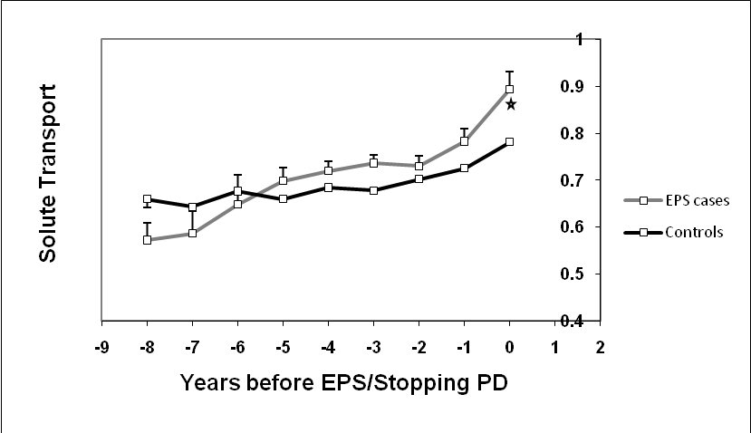

Figure 3
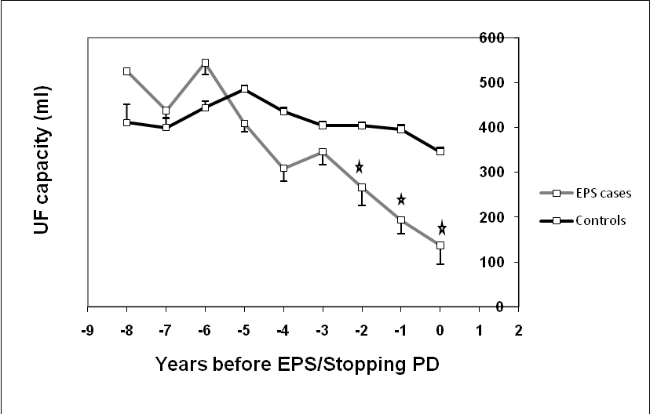

Figure 4
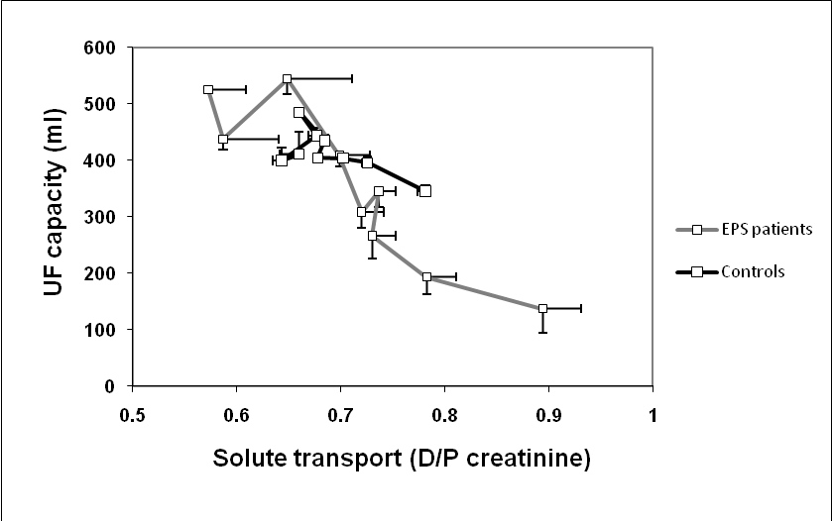

Figure 5
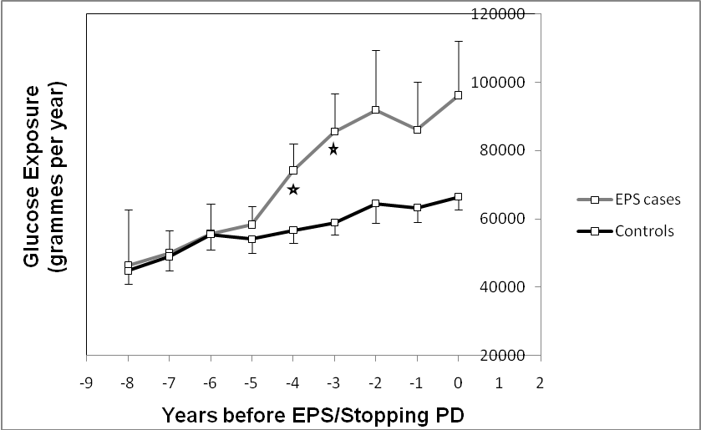
Figure 6
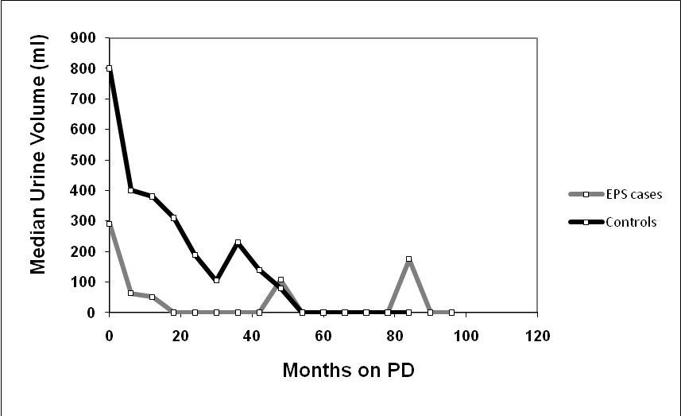

Figure 7
