That’s My Teacher! Children’s Ability to Recognize Personally Familiar and Unfamiliar Faces Improves with Age

Word count (text + references): 9887

Abstract
Most previous research on the development of face recognition has focused on recognition of highly controlled images. One of the biggest challenges of face recognition is to identify an individual across images that capture natural variability in appearance. We created a child-friendly version of the Jenkins, White, Van Montford & Burton (2011) sorting task to investigate children’s recognition of personally familiar and unfamiliar faces. Children between 4 and 12 years of age were presented with a familiar/unfamiliar teacher’s house and a pile of face photographs (nine pictures each of the teacher and another identity). Each child was asked to put all the pictures of the teacher inside the house while keeping the other identity out. Children over 6 years of age showed adult-like familiar face recognition. Unfamiliar face recognition improved across the entire age range, with considerable variability in children’s performance. These findings suggest that children’s ability to tolerate within-person variability improves with age and support a face-space framework in which faces are represented as regions, the size of which increases with age.

Keywords: Face Recognition; Identity Perception; Familiar Faces; Children

That’s My Teacher! Children’s Ability to Recognize Personally Familiar and Unfamiliar Faces Improves with Age

Adults are experts in face recognition (see Maurer, Le Grand, & Mondloch, 2002). They can recognize individual faces at a glance and are able to do so under poor lighting conditions, across variability in expression and point of view, and even after a face has aged several years. Adults' expertise has been attributed to norm-based coding (Rhodes, Jeffery, Taylor, Hayward, & Ewing, 2014; Valentine, 1991), holistic processing (Young, Hellawell, & Hay, 1987; Hole, 1994), sensitivity to feature shape and spacing (Freire & Lee, 2001; Mondloch, Le Grand, & Maurer, 2002), and specialized neural mechanisms (e.g., Allison, McCarthy, Nobre, Puce & Belger, 1994; Bentin, Allison, Puce, Perez, & McCarthy, 1996; Kanwisher, McDermott, & Chun, 1997). At what age face recognition and the underlying mechanisms become adult-like is a matter of ongoing debate.
To date, the focus has been on the development of underlying mechanisms rather than an absolute measure of children’s face recognition per se. Qualitatively, the mechanisms underlying face recognition appear to be adult-like by early childhood. Holistic processing, most directly measured by the composite effect whereby perception of one (e.g., the top) half of the face is influenced by the other half (Young et al., 1987; Hole, 1994), is evident by 4 to 6 years of age (e.g., de Heering, Houthuys, & Rossion, 2007; Macchi Cassia, Picozzi, Kuefner, Bricolo, & Turati, 2009; Mondloch, Pathman, Maurer, Le Grand, & de Schonen, 2007). Evidence from the part-whole task, whereby recognition of a face part (e.g., Joe’s eyes) is more accurate when the part is presented in the context of the face than when presented in isolation, is consistent with early emergence of holistic processing (Pellicano & Rhodes, 2003; Tanaka, Kay, Grinnell, Stansfield, & Szechter, 1998). Likewise, young children are sensitive to feature shape and spacing (e.g., Baudouin, Gallay, Durand, & Robichon, 2010; Gilchrist & McKone, 2003; Macchi Cassia, Turati, & Schwarzer, 2011; McKone & Boyer, 2006; Pellicano, Rhodes, & Peters, 2006; Mondloch & Thomson, 2008; Mondloch et al., 2002), and show adult-like patterns of norm-based coding (Anzures, Mondloch & Lackner, 2009; Hills, Holland & Lewis, 2010; Jeffery et al., 2010; Short, Hatry, & Mondloch, 2011; Nishimura, Maurer, Jeffery, Pellicano, & Rhodes, 2008), a process by which each face is individuated based on how much each face deviates from an average or internal norm.
What continues to be debated is the extent to which there is quantitative improvement in face processing during childhood. Some researchers (Crookes & Robbins, 2014; McKone, Crookes, Jeffrey, & Dilks, 2012; Weigelt, Koldewuyn, Dilks, Balas, McKone & Kanwisher, 2014) argue for quantitative maturity in face perception by 5 years of age with any further improvements being attributed to general cognitive development. Others (de Heering, Rossion, & Maurer, 2012; Short, Lee, Fu, & Mondloch, 2014; Tanaka et al., 2014) argue that quantitative improvements in face processing continue beyond this age. For example, Short et al. showed that norm-based coding continues to be refined after 5 years of age.
Although understanding the development of the processes underlying face recognition is of theoretical importance, recent developments in the field of adult face perception highlight an aspect of face recognition that has been largely ignored in the literature: The ability to recognize a face’s identity across a set of images that incorporate natural variability in appearance (Burton, 2013). The vast majority of studies investigating face recognition in adults and children have used tightly controlled stimuli. For example, Mondloch and colleagues (Mondloch, Geldart, & Maurer, 2003; Mondloch et al., 2002) created a carefully controlled set of stimuli in which all images were taken from the same distance, with the same camera, and under identical lighting conditions. Hair was covered with surgical caps, clothing was covered with a cape, and blemishes were removed. Presenting such images minimizes the observer’s ability to use non-face cues to identity and provides important information about our ability to discriminate between images/identities; however, it ignores the ability to recognize identity in natural images across which appearance varies naturally. This aspect of face recognition is crucial for daily interactions. It allows us to recognize our neighbor when she returns disheveled from a camping trip or our uncle after several years of aging.
In a seminal paper by Jenkins, White, Van Montfort, & Burton (2011) adults were given 40 photographs and asked to sort them into piles such that each pile contained all of the images of one person. Images were downloaded from the Internet and incorporated natural variation in appearance (in hairstyle, lighting, expression, viewpoint, makeup). Participants were not told that there were 20 pictures of each of two people (i.e., that the correct solution was two piles). Nonetheless, participants who were familiar with the identities performed without error. In contrast, participants who were unfamiliar with the identities made about seven piles (i.e., perceived seven different identities) but rarely placed pictures of the two identities into the same pile. These findings highlight the challenge associated with recognizing identity across natural variation in images when faces are unfamiliar. Although errors in discrimination, telling faces apart, were rare for both familiar and unfamiliar faces, errors in recognition, telling faces together (Jenkins et al.) were prevalent for unfamiliar faces, but rare for familiar faces.
Almost nothing is known about children’s ability to recognize familiar versus unfamiliar faces across images containing natural variability in appearance. The vast majority of studies investigating the development of recognition of unfamiliar faces (i.e., faces learned in the context of the experimental paradigm) have used identical images at study and test (Baudouin et al., 2010; Gilchrist & McKone, 2003; Macchi Cassia et al, 2011; McKone & Boyer, 2006; Pellicano et al., 2006; Mondloch & Thomson, 2008; Mondloch et al., 2002; Pellicano & Rhodes, 2003; Tanaka et al., 1998). A few have incorporated some variability, but even in these the variability was limited. de Heering et al. (2012) found improved identity matching between 6 and 12 years of age in the Bentin face recognition task when images of the target identity varied in viewpoint and lighting. A similar pattern of results was observed when images of the target were taken on different cameras (Megreya & Bindemann, 2015). Crookes and Robbins (2014) found no difference in the extent to which changes in viewpoint impaired face recognition in 8-year-olds and adults. However, they used facegen (computer-generated) images and simply showed the same image from a different view. In two previous studies (Bruce et al., 2000; Mondloch et al., 2003) children completed a delayed match-to-sample task in which the target identity was shown from a different point of view or displaying a different emotion at study and test; performance improved between 6 and 10 years of age. Nonetheless, all images were taken under similar lighting conditions, on the same day, and with the same camera. None of these studies challenged children with the degree of variability encountered in the Jenkins et al. sorting task.
Furthermore, only a few studies have contrasted children’s recognition of unfamiliar with familiar faces. Testing children with familiar faces is challenging because, unlike adults who can be tested with famous faces (e.g., politicians and actors), it is difficult to find a set of familiar faces with which a large number of children are familiar. A few studies have tested children with personally familiar faces (e.g., classmates or teachers). These studies showed that children, like adults, rely on internal features to recognize familiar faces but external features to recognize unfamiliar faces (Bonner & Burton, 2004; Ge et al., 2008; Wilson, Blades, Coleman & Pascalis, 2009; but see Newcombe & Lie, 1995) and that the effect of paraphernalia on children's face recognition is reduced for familiar faces (Diamond & Carey, 1977). Again, however, natural variation in appearance was limited. Bonner and Burton, like Newcombe and Lie, tested 7- to 11-year-old children with two images of each identity; the images were taken from two points of view, but all pictures were taken on the same day and models were asked to smile for each picture. Ge et al. used a single (looking ahead, neutral expression) image of each identity, as did Wilson et al. Collectively, these studies leave open the question as to whether children can tolerate the same variability as adults when viewing familiar faces.
In the current study we examined children's tolerance for natural variability when recognizing identity in unfamiliar and personally familiar faces by creating a child-friendly version of Jenkins et al’s (2011) sorting task. We collected 10 photographs from each of six female teachers. As in Jenkins et al., the images incorporated natural variability in appearance. One image was placed on the front of a shoebox decorated to look like a house. The remaining nine images were placed in a pile along with nine images of a matched identity—another woman of similar age and hairstyle. Children were asked to place all pictures of the target identity into the house while keeping all other people out. The number of pictures of the target identity placed into the house provides a measure of recognition (perceiving the same identity despite variability in appearance) whereas the number of pictures of the matched identity placed outside of the house provides a measure of discrimination (telling different people apart). Each child was tested with one target identity. Critically, we tested children across a broad age range (4 to 12 years) and half of the children were tested with images of their teacher, with whom they were highly familiar, and the other half were tested with images of a teacher from a different school, with whom they were unfamiliar. The same stimuli were shown to both groups of children.
To validate our child-friendly method, eight additional control images were intermixed with these test stimuli. Four control images were identical to the one on the front of the house and four control images showed another woman who was much older than the target identity and whose hair differed in both color and style. To be included in our analyses, children were required to place in the house at least three of the identical images and no more than one image of the dissimilar identity.
We made three predictions. First, we predicted improved performance with age. Children’s ability to match unfamiliar faces in images incorporating limited variability improves with age (e.g., Bruce et al. 2000; Mondloch et al, 2003; Heering et al., 2012; Megreya & Bindemann, 2015), a pattern likely due to improvements both in children’s ability to tell two faces apart, and their ability to recognize an identity despite variability in appearance (Megreya & Bindemann, 2015 found that correct identifications and correct rejections improve during childhood). This hypothesis would be supported if older children both put more pictures of the teacher and fewer pictures of the distractor into the house.
Second, we hypothesized that children, like adults, would make fewer errors when tested with a familiar than with an unfamiliar identity. As noted above, familiar faces can be characterized as having a sufficiently robust representation to allow recognition across a range of inputs (see Burton, Jenkins, Hancock & White, 2005; Johnston & Edmonds, 2009; Burton, Jenkins & Schweinberger, 2011; Jenkins et al., 2011). Evidence also suggests that lower-level image properties contribute more to unfamiliar than familiar face recognition (Hancock, Bruce & Burton, 2000). As a result children, like adults, might tolerate less variability for unfamiliar faces because they rely more on pictorial cues for recognition.
Third, we hypothesized that children, like adults, would make more errors in recognition (i.e., failing to recognize that multiple images belong to the same identity) than in discrimination (i.e. in misidentifying non-target images). This would be consistent with adults splitting images of the same person into multiple piles in the sorting task (Jenkins et al., 2011) and with one previous study (Saltz & Sigel, 1967) in which children’s ability to recognize identity across small variations in appearance was examined. In that study, 6- and 9-year-old children were shown a target face followed by three images; on any given trial either zero, one, two, or all three images matched the target in identity. Across all levels of task difficulty children were less likely than adults to find all matches, despite all pictures being taken on the same day and varying only in facial expression or slight differences in head position. In contrast, false alarms (misidentifying a foil as the target identity) did not change with age. Saltz and Sigel concluded that children overdiscriminate identity, as do adults when tested with unfamiliar faces in the sorting task (Jenkins et al.).

Method
Participants
Teachers. Six teachers from four schools agreed to donate their photographs to be used as stimuli. All teachers were Caucasian females. Of the six teachers that donated their pictures, all were shown to at least three children from their own school and five were shown to children from another school (i.e., to children for whom the teacher was an unfamiliar adult).
Children. A total of 139 children participated in the study and were included in the final analysis. Children were recruited from local elementary schools and received a small toy and a certificate for their participation. Sixty-six children (M_{age} = 7.04 years; range = 3.92 to 12.08) from four schools were familiar with one of the six teachers; a student was considered familiar with the teacher if they were currently in the teacher’s class, were in the teacher’s class the previous year, and/or had regular daily contact with the teacher. All students had known their teacher for at least 3 months.
We also tested 73 children (Mage = 9.26; range = 5.00 to 12.17) from two schools who were unfamiliar with the teachers. Given the performance of the youngest children tested with unfamiliar faces (see results) we did not test 4-year-olds in this condition.
Table 1 shows the number of children tested who were familiar versus unfamiliar with each of the six teachers, and their ages (mean and range). One additional child was excluded because they failed to successfully complete the training task (see procedure).
Table 1

The numbers, mean age, and age range of children familiar and unfamiliar with each of the six teachers.

Teacher | Familiar | Unfamiliar
A | n = 11  M age = 5.64 (4.25 to 7.17) | -
B | n = 4  M age = 6.48 (3.92 to 12.08) | n = 12  M age = 9.67 (6.25 to 12.17)
C | n = 3  M age = 5.08 (4.92 to 5.33) | n = 14  M age = 9.56 (5.67 to 12.08)
D | n = 12  M age = 6.12 (4.08 to 11.83) | n = 14  M age = 9.76 (6.58 to 12.17)
E | n = 9  M age = 4.76 (4.00 to 5.58) | n = 12  M age = 9.26 (6.42 to 11.67)
F | n = 27  M age = 9.09 (6.42 to 12.00) | n = 21  M age = 8.50 (5.00 to 11.83)
Overall | n = 66  M age = 7.04 (3.92 to 12.08) | n = 73  M age = 9.26 (5.00 to 12.17)

Stimuli
Teacher Stimuli. Collection and preparation of stimuli were based on the methods used by Jenkins et al. (2011). For each of the six teachers, the experimenters selected a matched identity. The matched identities were individuals known to the experimenters who matched in age, skin tone, and hair colour the teacher with whom they were paired. Ten pictures of each of six teachers and nine pictures of six matched identities were used as test stimuli. The teachers and the matched identities were instructed to provide pictures that met the following criteria: roughly frontal aspect, bigger than 150 pixels in height, free from occlusions. All the pictures were to have been taken on different days (see Figure 1).

Figure 1: An example of the variability contained in the images.
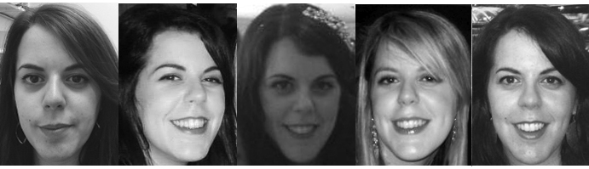
In addition to the above test stimuli we included control stimuli designed to ensure that each participant understood the task and remained attentive throughout. For each of the teachers, an unfamiliar dissimilar identity was selected (e.g., celebrities from XXXX who are not famous in XXXX). The dissimilar identities looked very different from the teachers (e.g., if the teacher had dark hair and a long, thin face then the dissimilar identity had light blonde hair and a round, plump face). A single image of each dissimilar identity was obtained via a Google image search. Four copies were embedded among the test stimuli. In addition one image of the teacher was selected to go on the front of a toy house and four copies of that image were embedded among the test stimuli. Children were required to include at least three of these exact image matches and no more than one instance of the dissimilar identity to be included in the final sample; all participants met this criterion.
All images were cropped so that only the head was visible, converted to greyscale and printed on card measuring 38 x 50 mm in size.
Training stimuli. Five pictures of Buzz Lightyear and four pictures of Noddy were obtained using a Google image search. The images were selected and prepared using the same criteria as Jenkins et al. (2011) and one image of Buzz Lightyear was selected to go on the front of a toy space ship.
Design and Procedure
Teacher task. The entire procedure received clearance from the Research Ethics Board at XXXX XXXX. We obtained informed written consent from each child’s parent and verbal assent from each child. Each child was presented with a house on which we mounted a single image of either a familiar teacher or an unfamiliar woman. The experimenter then explained: “This is Mrs. Smith’s house. Look, there’s a picture of Mrs. Smith on the front of the house. Have you ever seen Mrs. Smith before? I’ve got a pile of pictures; some of the pictures are of Mrs. Smith and some of the pictures are of other people. All of the pictures of Mrs. Smith need to go in the house but we have to be careful that no one else’s pictures go inside. Do you think you can help me put all of the pictures of Mrs. Smith inside her house? Great!” The experimenter then proceeded to give each picture to the child and the child was asked, “Does this picture go into Mrs. Smith’s house?” When the teacher was familiar to the child we used her real name.
There were a total of 26 pictures (trials): nine different pictures of the teacher; nine different pictures of an identity who looked physically similar to the teacher (matched identity); four images identical to the image on the front of the house (criterion trials); and four identical images of an identity who looked very dissimilar to the teacher (criterion trials). The pictures were divided into three blocks. In each block there were three pictures of the teacher, three pictures of the matched identity, and two criterion trials (one identical image and one image of the dissimilar identity). The images in each block were presented in a random order. After completing the three blocks each child completed two final criterion trials: one identical image and one dissimilar identity. This was to verify that each child had remained attentive through the experiment.
Training task. The teacher task was preceded by a training task in which each child was presented with Buzz Lightyear’s spaceship and a pile of nine pictures comprising five pictures of Buzz (one of which was identical to the image on the spaceship) and four pictures of another character (Noddy). They were instructed to place all images of Buzz into the spaceship but to keep Noddy out. To ensure that children understood both the importance of discriminating between identities and that Buzz’s appearance could change, they were required to put four out of the five images of Buzz inside the house and to place all pictures of Noddy aside to be included in our analyses. All but one child (a 10-year-old) met this criterion.
Results
Primary Analyses
Every child recognized all four of the images identical to the image on front of the house, and none of the children put any of the four images of the dissimilar distractor inside the house. Analyses were based on trials in which the teacher and her matched identity were presented. Signal detection theory (d’) was used to estimate accuracy: a hit was defined as putting a picture of the teacher into the house, a miss as placing a picture of the teacher outside of the house, and a false alarm as putting a picture of the matched identity into the house. Because adults’ performance on a comparable task varies for familiar vs. unfamiliar faces (Jenkins et al., 2011) we analyzed performance separately for familiar and unfamiliar faces. To better understand age-related changes in accuracy we conducted parallel follow-up analyses of hits and false alarms. Figure 2 shows age-related changes in d’, hits, and false alarms as a function of age for unfamiliar and familiar faces.
Unfamiliar Faces. Accuracy (M_{percentage correct} = 66.51%, s.e. = 1.79%) improved with age, as reflected in the significant correlation between age and d’, r = .36, p = .002. Children could make two kinds of errors: misses and false alarms. The mean number of misses (M = 4.41, s.e. = .35) was greater than the mean number of false alarms (M = 1.61, s.e. = .27, t (72) = 5.17, p < .001, r = .97) indicating that, like adults, recognizing an identity despite variability in appearance was more challenging than discriminating the two identities present. Although hits tended to increase with age, r = .19 and false alarms tended to decrease, r = -.17, neither correlation was significant, ps = .10 and .15, respectively. This indicates that age-related changes in recognition and discrimination both contributed to improved accuracy. This is consistent with our finding that the total number of faces put into the house was not correlated with age, r = .04, p = .74. Thus improved accuracy with age cannot be attributed simply to young children putting more or fewer pictures into the house compared to older children.
Familiar Faces. Accuracy (M_{percentage correct} = 92.51%, s.e. = 1.47%) improved with age, as reflected in the significant correlation between age and d’, r = .44, p < .001. Both misses (M = 1.03, s.e. = .24) and false alarms (M = .32, s.e. = .15) were rare, with misses occurring more frequently than false alarms, t (65) = 2.44, p = .02, r = .87. As with unfamiliar faces, the correlation between the number of false alarms and age was not significant, r = -.18, p = .16. However, there was a significant correlation between age and the number of hits, r = .38, p = .002, suggesting that the ability of children to recognize their teacher increased with age. We note, however, that the age range of children tested with a familiar face included 4- and 5-year-olds whereas the age range of children tested with unfamiliar faces did not. Thus, we conducted another set of analyses including only children aged 6 to 12 years (n = 34) who were tested with a familiar face. Their performance approached ceiling (M_{percentage correct} = 98.20%, s.e. = .80%). Almost every picture of the teacher was placed in the house (M = 8.82, s.e. = .13), pictures of the distractor were almost always kept out (M_{false alarms}= .15, s.e., = .07), and age did not correlate with any of our measures, ps > .24. Thus, by 6 years of age children, like adults, perform (nearly) without error when tested with familiar faces, with improvements between 4 and 6 years of age.

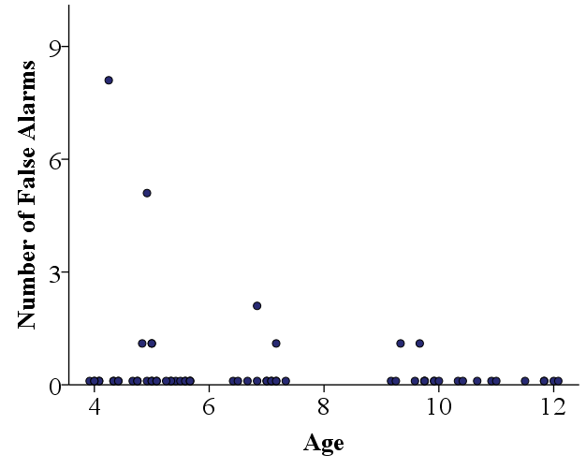
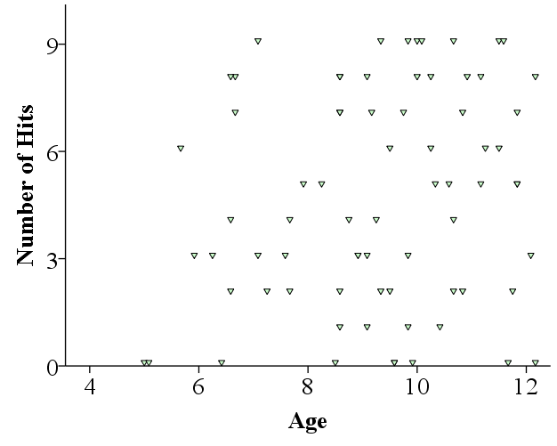
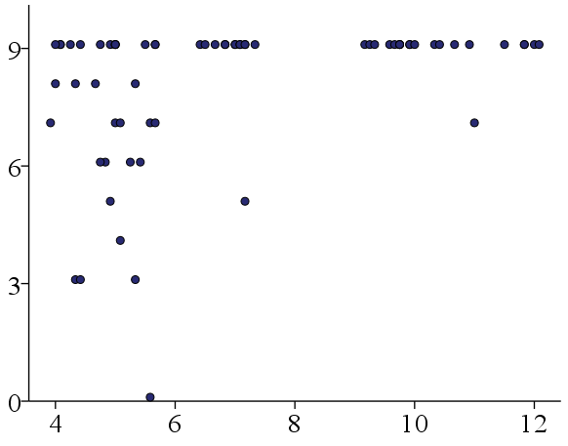
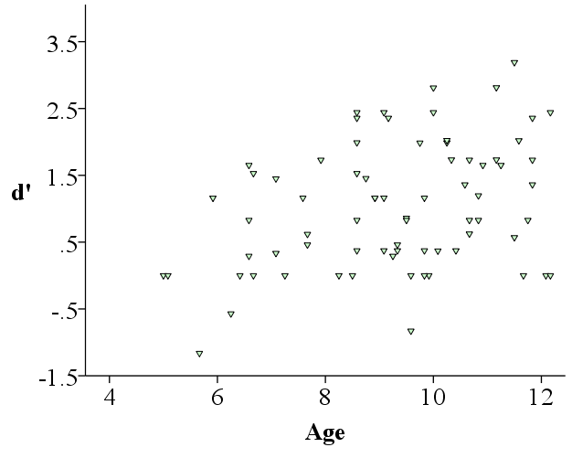
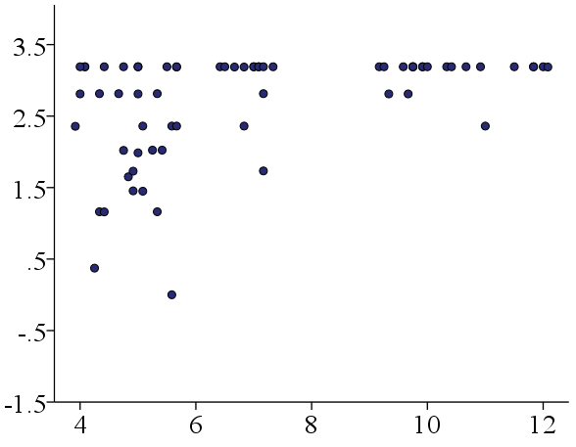
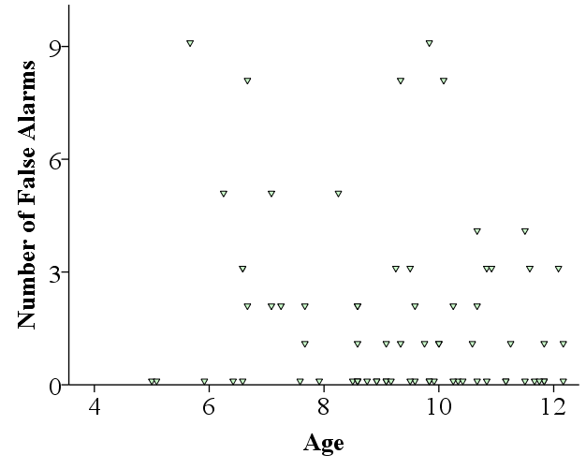
Figure 2. Children’s accuracy (d’), hits and false alarms for unfamiliar (a, c, e) and familiar (b, d, f) faces. Each dot represents the data for an individual child.
f)
d)
b)
e)
c)
a)
a)
c)
e)
Supplemental Analyses
General cognitive development. It is important to ask the extent to which age-related improvements in recognition of a target identity can be attributed to general cognitive development (e.g., a decrease in concentration over trials). For unfamiliar faces, a repeated measures ANOVA with Block as the repeated measure and age as a covariate showed there was no effect of block on accuracy (d’), p = .78, recognition (hits), p = .26, or discrimination (false alarms), p = .09. For familiar faces, older children performed essentially without error and so we analyzed whether performance of younger children (aged 4 and 5 years) changed across blocks. There was no change in performance across blocks: Repeated measures ANOVAs with Block as the within-subjects variable revealed no effect of block on accuracy (d’), p = .34, recognition (hits), p = .40 or discrimination (false alarms), p = .45. Collectively these analyses show that improvements in performance as a function of age cannot be attributed to young children losing concentration over time.
To further verify that deterioration in young children’s performance across blocks (e.g., loss of concentration) did not contribute to a significant effect of age we replicated our primary analyses but restricted our analysis to the first block of trials. We found a significant correlation between age and d’ for unfamiliar (r = .35, p = .003) and familiar (r = .34, p = .008) faces. The number of hits increased with age for familiar (r = .30, p = .02), but not unfamiliar (r = .18, p = .14) faces. The correlation between age and false alarms was not significant for unfamiliar (r = -.2, p = .09) or familiar (r = -.15, p = .23) faces. This pattern of results replicates the findings from the main analysis including all the trials.
Image analysis. One strength of our paper is that children were tested with five different unfamiliar identities, each of which also served as a familiar identity for other children. The number of children tested with each identity varied (n = 12 to 21) but the age ranges were comparable. Thus the developmental pattern observed cannot be attributed to any one identity and the difference in performance for familiar and unfamiliar faces cannot be attributed to stimulus effects. To determine whether some images were especially hard to match we calculated the proportion of children who placed each target image in the house and then calculated the mean and standard deviation across images. We identified seven images that fell more than 1SD below the mean; three of these differed from the target image in hairstyle (e.g., hair shorter/longer), one in the presence/absence of glasses, one in both hairstyle and the presence/absence of glasses, and one in other paraphernalia (the test image included a small crown whereas the target face did not). The final image did not deviate from the target in any easily identifiable way and none of the seven images differed in expression. Although this suggests that such changes may cross a threshold that children use to discriminate identities, we note that five other images differed similarly from the target face and yet were not especially difficult.
Another strength of our study is that children were tested with six different personally familiar adult identities. The number of children tested with each identity varied (between 3 and 27) because we could only test children who returned the consent form. One teacher was tested only with older children (> 6 years of age), the age range in which performance was (nearly) perfect (Mean d’ = 3.10); she did not instruct 4- and 5-year-olds. It is unlikely that (nearly) perfect performance among older children can be attributed to this identity because 1) we tested children from another school with the same identity and saw improvement with age, and 2) we saw similar performance among the seven children who were more than 6 years of age and tested with two other identities (Mean d’ = 2.93).
Three of the six teachers were familiar to >10 children. To determine whether some images were especially hard to match we calculated the proportion of children who put each image into the house and then calculated the mean and standard deviation. (We did not include the remaining identities in this analysis because sorting of particular images for these identities might reflect the spurious behavior of one child.) Across identities accuracy for two images fell below 1SD of the mean. Although one image differed from the target image in the presence/absence of glasses, so too did one other image that was successfully placed in the house. No feature distinguished the other image.
Duration of familiarity. There was some variability in how long children had known their teacher, a potential confound highlighted by Ge et al. (2008). Some 4- to 5-year-olds were tested late in November (i.e., after knowing their teacher for 3 months) in contrast to (all but one) older children who were tested in April or May (i.e., after knowing their teacher for 8 or 9 months). Again, this variability simply reflects the difficulty in obtaining teacher photos and then consents from children in the same classroom. The performance of children tested after knowing their teacher for 3 months (Mean d’ = 2.51, s.e. = .21) was comparable to (or slightly better than) that of the remaining 13 4- and 5-year-olds who were tested after knowing their teacher for 8 or 9 months (Mean d’ = 1.99, s.e. = .23). Thus, the shorter period of familiarity for these children cannot explain improved recognition of familiar faces between 3 and 6 years of age.

Discussion
To our knowledge, this is the first time children's recognition of familiar and unfamiliar faces has been measured using a task that is representative of the challenges encountered in the real world (e.g., in a task measuring recognition of identity in unconstrained natural images that incorporate within-person variability). It is also one of very few studies comparing children’s recognition of unfamiliar versus personally familiar faces (see also Bonner & Burton, 2004; Diamond & Carey, 1977; Ge et al., 2008; Newcombe & Lie, 1995; Wilson et al, 2009) and no previous study making this comparison has involved multiple images of familiar identities. Our results include two key findings. First, they provide evidence that children, like adults (Jenkins et al., 2011), are able to tolerate more variability for familiar than for unfamiliar faces. Second, they provide evidence that children's ability to recognize identity in natural images that incorporate within-person variability improves with age, with adult-like performance achieved at a younger age for familiar faces. After 6 years of age children performed (nearly) without error when tested with familiar faces whereas performance continued to improve when tested with unfamiliar faces. Although perfect or nearly perfect performance often is problematic because ceiling effects can mask developmental change, such a concern is not warranted here; in this design perfect performance indicates achievement of adult-like expertise. The fact that perfect performance was not achieved in children for whom the identities were unfamiliar suggests that our stimulus set was challenging. These results have important theoretical implications for debates about face-specific development during childhood as well as practical implications (e.g., for eye-witness testimony).
Our finding age-related improvements in unfamiliar identity recognition between 6 and 12 years of age is consistent with evidence from several studies showing age-related improvements in recognition of previously unfamiliar faces across smaller variations in appearance (e.g., Bruce et al., 2000; Mondloch et al., 2003; de Heering et al., 2012; Megreya & Bindemann, 2015; but see Crookes & Robbins, 2014 for computer-generated faces). Our experimental design has several distinct advantages. First, it allows us to separate the development of discrimination (telling people apart) versus recognition (recognizing identity across images that capture natural variation in appearance). Second, our task minimized memory demands because one image of the target identity was visible at all times. Weigelt et al. (2014) claim that although there is face-specific improvement in memory throughout childhood, there is no face-specific perceptual development after 5 years of age. Our task is perceptual in nature and thus contributes to this debate. Third, it directly compares performance for familiar versus unfamiliar faces because images of all but one teacher were shown to children in both the unfamiliar and familiar condition; this controls for stimulus effects. We discuss each of these points below.
Discrimination versus Recognition
A number of other studies investigating children’s view-invariant face recognition used choice-from-array (e.g., delayed match-to-sample) tasks (e.g., Bruce et al., 2000; Mondloch et al., 2003; de Heering et al, 2012; Anzures et al., 2013; Crookes & Robbins, 2014). A limitation of such tasks is that under conditions of uncertainty, children can rely on a process of elimination to complete the task (e.g., “the face on the left is not the target so I’ll select the face on the right”) because on each trial they are forced to choose one face as the correct response. Thus accurate performance might not reflect recognition per se; it might only reflect discrimination. Children use a similar elimination strategy when it comes to identifying novel facial expressions (e.g., Nelson & Russell, 2015) and words that they have never heard before (e.g., Carey & Bartlett, 1978). In our task a single face was presented on each trial. On each trial on which the teacher’s face was presented children had an opportunity to demonstrate recognition; the number of hits thus reflects their sensitivity to identity despite within-person variability in appearance. On each trial on which the similar distractor was presented children had an opportunity to demonstrate discrimination; the number of false alarms reflects children’s ability to tell two identities apart. Accuracy increased with age for unfamiliar faces; neither hits nor false alarms were significantly correlated with age indicating that changes in both recognition and discrimination contributed to improved performance.
Our results contradict those of Crookes and Robbins (2014) who found no difference in view-invariant face recognition between 8-year-olds and adults. In an old/new recognition task they matched adults’ and 8-year-olds’ accuracy in a same-view condition by adjusting the number of faces studied; the decrement in performance in their different-view condition was similar for the two age groups. However, they used highly controlled computer generated faces (minimizing variability) and their 2AFC task does not allow one to infer the strategy that children were using to complete the task (rejecting the foil vs. recognizing the target). Our results suggest that children’s invariant recognition (e.g., their ability to recognise a person despite variability in their appearance) does improve with age—at least when viewing photographic images of real faces that include natural variability in appearance.
Perception versus Memory
Weigelt et al. (2014) suggest a developmental dissociation for face perception and face memory, with no face-specific perceptual development after 5 years of age but continuing development of face-specific memory until age 10 (see also Crookes & Robbins, 2014; McKone et al., 2012). Our findings provide evidence that face-specific perceptual development might well continue throughout childhood; when tested with unfamiliar identities, performance improved between 6 and 12 years of age (see also Megreya & Bindemann, 2015).
Our task was designed to be perceptual in nature; memory demands were completely eliminated (although children for whom the target face was familiar were able to rely on previous experience with their teacher’s face). The house had a photograph of the teacher on the front, allowing children to compare each photograph in the pile with the photograph on the house. However, whereas previous studies required children to match nearly identical images (e.g., that differed only in viewpoint or emotional expression and were taken on the same day under similar lighting conditions), our task required them to recognize an identity across naturally varying images. Burton (2013) argues that identity recognition—the ability to recognize identity in natural, rather than tightly controlled, images—is a critical component of face recognition that has been largely ignored. As noted by Burton, “it is always easier to recognize a picture then to recognize the face” (p. 1469). Our findings suggest that when identity perception rather than image/picture perception is measured, development of identity perception of unfamiliar identities continues throughout childhood.
Familiar versus Unfamiliar Face Recognition
Our data indicate that the developmental trajectory for recognizing unfamiliar faces is different than that for familiar faces. The ability to recognize unfamiliar identities improved between 6 and 12 years age. In contrast, recognition of familiar identities continued to improve until 6 years of age, with no evidence for age-related improvement after that. This is consistent with Burton’s argument that there is an important difference between familiar and unfamiliar face recognition (Burton, 2013). In contrast to Weigelt et al. (2014) who found that memory for faces learned in the context of the experiment was close to chance performance in 5-year-olds, we found that familiar face recognition was good in 4- to 5-year-olds (a number of children performed without error), and (nearly) without error by 6 years of age. Unlike the children in Weigelt et al’s study, children tested with familiar identities in our study could base their decisions on preexisting knowledge of their teacher’s appearance in addition to the perceptual information available on each trial. It therefore seems that even very young children are able to build abstract representations of identity that are sufficient to allow recognition even when viewing never-before-seen images, at least for identities with longstanding representations (Burton et al., 2005; Burton et al., 2011). An interesting direction for future research will be to find out whether children take longer than adults to acquire robust representations for faces. The fact that 4- and 5-year-olds in our study made errors even when sorting familiar faces suggests that they do.
Domain-Specific vs. Domain-General Effects
Performance on any perceptual task, including face recognition, is influenced by general cognitive factors (e.g., selective attention, concentration, visual development [e.g., Vernier acuity]) as well as domain-specific abilities. Crookes and Robbins (2014) take the strong view that “improvement with age observed on face tasks results entirely from general development rather than face-specific development” (page 104). We reasoned that asking children to sort 40 photographs, as in Jenkins et al. (2011), would be challenging as such a task requires that they keep track of multiple images in multiple piles. Thus we created a child-friendly version of the Jenkins task in which children made a binary decision on each trial. We do not deny that general cognitive development might influence performance on this task. However, several pieces of evidence suggest that its influence on our key findings is minimal. First, children performed without error when given an image that was an exact match to the image mounted on the house for both familiar and unfamiliar identities. They also performed without error when given an image of a highly dissimilar identity. These control stimuli (four each) were evenly distributed across blocks, suggesting no decline in attention or concentration—at least on these relatively easy trials. Second, failure to discriminate (the number of false alarms for the matched identity) did not vary as a function of age or across blocks, regardless of whether children were tested with a familiar or unfamiliar identity. Third, recognition did not decline across blocks and an analysis of accuracy during the first block of trials yielded the same pattern of results as the analysis collapsed across all trials. We contend that our observed age-related improvements in identity recognition are, at least in part, attributable to face-specific effects.

Theoretical Implications
Our data call for new ways of thinking about the development of face recognition that incorporate within-person variability. The ability to recognize identity despite within-person variability in appearance can be conceptualized in the light of recent extensions of Valentine's (1991) influential model, in which each individual face is represented as a unique point in a multidimensional face space. The location of each face is determined by its values on the dimensions underlying face space, along which faces vary. These characteristics might be features and their spacing (e.g., nose length, distance between the eyes,) or more abstract dimensions (e.g., eigenfaces; Hancock, Burton & Bruce, 1996). The dimensions of face space are refined through perceptual experience to represent the facial properties that are optimal for discriminating identities from highly familiar categories (see O’Toole & Natu, 2013 for a discussion).
Recent extensions of this model take into account natural variability in appearance by incorporating attractor fields/identity regions. Attractor fields around each point in face space (Tanaka & Corneille, 2007; Tanaka, Giles, Kremen & Simon, 1998; see also Lewis & Johnston, 1999) reflect the range of inputs that are perceived as belonging to a given identity, allowing recognition despite changes in appearance. For example, all recognizable images of our neighbour would be represented within her attractor field. The size of an identity’s attractor field is constrained by the density of nearby representations (i.e., by its location in face space). This was directly shown by Tanaka and colleagues (Tanaka et al., 1998; Tanaka & Corneille, 2007; Tanaka, Meixner & Kantner, 2011) who reported that 50/50 morphs between two “parent” faces are perceived as more closely resembling the distinctive parent than the typical parent, consistent with distinctive faces having bigger attractor fields because they reside in a less populated area of face space (but also see Burton & Vokey, 1998).
Development has been characterized in terms of the refinement of face space (Short et al., 2014)—an increased sensitivity to differences along the dimensions of face space (e.g., Anzures et al., 2009; Jeffery et al., 2010) and an improved ability to rely on multiple dimensions simultaneously (Nishimura, Maurer & Gao, 2009; Tanaka et al., 2014). As noted by Johnston & Ellis (1995), adding exemplars to face space, as happens during childhood, likely increases inter-face distances; one obvious implication of this is improved discrimination. Our findings suggest that increased sensitivity to the dimensions along which faces vary (i.e., larger inter-face distances) also increases children’s ability to recognize identity when appearance varies. One way to conceptualize development, then, is in terms of increases in the size of attractor fields.
This explanation is consistent with evidence that adults’ face memory and their ability to recognize an unfamiliar identity across natural variation in appearance are both affected by experience. Adults who encountered fewer faces during childhood by virtue of growing up in a rural environment make more errors on a face memory task than adults who grew up in an urban environment (Balas & Seville, 2015) perhaps because they have a more compact face space with smaller attractor fields. Likewise, adults make more piles when sorting other-race faces than own-race faces (Laurence, Zhou, & Mondloch, 2015), suggesting that limited experience with other-race faces leads to those faces having smaller attractor fields. Just as variability in input facilitates language development, so too does it affect the refinement of face space (see Watson, Robbins, & Best, 2014).
Limitations & Future Directions
One possible limitation of this study was that only teachers’ faces were used as familiar stimuli. Although each child tested with a familiar teacher had known their teacher for a minimum of 3 months (with no difference in performance between children who had known their teacher for 3 versus 9 months), it is possible that children would show adult-like tolerance to variability for their caregiver’s face due to children’s early advantage with these faces. Newborn infants show a preference for their mother’s face (Pascalis, De Schonen, Morton, Deruelle, & Fabre-Grenet, 1995; Bushnell, 2001), and older infants show adult-like patterns of recognition for their mother’s face, such as recognition despite geometric distortions (Yamashita, Kanazawa & Yamaguchi, 2014) and masking of external features (Bartrip, Morton, & de Schonen, 2001), as well as inversion effects (Balas et al. 2009). In short, representations for caregivers might be more robust than for other familiar faces due to them being highly overlearned (Tong & Nakayama, 1999).
A second possible limitation is that we did not present non-face stimuli to our participants. Strictly speaking, this means that we cannot conclude whether the age-related improvements we observed are face specific. One of the challenges in addressing this question is to find appropriate control stimuli. Weigelt et al. (2014) compared perception of and memory for faces to three other stimulus categories that shared critical characteristics with faces: bodies (another social stimulus), cars (another object class with reasonably consistent first-order relations), and scenes (another stimulus class associated with discrete brain regions). Cars and scenes both differ from faces in a critical way: Neither varies in appearance in a way that is analogous to faces. Whereas the appearance of an individual face varies from moment to moment due to both internal factors (e.g., emotional expressions, direction of eye gaze, makeup) and external factors (e.g., camera angle, lighting conditions) the appearance of both cars and scenes is more stable. Although bodies can change in appearance from moment to moment (e.g., as a person moves) there is no evidence of expertise in individual body identity to our knowledge. The special challenge associated with identity recognition is the ability to recognize identity in natural images in which appearance varies; we know of no other stimulus class for which this is true. Whether experts with other biological categories (e.g., dog experts) show this extraordinary ability to recognize individual exemplars across variation in appearance remains to be seen.
To date, only one previous study has attempted to examine developmental changes in the size of attractor fields; however, this study investigated face recognition in infants rather than across childhood. Humphreys and Johnson (2007) habituated 4- and 7-month-old infants to one identity and then presented them with a morphed continuum in which that identity was morphed with another face. Younger infants were less sensitive to differences between morphed faces than older infants who, in turn, were less sensitive than adults; Humphreys and Johnson concluded that the size of attractor fields decreases during infancy. However two characteristics of their study warrant caution. First, each identity was represented by a single image; therefore, the range of variability represented in their stimuli was not representative of real world variability. Second, studies in which a single stimulus is presented during habituation are best suited to measure discrimination rather than recognition of an object/category across variability in appearance. To measure infants’ ability to recognize identity across variability in appearance (i.e., their ability to form a category ‘Alice’,) a method akin to that used to study categorization is needed whereby infants are habituated to multiple exemplars of one identity and then tested with a novel image of the familiar identity versus a novel identity (see Quinn, 2002 for an example). An interesting direction for future research will be to find out if infants, like children, will show increasing tolerance for natural variability in familiar and unfamiliar faces (see Watson et al., 2014 for a discussion).
Finally our task had a different structure than that of Jenkins et al. (2011). An advantage of our task is that it is likely less cognitively demanding because children did not need to keep track of 40 photographs simultaneously; rather, they made a yes/no decision for each image. Nonetheless, an advantage of Jenkins’ sorting task is that participants are free to make as many or as few piles as they like. Future research should examine whether these two tasks yield similar outcomes.
Summary
In summary, the current study used a child-friendly face-sorting task to investigate children’s ability to recognise an identity in images containing within-person variability. Overall, our findings show that children’s recognition of both familiar and unfamiliar faces improves with age, with adult-like performance achieved at a younger age for familiar faces. Their improvement was driven both by their ability to discriminate between two identities and their ability to recognise a single identity in images containing within-person variability, an ability that has been ignored in the vast majority of previous work. These findings support a framework where face recognition is not yet adult-like during childhood.

Acknowledgements
Removed for the purpose of blind review.

References
Allison, T., McCarthy, G., Nobre, A., Puce, A., & Belger, A. (1994). Human extrastriate visual cortex and the perception of faces, words, numbers, and colors. Cerebral Cortex, 4(5), 544-554. doi:10.1093/cercor/4.5.544
Anzures, G., Mondloch, C. J., & Lackner, C. (2009). Face adaptation and attractiveness aftereffects in 8‐year‐olds and adults. Child Development, 80(1), 178-191. doi:10.1111/j.1467-8624.2008.01253.x.
Anzures, G., Quinn, P. C., Pascalis, O., Slater, A. M., Tanaka, J. W., & Lee, K. (2013). Developmental origins of the other-race effect. Current Directions in Psychological Science, 22(3), 173-178. doi:10.1177/0963721412474459
Balas, B. J., Nelson, C. A., Westerlund, A., Vogel-Farley, V., Riggins, T., & Kuefner, D. (2009). Personal familiarity influences the processing of upright and inverted faces in infants. Frontiers in Human Neuroscience, 4(1), 1-6. doi:10.3389/neuro.09.001.2010
Balas, B., & Saville, A. (2015). N170 face specificity and face memory depend on hometown size. Neuropsychologia, 69, 211-217. doi:10.1016/j.neuropsychologia.2015.02.005
Bartrip, J., Morton, J., & de Schonen, S. (2001). Responses to mother's face in 3 week to 5-month old infants. British Journal of Developmental Psychology, 19(2), 219-232. doi:10.1348/026151001166047
Baudouin, J. Y., Gallay, M., Durand, K., & Robichon, F. (2010). The development of perceptual sensitivity to second-order facial relations in children. Journal of Experimental Child Psychology, 107(3), 195-206. doi:10.1016/j.jecp.2010.05.008
Bentin, S., Allison, T., Puce, A., Perez, E., & McCarthy, G. (1996). Electrophysiological studies of face perception in humans. Journal of Cognitive Neuroscience, 8(6), 551-565. doi:10.1162/jocn.1996.8.6.551
Bonner, L., & Burton, A. M. (2004). 7–11 year old children show an advantage for matching and recognizing the internal features of familiar faces: Evidence against a developmental shift. The Quarterly Journal of Experimental Psychology Section A, 57(6), 1019-1029. doi: 10.1080/02724980343000657
Bruce, V., Campbell, R. N., Doherty‐Sneddon, G., Langton, S., McAuley, S., & Wright, R. (2000). Testing face processing skills in children. British Journal of Developmental Psychology, 18(3), 319-333. doi:10.1348/026151000165715
Burton, A. M. (2013). Why has research in face recognition progressed so slowly? The importance of variability. The Quarterly Journal of ExperimentalPsychology, 66(8),1467-1485. doi:10.1080/17470218.2013.800125
Burton, A. M., Jenkins, R., Hancock, P. J., & White, D. (2005). Robust representations for face recognition: The power of averages. Cognitive Psychology, 51(3), 256-284. doi:10.1016/j.cogpsych.2005.06.003
Burton, A. M., Jenkins, R., & Schweinberger, S. R. (2011). Mental representations of familiar faces. British Journal of Psychology, 102(4), 943-958. doi:10.1111/j.2044-8295.2011.02039.x
Burton, A. M., & Vokey, J. R. (1998). The face-space typicality paradox: Understanding the face-space metaphor. The Quarterly Journal of Experimental Psychology: Section A, 51(3), 475-483. doi: 10.1080/713755768
Bushnell, I. W. R. (2001). Mother's face recognition in newborn infants: Learning and memory. Infant and Child Development, 10(1-2), 67-74. doi:10.1002/icd.248
Carey, S., & Bartlett, E. J. (1978). Acquiring a single new word. Papers and Reports on Child Language, 15, 17-29.
Crookes, K., & Robbins, R. A. (2014). No childhood development of viewpoint invariant face recognition: Evidence from 8-year-olds and adults. Journal of Experimental Child Psychology, 126, 103-111. doi:10.1016/j.jecp.2014.03.010
de Heering, A., Houthuys, S., & Rossion, B. (2007). Holistic face processing is mature at 4 years of age: Evidence from the composite face effect. Journal of Experimental Child Psychology, 96(1), 57-70. doi:10.1016/j.jecp.2006.07.001
de Heering, A., Rossion, B., & Maurer, D. (2012). Developmental changes in face recognition during childhood: Evidence from upright and inverted faces. Cognitive Development, 27(1), 17-27. doi:10.1016/j.cogdev.2011.07.001
Diamond, R., & Carey, S. (1977). Developmental changes in the representation of faces. Journal of Experimental Child Psychology, 23(1),1-22. doi:10.1016/0022-0965(77)90069-8
Freire, A., & Lee, K. (2001). Face recognition in 4-to 7-year-olds: Processing of configural, featural, and paraphernalia information. Journal of Experimental Child Psychology, 80(4), 347-371. doi:10.1006/jecp.2001.2639
Ge, L., Anzures, G., Wang, Z., Kelly, D. J., Pascalis, O., Quinn, P. C., ... & Lee, K. (2008). An inner face advantage in children’s recognition of familiar peers. Journal of Experimental Child Psychology, 101(2), 124-136. doi:10.1016/j.jecp.2008.05.006
Gilchrist, A., & McKone, E. (2003). Early maturity of face processing in children: Local and relational distinctiveness effects in 7-year-olds. Visual Cognition, 10(7), 769-793. doi:10.1080/13506280344000022
Hancock, P. J., Bruce, V., & Burton, A. M. (2000). Recognition of unfamiliar faces. Trends in Cognitive Sciences, 4(9), 330-337. doi:10.1016/S13646613(00)01519-9
Hancock, P. J., Burton, A. M., & Bruce, V. (1996). Face processing: Human perception and principal components analysis. Memory & Cognition, 24(1), 26-40. doi: 10.3758/BF03197270
Hills, P. J., Holland, A. M., & Lewis, M. B. (2010). Aftereffects for face attributes with different natural variability: Children are more adaptable than adolescents. Cognitive Development, 25(3), 278-289. doi:10.1016/j.cogdev.2010.01.002
Hole, G. J. (1994). Configurational factors in the perception of unfamiliar faces. Perception, 23(1), 65-74. http://dx.doi.org/10.1068/p230065
Humphreys, K., & Johnson, M. H. (2007). The development of “face-space” in infancy. Visual Cognition, 15(5), 578-598. doi:10.1080/13506280600943518
Jeffery, L., McKone, E., Haynes, R., Firth, E., Pellicano, E., & Rhodes, G. (2010). Four to-six-year-old children use norm-based coding in face-space. Journal of Vision, 10(5), 1-19. doi:10.1167/10.5.18
Jenkins, R., White, D., Van Montfort, X., & Burton, A. M. (2011). Variability in photos of the same face. Cognition, 121(3), 313-323. doi:10.1016/j.cognition.2011.08.001
Johnston, R. A., & Edmonds, A. J. (2009). Familiar and unfamiliar face recognition: A review. Memory, 17(5), 577-596. doi:10.1080/09658210902976969
Johnston, R. A., & Ellis, H. D. (1995). Age effects in the processing of typical and distinctive faces. The Quarterly Journal of Experimental Psychology, 48(2), 447 465. doi:10.1080/14640749508401399
Kanwisher, N., McDermott, J., & Chun, M. M. (1997). The fusiform face area: A module in human extrastriate cortex specialized for face perception. The Journal of Neuroscience, 17(11), 4302-4311.
Laurence, S., Zhou, X., & Mondloch, C. J. (in press). The flip side of the other-race coin: They all look different to me. British Journal of Psychology.
Lewis, M., & Johnston, R. (1999). A unified account of the effects of caricaturing faces. Visual Cognition, 6(1), 1-42. doi:10.1080/713756800
Macchi Cassia, V., Picozzi, M., Kuefner, D., Bricolo, E., & Turati, C. (2009). Holistic processing for faces and cars in preschool‐aged children and adults: Evidence from the composite effect. Developmental Science, 12(2), 236-248. doi:10.1111/j.1467-7687.2008.00765.x
Macchi Cassia, V., Turati, C., & Schwarzer, G. (2011). Sensitivity to spacing changes infaces and nonface objects in preschool-aged children and adults. Journal of Experimental Child Psychology, 109(4), 454-467. doi:10.1016/j.jecp.2011.03.003
Maurer, D., Le Grand, R., & Mondloch, C. J. (2002). The many faces of configural processing. Trends in Cognitive Sciences, 6(6), 255-260. doi:10.1016/S13646613(02)01903-4
McKone, E., & Boyer, B. L. (2006). Sensitivity of 4-year-olds to featural and second order relational changes in face distinctiveness. Journal of Experimental Child Psychology, 94(2), 134-162. doi:10.1016/j.jecp.2006.01.001
McKone, E., Crookes, K., Jeffery, L., & Dilks, D. D. (2012). A critical review of the development of face recognition: Experience is less important than previously believed. Cognitive Neuropsychology, 29(1-2), 174-212. doi:10.1080/02643294.2012.660138
Megreya, A. M., & Bindemann, M. (2015). Developmental improvement and age related decline in unfamiliar face matching. Perception, 44, 5-22. doi:10.1068/p7825
Mondloch, C. J., Geldart, S., Maurer, D., & Le Grand, R. (2003). Developmental changes in face processing skills. Journal of Experimental Child Psychology, 86(1), 67-84. doi:10.1016/S0022-0965(03)00102-4
Mondloch, C. J., Le Grand, R., & Maurer, D. (2002). Configural face processing develops more slowly than featural face processing. Perception, 31(5), 553-566. doi:10.1068/p3339
Mondloch, C. J., Pathman, T., Maurer, D., Le Grand, R., & de Schonen, S. (2007). The composite face effect in six-year-old children: Evidence of adult-like holistic face processing. Visual Cognition, 15(5), 564-577. doi:10.1080/13506280600859383
Mondloch, C. J., & Thomson, K. (2008). Limitations in 4-year-old children’s sensitivity to the spacing among facial features. Child Development, 79(5),1513-1523. doi:10.1111/j.1467-8624.2008.01202.x
Nelson, N. & Russell, J. (2015). Creating emotion categories: Children use a process of elimination to learn about novel expressions. Manuscript submitted for publication.
Newcombe, N., & Lie, E. (1995). Overt and covert recognition of faces in children and adults. Psychological Science, 6(4), 241-245. doi:10.1111/j.14679280.1995.tb00599.x
Nishimura, M., Maurer, D., & Gao, X. (2009). Exploring children’s face-space: A multidimensional scaling analysis of the mental representation of facial identity. Journal of Experimental Child Psychology, 103(3), 355-375. doi:10.1016/j.jecp.2009.02.005
Nishimura, M., Maurer, D., Jeffery, L., Pellicano, E., & Rhodes, G. (2008). Fitting the child's mind to the world: Adaptive norm-based coding of facial identity in 8 year-olds. Developmental Science, 11(4), 620-627. doi:10.1111/j.14677687.2008.00706.x
O'Toole, A. J., & Natu, V. (2013). Computational perspectives on the other-race effect. Visual Cognition, 21(9-10), 1121-1137. doi:10.1080/13506285.2013.803505
Pascalis, O., de Schonen, S., Morton, J., Deruelle, C., & Fabre-Grenet, M. (1995). Mother's face recognition by neonates: A replication and an extension. Infant Behavior and Development, 18(1), 79-85. doi: 10.1016/01636383(95)90009-8
Pellicano, E., & Rhodes, G. (2003). Holistic processing of faces in preschool children and adults. Psychological Science, 14(6), 618-622. doi:10.1046/j.09567976.2003.psci_1474.x
Pellicano, E., Rhodes, G., & Peters, M. (2006). Are preschoolers sensitive to configural information in faces? Developmental Science, 9(3), 270-277. doi:10.1111/j.1467-7687.2006.00489.x
Quinn, P. C. (2002). Category representation in young infants. Current Directions in Psychological Science, 11, 66-70. doi: 10.1111/1467-8721.00170
Rhodes, G., Jeffery, L., Taylor, L., Hayward, W. G., & Ewing, L. (2014). Individual differences in adaptive coding of face identity are linked to individual differences in face recognition ability. Journal of Experimental Psychology: Human Perception and Performance, 40(3), 897-903. http://dx.doi.org/10.1037/a0035939
Saltz, E., & Sigel, I. E. (1967). Concept overdiscrimination in children. Journal of Experimental Psychology, 73(1), 1-8. http://dx.doi.org/10.1037/h0024184
Short, L. A., Hatry, A. J., & Mondloch, C. J. (2011). The development of norm-based coding and race-specific face prototypes: An examination of 5- and 8-year olds’ face space. Journal of Experimental Child Psychology, 108(2), 338-357. doi:10.1016/j.jecp.2010.07.007
Short, L. A., Lee, K., Fu, G., & Mondloch, C. J. (2014). Category-specific face prototypes are emerging, but not yet mature, in 5-year-old children. Journal of Experimental Child Psychology, 126, 161-177. doi:10.1016/j.jecp.2014.04.004
Tanaka, J. W., & Corneille, O. (2007). Typicality effects in face and object perception: Further evidence for the attractor field model. Perception & Psychophysics, 69(4), 619-627. doi:10.3758/BF03193919
Tanaka, J., Giles, M., Kremen, S., & Simon, V. (1998). Mapping attractor fields in face space: the atypicality bias in face recognition. Cognition, 68(3), 199-220. doi:10.1016/S0010-0277(98)00048-1
Tanaka, J. W., Kay, J. B., Grinnell, E., Stansfield, B., & Szechter, L. (1998). Face recognition in young children: When the whole is greater than the sum of its parts. Visual Cognition, 5(4), 479-496. doi:10.1080/713756795
Tanaka, J. W., Meixner, T. L., & Kantner, J. (2011). Exploring the perceptual spaces of faces, cars and birds in children and adults. Developmental Science, 14(4), 762-768. doi:10.1111/j.1467-7687.2010.01023.x
Tanaka, J. W., Quinn, P. C., Xu, B., Maynard, K., Huxtable, N., Lee, K., & Pascalis, O. (2014). The effects of information type (features vs. configuration) and location (eyes vs. mouth) on the development of face perception. Journal of Experimental Child Psychology, 124, 36-49. doi: 10.1016/j.jecp.2014.01.001
Tong, F., & Nakayama, K. (1999). Robust representations for faces: Evidence from visual search. Journal of Experimental Psychology: Human Perception and Performance, 25(4), 1016-1035. http://dx.doi.org/10.1037/00961523.25.4.1016
Valentine, T. (1991). A unified account of the effects of distinctiveness, inversion, and race in face recognition. The Quarterly Journal of Experimental Psychology, 43(2), 161-204. doi:10.1080/14640749108400966
Watson, T., Robbins, R., & Best, C. (2014). Infant perceptual development for faces and spoken words: An integrated approach. Developmental Psychobiology, 56(7), 1454-1481. doi:10.1002/dev.21243
Weigelt, S., Koldewyn, K., Dilks, D. D., Balas, B., McKone, E., & Kanwisher, N. (2014). Domain‐specific development of face memory but not face perception. Developmental Science, 17(1), 47-58. doi: 10.1111/desc.12089
Wilson, R. R., Blades, M., Coleman, M., & Pascalis, O. (2009). Unfamiliar face recognition in children with autistic spectrum disorders. Infant and Child Development, 18(6), 545-555. doi:10.1002/icd.638
Yamashita, W., Kanazawa, S., & Yamaguchi, M. K. (2014). Tolerance of geometric distortions in infant's face recognition. Infant Behavior and Development, 37(1), 16-20. doi:10.1016/j.infbeh.2013.10.003
Young, A. W., Hellawell, D., & Hay, D. C. (1987). Configurational information in face perception. Perception, 16(6), 747-759. doi:10.1068/p160747

