Figure 1. Flowchart of procedure selection.

140,228 (88.5%)

30-day mortality missing: 6,258; 4.5%

Procedures in NHS England and Wales,
2013-2014

N=158,492
Age unknown or <18 or >100: 123; <0.1%
Sex unknown: 355; 0.2%
Bail-out/unknown indication: 1,131; 0.7%

Total: 1,584; 1.0%
156,908 (99.0%)

133,970 (84.5%)

Consultant ID missing: 3,245; 2.1%
Hospital with consultant ID missing >10%: 6,273; 4.0%
Within consultant’s first year in registry: 7,394; 4.7%

Total volume missing: 16,680; 10.6%
138,627 (87.5%)

In-hospital outcomes missing: 1,601; 1.1%

Figure 2 – Distribution of average operator volume
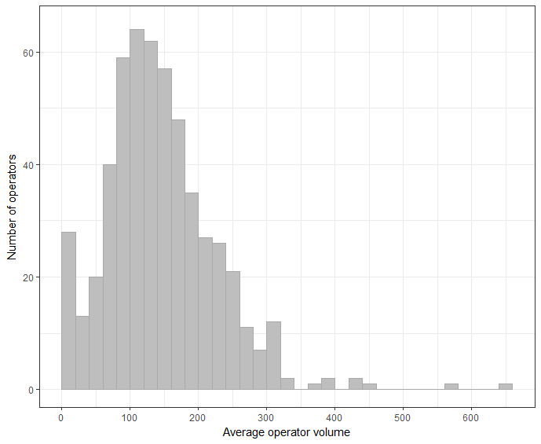
Figure 3 Operator volume versus mortality, all procedures
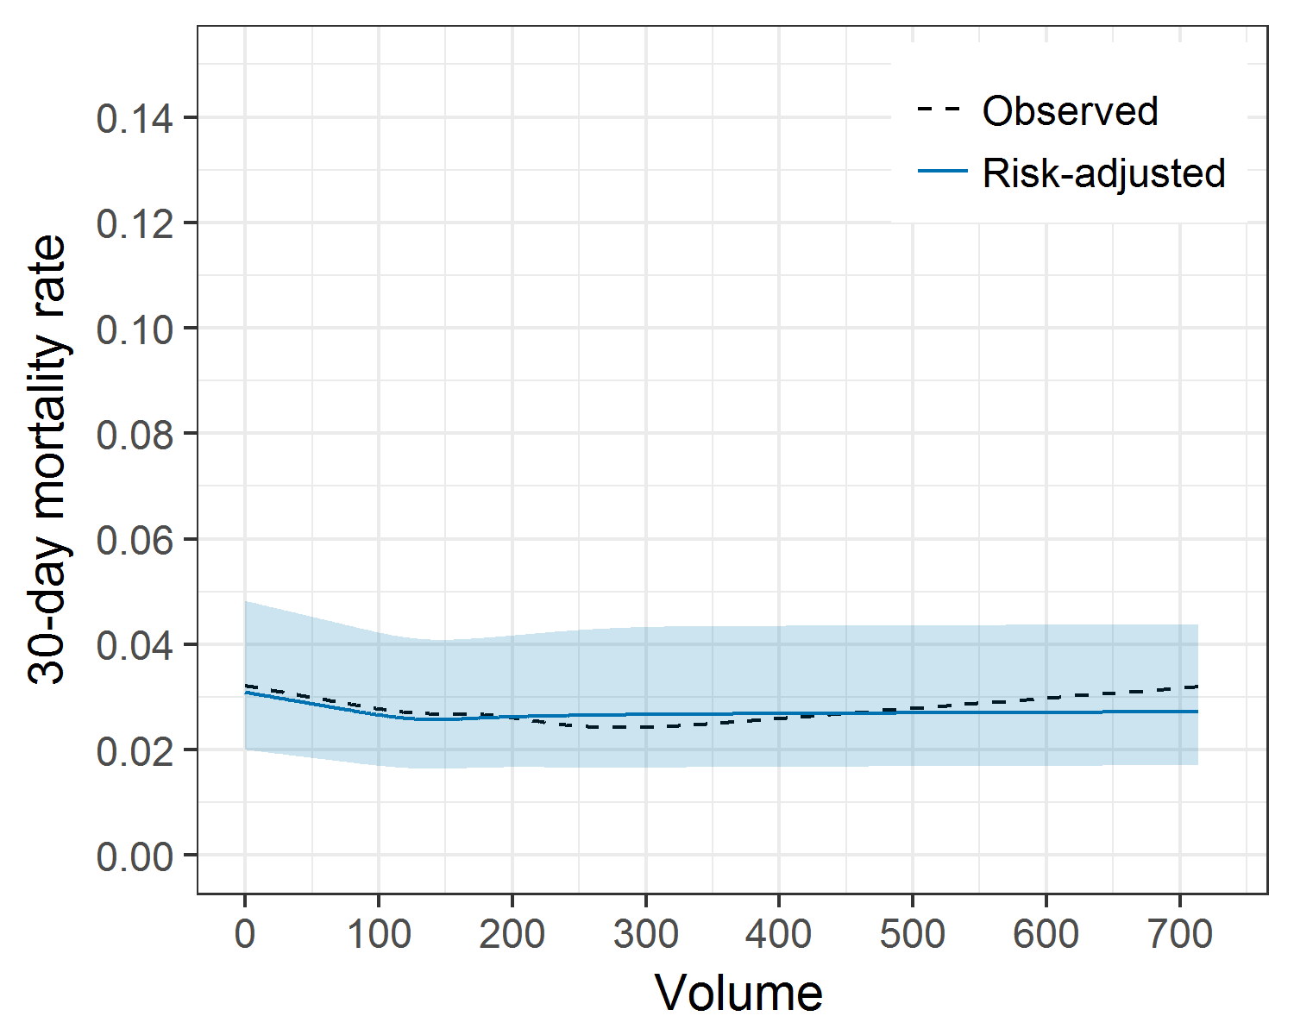
Figure 4 Operator volume versus mortality, ACS procedures
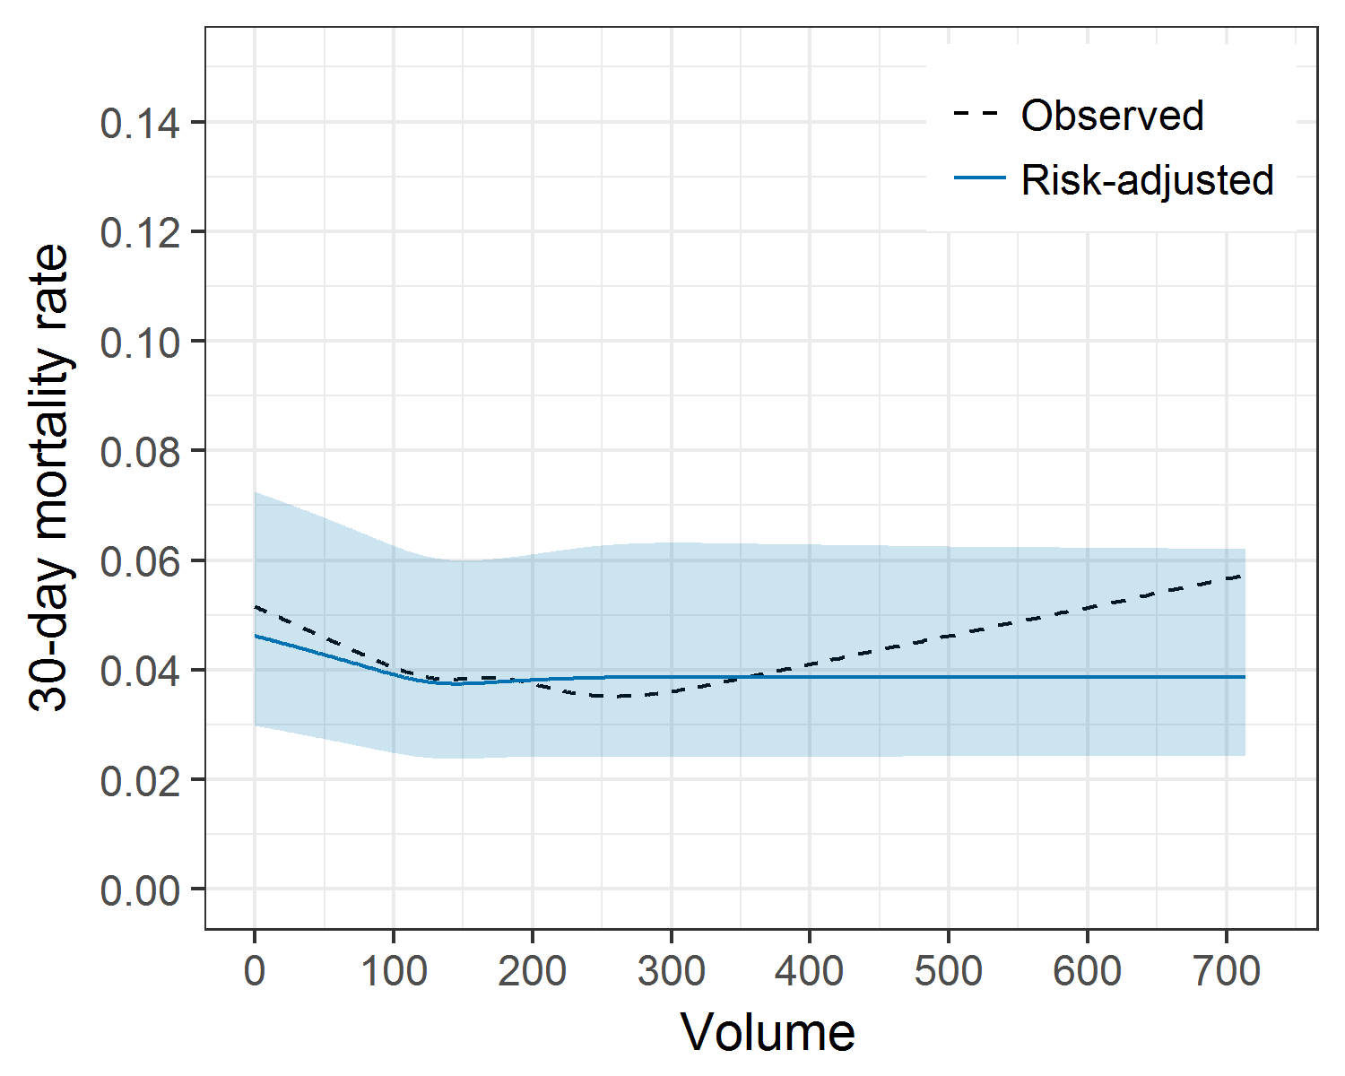
Figure 5 Operator volume versus mortality, primary PCI procedures
