Long-term Testosterone Therapy in Type 2 Diabetes is associated with reduced Mortality without improvement in conventional cardiovascular risk factors.
Geoffrey Hackett^{1,2}
Nigel Cole¹
Akhilesh Mulay³
Richard C Strange⁴
Sudarshan Ramachandran^{5, 6,7}

Department of Urology, University Hospitals Birmingham NHS Foundation Trust, West Midlands, B75 7RR, England, United Kingdom ¹
School of Health and Life Sciences, Aston University, Birmingham B4 7ET, England²
University of Cambridge, Cambridge CB2 1TN, England, United Kingdom³
Institute for Science and Technology in Medicine, Keele University Medical School, Staffordshire, ST5 5BG, England, United Kingdom⁴
Department of Clinical Biochemistry, University Hospitals of North Midlands / Faculty of Health Sciences, Staffordshire University, ST4 6QG, Staffordshire, England, United Kingdom⁵
College of Engineering, Design & Physical Sciences, Brunel University London, England, UB8 3PH⁶
Department of Clinical Biochemistry, University Hospitals of North Midlands / Faculty of Health Sciences, Staffordshire University, Staffordshire, England, United Kingdom7

Author for correspondence: Professor Geoffrey I Hackett
Department of Urology, Good Hope Hospital, University Hospitals Birmingham NHS Foundation Trust, Sutton Coldfield, West Midlands, United Kingdom, B75 7RR.
Telephone: +44(121)4247246
Email: hackettgeoff@gmail.com

Keywords
mortality, total testosterone (TT), hypogonadism (HG), testosterone replacement therapy (TRT), type 2 diabetes (T2DM), cardiovascular disease (CVD) risk factors.

Short title
Characterisation of the association between testosterone replacement and mortality.

Abstract
Background
To further characterise the beneficial impact of testosterone replacement therapy (TRT) on the association between mortality and hypogonadism (HG) in men with type 2 diabetes (T2DM). We aimed to determine firstly, if modification of cardiovascular disease (CVD) risk factors is evident, secondly whether the reduction in mortality is lost following discontinuation of TRT and finally, the presence of subgroups where benefit may be greater.
Materials and Methods
We studied 857 men with T2DM, screened for the BLAST study, over 3.8 years follow-up. The men were stratified by testosterone levels; Normal T/untreated: total testosterone (TT) >12nmol/l and free testosterone (FT) >0.25nmol/l, Low T: TT ≤12nmol/l or FT ≤0.25nmol/l and by TRT (Low T further stratified into those not on TRT (Low T/untreated) and on TRT (Low T/treated). The latter group was further stratified by whether TRT was discontinued (Low T/treated/stopped) or not (Low T/treated/continuous). The principal outcome, all-cause mortality, was studied using Cox regression.

Results
TRT was not associated with improvements in the CVD risk factors at either baseline or during follow-up. The CVD risk factors were not associated with mortality. The Normal T/untreated and Low T/treated men demonstrated lower mortality (reference: Low T/untreated) even with CVD risk factors included in regression models. Mortality was lower in the Low T/treated/stopped men (6.2%) and Low T/treated/continuous men (0%) compared to Low T/untreated men (16.9%). The lower mortality associated with Normal T/untreated and Low T/treated was only in older (>64.6 years) and less overweight (≤93.8Kg) men.
Conclusions
The benefits seen with normal testosterone levels and TRT (lasting even after discontinuation) do not appear to be related to improvements in the CVD risk factors studied. In view of TRT having greater impact in men of lower weight, better outcomes may be achieved with concurrent TRT and weight reduction programmes.

Introduction
Hypogonadism (HG), defined by low serum total testosterone (TT) (<12nmol/L) and sexual symptoms, occurs in about 70% men with type 2 diabetes (T2DM) [1]. Importantly, the European Male Ageing Study demonstrated that erectile dysfunction and low TT independently predict all-cause mortality [2]. Longitudinal studies by Muraleedaran et al [3] and Hackett et al [4] demonstrated that mortality in men with T2DM was significantly greater in those with TT ≤10.4nmol/l and ≤12.0nmol/l respectively. Such accumulating evidence has caused the American Association of Clinical Endocrinologists / American College of Endocrinology guidelines to recommend that HG should be excluded in all males with T2DM. (https://www.aace.com/files/guidelines/ObesityExecutiveSummary.pdf - accessed on 05/05/2018).

The usefulness of testosterone replacement therapy (TRT) in reversing the risk of increased mortality has been assessed in longitudinal studies; Muraleedaran et al [3] and Shores et al [5] showed reduced mortality in men with low testosterone following TRT, the former in men with T2DM. Our group also demonstrated that mortality was lower (age adjusted HR: 0.38, 95% CI: 0.16 – 0.90) in 175 men with T2DM prescribed TRT compared to that in 362 men with TT ≤12nmol/l or free testosterone (FT) ≤0.25nmol/l [4]. Further, the TRT associated benefit appeared independent of statin and phosphodiesterase 5-inhibitor (PDE5I) use. Importantly PDE5I use appeared to be strongly associated with lower mortality.

The impact of TRT on well-recognised markers of cardiovascular disease (CVD) related mortality has been assessed in meta-analyses of randomized controlled trials (RCT) lasting up to 12 months. TRT in men with and without T2DM, favorably affected the total cholesterol (TC), high density lipoprotein cholesterol (HDL-C), weight, body mass index (BMI), waist circumference, visceral fat mass, lean muscle mass, insulin levels, insulin resistance and high sensitivity c-reactive protein [2,6,7,8]. Registry studies of men on TRT suggested that improvements in metabolic parameters were maintained during a follow-up period of 8 years [9,10].
We now describe studies in 857 T2DM men [4], of whom 175 were initiated on TRT. Our aim was to further study the association between TRT and reduced mortality by comparing mortality data in men (mean follow-up was 3.8 years in the total cohort) whose TRT was discontinued with those on continuous treatment. We then established if changes in factors associated with CVD and T2DM, such as BMI, HbA1c, blood pressure (BP) and lipids differed firstly, with testosterone status (TT >12 nmol/l and FT > 0.25 nmol/l vs TT ≤12 nmol/l or FT ≤ 0.25 nmol/l) and secondly, in men on TRT, compared to those untreated and thirdly in men stratified by whether their TRT was continuous or discontinued. Finally, we determined whether the mortality pattern observed in men with low TT and those on TRT varied amongst subgroups stratified by age, weight and BMI, factors not directly affected by UK primary care T2DM management guidelines.

Methods
Patients and Treatment
Our cohort of 857 men with T2DM was screened for TT and FT between April 2007-April 2009 from the patient registers of 5 English Midlands practices during recruitment for the BLAST RCT; a double blind randomised placebo-controlled study designed to investigate the effects of long acting testosterone undecanoate (1000 mg) on sexual function scores and metabolic parameters [11]. Using early morning TT and FT levels, the men were classified as having normal T (TT >12 nmol/l and FT > 0.25 nmol/l: n=320 men, Normal T/untreated) or low T (TT ≤12 nmol/l or FT ≤ 0.25 nmol/l, n= 537 men). In patients with a TT ≤12 nmol/l, a second morning measurement was taken in accordance with European Association of Urology guidelines (https://uroweb.org/wp-content/uploads/18-Male-Hypogonadism_LR.pdf - accessed 05/05/2018) at least 2 weeks later. TRT was initiated in 175/537 men in the Low T group (Low T/treated). This Low T/treated group comprised 78 men in whom treatment was continuous until the end of follow up or death (Low T/treated/continuous) and, 97 men in whom treatment was stopped (Low T/treated/stopped) (Table 1). The remaining 362 men with low T were untreated and formed the Low T/untreated group (Table 1).
Mortality data were collected from the general practice databases, hospital letters and death certificates. Details of TRT, diabetes therapy and CVD risk factors such as BMI, HbA1c, BP and lipids were obtained from primary care records. The original screening and BLAST RCT were approved by the West Midlands Regional Ethics Committee (reference: 08/H1208/30), the National Institute for Health Research (Birmingham and the Black Country Comprehensive Local Research Park – RM&G reference: 1268) and Warwickshire Primary Care Trust (reference: WAR230909) with the long term follow-up approved as an audit by all the appropriate Primary Care Trust Ethics Committees.

Laboratory Methods
Baseline biochemistry was carried out on fasting samples. All analyses were carried out in an accredited NHS Laboratory and were subjected to daily internal and regular external quality assessment of accuracy and precision. TT was measured using the validated Roche common platform immunoassay. FT was estimated using the equations of Vermeulen et al [12]. Serum sex hormone binding globulin, albumin and lipids were analysed using a Roche Modular automated analyzer (Roche Diagnostics, Burgess Hill, UK). HbA1c was measured in whole blood using a Tosoh G7 ion exchange high performance liquid chromatography analyzer (Tosoh Bioscience Ltd., Redditch, UK) the method standardized using International Federation of Clinical Chemistry reference material and the results were adjusted to give derived National Glycohaemoglobin Standardisation Programme (NGSP) units (%). Laboratory data from the total cohort was obtained from primary and secondary care databases. While testosterone levels were used to stratify the 857 men into 3 testosterone groups, as a consequence of IT updates in the primary care practices, testosterone data was subsequently unavailable in 24 men.
Statistics
Between group differences in age and CVD risk factors were assessed with unpaired t-tests and χ² Square for discrete and continuous variables respectively; initially that between Normal T/untreated and Low T (untreated and treated combined), then between the Low T/untreated and Low T/treated groups and finally between the Low T/treated/continuous and Low T/treated/stopped patients. Intra category differences between initial and final visit were identified using paired t-tests. Cox regression models were used to compare survival data between the patient groups and CVD risk factors studied. Stata version 8 (College Station, TX) was used for all the statistical analyses.

Results
Description of patient groups
Table 1 shows the stratification of the 857 T2DM men into Normal T/untreated (320 men) and Low T (537 men). The Low T men were further sub grouped into the Low T/untreated (362 men) and Low T/treated (175 men). The Low T/treated group was further stratified into 78 men who were on continuous TRT (Low T/treated/continuous, mean treatment duration: 3.4 years) and 97 men whose treatment was discontinued (Low T/treated/stopped; TRT withdrawn after a mean 12.7 months). Table 1 also shows baseline data on age, CVD risk factors and treatment details at the end of follow-up for each of the groups and sub-groups.
Comparison of baseline characteristics: Normal T vs Low T
At initial visit, the 320 men in the Normal T/untreated group had significantly lower baseline BMI (p<0.0001), HbA1c (p=0.033), systolic (p=0.001) and diastolic (p=0.042) BP, TG (p<0.0001) and higher HDL-C (P=0.0001) than those in the Low T group (n=537). No difference was detected between the two groups regarding age and TC. No differences were observed between the groups regarding any of the treatments shown in Table 1.
Comparison of baseline characteristics: Low T sub-groups.
Men in the Low T/treated group were younger (p<0.0001) and had higher baseline diastolic BP (p=0.0011), TG (p=0.025) and TC (p=0.0003) compared to those in the Low T/untreated group. More men in the Low T/treated group had their diabetes diet controlled (p=0.005) and fewer were on insulin (p=0.002) compared to their Low T/untreated counterparts, however no difference in HbA1c was noted between the two groups (p=0.73). PDE5I treatment was higher in the Low T/treated men (P<0.001) compared to those classified as Low T/untreated. No difference in statin use (p=0.62) was observed between the above groups.
Of the 175 men in whom TRT was initiated, 78 were treated until final assessment (Low T/treated/continuous) whilst TRT was discontinued in 97 men (Low T/treated/stopped); interestingly TRT was discontinued in older men (p<0.0001) with lower baseline diastolic BP (p=0.0053) and TC (p=0.033). More men in the Low T/treated/continuous group had their diabetes diet controlled (p<0.001) and fewer were on insulin (p=0.019) compared to their Low T/treated/stopped counterparts, however no difference in HbA1c was noted between the two groups (p=0.25). Interestingly statin treatment was lower (p=0.010), but PDE5I use higher (p<0.001) in the Low T/treated/continuous men compared to those in the Low T/treated/stopped group.
Changes in modifiable CVD risk factors at the end of follow-up.
Table 2 shows baseline and changes in modifiable risk factors in each subgroup. Significant reductions in weight and BMI was observed in men who were not on TRT (Normal T/untreated and Low T/untreated). No change in HbA1c was seen in any of the groups. The Normal T/untreated men showed significant albeit clinically modest changes in TC and HDL-C, these changes were not apparent in any of the other groups. Interestingly systolic BP fell in all groups, apart from the Low T/treated and Low T/treated/continuous group whilst diastolic BP decreased in all groups.

Mortality in the patient groups.
Table 1 shows differences in mortality rates during follow-up in the subgroups; Low T/untreated: 16.85% (mean follow-up: 3.6 years, reference group in the Cox regression), Normal T/untreated: 11.3% (mean follow-up: 4.1 years, HR: 0.59, 95% CI: 0.39 – 0.89, p=0.013 ), Low T/treated/continuous: 0% (mean follow-up: 3.4 years, excluded from the Cox regression as no events) and Low T/treated/stopped: 6.19% (mean follow-up: 4.0 years, mean duration of TRT = 12.7 months, HR: 0.46, 95% CI: 0.17 – 1.07, p=0.070). Thus, the highest mortality was observed in the Low T/untreated group. Within this group, baseline TT (stratified by 8nmol/l and 10nmol/l) was not significantly associated with mortality (Cox regression analyses adjusted for baseline age); TT ≥ 8nmol/l (mortality rate: 17.7%), HR: 1.14, 95% CI: 0.66 – 1.97, p=0.65 (reference TT < 8nmol/l, mortality rate: 16.5%), TT ≥ 10nmol/l (mortality rate: 17.3%), HR: 1.18, 95% CI: 0.69 – 2.02, p=0.54 (reference TT < 10nmol/l, mortality rate: 16.4%).
PDE5I use was higher in the Low T/treated/stopped group (23.7%) than the reference Low T/untreated group (14.6%). Hence, the analysis was repeated in men not on PDE5I and the Low T/treated/stopped group was significantly associated with lower mortality (HR: 0.34, 95% CI: 0.12 – 0.94, p=0.037). The Low T/treated/continuous group was not included in the analysis as there were no deaths during follow-up.
We now wished to see if each of the risk variables in Table 2 (baseline and change observed during follow-up) were related to mortality. In individual Cox regression analyses, weight, BMI, TC, TG, HDL-C and BP (systolic and diastolic) were not associated with mortality, each model also including age and factorised testosterone status/TRT groups (Normal T/untreated, Low T/untreated (reference group) and Low T/treated). Age was significantly associated with mortality in all the regression models. Compared to the reference (Low T/untreated) group, Normal T/untreated and Low T/treated groups were associated with lower mortality; statistical significance was observed in all the regression models apart from that including systolic BP. In that model the association between Low T/treated and mortality only approached statistical significance (HR: 0.43, 95% CI: 0.18 – 1.01, p=0.053). Thus, the data from Table 2 and the Cox regression analyses suggests that the lower mortality associated with both the Low T/treated/continuous and Low T/treated/stopped groups could not be accounted for by the baseline weight, BMI, TC, TG, HDL-C or BP or changes observed during the follow-up period.
Association between TRT and mortality in men stratified by age, weight and BMI.
Table 3 shows the results of Cox regression analyses used to assess the association between testosterone status, TRT (reference group, Low T/untreated) and mortality in men stratified by median values of age, weight and BMI. Age was included in all the analyses as the Low T/treated men were younger. In the first model the total cohort of 857 men was stratified by median age (64.6 years). Age was associated with mortality only in men over 64.6 years. Further, the previously reported associations between mortality and testosterone status (Normal T/untreated vs Low T/untreated) and TRT (Low T/untreated vs Low T/treated) were also only evident in the older age group (Table 3). This finding is illustrated in Figure 1 (Kaplan-Meier plot).
When the men were stratified by median baseline weight, age was associated with mortality in both groups. However, the reduced mortality associated with the Normal T/untreated and Low T/treated men (reference: Low T/untreated) was evident only in men ≤ 93.80Kg. A Kaplan-Meier plot demonstrates this in Figure 2. When median baseline BMI (30.6 Kg/m2) was used to stratify the cohort, age was significantly associated with mortality in both groups. Normal T/untreated men demonstrated lower mortality compared to the reference (Low /untreated group) only in men with BMI ≤ 30.6 Kg/m², whilst the association with the Low T/treated group only approached statistical significance.

Discussion
(previously we showed that PDE5I was strongly associated with lower mortality [4])

Men are prescribed TRT for the relief of bothersome symptoms and not for reduction of cardiovascular or all cause mortality. Synder et al, in the T trial showed clear benefits in sexual function, mood, depression, quality of life, physical performance, vitality, anaemia and bone mineral density [13]. Despite these positive outcomes, concern continues to exist regarding the cardiovascular safety of TRT, especially from the FDA in the US [14,15] but not in Europe [16].

We previously showed that low testosterone levels (Low T/untreated men) were associated with increased mortality and TRT resulted in a significant reduction in mortality in men with T2DM [4,17]. In this paper using the same cohort of men we investigated factors that influenced the above associations. Of the 175 men with low testosterone commenced on TRT, only 78 continued on the treatment at final review (Table 1). TRT was withdrawn in the remaining 97 men, mean duration of treatment being 12.7 months. No reason for discontinuation of treatment was available, but baseline characteristics suggested that they were older men (mean age 61.8 years vs 54.0 years, p<0.0001). PDE5I use was significantly higher in men continued on TRT (Low T/treated/continuous) which points to TRT perhaps being used more in men with erectile dysfunction (ED). This is not surprising as TRT has not been included in mainstream primary care T2DM guidelines. Long-term follow-up of men recruited for the BLAST Study showed that International Index of Erectile Function-Erectile Function score was significantly higher (p<0.0001) in men continued on TRT (+8.6) compared to when TRT was discontinued (-2.6), this association independent of PDE5I use suggesting that TRT was used in men with ED (ref 18 WJMH). Interestingly the mortality rate during follow-up was 0% in men continuing on TRT (Low T/treated/continuous) and 6.2% in men whose TRT was discontinued (Low T/treated/stopped); mortality in men with low testosterone not on TRT (Low T/untreated) was 16.9%. The lower mortality rate in Low T/treated/stopped group approached significance (p=0.070) when compared to the reference Low T/untreated men and achieved statistical significance (p=0.037) in men not on PDE5I. This hints that the benefits associated with TRT may extend well after discontinuation of TRT (mean duration of TRT: 12.7± 9.1 months, mean total follow-up: 4.0±1.0 years). Meta-analyses of RCTs of TRT and all-cause mortality have been inconclusive due to small cohort size and insufficient duration (mean 32.5 weeks) [18 19,19 20,20 21]. Corona et al [19 20] concluded that there was evidence of benefit with TRT from RCTs only in men with type 2 diabetes and metabolic syndrome. Long term observational studies suggest possible benefit from TRT in terms of CV and all-cause mortality especially with with treatment duration of several years to achieve levels in the normal range [21 22,22 23,23 24]. Some observational studies excluded deaths and events within the first 6 months [19 20], concluding that these were likely due to the underlying under-treated hypogonadism. Despite this evidence, a 2013 FDA warning [14], based largely on 2 controversial publications [24 25,25 26], has not been updated. Observational studies, often based on healthcare registries are subject to considerable bias because of heterogeneous populations, uncertain diagnosis, mixed delivery (often obsolete) systems and poor information on compliance [26 27]. Our findings suggest that PDE5I use is much greater in men who continue with TRT and that the probable beneficial effect of these drugs must be assessed in future studies.

TRT in men with HG and T2DM has been associated with improvement in HbA1c, TC, waist circumference (WC) and BMI in the BLAST RCT after 30 weeks when other concomitant medications were not altered [18, 27 28]. Long-term follow-up (mean 3.8 years) of these patients showed only WC reduction was maintained after v3.8 years of routine care, perhaps due to treatment changes (diabetes, BP and dyslipidaemia). Our results in men screened for the BLAST Study did not show improvement in HbA1c and BMI, probably for the same reason. Unfortunately WC was not routinely documented in this cohort. The quality and outcome framework (QOF) in England, an incentive scheme and part of the general medical services contract for primary care in the United Kingdom sets annual targets for HbA1c and BP when treating patients with diabetes [28 29]. Treatment of dyslipidaemia is set out in the NICE clinical guidelines (CG 67 during the duration of this study, the TC target was to reduce total cholesterol by 25% or to less than 4mmol/l, whichever led to a lower TC level, CG 67 is now replaced by CG181now advocating the use of CVD risk algorithms; https://www.nice.org.uk/guidance/cg181/chapter/1-Recommendations - accessed on 05/05/2018). A study of HbA1c over 8 years following the issue of national diabetes guidelines [29 30] and QOF showed convergence towards the HbA1c target of 7.5%. Thus, we expect that the treatment of the men studied would have been titrated to achieve targets as laid out in QOF and national guidelines relating to individuals with T2DM. This was seen in both the Low T/treated/continuous and Low T/treated/stopped men when apart from BP no changes were observed in weight, BMI, HbA1c and lipids after a mean 3.4 and 4.0 years of follow-up respectively. In contrast both weight and BMI (both not subject to national guidelines) decreased significantly in the Normal T/untreated and Low T/untreated men after a mean 4.1 and 3.6 years of follow-up respectively, but not in the Low T/treated men. This cannot be explained by insulin treatment (which is associated with weight gain) which was lower in the Low T/treated men. In the Low T/treated group, associated with lower mortality only diastolic BP was lowered at the end of follow-up, a decrease also evident in the untreated men. Further, baseline levels and changes at the end of follow-up (HbA1c, lipids, weight, BMI and BP) was not associated with mortality. The lower mortality associated with Normal T/ untreated and Low T/treated men remained significant when the regression models were adjusted (baseline values and change) for lipids, HbA1c, weight, BMI and diastolic BP (Low T/treated approached significance when adjusted for systolic BP whilst Normal T/untreated remained associated with lower mortality). This suggests that the increased mortality observed with lower testosterone levels and the reduction associated with TRT was independent of weight, BMI, glycaemic control, dyslipidaemia and BP.

In our opinion many chronic pathologies are heterogeneous with common phenotypes leading them to be grouped as single diseases [30 31]. We have previously shown that statins and fibrates exert greater effects in certain dyslipidaemic subgroups [31 32, 32 33]. With HG heterogeneity in mind we wished to identify subgroups where the previously observed associations [4] were more marked. Age, weight and BMI were stratified by median values and the association between testosterone status/TRT and mortality was studied in each of the subgroups (Table 2). Subgroups stratified by HbA1c, lipids and BP were not used as these would have been treated to target in primary care during follow-up. Interestingly no significant association between testosterone status/TRT and mortality was observed in men ≤ 64.6 years. Even age entered as a continuous variable was not associated with mortality in these men. This could have been due to the low mortality rate (4.2%) in these men compared to 19.8% in complementary men >64.6 years. In men >64.6 years Normal T/untreated and Low T/treated men had significantly lower mortality compared to Low T/untreated men and age not surprisingly was also associated with mortality. We have previously shown that mortality rate in our cohort was in accordance with the exponential pattern described by Benjamin Gompertz with greatest benefit in mortality reduction seen in older men with T2DM treated with statin, TRT and PDE5I [33 34]. Although, this data may suggest that TRT may be associated with less risk reduction in younger men it must be remembered that our follow-up was relatively short. We need to be aware that TRT is not prescribed for risk reduction but for the relief of bothersome, often sexual, symptoms, that might be more relevant to younger men. Adopting lifestyle risk reduction as opposed to absolute and relative risk reduction will probably yield greater benefit and this would not preclude younger men from TRT [34 35]. The concept of lifetime risk reduction has been emphasised in the Joint British Societies 3 recommendations for prevention of CVD regarding lipid lowering treatment [35 36].
The effects of testosterone status/TRT on mortality was significant in men ≤ 93.8Kg as opposed to those >93.8Kg. In the BLAST RCT, TRT with testosterone undecanoate was associated with greater improvement in sexual symptoms in less obese men and those aged over 60 years, perhaps due to lower levels of testosterone being achieved [36 37]. Our analysis suggests that improvement in mortality is also more marked in similar men. Interestingly obesity is associated with lower testosterone levels [37 38]. Suppression of the hypothalamic pituitary gonadal axis by adipokines and proinflammatory factors secreted by adiposities may be relevant [38 39]. However, this does not explain our observation with exogenous TRT which is not subject to negative feedback. Our observations may be accounted for by increased aromatase levels, associated with male obesity, which may increase the conversion of testosterone to oestradiol and potentially blunt the efficacy of TRT [39 40]. A prospective RCT with serial measurements of testosterone (TT and FT) and metabolites would be required to determine the mechanism(s) of the associations that we have presented.

Strengths and Limitations
The 857 patients studied comprised all the men with T2DM in 5 primary care practices; hence, no selection bias is expected. In view of QOF much of the required data was available as computerised records. Importantly this included PDE5I prescribing on the NHS, important as PDE5I have been shown to be independently associated with lower mortality [4,40 41,41 42]. Thus, we were able to carry out some analyses in men not on PDE5I, thus eliminating its impact. Weaknesses include the difference in age between some of the groups; younger men were more likely to be on TRT, especially uninterrupted TRT. This is perhaps due to the use of TRT being considered as treatment of sexual symptoms which in turn may be perceived as more important in younger men. Further, the European Association of Urology guidelines at the time warned against safety of TRT in older men[xx]. Thus, selection bias is possible with TRT reserved for younger and fitter men. However, ED, a predictor and independent risk factor fof CVD [42 43] and all-cause mortality [43 44], is probably higher in the Low T/treated men in view of higher use of PDE5I. We did not have sufficient data to stratify the men by the type of TRT and study the outcome separately and hence, acknowledge that differences in outcome is a possibility.

Conclusions
There is considerable variation in guidelines issued regarding testosterone measurement. The 2018 American Urology Association Guideline recommends testosterone measurement in men with T2DM and or ED, further stating that men with low testosterone levels be informed of their increased cardiovascular risk [44 45]. In contrast the 2018 Endocrine Society Guidelines do not recommend either of these measures [45 46]. To achieve consensus it is essential that more information of outcomes such as cardiovascular events and mortality are obtained from RCT and well-designed longitudinal studies. Further, subgroups (e.g. stratification of the group by various TT/FT levels to refine TRT treatment thresholds) showing greater benefit must be identified.

There are many important findings in this paper that further our understanding of benefits associated with TRT. The analyses carried out suggest that the reduction in mortality is not accounted for by improvements in CVD risk factors. The mechanism still remains uncertain and requires a RCT with mechanism(s) of benefit as well as outcomes studied. The reduced mortality due to TRT may last many years following discontinuation of treatment. We have shown that the greatest benefit, in terms of reduction of all-cause mortality may be in older men, although we would not recommend restricting TRT to this group purely on the basis of lifetime risk reduction. Importantly, reduction in mortality was only seen in men ≤ 93.8Kg. There is evidence that weight reduction could lead to higher testosterone levels and this has led some to argue that weight reduction should be at the expense of TRT, despite lack of evidence for symptomatic benefit for weight reduction alone [46 47]. Men are prescribed and continue to take TRT for the relieve of bothersome clinical symptoms, not for risk reduction. However, our observations of reduced mortality in a relatively short period of time following TRT, together with data showing improvement in weight, BMI and waist circumference [9,10] suggests that concurrent weight reducing measures and TRT in men with HG would yield even greater benefit.

Disclosures
Professor Geoffrey I Hackett has received honoraria for acting as a speaker for Bayer plc who provided the grant. Professor Sudarshan Ramachandran has received educational grants to attend meetings and honoraria for serving as a speaker for Besins Health Care Ltd. Professor Geoffrey I Hackett has spoken at various national and international meetings on testosterone and PDE5I treatments in men.
Acknowledgements
The study was supported by a grant from Bayer to cover practice expenses. The sponsor had no role in the design of the study, statistical analysis, findings or preparation of manuscripts. Administrative, technical, or material support was provided by Mrs Sally Hackett and Mrs Alice Blakey.
Author contributions
Professors Geoffrey I Hackett and Sudarshan Ramachandran had full access to all the data in the study and take responsibility for the integrity of the data and the accuracy of the data analysis.
Study concept and design: Professor Geoffrey I Hackett.
Analysis and interpretation of data: Professor Geoffrey I Hackett, Professor Sudarshan Ramachandran, Mr Akhilesh Mulay and Professor Richard C Strange.

Drafting of the manuscript: Professor Geoffrey I Hackett, Dr Nigel Cole, Mr Akhilesh Mulay, Professor Richard C Strange, and Professor Sudarshan Ramachandran.

Critical revision of the manuscript for important intellectual content: Professor Geoffrey I Hackett, Professor Sudarshan Ramachandran and Professor Richard C Strange.

Statistical analysis: Professor Geoffrey I Hackett, Professor Richard C Strange and Professor Sudarshan Ramachandran.

Obtaining funding: Professor Geoffrey I Hackett.

These should conform to the Vancouver style. The references in the text should be numbered consecutively in the order in which they appear and indicated by Arabic numerals in parentheses, e.g. [1]. If there are six or fewer authors, all should be listed. If there are more than six, then the first three should be listed followed by et al.
Examples:
1. Hall SA, Link CL, Hu JC, Eggers PW, McKinlay JB. Drug treatment of urological symptoms: estimating the magnitude of unmet need in a community-based sample. BJU Int 2009; 104: 160–8.
2. Wright FS, Howards SS. Obsctructive injury. In Bremner BM, Rector FC eds, The Kidney, 2nd edn, Vol.II. Chapt 38. Philadelphia: Saunders, 1981: 2009-44.
- References to unpublished work, including papers in preparation, should be kept to a minimum and should be mentioned in parentheses in the text as unpublished work, not in the reference list. The names of all contributors to the work should be given. - Unpublished observations, personal communications and abstracts published only in proceedings of meetings should be quoted within the text of the manuscript, in parentheses. Information from manuscripts submitted but not yet accepted should be cited in the text as unpublished observations.

References
- Hackett G, Cole N, Deshpande A, Popple M, Kennedy D,Wilkinson P. Biochemical hypodonadism and type 2 diabetes in primary care. Br J Diabetes Vasc Dis 2009; 9: 226–31.
- Pye SR, I. T. Huhtaniemi, J. D. Finn, Lee DM, O'Neill TW, Tajar A, Bartfai G, Boonen S, Casanueva FF, Forti G, Giwercman A, Han TS, Kula K, Lean ME, Pendleton N, Punab M, Rutter MK, Vanderschueren D, Wu FC; EMAS Study Group. Late-onset hypogonadism and mortality in aging Men. J Clin Endocrinol Metab 2014; 99: 1357-66.
- Muraleedaran V, Marsh H, Kapoor D, Channer KS, Jones TH. Testosterone deficiency is associated with increased risk of mortality and testosterone replacement improves survival in men with type 2 diabetes. Eur J Endocrinol 2013; 169: 725-33.
- Hackett G. Heald AH, Sinclair A, Jones PW, Strange RC, Ramachandran S. Serum Testosterone, Testosterone Replacement Therapy and All- cause Mortality in men with Type 2 Diabetes: Retrospective Consideration of the impact of PDE5 Inhibitors and Statins. Int J Clin Pract 2016; 70:244-53.
- Shores MM, Smith NL, Forsberg CW, Anawalt BD, Matsumoto AM. Testosterone treatment and mortality in men with low testosterone levels. J Clin Endocrinol Metab. 2012; 97:2050-8.

Cai X, Tian Y, Wu T, Cao CX, Li H, Wang KJ. Metabolic effects of testosterone replacement therapy on hypogonadal men with type 2 diabetes mellitus: a systematic review and meta-analysis of randomized controlled trials. Asian J Androl. 2014;16: 146-52.

Guo C, Gu W, Liu M, Peng BO, Yao X, Yang B, Zheng J. Efficacy and safety of testosterone replacement therapy in men with hypogonadism: A meta-analysis study of placebo-controlled trials. Exp Ther Med. 2016; 11: 853-63.
- Fernández-Balsells MM, Murad MH, Lane M, Lampropulos JF, Albuquerque F, Mullan RJ, Agrwal N, Elamin MB, Gallegos-Orozco JF, Wang AT, Erwin PJ, Bhasin S, Montori VM. Clinical review 1: Adverse effects of testosterone therapy in adult men: a systematic review and meta-analysis. J Clin Endocrinol Metab. 2010; 95: 2560-75.
- Saad F, Haider A, Doros G, Traish A. Long-term treatment of hypogonadal men with testosterone produces substantial and sustained weight loss. Obesity (Silver Spring). 2013; 21:1975-81.
- Traish, A., Haider, A., Doros, G. and Saad, F. Long-term testosterone therapy in hypogonadal men ameliorates elements of the metabolic syndrome: an observational, long-term registry study. Int J Clin Pract 2014; 68: 314–329.
- Hackett G, Cole N, Bhartia M, Kennedy D, Raju J, Wilkinson P & Saghir A; Blast Study Group. (2014) The response to testosterone undecanoate in men with type 2 diabetes is dependent on achieving threshold serum Levels (the BLAST study). Int J Clin Pract 2014; 68: 203–15.
- Vermeulen A, Verdonck L, Kaufman JM. A critical evaluation of simple methods for the estimation of free testosterone in serum. J Clin Endocrinol Metab 1999; 84:3666-72.
- Snyder PJ, Bhasin S, Cunningham GR, Matsumoto AM, Stephens-Shields AJ, Cauley JA, Gill TM, Barrett-Connor E, Swerdloff RS, Wang C, Ensrud KE, Lewis CE, Farrar JT, Cella D, Rosen RC, Pahor M, Crandall JP, Molitch ME, Cifelli D, Dougar D, Fluharty L, Resnick SM, Storer TW, Anton S, Basaria S, Diem SJ, Hou X, Mohler ER 3rd, Parsons JK, Wenger NK, Zeldow B, Landis JR, Ellenberg SS; Testosterone Trials Investigators. Effects of Testosterone Treatment in Older Men. N Engl J Med. 2016; 374(7):611-24.
- Drug Safety Communication: FDA cautions about using testosterone products for low testosterone due to aging; requires labeling change to inform of possible increased risk of heart attack and stroke with use 2015. Available from: http://www.fda.gov/ Drugs/DrugSafety/ucm436259.htm FDA

- Miner M, Morgentaler A, Kheira M, Traish AM. The state of testosterone therapy since the FDA’s 2015 labelling changes: Indications and cardiovascular risk. Clinical Endocrinology. 2018;1–8. DOI: 10.1111/cen.13589
- PRAC review does not confirm increase in heart problems with testosterone medicines. 2014.http://www.ema.europa.eu/docs/en_GB/document_library/Referrals_document/Testosterone_31/Recommendation_provided_by_Pharmacovigilance_Risk_Assessment_Committee/WC500175213.pdf

- Hackett G, Jones PW, Strange RC, Ramachandran S. Statin, testosterone and phosphodiesterase 5-inhibitor treatments and age related mortality in diabetes. World J Diabetes 2017; 8: 104-11.

- Grossmann M, Hoermann R, Wittert , Yeap BB, Effects of testosterone treatment on glucose metabolism and symptoms in men with type 2 diabetes and the metabolic syndrome: a systematic review and meta-analysis of randomized controlled clinical trials. Clin Endocrinol (Oxf). 2015 Sep; 83(3):344-51.

- WJMH

- Corona G, Maseroli E, Rastrelli G, Isidori AM, Sforza A, Mannucci E, Maggi M. Cardiovascular risk associated with testosterone-boosting medications: a systematic review and meta-analysis. Expert Opin Drug Saf. 2014; 13(10):1327-51.

- Ponce O, Spencer-Bonilla G, Alvarez-Villalabos N et al.The efficacy and adverse events of testosterone replacement therapy in hypogonadal men: A systematic review and meta-analysis of randomized, placebo-controlled trials. The Journal of Clinical Endocrinology & Metabolism; Copyright 2018 DOI: 10.1210/jc.2018-0040463.

- Anderson JL, May HT, Lappé DL, Bair T, Le V, Carlquist JF, Muhlestein JB. Impact of Testosterone Replacement Therapy on Myocardial Infarction, Stroke, and Death in Men with Low Testosterone Concentrations in an Integrated Healthcare System. Am J Cardiol 2016 Mar 1;117(5):794-9. doi: 10.1016/j.amjcard.2015.

- Sharma R, Oni OA, Gupta K, Chen G, Sharma M, Dawn B, Sharma R, Parashara D, Savin VJ, Ambrose JA, Barua RS. Normalization of testosterone level is associated with reduced incidence of myocardial infarction and mortality in men. Eur Heart J. 2015; 36(40):2706-15.

- Wallis CJD, Lo K, Lee Y et al. Survival and cardiovascular events in men treated with testosterone replacement therapy: an intention-to-treat observational cohort study Volume 4, No. 6, p498–506, June 2016
- Vigen R, O'Donnell CI, Barón AE, Grunwald GK, Maddox TM, Bradley SM, Barqawi A, Woning G, Wierman ME, Plomondon ME, Rumsfeld JS, Ho PM. Association of testosterone therapy with mortality, myocardial infarction, and stroke in men with low testosterone levels. JAMA. 2013; 310(17): 1829-36.

- Finkle WD, Greenland S, Ridgeway GK, Adams JL, Frasco MA, Cook MB, Fraumeni JF Jr, Hoover RN. Increased risk of non-fatal myocardial infarction following testosterone therapy prescription in men. PLoS One. 2014; 9(1): e85805
- Borst S and Yarrow J. Injection of testosterone may be safer and more effective than transdermal administration for combating loss of muscle and bone in older men. Am J Physiol Endocrinol Metab 2015; 308: E1035–E1042. doi:10.1152/ajpendo.00111.2015.

- Hackett G, Cole N, Bhartia M, Wilkinson P, Raju J, Wilkinson P. Testosterone Replacement Therapy Improves Metabolic Parameters in Hypogonadal Men with Type 2 Diabetes but not in Men with Coexisting Depression: The BLAST Study. J Sex Med 2014; 11: 840-56.
- DHSC, 2003, “Investing in General Practice: Implementing the New GMS Contract,” Department of Health Social Care, London, accessed Mar. 21, 2018, http://www.nhsemployers.org/~/media/Employers/Documents/SiteCollectionDocuments/gms_contract_cd_130209.pdf accessed 05/05/2018.
- Clarke EL, Richardson JR, Bhartia M, Kennedy DM, Milles JJ, Ramachandran S. Convergence of HbA1c values towards target in 272 primary care patients following nine years of target-driven care. Quality in Primary Care 2013; 21: 285-90.
- Ramachandran S, Konig CS, Hackett G, Livingston M, Strange RC. Managing clinical heterogeneity: An argument for benefit based action limits. Journal of Medical Diagnostics and Therapy 2018; 1: 034701.
- Ramachandran S, Abbas A, Saraf S, Raju J, Jewkes C, Jones AF. Significant increase in high-density lipoprotein cholesterol with fibrates is associated with low pre-treatment high density lipoprotein cholesterol: findings from an out-patient clinic setting. Metab Syndr Relat Disord 2012; 10: 189-94.
- Shipman KE, Strange RC, Ramachandran S. Use of fibrates in the metabolic syndrome: a review. World J Diabetes 2016; 7: 74-88.
- Hackett G, Jones PW, Strange RC, Ramachandran S. Statin, testosterone and phosphodiesterase 5-inhibitor treatments and age related mortality in diabetes. World J Diabetes 2017; 8: 104-11.
- Ramachandran S, Hackett GI, Strange RC. Hypogonadism in men with diabetes: Should testosterone replacement therapy be based on evidence based testosterone levels and lifetime risk reduction? Edorium J Biochem 2017; 2: 1-3.
- Joint British Societies' consensus recommendations for the prevention of cardiovascular disease (JBS3). http://www.jbs3risk.com/ (accessed 7th June 2018)

Hackett G, Cole N, Bhartia M, Kennedy D, Raju J, and Wilkinson P. Testosterone replacement therapy with long-acting Testosterone Undecanoate improves sexual function and quality-of-life parameters vs. placebo in a population of men with type 2 diabetes. J Sex Med 2013; 10: 1612–27.

Mangolim AS, Brito LAR, Nunes-Nogueira VS. Effectiveness of testosterone therapy in obese men with low testosterone levels, for losing weight, controlling obesity complications, and preventing cardiovascular events: Protocol of a systematic review of randomized controlled trials. Medicine (Baltimore). 2018; 97: e0482.

Svartberg J, von Muhlen D, Sundsfjord J, Jorde R. Waist circumference and testosterone levels in community dwelling men. The Tromso study. Eur J Epidemiol 2004; 19: 657–63.

Saboor Aftab SA, Kumar S, Barber TM. The role of obesity and type 2 diabetes mellitus in the development of male obesity-associated secondary hypogonadism. Clin Endocrinol 2013; 78: 330–7.

Andersson DP, Lagerros YT, Grotta A, Bellocco R, Lehtihet M, Holtzmann M J. Association between treatment for erectile dysfunction and death or cardiovascular outcomes after myocardial infarction. Heart 2017; 103: 1264-70.

Anderson S, Hutchings DC, Woodward M. Rahimi K, Rutter MK, Kirby M, Hackett G, Trafford AW. Heath AH. Phosphodiesterase type-5 inhibitor use in type 2 diabetes is associated with a reduction in all-cause mortality. Heart 2016; 102: 1750-6.

Hippisley-Cox J, Coupland D, Vinogradova Y, et al. Predicting cardiovascular risk in England and Wales: prospective derivation and validation of QRISK2.BMJ. 2008;336:1475-1482.

Dong JY, Zhang YH, Qin LQ. Erectile dysfunction and risk of cardiovascular disease: meta-analysis of prospective cohort studies. J Am Coll Cardiol. 2011; 58:1378-85.
- Mulhall JP, Trost LW, Brannigan RE, Kurtz EG, Redmon JB, Chiles KA, Lightner DJ, Miner MM, Murad MH, Nelson CJ, Platz EA, Ramanathan LV, Lewis RW, Evaluation and Management of Testosterone Deficiency: AUA Guideline, The Journal of Urology® (2018), doi: 10.1016/ j.juro.2018.03.115.

- Bhasin S, Brito JP, Cunningham GR et al Testosterone therapy in men with Hypogonadism, An Endocrine Society Guideline. J Endocrinol Metabolism 2018:103(5):1-30.

- Ng Tang Fui M, Hoermann R, Prendergast LA et al. Symptomatic response to testosterone treatment in dieting obese men with low testosterone levels in a randomized, placebo-controlled clinical trial. Int J Obes 2017;41:420-426.

Table 1: Demographic and mortality data of the study group when classified by testosterone status and treatment categories
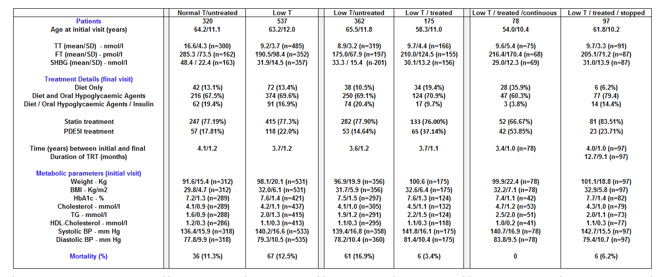

Table 2: Baseline characteristics and changes observed at the end of follow-up in the various subgroups defined by testosterone replacement and treatment. The baseline values differ from Table 1 as only patients with values documented at initial visit and final visit were included in the paired t-test analysis.
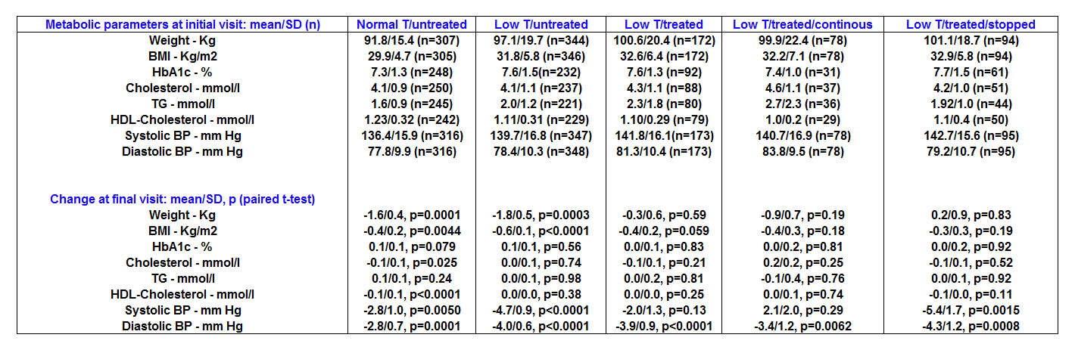

Table 3: Cox regression analysis with time to death/last visit as the dependent variable and factorised testosterone status/treatment groups as independent variables in patients stratified by median age, weight and BMI.
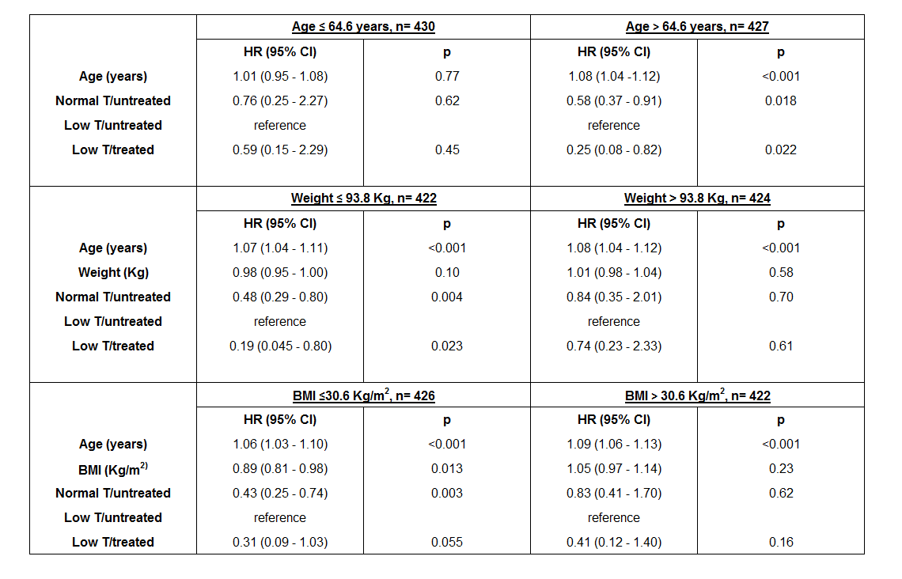

Figure 1: The Kaplan-Meier plot graphically displays the survival of Normal T/untreated, Low T/untreated and Low T/treated men aged over 64.6 years (median age of the cohort).
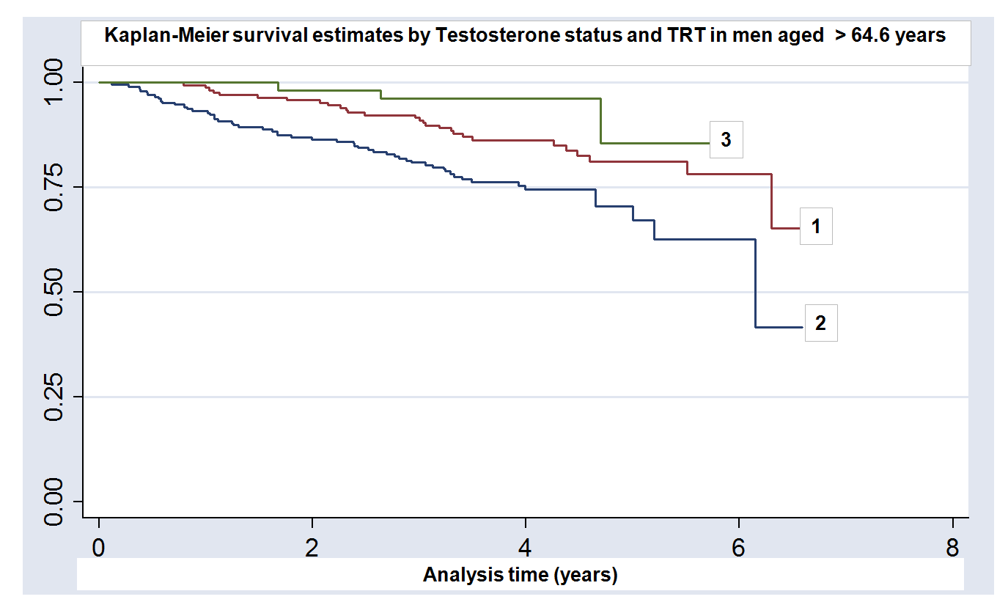
1.Normal T/untreated 2.Low T/untreated 3.Low T/treated
Figure 2: The Kaplan-Meier plot graphically displays the survival of Normal T/untreated, Low T/untreated and Low T/treated men whose weight is below the cohort median (93.8Kg).
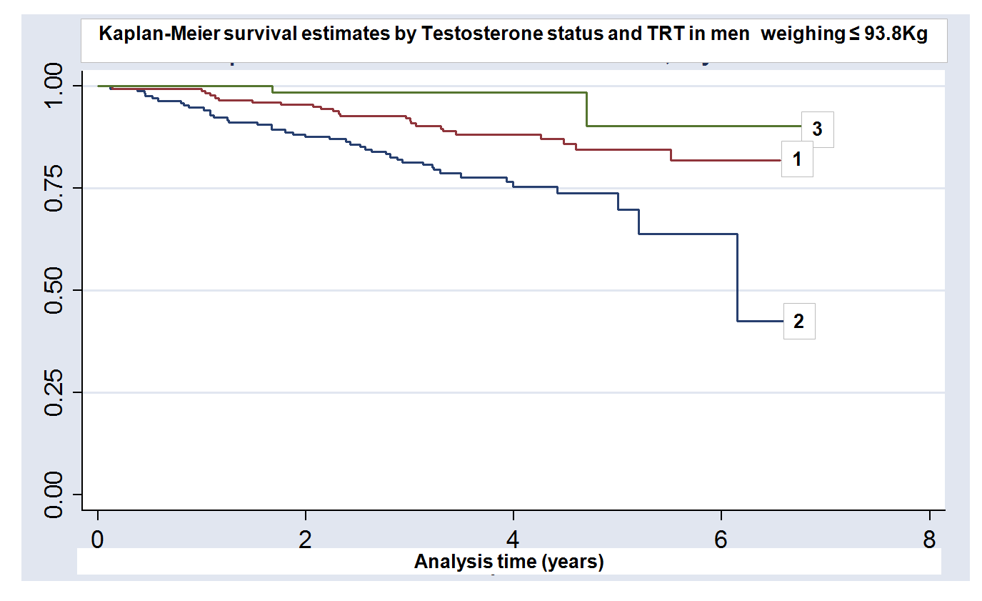
1.Normal T/untreated 2.Low T/untreated 3.Low T/treated

