Effect of access site, gender and indication on clinical outcomes following percutaneous coronary intervention: Insights from the British Cardiovascular Intervention Society
Short title: Gender, access site choice and PCI outcomes
Chun Shing Kwok¹, Evangelos Kontopantelis², Vijay Kunadian³, Karim Ratib⁴, Mathew Sperrin², Azfar Zaman³, Peter F Ludman⁵, Mark A. de Belder⁶ James Nolan⁴, Mamas A. Mamas^{2,4,7} on behalf of the British Cardiovascular Intervention Society and the National Institute for Cardiovascular Outcomes Research

1. Cardiovascular Research Group, Institute of Cardiovascular Sciences, University of Manchester, Manchester, UK.
2. Farr Institute , University of Manchester, Manchester, UK
3. Institute of Cellular Medicine, Newcastle University, Newcastle, UK
4. Royal Stoke Hospital, University Hospital North Midlands, Stoke-on-Trent, UK
5. Queen Elizabeth Hospital, Edgbaston, Birmingham, UK
6. The James Cook University Hospital, Middlesbrough, UK
7. Cardiovascular Research Group, Institutes of Science and Technology in Medicine and Primary Care, Keele University, UK
No relationships with industry
Corresponding author:
Mamas Mamas
Cardiovascular Research Group,
Institutes of Science and Technology in Medicine and Primary Care,
Keele University,
Staffordshire, ST5 5BG
United Kingdom.

Tel: +44 (0) 161 2768666
Fax: +44 (0) 161 2767956
Email: mamasmamas1@yahoo.co.uk
Keywords: Access site, gender, indication, PCI
Word count: 4,989
Abstract
Background: Gender is a strong predictor of peri-procedural major bleeding complications following PCI. The access site represents an important site of such bleeding complications, which has driven adoption of the transradial access (TRA) utilisation during PCI although female gender is an independent predictor of transradial PCI failure. This study sought to define gender differences in access site practice and study associations between access site choice and clinical outcomes for PCI over a 6-year period, through analysis of the British Cardiovascular Intervention Society observational database.
Methods and Results: In-hospital major adverse cardiovascular events (MACE) (a composite of in-hospital mortality and in-hospital myocardial re-infarction, target vessel revascularization), in-hospital bleeding complications and 30-day mortality were studied based on gender and access site choice (transfemoral: TFA, transradial: TRA) in 412,122 patients who underwent PCI between 2007-2012 in the United Kingdom. Use of TRA increased in both genders over time, although this lagged behind in women (21% in 2007 to 58% in 2012) compared to men (24% in 2007 to 64% in 2012). In both men and women, TRA was independently associated with a lower in-hospital MACE (OR 0.82 95% CI 0.76-0.90; OR 0.75 95% CI 0.66-0.84), in-hospital major bleeding (OR 0.54 95% CI 0.44-0.66; OR 0.26 95% CI 0.20-0.33) and 30-day mortality (OR 0.80 95% CI 0.73-0.89; OR 0.82 95% CI 0.71-0.94) respectively.
Conclusions: Where possible, TRA should be considered as the preferred access site choice for PCI, particularly in women in whom the greatest reductions bleeding endpoints were observed across all indications.

Introduction
Peri-procedural major bleeding complications following percutaneous coronary intervention (PCI) independently predict increased mortality and major adverse cardiovascular events.¹ Gender is a strong predictor of such bleeding complications and is a key component of many contemporary risk stratification scores used in clinical practice to predict bleeding risk,^{2,3} with female gender independently increasing the risk of major bleeding by 50-80%.²⁻⁴ Bleeding avoidance strategies vary according to gender, with women less likely to undergo PCI through the radial approach or receive vascular closure devices post PCI.⁵
The access site represents an important site of bleeding during PCI, with 30-60% of all major bleeds occurring at the femoral access site,^{6,7} which has driven the increased adoption of the transradial access site (TRA) across Europe and North America⁸⁻¹⁰ because of its association with reduced access site related bleeding complications and mortality.¹⁰⁻¹² Previous studies have reported that female gender is an independent predictor of failure of transradial PCI¹³ and an independent predictor of radial spasm¹⁴ limiting the success of the transradial procedure. However, the recent randomized SAFE-PCI trial has demonstrated a significant reduction in Bleeding Academic Research Consortium type 2,3 and 5 bleeding¹⁵ or vascular complications associated with TRA use in women, although significance was not demonstrated in the PCI cohort.¹⁶ Whilst changes in access site practice have been documented from a national perspective,^{8,10,17} it remains unclear whether these have occurred at a similar rate across both genders and whether the association between access site choice and favorable PCI outcomes that have been previously reported is greatest in females who are at the greater risk of baseline bleeding complications.
The purpose of this study is to better define gender differences in access site practice and study associations between access site choice and clinical outcomes in both genders across different indications for PCI using the national British Society Cardiovascular Intervention Society observational database over a 6-year period of PCI cases performed nationally in England and Wales.

Methods
Setting, data source, and study size
Data were obtained from the British Cardiovascular Intervention Society (BCIS) dataset which records information related to PCI practices in the United Kingdom.¹⁸ The BCIS-NICOR database collects information on clinical, procedural and outcomes data and contains 113 variables with approximately 80,000 new records added each year. The participants of the database are tracked by the Medical Research Information Services for subsequent mortality using the patients' NHS number, a unique identifier for any person registered within the NHS in England and Wales.

Study definitions
We analyzed all recorded PCI procedures that were undertaken in England and Wales between 2007-2012. Patients who underwent PCI through the left or right femoral artery or the left or right radial artery were included in the femoral and radial cohorts, respectively and indication for PCI was classified as stable angina, NSTEMI and STEMI. The outcomes examined were in-hospital major adverse cardiovascular events (MACE) (a composite of in-hospital mortality and in-hospital myocardial infarction or re-infarction and target vessel revascularization), in-hospital major bleeding (defined as gastrointestinal bleed, intra-cerebral bleed, retroperitoneal hematoma, blood or platelet transfusion, or an arterial access site complication requiring surgery) and 30-day mortality. Participants with missing age, gender, access site, or mortality outcomes were excluded. A detailed account of the participant inclusion process is shown in Figure 1.
Statistical Analyses
We examined the baseline characteristics across men and women and tested for associations between each categorical variable and gender using a two-sided Fisher's exact test and for continuous variables we used one-way analysis of variance. The crude rates for in-hospital MACE and in-hospital bleeding, 30-day mortality were calculated after stratification by gender and indication. We used multivariate logistic regressions to identify predictors of in-hospital MACE, in-hospital bleeding and 30-day mortality, focusing on access site (femoral or radial). In-hospital bleeding was defined by in-hospital gastrointestinal bleed, intra-cerebral bleed, retroperitoneal bleed, blood transfusion or platelet transfusion, or an arterial access site complication requiring surgery.^{17,19,20} Covariates included in the multivariate regression models were: age, diabetes, hypertension, hypercholesterolemia, peripheral vascular disease, stroke, myocardial infarction, smoking, previous PCI, previous CABG, indication, pre-procedure cardiogenic shock, pre-procedure ventilation, circulatory support, and glycoprotein inhibitor use. In addition we performed two sets of sensitivity analyses, to better account for patient severity and missing data. The first set used propensity scores to generate a more closely 1 to 1 nearest-neighbor matched subsample of femoral and radial access patients, across different levels of indication, on which the age-stratified logistic regressions were re-executed. The second set of analyses used inverse probability weighting to better account for ‘missingness’ in site access, by giving increased weights to cases who were more likely to be missing, with the treatment-independent age covariate being the only variable we included in the weighting model. We performed further logistic regression analysis considering the effect of gender and year of PCI on risk of radial access using both univariate and multivariate models. Finally, to allow comparison between included and excluded participants and assess the potential presence of bias, we report the characteristics of both the original and excluded cohorts.

Results
Study cohort
A total of 412,122 participants who underwent PCI from January 2007-December 2012 in England and Wales were included in the analysis after exclusion of participants with missing data (Figure 1). The characteristics of the participants with complete data and missing data are shown in Supplementary Table 1. We observed significant differences between cohorts included in current analysis and those excluded, with a greater prevalence of baseline comorbidity and severity of presentation as indicated by higher rates of pre-procedural shock, pre-procedural ventilation and receipt of circulatory support in cohort excluded from analysis (5.6% of total cohort who underwent PCI during timeframe studied).

Characteristics of participants
The cohort included 305,397 men (74.1%) and 106,725 women (25.9%) and Table 1 shows their baseline characteristics. Women were significantly older than men and were more likely to be diabetic, hypertensive and more likely to undergo PCI for NSTEACS indications but were less likely to undergo PCI through the radial approach. Table 2 illustrates differences in baseline characteristics across both genders by access site. Patients undergoing PCI through the TRA were younger, less likely to be in cardiogenic shock or in receipt of circulatory support and were more likely to undergo PCI for STEMI indications. Figure 2 illustrates changes in radial access site utilization in men and women over time, and illustrates that whilst radial access site adoption increased over time, the adoption of TRA in women lagged behind that of men. Using multivariate analysis with and without interaction terms, we found that female gender was significantly less likely to receive radial PCI and with increasing year of PCI there was a significantly higher likelihood adopting a radial approach (Data not shown).

In-hospital MACE, in-hospital major bleeding and 30-day mortality rates by gender
The gender-specific crude rates of adverse outcomes stratified by access site are shown in Table 2. We observed lower in-hospital MACE and in-hospital major bleeding events in both men and women who underwent PCI through the TRA compared to the TFA, p<0.001. Adoption of TRA was also associated with a lower 30-day mortality compared to TFA.
In both genders, TRA utilization was independently associated lower adverse outcomes compared to the groups of patients in whom TFA was used in both men and women.

Rates by gender and indication
Figures 3a-c illustrate changes in access site adoption over time by gender and syndrome and demonstrate that adoption of the TRA was slower in women than in men across all indications for PCI. Baseline procedural and clinical demographics by gender and access site for each of the syndromes are presented in Supplementary Table 2.
The gender-specific crude rates of adverse outcomes stratified by access site and indication are presented in Supplementary Table 3. For all outcomes there was a higher rate of events for the femoral access group compared to radial access and outcomes were lowest in the stable angina group and highest in the STEMI group. Among men, femoral access the in-hospital MACE ranged from 0.9% in the stable angina group to 4.1% in the STEMI group. For radial access the parallel range was much lower from 0.8% to 2.1%. For women who had femoral access, in-hospital MACE was 1.2% for stable angina and 5.9% for STEMI while for radial access it ranged from 0.9% for stable angina to 3.2% for STEMI. Similar trends were observed for in-hospital bleeding and 30-day mortality.
Results from the gender and indication stratified multivariate logistic regression analyses across the three adverse outcomes are presented in Figure 4a-b. TRA was independently associated with decreased in-hospital major bleeding rates for both men and women although no differences in in-hospital MACE or 30-day mortality were observed. Among men, TRA was independently associated with reduced risk of in-hospital MACE, in-hospital major bleeding and 30-day mortality in patients with NSTEMI and STEMI. For women, TRA was independently associated with decreased in-hospital major bleeding and in-hospital MACE but not 30-day mortality in NSTEMI, but was independently associated with significant reductions in in-hospital major bleeding, in-hospital MACE and 30-day mortality in women undergoing PCI for STEMI.

Sensitivity analyses
In order to reduce the influence of unmeasured confounders on outcomes, a propensity score matched cohort was generated. The propensity matched gender specific participant demographics are shown in Supplementary Table 4. The logistic regression results with the propensity-matched cohort are shown in Supplementary Table 5. The analyses recorded similar findings to the data reported previously. Further analysis using inverse probability weighting analysis showed similar results to the data reported previously and gender specific outcomes according to indication by access site are summarized in Supplementary Table 6.

Discussion
Our analysis of over 400,000 PCI procedures undertaken in the England and Wales over a 6-year period has demonstrated that the adoption of TRA in women has lagged behind that of men across all indications for PCI. Our analysis suggests that TRA choice in both men and women is independently associated with lower in-hospital MACE, major bleeding complications and 30-day mortality. Finally, our analysis suggests that whilst TRA is associated with lower bleeding complications across all indications for PCI in both genders, the lower 30-day mortality associated with TRA adoption is observed in NSTEMI and STEMI cases in men and STEMI cases in women.
The TRA has grown to become the default access site in the United Kingdom over the past few years^{8,21} Our analysis is the first to systematically study change in access site practice nationally across different indications for PCI in men and women and its relationship with clinical outcomes. Whilst other studies derived from NCDR national data have systematically studied bleeding avoidance strategies including access site on bleeding endpoints, and their relationship with gender,⁵ they have not reported MACE or mortality outcomes and TRA adoption in these analyses was around 3-3.5% (which would equate to a female TRA cohort size of around 5500 patients), whereas in the current study data derived from over 43,000 women undergoing PCI through TRA represents the largest analysis of gender specific access site related outcomes to date. Furthermore, our study is the first to describe national differences in access site practice and outcomes by gender across different indication for PCI over a timeframe in which TRA has grown to become the default access site choice.
We have observed that the growth of TRA utilization in women has lagged behind that of men for each year studied that may be explained by observations that female gender is an independent predictor of failure of transradial PCI¹³ and the smaller radial artery diameter in women increases the risk of radial occlusion,²² further limiting the ability to perform successive procedures through the radial artery.²³

Studies have previously reported an association between TRA and lower mortality and MACE outcomes in a number of populations undergoing PCI^{17,19,24}. Our current analysis shows TRA is independently associated with lower in-hospital major bleeding complications, in-hospital MACE and 30-day mortality outcomes in both men and women with the greatest absolute difference in crude event rates between TFA and TRA groups observed in women. Similarly, data derived from the National Cardiovascular Data Registry (NCDR), demonstrated that the greatest difference in crude bleeding rates between TFA and TRA were observed in women (2.86 vs 1.1%) compared to men (1.22 vs 0.67%), which persisted following adjustment for baseline co-variates.²⁵ Local anatomical differences at the access site may contribute to the increased risk of bleeding in women, the common femoral artery in women is shorter and smaller diameter, reducing the area for safe vascular puncture⁴ with a previous analysis of 14,180 patients showing that access site related bleeding complications were twice as likely to occur in women compared to men, with no significant differences in non-access site related bleeding complications.⁴
The recent SAFE-PCI randomized trial evaluated outcomes associated with TRA compared to TFA but was terminated early on the basis of a lower than expected rate of bleeding or vascular complications in the cohort.¹⁶ Radial access did not significantly reduce bleeding or vascular complications among women undergoing PCI in this study, although this may have related to the small sample size of women undergoing PCI and the absence of patients most likely to derive benefit from TRA who are at highest risk of bleeding complications¹⁹ such as primary PCI patients.^{17,26}
We observe that utilization of the TRA is independently associated with decreased major bleeding complications across both elective and ACS indications for PCI in both genders, but statistically significant decreases in 30-day mortality were only observed in patients undergoing PCI in the setting of STEMI and NSTEMI in men and STEMI in women. These observations remained consistent, even following propensity score matching and inverse probability weighting.
The lack of a statistically significant reduction in 30-day mortality in patients undergoing elective PCI associated with TRA may relate to low baseline bleeding risk. Recent data from the United Kingdom has suggested that the observed reduction in 30-day mortality associated with TRA utilization relates to baseline bleeding risk, with those at highest risk of bleeding complications gaining the greatest benefit.¹⁹ In the current analysis, the greatest 30-day mortality decrease associated with TRA adoption in both genders was observed in patients undergoing PCI for STEMI indications who are at highest risk for major bleeding complications. Previous RCTs such as RIVAL²⁷, RIFLE-STEACS²⁸ and STEMI-RADIAL²⁹ have shown improved clinical outcomes associated with TRA utilisation in the setting of STEMI, which may relate to reductions in access site related bleeding complications although other mechanisms such as receipt of a blood transfusion^{30,31} and more experienced centers/operators performing radial PCI^{30,32} are likely to contribute to the mortality benefits reported.
Our study has a number of potential limitations. Whilst mortality tracking within England and Wales is robust, the cause of mortality is not available; and all other outcomes and complications are self-reported and are not formally audited by BCIS, subjecting the data to reporting biases. Secondly, we were unable to account for crossover in access site because this data is not captured in the BCIS dataset. Finally, although we have attempted to correct for differences in baseline and procedural demographics observed between the TFA and TRA cohorts using a variety of statistical techniques the relationship between access site and favorable outcomes in both men and women does not infer causality, and unmeasured confounders may contribute to the unfavorable outcomes observed in the TFA cohort.
In conclusion, we have observed that TRA has grown to be the preferred access site choice across all indications for PCI in men and women in the England and Wales, with uptake in women lagging behind that of men. Our analysis suggests that TRA choice in both men and women is independently associated with lower 30-day mortality and in-hospital MACE and major bleeding complications, and that the absolute decreases in crude event rates associated with TRA are greatest in women. Finally, our analysis suggests that whilst TRA is associated with lower bleeding complications across all indications for PCI in both genders, decreased 30-day mortality rates associated with TRA choice are observed in PCI procedures undertaken for ACS indications. These observational data would support that, where possible, TRA should be considered as the preferred access site choice for PCI, particularly in women in whom the greatest absolute reductions in in-hospital MACE and 30-day mortality endpoints were observed.

Acknowledgement
None

Funding Sources
None

Disclosures
None
References
1. Kwok CS, Rao SV, Myint PK, Keavney B, Nolan J, Ludman PF, et al. Major bleeding after percutaneous coronary intervention and risk of subsequent mortality: a systematic review and meta-analysis. Open Heart 2014;1(1):e000021.
2. Mehran R, Pocock S, Nikolsky E, Dangas GD, Clayton T, Claessen BE, et al. Impact of bleeding on mortality after percutaneous coronary intervention results from a patient-level pooled analysis of the REPLACE-2 (randomized evaluation of PCI linking angiomax to reduced clinical events), ACUITY (acute catheterization and urgent intervention triage strategy), and HORIZONS-AMI (harmonizing outcomes with revascularization and stents in acute myocardial infarction) trials. JACC Cardiovasc interv 2011;4(6):654-64.
3. Mehta SK, Frutkin AD, Lindsey JB, House JA, Spertus JA, Rao SV, et al. Bleeding in patients undergoing percutaneous coronary intervention: the development of a clinical risk algorithm from the National Cardiovascular Data Registry. Circulation Cardiovasc Interv 2009;2(3):222-9.
4. Ndrepepa G, Schulz S, Neumann FJ, Byrne RA, Hoppmann P, Cassese S, et al. Bleeding after percutaneous coronary intervention in women and men matched for age, body mass index, and type of antithrombotic therapy. Am Heart J 2013;166(3):534-40.
5. Daugherty SL, Thompson LE, Kim S, Rao SV, Subherwal S, Tsai TT, et al. Patterns of use and comparative effectiveness of bleeding avoidance strategies in men and women following percutaneous coronary interventions: an observational study from the National Cardiovascular Data Registry. J Am Coll Cardiol 2013;61(20):2070-8.
6. Verheugt FW, Steinhubl SR, Hamon M, Darius H, Steg PG, Valgimigli M, et al. Incidence, prognostic impact, and influence of antithrombotic therapy on access and nonaccess site bleeding in percutaneous coronary intervention. JACC Cardiovasc Interv 2011;4(2):191-7.
7. Ndrepepa G, Neumann FJ, Richardt G, Schulz S, Tolg R, Stoyanov KM, et al. Prognostic value of access and non-access sites bleeding after percutaneous coronary intervention. Circulation Cardiovasc Interv 2013;6(4):354-61.
8. Ratib K, Mamas MA, Routledge HC, Ludman PF, Fraser D, Nolan J. Influence of access site choice on incidence of neurologic complications after percutaneous coronary intervention. Am Heart J 2013;165(3):317-24.
9. Bertrand OF, Rao SV, Pancholy S, Jolly SS, Rodes-Cabau J, Larose E, et al. Transradial approach for coronary angiography and interventions: results of the first international transradial practice survey. JACC Cardiovasc Interv 2010;3(10):1022-31.
10. Subherwal S, Peterson ED, Dai D, Thomas L, Messenger JC, Xian Y, et al. Temporal trends in and factors associated with bleeding complications among patients undergoing percutaneous coronary intervention: a report from the National Cardiovascular Data CathPCI Registry. J Am Coll Cardiol 2012;59(21):1861-9.
11. Chase AJ, Fretz EB, Warburton WP, Klinke WP, Carere RG, Pi D, et al. Association of the arterial access site at angioplasty with transfusion and mortality: the M.O.R.T.A.L study (Mortality benefit Of Reduced Transfusion after percutaneous coronary intervention via the Arm or Leg). Heart 2008;94(8):1019-25.
12. Bertrand OF, Belisle P, Joyal D, Costerousse O, Rao SV, Jolly SS, et al. Comparison of transradial and femoral approaches for percutaneous coronary interventions: a systematic review and hierarchical Bayesian meta-analysis. Am Heart J 2012;163(4):632-48.
13. Abdelaal E, Brousseau-Provencher C, Montminy S, Plourde G, MacHaalany J, Bataille Y, et al. Risk score, causes, and clinical impact of failure of transradial approach for percutaneous coronary interventions. JACC Cardiovasc Interv 2013;6(11):1129-37.
14. Rosencher J, Chaib A, Barbou F, Arnould MA, Huber A, Salengro E, et al. How to limit radial artery spasm during percutaneous coronary interventions: The spasmolytic agents to avoid spasm during transradial percutaneous coronary interventions (SPASM3) study. Catheter Cardiovasc Interv 2014;84(5):766-71.
15. Mehran R, Rao SV, Bhatt DL, Gibson CM, Caixeta A, Eikelboom J, et al. Standardized bleeding definitions for cardiovascular clinical trials: a consensus report from the Bleeding Academic Research Consortium. Circulation 2011;123(23):2736-47.

16. Rao SV, Hess CN, Barham B, Aberle LH, Anstrom KJ, Patel TB, et al. A registry-based randomized trial comparing radial and femoral approaches in women undergoing percutaneous coronary intervention: the SAFE-PCI for Women (Study of Access Site for Enhancement of PCI for Women) trial. JACC Cardiovasc Interv 2014;7(8):857-67.
17. Mamas MA, Ratib K, Routledge H, Neyses L, Fraser DG, de Belder M, et al. Influence of arterial access site selection on outcomes in primary percutaneous coronary intervention: are the results of randomized trials achievable in clinical practice? JACC Cardiovasc Interv 2013;6(7):698-706.
18. Ludman PF, British Cardiovascular Intervention S. British Cardiovascular Intervention Society Registry for audit and quality assessment of percutaneous coronary interventions in the United Kingdom. Heart 2011;97(16):1293-7.
19. Mamas MA, Anderson SG, Carr M, Ratib K, Buchan I, Sirker A, et al. Baseline bleeding risk and arterial access site practice in relation to procedural outcomes after percutaneous coronary intervention. J Am Coll Cardiol 2014;64(15):1554-64.
20. Mamas MA, Anderson SG, Ratib K, Routledge H, Neyses L, Fraser DG, et al. Arterial access site utilization in cardiogenic shock in the United Kingdom: is radial access feasible? Am Heart J 2014;167(6):900-8 e1.
21. Ratib K, Mamas MA, Anderson SG, Bhatia G, Routledge H, De Belder M, et al. Access site practice and procedural outcomes in relation to clinical presentation in 439,947 patients undergoing percutaneous coronary intervention in the United kingdom. JACC Cardiovascular interventions 2015;8(1 Pt A):20-9.
22. Saito S, Ikei H, Hosokawa G, Tanaka S. Influence of the ratio between radial artery inner diameter and sheath outer diameter on radial artery flow after transradial coronary intervention. Catheter Cardiovasc Interv 1999;46(2):173-8.
23. Mamas MA, Fraser DG, Ratib K, Fath-Ordoubadi F, El-Omar M, Nolan J, et al. Minimising radial injury: prevention is better than cure. EuroIntervention 2014;10(7):824-32.

24. Baklanov DV, Kaltenbach LA, Marso SP, Subherwal SS, Feldman DN, Garratt KN, et al. The prevalence and outcomes of transradial percutaneous coronary intervention for ST-segment elevation myocardial infarction: analysis from the National Cardiovascular Data Registry (2007 to 2011). J Am Coll Cardiol 2013;61(4):420-6.

25. Rao SV, Ou FS, Wang TY, Roe MT, Brindis R, Rumsfeld JS, et al. Trends in the prevalence and outcomes of radial and femoral approaches to percutaneous coronary intervention: a report from the National Cardiovascular Data Registry. JACC Cardiovasc Interv 2008;1(4):379-86.
26. Mamas MA, Ratib K, Routledge H, Fath-Ordoubadi F, Neyses L, Louvard Y, et al. Influence of access site selection on PCI-related adverse events in patients with STEMI: meta-analysis of randomised controlled trials. Heart 2012;98(4):303-11.
27. Jolly SS, Yusuf S, Cairns J, Niemela K, Xavier D, Widimsky P, et al. Radial versus femoral access for coronary angiography and intervention in patients with acute coronary syndromes (RIVAL): a randomised, parallel group, multicentre trial. Lancet 2011;377(9775):1409-20.
28. Romagnoli E, Biondi-Zoccai G, Sciahbasi A, Politi L, Rigattieri S, Pendenza G, et al. Radial versus femoral randomized investigation in ST-segment elevation acute coronary syndrome: the RIFLE-STEACS (Radial Versus Femoral Randomized Investigation in ST-Elevation Acute Coronary Syndrome) study. J Am Coll Cardiol 2012;60(24):2481-9.
29. Bernat I, Horak D, Stasek J, Mates M, Pesek J, Ostadal P, et al. ST-segment elevation myocardial infarction treated by radial or femoral approach in a multicenter randomized clinical trial: the STEMI-RADIAL trial. J Am Coll Cardiol 2014;63(10):964-72.
30. Huff CM, Kapadia S, Rao SV. Mechanisms by which transradial approach may reduce mortality in ST-segment-elevation myocardial infarction. Circulation Cardiovasc Interv 2014;7(4):621-7.
31. Kwok CS, Sherwood MW, Watson SM, Nasir SB, Sperrin M, Nolan J, et al. Blood Transfusion After Percutaneous Coronary Intervention and Risk of Subsequent Adverse Outcomes: A Systematic Review and Meta-Analysis. JACC Cardiovasc Interv 2015; doi:10.1016/j.jcin/2014.09.026
32. Jolly SS, Cairns J, Yusuf S, Niemela K, Steg PG, Worthley M, et al. Procedural volume and outcomes with radial or femoral access for coronary angiography and intervention. J Am Coll Cardiol 2014;63(10):954-63.

Table 1: Gender specific participant demographics
Variable | Men (n=305,397) | Women (n=106,725) | p-value*
Age(±SD) | 63.5 (±11.5) | 68.3 (±11.5) | <0.001
Diabetes | 53,510/291,767 (18.3%) | 20,829/102,116 (20.4%) | <0.001
Hypertension | 151,584/296,420 (51.1%) | 60,967/103,639 (58.8%) | <0.001
Hypercholesterolemia | 165,805/296,420 (55.9%) | 59,208/103,639 (57.1%) | <0.001
Renal disease | 5,737/289,267 (2.0%) | 1,785/101,055 (1.8%) | <0.001
Peripheral vascular disease | 13,938/296,420 (4.7%) | 4,921/103,639 (4.8%) | 0.55
Smoking (Ex-smoker or current) | 184,927/269,138 (68.7%) | 50,154/93,634 (53.5%) | <0.001
Previous myocardial infarction | 79,558/271,987 (29.3%) | 23,227/95,180 (24.4%) | <0.001
Previous stroke | 10,700/296,420 (3.6%) | 4,667/103,639 (4.5%) | <0.001
Previous PCI | 68,651/293,162 (23.4%) | 19,777/102,558 (19.3%) | <0.001
Previous CABG | 27,799/292,599 (9.5%) | 5,668/102,156 (5.6%) | <0.001
Family history of heart disease | 120,387/260,272 (46.3%) | 42,671/90,780 (47.0%) | <0.001
Indication for PCI  Stable angina  NSTEACS  STEACS | N=300,644  124,682 (41.5%)  111,394 (37.1%)  64,568 (21.5%) | N=105,065  41,556 (39.6%)  42,103 (40.1%)  21,406 (20.4%) | <0.001
Pre-procedural shock | 4,797/284,611 (1.7%) | 1,916/99,596 (1.9%) | <0.001
Pre-procedural ventilation | 3,253/255,840 (1.3%) | 1,049/89,073 (1.2%) | 0.030
Circulatory support | 5,037/283,315 (1.8%) | 1,935/98,714 (2.0%) | <0.001
Glycoprotein inhibitor use | 66,013/267,071 (24.7%) | 19,430/92,849 (20.9%) | <0.001
Radial access | 139,055/305,397 (45.5%) | 43,456/106,725 (40.7%) | <0.001
In-hospital MACE | 4,466/305,397 (1.5%) | 2,146/106,725 (2.0%) | <0.001
In-hospital bleed | 744/297,323 (0.3%) | 650/103,690 (0.6%) | <0.001
Mortality at 30 days | 4,347/305,397 (1.4%) | 2,218/106,725 (2.1%) | <0.001
*p-values for continuous variables were calculated from two-sided Fisher's Exact Test and p-values for categorical variables were calculated from one-way analysis of variance
Table 2: Gender specific participant demographics and outcomes by access site
 | Men |  |  | Women
Access site | Femoral access  (n=166,342) | Radial access (n=139,055) | p-value* | Femoral access (n=63,269) | Radial access (n=43,456) | p-value*
Age(±SD) | 63.8(±11.5) | 63.1(±11.5) | <0.001 | 68.6 (±11.6) | 67.9(±11.5) | <0.001
Diabetes | 29,686/156,601 (19.0%) | 23,824/135,166 (17.6%) | <0.001 | 12,168/59,811 (20.3%) | 8,661/42,305 (20.5%) | 0.62
Hypertension | 81,210/159,986 (50.8%) | 70,374/136,434 (51.6%) | <0.001 | 35,491/61,001 (58.2%) | 25,476/42,638 (59.8%) | <0.001
Hypercholesterolemia | 89,399/159,986 (55.9%) | 76,406/136,434 (56.0%) | 0.50 | 34,309/61,001 (56.2%) | 24,899/42,638 (58.4%) | <0.001
Renal disease | 3,548/155,171 (2.3%) | 2,189/134,096 (1.6%) | <0.001 | 1,165/59,129 (2.0%) | 620/41,926 (1.5%) | <0.001
Peripheral vascular disease | 7,383/152,986 (4.6%) | 6,555/136,434 (4.8%) | 0.015 | 2,779/61,001 (4.6%) | 2,142/42,638 (5.0%) | 0.001
Smoking (Ex-smoker or current) | 97,722/142,298 (68.7%) | 87,205/126,840 (68.8%) | 0.67 | 28,128/54,001 (52.1%) | 22,006/39,633 (55.5%) | <0.001
Previous myocardial infarction | 45,835/142,314 (32.2%) | 33,723/129,673 (26.0%) | <0.001 | 14,451/54,574 (26.5%) | 8,776/40,606 (21.6%) | <0.001
Previous stroke | 5,587/159,986 (3.5%) | 5,113/136,434 (3.8%) | <0.001 | 2,656/61,001 (4.4%) | 2,011/42,638 (4.7%) | 0.006
Previous PCI | 39,866/157,171 (25.4%) | 28,785/135,991 (21.2%) | <0.001 | 12,521/60,003 (20.9%) | 7,256/42,555 (17.1%) | <0.001
Previous CABG | 20,656/158,229 (13.1%) | 7,143/134,370 (5.3%) | <0.001 | 4,325/60,089 (7.2%) | 1,343/42,067 (3.2%) | <0.001
Family history of heart disease | 64,247/137,166 (46.8%) | 56,140/123,106 (45.6%) | <0.001 | 24,658/52,315 (47.1%) | 18,013 (46.8%) | 0.37
Indication for PCI  Stable angina  NSTEMI  STEMI | 72,182 (44.5%)  57,320 (35.3%)  32,880 (20.3%) | 52,500 (38.0%)  54,074 (39.1%)  31,688 (22.9%) | <0.001 | 25,963 (42.0%)  23,765 (38.4%)  12,099 (19.6%) | 15,593 (36.1%)  18.338 (42.4%)  9.307 (21.5%) | <0.001
Pre-procedural shock | 3,507/151,955 (2.3%) | 1,290/132,656 (1.0%) | <0.001 | 1,488/58,206 (2.6%) | 428/41,390 (1.0%) | <0.001
Pre-procedural ventilation | 2,326/131,465 (1.8%) | 927/124,375 (0.8%) | <0.001 | 774/50,204 (1.5%) | 275/38,869 (0.7%) | <0.001
Circulatory support | 3,829/150,693 (2.5%) | 1,208/132,622 (0.9%) | <0.001 | 1,555/57,359 (2.7%) | 380/41,35 (0.9%) | <0.001
Glycoprotein inhibitor use | 33,962/139,917 (24.3%) | 32,051/127,154 (25.2%) | <0.001 | 10,852/53,262 (20.4%) | 8,578/39,587 (21.7%) | <0.001
In-hospital MACE | 2,840/166,342 (1.7%) | 1,626/139,055 (1.2%) | <0.001 | 1,502/63,269 (2.4%) | 644/43,456 (1.5%) | <0.001
In-hospital bleed | 518/162,670 (0.3%) | 226/134,603 (0.2%) | <0.001 | 550/61,712 (0.9%) | 100/41,978 (0.2%) | <0.001
Mortality at 30 days | 2,906/166,342 (1.8%) | 1,441/139,055 (1.0%) | <0.001 | 1,564/63,269 (2.5%) | 654/43,456 (1.5%) | <0.001
*p-values for continuous variables were calculated from two-sided Fisher's Exact Test and p-values for categorical variables were calculated from one-way analysis of variance

Figure Legend
Figure 1: Participant flow diagram
Figure 2: Gender specific % of patient with radial access site as a function of year (2007-2012) (n=412,122)
Figure 3a-c: Gender specific access site utilisation as a function of year (2007-2012) for different indications for PCI A) Stable Angina; B) NSTEMI; C) STEMI
Figure 4a-b: Adjusted effect of access site on risk of outcomes stratified by gender and indication

Figure 1: Participant flow diagram
Total number of participants from England and Wales 436,411.

24,289 excluded because of missing gender (n=899), missing site of access (n=23,144), missing age (n=246).
Number of participants 412,122 included in analysis.

Figure 2: Gender specific % of patient with radial access site as a function of year (2007-2012) (n=412,122)
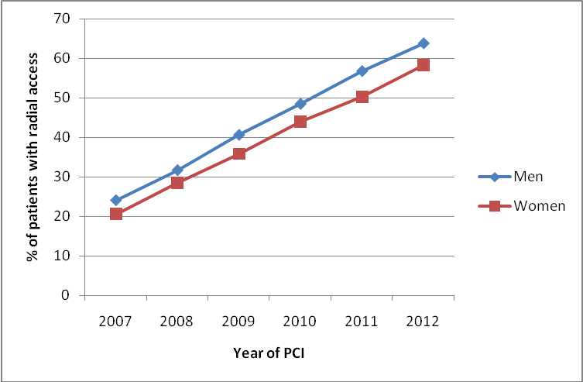
Figure 3a-c: Gender specific access site utilization as a function of year (2007-2012) for different indications for PCI A) Stable Angina; B) NSTEMI; C) STEMI
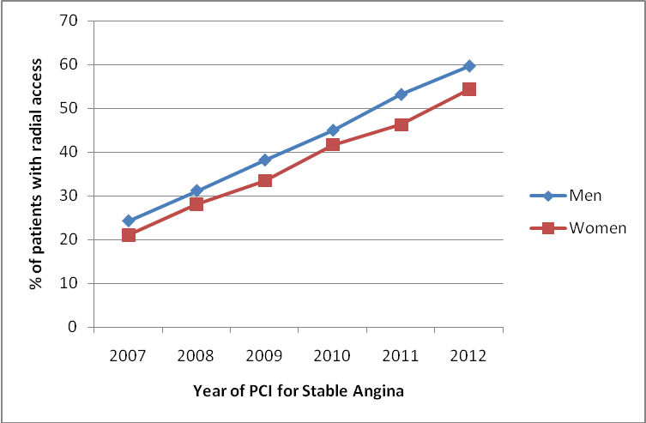
p<0.001
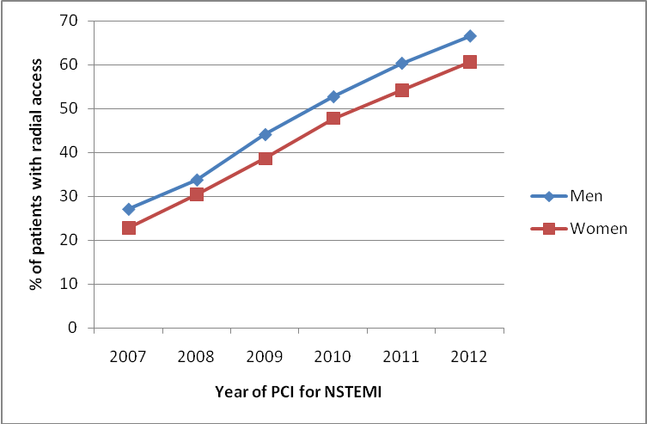
p<0.001
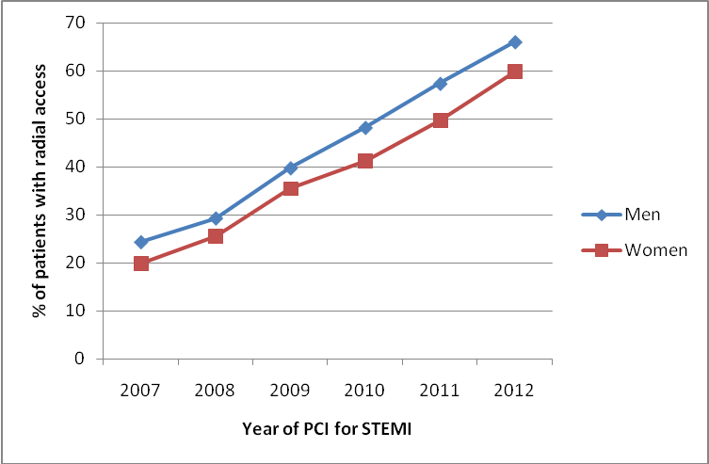
p<0.001
Figure 4a-b: Adjusted effect of access site on risk of outcomes stratified by gender and indication
A)
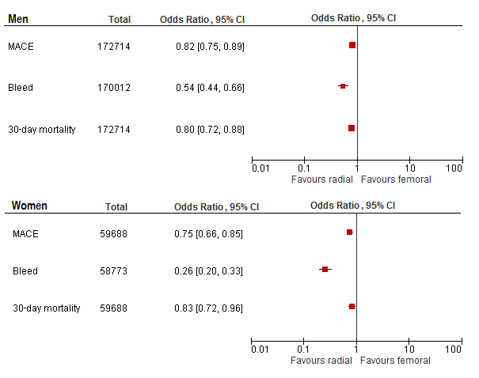

B)
