Title: The role of intergroup contact in promoting social change toward greater equality

Authors:
Tabea Hässler¹, Johannes Ullrich¹, Michelle Bernardino², Nurit Shnabel³, Daniel Valdenegro⁴, Colette Van Laar⁵, Simone Sebben¹, Emilio Paolo Visintin⁶, Linda R. Tropp⁷, Roberto González², Dominic Abrams⁸, Ruth Ditlmann⁹, Hema Preya Selvanathan⁷, Jorina von Zimmermann¹⁰, Stephen Wright¹¹, Marija Brankovic¹², Anna Lisa Aydin¹³, Michael Pasek^{14,15}, Adrienne Pereira¹⁶, Iris Žeželj¹⁷, Nóra Anna Lantos¹⁸, Mario Sainz^{19,20}, Andreas Glenz¹, Hana Oberpfalzerova²¹, Michal Bilewicz²², Anna Kende¹⁸, Olga Kuzawinska²², Sabine Otten²³, Edona Maloku²⁴, Pelin Gul²⁵, Masi Noor²⁶, Jessica Pistella²⁷, Roberto Baiocco²⁷, Margareta Jelic²⁸, Evgeny Osin²⁹, Orly Bareket³, Dinka Corkalo Biruski²⁸, Jonathan Cook³⁰, Maneeza Dawood³¹, Lisa Droogendyk³², Angélica Herrera Loyo³³, Kaltrina Kelmendi³⁴, & Luiza Mugnol Ugarte³⁵.

Abstract:
Beginning with the historic racial desegregation in the United States, and spreading to other parts of the world, policy makers, guided by the findings of social scientists, have advocated for increased intergroup contact (e.g., in schools and neighborhoods) as the key to prejudice reduction and increased social cohesion. There is contradictory evidence, however, as to whether intergroup contact hinders or promotes support for social change toward equality. Using a larger and more heterogeneous dataset than ever before in the intergroup contact literature (N = 12,997 individuals from 69 countries), we demonstrate that intergroup contact is associated with increased support for social change toward greater equality among members of advantaged groups (ethnic majorities and cis-heterosexuals) but decreased support among members of disadvantaged groups (ethnic minorities and sexual and gender minorities). Specification curve analysis revealed important variation in the size—and at times, direction—of correlations, depending on how contact and support for social change were measured. This allowed us to identify one type of support for change, willingness to work in solidarity to promote social equality, that is positively associated with intergroup contact among both advantaged- and disadvantaged-group members.

Intergroup contact is widely believed to promote social change. Since initial efforts toward racial desegregation in the US, social scientists (e.g., Allport, 1954) and practitioners have advocated for bringing majority and minority group members together in an effort to foster equality. Although there is overwhelming evidence that contact can reduce prejudice and increase social cohesion across group divides (Lemmer & Wagner, 2015; Pettigrew & Tropp, 2006), a new line of thinking challenges our conventional understanding of intergroup contact by suggesting that contact can have an ironic effect, whereby increased perceptions of harmony may undermine the will of minority and majority group members to demand and advocate for greater equality and social justice (Dixon, Durrheim, & Tredoux, 2007). This “irony of harmony” effect (Saguy, Tausch, Dovidio, & Pratto, 2009) has important implications for public policy. Comprehensive and rigorous tests are needed to elucidate when contact may be associated with more or less support for social change. This research provides such a test using the largest and most heterogeneous dataset on intergroup contact to date.
The relation between intergroup contact and support for social change is more nuanced than is typically recognized. For members of advantaged groups (e.g., ethnic majorities and cis-heterosexuals), contact with disadvantaged-group members (e.g., ethnic and LGBTIQ+ individuals) generally—but not invariably—leads to greater support for intergroup equality and social change (e.g., Çakal, Hewstone, Güler, & Heath, 2016; Dixon et al., 2007; Kamberi, Martinovic, & Verkuyten, 2017; Wright & Lubensky, 2009). Yet, some research suggests that contact can improve advantaged-group members’ feelings toward disadvantaged-group members while having little impact on their support for policies designed to redress group-based inequalities (Jackman & Crane, 1986). Support for social change among disadvantaged-group members is generally thought to be motivated by perceived injustice and anger (van Stekelenburg & Klandermans, 2013; van Zomeren, Postmes, & Spears, 2008). Yet, for disadvantaged group members, it is possible that these feelings can be undercut to the extent intergroup contact increases perceptions of harmonious intergroup relations. As a result, even without affecting underlying inequality, intergroup contact may reduce the will of disadvantaged-group members to fight for greater equality (e.g., Çakal, Hewstone, Güler, et al., 2016; Dixon et al., 2007; Kamberi et al., 2017; Wright & Lubensky, 2009). The potential for contact to both promote and undermine support for social change highlights the need for research elucidating when, for whom, and in what contexts intergroup contact increases or decreases the will of individuals to advocate and act for social equality.
Given the practical and theoretical relevance of this question, it is important to recognize that the forms, content, and nature that contact can take are as varied as are efforts to achieve social change. To illustrate, members of advantaged and disadvantaged groups may be friends with each other; alternatively, they may only be acquainted with each other, or they simply may know of people from their own group who have contact with people in the other group. Contact might also differ in its valence—it can be positive, neutral, or negative. Similarly, action for social change can include a range of activities, such as attending demonstrations, launching or signing petitions, raising peers’ awareness of inequality, supporting policies that empower disadvantaged groups, or working in solidarity with other groups. To establish both whether and when contact will promote social change it is necessary to systematically assess the relationship between these different forms of contact and actions for social change.
As is typically the case in social science research, extant studies have used a wide range of conceptualizations and measures of contact and support for change to assess these constructs. Research also makes use of a wide range of methodologies, analytic approaches, and samples of participants (e.g., Çakal, Hewstone, Schwär, & Heath, 2011; Droogendyk, Wright, Lubensky, & Louis, 2016; Reimer et al., 2017). While these diverse methods may help to triangulate the overall effects of contact, such unsystematic variation is problematic for research questions that carry critical implications for public policy. To assess the reliability of a particular finding, and the characteristics of studies that are associated with stronger, weaker, or reversed effects, a study must be repeated across many contexts using systematic variation of measures and analytic procedures. The present research is the first systematic effort to test for both the reliability of the association between contact and support for social change and its potential variability across measures and analytic decisions.
In this multinational collaboration involving a large set of established scholars and research teams, all researchers assessed the same extensive array of commonly used measures of contact and support for social change (see Table 1). This enabled us to estimate not only an overall correlation, but the conditional correlations that arise from different combinations of varied forms of contact and actions for social change (see Kenny & Judd, 2018; Patel, Burford, & Ioannidis, 2015; Rubin, 1992; Steegen, Tuerlinckx, Gelman, & Vanpaemel, 2016). Using specification curve analysis (Simonsohn, Simmons, & Nelson, 2015), we graphed the distribution of correlations between contact and support for social change that result from the many combinations of types of contact and support for change and tested for joint significance. In so doing, this research provides the most conclusive and fine-grained answer to a long-debated question.

Table 1
Overview of Constructs, Measures, and Example Items
Construct: INTERGROUP CONTACT
 | Measures: |  | Example Items:
 |  | 1) Quantity of contact† | How many [outgroup people] do you know, at least as acquaintances?
 |  | 2) Positive contact | When you interact with [outgroup], to what extent do you experience the following: The contact is friendly?
 |  | 3) Absence of negative contact | When you interact with [outgroup], to what extent do you experience the following: The contact is unfriendly? (recoded)
 |  | 4) Number of outgroup friends | How many of your friends are [outgroup]?
 |  | 5) Frequency of meeting outgroup friends | How often do you meet your [outgroup] friends?
 |  | 6) Quantity of indirect outgroup friends† | As far as you are aware, how many of your [ingroup] friends or close relatives have [outgroup] friends?
 |  | 7) Positive indirect contact | As far as you are aware, how many of your [ingroup] friends or close relatives have had good experiences with [outgroup] members?
 |  | 8) Absence of negative indirect contact | As far as you are aware, how many of your [ingroup] friends or close relatives have had bad experiences with [outgroup] members, like tensions or conflict? (recoded)
Construct: SUPPORT FOR SOCIAL CHANGE
 | Measures: |  | Example Items:
 |  | 1) Low cost collective action | Signing an online/regular petition to support action against the unequal treatment of [disadvantaged group].
 |  | 2) High cost collective action | Attending demonstrations, protests or rallies against the unequal treatment of [disadvantaged group].
 |  | 3) Support for empowering policies | [Disadvantaged group] should obtain much more power in the decision-centers of our society.
 |  | 4) Raising ingroup awareness | When I come into contact with ingroup members, we talk about injustices in society regarding [disadvantaged group].
 |  | 5) Working in solidarity | How willing are you to unite with [outgroup] to work for justice for [disadvantaged group]?
Note: †Quantity of contact and quantity of indirect outgroup friends were not included among LGBTIQ+ individuals because almost every LGBTIQ+ individual has more cis-heterosexual friends than 10 (i.e., the highest scale value) or LGBTIQ+ friends who have more than 10 cis-heterosexual friends.

Setting new standards of conduct, the present research heeded calls for more collaborative, high-powered, transparent, and reproducible research processes (Nosek et al., 2015) to rigorously test the association between contact and support for social change. We collected the largest and most heterogeneous dataset ever in the intergroup contact literature, emerging over six decades ago, sampling 12,997 participants from 69 countries and four populations (ethnic majorities, cis-heterosexuals, ethnic minorities, and LGBTIQ+ LGBTIQ+ individuals; see Tables S1-S3 for more details). All authors complied with all relevant ethic regulations and informed consent from all included participants was obtained. While a large body of research on intergroup contact has focused on ethnic/racial groups, contact between members of the LGBTIQ+ communities and cis-heterosexuals has been largely neglected. Including samples of LGBTIQ+ individuals and cis-heterosexuals allowed examination of the association between contact and support for social change using disadvantaged and advantaged groups that are consistent across all countries. Although we expected that contact and support for social change would generally be positively related among advantaged groups (ethnic majorities and cis-heterosexuals) and negatively related among disadvantaged groups (ethnic minorities and LGBTIQ+ individuals), variations in these overall effects are of most interest. As such, this research is the first systematic test of the reliability and variability of the relation between contact and support for social change among members of both disadvantaged and advantaged groups in a broad range of societies.
Results
Specification Curve Analysis
The study followed a preregistered analysis plan stored along with the questionnaires, data, and code at: https://osf.io/m5pb6/?view_only=fd97cc15ba5f4874ad024680ca720bad (see also Table S10). We used specification curve analysis (Simonsohn et al., 2015) to estimate bivariate correlations between contact and support for social change, conditional on measurement choices and analytic decisions (see Figure S3). With this method, we estimated the magnitude of the association between contact and social change simultaneously using every combination of available measures, maximizing transparency and credibility of results. In addition, we tested the impact of two analytic decisions typically faced by survey researchers: whether to exclude or include statistical outliers and participants who failed the attention check. Combining these four model specification factors in a full factorial design (Table S7) —5 (support for social change measures) × 8 [6 for LGBTIQ+ individuals, see Table 1] (contact measures) × 2 (attention check failures included/excluded) x 2 (outliers included/excluded) — results in 160 [120 for LGBTIQ+ individuals] model specifications. Thus, summing over the four populations, there were 600 opportunities to estimate the correlation between contact and support for social change.
First, we conducted an individual significance test for each single model specification. We performed one-tailed tests using an alpha of .05 in line with our preregistered directional hypotheses. Next, to test the overall hypothesis that contact predicts social change positively for advantaged groups and negatively for disadvantaged groups, we conducted a joint significance test (Figure S3; Simonsohn et al., 2015) for each of the four populations. Considering results of all 160 [120] model specifications for a given population at once, this joint significance test indicates whether the null hypothesis (i.e., none of the correlations are different from zero) should be rejected. Using permutation, we determined the likelihood of obtaining the observed number of significant correlations by chance (if the null hypothesis was true) by shuffling the data set 1,000 times. We rejected the null hypothesis when this likelihood was less than .05.
To examine in more detail how results depend on model specification, we visually inspected the specification curves (Figures 1 and 2). In addition, we regressed the correlation coefficient on our four model specification factors: support for social change measures, contact measures, attention check failures included/excluded, and outliers included/excluded (Table S7). This meta-regression allows us to quantify the influence of using a specific measure of contact or support for social change or analytic decision on the correlations.
Test of Preregistered Hypotheses
Table 2 shows the number of significant correlations between contact and support for social change that were in the predicted direction among the 160 [120] model specifications for each of the four populations as well as the p-values from the joint significance test. For all four populations, the number of significant correlations clearly exceeded the number expected by chance. Thus, the results of the joint significance test support the preregistered hypotheses that the correlation between contact and support for social change is positive among ethnic majority group members and cis-heterosexuals and negative among ethnic minority group members and LGBTIQ+ individuals.
Table 2
Joint Significance Tests of Preregistered Hypotheses
Population | Sample size | Number of model specifications | Number of significant correlations in the predicted direction | p-value
Ethnic Majorities | 3,216 | 160 | 158 | <.001
Cis-Heterosexuals | 4,898 | 160 | 149 | <.001
Ethnic Minorities | 1,000 | 160 | 64 | <.001
LGBTIQ+ Individuals | 3,883 | 120 | 86 | <.001
Note: p-values correspond to the number of shuffled datasets with as many or more significant correlations than in the original data set divided by the total number of shuffled datasets (i.e., 1,000). The smallest possible p-value with 1,000 reshuffled samples is p < 1/1,000.

Understanding the Variability of Results among Advantaged Groups
Figure 1A shows all results for ethnic majorities. The top of the figure shows the sorted correlations between contact and support for social change, along with confidence intervals for the population value. The bottom of Figure 1A indicates the model specification underlying each correlation. For example, the model specification that produced the largest positive correlation between contact and social change among ethnic majorities (highlighted on the far right of Figure 1A) includes working in solidarity with the disadvantaged group as a measure of support for social change in combination with the measure positive contact and excluding participants who failed the attention check and statistical outliers. Figure 1B shows all results for cis-heterosexuals. Visual examination of Figures 1A and 1B reveals that almost all correlations between contact and support for social change were positive among advantaged groups. Moreover, correlations varied considerably depending on model specification, ranging from r = .01 to r = .46 (mean r = .20) among ethnic majorities and from r = -.11 to r = .43 (mean r = .23) among cis-heterosexuals.
Meta-regression revealed which measures and analytic decisions produced larger or smaller correlations. The coefficients shown in parentheses in Figures 1A and 1B represent the predicted change in correlations (relative to the grand mean of correlations) resulting from using one particular measure or analytic decision (see Table S8 for individual significance tests).
The effects of using a particular measure of support for social change were similar across both advantaged groups (see cross-validation analyses in Table S9). Model specifications including working in solidarity as the dependent variable consistently produced larger positive correlations, whereas models including raising ingroup awareness as the dependent variable produced smaller positive correlations. Thus, the predicted positive correlation between contact and support for social change emerged particularly clearly with regard to advantaged-group members’ willingness to work in solidarity with members of disadvantaged groups. Among measures of contact, positive contact produced larger positive correlations among both ethnic majorities and cis-heterosexuals. However, the patterns for other measures were different for ethnic majorities and cis-heterosexuals. Finally, both analytic decisions—to include or exclude attention check failures or statistical outliers (i.e., analytical decisions)—had negligible effects on the size of the correlations.
Understanding the Variability of Results among Disadvantaged Groups
In contrast to the consistent positive correlations observed among advantaged groups, visual examination of Figures 2A and 2B reveals variation in correlation coefficients among disadvantaged groups, with correlations ranging from r = -.28 to r = .21 (mean r = -.04) among ethnic minorities and from r = -.37 to r = .15 (mean r = -.09) among LGBTIQ+ individuals. In fact, despite the overall support for the predicted negative relation, we also observed some positive correlations.
The specific measure of support for social change used in the model specification determined the size and direction of the correlation for both ethnic minorities and LGBTIQ+ individuals. Larger negative correlations between contact and support for social change resulted from model specifications including raising ingroup awareness and high cost collective action. By contrast, positive correlations were almost exclusively produced by working in solidarity. With regard to the contact measures, the most striking results were the strong negative correlations revealed by measures of absence of negative contact. That is, members of disadvantaged groups who reported fewer negative contact experiences (e.g., direct experience of derogation and discrimination) reported less support for social change. Also, model specifications including number of outgroup friends fairly consistently produced significant negative correlations. In contrast, smaller negative and even some positive correlations were found for model specifications including the frequency of meeting outgroup friends. Interestingly, positive contact was positively related to working in solidarity but negatively related to other measures of support for social change. Again, the inclusion or exclusion of attention check failures and statistical outliers (i.e., analytic decisions) had negligible effects on the size of the correlations. Cross-validation analyses (Table S9) confirmed the impression of highly similar patterns of results between ethnic minorities and LGBTIQ+ individuals, indicating robustness and generalizability.
Discussion
The apparent dilemma that facilitating intergroup contact promises to reduce prejudice but threatens to reduce willingness to fight for social equality has important and far-reaching practical and policy implications, and thus is worthy of rigorous testing. Our confirmatory analyses support the preregistered hypotheses that contact is positively associated with support for social change among ethnic majorities and cis-heterosexuals and negatively associated with support for social change among ethnic minorities and LGBTIQ+ individuals. However, the multifaceted analyses presented here, involving 600 tests of the association between contact and support for social change, puts concerns about the potential pitfalls of intergroup contact into perspective.
First, increasing the quantity or frequency of contact with advantaged-group members does not particularly seem to dampen disadvantaged-group members’ support for social change. Instead, lower support for social change among ethnic minorities and LGBTIQ+ groups tends to occur when they experience more positive and intimate contact (e.g., friendships) or lack negative contact experiences. This is consistent with research showing that contact that is positive on an individual level but does not address structural inequalities can decrease anger (Tausch, Saguy, & Bryson, 2015; Ufkes, Dovidio, & Tel, 2015), distract attention away from group-based inequality (Dixon et al., 2007; Saguy et al., 2009), and decrease identification with the disadvantaged ingroup (Tausch et al, 2015; Wright & Lubensky, 2009). All of these effects can reduce support for social change among members of disadvantaged groups (Saguy et al., 2009; Saguy, 2017; Ufkes et al., 2015; Wright & Lubensky, 2009).
Second, among both advantaged and disadvantaged groups contact was positively associated with one particular form of support for social change, namely working in solidarity. The more contact occurs between advantaged and disadvantaged-group members, and the more positively this contact is experienced, the more willing members of both groups are to collaborate in efforts to achieve greater social equality. Endorsement of this novel measure reflects the belief that social change is not only a struggle of disadvantaged groups (Pettigrew & Hewstone, 2017). Working in solidarity captures a pathway to social change that is increasingly observed on the streets (e.g., straight-gay alliances) but has been largely overlooked in research on the relation between contact and social change.
Nevertheless, the results suggest inherent difficulties in leveraging solidarity for social change among advantaged and disadvantaged groups. The positive association between contact and working in solidarity may not outweigh the negative association between contact and engagement in high cost collective action and raising ingroup awareness among members of disadvantaged groups. If disadvantaged-group members no longer raise awareness about inequalities or engage in public protest and/or other more direct efforts to produce social change, solidarity of advantaged-group members would lack meaningful routes for deployment.
Thus, our results pose two major questions for future research. How can positive and intimate contact between groups occur without reducing disadvantaged-group members’ support for social change? How can support for social change be increased among disadvantaged-group members without requiring negative contact experiences? Possible answers to both questions may be that advantaged-group members who engage in contact should openly acknowledge structural inequalities and express support for efforts by disadvantaged-group members to reduce these inequalities (Becker, Wright, Lubensky, & Zhou, 2013; Droogendyk, Louis, & Wright, 2016). If disadvantaged-group members, allies, or interventions aim to encourage a wide range of behaviors to promote and support social change, it seems essential that contact is not simply experienced as pleasant but that it prepares both advantaged- and disadvantaged-group members to address structural inequalities.
This research makes substantial advances in our understanding of the relation between intergroup contact and social change. We found robust evidence that members of advantaged groups with more frequent, positive, and intimate forms of intergroup contact reported more support for social change. In contrast, among disadvantaged groups we found that positive contact with advantaged groups was associated with decreased support for social change. There is, however, an important exception: Among both advantaged and disadvantaged groups, contact predicted greater willingness to work in solidarity to achieve greater social equality. Thus, this research may offer a new route to reach social cohesion and social change, such that social harmony would not come at the expense of social justice.
Method
This project sampled 12,997 participants from four populations (ethnic majorities, cis-heterosexuals, ethnic minorities, and LGBTIQ+ individuals), several of them non-WEIRD (non-Western, Educated, Industrialized, Rich, and Democratic; see Henrich, Heine, & Norenzayan, 2010). We administered surveys in 69 countries, totaling 3,216 ethnic majority group members (1,040 male, 2,162 female, 14 other, M_{age} = 28.08, SD_{age} = 11.28), 4,898 cis-heterosexuals (1,575 male, 3,323 female, M_{age} = 29.47, SD_{age} = 12.84), 1,000 ethnic minority group members (412 male, 585 female, 1 other, 2 NA, M_{age} = 29.15, SD_{age} = 11.13), and 3,883 LGBTIQ+ individuals (1,445 male, 2,061 female, 377 other, M_{age} = 30.42, SD_{age} = 12.53) (see Figure S1 for inclusion criteria). This represents the largest and most heterogeneous dataset in the intergroup contact literature (Tables S1-S3 for more details).
Analytic Procedure
First, we regressed the original items on the subsample identifier variable to obtain residualized item scores. This was done to ensure that we would test the association of contact and support for social change at the level of individuals rather than at the level of subsamples or countries. Next, we conducted confirmatory factor analyses to select the final set of items and scales. Confirmatory factor analyses justified using the same eight contact scales and five support for social change scales for all four populations except for contact reported by LGBTIQ+ individuals where we used only six contact scales (Table 1, see Table S4 for a detailed overview and Tables S5 and S6 for descriptive statistics). Finally, to estimate the bivariate correlations between intergroup contact and support for social change conditional on methodological choices, we conducted specification curve analyses following Simonsohn and colleagues’ procedure (2015). Figure S2 gives an overview of the procedure. All steps of the specification curve analysis can be reproduced with the Master_Script.R and the underlying Functions.R script. The files and the aggregated dataset underlying the specification curve analysis as well as the corresponding codebook can be found online (https://osf.io/m5pb6/?view_only=fd97cc15ba5f4874ad024680ca720bad).
Data Availability
Data underlying the analyses reported in the paper have been deposited on the Open Science Framework under the following link https://osf.io/m5pb6/?view_only=fd97cc15ba5f4874ad024680ca720bad.
References
Allport, G. W. (1954). The nature of prejudice. Reading, MA: Addison-Wesley.
Becker, J.C., Wright, S.C., Lubensky, M.E., & Zhou, S. (2013). Friend or Ally: Whether cross-group contact undermines collective action depends what advantaged group members say (or don’t say). Personality and Social Psychology Bulletin, 39(4), 442-455. doi: 10.1177/0146167213477155
Çakal, H., Hewstone, M., Güler, M., & Heath, A. (2016). Predicting support for collective action in the conflict between Turks and Kurds: Perceived threats as a mediator of intergroup contact and social identity. Group Processes & Intergroup Relations, 19(6), 732–752. doi:10.1177/1368430216641303
Çakal, H., Hewstone, M., Schwär, G., & Heath, A. (2011). An investigation of the social identity model of collective action and the ‘sedative’ effect of intergroup contact among Black and White students in South Africa. British Journal of Social Psychology, 50(4), 606–627. doi:10.1111/j.2044-8309.2011.02075.x
Dixon, J., Durrheim, K., & Tredoux, C. (2007). Intergroup contact and Attitudes Toward the Principle and Practice of Racial Equality. Psychological Science, 18(10), 867–872. https://doi.org/10.1111/j.1467-9280.2007
Droogendyk, L., Louis, W. R., & Wright, S. C. (2016). Renewed promise for positive cross-group contact: The role of supportive contact in empowering collective action. Canadian Journal of Behavioural Science/Revue canadienne des sciences du comportement, 48(4), 317–327. doi: 10.1037/cbs0000058
Droogendyk, L., Wright, S. C., Lubensky, M., & Louis, W. R. (2016). Acting in Solidarity: Cross‐Group Contact between Disadvantaged Group Members and Advantaged Group Allies. Journal of Social Issues, 72: 315-334. doi:10.1111/josi.12168
Henrich, J., Heine, S. J., & Norenzayan, A. (2010). The weirdest people in the world? Behavioural and Brain Sciences, 33(2-3), 61–135. doi: 10.1371/journal.pone.0047688
Herek, G. M., & McLemore, K. A. (2013). Sexual prejudice. Annual Review of Psychology, 64(1), 309–333. doi:10.1146/annurev-psych-113011-143826
Jackman, M. R., & Crane, M. (1986). “Some of my best friends are Black”: Interracial friendship and Whites racial attitudes. Public Opinion Quarterly, 50, 459-486. doi:10.1086/268998
Kamberi, E., Martinovic, B., & Verkuyten, M. (2017). Intergroup contact and minority group empowerment: The perspective of Roma and non-Roma adolescents in Macedonia. Journal of Community & Applied Social Psychology, 27(5), 424–434. doi:10.1002/casp.2320
Kenny, A., & Judd. C. M. (2018). The unappreciated heterogeneity of effect sizes: Implications of power, precision, planning of research, and replication. Retrieved from https://osf.io/n5v4p/
Lemmer, G., & Wagner, U. (2015). Can we really reduce ethnic prejudice outside the lab? A meta-analysis of direct and indirect contact interventions. European Journal of Social Psychology, 45 (2), 152–168. doi:10.1002/ejsp.2079
Nosek, B. A., Alter, G., Banks, G. C., Borsboom, D., Bowman, S. D., Breckler, S. J., . . . Yarkoni, T. (2015). Promoting an open research culture. Science, 348(6242), 1422–1425. doi:10.1126/science.aab2374
Patel, C. J., Burford, B., & Ioannidis, J. P. A. (2015). Assessment of vibration of effects due to model specification can demonstrate the instability of observational associations. Journal of Clinical Epidemiology, 68(9), 1046–1058. doi:10.1016/j.jclinepi.2015.05.029
Pettigrew, T. F., & Hewstone, M. (2017). The single factor fallacy: Implications of missing critical variables from an analysis of intergroup contact theory. Social Issues and Policy Review, 11(1), 8–37. doi:10.1111/sipr.12026
Pettigrew, T. F., & Tropp, L. R. (2006). A meta-analytic test of intergroup contact theory. Journal of Personality and Social Psychology, 90(5), 751–783. doi:10.1037/0022-3514.90.5.751
Reimer, N. K., Becker, J. C., Benz, A., Christ, O., Dhont, K., Klocke, U. ,... Hewstone, M. (2017). Intergroup contact and social change. Personality and Social Psychology Bulletin, 43(1), 121–136. doi:10.1177/0146167216676478
Rubin, D. (1992). Meta-analysis: Literature synthesis or effect-size surface estimation? Journal of Educational Statistics, 17(4), 363–374. doi:10.2307/1165129
Saguy, T. (2017). Downside of intergroup harmony?: When reconciliation might backfire and what to do. Policy Insights from the Behavioral and Brain Sciences, 5(1), 75–81. doi:10.1177/2372732217747085
Saguy, T., Tausch, N., Dovidio, J. F., & Pratto, F. (2009). The irony of harmony: Intergroup contact can produce false expectations for equality. Psychological Science, 20(1), 114–121. doi:10.1111/j.1467-9280.2008.02261.x
Simonsohn, U., Simmons, J. P., & Nelson, L. D. (2015). Specification curve: Descriptive and inferential statistics on all reasonable specifications. Retrieved from http://papers.ssrn.com/sol3/papers.cfm?abstract_id=2694998
Steegen, S., Tuerlinckx, F., Gelman, A., & Vanpaemel, W. (2016). Increasing transparency through a multiverse analysis. Perspectives on Psychological Science, 11(5), 702–712. doi:10.1177/1745691616658637
Tausch, N., Saguy, T., & Bryson, J. (2015). How does intergroup contact affect social change? Its impact on collective action and individual mobility intentions among members of a disadvantaged group. Journal of Social Issues, 71(3), 536–553. doi:10.1111/josi.12127
Ufkes, E. G., Dovidio, J. F., & Tel, G. (2015). Identity and collective action among European Kurds. The British Journal of Social Psychology, 54(1), 176–186. doi:10.1111/bjso.12084
United Nations Human Rights Council (2015). Discrimination and violence against individuals based on their sexual orientation and gender identity. Retrieved from http://www.refworld.org/docid/5571577c4.html
Van Stekelenburg, J., & Klandermans, B. (2013). The social psychology of protest. Current Sociology, 61(5-6), 886–905. doi:10.1177/0011392113479314
Van Zomeren, M., Postmes, T., & Spears, R. (2008). Toward an integrative social identity model of collective action: A quantitative research synthesis of three socio-psychological perspectives. Psychological Bulletin﻿, 134, 504–535. doi: 0.1037/0033-2909.134.4.504
Wright, S. C., & Lubensky, M. E. (2009). The struggle for social equality: Collective action versus prejudice reduction. In S. Demoulin, J.-P. Leyens, J. F. Dovidio (Eds.). Intergroup misunderstandings: Impact of divergent social realities (pp. 291–310). New York, NY, US: Psychology Press.
Supplementary Information
Supplementary Materials:
Supplementary Materials and Methods, Figures S1-S3, Tables S1-S10, Supplementary References.

Supplementary Software
R code and scripts to reproduce the analyses presented in the manuscript. This code can be found on the Open Science Framework at:
https://osf.io/m5pb6/?view_only=fd97cc15ba5f4874ad024680ca720bad
Acknowledgments:
We thank Luisa Liekefett, Dogan Kokdemir, Dana Indreica, Ana Figueiredo, Neela Mühlemann, and Yasin Koc for their additional help with the translation and/or data collection. We also thank Jeremy Ginges for his insightful comments. Finally, we thank the SoSci Panel, PlanetRomeo, East meets West, Psychologie Heute, and all other LGBTIQ+ organizations for distributing our survey.

Author Contributions:
Primary idea: T.H. and J.U. Conceptualization of the project and acquisition of the seed money: T.H., J.U., M.B., D.V., and R.G. Creation of research design/instrument construction: T.H., J.U., M.B., D.V., N.S., C.V., S.S., E.V., L.T., R.G., R.D., D.A., H.S., J.Z., and A.A. Draft of preregistration: T.H., J.U., M.B., and D.V. Coordination of the project: T.H. and J.U. Data collection: All authors collected at least 100 participants. Data preparation: T.H. and S.S. Data analysis: A.G., J.U., T.H., and S.S. Paper draft: T.H. and J.U., supported by S.S. Revision: C.V., N.S., L.T., E.V., M.B., D.V., R.D., S.W., H.S., M.P., M.B., R.G., D.A., supported by A.K., E.M., J.Z., I.Z., N.L., M.N., J.P., M.S., A.A., M.B., R.B., P.G., S.O., and E.O. This project received direct financial support through the Swiss Bilateral Program of the State Secretariat for Education, Research and Innovation (SERI) awarded to Johannes Ullrich, Robert González, Tabea Hässler, Michelle Bernadino, and Daniel Valdenegro. The Chilean research team was supported by Fondecyt (1161371), the Center for Social Conflict and Cohesion Studies (FONDAP 15130009), and the Center for Intercultural and Indigenous Research (FONDAP 15110006) awarded to Roberto González. The Dutch part of this research was funded by FWO Odysseus grant (G.O.E66.14N) awarded to Colette van Laar. The English part of this research was funded by a grant from the ESRC commissioning (403006662) awarded to Dominic Abrams and Giovanni Travaglino. Stephen Wright was funded by a grant from the Social Science & Humanities Research Council of Canada. Iris Žeželj was funded by the Serbian ministry of education, science and technological development (179018). The Polish part of this research was funded by the Foundation for Polish Science (TEAM), co-financed by the EU ERDF (“Language as a Cure” Project) awarded to Michal Bilewicz and Olga Kuzawinska. Evgeny Osin was supported by the HSE University Basic Research Program and the Russian Academic Excellence Project '5-100'.

Author Information:
Affiliations:
1 University of Zurich, Switzerland; 2 Pontificia Universidad Católica de Chile; 3 Tel-Aviv University, Israel; 4 University of Leeds, United Kingdom; 5 University of Leuven, Belgium; 6 University of Ferrara, Italy; 7 University of Massachusetts Amherst, USA; 8 University of Kent, United Kingdom; 9 Berlin Social Science Center, Germany; 10 University College London, United Kingdom; 11 Simon Fraser University, Canada; 12 Singidunum University, Serbia; 13 Goethe University, Frankfurt, Germany; 14 The New School for Social Research, New York, USA; 15 ARTIS International, Scottsdale, USA; 16 University of Lausanne, Switzerland; 17 University of Belgrade, Serbia; 18 ELTE Eötvös Loránd University, Budapest, Hungary; 19 University of Granada, Spain; 20 University of Monterrey, Mexico; 21 Charles University, Prague, Czech Republic; 22 University of Warsaw, Poland; 23 University of Groningen, Netherlands; 24 Rochester Institute of Technology in Kosovo, Kosovo; 25 Iowa State University, USA; 26 Keele University, United Kingdom; 27 Sapienza University of Rome, Italy; 28 University of Zagreb, Croatia; 29 National Research University Higher School of Economics, Russia; 30 The Pennsylvania State University, USA; 31 Columbia University in the City of New York, USA; 32 Sheridan College, Canada; 33 ETH Zurich, Switzerland; 34 University of Prishtina, Kosovo; & 35 D’OR Institute for Research and Education, Brazil.
Competing interests:
The authors have no competing interests.

Corresponding author:
Correspondence to Tabea Hässler (tabea.haessler@uzh.ch)
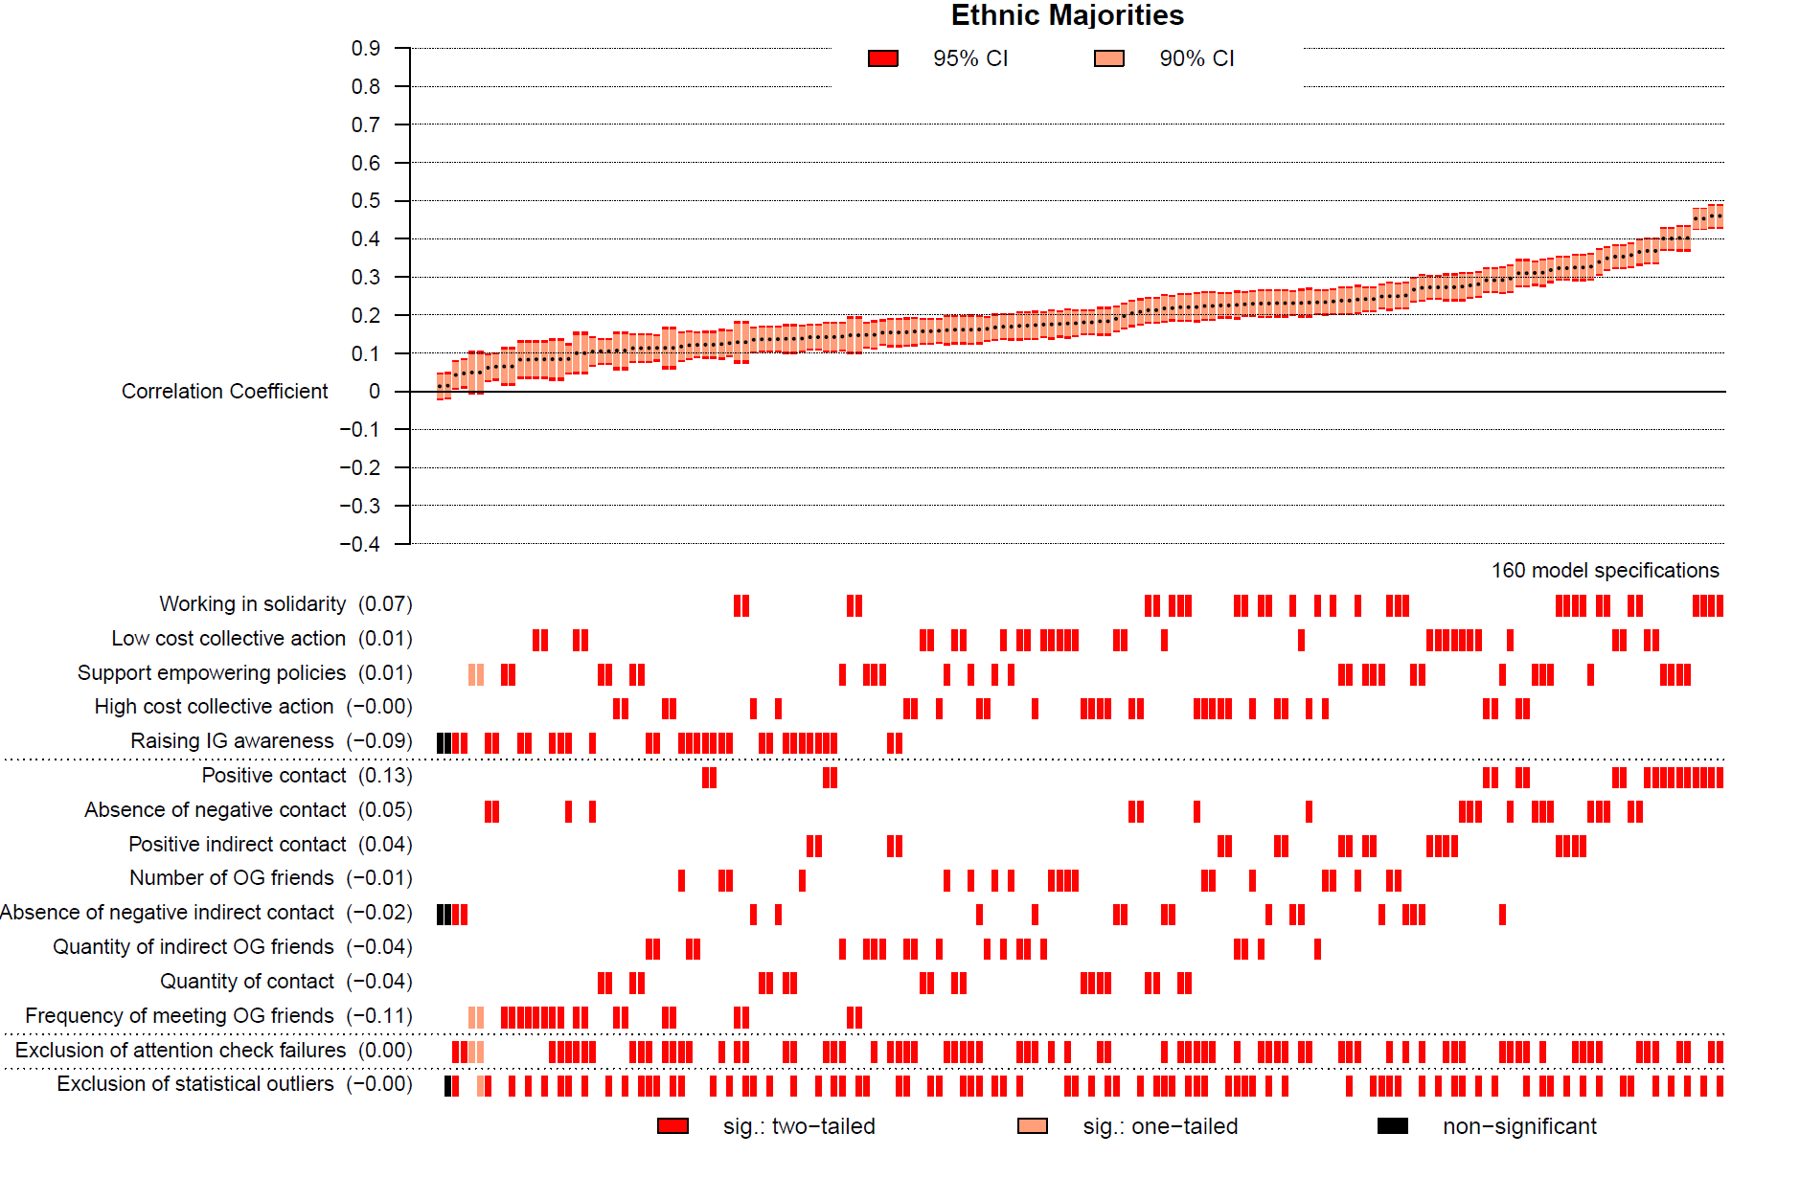Figure 1A. Results of the specification-curve analysis showing the correlation between intergroup contact and support for social change among ethnic majorities (n = 3,216).
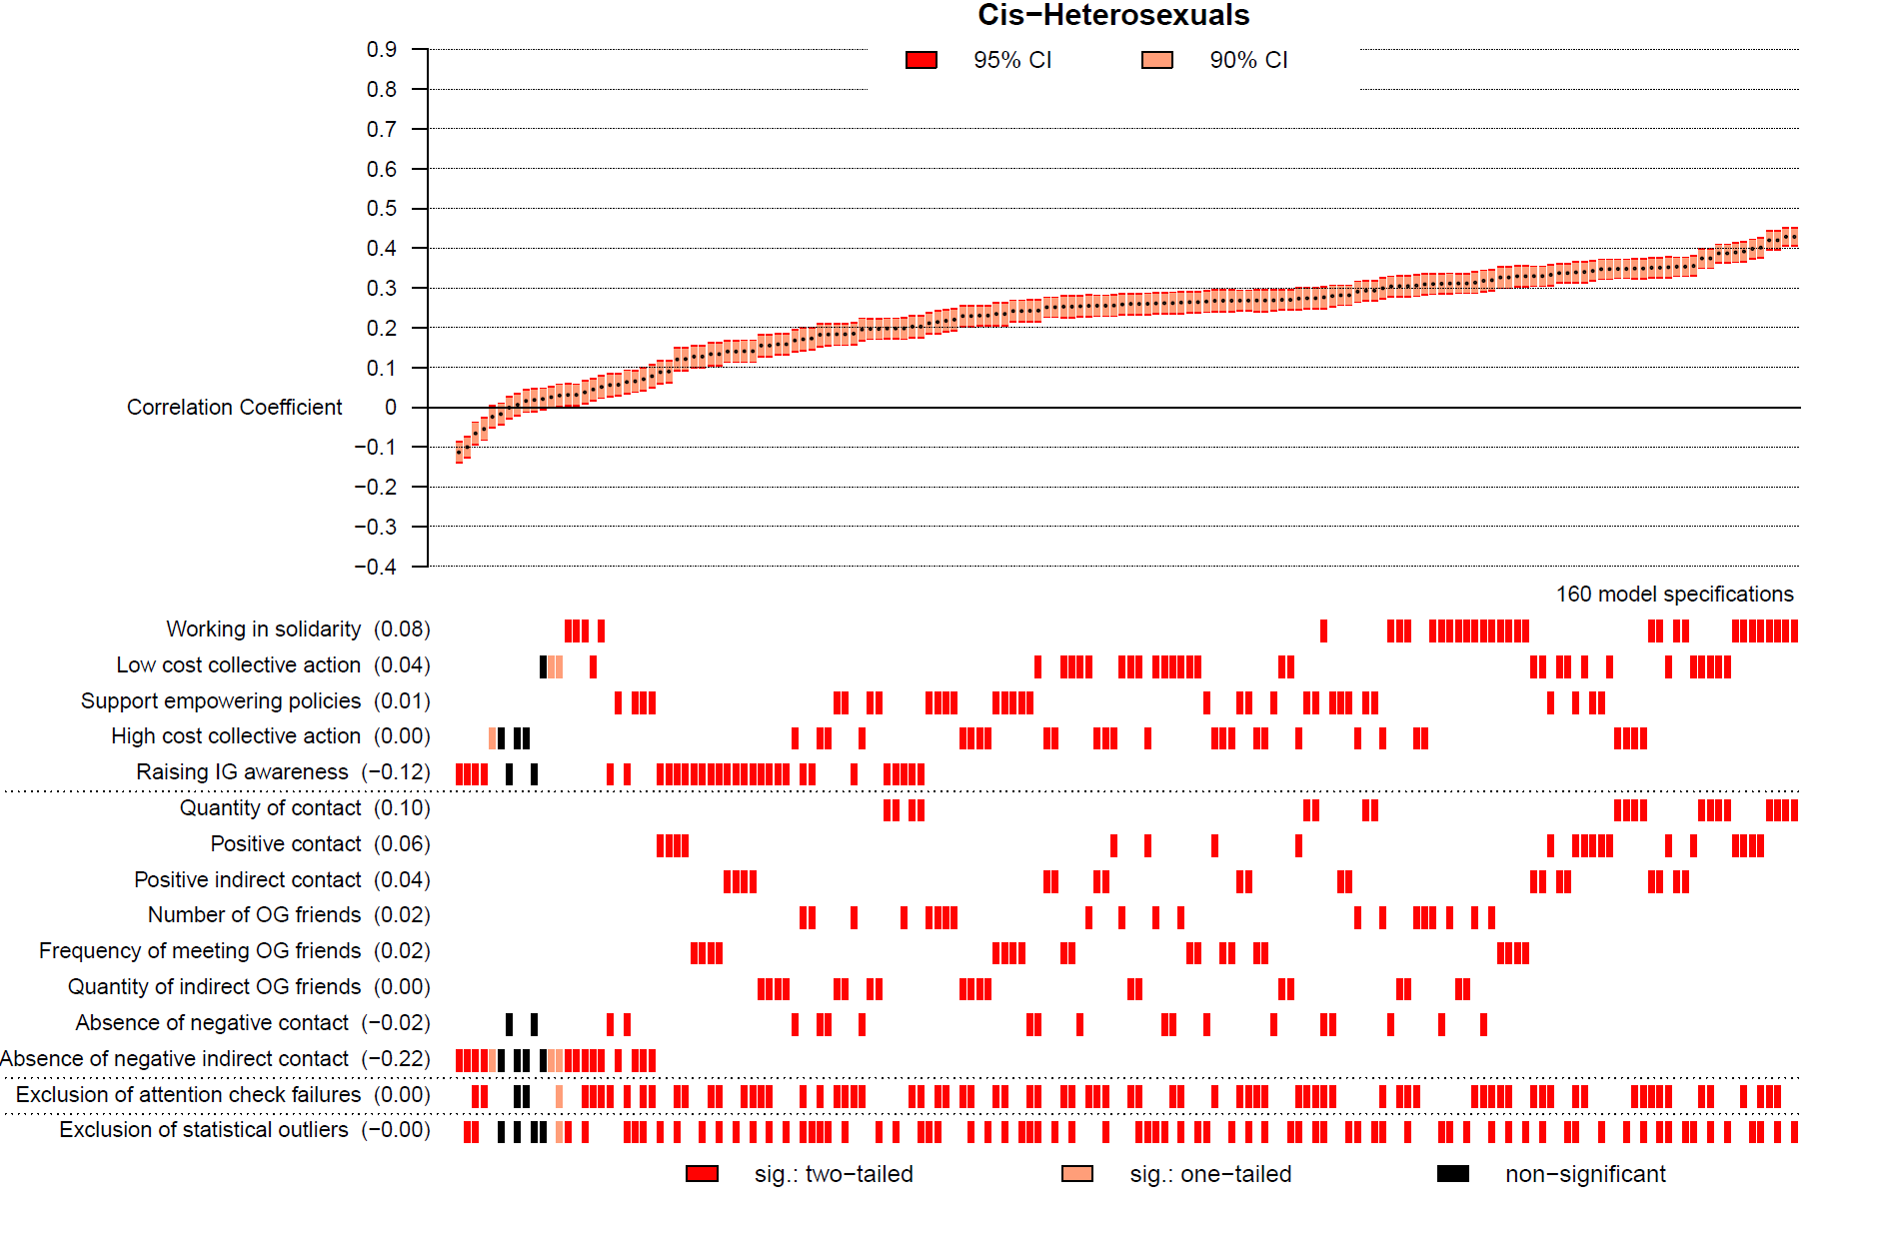
Figure 1B. Results of the specification-curve analysis showing the correlation between intergroup contact and support for social change among cis-heterosexuals (n= 4,898).
Note: The top part of Figures 1A and 1B shows sorted correlations and 90% (95%) confidence intervals in light (dark) red. The bottom part shows the combinations of measures and analytic decisions underlying each correlation. The numbers in parentheses on the left-hand side indicate the change in size of the correlations (relative to the grand mean of correlations) resulting from using this particular measure or analytic decision.
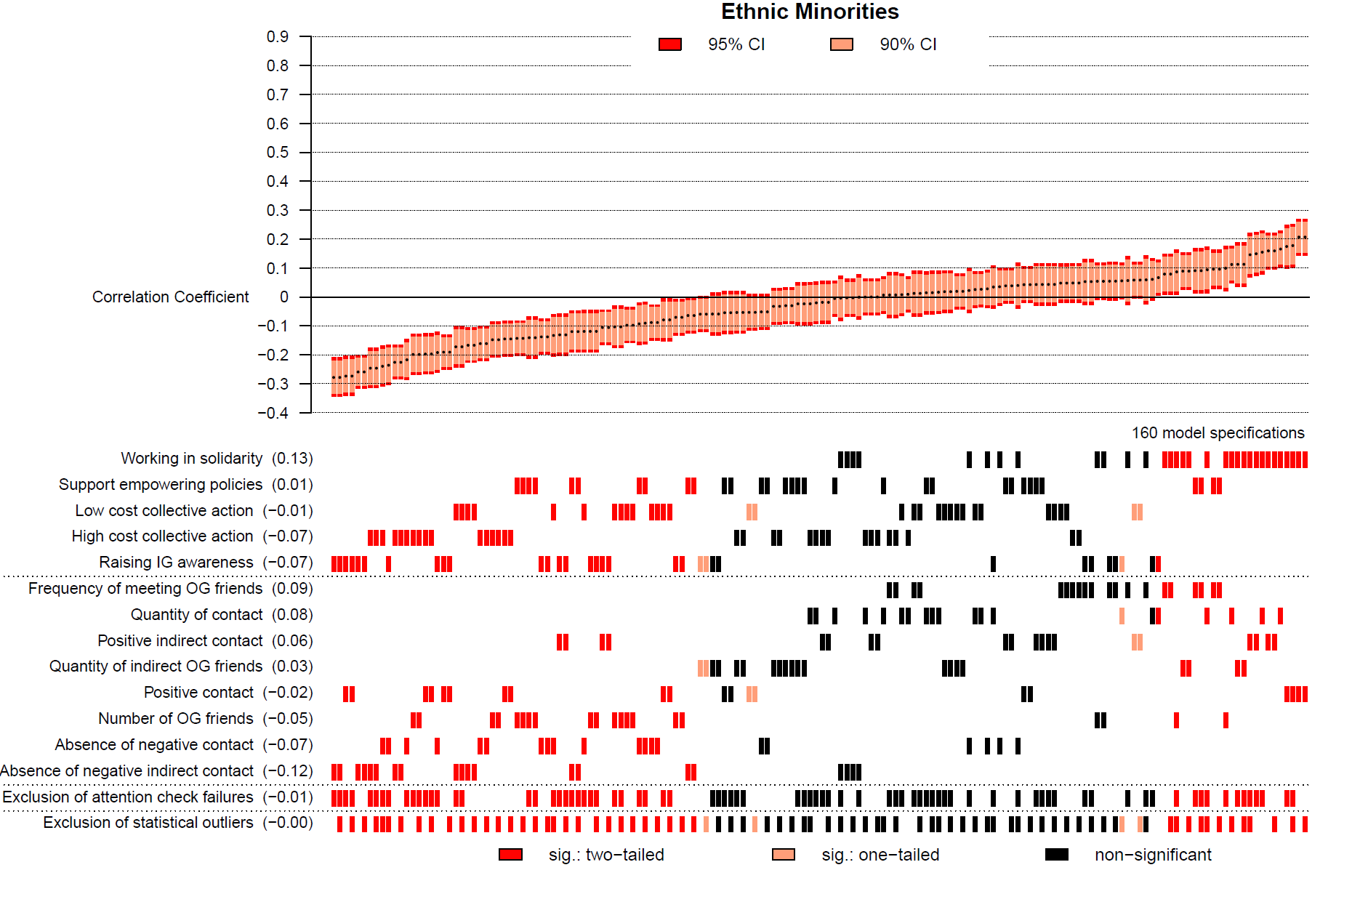Figure 2A. Results of the specification-curve analysis showing the correlation between intergroup contact and support for social change among ethnic minorities (n= 1,000).

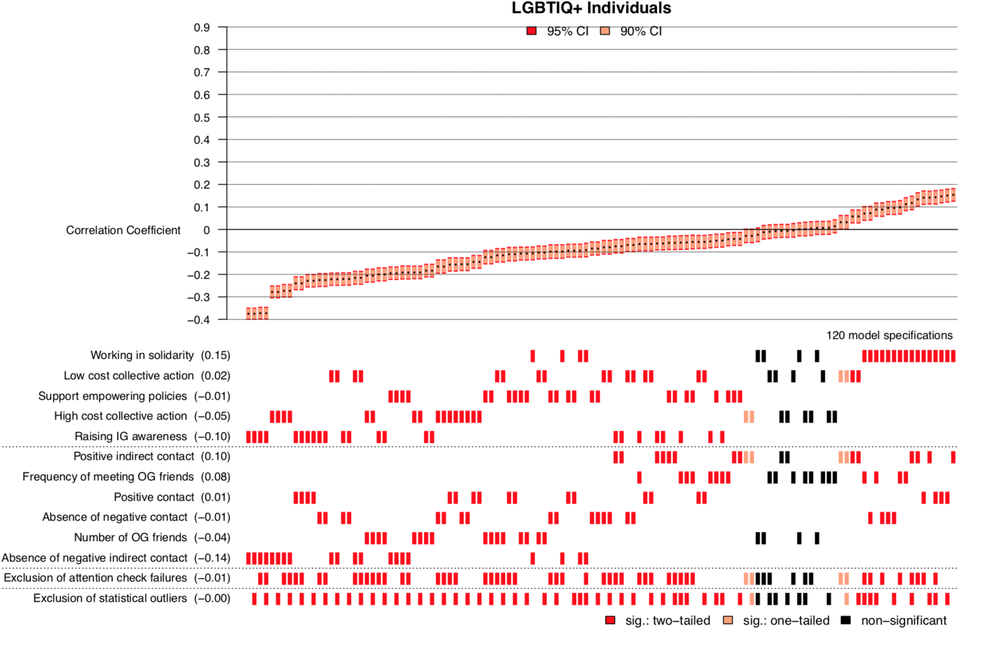
Figure 2B. Results of the specification-curve analysis showing the correlation between intergroup contact and support for social change among LGBTIQ+ individuals (n= 3,883).
Note: The top part of Figures 2A and 2B shows sorted correlations and 90% (95%) confidence intervals in light (dark) red. The bottom part shows the combinations of measures and analytic decisions underlying each correlation. The numbers in parentheses on the left-hand side indicate the change in size of the correlations (relative to the grand mean of correlations) resulting from using this particular measure or analytic decision.

The term cis-heterosexuals denotes heterosexual individuals whose gender identity corresponds to their assigned sex.
The term LGBTIQ+ denotes individuals identifying as lesbian, gay, bisexual, transgender, intersexual, queer, or other sexual and gender minorities. The LGBTIQ+ community has faced, and often continues to face, direct discrimination by cis-heterosexuals (Herek & McLemore, 2013) and structural disadvantage (e.g., exclusion for adoption; United Nations Human Rights Council, 2015).
The in- and outgroup were adapted to the specific in- and outgroups in each context.
The term ethnic minority is used as umbrella term, denoting groups within a country who are structurally disadvantaged due to their racial, ethnic, national, tribal, religious, or cultural background.

