**Testosterone replacement therapy: Pre-treatment sex hormone binding globulin levels and age may identify clinical subgroups.**

Sudarshan Ramachandran 1,2,3,4

Geoffrey I Hackett5

Richard C Strange4

Department of Clinical Biochemistry, University Hospitals of North Midlands/Faculty of Health Sciences, Staffordshire University, Staffordshire, England, United Kingdom1Department of Clinical Biochemistry, University Hospitals Birmingham NHS Foundation Trust, West Midlands, England, United Kingdom2Department of Mechanical and Aerospace Engineering, Brunel University London, England, United Kingdom3Institute for Science and Technology in Medicine, Keele University, Staffordshire, England, United Kingdom4School of Health and Life Sciences, Aston University, Birmingham, United Kingdom5

**Author for correspondence:** Professor S Ramachandran

Department of Clinical Biochemistry, University Hospitals Birmingham NHS Foundation Trust, Good Hope Hospital, Rectory Road, Sutton Coldfield, West Midlands B75 7RR, United Kingdom. e.mail:sud.ramachandran@heartofengland.nhs.uk, Telephone: +44-121-424 7246, Fax: +44-121-311 1800

**Short title:** Baseline SHBG and level change after testosterone therapy

**Key words:** testosterone therapy, sex hormone binding globulin, testosterone, type 2 diabetes

**Abstract.**

**Background** Testosterone replacement therapy (TRT) improves health in some but not all men with type 2 diabetes (T2DM) and adult onset testosterone deficiency (TD). Such heterogeneity is compatible with the concept of patient subgroups that respond differently to therapy.

**Objectives** Use baseline SHBG and age to identify putative subgroups that demonstrate different responses in variables such as waist circumference and HbA1c following TRT.

**Materials and Methods** A randomiseddouble-blind trial approach was used to recruit and randomise men with T2DM and adult onset TD into placebo and TRT treated groups. Multiple regression was used to study differences between groups.

**Results** Baseline SHBG and change in SHBG (∆SHBG) were inversely related in the TRT group. Both median values of SHBG and age mediated the effect of TRT on ∆SHBG depending on whether baseline values were ≤ or >median (28.1nmol/l, 63 years respectively). In men with both SHBG≤28.1 nmol/l and age≤63 years (subgroup 1), TRT was positively associated with ∆SHBG (c = 4.67, 95%CI 1.17 - 8.16, p=0.010) while in those with SHBG>28.1 nmol/l and age>63.1 years (subgroup 4) the association was inverse (c = -7.07, 95%CI -11.64 - -2.49, p=0.003). The association between TRT and change (∆) in waist circumference, HbA1c and International Index of Erectile Function (IIEF) score differed between subgroups; in subgroup 4 but not subgroup 1, the therapy was significantly, associated with ∆waist circumference, ∆HbA1c and ∆IIEF.

**Discussion** Though the mechanism remains unclear, our finding of different responses to TRT in terms of change in waist circumference, HbA1c and IIEF score supports the concept of subgroups in men with T2DM and adult onset TD.

**Conclusion** Our approach may provide a basis for identifying men who will or will not derive benefit from TRT though a larger study is required.

.

**Introduction**Sex hormone binding globulin (SHBG) functions as a transporter for testosterone and via high-affinity binding, a determinant of the level of the steroid in free solution1,2. The importance of SHBG is indicated by studies showing its levels are associated with markers of androgen deficiency, type 2 diabetes (T2DM) risk and all-cause mortality3-7. Thus, gaining a better understanding of SHBG’s role in determining the consequences of altered levels of testosterone should improve management of adult onset testosterone deficiency (TD) a common condition in men with T2DM (reported prevalence 40-70%)8-11. Adult onset TD is characterised by low testosterone levels, increased mortality and phenotypes that may include decreased bone density, muscle strength, cognitive function, sexual function and increased fat mass10,12-15.

In men with T2DM and adult onset TD, testosterone therapy (TRT) can improve sexual health and increase lean mass and, reduce body fat, fasting glycaemia, insulin resistance and all-cause mortality though importantly, not all men demonstrate beneficial effects15,16-22. Understanding the role of SHBG in this process is complicated by the finding that in adults, serum SHBG levels increase with age and demonstrate marked inter- and intra-individual variation23. Thus, in 857 men with T2DM, we found concentrations between 7.9-185.5 nmol/l6,7. A variety of factors mediate serum SHBG including some hormones, physical activity, body-mass-index, some drugs, diet and age and expression appears carefully regulated during periods of metabolic activity such as reproductive tract development.24,25 The variation in SHBG level raises issues regarding how a therapy that changes body testosterone content might influence the serum level and if so would this have clinical implications26-29. We are unaware of a formal study though the BLAST double-blind placebo-controlled intervention randomised controlled trial (RCT) in men with T2DM found after 30 weeks TRT, that SHBG levels decreased significantly in those with pre-treatment total testosterone< 8nmol/l.17

The significance of a TRT-associated fall in SHBG is unclear though it could be related to data indicating the protein functions as more than a steroid hormone carrier17,24,30,31. Thus, SHBG is associated with a variety of clinical phenotypes independently of free testosterone3-7,31 though this may partly reflect recognised difficulties in the determination of this variable.2 Further, there are reports indicating that both SHBG and the SHBG-testosterone complex have metabolic effects2,25. It is possible therefore, that associations of SHBG with clinical phenotypes with or without adjustment for free testosterone, reflect functions of the protein other than as a carrier protein31. We believe that these findings, together with difficulties in quantifying free testosterone warrent further investigation into associations between SHBG and clinical phenotypes.2

We now describe further analysis of BLAST RCT data to determine the extent of change in SHBG levels (∆SHBG) after TRT. We hypothesised firstly, that the levels of SHBG found in men with adult onset TD would show significant inter-individual variability in the degree of change following TRT, and secondly, that the wide range of SHBG levels prior to TRT and expected variation in the extent of change during therapy would demonstrate aspects of patient heterogeneity and possibly help identify subgroups that respond differently to therapy.26 Accordingly, we first determined if TRT was associated with change in SHBG over the 30 week study and if baseline SHBG and age were associated with ∆SHBG. We used these data to identify subgroups based on combinations of median values of baseline SHBG and age and, determine if TRT differently affected change in relevant variables such as waist circumference, HbA1c and blood pressure in the putative subgroups.

**Materials and Methods**

The BLAST RCT describes a 30 week randomised double-blind placebo-controlled multicentre study carried out between September 2008-June 2012 to assess the impact of TRT on men with T2DM16. The study duration adhered to guidelines recommending TRT trial periods of 3–6 months in men with TD. The study was conducted in accordance with the revised guidelines of the World Medical Association Declaration of Helsinki (<https://www.wma.net/policies-post/wma-declaration-of-helsinki-ethical-principles-for-medical-research-involving-human-subjects/> - accessed on 10/12/2019). The study (EudraCT 2008-000931-16) was approved by the Multicentre Research Ethics Committee (reference: 08/H1208/30).

Change in glycaemic control (HbA1c) was the primary efficacy end-point and secondary end points included changes in International Index of Erectile Function (IIEF) scores.16 The target sample size of 100 men in the TRT and placebo arms had an 80% probability of demonstrating a statistically significant treatment difference in the event of an HbA1c change of 0.4%. This calculation used a standard deviation of 1%, a significance level of 5% (two-sided) and analysis of covariance with baseline HbA1c as covariate. HbA1c change of 0.4% was accepted as significant and an SD (baseline corrected) of 1% was derived from previous trials. Physicians were asked, if possible, to avoid therapy changes during the study. Any patient requiring anti-coagulation was to be withdrawn. Adverse events were identified at each visit using a non-leading question.

Inclusion criteria included men aged 18–80 years with symptoms of TD defined by the Aging Male Symptom Scale (AMSS) together with an initial TT ≤12.0nmol/l or calculated Free Testosterone (cFT) ≤ 0.25nmo/l according to the then European Association of Urology guidelines (<https://uroweb.org/wp-content/uploads/18-Male-Hypogonadism_LR.pdf> - accessed 0n 10/12/2019). Exclusion criteria included men considered too frail, previous TRT, abnormal digital rectal examination, PSA >4μg/L, haematocrit >0.50, history of prostate cancer or other serious co-morbidities. Thyroid function was not checked at screening. From the primary care T2DM register of 857 men, 550 men with an 8–11 am total testosterone level ≤12.0nmol/l or calculated free testosterone≤ 0.25nmo/l were pre-screened; eligibility was evaluated using the above criteria (including 2, total and calculated free testosterone levels taken at least 6 weeks apart). Of the eligible 211 men at visit 1, 11 were excluded (raised PSA: 10, atrial fibrillation: 1) and recruitment was closed when the target of 200 men was reached (Figure 1). Subsequently 1 patient withdrew and the remaining199 men were randomised to TRT using testosterone undecanoate (TU) (92 men) or Placebo (107 men) at 0 weeks (visit 2) with further TU administration at 6 (visit 3), 18 (visit 4) and 30 weeks (visit 5). Exercise and dietary advice using standard NHS diabetes literature was given at visit 1. Of the 199 men commencing the study, 189 men (TRT: 86, Placebo: 103) completed the 30 weeks (reasons for non-completion and adverse events shown in Figure 1).

**Randomisation and treatment.**Subjects were randomised to TU 1000 mg (TRT) or Placebo into the right or left upper outer gluteal region. TU (trade name: Nebido) and Placebo were prepared by the manufacturing company Bayer (Pharma AG, Berlin, Germany) and randomised. Identification of trial medication was via numbered sealed packages with each man assigned to the next lowest package. The code breaks were retained by study statisticians until the last man was recruited and codes were broken after the final procedure and data bases were locked. The dose interval was in accordance with manufacturer’s recommendations (Figure 1). The Placebo was an analogue of the same appearance minus active substance containing the vehicle castor oil and benzyl benzoate.

**Laboratory Testing.**Morning (8-11 AM) fasting blood samples were taken at visits, -2 (visit 1), 6 (visit 3), 18 (visit 4), and 30 (visit 5) weeks for measurement of HbA1c, lipids and serum total testosterone and SHBG. these were carried out at the University Hospitals Birmingham Foundation NHS Trust. Total testosterone was measured using a Roche Common Platform Immunoassay (validated against mass spectrometry), SHBG and lipid levels using a Roche Modular automated analyzer (Roche Diagnostics, Burgess Hill, UK). Free testosterone was calculated using an online calculator.27

**Statistical Analysis.**Comparison of baseline characteristics between placebo and TRT groups were checked using non-parametric rank sum tests. Associations between baseline SHBG (dependent variable) and predictors (independent variables) were determined in separate linear regression models. Changes in within-group parameters during the 30 week trial was analysed using non-parametric sign rank tests. We established factors (dependent variables) associated with ∆SHBG (independent variable) in linear and multiple regression models. The effect of TRT (reference: placebo) on ∆SHBG (dependent variable) was determined in the total and stratified (by median values) cohorts using multiple regression analyses. These analyses formed the basis of subgroup identification. Finally the association between TRT (independent variable) and change in metabolic and sexual function parameters (dependent variable) in subgroups was determined using multiple regression models (in the case of IIEF-EF scores additional non-parametric rank sum tests were carried out as the scores were ordinal, restricted and not continuous though with a wide distribution).

**Results**

**Comparison of baseline characteristics in placebo and TRT groups**We assessed the effectiveness of randomisation by comparing in the189 men allocated to placebo or TRT, baseline values of characteristics relevant in assessing patients with T2DM and hypogonadism. At baseline, values of the variables including age, total testosterone and SHBG in the two groups were not significantly different (non-parametric test rank sum used) (Table 1).

**Associations between baseline SHBG and variables.**

To determine if baseline SHBG was associated with the variables in Table 1, we used individual regression analysis models to identify positive, significant associations between baseline SHBG and total testosterone (coefficient (c)=2.16, 95% CI: 1.65, 2.66, p<0.001) and age (c=0.65, 95% CI: 0.47,0.83, p<0.001) and inverse associations with waist circumference (c=-0.23, 95% CI: -0.39, -0.075, p=0.004), weight (c= -0.25, 95% CI: -0.35, -0.14, p<0.001), body mass index (c= -0.70, 95% CI: -1.06, -0.33, p<0.001), HbA1c (c=-3.00, 95% CI: -4.62, -1.37, p<0.001), total cholesterol (c= -2.45, 95% CI: -4.70, -0.21, p=0.032), triglyceride (c = -3.28, 95% CI: -4.92, -1.63, p<0.001) and diastolic (not systolic) blood pressure (c= -0.32, 95% CI: -0.54, -0.11, p=0.003). SHBG was not significantly associated with IIEF score (-0.094, 95% CI: -0.30, 0.11, p = 0.37). Inclusion of calculated free testosterone as a confounding variable did not alter any of the associations of baseline SHBG with the clinical variables studied (data not shown).

**Comparison of values in the placebo and TRT-treated groups after 30 weeks**

As expected, after 30 weeks TRT, trough levels of total testosterone were significantly greater in treated men (median: +1.50, IQR: -1.35/3.85, p (sign rank)= 0.0007) than in those given placebo (median: +0.75, IQR: -1.40/1.95, p (sign rank)=0.13). SHBG changed (ΔSHBG: visit 5 – baseline SHBG values) non significantly after 30 weeks in the total (median: -1.0, IQR: -4.40/3.20, p (sign rank)=0.071), placebo (median: -0.70, IQR: -4.10/1.95, p (sign rank)=0.46) and TRT (median: -1.2, IQR: -4.60/2.05, p (sign rank) =0.058) groups though in the total and TRT groups, the change approached significance. In the TRT group, significant reductions were found in waist circumference (-3.0cm, IQR: -5.30/0.0, p<0.0001), weight (median: -1.0kg, IQR: -2.75/0.55, p=0.0014), body mass index (median: -0.3, IQR: -0.90/0.25, p=0.0032) and total cholesterol (-0.2, IQR: -0.60/0.10, p=0.0036). In the placebo group, only HbA1c changed, demonstrating a significant increase after 30 weeks (median: +0.10, IQR: -0.20/0.50, p=0.032).

**Examining the data for subgroups using baseline SHBG and age**

Table 2 shows baseline SHBG level was significantly associated with ∆SHBG (dependent variable) in the total cohort and TRT-treated men (model 1: c= -0.32 (95% CI: -0.44,-0.20), p<0.001) but not placebo group suggesting the association in the total cohort was driven by TRT. Model 2 shows that age was also significantly associated with ∆SHBG in the placebo and TRT groups though the association differed; in the placebo group the coefficient (c) was positive while in men treated with TRT an inverse association was observed. Model 3 includes baseline SHBG and age as independent variables and shows baseline SHBG but not age, was significantly associated with ∆SHBG in TRT group. In the placebo group, the association with age was significant while that with SHBG only approached significance (Table 2). None of the other variables including total testosterone, weight, waist circumference, HbA1c, blood pressure and lipids were significantly associated with ∆SHBG when included individually in model 3 (data not shown).

The association between baseline SHBG and ∆SHBG in TRT treated men (model 1, Table 2) demonstrates a negative coefficient indicating an inverse association; thus, the value of ∆SHBG (either positive or negative) is higher the lower the value of baseline SHBG (Figure 2). Importantly, the coefficient does not show whether ∆SHBG is positive or negative, this is shown by whether the line intercepts the y axis (∆SHBG) at ≤0 or >0. Accordingly, Figure 2 shows for each individual subject given TRT or placebo, baseline SHBG plotted against ∆SHBG. It shows firstly, an inverse relationship between the two variables in the TRT group with scatter and secondly, indicates that men with lower levels of baseline SHBG values are likely to have higher SHBG values at the end of TRT while the converse is true in men with baseline values greater than 24.7nmol/l (calculated using the regression shown in Figure 2). Figure 3 shows the corresponding relationship between age and ∆SHBG in the placebo and TRT groups. The placebo group demonstrated a positive coefficient while in the TRT group it was negative.

We also examined the possibility that baseline testosterone level might mediate the association of SHBG with ∆SHBG (dependent variable) by dichotomising the men given TRT into those with baseline concentrations <8nmol/l or 8-12nmol/l. In a multiple regression model comprising baseline SHBG and age, we found that while baseline SHBG was significantly associated with ∆SHBG, no associations were observed for testosterone in men stratified by testosterone levels<8nmol/l (c=0.18, 95% CI -0.97,1.32, p=0.75) or 8-12nmol/l (c=0.25, 95% CI -0.72,1.23, p=0.60).

**Effects of TRT on ∆SHBG after 30 weeks**

The data in Table 2 and Figures 2 and 3 show firstly, that both baseline SHBG and age mediate the effect of TRT (compared to placebo) on ∆SHBG and secondly, suggest these factors could be used to identify subgroups. Accordingly, we studied the association between TRT (compared to placebo) and ∆SHBG in patients stratified by median baseline SHBG (28.1nmol/l) and age (63 years). To determine whether stratification by baseline SHBG identified subgroups with varying outcomes, we used multiple regression to show that relative to the placebo group, TRT had different effects on ∆SHBG depending on whether baseline values were ≤ or >28.1nmol/l. Thus, in men with baseline values ≤28.1nmol/l, TRT was associated with a significant positive coefficient for ∆SHBG while in those with baseline values>median value, the association was significant but inverse (Table 3).

Table 3 also shows that while TRT was significantly associated with ∆SHBG in men aged ≤63 and >63 years, the association demonstrated a positive coefficient in younger and a negative coefficient in older men.

Table 4 shows the results of regression analyses in which men were stratified into subgroups 1-4 using median values of both age and SHBG and the association between ∆SHBG (dependent variable) and TRT determined. Each model was adjusted for the age and the baseline SHBG values within that subgroup. In the 58 men with SHBG≤28.1 nmol/l and age≤63 years (subgroup 1), TRT was positively associated with ∆SHBG (c = 4.67, 95%CI 1.17, 8.16, p=0.010) while in those with SHBG > 28.1 nmol/l and age >63.1 years (subgroup 4) the association was inverse (c = -7.07, 95%CI -11.64, -2.49, p=0.003). No significant associations were observed in the other two categories; SHBG ≤28.1 nmol/l, age>63.1 years (subgroup 2) and SHBG >28.1 nmol/l, age<63.1 years (subgroup 3). Subgroups 2 and 3 comprised fewer men because of the positive association between SHBG and age.

**Combinations of baseline SHBG and age and their association with change in variables after 30 weeks TRT.**

The finding that the association of TRT with ΔSHBG was different in men stratified by baseline SHBG and age suggested these two variables may help identify subgroups of men who demonstrate different responses in characteristics associated with TD and T2DM after 30 weeks TRT. Table 5 shows the association between TRT and change in variables (dependent variable: ∆ variable) associated with hypogonadism and T2DM in men with the combination of SHBG<28.1nmol/l and age<63years (subgroup 1) or, SHBG >28.1nmol/l and age >63years (subgroup 4). We found that ∆waist circumference in men with SHBG≤28.1 nmol/l/age≤63 years and those with SHBG>28.1 nmol/l/age>63 years differed; in subgroup 1 the association between TRT and ∆waist circumference did not achieve significance while in subgroup 4 the therapy was significantly, inversely associated with ∆waist circumference. Similarly, only in the latter group was the association of TRT with ∆HbA1c inversely significant. Of the other ∆variables studied only the association between TRT and ∆IIEF score was significant in the men with SHBG>28.1 nmol/l/age>63 years..

**Discussion**

TRT can improve symptoms in men with T2DM and adult onset TD though subgroups may respond differently.17-19,28, Thus, Hackett et al showed that while 30 weeks TRT was associated with improvement in different domains of sexual function in men with total testosterone≤8 nmol/l, only sexual desire improved signiﬁcantly in those with testosterone 8-12nmol/l.18 Further, in men given TRT only those with testosterone ≤8nmol/l showed a significant reduction in SHBG.14 Accumulating data shows that total and calculated free testosterone, age and SHBG are associated with clinical phenotype.29 However, our hypothesis that TRT would be associated with a change in SHBG was correct with the direction of change influenced by baseline SHBG and age; Figures 2 and 3 show that an increase in SHBG was associated with lower baseline levels and younger age. The putative importance of SHBG level is suggested by our finding that associations between age, waist circumference, body mass index, HbA1c, lipids, diastolic blood pressure and SHBG were not altered by inclusion of calculated free testosterone in regression models. The importance of SHBG is further indicated by examining the men stratified into four groups by combinations of high or low values of total and free testosterone; the two groups with the highest values of SHBG demonstrated the worse sexual, physical and psychological function scores.29 Accordingly, we speculated that SHBG and age might modify the effect of therapy on clinical phenotype thereby allowing subgroups to be identified.26

Age was considered an essential variable as it is linked many factors that define T2DM and TD. For example, Hackett et al found the greatest benefit of TRT in terms of reduction in all-cause mortality was in older men.20 SHBG is associated independently of total testosterone, with markers of androgen deficiency, T2DM risk and insulin resistance suggesting the use of change in waist circumference, HbA1c and IIEF EF scores after TRT as outcomes.3,30,31

We initially focused on factors identified with ∆SHBG. Baseline SHBG was associated with ∆SHBG in men given TRT, but not placebo. Age at study onset was associated with ∆SHBG in both men on TRT and placebo though the direction of the regression coefficient differed. Stratification of the cohort by baseline SHBG and age was used when studying the association between outcomes (∆SHBG and clinical parameters) and TRT. In men with baseline SHBG≤28.1 nmol/l or age≤63 years, TRT compared to placebo was associated with a significant positive coefficient while in those with baseline SHBG>28.1 nmol/l or age>63 years, the therapy was associated with a significant negative coefficient in SHBG after 30 weeks. These associations were clearly evident in men with combinations of both SHBG and age below the median compared with men with values of the two variables above the median value.

The finding that the association of TRT with ΔSHBG was different in men stratified by baseline SHBG and age prompted us to examine corresponding associations between change in variables associated with baseline SHBG over 30 weeks TRT in men stratified by median values of baseline SHBG and age. For waist circumference, the association between TRT and Δwaist circumference differed in men with SHBG≤28.1 nmol/l and age≤63 years and those with SHBG>28.1 nmol/l and age>63 years; in the younger men with lower SHBG levels the association between TRT and waist circumference change did not achieve significance while in the other group the therapy was significantly and negatively associated with waist circumference. Similarly, only in the latter group of men was the association of TRT with HbA1c change inversely significant. Of the other variables studied only the association between TRT and IIEF score was significant in the men with SHBG>28.1 nmol/l and age>63 years. A fuller assessment of the influence of age on the impact of TRT on variables including waist circumference, HbA1c and IIEF score using a randomised control approach would be useful.

Our study has strengths and weaknesses. A main strength is the use of data from an RCT with continuity of treatment over 30 weeks and a dedicated nurse to administer testosterone ensuring compliance. A weakness is the relatively small number of patients available for study and an Ethics committee-imposed study time of 30 weeks. A larger study with a longer treatment period is needed as Hackett et al20 showed variables such as erectile function scores continue to improve with longer term TRT. A further issue is the mechanism(s) for the results described. Thus, why the extent of change in SHBG during TRT is related to baseline values is not known and the finding that change in both waist circumference and HbA1c after TRT is associated with a decrease in SHBG is not expected as increasing insulin resistance is associated with lower levels of the protein.30 Further, as TRT effects an increase in the body content of testosterone it might be expected that levels of free hormone would also increase resulting in increased levels of SHBG rather than a fall if a feedback mechanism dependent on total or free testosterone lowered SHBG in men with adult onset TD prior to TRT. Nonetheless, stratifying patients using baseline SHBG and age appears to have identified subgroups of men who demonstrate different responses to TRT even after only 30 weeks of treatment. For example, TRT was associated in subgroup 4 but not subgroup 1, with significant inverse correlation with Δwaist circumference and ΔHbA1c and positive association with ΔIIEF-EF score.

While it is unclear whether these results reflect the functional role of SHBG or an unrecognised association with other variables they complement data showing TRT-related improvement in IIEF-EF was associated with baseline testosterone levels ≤8nmol/l.17 Thus, while we acknowledge that patient numbers are small, we further stratified subgroup 4 using baseline testosterone levels (Table 5 footnote); ΔIIEF-EF score improved with TRT in both groups (total testosterone ≤8nmol/l, n=19: c=7.66, 95% CI: 1.06, 14.27, p=0.025, total testosterone >8nmol/l, n=34: c=4.69, 95% CI: 0-014, 9.38, p=0.049). However, as suggested by previous results (Hackett 2016) ΔIIEF-EF score improvement following TRT was greater in men with testosterone ≤8nmol/l (mean ΔIIEF-EF: TRT: 5.2, Placebo: -2.5) than in men with total testosterone >8nmol/l (mean ΔIIEF-EF: TRT: -0.6, Placebo: -5.3). Thus, while men with total testosterone ≤8nmol/l should continue to be considered for TRT, treatment should perhaps be extended to older men with total testosterone >8nmol/l and high SHBG (subgroup 4) if our findings are validated.

Our results appear to reflect change over time in both TRT and placebo groups. For example, there was an unexpected age-related change of SHBG in men on placebo (though both groups received instruction in diet and lifestyle at baseline). The change in the placebo group appeared age related and different to that in the TRT group. While the placebo group is not a conventional, stable control group, initial randomisation was effective and change in SHBG may reflect progression of adult onset TD. Further, differences between groups appear to result from small changes in both; variables in the placebo group worsened while in the TRT group they improved. If so it may be possible to direct treatment at appropriate patients. Our finding that the benefits of TRT in terms of waist circumference, HbA1c and erectile function are most evident in older men with higher levels of SHBG suggests it would be worthwhile to investigate the associations between various variables and TRT outcomes in a larger and longer study to determine if clinical outcomes continue to diverge with TRT in subgroups. This approach should facilitate continuing evolution of clinical management guidelines for adult onset TD.

Accumulating data suggest the importance of SHBG in the development of various phenotypes found in adult onset TD3-7,24, 25,30,31. The associations described may reflect the protein’s role in mediating the free testosterone level (and other steroids) as well as the impact of other compounds that alter serum SHBG.2 Any consideration of the clinical usefulness of SHBG level requires further study. For example, Corviello et al showed subjects with an SHBG genotype comprising three risk rs12150660 and rs6258 alleles were at higher risk of low serum testosterone than those with no risk allele.32 The impact of these (and other) polymorphisms will depend in part, on allele frequency and while rs12150660 G and T alleles are reasonably common, rs6258 T allele is uncommon. A further factor is that development of adult onset TD symptoms may be more complicated in terms of hormonal responsibility. For example, serum oestradiol levels also fall during male aging and while risk of various pathologies is often attributed to low testosterone, low oestradiol or an altered testosterone/oestradiol ratio may be relevant as both hormones are bound by SHBG. Thus, Finkelstein et al found the testosterone dose required to effect changes in different tissues varied in men after suppression of testosterone and oestrogen synthesis and, the influence of testosterone and oestradiol differed though both were associated with libido and erectile function.33

The finding that total testosterone is associated with mortality raises issues regarding how the components of its often labile carrier system mediate the clinical phenotypes and outcomes seen in adult onset TD. SHBG and total testosterone are independent risk variables that mediate age-related mortality and while data on calculated free testosterone are supportive of these findings there have been criticisms of various algorithms used to produce such values. Clearly, it would be very useful to have a precise and accurate assay that allowed measurement of free testosterone.2,34

**References.**

1.Ahern T, Wu FCW. New horizons in testosterone and the ageing male. Age and Ageing 2015; 44: 188–195

2.Goldman AL, Bhasin S, Wu FCW, Krishna M, Matsumoto AM, Jasuja RA. Reappraisal of Testosterone's Binding in Circulation: Physiological and Clinical Implications. Endocr Rev 2017; 38: 302-324.

3.Rastrelli G, Corona G, Cipriani S, Mannucci E, Maggi M. Sex hormone-binding globulin is associated with androgen deficiency features independently of total testosterone. Clin Endocrinol. 2018; 88:556-564.

4.Ding E, Song Y, Manson JE, Hunter DJ, Lee CC, Rifai N, Buring JE, Gaziano JM, Liu S. Sex Hormone–Binding Globulin and Risk of Type 2 Diabetes in Women and Men. N Engl J Med 2009; 361: 1152–1163.

5. Tint AN, Hoermann R, Wong H, Ekinci EI, MacIsaac RJ, Jerums G, Zajac JD, Grossman M. Association of sex hormone-binding globulin and free testosterone with mortality in men with type 2 diabetes mellitus. Eur J Endocrinol 2016; 174: 59-68.

6. Ramachandran S, Strange RC, Fryer AA, Saad F, Hackett GI.The association of sex hormone binding globulin with mortality is mediated by age and testosterone in men with type 2 diabetes. Andrology 2018; 6: 846-853

7. Ramachandran S, Hackett GI, Strange RC. Sex hormone binding globulin: A review of its role in determining age-related mortality in men with type 2 diabetes. Sexual Med Reviews 2019; 7: 669-678

8. Hackett G, Cole N, Deshpande A, Popple M, Kennedy D, Wilkinson P.Biochemical hypogonadism and type 2 diabetes in primary care. Br J Diab Vasc Dis. 2009; 9: 226-231.

9. Kapoor D, Aldred H, Clark S, Channer KS, Jones TH. Clinical and biochemical assessment of hypogonadism in men with type 2 diabetes: correlations with bioavailable testosterone and visceral adiposity. Diabetes Care 2007; 30: 911-917.

10. Pye SR, Huhtaniemi IT, Finn JD Lee DM, O'Neill TW, Tajar A, Bartfai G, Boonen

S, Casanueva FF, Forti G, Giwercman A, Han TS, Kula K, Lean ME, Pendleton N,

Punab M, Rutter MK, Vanderschueren D, Wu FC; EMAS Study Group. Late-onset hypogonadism and mortality in aging Men. J Clin Endocrinol Metab 2014; 99: 1357–1366.

11. Hackett G, Kirby M, Edwards D, Jones TH, Wylie K, Ossei-Gerning N, David J, Muneer A. British Society for Sexual Medicine guidelines on adult testosterone deficiency, with statements for UK practice. J Sex Med 2017;14; 1504 – 1523

12. Wu FC, Tajar A, Beynon JM, Pye SR, Silman AJ, Finn JD, O'Neill TW, Bartfai G, Casanueva FF, Forti G, Giwercman A, Han TS, Kula K, Lean ME, Pendleton N, Punab M, Boonen S, Vanderschueren D, Labrie F, Huhtaniemi IT; EMAS group. Identification of late-onset hypogonadism in middle-aged and elderly men. N Engl J Med 2010; 363; 123-135.

13. Fabbri E, An Y, Gonzalez-Freire M, Zoli M, Marcello Maggio M, Studenski SA, Egan JM, Chia CW, Ferrucci L (2016) Bioavailable Testosterone Linearly Declines Over A Wide Age Spectrum in Men and Women From The Baltimore Longitudinal Study of Aging. J Gerontol A Biol Sci Med Sci. 2016; 71: 1202–1209

14. Khera M, Broderick GA, Carson CC, Dobs AS, Faraday MM, Goldstein I, [Hakim LS](https://www.ncbi.nlm.nih.gov/pubmed/?term=Hakim%20LS%5BAuthor%5D&cauthor=true&cauthor_uid=27343020), [Hellstrom WJ](https://www.ncbi.nlm.nih.gov/pubmed/?term=Hellstrom%20WJ%5BAuthor%5D&cauthor=true&cauthor_uid=27343020), [Kacker R](https://www.ncbi.nlm.nih.gov/pubmed/?term=Kacker%20R%5BAuthor%5D&cauthor=true&cauthor_uid=27343020), [Köhler TS](https://www.ncbi.nlm.nih.gov/pubmed/?term=K%C3%B6hler%20TS%5BAuthor%5D&cauthor=true&cauthor_uid=27343020), [Mills JN](https://www.ncbi.nlm.nih.gov/pubmed/?term=Mills%20JN%5BAuthor%5D&cauthor=true&cauthor_uid=27343020), [Miner M](https://www.ncbi.nlm.nih.gov/pubmed/?term=Miner%20M%5BAuthor%5D&cauthor=true&cauthor_uid=27343020), [Sadeghi-Nejad H](https://www.ncbi.nlm.nih.gov/pubmed/?term=Sadeghi-Nejad%20H%5BAuthor%5D&cauthor=true&cauthor_uid=27343020), [Seftel AD](https://www.ncbi.nlm.nih.gov/pubmed/?term=Seftel%20AD%5BAuthor%5D&cauthor=true&cauthor_uid=27343020), [Sharlip ID](https://www.ncbi.nlm.nih.gov/pubmed/?term=Sharlip%20ID%5BAuthor%5D&cauthor=true&cauthor_uid=27343020), [Winters SJ](https://www.ncbi.nlm.nih.gov/pubmed/?term=Winters%20SJ%5BAuthor%5D&cauthor=true&cauthor_uid=27343020), [Burnett AL](https://www.ncbi.nlm.nih.gov/pubmed/?term=Burnett%20AL%5BAuthor%5D&cauthor=true&cauthor_uid=27343020). Adult-Onset Hypogonadism Mayo Clin Proc 2016; 91: 908-926.

15. Muraleedaran V, Marsh H, Kapoor D, Channer KS, Jones TH. Testosterone deficiency is associated with increased risk of mortality and testosterone replacement improves survival in men with type 2 diabetes. [Eur J Endocrinol](http://www.ncbi.nlm.nih.gov/pubmed/23999642) 2013;169: 725-733

16. Hackett G, Cole N, Bhartia M, Kennedy D, Raju J, Wilkinson P, Saghir A, Blast Study Group.The response to testosterone undecanoate in men with type 2 diabetes is dependent on achieving threshold serum Levels (the BLAST study). Int J Clin Pract 2014; 68: 203–215.

17.Hackett G, Heald AH, Sinclair A, Jones PW, Strange RC, Ramachandran S. Serum testosterone, testosterone replacement therapy and all-cause mortality in men with type 2 diabetes: retrospective consideration of the impact of PDE5 inhibitors and statins. Int J Clin Pract 2016; 70: 244-253.

18.Hackett G, Cole N, Saghir A, Jones P, Strange RC, Ramachandran S. Testosterone replacement therapy: improved sexual desire and erectile function in men with type 2 diabetes following a 30-week randomized placebo-controlled study. Andrology 2017; 5: 905-913 1

19.Hackett G, Jones PW, Strange RC, Ramachandran S. Statin, testosterone and phosphodiesterase 5-inhibitor treatments and age related mortality in diabetes. World J Diabetes 2017; 8: 104-111.

20.Hackett G, Cole N, Mulay A, Strange RC, Ramachandran S. Long-Term Testosterone Therapy in Type 2 Diabetes Is Associated with Decreasing Waist Circumference and Improving Erectile Function. World J Mens Health 2018;36, e33

21.Hackett GI, Cole N, Mulay A, Strange RC, Ramachandran S. Long-term

Testosterone Therapy in Type 2 Diabetes is associated with reduced Mortality

without improvement in conventional cardiovascular risk factors. BJUInt 2019;123;

519-529

22. Corona G, Giagulli VA, Maseroli E, Vignozzi L, Aversa A, Zitzmann M Saad F, Mannucci E, Maggi M. Testosterone supplementation and body composition: results from a meta-analysis of observational studies. J Endocrinol Invest 2016; 39; 967-981

23. Krakowsky Y, Conners W, Morgentaler A. Serum Concentrations of Sex Hormone–binding Globulin Vary Widely in Younger and Older Men: Clinical Data from a Men’s Health Practice. Eur Urol Focus 2019; 5:273-279

24. Hammond GL. Diverse Roles for Sex Hormone-Binding Globulin in reproduction. Biology of Reproduction.2011**;**85: 431–441

25. Thaler MA, Seifert-Klauss V, Luppa PB. The biomarker sex hormone-binding globulin. From established applications to emerging trends in clinical medicine. Best Practice & Research Clinical Endocrinology & Metabolism 2015; 29: 749-760

26. Ramachandran S, König CS, Hackett G, Livingstone M, Strange RC. Managing clinical heterogeneity: An argument for benefit based action limits. J Eng Sci Med Diag Therapy 2018;1; 034701-034707

27. Vermeulen A, Verdonck L, Kaufman JM. A critical evaluation of simple methods for the estimation of free testosterone in serum. J Clin Endocrinol Metab 1999; 84; 3666–3672

28. Morgentaler A, Zitzmann M, Traish AM, Fox AW, Hugh Jones T, Maggi M, Arver S, Aversa A, Chan JCN, Dobs AS, Hackett GI, Hellstrom WJ, Lim P, Lunenfeld B, Mskhalaya G, Schulman CC, Torres LO. Fundamental Concepts Regarding Testosterone Deficiency and Treatment: International Expert Consensus Resolutions. Mayo Clin Proc 2016; 91: 881-896

29. Antonio L, Wu FCW, O’Neill TW, Pye SR, Ahern TB, Laurent MR, Huhtaniemi IT, Lean MEJ, Keevil BG, Rastrelli G, Forti G, Bartfai G, Casanueva FF, Kula K, Punab M, Giwercman A, Claessens F, Decallonne B, Vanderschueren D and the European Male Ageing Study Study Group. Low Free Testosterone Is Associated with Hypogonadal Signs and Symptoms in Men with Normal Total Testosterone. J Clin Endocrinol Metab 2016;101; 2647–2657

30. Wallace IR, Michelle C. McKinley MC, Bell PM, Hunter SJ. Sex hormone binding globulin and insulin resistance Clinical Endocrinology 2013; 78; 321–329

31. Handelsman DJ. Free Testosterone: Pumping up the Tires or Ending the Free Ride? Endocrine Reviews 2017; 38; 297–301

32. Coviello AD, Haring R, Wellons M, Vaidya D, Lehtimaki T, Keildson S, Lunetta KL, He C, Fornage M, Lagou V, Mangino M, Onland-Moret NC, Chen B, Eriksson J, Melissa Garcia M, Liu YM, Koster A, Lohman K, Lyytikainen L-P , Petersen A-K, Prescott J, Stolk L, Vandenput L, Wood AR, Zhuang WV, Ruokonen A, Hartikainen A-L, Pouta A, Bandinelli S, Biffar R, Brabant G, Cox DG, Chen Y, Cummings S, Ferrucci L, Gunter MJ, Hankinson SE, Martikainen H, Hofman A, Homuth G, Illig T, Olov Jansson J-O, Johnson AD, Karasik D, Karlsson M, Kettunen J, Kiel DP, Kraft P, Liu J, Ljunggren O, Lorentzon M, Maggio M, Markus MRP, Mellstrom D, Miljkovic I, Mirel D, Nelson S, Papunen LM, Peeters PHM, Prokopenko I, Raffel L, Reincke M, Reiner AP, Rexrode K, Rivadeneira F, Schwartz SM, Siscovick D, Soranzo N, Stockl D, Tworoger S, Uitterlinden AG, van Gils CH, Vasan RS, Wichmann E-H, Zhai G, Bhasin S, Bidlingmaier M, Chanock SJ, De Vivo I, Harris TB, Hunter DJ, Kahonen M, Liu S, Ouyang P, Spector TD, van der Schouw YT, Viikari J, Wallaschofski H, McCarthy MI, Frayling TM, Murray A, Franks S, Jarvelin MR, de Jong FH, Raitakari O, Teumer A, Ohlsson C, Murabito JM, Perry JRB. A Genome-Wide Association Meta-Analysis of Circulating Sex Hormone–Binding Globulin Reveals Multiple Loci Implicated in Sex Steroid Hormone Regulation 2012; PLoS Genet 8; e1002805.

33. Finkelstein JS, Lee H, Burnett-Bowie S-AM, Pallais JC, Yu EW, Borges LF, Jones BF, Barry CV, Wulczyn KE, Thomas BJ, Leder BZ. Gonadal Steroids and Body Composition, Strength, and Sexual Function in Men. N Engl J Med. 2013; 369; 1011–1022.

34. Zakharov MN, Bhasin S, Travison TG, Xue R, Ulloor J, Vasan RS, Carter E, Wu F, Jasuja R. A multi-step, dynamic allosteric model of testosterone’s binding to sex hormone binding globulin. Mol Cell Endocrinol. 2015; 399;190–200

**Table 1 Baseline characteristics of the total cohort and after randomisation into Placebo and ~~TTh~~ TRT arms.**

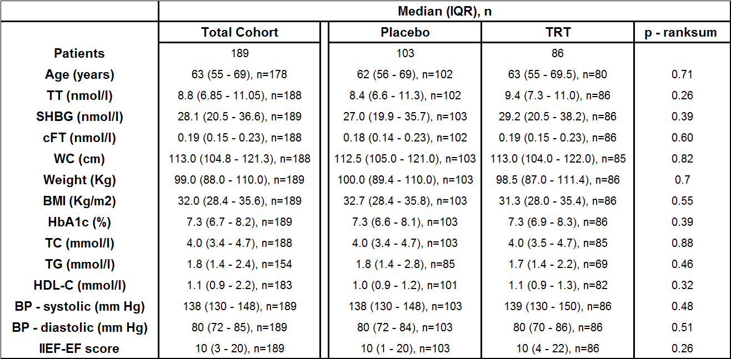

TT: total testosterone, cFT: calculated free testosterone, BMI: body mass index, WC: waist circumference, TC: total cholesterol, TG: triglycerides, HDL-C: high density lipoprotein – cholesterol, BP: blood pressure.

**Table 2: Association between baseline age and SHBG as continuous variables and ∆SHBG in the total cohort and ~~TTh~~ TRT groups**

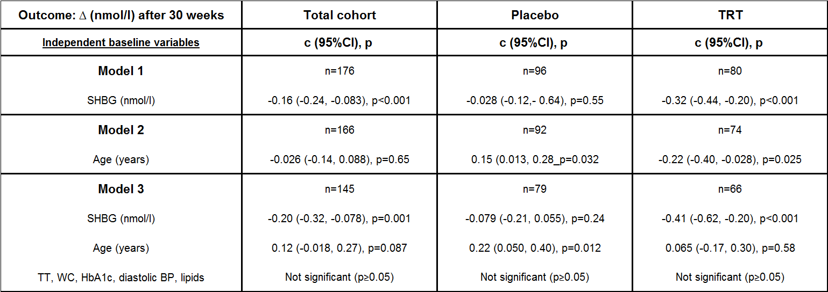

Model 1: SHBG alone. Model 2: Age alone. Model 3: SHBG and Age together in the same regression model.

**Table 3. The association between 30 weeks ~~TTh~~ TRT and ∆SHBG in the total cohort and men stratified by baseline median SHBG and age.**

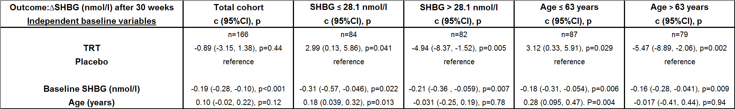

**Table 4: The association between 30 weeks ~~TTh~~ TRT and ∆SHBG in the total cohort and men grouped by baseline median SHBG and age.**

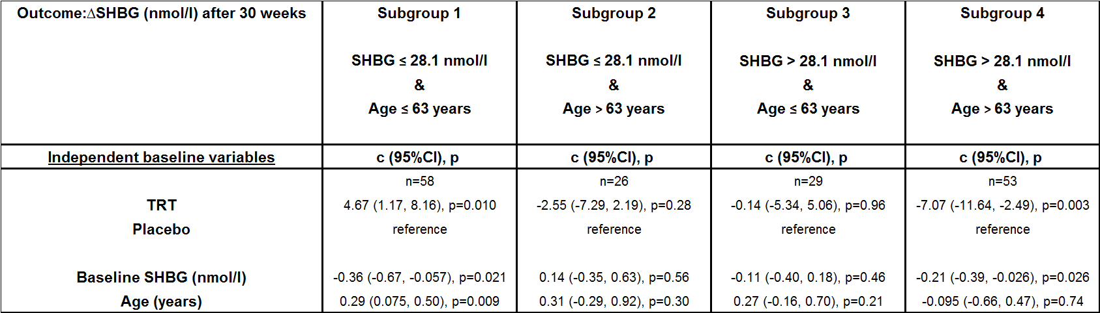

**Table 5: Association between change in selected variables in and ~~TTh~~ TRT (reference: placebo) in men in groups 1 and 4.**

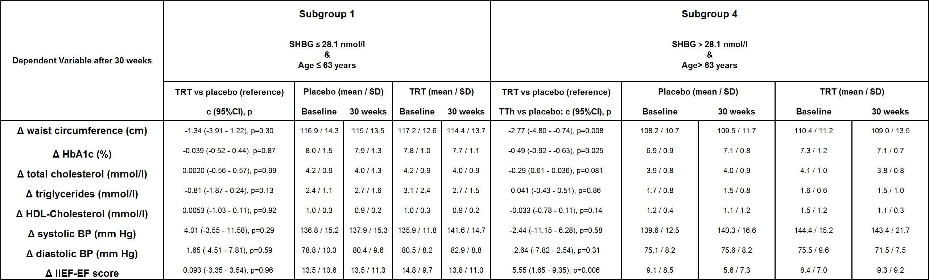

As IIEF-EF scores are not continuous variables the associations between ∆IIEF-EF and TRT (reference: placebo) were checked via non-parametric ranksum tests (Subgroup 1: p = 0.56, Subgroup 4: p=0.014).

Subgroup 4 was further stratified by baseline total testosterone levels in view of previous findings (Hackett 2016) and the effects of TRT (vs Placebo) studied via regression analyses.

total testosterone ≤8nmol/l: c=7.66, 95% CI: 1.06, 14.27, p=0.025, Mean ΔIIEF-EF: TRT: 5.2 (n=10), Placebo: -2.5 (n=9)

total testosterone >8nmol/l: c=4.69, 95% CI: 0-014, 9.38, p=0.049, Mean ΔIIEF-EF: TRT: -0.6 (n=18), Placebo: -5.3 (n=16)

Figure 1: Details of recruitment and protocol of the BLAST RCT

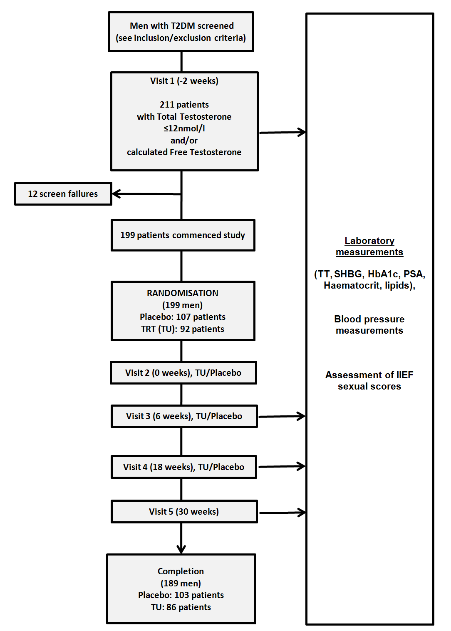

TT: total testosterone

PSA: prostate specific antigen

Figure 2: The change in SHBG levels after 30 weeks of TRT and placebo is plotted against baseline SHBG for each individual man with a trend lines superimposed.

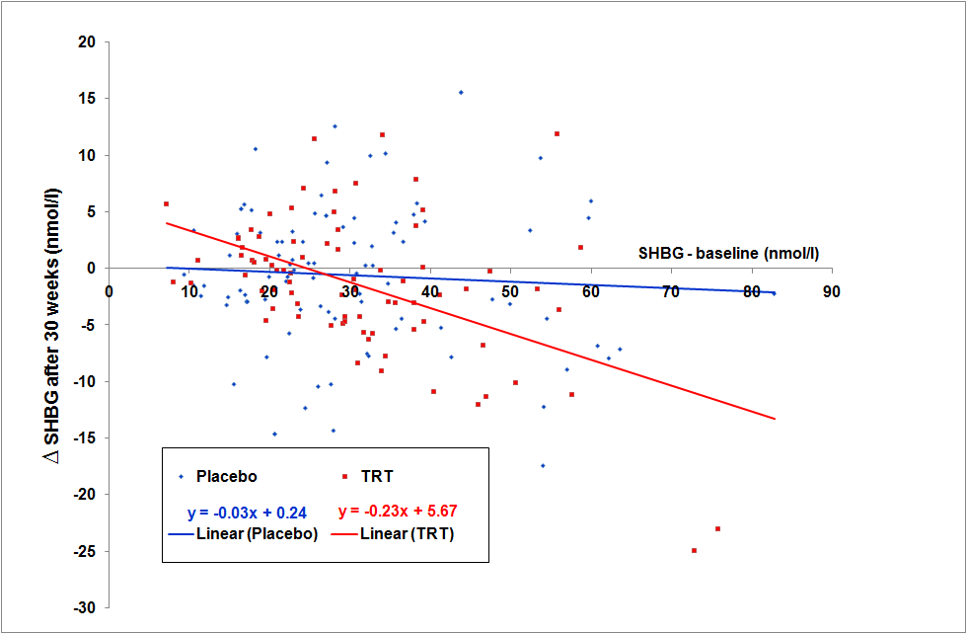

Figure 3: The change in SHBG levels after 30 weeks of TRT and placebo is plotted against baseline age for each individual man with a trend lines superimposed.

