Abstract
Background: Dynamic “knee valgus” has been identified as a risk factor for significant knee injuries, however, the limits and sources of error associated with existing 3D motion analysis methods have not been well established.
Research question: What effect does the use of differing static and functional knee axis orientation methods have on the observed knee angle outputs for the activities of gait, overhead squatting and a hurdle step?
Methods: A pre-existing dataset collected from one season (September 2015–May 2016) as part of a prospective observational longitudinal study was used. A secondary analysis of data for 24 male footballers, from a single British University football team, was conducted in order to evaluate the effect of static (conventional gait model) and dynamic (constrained and unconstrained mDynaKAD) methods on knee joint kinematics for flexion-extension and valgus-varus angles.
Results: No single calibration method consistently achieved both the highest flexion and lowest valgus angle for all tests. The constrained and unconstrained mDynaKAD methods achieved superior alignment of the knee medio-lateral axis compared to the conventional gait model, when the movement activity served as its own calibration. The largest mean difference between methods for sagittal and coronal plane kinematics was less than 4⁰ and 14⁰ respectively. Cross-talk could not account for all variation within the results, highlighting that soft tissue artefact, associated with larger muscle volumes and movements, can influence kinematics results.
Significance: When considering the trade-off between achieving maximum flexion and minimal valgus angle, the results indicate that the mDynaKAD methods performed best when the selected movement activity served as its own calibration method for all activities. Clinical decision making processes obtained through use of these methods should be considered in light of the model errors associated with cross-talk and effect of soft tissue artefact.

Keywords: Kinematics, motion analysis, injury screening, knee biomechanics, dynamic knee valgus

Funding statement: This research did not receive any specific grant from funding agencies in the public, commercial, or not-for-profit sectors.
Competing interest statement: None of the authors have any financial or personal relationships with other people or organisations to disclose that could inappropriately influence (bias) their work.

Introduction
Measurement accuracy is a fundamental issue in injury screening. Injury mechanisms and the resulting burden need to be quantified accurately, as the prediction and hence prevention of injury is an important goal in sport [1, 2]. Several clinical screening techniques have been developed which try to replicate the demands of the sport or proposed injury mechanisms [3-8]. It is therefore important that measurements of these activities are accurately capturing the true physiological processes.

In an attempt to better understand the mechanisms of injury, or validate the clinical screening tests, several research studies have used 3D motion analysis for the kinematic and kinetic analysis of the movement tasks [5, 7-9]. This requires placement of markers on the skin to define segments e.g. the thigh. Two assumptions are made, firstly that the segments are rigid i.e. that the markers do not move with respect to the underlying bone. Secondly, the markers are also assumed to have a specific orientation with respect to the joint centres and axes, which allows these anatomical features to be located and orientated reliably from the external marker set.

The underlying biomechanical models are based on marker sets and joint centre and axis location techniques initially designed for use in the study of gait, but which have since been adopted for use with complex and explosive movement. These movement tasks, which are common in sports injury research, such as running and jumping, challenge key assumptions about the location of surface markers for movement analysis. Sporting movements occur at higher velocities and across larger ranges of movement. The ballistic nature of some movements, when coupled with increased soft tissue volumes (muscle bulk), results in increased marker movement with respect to the underlying bone. The aforementioned factors are known sources of error and may introduce noise, distorting the true results [10]. The ability of clinicians to derive meaningful conclusions can be significantly compromised if this loss in accuracy is not fully understood. [10].

In clinical gait analysis, specific sources of experimental uncertainties and model limitations are widely known and well characterised, resulting in scrupulous interpretation of the results [10, 11]. Despite commonality in use of identical or similar biomechanical models between the research areas of sports injuries and gait analysis, it has been identified that the same level of critical evaluation of artefact is not generally applied. For example, the absolute values of knee valgus-varus angles are often reported within the field of sports and exercise medicine, with only a few papers reporting the observed error and associated impact on their interpretation of the results [12-14]. In clinical gait analysis knee valgus-varus values are used as an ad hoc quality control index when checking the data, as these measurements are known to be diagnostic of marker placement errors which can cause cross-talk. Cross-talk is the phenomenon resulting from a suboptimal alignment of an axis in relation to the true physiological axis. Therefore, as a segment rotates about the true physiological axis, increasing range of motion, this movement is then reflected in another plane. In this case, if the medio-lateral axis is not correctly aligned, movement in the sagittal plane (flexion-extension) will incorrectly be measured as occurring in the coronal plane (valgus-varus). This is not a true physiological movement but rather artefactual movement resulting from cross-talk. This is most evident for the swing phase of gait, where an artefactual change in the knee valgus-varus values occurs with an increase in knee flexion [10].

Vigilance should therefore be exercised when the outcome of interest is knee valgus-varus values for tasks which typically involve large amounts knee flexion, such as the landing error scoring system and activities such as running and cutting. This practice is in contrast to the ways in which knee valgus-varus values are reported and interpreted within sport injury research. Dynamic “knee valgus” has been proposed as a risk factor for ACL [5, 8] and is a commonly reported output of the models within sports injury research, with reported values of greater than 25⁰ [15, 16]. Arguably these values are too large to be considered a true measurement of the underlying physiological process being investigated. However, multiple screening and interventions programs have been developed for use in sports based on the clinical interpretation of these measurements which are likely derived from measurement artefact. This may be a contributing factor to the lack of predictive ability associated with these tests [7, 9, 14, 17, 18].

The DynaKAD method, a functional knee calibration technique, has been identified as a suitable method for managing soft-tissue artefact and cross-talk during gait [19]. This method is referred to as a functional calibration method as alignment of the medio-lateral axis is not determined through bony landmarks but by the movement of the tibial markers relative to the femur [11, 19]. Most functional calibration methods use an optimisation function to identify the single axis of rotation, treating the knee as a hinge joint. However, for the DynaKAD [11] method, the knee is modelled as having 2 degrees of freedom i.e. (flexion-extenstion and internal-external rotation). As a result of this process, DynaKAD [11] has recently been renamed 2DoFKnee[19]. Irrespective of the name, this method is aimed at giving more consistency to hip rotation during gait and adjusting the femoral coronal plane so as to minimize the variance of the knee valgus-varus angle. Through an iterative process, this method identifies an optimal thigh offset that mimimizes cross-talk[19]. An axial rotation offset can generally then be computed from any movement. Therefore, the coronal femur plane is realigned from a thigh rotation offset computed on knee flexion-extension functional trials. Knee kinematics are important for understanding injury mechanisms. Given the likely error from marker movement during sporting activities, managing soft tissue artefact (STA) and correct alignment of the knee axis are necessary. The aforementioned factors may independently, and in combination, affect knee angles derived from kinematic analysis. The aim of this study was therefore to evaluate the effect of differing knee axis orientation methods on the observed knee angle outputs for a series of activities and clinical screening tests. Our study hypotheses were that (1) the fundamental mechanism responsible for knee valgus-varus artefact is sub-optimal alignment of the medio-lateral knee axis resulting in cross talk and (2) using larger ranges of movement for calibration of the knee medio-lateral axis will result in decreased valgus-varus artefact.

Methods
A pre-existing dataset collected as part of a prospective observational longitudinal study was used in this study [20]. Ethical approval was granted to use the photogrammetric Vicon motion capture system (Vicon Motion Systems, Oxford, UK) to simultaneously quantify participants’ 3D kinematics during their preseason Functional Movement Screen. A total of 25 male participants from a single football team competing in the British Universities and College Sports (BUCS) league, over one season (September 2015–May 2016), were recruited. One participant was excluded due to an existing injury at the time of screening.

Inclusion criteria
Participants older than 17 years of age, suitable for participation within the BUCS league and able to provide informed consent were included.

Exclusion criteria
Participants undergoing rehabilitation from surgery or presenting with a previously diagnosed injury at time of screening were excluded.

Marker placement and data capture and processing
Retroreflective marker displacements were collected by 8 MX-T20 Vicon Cameras, sampled at 100 Hz. Markers were placed according the full body Conventional Gait Model (CGM), distributed as Vicon Plug in-Gait (Vicon PiG) with addition of two pelvic markers to compensate for marker occlusion. An additional temporary medial condyle marker was used for calibration of the knee axis during the static trial. Orientation of the medio-lateral axis of the femur and location of the knee joint centre, according to the CGM, was achieved through placement of markers on the lateral and medial epicondyles of the femur. This is equivalent to the use of a Knee Alignment Device (KAD) (figure 1). Condyle marker placement was done according to a locally-developed, standardised palpation method using well known anatomical landmarks.

Figure 1. Virtual construction of the KAD for determining thigh rotational offset
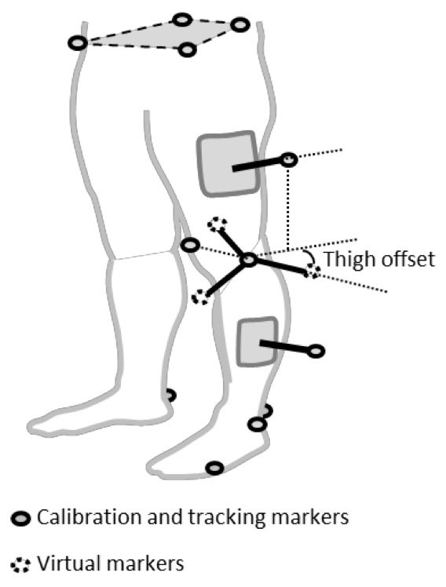

Experiential tests used for analysis
For this study the movement activities evaluated were (1) gait, (2) an overhead/ deep squat with heel raise (considered closed chain / loaded knee flexion-extension) and (3) a hurdle step (considered open chain / unloaded knee flexion-extension).

Data processing
Marker trajectories were filtered with Woltring cross-validity quintic spline routine [21]. Data reconstruction and labelling was carried out using Vicon Nexus 1.8.5 and Body builder 3.6.2. PiG processing was performed through pyCGM2, an open source python package embedding a Vicon PiG Clone, renamed CGM1 [22]. Functional calibrations of the knee medio-lateral axis were performed using a modified DynaKAD approach (mDynaKAD), whereby the rotation is performed about the long axis (hip to knee joint centre line) rather than the hip joint centre to lateral knee marker line [11]. Correction about the long axis using the mDynaKAD approach is more anatomically appropriate and also reduces the dependency on accurate knee marker placement. Kinematics were extracted for the right knee only. Following data collection, a secondary analysis of data was conducted in order to evaluate the effect of seven different knee axis calibration methods for determining knee joint kinematics, namely the CGM without functional calibration or knee axis alignment correction (1), unconstrained mDynaKAD functional calibration using the whole available range of motion for gait(2), squat(3) and hurdle step(4) and constrained [20⁰ to 90⁰] mDynaKAD functional calibration for gait(5), squat(6) and hurdle step(7). Each calibration method was applied to each movement activity, leading to 21 combinations. A total of three attempts was analysed for each activity, and the mean of the peaks with standard deviation for range of movement relating to sagittal plane (flexion-extension) and coronal plane (valgus-varus) kinematics were reported.

Results
Results for patient demographics and overall performance of calibration methods on movement activities
Data from 24 participants was used in this study. Participant demographics and anthropometric measures have been reported previously [20]. The kinematic results for knee flexion-extension and knee valgus-varus are reported in table 1. It is assumed that correct orientation of the knee axis will minimise cross-talk leading to maximum flexion and minimal valgus-varus. No single calibration method managed to consistently achieve this for all tests. When considering the trade-off between achieving maximum flexion-extension and minimal valgus-varus angle, the results indicate that the unconstrained mDynaKAD method performed best when the selected movement activity served as its own calibration method for all activities. Differences between the constrained and unconstrained mDynaKAD methods, for both sagittal and coronal movements, were small approximately 1⁰ to 2⁰.

Kinematic results for the effect of knee calibration methods on knee valgus-varus angle
The kinematic results for knee valgus-varus angle ranges according to the selected calibration method have been presented in figure 2. Lower knee valgus-varus angle ranges were achieved for both the unconstrained mDynaKAD and constrained mDynaKAD methods when compared to the CGM, except for the mDynaKAD calibrations based on the hurdle step. The unconstrained mDynaKAD method was superior to the constrained mDynaKAD method for all tests, however, this difference is small with the biggest difference of 3.21⁰ observed in the squat test.

Kinematic results for the effect of knee calibration methods on knee flexion-extension angle
The kinematic results for knee flexion-extension angle ranges according to the selected calibration method have been presented in figure 3. Knee flexion range was similar across all trials, irrespective of the calibration method used. For flexion, the largest mean difference (approximately 4⁰) was observed for the experimental hurdle step test, between the constrained hurdle step calibration technique and the CGM calibration method.

Table 1. Kinematic results of knee flexion-extension and knee valgus-varus ranges for all movement activities and the respective calibration methods
Each numbered column corresponds to the calibration method and test outlined in the data processing section. For example, the column (1) CGM uncorrected, indicates that this method was applied to the experimental tests of gait, squat and hurdle step. For the column (2) Gait, this indicates that the correction offsets were determined using the unconstrained mDynaKAD method during gait and then this was then applied to the experimental tests of gait, squat and hurdle step.

 |  | Movement  angle | Calibration tests
 |  |  | (1) CGM uncorrected | mDynaKAD unconstrained ROM⁰ |  |  | mDynaKAD constrained ROM⁰ [20⁰ to 90⁰]
 |  |  |  | (2) Gait | (3) Squat | (4) Hurdle | (5) Gait | (6) Squat | (7) Hurdle
EXPERIMENTAL TEST | GAIT | Flexion ⁰ (mean (SD)) | 56.50 (6.89) | 56.79 (6.91) | 56.52 (6.89) | 54.54 (7.12) | 56.83 (6.88) | 55.79 (7.13) | 54.21 (6.95)
 |  | Valgus ⁰ (mean (SD)) | 11.33 (4.44) | 9.51 (2.84) | 10.53 (2.97) | 17.88 (4.80) | 9.90 (3.18) | 12.74 (5.78) | 18.87 (4.13)
 | SQUAT | Flexion ⁰ (mean (SD)) | 122.37 (22.17) | 122.08 (22.01) | 121.76 (22.00) | 120.29 (21.97) | 122.41 (22.22) | 121.27 (22.06) | 120.05 (22.02)
 |  | Valgus ⁰ (mean (SD)) | 12.61 (7.32) | 10.68 (4.55) | 9.04 (3.94) | 22.00 (6.35) | 12.11 (4.68) | 12.25 (7.02) | 23.09 (5.81)
 | HURDLE STEP | Flexion ⁰ (mean (SD)) | 132.67 (6.60) | 131.60 (5.83) | 131.22 (5.82) | 128.68 (5.79) | 132.16 (5.95) | 130.45 (5.88) | 128.38 (5.88)
 |  | Valgus ⁰ (mean (SD)) | 26.69 (8.72) | 23.17 (5.50) | 22.41 (4.78) | 15.73 (4.52) | 24.77 (6.35) | 20.33 (5.05) | 15.39 (4.18)

For the mDynaKAD unconstrained and constrained calibration methods independently, results in bold indicate
- For flexion-extension, where the highest value has been achieved,
- For valgus-varus where the lowest value has been achieved.

Figure 2. Results for the effect of differing calibration methods on knee valgus-varus angle for all movement activities
Calibration tests (columns) used to determine correction offsets for respective experimental tests (rows)

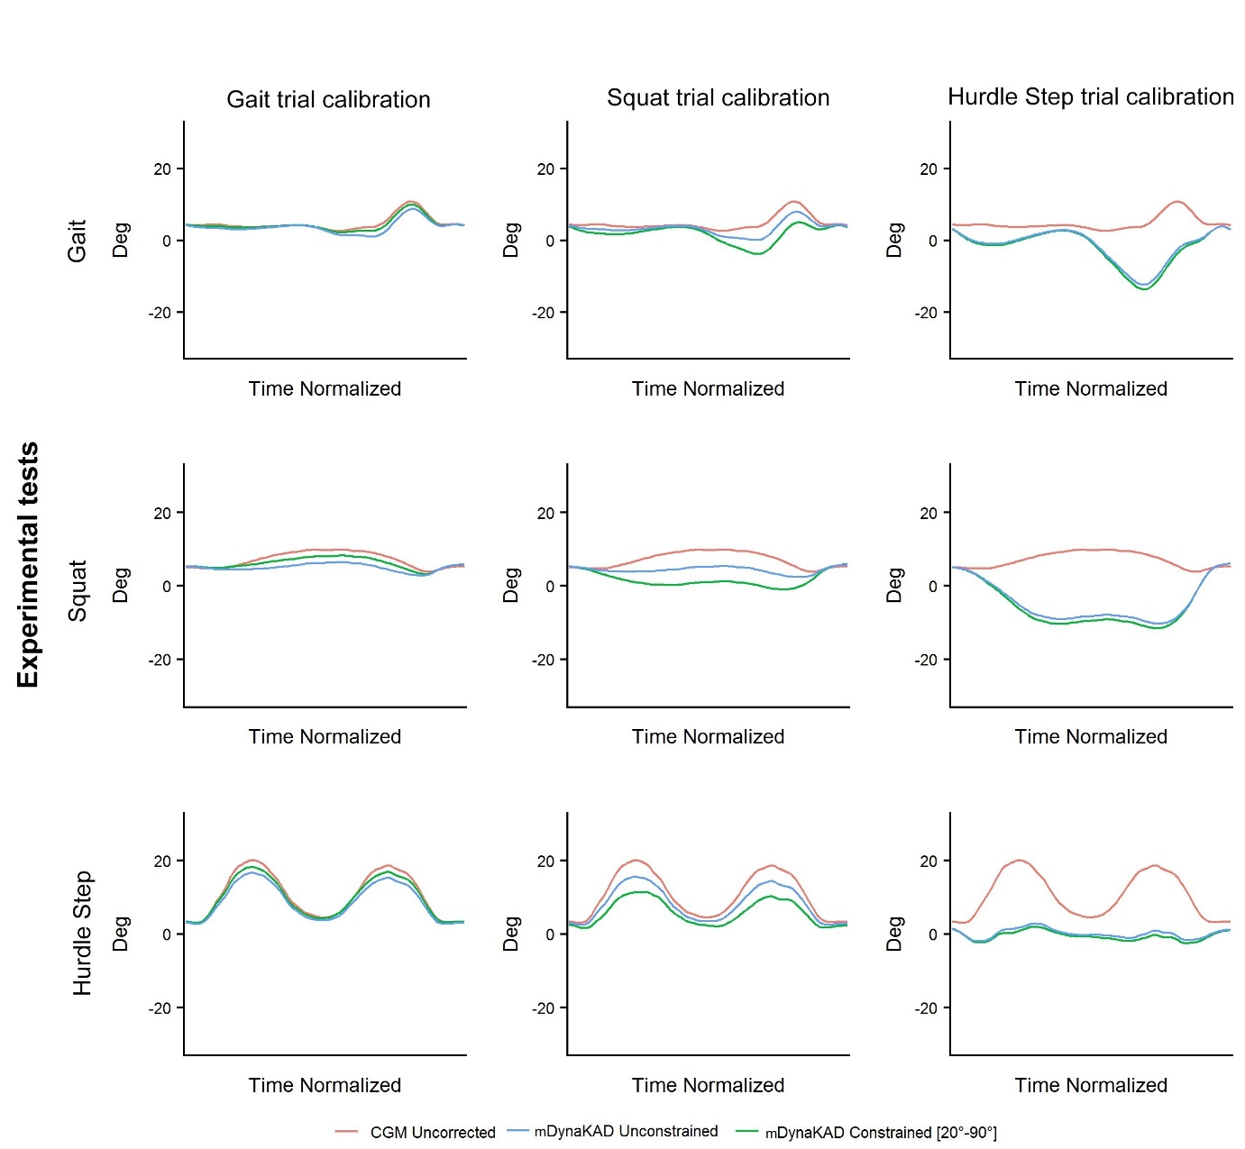
Figure 3. Results for the effect of differing calibration methods on knee flexion-extension angle for all movement activities
Calibration tests (columns) used to determine correction offsets for respective experimental tests (rows)
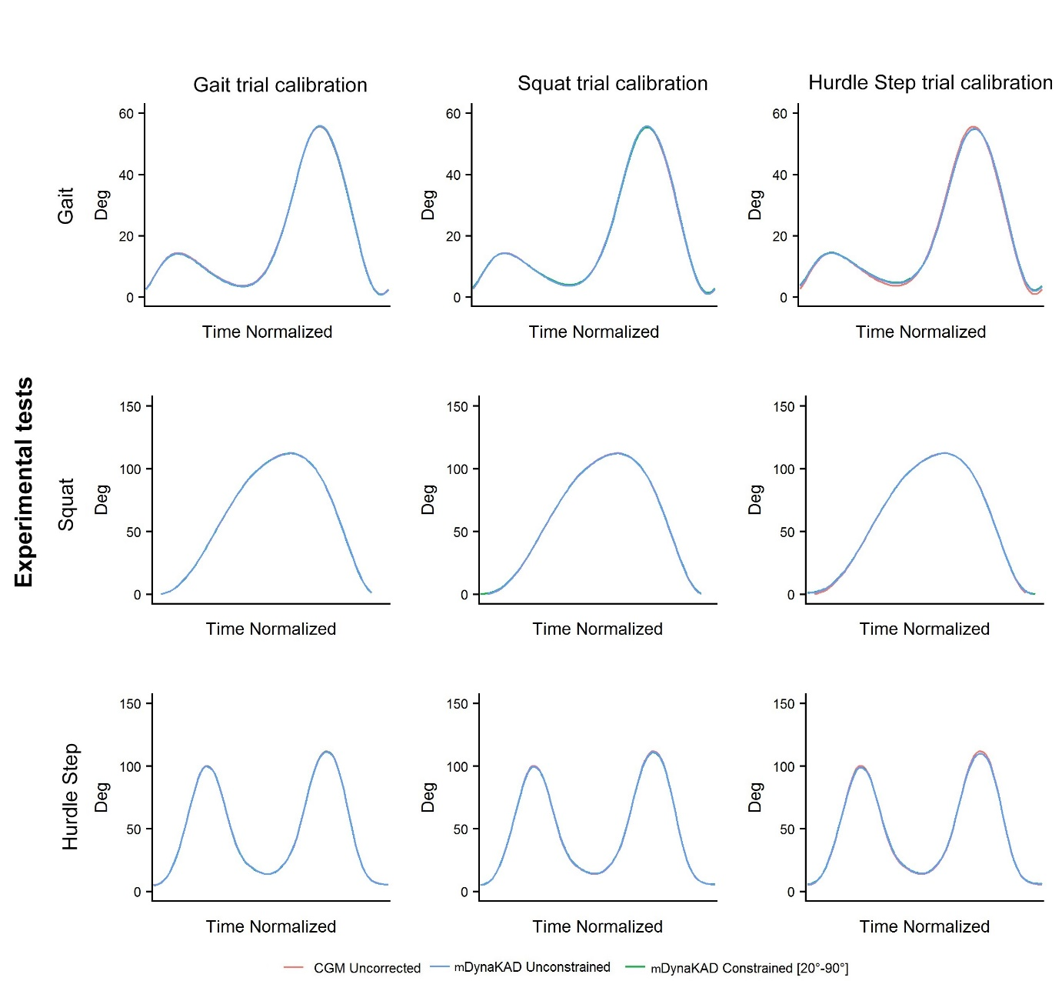

Discussion
The aim of this study was to evaluate the effect of differing knee axis orientation methods on the observed knee angle outputs for a series of activities and clinical screening tests. Our study hypotheses were that (1) the fundamental mechanism responsible for knee valgus-varus artefact is sub-optimal alignment of the medio-lateral knee axis resulting in cross talk and (2) using larger ranges of movement for calibration of the knee medio-lateral axis will result in decreased valgus-varus artefact,
Clinical implications for selected marker set, model and knee calibration methods
Our results indicate that in order to achieve the best result for alignment of the medio-lateral knee axis, either mDynaKAD calibration method should be used and based on the movement to be analysed. Therefore, not every calibration method and movement activity can be advocated for all activities i.e. rotational offsets derived from one movements’ calibration method cannot be applied to another movement activity in order to determine kinematic results of equivalent accuracy. The use of a single functional calibration activity for analysis of multiple complex movements is therefore questionable. This poses challenges for sports teams and studies looking to evaluate knee kinematics of subjects completing random or spontaneous movements, in which the movements are not repeatable reference tasks, or vary significantly from the movement used for calibration. Our study cohort was without significant knee injury at the time of screening. Therefore, the level of dynamic knee valgus observed is much more likely to stem from the occurrence of cross-talk from knee flexion as opposed to true abduction of the tibia relative to the femur. The same would be true for other studies reporting values of similar magnitudes [23, 24].

Comparison of mDynaKAD methods and CGM for knee kinematics (flexion-extension)
For all movement activities, it was identified that there was minimal difference between group means for all of the calibration methods when determining knee flexion-extension range values. Only 2 of the 24 participants had differences of more than 10⁰ between calibration methods when determining flexion-extension range values. Within our study, marker placement was done with accurate palpation of bony landmarks and alignment of the knee medio-lateral axis was achieved with a KAD equivalent as opposed to use of the thigh marker, resulting in a more accurate estimation of the medio-lateral axis. Therefore, it is possible that the full benefits of the mDynaKAD methods were not observed, as only minimal improvements were made to the original uncorrected dataset. In the literature, sagittal differences between normal and painful subjects range from approximately 1⁰ to 5⁰ for variations in walking [25-28], whilst no clinically important differences have been identified in larger amplitude movements such as running [29]. The largest mean difference between all calibration methods within our study was approximately 4⁰, observed for the experimental hurdle step test. Based on our study, any of the calibration methods could be advocated for sagittal plane movements in the activities evaluated if marker placement is accurate, as the experimental differences are smaller than the clinical differences reported.
Comparison of mDynaKAD methods and CGM for knee kinematics (valgus-varus)
A principle function of the mDynaKAD method is minimisation of the variance of the knee valgus-varus angle [19]. Both mDynaKAD methods were able to “flatten out” the valgus-varus wave that would occur if alignment of the medio-lateral axis was not optimal. In the literature, a mean valgus-varus difference of 4.93⁰ (95% CI 2.06⁰ to 7.80⁰) have been identified between individuals with and without knee pain [30]. For our study, the difference between calibration methods, when applied to other movement activities, is larger than the identified important clinical differences. It is therefore unlikely, that 3D movement analysis is able to get the measurement error low enough to be smaller than the difference to be recorded.

Evaluating other sources of variation in knee kinematics, other than cross-talk, of sources contributing to variations in knee kinematics
Irrespective of the calibration method used, it is recognised that accurate marker placement is the foremost process during data collection [11]. Variations in proximal-distal placement of the thigh marker can account for differences of approximately 4⁰ when determining knee flexion-extension and valgus-varus ranges during gait [31].For variations in marker set selection, differences of 13.7⁰ (5.4⁰) and 15.8⁰ (5.8⁰) have been observed for knee valgus-varus angles in the activities of a side-stepping and drop jump manoeuvre respectively [13]. Marker placement within our study was done as accurately as possible and therefore less likely to influence the results. Correct orientation of the medio-lateral knee axis should result in higher flexion-extension range values whilst reducing valgus-varus range values. No single method has been identified as being consistently superior to another method for both flexion-extension and valgus-varus angle ranges. These results indicate that if, the valgus-varus waves observed were purely from cross-talk, the offset determined from either mDynaKAD method or calibration movement, should have universally rectified this problem for all movement activities. Therefore, cross-talk is not likely to fully account for the observed results and this is consistent with other studies [13].
STA is most likely to influence valgus-varus angles within our study, given the nature of our athletic population with arguably larger muscle bulk, completing movements over a larger range and higher speeds. For movements such as a side step cutting manoeuvre, STA has been shown to account for absolute errors ranging from 6.7⁰ (5.4⁰) to 13.1⁰ (9.8⁰) [32]. The influence of STA cannot completely be removed from motion analysis using skin based marker sets, however, when compared to alternate methods of functional calibration, the mDynaKAD method is least affected by STA in gait [19].It is worth noting that Sangeux et al [19] used a total of 5 markers across thigh and tibial segments in comparison to our study which used a total of 2. Levels of STA may therefore be higher in our study, owing to a reduced number of markers.

For our study, it was identified that all of the movement activities would likely have different soft-tissue artefact amplitudes. Therefore, the mDynaKAD method was applied on a restricted range of motion (constrained) for the knee. However, it has been identified that the results between the constrained and unconstrained methods were similar, with the unconstrained methods achieving better results. It is therefore possible, that methods inherent to mDynaKAD may be trying to optimise for both the processes of cross-talk and STA . The results of this study are comparable to another study investigating differing calibration methods of similar activities namely gait, loaded flexion-extension (squat) and unloaded flexion-extension [33]. As stated previously, our study may have had higher levels of STA due to our population completing movements over a larger range. This may have affected the performance of the mDynaKAD methods on the hurdle step when compared to the unloaded flexion-extension activity in the aforementioned study i.e. for flexion-extension approximately (129⁰ (6⁰) versus 108⁰ (30⁰) respectively) and valgus-varus approximately (15⁰ (4⁰) versus 11⁰ (5⁰) respectively). In order to minimise the effects of STA, one possibility would be to reconsider the marker placement for dynamic movements away from areas of high skin movement such as the femoral condyles. The thigh segment provides a limited number of options, however, any placement could be used with appropriate calibration. Whilst arguably cluster-based marker sets may provide a solution to this, previous research has identified that variation still exists with this method due to a lack of standardised thigh marker clusters and failure to use non-anatomical landmarks [13]. It is recognised that no marker set or model is without error. Currently however, there is no agreed marker set or models for use within sports injury screening. Furthermore, an inability to understand the contributing sources of error or limitations of the model can impact clinical practice e.g. Failure to recognise the source of movement variations and accurately name these processes linked to proposed injury mechanisms may therefore result in situations where performance or rehabilitation interventions are not appropriately targeted.

Addressing the study hypotheses and limitations
Our study results disprove both of our initial hypotheses. For hypothesis (1) STA was additionally found to affect valgus-varus angles. Therefore, sub-optimal alignment of the medio-lateral knee axis resulting in cross-talk cannot be considered the sole mechanism for valgus-varus artefact. If knee valgus-varus artefact was entirely due to cross-talk arising from misalignment of the knee axis, then when comparing activities with similar flexion-extension ranges (e.g. squat and hurdle-step) similar valgus-varus range values would be expected. This hypothesis also assumes a single axis for flexion-extension is a valid approach and the medio-lateral axis of the femur does not move and is located in the same coronal plane of the condylar axis. For hypothesis (2) calibration of the knee medio-lateral axis using larger flexion-extension ranges did not result in decreased valgus-varus artefact. If this hypothesis were true, then optimisation of the knee medio-lateral axis based on the hurdle step or squat should have decreased valgus-varus angles in gait. Whilst better outcomes were achieved when activities served as their own calibration method, the incorporation of systematic STA into the optimisation process and lack of generalisability to other activities is recognised as a limitation of this method.

Conclusion
Both the constrained and unconstrained mDynaKAD methods achieved superior alignment of the knee medio-lateral axis compared to the CGM, when the movement activity served as its own calibration. The unconstrained method was superior to the constrained method when considering the trade-off between maximum sagittal plane (flexion-extension) and minimum coronal plane (valgus-varus) kinematics. However, differences between either method was small. For the movements analysed, the marker set and selection of any calibration method could be considered for sagittal plane kinematics in sports injury screening, given the small differences observed between methods. Variations in the rotational offset determined between calibration methods indicates that cross-talk is unlikely to explain all variations within the kinematic results. STA, associated with increased muscle volume and movements of larger range and amplitude may therefore influence kinematic results. Use of these models in athletic activities such as injury screening require further validation to ensure measurements are a true reflection of the underlying physiological processes. Clinical decision making processes based on the measurements obtained through use of these methods should be conducted in light of the identified limitations.
[1] Finch C. A new framework for research leading to sports injury prevention. J Sci Med Sport. 2006;9:3-9; discussion 10.
[2] van Mechelen W, Hlobil H, Kemper HC. Incidence, severity, aetiology and prevention of sports injuries. A review of concepts. Sports medicine (Auckland, NZ). 1992;14:82-99.
[3] Cook G, Burton L, Hoogenboom B. Pre-participation screening: the use of fundamental movements as an assessment of function–part 1. North American journal of sports physical therapy: NAJSPT. 2006;1:62.
[4] Cook G, Burton L, Hoogenboom B. Pre-participation screening: The use of fundamental movements as an assessment of function–Part 2. North American journal of sports physical therapy: NAJSPT. 2006;1:132.
[5] Hewett TE, Myer GD, Ford KR, Heidt RS, Colosimo AJ, McLean SG, et al. Biomechanical measures of neuromuscular control and valgus loading of the knee predict anterior cruciate ligament injury risk in female athletes. The American journal of sports medicine. 2005;33:492-501.
[6] Kiesel K, Plisky PJ, Voight ML. Can Serious Injury in Professional Football be Predicted by a Preseason Functional Movement Screen? North American Journal of Sports Physical Therapy: NAJSPT. 2007;2:147.
[7] Kristianslund E, Krosshaug T. Comparison of drop jumps and sport-specific sidestep cutting: implications for anterior cruciate ligament injury risk screening. Am J Sports Med. 2013;41:684-8.
[8] Myer GD, Ford KR, Khoury J, Succop P, Hewett TE, Myer GD, et al. Biomechanics laboratory-based prediction algorithm to identify female athletes with high knee loads that increase risk of ACL injury. British Journal of Sports Medicine. 2011;45:245-52.
[9] Padua DA, Marshall SW, Boling MC, Thigpen CA, Garrett WE, Jr., Beutler AI. The Landing Error Scoring System (LESS) Is a valid and reliable clinical assessment tool of jump-landing biomechanics: The JUMP-ACL study. Am J Sports Med. 2009;37:1996-2002.
[10] Schwartz MH, Trost JP, Wervey RA. Measurement and management of errors in quantitative gait data. Gait & posture. 2004;20:196-203.
[11] Baker R, Finney L, Orr J. A new approach to determine the hip rotation profile from clinical gait analysis data. Human Movement Science. 1999;18:655-67.
[12] Mok K-M, Petushek E, Krosshaug T. Reliability of knee biomechanics during a vertical drop jump in elite female athletes. Gait & posture. 2016;46:173-8.
[13] Mok KM, Kristianslund E, Krosshaug T. The Effect of Thigh Marker Placement on Knee Valgus Angles in Vertical Drop Jumps and Sidestep Cutting. Journal of applied biomechanics. 2015;31:269-74.
[14] Krosshaug T, Steffen K, Kristianslund E, Nilstad A, Mok K-M, Myklebust G, et al. The vertical drop jump is a poor screening test for ACL injuries in female elite soccer and handball players: a prospective cohort study of 710 athletes. The American journal of sports medicine. 2016;44:874-83.
[15] Russell KA, Palmieri RM, Zinder SM, Ingersoll CD. Sex differences in valgus knee angle during a single-leg drop jump. Journal of athletic training. 2006;41:166.
[16] Ford KR, Myer GD, Hewett TE. Valgus knee motion during landing in high school female and male basketball players. Medicine & Science in Sports & Exercise. 2003;35:1745-50.
[17] Cowley HR, Ford KR, Myer GD, Kernozek TW, Hewett TE. Differences in Neuromuscular Strategies Between Landing and Cutting Tasks in Female Basketball and Soccer Athletes. Journal of Athletic Training. 2006;41:67-73.
[18] Bahr R. Why screening tests to predict injury do not work—and probably never will…: a critical review. British Journal of Sports Medicine. 2016;50:776-80.
[19] Sangeux M, Barré A, Aminian K. Evaluation of knee functional calibration with and without the effect of soft tissue artefact. Journal of Biomechanics. 2017;62:53-9.
[20] Philp F, Blana D, Chadwick EK, Stewart C, Stapleton C, Major K, et al. Study of the measurement and predictive validity of the Functional Movement Screen. BMJ Open Sport & Exercise Medicine. 2018;4.
[21] Woltring HJ. A Fortran package for generalized, cross-validatory spline smoothing and differentiation. Advances in Engineering Software (1978). 1986;8:104-13.
[22] Leboeuf F, Sangeux M, Baker R. An open source implementation of the Conventional Gait Model in Python. Gait & posture. 2017;57:236.
[23] Ford KR, Myer GD, Hewett TE. Valgus knee motion during landing in high school female and male basketball players. Med Sci Sports Exerc. 2003;35:1745-50.
[24] Russell KA, Palmieri RM, Zinder SM, Ingersoll CD. Sex Differences in Valgus Knee Angle During a Single-Leg Drop Jump. Journal of Athletic Training. 2006;41:166-71.
[25] Barton CJ, Levinger P, Menz HB, Webster KE. Kinematic gait characteristics associated with patellofemoral pain syndrome: A systematic review. Gait & posture. 2009;30:405-16.
[26] Heino Brechter J, Powers CM. Patellofemoral stress during walking in persons with and without patellofemoral pain. Med Sci Sports Exerc. 2002;34:1582-93.
[27] Powers CM, Heino JG, Rao S, Perry J. The influence of patellofemoral pain on lower limb loading during gait. Clinical Biomechanics. 1999;14:722-8.
[28] Powers CM, Landel R, Perry J. Timing and intensity of vastus muscle activity during functional activities in subjects with and without patellofemoral pain. Physical therapy. 1996;76:946-55.
[29] Neal BS, Barton CJ, Gallie R, O’Halloran P, Morrissey D. Runners with patellofemoral pain have altered biomechanics which targeted interventions can modify: a systematic review and meta-analysis. Gait & posture. 2016;45:69-82.
[30] Leibbrandt D, Louw Q. Kinematic factors associated with anterior knee pain during common aggravating activities: a systematic review. Physical Therapy Reviews. 2017;22:34-47.
[31] Cockcroft J, Louw Q, Baker R. Proximal placement of lateral thigh skin markers reduces soft tissue artefact during normal gait using the Conventional Gait Model. Computer methods in biomechanics and biomedical engineering. 2016;19:1497-504.
[32] Benoit DL, Ramsey DK, Lamontagne M, Xu L, Wretenberg P, Renstrom P. Effect of skin movement artifact on knee kinematics during gait and cutting motions measured in vivo. Gait & posture. 2006;24:152-64.
[33] Passmore E, Sangeux M. Defining the medial-lateral axis of an anatomical femur coordinate system using freehand 3D ultrasound imaging. Gait & posture. 2016;45:211-6.

