SUPPLEMENTARY MATERIAL

Health inequalities in heart failure; national trends in outcomes by place of diagnosis, gender and socioeconomic status: 1998-2017

Lawson CA, Zaccardi F, Squire I, Ling S, Davies M, Lam C, Mamas M, Khunti K, Kadam UT

Table of Contents

Supplementary Figures 3
S1 Flow chart of the patient selection process 3
S2 Proportion of HF patients diagnosed in the community or hospital by calendar year 4
S3 Predicted overall survival by population group 5
S4 Cumulative incidence of death by cause and population group 6

Supplementary Tables 7
S1 Heart failure selection CPRD code set 7
S2 Heart failure selection ICD code set 8
S3 Missing data 9
S4 Predicted rates of admissions during the second and subsequent years following HF diagnosis by population groups and calendar year 10
S5 Age standardised mortality risk by diagnosis time-period and population group at 1, 3 and 5 years following HF diagnosis 13
S6 Complete case analysis: Associations between population groups 14

Supplementary Figures

S1 Flow chart of the patient selection process

CPRD acceptable incident HF population aged ≥30 years
142,682

252,584
HES HF patients ≥ 30 years with a primary ICD code for HF
60,279

Incident HF cohort (CPRD and HES combined) ≥30 years
202,961
CPRD patients not eligible for linkage to HES
65,772 (32%)

CPRD HF acceptable patients linked to HES
137,189

Exclude if first HF code (HES or CPRD) prior to 1/1/98 or after 31/7/17
12,240 (8.9%)
Incident HF cohort between 1/1/98 and 31/7/17
124,949

Exclude if clinical data not plausible in relation to date of death or death not recorded in ONS
709 (0.6%)

Plausible data
124,240

Exclude if less than 1 year of UTS registration before the HF index date
35,824 (29%)

At least 1 year up-to-standard records before HF index date 88,416

Location of Care: 88,416
- Community 52,001
- Hospital 36,415

Patients with socioeconomic data: 88,262

- IMD 1: 16,481
- IMD 2: 20,468
- IMD 3: 18,910
- IMD 4:17,542
- IMD 5: 14,861
Gender: 88,416
- Male 44,955
- Female 43,461

S2 Proportion of HF patients diagnosed in the community or hospital by calendar year
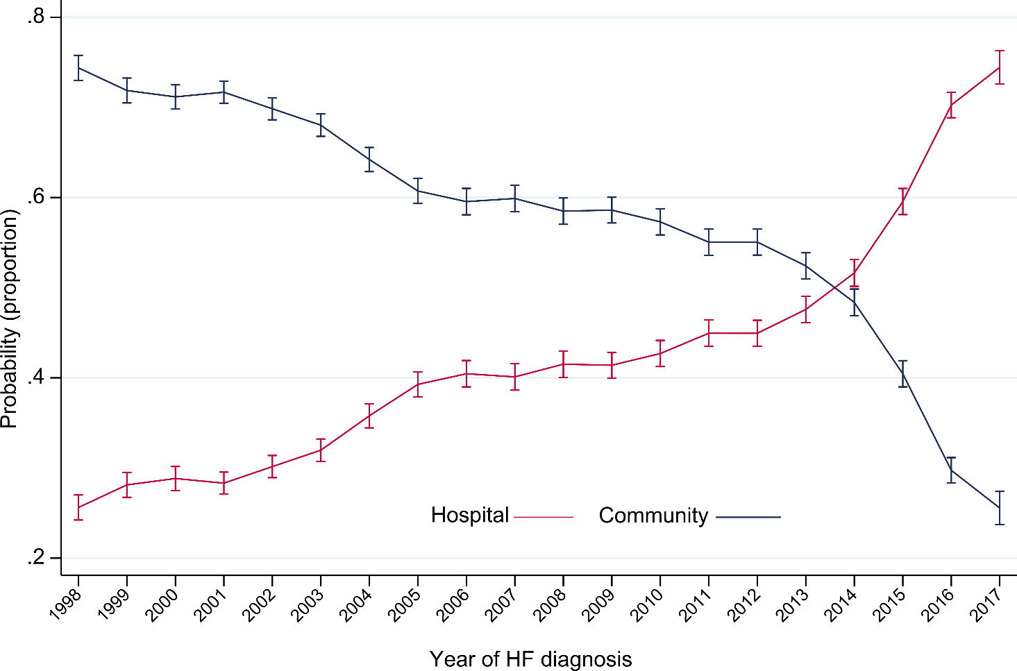

S3 Predicted overall survival by population group

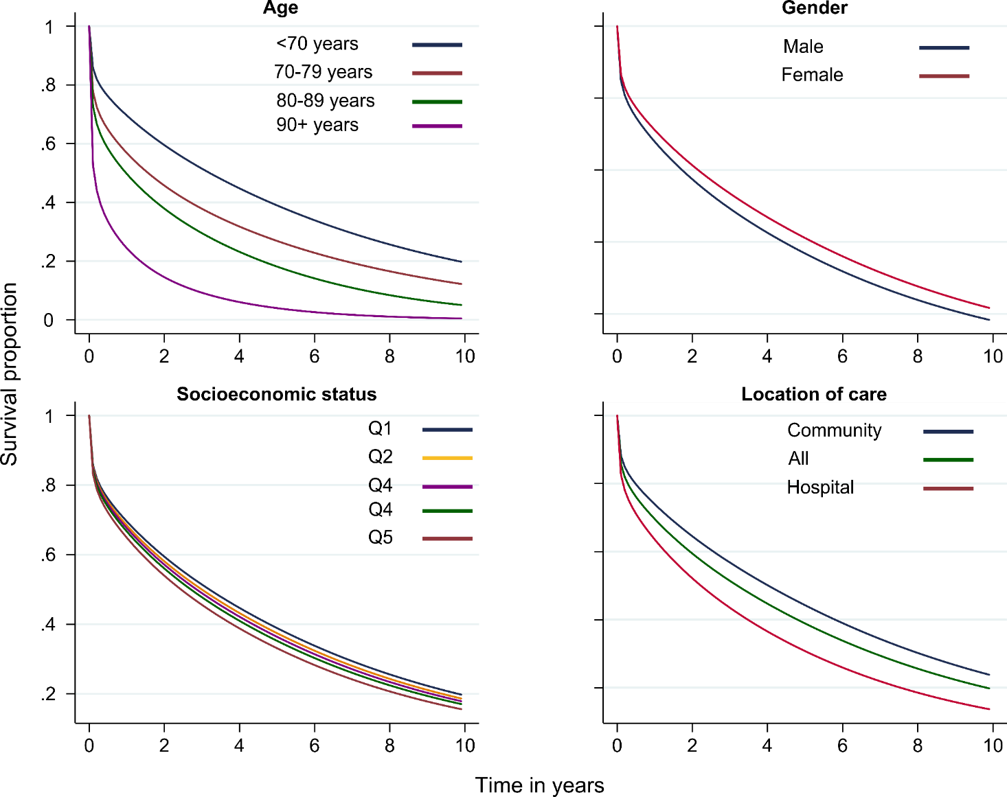

Age-standardised survival curves plotted against time in years following HF diagnosi

S4 Cumulative incidence of death by cause and population group

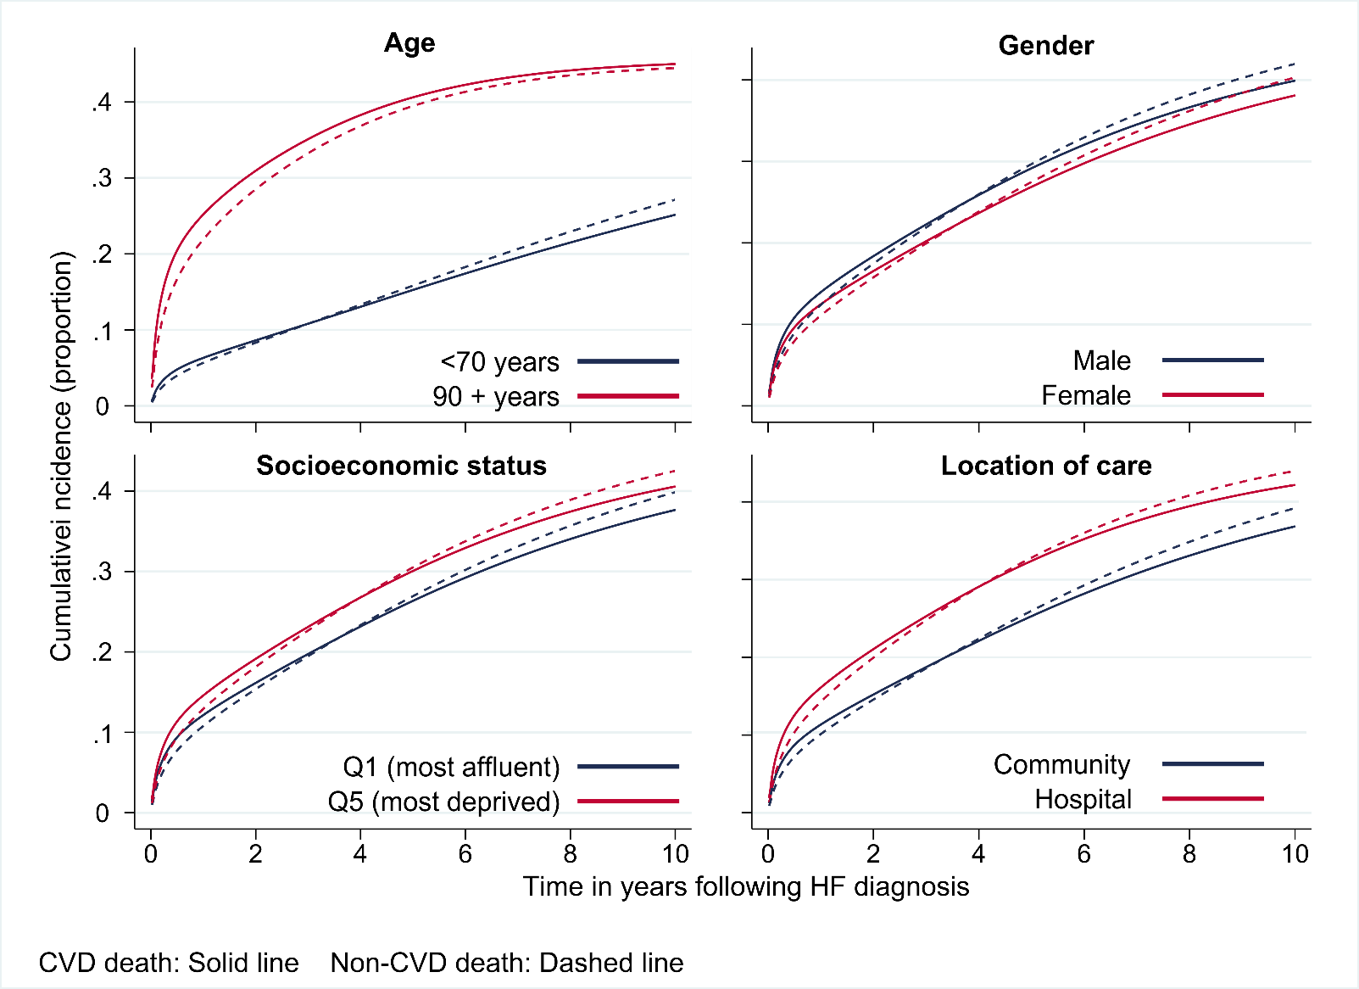
Cumulative incidence curves predicted at mean population age (78 years).

Supplementary Tables

S1 Heart failure selection CPRD code set

Medcode | Read code | Read term
2062 | G58..00 | Heart failure
1223 | G58..11 | Cardiac failure
398 | G580.00 | Congestive heart failure
2906 | G580.11 | Congestive cardiac failure
10079 | G580.12 | Right heart failure
10154 | G580.13 | Right ventricular failure
9524 | G580.14 | Biventricular failure
23707 | G580000 | Acute congestive heart failure
32671 | G580100 | Chronic congestive heart failure
27884 | G580200 | Decompensated cardiac failure
11424 | G580300 | Compensated cardiac failure
94870 | G580400 | Congestive heart failure due to valvular disease
884 | G581.00 | Left ventricular failure
23481 | G581.11 | Asthma - cardiac
43618 | G581.12 | Pulmonary oedema - acute
5942 | G581.13 | Impaired left ventricular function
5255 | G581000 | Acute left ventricular failure
27964 | G582.00 | Acute heart failure
101138 | G583.00 | Heart failure with normal ejection fraction
101137 | G583.11 | HFNEF - heart failure with normal ejection fraction
106897 | G583.12 | Heart failure with preserved ejection fraction
104275 | G584.00 | Right ventricular failure
4024 | G58z.00 | Heart failure NOS
12590 | G58z.11 | Weak heart
17278 | G58z.12 | Cardiac failure NOS
9913 | 1O1..00 | Heart failure confirmed
22262 | G1yz100 | Rheumatic left ventricular failure
21837 | G232.00 | Hypertensive heart&renal dis wth (congestive) heart failure

S2 Heart failure selection ICD code set

ICD-10 Code | ICD-10 term
I50 | Heart failure
150.0 | Congestive heart failure
I50.1 | Left ventricular failure
I50.9 | Heart failure, unspecified
I11.0 | Hypertensive heart disease with (congestive) heart failure
I13.2 | Hypertensive heart and renal disease with both (congestive) heart failure and renal failure
I13.0 | Hypertensive heart and renal disease with (congestive) heart failure

S3 Missing data

Characteristics | Missing (%)
Age | -
Gender | -
Socioeconomic status | 0.2
Prescribed drugs | 17.5
Comorbidities | -
Smoking | 5.9
Alcohol | 14.1
BMI (kg/m2) | 14.7
Systolic BP (mm/Hg) | 2.6
Cholesterol (mmol/L) | 32.9
Haemoglobin (g/dL) | 24.7
eGFR (ml/min/m2) | 23.3
BMI, body mass index; BP, blood pressure; eGFR, estimated glomerular filtration rate

S4 Predicted rates of admissions during the second and subsequent years following HF diagnosis by population groups and calendar year
 | Predicted rate  per 100 person-years (95% CI) |  | Relative diff. (%)ª | P  Interaction^{b} | Average annual percent change per year (95% CI)^{c} | Slope change: annual percent change before  and after trend change (95% CI)^{d}
 | 1998-2001 | 2012-2015 |  |  |  | Before | Break | After
All | 81.6 (79.7, 83.5) | 82.9 (80.8, 85.0) | 2 |  | 0.2 (-0.6, 0.9) | 0.2 (-0.6, 0.9) | N/A | 0.2 (-0.6, 0.9)
<70 years | 69.2 (65.9, 72.5) | 53.3 (50.7, 56.0) | -23 |  | -1.5 (-2.8, -0.1)
70 to 79 years | 77.8 (74.9, 80.8) | 76.4 (72.9, 79.9) | -2 | <0·0001 | -0.3 (-1.2, 0.5) | 2.1 (0.9, 3.3) | 2007 | -3.0 (-4.4, -1.5)
80 to 89 years | 85.7 (82.1, 89.3) | 99.4 (95.3, 103.5) | 16 | <0·0001 | 1.1 (0.1, 2.1) | 3.8 (2.3, 5.3) | 2007 | -1.9 (-3.3, -0.4)
90 years and over | 82.1 (74.3, 89.9) | 121.7 (111.8, 131.6) | 48 | <0·0001 | 3.2 (1.6, 4.7) | 6.3 (3.3, 9.4) | 2006 | 0.4 (-1.3, 2.3)
Men | 88.3 (85.3, 91.3) | 81.0 (78.2, 83.7) | -8 |  | -0.4 (-1.1, 0.3 | -0.4 (-1.1, 0.3 | N/A | -0.4 (-1.1, 0.3
Women | 75.8 (73.4, 78.3) | 85.3 (82.2, 88.4) | 13 | <0·0001 | 0.7 (-0.8, 2.1) | 0.7 (-0.8, 2.1) | N/A | 0.7 (-0.8, 2.1)
Most affluent (Q1) | 69.0 (65.0, 73.0) | 69.6 (65.6, 73.5) | 1 |  | 0.2 (-1.3, 1.7) | 3.3 (-0.5, 7.4) | 2004 | -1.5 (-2.9, 0.0)
Most deprived (Q2) | 99.0 (93.6, 104.3) | 101.9 (95.6, 108.1) | 3 | 0·113 | 0.4 (-1.1, 1.8) | 0.4 (-1.1, 1.8) | N/A | 0.4 (-1.1, 1.8)
Community diagnosis | 72.7 (70.7, 74.6) | 65.9 (63.7, 68.1) | -9 |  | -1.1 (-2.0, -0.2) | 0.5 (-0.3, 1.4) | 2009 | -4.0 (-6.2, -1.8)
Hospital diagnosis | 112.0 (106.7, 117.3) | 106.5 (102.6, 110.4) | -5 | 0·262 | -0.1 (-0.9, 0.8) | 3.2 (1.7, 4.8) | 2006 | -2.9 (-4.1, -1.8)
HF admissions
All | 8.8 (8.3, 9.3) | 9.7 (9.1, 10.3) | 10 |  | 0.6 (-0.1, 1.4) | 0.6 (-0.1, 1.4) | N/A | 0.6 (-0.1, 1.4)
<70 | 7.7 (6.9, 8.6) | 5.6 (4.9, 6.3) | -27 |  | -2.7 (-3.9, -1.5) | -2.7 (-3.9, -1.5) | N/A | -2.7 (-3.9, -1.5)
70 to 79 | 8.0 (7.3, 8.7) | 9.5 (8.4, 10.5) | 19 | <0·0001 | 0.8 (-0.2, 1.7) | 0.8 (-0.2, 1.7) | N/A | 0.8 (-0.2, 1.7)
80 to 89 | 9.1 (8.2, 10.0) | 12.0 (10.8, 13.1) | 32 | <0·0001 | 1.9 (0.2, 3.5) | 1.9 (0.2, 3.5) | N/A | 1.9 (0.2, 3.5)
>90 | 7.2 (5.4, 9.0) | 12.3 (9.8, 14.9) | 71 | <0·0001 | 1.7 (-2.6, 6.1) | 6.0 (3.2, 8.9) | 2012 | -16.3 (-33.8, 5.7)
Men | 10.4 (9.5, 11.2) | 9.9 (9.1, 10.7) | -5 |  | -0.5 (-1.3, 0.3) | -0.5 (-1.3, 0.3) | N/A | -0.5 (-1.3, 0.3)
Women | 7.4 (6.9, 8.0) | 9.5 (8.6, 10.3) | 28 | <0·0001 | 1.5 (0.3, 2.7) | 1.5 (0.3, 2.7) | N/A | 1.5 (0.3, 2.7)
Most affluent | 6.9 (6.0, 7.9) | 8.8 (7.7, 10.0) | 28 |  | 1.2 (-0.1, 2.5) | 1.2 (-0.1, 2.5) | N/A | 1.2 (-0.1, 2.5)
Most deprived | 10.2 (9.0, 11.5) | 11.9 (10.2, 13.6) | 17 | 0·582 | 0.7 (-0.4, 1.7) | 0.7 (-0.4, 1.7) | N/A | 0.7 (-0.4, 1.7)
Community diagnosis | 6.4 (6.0, 6.8) | 6.5 (6.0, 7.1) | 2 |  | 0.0 (-1.8, 1.9) | 3.4 (-0.3, 7.3) | 2005 | -2.3 (-4.4, -0.1)
Hospital diagnosis | 17.4 (15.6, 19.2) | 14.2 (13.0, 15.4) | -18 | 0·040 | -1.7 (-3.0, -0.4) | -1.7 (-3.0, -0.4) | N/A | -1.7 (-3.0, -0.4)
Other CVD admissions
All | 14.1 (13.6, 14.7) | 11.7 (11.1, 12.2) | -17 |  | -1.3 (-2.2, -0.4) | 0.9 (-0.3, 2.1) | 2007 | -3.8 (-5.4, -2.2)
<70 | 12.8 (11.8, 13.7) | 9.6 (8.8, 10.5) | -25 |  | -1.9 (-2.7, -1.0) | -1.9 (-2.7, -1.0) | N/A | -1.9 (-2.7, -1.0)
70 to 79 | 13.8 (13.0, 14.7) | 10.9 (10.0, 11.9) | -21 | 0.150 | -1.2 (-2.7, 0.2) | -1.2 (-2.7, 0.2) | N/A | -1.2 (-2.7, 0.2)
80 to 89 | 14.2 (13.2, 15.2) | 12.4 (11.4, 13.4) | -13 | 0.011 | -1.1 (-2.7, 0.6) | 2.9 (0.6, 5.2) | 2007 | -5.3 (-8.1, -2.5)
>90 | 13.6 (11.3, 15.9) | 14.9 (12.5, 17.2) | 10 | <0.0001 | 1.4 (-0.5, 3.2) | 1.4 (-0.5, 3.2) | N/A | 1.4 (-0.5, 3.2)
Men | 15.8 (14.9, 16.7) | 12.0 (11.2, 12.7) | -24 |  | -1.6 (-2.5, -0.8) |  | N/A
Women | 12.8 (12.1, 13.4) | 11.3 (10.6, 12.1) | -12 | 0.003 | -0.7 (-1.4, 0.0) | 2.3 (1.1, 3.6) | 2006 | -3.3 (-4.4, -2.3)
Most affluent | 12.3 (11.2, 13.4) | 9.3 (8.3, 10.3) | -24 |  | -1.8 (-3.3, -0.4) | -1.8 (-3.3, -0.4) | N/A | -1.8 (-3.3, -0.4)
Most deprived | 15.7 (14.4, 17.1) | 13.3 (11.7, 14.8) | -15 | 0·151 | -0.8 (-2.1, 0.5) | -0.8 (-2.1, 0.5) | N/A | -0.8 (-2.1, 0.5)
Community diagnosis | 12.5 (12.0, 13.1) | 10.4 (9.8, 11.1) | -17 |  | -1.6 (-2.7, -0.4) | -0.2 (-1.1, 0.7) | 2010 | -4.7 (-8.4, -0.8)
Hospital diagnosis | 20.0 (18.5, 21.5) | 13.4 (12.5, 14.3) | -33 | <0.0001 | -2.8 (-4.2, -1.3) | 0.0 (-1.7, 1.8) | 2007 | -5.8 (-8.4, -3.1)
Non CVD admissions
All | 58.5 (57.0, 60.0) | 64.0 (62.3, 65.8) | 9 |  | 0.8 (0.1, 1.5) | 3.6 ((2.4, 4.8) | 2006 | -1.6 (-2.5, -0.7)
<70 | 48.4 (45.9, 50.9) | 39.7 (37.5, 41.8) | -18 |  | -0.9 (-2.7, 0.9) | -0.9 (-2.7, 0.9) | N/A | -0.9 (-2.7, 0.9)
70 to 79 | 55.6 (53.4, 57.9) | 58.3 (55.4, 61.2) | 5 | <0·0001 | 0.1 (-0.9, 1.2) | 2.8 (1.3, 4.4) | 2007 | -2.8 (-4.6, -1.0)
80 to 89 | 62.3 (59.5, 65.1) | 78.5 (75.0, 82.0) | 26 | <0·0001 | 1.7 (0.7, 2.8) | 4.0 (2.2, 5.7) | 2007 | -0.7, -2.3, 0.9)
>90 | 60.7 (54.4, 67.0) | 96.1 (87.7, 104.5) | 58 | <0·0001 | 3.0 (2.0, 4.0) | 3.0 (2.0, 4.0) | N/A | 3.0 (2.0, 4.0)
Men | 62.1 (59.9, 64.4) | 61.7 (59.5, 64.0) | -1 |  | 0.2 (-0.6, 1.0) | 0.2 (-0.6, 1.0) | N/A | 0.2 (-0.6, 1.0)
Women | 55.3 (53.4, 57.2) | 66.8 (64.1, 69.4) | 21 | <0·0001 | 1.0 (-0.7, 2.8) | 1.0 (0.7, 2.8) | N/A | 1.0 (0.7, 2.8)
Most affluent (Q1) | 49.2 (46.1, 52.2) | 53.8 (50.5, 57.1) | 9 |  | 0.4 (-0.5, 1.3) | 0.4 (-0.5, 1.3) | N/A | 0.4 (-0.5, 1.3)
Most deprived (Q5) | 73.5 (69.3, 77.8) | 80.3 (75.0, 85.6) | 9 | 0·200 | 0.8 (-0.9, 2.5) | 0.8 (-0.9, 2.5) | N/A | 0.8 (-0.9, 2.5)
Community diagnosis | 53.8 (52.3, 55.4) | 50.8 (49.0, 52.6) | -6 |  | -0.8 (-1.7, 0.1) | 0.7 (-0.2, 1.6) | 2009 | -3.5 (-5.7, -1.2)
Hospital diagnosis | 74.2 (70.4, 78.0) | 82.6 (79.3, 85.8) | 11 | <0·0001 | 1.1 (0.2, 2.0) | 5.8 (4.2, 7.5) | 2006 | -2.9 (-4.0, -1.8)
Rates were conducted in survivors of the first year. With the exception of age groups, all predictions are at the mean population age (78 years). Follow up was until death or study end. Relative diff., relative difference; py, person-years; CI, confidence interval.
a relative percentage difference in admission rates (per 100 person-years) between the first and second diagnosis time periods, calculated by 100*([time-period 2 – time period 1] / time-period 1].
b P value for the difference in trend lines between groups. Estimated by fitting an interaction term between calendar year and group in the negative binomial models also containing age.
c Average annual percentage change in rates (per 100 person-years) for each increasing year of diagnosis
d Change in slope estimated using Joinpoint regression.

S5 Age standardised mortality risk by diagnosis time-period and population group at 1, 3 and 5 years following HF diagnosis

 | 1-year |  | 3-year |  | 5-year
Calendar year of diagnosis | 1998-2001 | 2012-2015 | 1998-2001 | 2012-2015 | 1998-2001 | 2012-2015
All | 32 (31,32) | 29 (28,29) | 50 (50,51) | 46 (46,47) | 63 (62,63) | 59 (58,59)
<70 years | 14 (14,15) | 12 (12,13) | 25 (24,26) | 22 (22,23) | 35 (34,36) | 31 (30,32)
70 to 79 years | 25 (24,25) | 22 (21,22) | 42 (41,42) | 37 (37,38) | 55 (54,56) | 50 (49,51)
80 to 89 years | 39 (39,40) | 35 (35,36) | 61 (60,62) | 56 (55,57) | 75 (75,76) | 70 (70,71)
90 years and over | 58 (57,58) | 53 (52,53) | 80 (79,81) | 76 (75,76) | 91 (90,91) | 88 (87,88)
Men | 34 (33,34) | 30 (30,31) | 52 (52,53) | 48 (47,49) | 65 (64,66) | 61 (60,61)
Women | 30 (30,31) | 27 (27,28) | 48 (48,49) | 44 (43,45) | 61 (60,61) | 56 (56,57)
Q1 Most affluent | 29 (29,30) | 27 (26,27) | 47 (46,48) | 43 (43,44) | 59 (59,60) | 56 (55,57)
Q2 | 31 (30,31) | 28 (27,29) | 49 (48,49) | 45 (44,46) | 61 (61,62) | 57 (57,58)
Q3 | 32 (31,32) | 29 (28,30) | 50 (49,51) | 46 (45,47) | 63 (62,63) | 59 (58,60)
Q4 | 33 (32,33) | 30 (29,31) | 51 (51,52) | 48 (47,48) | 64 (63,65) | 60 (59,61)
Q5 Most deprived | 35 (34,36) | 32 (31,33) | 54 (53,55) | 50 (49,51) | 66 (66,67) | 63 (62,64)
Community diagnosis | 29 (28,29) | 24 (23,24) | 46 (46,47) | 40 (39,40) | 59 (59,60) | 52 (51,53)
Hospital diagnosis | 39 (39,40) | 34 (33,34) | 60 (59,60) | 53 (52,53) | 72 (72,73) | 66 (65,66)
Risk is reported as percentages with 95% Confidence intervals. Q; quintile

S6 Complete case analysis: Associations between population groups

 | All | CVD | Non-CVD
Group | Adjustedª | Adjustedª | Adjustedª
Hospital Admissions (IRR with 95% CI)
<70 years | 1.0 | 1.0 | 1.0
70 to 79 years | 1.19 (1.15, 1.24) | 1.11 (1.06, 1.17) | 1.23 (1.19, 1.28)
80 to 89 years | 1.48 (1.42, 1.54) | 1.41 (1.34, 1.50) | 1.52 (1.45, 1.58)
90 years and above | 1.79 (1.70, 1.90) | 1.70 (1.57, 1.85) | 1.83 (1.72, 1.94)
Male (ref) | 1.0 | 1·0 | 1·0
Female | 0·90 (0·87, 0·92) | 0·86 (0·83, 0·90) | 0·90 (0·88,0·93)
Socioeconomic status
Q1 Most affluent (ref) | 1·0 | 1·0 | 1·0
Q2 | 1.06 (1.02, 1.10) | 1.08 (1.02, 1.14) | 1.04 (1.00, 1.08)
Q3 | 1.06 (1.02, 1.10) | 1.08 (1.02, 1.14) | 1.05 (1.00, 1.09)
Q4 | 1.15 (1.10, 1.19) | 1.14 (1.07, 1.21) | 1.15 (1.10, 1.19)
Q5 Most deprived | 1·17 (1·12,1·21) | 1·16 (1·10,1·24) | 1·17 (1·11,1·22)
Community (ref) | 1·0 | 1.0 | 1.0
Hospital | 1·54 (1·50, 1·58) | 1·73 (1·66, 1·80) | 1·45 (1·41, 1·49)
Death (HR with 95% CI)
<70 years
70 to 79 years | 1.56 (1.50, 1.63) | 1.43 (1.36, 1.51) | 1.68 (1.57, 1.79)
80 to 89 years | 2.55 (2.44, 2.66) | 2.37 (2.24, 2.50) | 2.64 (2.46, 2.83)
90 years and above | 4.08 (3.87, 4.30) | 3.72 (3.46, 3.99) | 4.37 (3.98, 4.78)
Male (ref) | 1·0 | 1·0 | 1·0
Female | 0·84 (0·82, 0·87) | 0·85 (0·82, 0·88) | 0·84 (0·80,0·88)
Socioeconomic status
Q1 Most affluent (ref) | 1·0 | 1·0 | 1·0
Q2 | 1.05 (1.02, 1.09) | 1.09 (1.04, 1.14) | 1.01 (0.95, 1.08)
Q3 | 1.05 (1.02, 1.09) | 1.11 (1.05, 1.16) | 1.00 (0.94, 1.07)
Q4 | 1.11 (1.07, 1.15) | 1.11 (1.06, 1.17) | 1.11 (1.04, 1.18)
Q5 Most deprived | 1·13 (1·09, 1·17) | 1·14 (1·08, 1·20) | 1·13 (1·05, 1·20)
Community (ref) | 1.0 | 1.0 | 1.0
Hospital | 1·51 (1·47, 1·55) | 1·61 (1·56, 1·67) | 1·32 (1·26, 1·37)
IRR; Incidence rate ratio, CI; Confidence interval, Q; quintile
a adjusted for age gender socioeconomic status, ethnicity, place of diagnosis, calendar year, beta-blocker, angiotensin converting enzyme inhibitor, angiotensin receptor blocker; aldosterone antagonist, aspirin, loop diuretic, number of comorbidities, ischaemic heart disease, myocardial infarction, atrial fibrillation, hypertension, diabetes, stroke, anaemia, obesity, chronic kidney disease, chronic obstructive pulmonary disease, asthma, depression, osteoarthritis, cancer and dementia, smoking, alcohol, body mass index, systolic blood pressure, cholesterol, haemoglobin and estimated glomerular filtration rate.

