**Chemical synthesis of a sulfated D‑glucosamine library and evaluation of cell proliferation capabilities**

Aisling Ní Cheallaigh,1,2,4 Scott E. Guimond,3 Stefan Oscarson2 and Gavin J. Miller1*

*1Lennard-Jones Laboratory,School of Chemical and Physical Sciences, Keele University, Keele, Staffordshire, ST5 5BG, U.K.*

2 *Centre for Synthesis and Chemical Biology, University College Dublin, Belfield, Dublin 4, Ireland*

*3School of Medicine, Keele University, Keele, Staffordshire, ST5 5BG, UK.*

*4Current address: Manchester Institute of Biotechnology, University of Manchester, Manchester, M1 7DN, U.K.*

*\*Corresponding author. Email:* [*g.j.miller@keele.ac.uk*](mailto:g.j.miller@keele.ac.uk)

*Keywords: glycosaminoglycan, D-glucosamine, sulfation, heparan sulfate, proliferative assay, FGF-2*

1. **Introduction**

Amongst the multitude of sugar components in nature, D-glucosamine (D-GlcN) and *N*‑substituted derivatives thereof are found in many biologically important molecules, including cell surface glycoproteins, cell wall components and carbohydrate effector ligands. Within this broad classification, sulphated and acetylated forms of D-GlcN are commonly associated with the glycosaminoglycan (GAG) polysaccharide family due to their presence in the repeating disaccharide unit in heparin and heparan sulfate (H/HS). These highly functionalised GAGs are involved in a myriad of important biological recognition processes.1–3 and consequently there has been an intense focus on using chemical4–10 and enzymatic11–16 methods to provide structurally defined, homogenous H/HS materials for biological evaluations and applications.

More specifically, the role of sulfation and/or acetylation microhetereogeneity (*Figure 1*) and its contribution to H/HS biological ubiquity has resulted in the need for access to libraries of sulfation-site programmed oligosaccharide sequences.17 Whilst many groups have successfully synthesised defined H/HS di- and oligosaccharide sequences,18–28 there is still a need to access the simplest monosaccharide components of H/HS (D-GlcN, D-GlcA, L-IdoA) with defined sulfation and acetylation patterns. This will enable their application, not only in chemical biology and biomedical contexts,29,30 but within the field of carbohydrate metrology, which is rapidly expanding as new analytical techniques for glycan analysis are developed.31,32



**Figure 1.** Representative illustration of D-GlcN within a HS chain. Possibilities for *O*/*N*-sulfation and *N*‑acetylation are shown in blue.

Herein, a convenient synthetic route to a small matrix of *N*- and 6-*O*-substituted D-GlcN monosaccharides, capped as the *O*-methyl glycoside with α- and β-anomeric linkages has been developed (*Figure 2*). This will enable their use as comparative tools in analytical and biological contexts. To initiate such applications, their ability to affect cell proliferation and the FGF-2 signaling system regulated by HS has been examined here.



**Figure 2.** Strategy to an *N*/*O*-substituted D-GlcN monosaccharide library.

**2. Results and Discussion**

As we required access to α- and β-linked *O*-methyl glycoside derivatives ofD-GlcN, parallel synthetic routes from *N*-protected monosaccharides **1** and **8** towards the six target structures **5**-**7** and **12**-**14** were developed.

*2.1. Synthesis of α-OMe-D-GlcN derivatives*

Our synthesis of α-OMe linked targets were accessed from *N*-CBz-protected glucosamine derivative **1**, obtained from commercial D-GlcN in two steps.33,34 The route was designed to generate a key 6-*O*-sulfated intermediate **4**, from which all targets could then be acquired in a divergent manner (*Scheme 1*). Accordingly, the primary hydroxyl group of **1** was selectively protected as a TBDPS ether and the remaining secondary hydroxyl positions *O*-benzoylated in the same reaction vessel, delivering **2** in very good yield (88%). Attempts to remove the primary TBDPS group, to enable *O*-sulfation, found that treatment of **2** with TBAF at room temperature resulted in ester migration, with a 3,6-di-*O*-benzoylated regioisomer observed as the major migration product. This unwanted migration persisted even when trialling lower reaction temperatures (-20 °C and 0 °C). However, switching to Lewis acidic deprotection conditions using BF3.Et2O successfully removed the group with no observed migration, delivering **3** successfully,albeit in a lower than expected yield of 42%. The primary hydroxyl group of **3** was then *O*-sulphated using sulfur trioxide-pyridine complex in a microwave reactor at 100 °C. This delivered the key 6-*O*-sulfated intermediate **4** in essentially quantitative yield, isolated as the ammonium salt.



**Scheme 1.** Synthesis of differentially sulphated D-glucosamines **5**-**7**. a) TBDPSCl, imidazole, DMF then BzCl,

DMAP, pyridine, 88% b) BF3.Et2O, CH2Cl2, 42% c) SO3.pyridine, pyridine, 100°C, microwave, 96% d) Pd/C, H2, MeOH, then NaOMe, MeOH, 63% e) MeOH, Ac2O, 78% f) SO3.pyridine, NaHCO3, H2O, 38%.

Hydrogenolysis of **4** using Pd/C as catalyst was then employed to remove the *N*-Cbz group, followed by treatment with NaOMe to remove the OBz groups and deliver the first 6-OS-D-GlcNH2 target **5** in 63% yield over the two steps. From this free amine, independent *N*-acetylation and *N*-sulfation steps delivered 6-OS-D-GlcNHAc **6** and 6-OS-D-GlcNS **7** in 78% and 38% yields respectively. The lower than expected final yield for **7** was attributed to loss of material during extensive desalting, required for obtaining pure quantities of material and was also observed for β-linked target **14**. Overall, this synthetic route delivered three homogenous, differentially sulphated or acetylated monosaccharides from commercial D-GlcNH2 in only six steps to the key intermediate **5**; this compares favourably to a recently reported synthesis accessing **5** in nine steps from D-GlcN.29

*2.2. Synthesis of β-OMe-D-GlcN derivatives*

The comparative series of β-OMe-linked derivatives, was accessed through a second synthetic route from *N*-phthalimido glucosamine **8**,accessed from D-GlcN in 4 steps (*Scheme 2*).35,36 Similar one-pot regioselective 6-OH protection and 3,4-di-*O*-benzolyation proceeded smoothly in excellent yield (96%), delivering **9**, and was followed by Lewis acid mediated deprotection to furnish **10**. Sulfation of the D-GlcN 6-OH was again accomplished in high yield (96%) to give **11** which, in contrast to the method established for **5**, could then be simultaneously *N*- and *O*-3,4 deprotected usingethylene diamine in hot ethanol to furnish **12** in an acceptable yield of 56%. 6-*O*-sulfated free amine **12** was then *N*-acetylated and *N*-sulfated to access novel targets **13** and **14** in 83% and 51% yields respectively.



**Scheme 2.** Synthesis of differentially sulphated D-glucosamines **12**-**14** a) i) TBDPSCl, imidazole, DMF then BzCl, DMAP, pyridine, 96% b) BF3.Et2O, CH2Cl2, 46% c) SO3.pyridine, pyridine, 100 °C, microwave, 95% d) ethylene diamine, EtOH, 70 °C, 56% e) MeOH, Ac2O, 83% f) SO3.pyridine, NaHCO3, H2O, 51%.

Completing a parallel synthesis of α- and β-OMe derivatives enabled a comparative examination of their NMR spectra. Illustrated in *Figure 3* are the 1H NMR spectra for 6S-D-GlcNS derivatives **7** and **14**, highlighting the observed differences for H1 and H2 between these two anomeric forms. Chemical shifts for these protons were downfield for **7** (δH = 4.94 ppm [d, 3*JH1-H2* = 3.6 Hz, H1]) compared to **14** (δH = 4.41 ppm [d, 3*JH1-H2* = 8.4 Hz, H1]) and this enabled their easy distinction. In addition, 13C NMR for **12** and **14** showed distinctive chemical shift differences at C2 for the free amine (55.8 ppm) *vs* *N*-sulfated (59.9 ppm) forms. These observations were mirrored in the α-series (C2 53.8 ppm for **5** and 57.2 ppm for **7**). With multi-milligram amounts of site-specifically sulfated glucosamine derivatives **5-7** and **12**-**14** in hand, their ability to support HS-mediated proliferative pathways was evaluated.

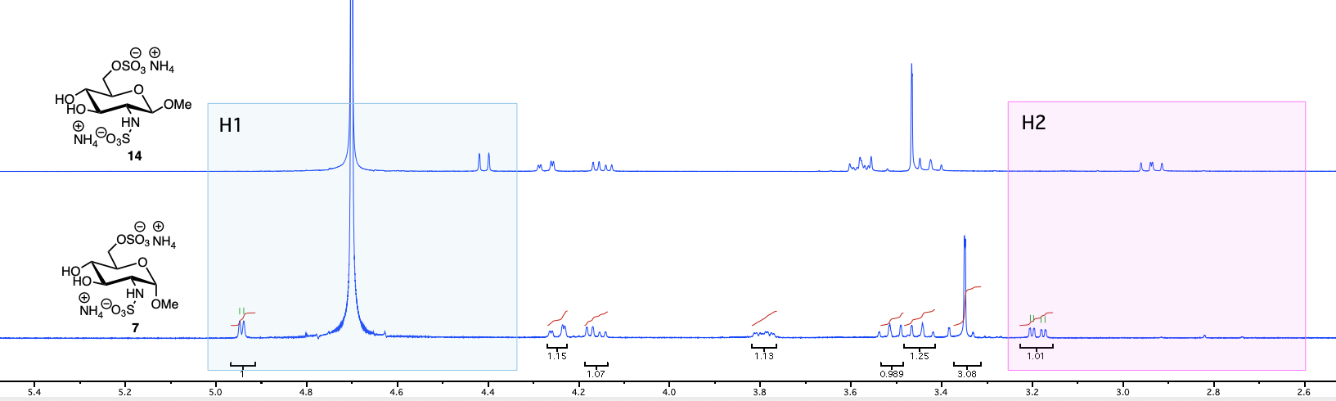

**Figure 3.** Comparison of key 1H NMR chemical shifts for **7** and **14**,highlighting differences for H1 and H2 in the α- and β-anomers. See SI for comparative overlay of **12** and **14** highlighting chemical shift differences for H2 in the free amine *vs* *N*-sulfated forms.

*2.3. Biological evaluations*

The saccharide constituents of the glycosaminoglycan HS are generally considered non-toxic to cells, but it is unknown if the monosaccharide components thereof (including **5**-**7** and **12**-**14**) have any adverse effect on cells. To examine this possibility, the ability of compounds **5**-**7** and **12**-**14** to affect cells was examined using toxicity tests in lymphocytic (BaF3), fibroblastic (NIH 3T3) and epithelial cell lines (Vero). None of the compounds tested exhibited any toxicity towards these cell types. *Figure 4* demonstrates that monosaccharide concentrations of 100 μg/ml (100-1000 times a typical biologically relevant concentration37) did not inhibit cell proliferation in response to 10% FBS in 3T3 cells. Similarly, compounds **5**-**7** and **12**-**14** were not able to counter the ability of Il-3 to suppress apoptosis in BaF3 cells and did not inhibit cell proliferation in response to 10% FBS in Vero cells (see Supplementary Information).

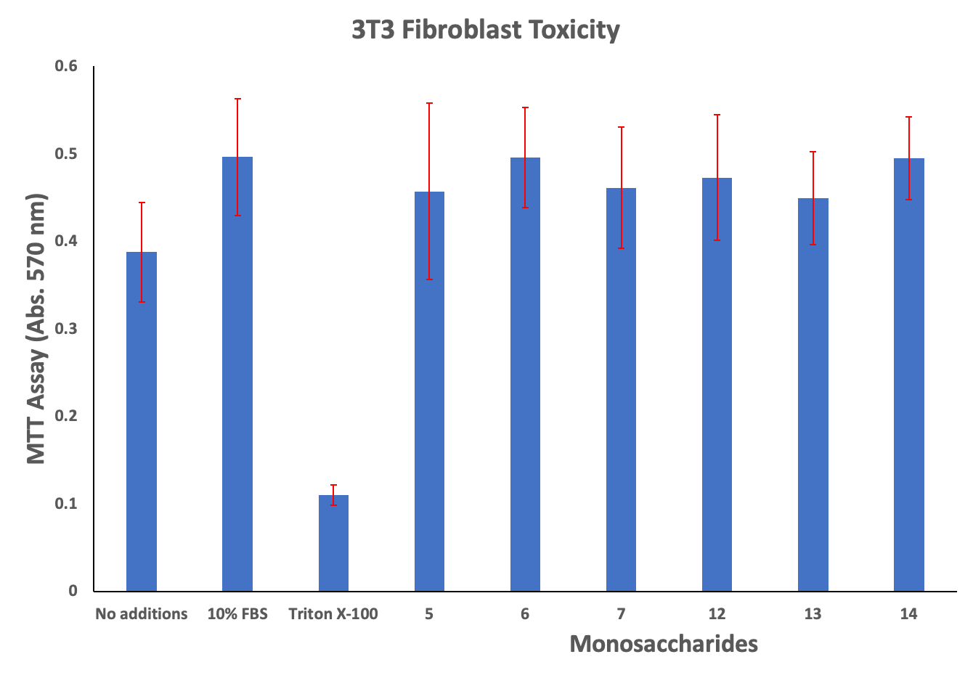

**Figure 4**. Ability of compounds **5**-**7** and **12**-**14** to affect a proliferative response in response to 10% FBS using fibroblastic (NIH 3T3) cell line. Monosaccharide concentrations were 100 ug/ml with 10% FBS. Triton X-100 was 0.1% with 10% FBS. Cells were incubated with saccharides for 72 hours and results are representative of three independent experiments with triplicate wells in each experiment.

HS oligosaccharides shorter than a hexasaccharide do not have the ability to positively regulate protein activity, but those smaller than hexasaccharide can act as competitive inhibitors of H/HS to suppress protein activity.38 In light of this, compounds **5**-**7** and **12**-**14** were also tested for their ability to suppress FGF-2 signalling in BaF3 cells expressing FGFR1c in the presence of heparin (*Figure 5*).

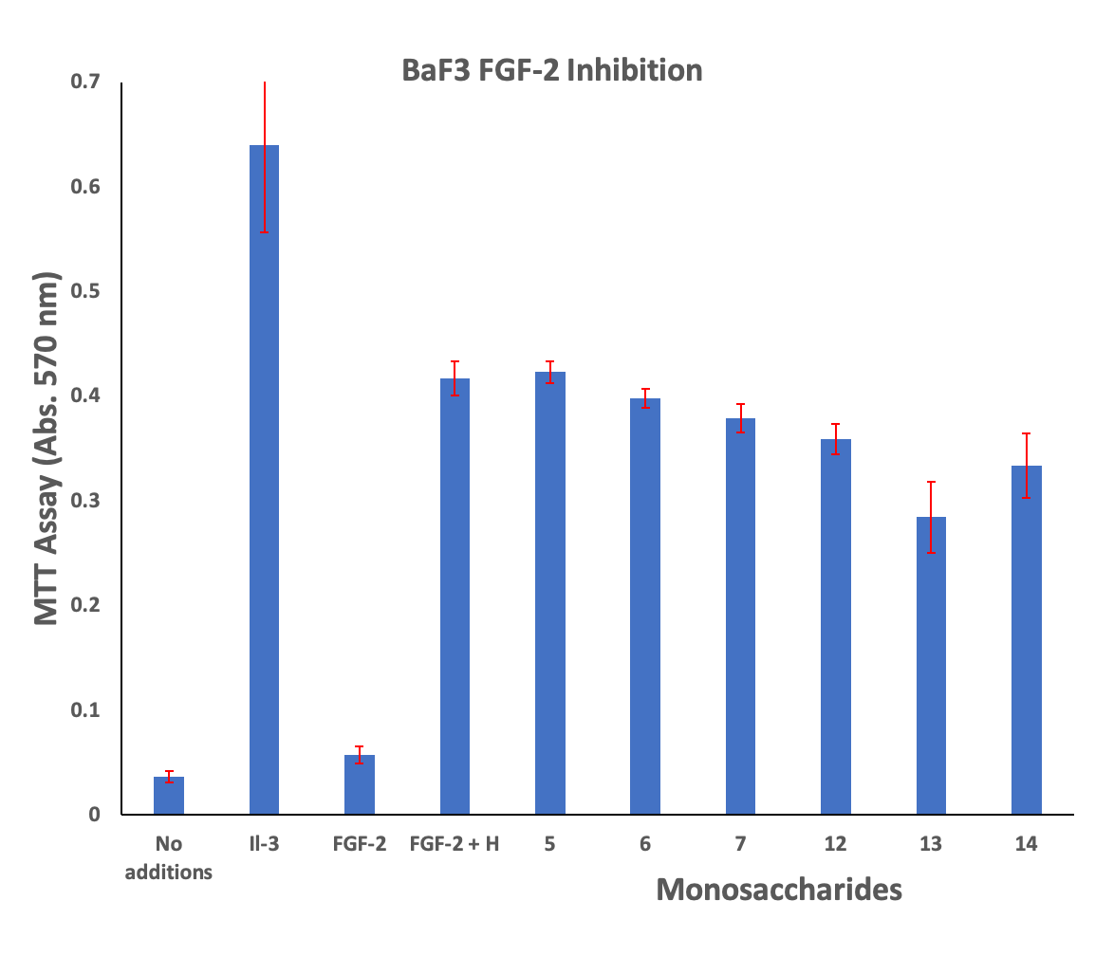

**Figure 5**. Compounds **5**-**7** and **12**-**14** do not affect the ability of heparin to support FGF-2 signalling.

Monosaccharide concentrations were 100 ug/ml with 0.3 ng/ml FGF-2 + 1 ug/ml heparin. Il-3 = 1 ng/ml. Results are representative of three independent experiments with triplicate wells in each experiment.

In these cells, FGF-2 signalling can substitute for Il-3 signalling when Il-3 is withdrawn, allowing the cells to proliferate normally. This only happens in the presence of heparin or an HS saccharide that supports FGF-2 activity. Saccharides that do not bind to FGF-2, FGFR1c or would otherwise inhibit FGF-2 signalling would not support BaF3 cell proliferation. None of compounds **5**-**7** and **12**-**14** had a statistically significant effect on the ability of heparin to support FGF-2 signalling, indicating that they do not interfere with FGF-2 activity.

**3. Conclusion**

A six-step chemical synthesis of α- and β-OMe D-GlcN intermediates enables simple acylation or *N*-sulfation to afford a small matrix of six differentially sulphated or acetylated derivatives. These constituent monosaccharides of heparin/heparan sulfate were shown not to support proliferative pathways in lymphocytic (BaF3), fibroblastic (NIH 3T3) and epithelial (Vero) cell lines or an ability to interfere with FGF-2 signalling. They will however provide important, structurally defined standards for alternative biological and analytical applications.

**4. Experimental section**

*4.1. General Methods and Materials*

1H NMR spectra were recorded on a Bruker Avance 400 (400 MHz) instrument using deuterochloroform (or other indicated solvent) as reference. The chemical shift data for each signal are given as δ in units of parts per million (ppm) relative to tetramethylsilane (TMS) where δ (TMS) = 0.00 ppm. The multiplicity of each signal is indicated by: s (singlet); brs (broad singlet); d (doublet); t (triplet); dd (doublet of doublets); ddd (doublet of doublet of doublets); dddd (doublet of doublet of doublet of doublets); ddt (doublet of doublet of triplets); sp (septet) or m (multiplet). The number of protons (n) for a given resonance is indicated by nH. Coupling constants (*J*) are quoted in Hz and are recorded to the nearest 0.1 Hz. 13C NMR spectra were recorded on a Bruker Avance 400 (100 MHz) instrument using the PENDANT sequence and internal deuterium lock. The chemical shift data for each signal are given as δ in units of ppm relative to TMS where δ (TMS) = 0.00 ppm. Analytical thin layer chromatography (TLC) was carried out on pre-coated 0.25 mm ICN Biomedicals GmbH 60 F254 silica gel plates. Visualisation was by absorption of UV light or thermal development after dipping in 5% H2SO4 in MeOH. Optical activities were recorded on automatic Rudolph Autopol I or Bellingham and Stanley ADP430 polarimeters (concentration in g/100mL).HRMS (ESI) were obtained on Agilent 6530 Q-TOF, LQT Orbitrap XL1 or Waters (Xevo, G2-XS TOF or G2-S ASAP) Micromass LCT spectrometers using a methanol mobile phase in positive/negative ionisation modes as appropriate. Manual column chromatography was carried out on silica gel (Sigma Aldrich 40-63 micron) under a positive pressure of compressed air. Automatic Column Flash chromatography was carried out on silica gel (Reveleris® X2 system) under a positive pressure of compressed N2. Dry CH2Cl2 and DMF was acquired from an Inovative Technology solvent purification system. Anhydrous MeOH was dried over 4 Å molecular sieves. Chemicals were purchased from Acros UK, Aldrich UK, Avocado UK, Fisher UK or Fluka UK. All solvents and reagents were purified and dried where necessary, by standard techniques. Where appropriate and if not stated otherwise, all non-aqueous reactions were performed under an inert atmosphere of nitrogen, using a vacuum manifold with nitrogen passed through 4 Å molecular sieves and self-indicating silica gel. *In vacuo* refers to the use of a rotary evaporator attached to a diaphragm pump. Brine refers to a saturated aqueous solution of sodium chloride. Hexane refers to *n*-hexane and petroleum ether to the fraction boiling between 40 and 60 °C.

*4.2. General method for TBDPS and benzoate introduction*

Compound **1** or **8** (1.0 mmol) was dissolved in DMF (3.3 mL) at room temperature. The solution was cooled to 0 °C and imidazole (350 mg, 5.10 mmol) was added followed by dropwise addition of TBDPSCl (800 μL, 3.10 mmol). The solution was stirred at room temperature for 2 hr. Upon complete conversion to the 6-OTBDPS derivative, as indicated by TLC (100% EtOAc, starting material Rf ~ 0.1-0.2, product Rf ~0.8-0.9) pyridine was added (3.3 mL) followed by BzCl (500 μL 4.10 mmol) and DMAP (13 mg, 51 μmol). The solution was stirred at room temperature for 3 hr before being reduced to dryness. The residue was taken up in EtOAc (50 mL) and washed with 2.0 M aq. HCl (2 x 25 mL), saturated aqueous NaHCO3 (2 x 25 mL), deionised water (2 x 25 mL) and brine (25 mL). The organic layer was dried over MgSO4, filtered and solvent removed under reduced pressure. Silica gel column chromatography using a gradient elution (0-5% EtOAc in toluene) gave the products as white foams in 88-96% yields.

*4.2.1. Methyl 3,4-O-benzoyl-2-N-carboxybenzyl-6-O-tertbutyldiphenylsilyl-2-deoxy-α-D-glucopyranoside (****2****)*

250 mg of **1** gave **2** (560 mg, 88%); White foam was crystallized from petroleum ether and diethylether to give **2** as white crystals. R*f* = 0.7 (toluene/EtOAc, 9/1); ${[α]}_{D}^{25}$ = +19.0 (c = 2.0 CHCl3); 1H NMR (400 MHz, CDCl3) δ 7.93 (d, *J* = 7.2 Hz, 2H, ArH), 7.84 (d, *J* = 7.2 Hz, 2H, ArH), 7.65 (d, *J* = 6.5 Hz, 2H, ArH), 7.58 (dd, *J* = 8.0, 1.3 Hz, 2H, ArH), 7.49 (q, *J* = 7.2 Hz, 2H, ArH), 7.32 (m, 8H, ArH), 7.19 (m, 7H, ArH), 5.68–5.61 (t, *J* = 10.4 Hz, 1H, H3), 5.54 (t, *J* = 9.8 Hz, 1H, H4), 5.17 (d, *J* = 9.9 Hz, 1H, N*H*), 4.95 (s, 2H, C*H*2Ph), 4.89 (d, *J* = 3.5 Hz, 1H, H1), 4.28 (td, *J* = 10.3, 3.6 Hz, 1H, H2), 4.04 (ddd, *J* = 9.9, 5.0, 2.4 Hz, 1H, H5), 3.82 (dd, *J* = 11.5, 5.1 Hz, 1H, H6a), 3.77 (dd, *J* = 11.4, 2.4 Hz, 1H, H6b) 3.46 (s, 3H, OCH3), 1.02 (s, 9H, C[C*H*3]3); 13C NMR (101 MHz, CDCl3) δ 166.9 (C=O), 165.2 (C=O), 156.0 (NC=O), 136.3, 135.8, 135.7, 133.3, 133.2, 130.1, 129.9, 129.7, 129.5, 129.4, 128.5, 128.4, 128.1, 128.0, 127.7, 98.7 (C1), 72.3 (C3), 71.1 (C5), 69.4 (C4), 66.9 (CH2Ph), 63.1 (C6), 55.4 (OCH3), 54.4 (C2), 26.8 (C[*C*H3]3); HRMS [M+Na]+ calculated for C45H47NNaO9Si: 796.2912; found: 796.2944.

*4.2.2. Methyl 3,4-O-benzoyl-2-N-phthalimido-6-O-tertbutyldiphenylsilyl-2-deoxy-β-D-glucopyranoside (****9****)*

780 mg of **8** gave **9** (1.80 g, 96%); R*f* = 0.7 (toluene/EtOAc, 9/1); ${[α]}_{D}^{25}$ = +36.0 (c = 2.0 CHCl3); 1H NMR (400 MHz, CDCl3) δ 7.88-7.21 (m, 24H, ArH), 6.22 (dd, *J* = 10.8, 9.2 Hz, 1H, H3), 5.66 (t, *J* = 9.6 Hz, 1H, H4), 5.44 (d, *J* = 8.4 Hz, 1H, H1), 4.55 (dd, *J* = 10.8, 8.4 Hz, 1H, H2), 3.96 (ddd, *J* = 9.9, 4.4, 2.7 Hz, 1H, H5), 3.94-3.92 (m, 2H, H6a, H6b), 3.51 (s, 3H, OCH3), 1.05 (s, 9H, [C(CH3)3]); 13C NMR (101 MHz, CDCl3) δ 165.9 (C=O), 165.2 (C=O), 135.8, 135.7, 134.9, 134.2, 133.3, 133.2, 130.0, 129.9, 129.8, 129.7, 129.4, 128.9, 128.5, 128.4, 127.9, 127.8, 127.7, 123.7, 99.1 (C1), 75.2 (C5), 71.7 (C3), 70.0 (C4), 63.0 (C6), 56.9 (OCH3), 55.1 (C2), 26.8 (C[*C*H3])3; HRMS [M+Na]+ calculated for C45H43NNaO9Si: 792.2599; found: 792.2628.

*4.3. General method for TBDPS removal*

Silyl protected **2** or **9** (1.0 mmol) was dissolved in CH2Cl2 (10 mL) and to this solution BF3.Et2O (1.2 mL, 10 mmol) was added and the reaction stirred for 6 h. The reaction was diluted with CH2Cl2 (40 mL) and quenched by addition of saturated aqueous NaHCO3 (100 mL). The biphasic mixture was stirred vigorously until a pH of 7 was achieved for the organic phase. The organic phase was then separated and reduced to dryness. The products **3** and **10** were isolated by silica gel column chromatography using a gradient elution (0-10 % EtOAc in toluene) as white foams in 42-46 % yields.

*4.3.1. Methyl 3,4-O-benzoyl-2-N-carboxybenzyl-2-deoxy-α-D-glucopyranoside (****3****)*

560 mg of **2** gave **3** (164 mg, 42%); R*f* = 0.15 (toluene/EtOAc, 4/1); ${[α]}_{D}^{25}$ = +20.0 (c = 2.0 CHCl3); 1H NMR (400 MHz, CDCl3) δ 7.96-7.93 (m, 4H), 7.54-7.47 (m, 2H), 7.39-7.33 (m, 5H), 7.21-7.13 (m, 4H), 5.75 (dd, *J* = 10.5, 9.8 Hz, 1H, H3), 5.42 (t, *J* = 9.8 Hz, 1H, H4), 5.17 (d, *J* = 10.0 Hz, 1H, NH), 4.94 (s, 2H, CH2Ph), 4.90 (d, *J* = 3.5 Hz, 1H, H1), 4.32 (td, *J* = 10.4, 3.6 Hz, 1H, H2), 3.95 - 3.92 (m, 1H, H5), 3.80-3.77 (m, 1H, H6a), 3.70 (dd, *J* = 12.8, 3.5 Hz, 1H, H6b), 3.46 (s, 3H, OCH3), 2.70 (s, 1H, OH); 13C NMR (101 MHz, CDCl3) δ 166.7 (C=O), 166.5 (C=O), 155.9 (NC=O), 136.2, 133.8, 133.4, 130.1, 130.0, 129.3, 128.8, 128.6, 128.5, 128.5, 128.2, 127.9, 98.9 (C1), 71.6 (C3), 70.4 (C5), 69.7 (C4), 67.0 (CH2Ph), 61.3 (C6), 55.7 (OCH3), 54.2 (C2); HRMS [M+Na]+ calculated for C29H29NNaO9Si: 558.1735; found: 558.1759.

*4.3.2. Methyl 3,4-O-benzoyl-2-N-phthalimido-2-deoxy-β-D-glucopyranoside (****10****)*

1.5 g of **9** gave **10** (389 mg, 46%); R*f* = 0.15 (toluene/EtOAc, 4/1); 1H NMR (400 MHz, CDCl3) δ 8.06–7.19 (m, 14H, ArH), 6.32 (dd, *J* = 10.8, 9.2 Hz, 1H, H3), 5.52 (t, *J* = 9.6 Hz, 1H, H4), 5.48 (d, *J* = 8.4 Hz, 1H, H1), 4.55 (dd, *J* = 10.8, 8.4 Hz, 1H, H2), 3.90 (m, 2H, H5, H6a), 3.82–3.68 (m, 1H, H6b), 2.61 (s, 1H, OH); 13C NMR (101 MHz, CDCl3) δ 166.3 (C=O), 165.8 (C=O), 134.3, 133.8, 133.4, 130.1, 129.9, 128.8, 128.7, 128.6, 128.5, 123.7, 99.4(C1), 74.5 (C5), 71.0 (C3), 70.3 (C4), 61.5 (C6), 57.3 (OCH3), 54.9 (C2); Data matched those reported previously.39

*4.4. General method for 6-O-Sulfation*

Compound **3** or **10** (0.5 mmol) was dissolved in pyridine (1.0 mL) in a microwave tube. SO3.pyridine complex (480 mg, 3 mmol) and a magnetic stirer bar were added and the vessel was sealed. The reaction was heated to 100 °C and irradiated for 1 h. The reaction was reduced to dryness then taken up in EtOAc (20 mL) and dry loaded on to silica gel. The products  **4** and **11** were subsequently isolated by column chromatography using a gradient elution (0-20% MeOH in EtOAc then EtOAc/MeOH/33% aq. NH4OH, 7/2/1) to furnish the products as white solids in 95-96% yields.

*4.4.1. Methyl 3,4-O-benzoyl-2-N-carboxybenzyl-6-O-sulfonate-2-deoxy-α-D-glucopyranoside ammonium salt (****4****)*

150 mg of **3** gave **4** (168 mg, 95%); Rf = 0.7 (EtOAc/MeOH/33% aq. NH3OH, 7/2/1); = +37.0 (c = 2.0 CHCl3) 1H NMR (400 MHz; MeOD) δ 7.93-7.85 (m, 4H, ArH), 7.55-7.50 (m, 2H, ArH), 7.37 (m, 4H, ArH), 7.20-7.08 (m, 5H, ArH), 5.73 (dd, *J* = 10.6, 9.6 Hz, 1H, H3), 5.44 (t, *J* = 9.8 Hz, 1H, H4), 5.05-4.92 (dd, 2H, CH2Ph), 4.88 (d, *J* = 3.5 Hz, 1H, H1), 4.38-4.27 (m, 2H, H2, H5), 4.25-4.14 (m, 2H, H6a, H6b), 3.52 (s, 3H, OCH3); 13C NMR (101 MHz; MeOD) δ 166.2 (C=O), 165.5 (C=O), 157.1 (NC=O), 148.6, 137.2, 136.6, 133.2, 133.1, 129.4, 129.3, 129.2, 129.1, 128.1, 128.0, 127.9, 127.4, 127.0, 98.7 (C1), 72.1 (C3), 70.0 (C4), 68.3 (C5), 66.3 (C6), 66.1 (CH2Ph), 54.7 (OCH3), 53.9 (C2).

*4.4.2. Methyl 3,4-O-benzoyl-2-N-phthalimido-6-O-sulfonate-2-deoxy-β-D-glucopyranoside ammonium salt (****11)***

370 mg of **10** gave **11** (440 mg, 95%); Rf = 0.7 (EtOAc/MeOH/33% aq. NH3OH, 7/2/1); = +48.0 (c = 2.0 CHCl3); 1H NMR (400 MHz; CDCl3) δ 7.94 (tt, *J* = 7.7, 1.7 Hz, 5H, ArH), 7.86-7.84 (m, 2H, ArH), 7.76-7.74 (m, 2H, ArH), 7.47 (tt, *J* = 7.4, 1.5 Hz, 1H, ArH), 7.42 (tt, *J* = 7.5, 1.5 Hz, 1H ArH), 7.34-7.24 (m, 4H, ArH), 6.20 (dd, *J* = 10.8, 9.2 Hz, 1H, H3), 5.54 (dd, *J* = 10.0, 9.2 Hz, 1H, H4), 5.46 (d, *J* = 8.5 Hz, 1H, H1), 4.47-4.41 (m, 2H, H2, H6a), 4.35 (dd, *J* = 11.2, 5.2 Hz, 1H, H6b), 4.26 (ddd, *J* = 10.1, 5.2, 2.5 Hz, 1H, H5), 3.48 (s, 3H, OCH3); 13C NMR (101 MHz; CDCl3) δ 165.7 (C=O), 165.6 (C=O), 134.1, 134.0, 133.3, 133.1, 131.5, 131.4, 131.3, 129.9, 129.7, 129.6, 128.8, 128.7, 128.3, 128.2, 123.5, 99.5 (C1), 72.31 (C5), 71.5 (C3), 69.4 (C4), 65.6 (C6), 57.9 (OCH3), 54.5 (C2);HRMS [M+Na]+ calculated for C29H25NNaO12S: 634.0995; found: 634.1006.

*4.5 Methyl 2-amino-6-O-sulfonate-2-deoxy-α-D-glucopyranoside ammonium salt (****5****)*

6-*O*-sulfate **4** (166 mg, 0.25 mmol) was dissolved in MeOH (6 mL) and to this Pd/C (67 mg, 0.06 mmol) was added. The reaction was placed under an H2 atmosphere, stirred for 16 h, filtered through a Celite® pad and reduced to dryness. Crude NMR and LRMS analyses confirmed loss of the CBz group. The crude material was taken up in MeOH (5 mL) and 1M NaOMe in MeOH was added until a pH of 10 was achieved. The reaction was then heated to 40 °C for 2 h, cooled to room temperature and Amberlite IR120 H+ resin added. This suspension was stirred until a pH of 7 was achieved, filtered, washed with MeOH (5 mL) and water (5 mL) and the filtrate reduced to dryness. The crude product was purified by silica gel column chromatography (EtOAc/MeOH/ 33% aq. NH3OH, 7/2/1 then EtOH/33% aq. NH3OH, 9/1). The product-containing fractions were reduced to dryness and lyophilised to furnish **5** as a white solid (46 mg, 63%). Rf = 0.4 (MeCN/33% aq. NH3OH, 4/1); = +79.0 (c = 1.4 H2O); 1H NMR (400 MHz; D2O) δ 4.93 (d, *J* = 3.4 Hz, 1H, H1), 4.27-4.23 (m, 1H, H6a), 4.19 (dd, *J* = 11.4, 4.7 Hz, 1H, H6b), 3.86-3.82 (m, 1H, H5), 3.78 (t, *J* = 9.8 Hz, 1H, H3), 3.47 (t, *J* = 9.6 Hz, 1H, H4), 3.38 (s, 3H, CH3), 3.27 (m, 1H, H2); 13C NMR (101 MHz; D2O) δ 96.2 (C1), 69.9 (C5), 69.8 (C3), 69.1 (C4), 66.7 (C6), 55.3 (OCH3), 53.8 (C2); HRMS [M-H]- calculated for C7H14NO8S: 272.0440; found: 272.0446. Data matched those previously reported.29

*4.6 Methyl 2-amino-6-O-sulfonate-2-deoxy-β-D-glucopyranoside ammonium salt (****12****)*

6-*O*-sulfate **11** (370 mg, 0.57 mmol) was dissolved in EtOH (20 mL) and to this ethylene diamine (760 μL, 11.4 mmol) was added. The solution was heated to 70 °C for 16 h then reduced to dryness. The crude product was purified by silica gel column chromatography (EtOAc/MeOH/ 33% aq. NH3OH, 7/2/1 then EtOH/33% aq. NH3OH, 9/1). The product-containing fractions were reduced to dryness and lyophilised to furnish **12** as a white solid (92 mg, 56%). Rf = 0.1 (EtOAc/MeOH/33% aq. NH3OH, 7/2/1); = -21.0 (c = 1.6 H2O); 1H NMR (400 MHz; D2O) δ 4.50 (d, *J* = 8.4 Hz, 1H, H1), 4.27 (dd, *J* = 11.3, 2.1 Hz, 1H, H6a), 4.17 (dd, *J* = 11.2, 4.8 Hz, 1H, H6b), 3.63 (ddd, *J* = 9.7, 4.8, 2.1 Hz, 1H, H5), 3.56-3.45 (m, 6H, H3, H4, OCH3), 2.86 (dd, *J* = 10.2, 8.4 Hz, 1H, H2); 13C NMR (101 MHz; D2O) δ 101.0 (C1), 73.9 (C5), 72.8 (C3), 69.3 (C4), 66.6 (C6), 57.4 (OCH3), 55.8 (C2); HRMS [M-H]- calculated for C7H14NO8S: 272.0440; found: 272.0446.

*4.7 General procedure for N-acetylation*

Compound **5** or **12** (50 μmol) were dissolved in a solution of MeOH/Ac2O (2.20 mL, 10/1). The reaction was stirred for 16 h then reduced to dryness and purified by silica gel column chromatography (MeCN/33% aq. NH3OH, 4/1). The product-containing fractions were reduced to dryness and lyophilised to furnish the products as white powders in 78-83% yields.

*4.7.1. Methyl 2-N-acetamido-6-O-sulfonate-2-deoxy-α-D-glucopyranoside ammonium salt (****6****)*

10 mg of **5** gave **6** (9 mg, 78%). Rf = 0.4 (MeCN/33% aq. NH3OH, 4/1); = +52 (c = 0.7 H2O); 1H NMR (400 MHz; D2O) δ 4.62 (d, *J* = 3.6 Hz, 1H, H1), 4.19 (dd, *J* = 11.2, 2.2 Hz, 1H, H6a), 4.11 (dd, *J* = 11.2, 5.2 Hz, 1H, H6b), 3.81 (dd, *J* = 10.6, 3.6 Hz, 1H, H2), 3.78-3.73 (m, 1H, H5), 3.58 (t, *J* = 9.8 Hz, 2H, H3), 3.39 (dd, *J* = 10.1, 9.1 Hz, 1H, H4), 3.25 (s, 3H, OCH3), 1.85 (s, 3H, CH3); 13C NMR (peaks extrapolated from HSQC) δ 97.9 (C1), 70.8 (C3), 69.8 (C5), 69.4 (C4), 66.8 (C6), 55.2 (OCH3), 53.3 (C2), 21.1 (CH3); HRMS [M-H]- calculated for C9H16NO9S: 314.0546; found: 314.0548. Data matched those previously reported.29

*4.7.2. Methyl 2-N-acetamido-6-O-sulfonate-2-deoxy-β-D-glucopyranoside ammonium salt (****13****)*

20 mg of **12** gave **13** (19 mg, 83%). Rf = 0.2 (MeCN/33% aq. NH3OH, 4/1); 1H NMR (400 MHz; MeOD) δ 4.37 (dd, *J* = 11.0, 2.0 Hz, 1H, H6a), 4.32 (d, *J* = 8.4 Hz, 1H, H1), 4.16 (dd, *J* = 11.0, 5.8 Hz, 1H, H6b), 3.67 (dd, *J* = 10.1, 8.4 Hz, 1H, H2), 3.52-3.49 (m, 1H, H5), 3.48-3.44 (m, 4H, OCH3, H4), 3.37 (dd, *J* = 9.7, 8.8 Hz, 1H, H3), 2.00-1.99 (m, 3H, CH3); HRMS [M-H]- calculated for C9H16NO9S: 314.0546; found: 314.0548; Data matched those previously reported.40

*4.8. General Procedure for N-Sulfation*

Compound **5** or **12** (50 μmol) were dissolved in water (2.0 mL). A portion from both NaHCO3 (70 mg) and SO3.pyridine (50 mg) was added at 10 min., 1 h, 2 h and 4 h time points and the suspension was then stirred at room temperature for a further 16 h. The reaction was reduced to dryness, MeOH (5 mL) was added, the suspension centrifuged and the liquors were removed and reduced. This process was repeated three times to remove excess salt. The crude residue was then purified by silica gel column chromatography (MeCN/33% aq. NH3OH, 4/1). The product-containing fractions were combined, reduced to dryness and lyophilised to furnish the products as white powders in 38-51% yields.

*4.8.1 Methyl 6-O-sulfonate-2-deoxy-2-sulfamino-α-D-glucopyranoside ammonium salt* (**7**)

10 mg of **5** gave **7** (5 mg, 38%). Rf = 0.3 (MeCN/33% aq. NH3OH, 4/1); = +28 (c = 0.3 H2O); 1H NMR (400 MHz; D2O) δ 4.94 (d, *J* = 3.6 Hz, 1H, H1), 4.25 (dd, *J* = 11.0, 1.9 Hz, 1H, H6a), 4.16 (dd, *J* = 11.5, 5.0 Hz, 1H, H6b), 3.81-3.77 (m, 1H, H5), 3.51 (dd, *J* = 9.8, 9.3 Hz, 1H, H3), 3.44 (t, *J* = 9.5 Hz, 1H, H4), 3.35 (s, 3H, OCH3), 3.19 (ddd, *J* = 10.1, 3.7, 0.8 Hz, 1H, H2); 13C NMR (peaks extrapolated from HSQC) δ 98.1 (C1), 71.1 (C3), 69.3 (C4), 69.1 (C5), 66.7 (C6), 57.2 (C2), 55.0 (OCH3); HRMS [M-H]2- calculated for C7H13NO11S2: 175.4970; found: 175.4975. Data matched those previously reported.29

*4.8.2 Methyl 6-O-sulfonate-2-deoxy-2-sulfamino-β-D-glucopyranoside ammonium salt (****14****)*

20 mg of **12** gave **14** (13.5 mg, 51%). Rf = 0.3 (MeCN/33% aq. NH3OH, 4/1); = -15.0 (c = 1.2 H2O) 1H NMR (400 MHz; D2O) δ 4.41 (d, *J* = 8.4 Hz, 1H, H1), 4.27 (dd, *J* = 11.2, 2.1 Hz, 1H, H6a), 4.15 (dd, *J* = 11.2, 5.2 Hz, 1H, H6b), 3.60-3.56 (m, 2H, H3, H5), 3.47 (s, 3H, OCH3), 3.42 (t, *J* = 9.4 Hz, 1H, H4), 2.94 (dd, *J* = 10.1, 8.4 Hz, 1H, H2); 13C NMR (101 MHz; D2O) δ 102.5 (C1), 74.5 (C3 or C5), 73.4 (C3 or C5), 69.5 (C4), 67.0 (C6), 59.9 (C2), 57.2 (OCH3); HRMS [M-H]2- calculated for C7H13NO11S2: 175.4970; found: 175.4973.

4.9. *Cell* *based assays*

Murine NIH 3T3 fibroblast cells and African green monkey Vero kidney epithelial cells were purchased from ATCC. Murine BaF3 lymphocytes transfected with human FGFR1c were a kind gift from Prof. David Ornitz (Washington University, St. Louis, USA). Vero and 3T3 cells were maintained at 50-75% confluence in DMEM supplemented with 10% foetal bovine serum, 20 mM L-glutamine, 100 U/ml penicillin-G and 100U/ml streptomycin sulfate (all purchased from Gibco/ThermoFisher, UK). BaF3 cells were maintained at no greater than 1 x 106 cells/mL in RPMI supplemented with 10% foetal bovine serum, 20 mM L-glutamine, 100 U/ml penicillin-G, 100U/ml streptomycin sulfate (all purchased from Gibco/ThermoFisher, UK) and 1 ng/ml recombinant murine Il-3 (R&D Systems, UK). Cells were maintained at 37 °C, 5% CO2.

4.9.1 *Cell toxicity assays*

Vero and 3T3 cells were plated into 96-well cell culture plates at 1000 cells/well in 100 μl of maintenance medium. Cells were allowed to adhere overnight. Medium was replaced with 100 μl maintenance medium +/- 100 μg/ml of saccharides or 0.1% Triton X-100 (Roche/Sigma). Cells were incubated for 48 hours then 250 μg/ml MTT (final concentration, Roche/Sigma) was added and the cells were incubated a further 4 hours. Formazan product was solubilised with the addition of 50 μl 10% SDS + 0.1N HCl (both from Roche/Sigma). Absorbance was read at 570 nm on a Tecan Infinite M200Pro plate reader. The procedure for BaF3 cells was identical, with the following exceptions. Cells were plated at 10000 cells/well, incubated with saccharides for 72 hours and removal of Il-3 served as a control for cell death, rather than Triton X-100. Results are representative of 3 independent experiments for each cell type with triplicate wells for each condition.

4.9.2 *FGF-2 Cell proliferation assays*

BaF3 cells were maintained as per 4.9. For FGF-2 proliferation assays cells were washed 2 x with 10 mL of maintenance medium without Il-3 to remove Il-3. Cells were plated at 10000 cells/ml in 96 well cell culture plates with 100 μl of maintenance medium supplemented with 1nM recombinant human FGF-2 (R&D Systems) and 1 μg/ml porcine intestinal mucosa heparin (Celsus) alone or in combination with 100 μg of the indicated saccharides. Cells were incubated for 72 hours then cell number was determined by MTT as in 4.9.1.

**Acknowledgements**

Science Foundation Ireland (Award 13/IA/1959) and EPSRC (EP/P000762/1) are thanked for project grant funding. We also thank the EPSRC UK National Mass Spectrometry Facility (NMSF) at Swansea University.

**References**

1 J. R. Bishop, M. Schuksz and J. D. Esko, *Nature*, 2007, **446**, 1030–1037.

2 B. Casu, A. Naggi and G. Torri, *Matrix Biol.*, 2010, **29**, 442–452.

3 P. H. Seeberger and D. B. Werz, *Nature*, 2007, **446**, 1046–1051.

4 G. J. Miller, S. U. Hansen, E. Avizienyte, G. Rushton, C. Cole, G. C. Jayson and J. M. Gardiner, *Chem. Sci.*, 2013, **4**, 3218–3222.

5 S. U. Hansen, G. J. Miller, M. J. Cliff, G. C. Jayson and J. M. Gardiner, *Chem. Sci.*, 2015, **6**, 6158–6164.

6 S. U. Hansen, G. J. Miller, C. Cole, G. Rushton, E. Avizienyte, G. C. Jayson and J. M. Gardiner, *Nat. Commun.*, 2013, **4**, 2016.

7 K. Sheerin, L. Guazzelli and S. Oscarson, *Carbohydr. Res.*, 2017, **440**, 16–31.

8 N. J. Pawar, L. Wang, T. Higo, C. Bhattacharya, P. K. Kancharla, F. Zhang, K. Baryal, C. Huo, J. Liu, R. J. Linhardt, X. Huang and L. C. Hsieh‐Wilson, *Angew. Chem.*, 2019, **58**, 18577–18583.

9 N. V. Sankaranarayanan, T. R. Strebel, R. S. Boothello, K. Sheerin, A. Raghuraman, F. Sallas, P. D. Mosier, N. D. Watermeyer, S. Oscarson and U. R. Desai, *Angew. Chem.*, 2017, **129**, 2352–2357.

10 J. D. C. Codée, B. Stubba, M. Schiattarella, H. S. Overkleeft, C. A. A. van Boeckel, J. H. van Boom and G. A. van der Marel, *J. Am. Chem. Soc.*, 2005, **127**, 3767–3773.

11 W. Lu, C. Zong, P. Chopra, L. E. Pepi, Y. Xu, I. J. Amster, J. Liu and G.-J. Boons, *Angew. Chem.*, 2018, **57**, 5340–5344.

12 Y. Xu, K. Chandarajoti, X. Zhang, V. Pagadala, W. Dou, D. M. Hoppensteadt, E. M. Sparkenbaugh, B. Cooley, S. Daily, N. S. Key, D. Severynse-Stevens, J. Fareed, R. J. Linhardt, R. Pawlinski and J. Liu, *Sci. Transl. Med.*, 2017, **9**, eaan5954.

13 J. Liu and R. J. Linhardt, *Nat. Prod. Rep.*, 2014, **31**, 1676–1685.

14 Y. Xu, C. Cai, K. Chandarajoti, P.-H. Hsieh, L. Li, T. Q. Pham, E. M. Sparkenbaugh, J. Sheng, N. S. Key, R. Pawlinski, E. N. Harris, R. J. Linhardt and J. Liu, *Nat. Chem. Biol.*, 2014, **10**, 248–250.

15 Y. Xu, S. Masuko, M. Takieddin, H. Xu, R. Liu, J. Jing, S. A. Mousa, R. J. Linhardt and J. Liu, *Science*, 2011, **334**, 498–501.

16 Y. Chen, Y. Li, H. Yu, G. Sugiarto, V. Thon, J. Hwang, L. Ding, L. Hie and X. Chen, *Angew. Chem.*, 2013, **52**, 11852–11856.

17 C. I. Gama, S. E. Tully, N. Sotogaku, P. M. Clark, M. Rawat, N. Vaidehi, W. A. Goddard, A. Nishi and L. C. Hsieh-Wilson, *Nat. Chem. Biol.*, 2006, **2**, 467–473.

18 G. J. Miller, S. U. Hansen, M. Baráth, C. Johannessen, E. W. Blanch, G. C. Jayson and J. M. Gardiner, *Carbohydr. Res.*, 2014, **400**, 44–53.

19 R. Schwörer, O. V. Zubkova, J. E. Turnbull and P. C. Tyler, *Chem. Eur. J.*, 2013, **19**, 6817–6823.

20 Y.-P. Hu, S.-Y. Lin, C.-Y. Huang, M. M. L. Zulueta, J.-Y. Liu, W. Chang and S.-C. Hung, *Nat. Chem.*, 2011, **3**, 557–563.

21 Y.-P. Hu, Y.-Q. Zhong, Z.-G. Chen, C.-Y. Chen, Z. Shi, M. M. L. Zulueta, C.-C. Ku, P.-Y. Lee, C.-C. Wang and S.-C. Hung, *J. Am. Chem. Soc.*, 2012, **134**, 20722–20727.

22 C.-T. Tsai, M. M. L. Zulueta and S.-C. Hung, *Curr. Opin. Chem. Biol.*, 2017, **40**, 152–159.

23 J. Tatai, G. Osztrovszky, M. Kajtár-Peredy and P. Fügedi, *Carbohydr. Res.*, 2007, **343**, 596–606.

24 F. Baleux, L. Loureiro-Morais, Y. Hersant, P. Clayette, F. Arenzana-Seisdedos, D. Bonnaffé and H. Lortat-Jacob, *Nat. Chem. Biol.*, 2009, **5**, 743–748.

25 A. Lubineau, H. Lortat-Jacob, O. Gavard, S. Sarrazin and D. Bonnaffé, *Chem. Eur. J.*, 2004, **10**, 4265–4282.

26 D. Budhadev, K. Saxby, J. Walton, G. Davies, P. C. Tyler, R. Schwörer and M. A. Fascione, *Org. Biomol. Chem.*, 2019, **17**, 1817–1821.

27 S. B. Dulaney and X. Huang, *Adv. Carbohydr. Chem. Biochem.*, 2012, **67**, 95–136.

28 J. L. de Paz and M. Martín-Lomas, *Eur. J. Org. Chem.*, 2005, **2005**, 1849–1858.

29 A. K. Gorle, P. Rajaratnam, C.-W. Chang, M. von Itzstein, S. J. Berners-Price and N. P. Farrell, *Inorg. Chem.*, 2019, **58**, 7146–7155.

30 M. Egan, H. Jiang, M. O. Motherway, S. Oscarson and D. van Sinderen, *Appl. Environ. Microb.*, 2016, **82**, 6611–6623.

31 I. Compagnon, B. Schindler, G. Renois-Predelus and R. Daniel, *Curr. Opin. Struct. Biol.*, 2018, **50**, 171–180.

32 R. L. Miller, S. E. Guimond, R. Schwörer, O. V. Zubkova, P. C. Tyler, Y. Xu, J. Liu, P. Chopra, G.-J. Boons, M. Grabarics, C. Manz, J. Hofmann, N. G. Karlsson, J. E. Turnbull, W. B. Struwe and K. Pagel, *Nat. Commun.*, 2020, **11**, 1481.

33 A. Neuberger and R. P. Rivers, *J. Chem. Soc.* , 1939, 122–126.

34 P. W. Jeffs, G. Chan, R. Sitrin, N. Holder and C. DeBrosse, *J. Org. Chem.*, 1985, **50**, 1726–1731.

35 D. R. Bundle and S. Josephson, *Can. J. Chem.*, 1980, **58**, 2679–2685.

36 D. A. Schwartz, H.-H. Lee, J. P. Carver and J. J. Krepinsky, *Can. J. Chem.*, 1985, **63**, 1073–1079.

37 S. E. Guimond and J. E. Turnbull, *Curr. Biol.*, 1999, **9**, 1343–1346.

38 S. Guimond, M. Maccarana, B. B. Olwin, U. Lindahl and A. C. Rapraeger, *J. Biol. Chem.*, 1993, **268**, 23906–14.

39 A. Stévenin, F.-D. Boyer and J.-M. Beau, *J. Org. Chem.*, 2010, **75**, 1783–1786.

40 A. G. Pearson, M. J. Kiefel, V. Ferro and M. von Itzstein, *Org. Biomol. Chem.*, 2011, **9**, 4614–4625.