Differential patterns and outcomes of over 20.6 million cardiovascular emergency department encounters for men and women in the USA

Zahra Raisi-Estabragh (MBChB, PhD)^{1,2*}, Ofer Kobo (MD MHA)^{3,4*}, Ayman Elbadawi (MD)⁵, Poonam Velagapudi (MBBS)⁶, Garima Sharma (MBBS)⁷, Renee P. Bullock-Palmer (MD)⁸, Steffen E Petersen (MD, DPhil)^{1,2,9,10}, Laxmi S Mehta (MD)¹¹, Waqas Ullah (MD)¹², Ariel Roguin (MD Ph.D)⁴, Louise Y. Sun (MD, SM)¹³, Mamas A. Mamas (MBBS, DPhil)^{3,14}

- William Harvey Research Institute, NIHR Barts Biomedical Research Centre, Centre for Advanced Cardiovascular Imaging, Queen Mary University London, UK.
- Barts Heart Centre, St Bartholomew’s Hospital, Barts Health NHS Trust, West Smithfield, EC1A 7BE, London, UK
- Keele Cardiovascular Research Group, Keele University, Keele, UK.
- Department of Cardiology, Hillel Yaffe Medical Center, Hadera, Israel.
- Department of Cardiovascular Medicine and Division of Cardiology, Baylor College of Medicine, Houston, Texas.
- University of Nebraska Medical Center, Omaha, Nebraska, USA.
- Division of Cardiology, Johns Hopkins Ciccarone Center for Prevention of Cardiovascular Disease, Johns Hopkins University School of Medicine and Hospital, Baltimore, MD.
- Department of Cardiology, Deborah Heart and Lung Center, Brown Mills, NJ, USA.
- Health Data Research UK, London, UK
- Alan Turing Institute, London, UK
- Division of Cardiology, Department of Internal Medicine, The Ohio State University, Columbus, Ohio, USA.
- Thomas Jefferson University Hospitals, Philadelphia, USA
- Division of Cardiac Anesthesiology, University of Ottawa Heart Institute, and School of Epidemiology and Public Health, University of Ottawa, Ontario, Canada.
- Institute of Population Health, University of Manchester.

*These authors have contributed equally and share first authorship.

Corresponding author: Prof. Mamas A. Mamas; Keele Cardiovascular Research Group, Centre for Prognosis Research, Keele University, Stoke-on-Trent, UK; E-mail: mamasmamas1@yahoo.co.uk; Tel: +44 1782 671654; Fax: +44 1782 734719
Abstract

Background: We describe sex-differential disease patterns and outcomes of over 20.6 million cardiovascular emergency department (ED) encounters in the USA.

Methods and Results: We analysed primary cardiovascular encounters from the Nationwide Emergency Department Sample between 2016-2018. We grouped cardiovascular diagnoses into 15 disease categories. The sample included 48.7% women; median age was 67 [54,78] years. Men had greater overall baseline co-morbidity burden; however, women had higher rates of obesity, hypertension, and cerebrovascular disease. For women, the most common ED encounters were essential hypertension (16.0%), hypertensive heart or kidney disease (14.1%), and atrial fibrillation (AF)/flutter (10.2%). For men, the most common encounters were hypertensive heart or kidney disease (14.7%), essential hypertension (10.8%), and acute myocardial infarction (AMI, 10.7%). Women were more likely to present with essential hypertension, hypertensive crisis, AF/flutter, supraventricular tachycardia, pulmonary embolism, or ischaemic stroke. Men were more likely to present with AMI or cardiac arrest. In logistic regression models adjusted for baseline covariates, compared to men, women with intracranial haemorrhage had higher risk of hospitalisation and death. Women with ischaemic stroke had higher risk of hospitalisation and death in ED. Women presenting with pulmonary embolism or deep vein thrombosis were less likely to be hospitalised. Women with aortic aneurysm/dissection had higher odds of hospitalisation and death. Men were more likely to die following presentations with hypertensive heart or kidney disease, AF/flutter, AMI, or cardiac arrest.

Conclusions: In this large nationally representative sample of cardiovascular ED presentations, we demonstrate significant sex differences in disease distribution, hospitalisation, and death.

Keywords: Cardiovascular disease; Emergency department; Sex differences; Women’s health; Epidemiology
Clinical Perspective
What is new?
- In this nationally representative sample of over 20.6 million cardiovascular emergency presentations, we demonstrate differences in baseline disease burden, cardiovascular disease (CVD) susceptibility, and clinical outcomes of men and women.
- The most common emergency department encounters in women were essential hypertension (16.0%), hypertensive heart or kidney disease (14.1%), and atrial fibrillation/flutter (10.2%). For men, the most common encounters were hypertensive heart or kidney disease (14.7%), essential hypertension (10.8%), and acute myocardial infarction (10.7%).
- Whilst women appeared lower risk overall, their risk of death was augmented within specific CVDs, indicating potential target areas for healthcare improvement.

What are the clinical implications?
- Our findings highlight differences in cardiovascular healthcare needs of men and women, which may be used to inform service planning and provision.
- Additionally, our work encourages further research to understanding the underlying biologic and socio-demographic factors driving differential CVD patterns and outcomes in men and women.

Non-standard Abbreviations and Acronyms

ACS: acute coronary syndrome
AF: atrial fibrillation
AMI: acute myocardial infarction
CI: confidence intervals
CVD: cardiovascular disease
DVT: deep vein thrombosis
ED: emergency department
HCUP: Healthcare Cost and Utilization Project
ICD: international classification of disease
NEDS: Nationwide Emergency Department Sample
OR: odds ratios
PE: pulmonary embolism
SVT: supraventricular tachycardia
VHD: valvular heart disease
USA: United States of America

Introduction
There are major differences in cardiovascular disease (CVD) patterns and outcomes between men and women¹. Biological factors, sociodemographics, and health inequalities are key determinants of these sex-differential disease susceptibilities^{2–4}. Complex psychosocial factors may also drive differences in health seeking behaviours and healthcare utilisation patterns in men and women, which may in turn influence healthcare outcomes^{5–7}.
Previous studies have highlighted differences in disease distribution amongst men and women hospitalised with CVD, as well as sex disparities in hospital treatments and in subsequent clinical outcomes^{8–11}. However, as these studies are limited to inpatients, they do not account for differential propensity to hospitalise men and women. Furthermore, they overlook the highest risk patients who may not survive the first medical contact prior to admission. Thus, existing work presents an incomplete picture of sex disparities in acute cardiovascular care.
The emergency department (ED) is typically the first point of contact for patients presenting with acute CVD. The encounters and outcomes in the ED have the potential to importantly alter the trajectory of patients’ diagnostic and treatment pathways. Existing work indicates sex differences in risk stratification and in the manifestation of symptoms in ED presentations^{12–14}. Several others have identified, more specifically, sex differences in presentation, management, and outcomes of patients presenting with chest pain or suspected acute coronary syndrome (ACS)^{15–18}. However, there is limited data comparing the distribution and outcomes from a wider range of CVD ED presentations in men and women. Such analyses are key to understanding disparities in healthcare needs, informing service planning and provision, and reducing health inequalities.
We studied ED encounters in adults with a primary CVD diagnosis from the Nationwide Emergency Department Sample (NEDS) between 2016-2018, including over 20.6 million nationally representative ED encounters in the United States of America (USA). We first described disease-specific distribution of CVDs across 15 diagnostic categories, separately for men and women. Second, we examined sex differences in two key clinical outcomes of hospitalisation and death separately for each CVD category, whilst adjusting for baseline sociodemographic and clinical factors.

Methods
Transparency and Openness Promotion statement
All data and materials are available via the NEDS resource and can be accessed at: https://www.hcup-us.ahrq.gov/nedsoverview.jsp

Data source and analysis sample
The NEDS¹⁹ is the largest all-payer ED database in the USA. Unweighted, it includes data from more than 30 million ED visits each year. Weighted, it estimates approximately 145 million nationally representative ED encounters. The dataset comprises discharge data for ED visits from 989 hospitals located in 40 States and the District of Columbia, approximating a 20-percent stratified sample of U.S. hospital-owned EDs. The NEDS captures patients initially seen in the ED and subsequently admitted to the same hospital as well as ED visits that do not result in a direct admission (i.e., treat-and-release, transfer to another hospital).
Each ED encounter includes associated diagnostic labels recorded according to the international classification of disease (ICD) codes, which from 2016 onward are as per the 10th revision (ICD-10). Patient demographics characteristics (e.g., sex, age, race/ethnicity, urban-rural designation of residence, national quartile of median household income for patient's ZIP Code), expected payment source (e.g., Medicare, Medicaid, private insurance, self-pay, no charge, and other insurance type), and hospital characteristics (e.g., region, trauma centre indicator, urban-rural location, teaching status) are also available. Additionally, there is record of whether an ED encounter resulted in admission. For those admitted, information is available on inpatient stay, such as total charges and length of stay. Discharge destination is available for patients who were treated in the ED and not admitted directly to the hospital (e.g., released home, transferred). ED and in-hospital all-cause death data is also available. For the present study, we included all ED encounters in adults (age ≥ 18 years-old) with a primary CVD diagnosis recorded between 2016-2018. Cases with missing data on age, sex, or mortality were excluded from the analysis. Cases excluded due to missing data represented 0.2% (n=43,227) of the original dataset (supplementary figure 1).

Ethics statement
This study was conducted using anonymised routine health data. Ethical approval was not required

Cardiovascular diseases
CVDs were ascertained according to ICD-10 codes and grouped into the following 15 disease categories: acute myocardial infarction (AMI; I21-I22), ischaemic stroke (I63), intracranial haemorrhage (I60-I62), essential hypertension (I10), hypertensive crisis (I16), hypertensive heart or kidney disease (I11-I13), aortic aneurysm or dissection (I71), heart failure (I50), atrial fibrillation(AF)/flutter (I48), supraventricular tachycardia (SVT; I47.1), cardiac arrest (I46), pulmonary embolism (PE, I26), deep vein thrombosis (DVT; I82.4), valvular heart disease (VHD; I34-I37), pericarditis (I30). These disease categories were selected to identify a broad range of acute conditions that could be unambiguously defined from ICD-10 codes and reliably diagnosed in the ED setting. The diagnostic codes used are based on codes recorded at completion of the ED encounter.

Outcomes
The outcomes of interest were hospitalisation and death. Hospitalisation was extracted from NEDS discharge destination data. Deaths were also available from NEDS and include all-cause death after ED presentation; we examined separately 1) ED death and 2) overall deaths, with the latter including deaths in ED and subsequent in-hospital deaths.

Statistical analysis
Continuous variables are presented as median (25th percentile, 75th percentile), due to skewed data. Categorical data are presented as frequencies and percentages. Categorical variables were compared using Pearson's chi square test. Continuous variables were compared using Mann U Whitney test. All analyses were weighted using the provided discharge weights as per Healthcare Cost and Utilization Project (HCUP) recommendations²⁰.
We calculated the proportion of admissions attributed to each CVD category, separately for men and women. We calculated the rates of hospitalisation and death, stratified by primary CVD diagnosis and sex. We used multivariable logistic regression to estimate the association of sex (exposure of interest) with 1) hospitalisation, 2) ED death, and 3) overall death (each set individually as the model outcome). Associations were examined separately for each CVD category. We excluded individuals who died in ED from the hospital admission outcome analysis. Hierarchical multilevel modelling was used to account for clustering/nesting of observations, by adjusting for the ED stratification and hospital clustering ²¹. We further adjusted for the following covariates: region of hospital, location/teaching status of hospital, income, age, weekend admission, primary expected payer, smoking status, previous myocardial infarction, previous cerebrovascular accident, dementia, dyslipidaemia, obesity, thrombocytopenia, and other comorbidities (malignancy, anaemias, chronic lung disease, coagulopathy, diabetes mellitus, liver disease, peripheral vascular disorders, chronic renal failure). The associations are reported as odds ratios (OR), along with the corresponding 95% confidence intervals (CI) and p-values. Statistical analysis was performed on IBM SPSS version 26 and Stata MP version 17.0. Statistical significance was based on the 2-tailed 0.05 level, without any multiplicity adjustment.

Results
Baseline characteristics
The analysis sample comprised 20.6 million weighted ED encounters in adults (48.7% women) with a primary cardiovascular diagnosis and recording of baseline demographics that fulfilled inclusion criteria (Figure 1, Figure S1). The baseline characteristics of the sample is summarised in Table 1. The median age for men was lower than women (64 vs. 69 years). The majority of encounters were recorded in metropolitan hospitals (85.0%), with most being in teaching centres (58.9%). The payer for most encounters was Medicare or Medicaid (68.6%). Men were more likely to be uninsured or to have their encounter covered privately.
Overall, men had greater pre-existing co-morbidity burden than women, particularly with regards to cardiometabolic risk factors (Table 1). Men were more likely to be smokers, have dyslipidaemia, diabetes, previous AMI, or peripheral vascular disease. Whilst women had higher rates of hypertension, obesity, anaemia, cerebrovascular disease, and valvular heart disease.

Overall CVD distribution and outcomes
The most common reasons for ED visit for women were essential hypertension (16.0%), hypertensive heart or kidney disease (14.1%), and AF/flutter (10.2%). For men, the top three ED encounters were hypertensive heart or kidney disease (14.7%), essential hypertension (10.8%), and AMI (10.7%). Women were significantly more likely than men to present with essential hypertension, hypertensive crisis, AF/flutter, SVT, PE, or ischaemic stroke. Whilst men were more likely to present with AMI or cardiac arrest. Frequency of encounters with other conditions was generally comparable between men and women (Figure 2, Table 2).
We observed sex differential rates of hospitalisation and death, which varied between CVD categories. For women, the poorest clinical outcomes were observed after admission with an intracranial event (Table 2, Table 3). Following an ED encounter with intracranial haemorrhage, compared with men, women had significantly higher odds of hospitalisation, death in ED, and overall death (Table 3). Similarly, women presenting to ED with an ischaemic stroke had a poorer outlook than men, having greater odds of requiring inpatient care and of death in the ED. Women presenting with PE has lower odds of hospitalisation but were significantly higher odds of death. Following an AF/flutter encounter, women has higher odds of hospital admission, whilst men had greater odds of death in ED and overall death. Men with AMI had higher odds of death and overall death. Men also had poorer outcomes following visits with hypertensive heart or kidney disease, with greater odds of death in ED and overall death.

Hypertension and related conditions
For both men and women, essential hypertension, hypertensive crises, and hypertension related end-organ damage were prominent reasons for ED visits (Table 2, Figure 2). Essential hypertension was the most common diagnosis among women, accounting for 16.0% of all primary CVD encounters. Men were less likely to be labelled with essential hypertension as their primary diagnosis (10.8% of all CVD attendances). The rates of hospitalisation after an encounter with essential hypertension was low for both men and women (2.6% and 2.8%, respectively), and there were very few associated deaths (<0.1%) (Table 2, Figure 3).
Whilst women were more likely to present with an acute hypertensive crisis, they were less likely to be subsequently admitted. After adjustment for baseline covariates, women had significantly lower odds of hospitalisation [OR 0.87 (0.85, 0.90), p<0.001] or death [OR 0.66 (0.48, 0.92), p=0.01] following such presentations (Table 3).
Women were less likely than men to present with late-stage end-organ consequences of hypertension: specifically, hypertensive heart or kidney disease. These presentations required hospitalisation in over three quarters of cases. In fully adjusted models, women had lower odds of hospitalisation [OR 0.92 (0.88, 0.96), p<0.001], death in ED [OR 0.67 (0.45, 0.99), p=0.05], or overall death [OR 0.76 (0.71, 0.82), p<0.001] following such presentations (Table 3). Women also had fewer presentations with aortic aneurysm or dissection than men (0.4% vs 0.7%); however, they had both significantly higher odds of hospitalisation [OR 1.08 (1.00, 1.16), p<0.001] and death [OR 1.11 (1.02, 1.21) p<0.001] (Table 3).

Acute myocardial infarction and related conditions
AMI presentations were significantly more common in men than in women (Figure 2, Figure 3, Table 2). Men presenting with AMI had significantly higher risk of death both in ED and overall (Table 3).
Men were more likely to present with cardiac arrest than women (2.9% vs 1.9%, p<0.001) and had higher odds of death following such presentations. Following an ED visit with cardiac arrest, in fully adjusted models, compared to men, women had significantly lower odds of death in ED [OR 0.90 (0.87, 0.94), p=0.01] and lower odds of overall death [OR 0.94 (0.87, 0.99), p=0.04]. Accordingly, women had significantly higher odds of hospitalisation following such encounters [OR 1.17 (1.06, 1.18), p<0.001].
Despite similar rates of presentation with heart failure, women had greater odds of hospital admission [OR 1.10 (1.08, 1.12), p<0.001], but lower odds of death either in the ED [OR 0.95 (0.90, 0.99), p=0.05] or overall [OR 0.93 (0.87, 0.98), p=0.02] (Table 3).

Stroke
Ischaemic stroke appeared more commonly in women than men (8.3% vs 7.9%, p<0.001) with most cases (79.8% in whole cohort) being hospitalised (Table 2, Figure 2). In fully adjusted models, women had significantly higher odds of hospitalisation following an ischaemic stroke presentation [OR 1.02 (1.00, 1.04), p=0.05], had higher odds of death in ED [OR 1.27 (1.01, 1.53), p=0.05], but slightly lower odds of death overall [OR 0.92 (0.84, 0.99), p=0.05] (Table 3).
Intracranial haemorrhage was a less common presentation than ischaemic stroke, occurring with comparable frequency in men and women. However, following an ED encounter with intracranial haemorrhage, women had significantly higher odds of hospitalisation [OR 1.04 (1.01, 1.08), p=0.04], death in ED [OR 1.41 (1.25, 1.58), p<0.001], or death overall [OR 1.18 (1.14, 1.22), p<0.001].

Arrhythmias
Both AF/flutter and SVTs were more commonly recorded in women than men. The requirement for hospitalisation was overall greater following AF/flutter (50.5% in whole cohort) than SVT (23.7% in whole cohort) presentations (Table 2, Figure 3). Women with AF/flutter had higher odds of hospitalisation [OR 1.08 (1.05, 1.12), p<0.001], but lower odds of death in ED [OR 0.40 (0.25, 0.65), p<0.001], or overall death [OR 0.91 (0.84, 0.99), p=0.03]. Women with SVT had lower odds of hospitalisation [OR 0.79 (0.76, 0.82), p<0.001] and lower odds of overall death [OR 0.74 (0.62, 0.86), p<0.001]; there was no significant sex difference in ED deaths (Table 3).

Venous thromboembolism
Whilst the frequency of DVT encounters was comparable amongst men and women (Figure 2, Table 2), PE presentations were significantly more common in women (3.3%) than men (2.8%). A greater proportion of PE encounters resulted in hospital admission (76.1% in whole cohort) than DVT (34.6% in whole cohort) encounters (Table 2, Figure 3). Compared with men, women had lower odds of hospitalisation following ED visit with either PE [OR 0.90 (0.87, 0.93), p<0.001] or DVT [OR 0.92 (0.90, 0.94), p<0.001] (Table 3).

Valvular heart disease
Valvular heart disease was an uncommon reason for ED visit, accounting for only 0.3% of all CVD presentations for both men and women (Figure 2, Table 2), of these 78.1% required hospitalisation in men and 72.0% for women (Figure 3, Table 2). In fully adjusted models, following ED presentation with valvular heart disease, women had lower odds of inpatient admission than men [OR 0.71 (0.65, 0.78), p<0.001]. The proportion of deaths following valvular heart disease presentations was low (<3% for both men and women) and there was no evidence of sex differential risk of death (Table 3).

Pericarditis
A total of 0.2% of CVD encounters were attributed to pericarditis in women, the corresponding figure in men was 0.3% (Figure 2, Table 2). Of the men presenting with pericarditis 51.3% were hospitalised, compared to 60.2% of women (Figure 3, Table 2). In models adjusting for demographic and clinical factors, there was no statistically significant difference in risk of hospitalisation between men and women. Following presentation with pericarditis, 0.3% of women and 0.5% of the men died; the risk of death did not appear statistically different in fully adjusted models (Table 3).

Discussion
Summary of findings
In this large nationally representative sample of ED visits from the USA, we observed sex differences in the distribution of CVD presentations, hospitalisation rates, and risk of death. The cohort presenting to ED with a primary CVD diagnosis included a smaller proportion of women, who were older than the men, and with a lower co-morbidity burden. Men had poorer overall baseline cardiometabolic profile; although women had higher rates of obesity, hypertension, and cerebrovascular disease.
Women were more likely to present with essential hypertension, hypertensive crises, ischaemic stroke, AF/flutter, SVT, or PE. Whilst men were more likely to present with AMI or cardiac arrest. Women presenting with intracranial events, aortic aneurysm or dissection, and PE had higher odds of death than men. Men had higher odds of death following presentations with AMI, cardiac arrest, hypertensive heart or kidney disease, hypertensive crises, or heart failure. We also observed sex differences in the propensity towards hospital admission, which varied by CVD category.

Comparison with existing literature
Existing work has demonstrated sex differential patterns of CVD amongst hospitalised cohorts^{8,9} and disparities in inpatient management and clinical outcomes of men and women^{10,11,22}. However, as these studies are restricted to patients already admitted to hospital, they do not capture the differential tendency to hospitalise men and women. Furthermore, these studies exclude the highest risk patients who may have died prior to hospitalisation. Examining CVD encounters in the ED and their subsequent related outcomes provides a more complete picture of the cardiovascular healthcare needs of men and women, as it captures encounters prior to hospitalisation. Existing studies of sex differences in CVD ED encounters are limited to studies of suspected ACS presentations^{15–17}. Thus, in the present analysis, we aimed to better understand the full spectrum of the acute cardiovascular healthcare needs of men and women, by examining the distribution of 15 CVD diagnostic categories in men and women presenting to the ED, as well as sex disparities in hospitalisation and subsequent risk of death.
A high proportion of ED CVD visits in our sample was attributed to hypertensive diseases. Essential hypertension was the most common CVD diagnosis in women and second most common in men. These presentations rarely resulted in inpatient admission (<3%) and there were very few associated deaths, suggesting that these visits mostly related to routine management of uncomplicated hypertension. The use of the ED in this context is likely a reflection of limited access to more appropriate primary care services within the US healthcare system. Indeed, in nations with universal healthcare, such ED visits would be expected to be less frequent than was observed in our sample. Attendances for essential hypertension were more common in women, which may reflect higher rate of pre-existing hypertension in women (76.6% vs. 74.4%). These findings may reflect poorer control of hypertension or poorer access to primary care in women. It is also possible that women were more diligent in seeking medical care for their sub-optimally treated blood pressure. Indeed, previous work has demonstrated lower healthcare utilisation by men across multiple healthcare settings⁶. Further supporting these suppositions, in our sample, although men were less likely to present to the ED with essential hypertension, they were slightly more likely to present with long-term consequences of hypertension related end-organ damage (hypertensive heart or kidney disease) and were more likely to die following such presentations, suggesting longer duration of exposure to poorly controlled hypertension than women. On the other hand, women had higher rates of death following intracranial haemorrhage and aortic aneurysm/dissection presentations. Overall, it appears that there are sex differences in health seeking behaviours for the management of hypertension and that whilst both men and women may present with serious long-term consequences of poor hypertension control, the distribution and associated risk varies by sex.
A total of 10.0% of all CVD visits in the whole cohort was attributed to AF/flutter, occurring commonly in both men and women. The incidence and prevalence of AF are increasing in the general population²³, driven largely by aging populations and clustering of cardiometabolic factors. We found AF/flutter ED visits to be more frequent in women than in men. This may be attributed to preponderance of several risk factors for AF amongst women in our sample; specifically, women were older and had greater rates of obesity and hypertension than men. Greater obesity is thought to have a mechanistic role in perpetuating AF through electroanatomic remodelling²⁴. Indeed, amongst the classic vascular risk factors, body mass index has been found to explain the largest proportion of AF risk²⁵. Our findings highlight the growing importance of AF and highlight potential factors that may be driving sex differences in disease rates. Given the increasing burden of AF and its known associations with stroke and greater mortality²⁵, evaluating multifactorial aspects of its pathophysiology and their relevance to sex-specific risk stratification and disease prevention strategies is a public health priority.
In our sample, women were more likely than men to attend the ED with PE and, although they were less likely to be hospitalised, they had significantly higher subsequent risk of death. These findings may relate to female-specific risk factors for venous thromboembolism, such as obesity, contraceptive pill usage, and pregnancy. These factors may predispose women to increased occurrence of PE, greater thrombotic burden, and to the development of high-risk thromboembolisms. Indeed, in a large registry study of patients with acute PE, Tanabe et al.²⁶ found a significantly greater number of severe cases with massive embolism and higher subsequent 30-day mortality risk in women compared to men. Our findings suggest greater propensity for PE in women with likely more severe disease resulting in poorer prognosis. Furthermore, our observation that women presenting with PE were less likely to be hospitalised may indicate that associated risks in women are underestimated.
As expected, AMI appeared more commonly in men than women. Whilst there was little sex difference in rates of hospitalisation following AMI; men had significantly higher risk of death (both in ED and overall). Furthermore, men were more likely to present with cardiac arrest and heart failure and had higher risk of subsequent death; although we cannot be certain about the underlying aetiology of these presentations, the most common cause for both conditions is coronary heart disease. Thus, our results suggest higher rates of AMI in men than women and greater risk of adverse associated outcomes, both in the context of the initial acute infarct and with regards potential medium- and longer-term complications of cardiac arrest and heart failure. In a prospective analysis of 970 patients presenting to the ED with suspected ACS, Hess et al.¹⁷ report, similar to our findings, higher rates of confirmed AMI in men compared to women. They also report higher rates of coronary angiography in men than women, but state that this was appropriate for probability of disease¹⁷. Preciado et al.¹⁶ evaluated risk stratification of 34,715 patients presenting to the ED with suspected ACS. Consistent with our observations they report higher risk of AMI and subsequent death in men compared to women¹⁶. As with Hess et al. ¹⁷, they additionally indicate that the higher risk in men is appropriately reflected in the risk stratification procedure. Similarly, in a smaller retrospective review of 182 patients presenting to ED with chest pain, Silbergleit et al.²⁷ report higher rates of hospitalisation and evaluation for coronary artery disease in men than women, but do not find evidence of any difference in ED chest pain evaluations. These observations are further corroborated by Kaul et al.²⁸ who studied 54,134 patients presenting to the ED with suspected ACS; they report that although there were lower rates of hospitalisation and coronary revascularisation in women, this did not translate into poorer outcomes (in terms of 1-year mortality) indicating that these management decisions were likely to be appropriate. Our findings in this large cohort of patients presenting to the ED confirms previous reports of higher rates and risk of AMI in men than women.
Our findings indicate that, whilst there were disease-specific variations, following an ED visit with any CVD encounter, women were less likely to be hospitalised or to die (ED, overall), even after adjustment for baseline demographic and clinical variables. Consistently, in a study comparing risk stratification of 148,825 men and women in the ED, Candel et al.¹² report higher risk of adverse outcomes for men across all triage categories and for almost all presenting complaints. Whilst this may indicate true higher risk of adverse outcomes in men, there may be several explanations for the observation in our study. Firstly, it is possible that women have lower risk acute CVD presentations which may be safely managed in the ED without requirement for inpatient care. Future insight may be gained by incorporating details of disease severity in future research. An alternative possibility is that there is disproportionate inappropriate discharge of women from the ED. Indeed, previous work has indicated that women experience longer system delays, and delays in receiving correct CVD diagnoses and guideline directed therapies^{3,29}. Lower hospitalisation rates also have a potential secondary impact on our observed risk of death. The death outcomes in our analysis include deaths in the ED or in-hospital. As we do not track deaths outside the ED or hospital settings, there may be unobserved deaths in non-hospitalised individuals. If women are inappropriately discharged from ED and subsequently die at home or in another setting, these events will not be accounted for in our analysis. Thus, in this way, there is theoretically potential for artefactual underestimation of risk of death in women. On balance, it is likely that the lower rate of adverse outcomes in women is driven by genuine lower risk presentations and perhaps inflated by lower tendency to hospitalisation. Given strong evidence in previous work demonstrating systemic undertreatment of women, further studies looking at severity of disease presentations and tracking outcomes for the whole cohort are needed to allow more complete understanding of these issues and for definitive conclusions.
Our findings highlight important disparities in distribution and outcomes of cardiovascular ED encounters between men and women. A multitude of factors are likely implicated in driving these observed differences. Differences in patterns of cardiovascular disease in men and women are well documented^{30–32}. Whilst underlying biologic mechanisms are incompletely understood, differences in hormonal levels, cardiometabolic burden, and lifestyle factors have all been proposed as potential explanations^{33–35}. Further mechanistic research is warranted to better understand the drivers of differences in propensity to specific CVDs in men and women. Such biologic factors likely partially explain the sex differences in our analysis. Socio-economic and demographic disadvantages are further highly important considerations that influence both accessibility and quality of health care. Previous work has highlighted that ethnicity, educational level, income, employment status, and deprivation are important determinants of cardiovascular risk^{36,37}. Our study contributes an important step towards describing, from an epidemiologic perspective, sex differences in emergency cardiovascular encounters and outcomes. There is need for further high-quality data to understand and address the specific factors driving differences in cardiovascular healthcare experiences of men and women

Strengths and limitations
In using the NEDS resource, we were able to extract ED encounter level data from a very large nationally representative sample in the USA. This enabled examination of differential disease patterns and outcomes for a wide range of common and uncommon CVDs. The detailed baseline demographic and clinical data permitted comprehensive characterisation of the study sample and adequate adjustment for confounders in modelling analyses. We used ICD-10 codes for ascertainment of CVDs, which provided a standardised method for diagnostic classification. However, this approach may be subject to coding and misclassification errors. In our study the diagnostic labels were based on codes recorded on discharge from the ED, at this early stage of presentation, the definitive diagnosis may not be apparent. Indeed, diagnoses in the ED may be revised once more information becomes available later in the patient journey. These potential errors are more problematic for conditions with insidious onset and potentially subjective diagnostic criteria (e.g., pericarditis), and less so for conditions with more definitive diagnostic criteria (AMI, stroke). Another related important consideration is that our analysis would not have identified individuals who were incorrectly labelled with non-CVD diagnosis in the ED. Thus, we cannot evaluate whether misdiagnosis of CVD occurs differently amongst patient groups. Other pertinent issues include timing and accuracy of final cardiovascular diagnoses after the ED encounter. The present data source does not allow verification of the diagnostic labels beyond the ED. Further studies dedicated to examination of these considerations would be of interest. These would be a key question for future dedicated studies. As the NEDS produces encounter level data, we cannot distinguish multiple attendances by the same individual and it is not possible to track longer term outcomes at an individual patient level. Our analysis includes all-cause death, which is restricted to deaths occurring in ED or within hospital. This is because deaths occurring outside of these settings or after longer periods of time are not covered by NEDS. Thus, we cannot evaluate deaths in individuals who were discharged from the ED. Furthermore, cause of death information is not available, which means that inferences about disease-specific mortality risk are not possible.

Conclusions
In this large nationally representative sample of cardiovascular ED presentations, we demonstrate differences in baseline disease burden, CVD susceptibility, and clinical outcomes of men and women. Whilst women appeared lower risk overall, their risk of death was augmented within specific CVDs, indicating potential target areas for healthcare education and improvement. Thus, our findings highlight differences in healthcare needs of men and women, which may be used to inform service planning and provision. In addition, our work encourages further research to understanding the underlying factors driving differential CVD patterns and outcomes in men and women.

Ethics statement
This study was conducted using anonymised routine health data. Ethical approval was not required.

Data availability statement
The data underlying this article are available through the Nationwide Emergency Department Sample (NEDS) at https://www.hcup-us.ahrq.gov/nedsoverview.jsp.

Funding
ZR-E recognizes the National Institute for Health Research (NIHR) Integrated Academic Training programme which supports her Academic Clinical Lectureship post and was also supported by British Heart Foundation Clinical Research Training Fellowship No. FS/17/81/33318. SEP acknowledges support from the National Institute for Health Research (NIHR) Biomedical Research Centre at Barts. This work was supported by Health Data Research UK, an initiative funded by UK Research and Innovation, Department of Health and Social Care (England) and the devolved administrations, and leading medical research charities. LS was named National New Investigator by the Heart and Stroke Foundation of Canada and holds a Clinical Research Chair in Big Data and Cardiovascular Outcomes at the University of Ottawa.

Conflict of interest
None declared.

References
1. Timmis A, Vardas P, Townsend N, Torbica A, Katus H, De Smedt D, Gale CP, Maggioni AP, Petersen SE, Huculeci R, et al. European Society of Cardiology: cardiovascular disease statistics 2021. Eur Heart J. 2022;43:716–799.
2. Mosca L, Barrett-Connor E, Kass Wenger N. Sex/Gender Differences in Cardiovascular Disease Prevention. Circulation. 2011;124:2145–2154.
3. Haider A, Bengs S, Luu J, Osto E, Siller-Matula JM, Muka T, Gebhard C. Sex and gender in cardiovascular medicine: Presentation and outcomes of acute coronary syndrome. Eur Heart J. 2020;41:1328–1336.
4. Gerdts E, Regitz-Zagrosek V. Sex differences in cardiometabolic disorders. Nat Med. 2019;25:1657–1666.
5. Osika Friberg I, Krantz G, Määttä S, Järbrink K. Sex differences in health care consumption in Sweden: A register-based cross-sectional study. Scand J Public Health. 2016;44:264–273.
6. Pinkhasov RM, Wong J, Kashanian J, Lee M, Samadi DB, Pinkhasov MM, Shabsigh R. Are men shortchanged on health? Perspective on health care utilization and health risk behavior in men and women in the United States. Int J Clin Pract. 2010;64:475–487.
7. Redondo-Sendino Á, Guallar-Castillón P, Banegas JR, Rodríguez-Artalejo F. Gender differences in the utilization of health-care services among the older adult population of Spain. BMC Public Health. 2006;6:155.
8. Laverty AA, Bottle A, Kim S-H, Visani B, Majeed A, Millett C, Vamos EP. Gender differences in hospital admissions for major cardiovascular events and procedures in people with and without diabetes in England: a nationwide study 2004–2014. Cardiovasc Diabetol. 2017;16:100.
9. Pinaire J, Azé J, Bringay S, Cayla G, Landais P. Hospital burden of coronary artery disease: Trends of myocardial infarction and/or percutaneous coronary interventions in France 2009–2014. PLoS One. 2019;14:e0215649.
10. Milcent C, Dormont B, Durand-Zaleski I, Steg PG. Gender Differences in Hospital Mortality and Use of Percutaneous Coronary Intervention in Acute Myocardial Infarction. Circulation. 2007;115:833–839.
11. Hao Y, Liu J, Liu J, Yang N, Smith SC, Huo Y, Fonarow GC, Ge J, Taubert KA, Morgan L, et al. Sex Differences in In-Hospital Management and Outcomes of Patients With Acute Coronary Syndrome. Circulation. 2019;139:1776–1785.
12. Candel BG, Dap S, Raven W, Lameijer H, Gaakeer MI, de Jonge E, de Groot B. Sex differences in clinical presentation and risk stratification in the Emergency Department: An observational multicenter cohort study. Eur J Intern Med. 2022;95:74–79.
13. Anson O, Carmel S, Levin M. Gender differences in the utilization of emergency department services. Women Heal. 1991;17:91–104.
14. Chen PG, Tolpadi A, Elliott MN, Hays RD, Lehrman WG, Stark DS, Parast L. Gender Differences in Patients’ Experience of Care in the Emergency Department. J Gen Intern Med. 2022:37:676-679.
15. Ruane L, H Greenslade J, Parsonage W, Hawkins T, Hammett C, Lam CS, Knowlman T, Doig S, Cullen L. Differences in Presentation, Management and Outcomes in Women and Men Presenting to an Emergency Department With Possible Cardiac Chest Pain. Hear Lung Circ. 2017;26:1282–1290.
16. Preciado SM, Sharp AL, Sun BC, Baecker A, Wu YL, Lee MS, Shen E, Ferencik M, Natsui S, Kawatkar AA, et al. Evaluating Sex Disparities in the Emergency Department Management of Patients With Suspected Acute Coronary Syndrome. Ann Emerg Med. 2021;77:416–424.
17. Hess EP, Perry JJ, Calder LA, Thiruganasambandamoorthy V, Roger VL, Wells GA, Stiell IG. Sex differences in clinical presentation, management and outcome in emergency department patients with chest pain. Can J Emerg Med. 2010;12:405–413.
18. Van Oosterhout REM, De Boer AR, Maas AHEM, Rutten FH, Bots ML, Peters SAE. Sex Differences in Symptom Presentation in Acute Coronary Syndromes: A Systematic Review and Meta‐analysis. J Am Heart Assoc. 2020;9:e014733.
19. Overview of the Nationwide Emergency Department Sample (NEDS). Available at https://www.hcup-us.ahrq.gov/nedsoverview.jsp. Accessed January 2, 2022.
20. Checklist for Working with the NEDS. Available at https://www.hcup-us.ahrq.gov/db/nation/neds/nedschecklist.jsp. Accessed June 26, 2022.
21. HCUP Methods Series Hierarchical Modeling using HCUP Data Report# 2007-01. Available at http://www.hcup-us.ahrq.gov/reports/methods.jsp. Accessed June 26, 2022.
22. Purroy F, Vena A, Forné C, De Arce AM, Dávalos A, Fuentes B, Arenillas JF, Krupinski J, Gómez-Choco M, Palomeras E, et al. Age- and Sex-Specific Risk Profiles and In-Hospital Mortality in 13,932 Spanish Stroke Patients. Cerebrovasc Dis. 2019;47:151–164.
23. Kornej J, Börschel CS, Benjamin EJ, Schnabel RB. Epidemiology of Atrial Fibrillation in the 21st Century. Circ Res. 2020;127:4–20.
24. Lavie CJ, Pandey A, Lau DH, Alpert MA, Sanders P. Obesity and Atrial Fibrillation Prevalence, Pathogenesis, and Prognosis: Effects of Weight Loss and Exercise. J Am Coll Cardiol. 2017;70:2022–2035.
25. Magnussen C, Niiranen TJ, Ojeda FM, Gianfagna F, Blankenberg S, Njølstad I, Vartiainen E, Sans S, Pasterkamp G, Hughes M, et al. Sex differences and similarities in atrial fibrillation epidemiology, risk factors, and mortality in community cohorts: Results from the biomarcare consortium (Biomarker for cardiovascular risk assessment in Europe). Circulation. 2017;136:1588–1597.
26. Tanabe Y, Yamamoto T, Murata T, Mabuchi K, Hara N, Mizuno A, Nozato T, Hisatake S, Obayashi T, Takayama M, et al. Gender Differences Among Patients With Acute Pulmonary Embolism. Am J Cardiol. 2018;122:1079–1084.
27. Silbergleit R, McNamara RM. Effect of Gender on the Emergency Department Evaluation of Patients with Chest Pain. Acad Emerg Med. 1995;2:115–119.
28. Kaul P, Chang WC, Westerhout CM, Graham MM, Armstrong PW. Differences in admission rates and outcomes between men and women presenting to emergency departments with coronary syndromes. C Can Med Assoc J. 2007;177:1193.
29. Zhao M, Woodward M, Vaartjes I, Millett ERC, Klipstein‐Grobusch K, Hyun K, Carcel C, Peters SAE. Sex Differences in Cardiovascular Medication Prescription in Primary Care: A Systematic Review and Meta‐Analysis. J Am Heart Assoc. 2020;9:e014742.
30. Mosca L, Manson JE, Sutherland SE, Langer RD, Manolio T, Barrett-Connor E. Cardiovascular Disease in Women. Circulation. 1997;96:2468–2482.
31. Garcia M, Mulvagh SL, Bairey Merz CN, Buring JE, Manson JE. Cardiovascular Disease in Women. Circ Res. 2016;118:1273–1293.
32. Bots SH, Peters SAE, Woodward M. Sex differences in coronary heart disease and stroke mortality: a global assessment of the effect of ageing between 1980 and 2010. BMJ Glob Heal. 2017;2:e000298.
33. Ji H, Kim A, Ebinger JE, Niiranen TJ, Claggett BL, Bairey Merz CN, Cheng S. Sex Differences in Blood Pressure Trajectories over the Life Course. JAMA Cardiol. 2020;5:255–262.
34. El Khoudary SR, Aggarwal B, Beckie TM, Hodis HN, Johnson AE, Langer RD, Limacher MC, Manson JE, Stefanick ML, Allison MA. Menopause Transition and Cardiovascular Disease Risk: Implications for Timing of Early Prevention: A Scientific Statement From the American Heart Association. Circulation. 2020;142:506–532.
35. Millett ERC, Peters SAE, Woodward M. Sex differences in risk factors for myocardial infarction: cohort study of UK Biobank participants. BMJ. 2018;363:k4247.
36. Schultz WM, Kelli HM, Lisko JC, Varghese T, Shen J, Sandesara P, Quyyumi AA, Taylor HA, Gulati M, Harold JG, et al. Socioeconomic Status and Cardiovascular Outcomes. Circulation. 2018;137:2166–2178.
37. Winkleby MA, Kraemer HC, Ahn DK, Varady AN. Ethnic and Socioeconomic Differences in Cardiovascular Disease Risk Factors: Findings for Women From the Third National Health and Nutrition Examination Survey, 1988-1994. JAMA. 1998;280:356–362.

Table 1. Baseline participant characteristics and summary of outcomes
 | Whole cohort | Men | Women | P Value*
Number of weighted records, % | 20,637,269 | 10,593,137 (51.3%) | 10,044,132, (48.7%)
Age (years), median (IQR) | 67 (54,78) | 64 (53,75) | 69 (56,81) | <0.001
Hospital Location
Northeast | 17% | 17.1% | 17% | <0.001
Midwest | 22.6% | 22.2% | 23%
South | 42.4% | 42% | 42.9%
West | 17.9% | 18.7% | 17.1%
Hospital Location/ teaching Status
Metropolitan non-teaching | 26.1% | 25.9% | 26.3% | <0.001
Metropolitan teaching | 58.9% | 59.3% | 58.4%
Non-metropolitan | 15.4% | 14.8% | 15.4%
Weekend Admission | 24.6% | 24.5% | 24.6%
Median ZIP income
1st quartile | 33.2% | 32.6% | 33.8% | <0.001
2nd quartile | 27.1% | 27.1% | 27.1%
3rd quartile | 21.7% | 21.8% | 21.5%
4th quartile | 18% | 18.5% | 17.6%
Expected Primary Payer
Medicare | 56.7% | 52.2% | 61.4% | <0.001
Medicaid | 11.9% | 12.2% | 11.6%
Private | 22.2% | 24.3% | 19.9%
Uninsured | 6.4% | 7.6% | 5.2%
No charge | 0.3% | 0.4% | 0.3%
Other | 2.5% | 3.4% | 1.6%
Prevalent baseline comorbidities
Previous AMI | 9% | 10.9% | 6.9% | <0.001
Cerebrovascular disease | 5.7% | 5.6% | 5.9% | <0.001
Heart failure | 31.1% | 31.8% | 30.3% | <0.001
Valvular disease | 8.9% | 8.0% | 9.7% | <0.001
Atrial fibrillation/flutter | 26.3% | 26.8% | 25.8% | <0.001
Hypertension | 75.5% | 74.4% | 76.6% | <0.001
Dyslipidaemia | 37.6% | 39.3% | 35.8% | <0.001
Diabetes Mellitus | 30.2% | 31.1% | 29.2% | <0.001
Smoking | 35.2% | 41.5% | 28.4% | <0.001
Peripheral vascular disease | 5.7% | 5.9% | 5.4% | <0.001
Chronic lung disease | 19% | 17.8% | 20.2% | <0.001
Chronic renal failure | 20.9% | 22.5% | 19.2% | <0.001
Obesity | 12.6% | 12.1% | 13.0% | <0.001
Anaemia | 15.8% | 15.1% | 16.5% | <0.001
Thrombocytopenia | 2.8% | 3.4% | 2.1% | <0.001
Coagulopathy | 1.3% | 1.3% | 1.3% | <0.001
Dementia | 5.1% | 4% | 6.3% | <0.001
Chronic Liver Disease | 0.8% | 0.9% | 0.7% | <0.001
Malignancy | 3.4% | 3.7% | 3.2% | <0.001
Clinical outcomes
Inpatient admission | 50.7% | 52.3% | 49.1% | <0.001
LOS (days), median, (IQR) | 3 (2,6) | 3 (2,5) | 3 (2,6) | <0.001
Death (ED) | 2.2% | 2.6% | 1.7% | <0.001
Death (in-hospital) | 1.7% | 1.7% | 1.6% | <0.001
Death (total) | 3.8% | 4.3% | 3.3% | <0.001
Table 1 footnote. *P value for men vs women; ED: emergency department; IQR: interquartile range; LOS: length of stay; AMI: acute myocardial infarction.

Table 2. Summary of the distribution of cardiovascular presentations and outcomes by sex and disease
 | Whole cohort | Men | Women | P value
Acute myocardial infarction | 1,829,582 (8.9%) | 1,129,478 (10.7%) | 700,104 (7.0%) | <0.001
Death (ED) | 0.6% | 0.6% | 0.7% | <0.001
Death (overall) | 4.2% | 4.0% | 4.7% | <0.001
Hospitalisation | 79.1% | 78.9% | 79.5% | <0.001
Length of stay | 3 (2,5) | 3 (2,5) | 3 (2,5) | <0.001
Ischaemic stroke | 1,662,441 (8.1%) | 834,387 (7.9%) | 828,054 (8.3%) | <0.001
Death (ED) | 0.1% | <0.1% | 0.1% | <0.001
Death (overall) | 2.9% | 2.7% | 3.1% | <0.001
Hospitalisation | 79.8% | 79.4% | 80.2% | <0.001
Length of stay | 3 (2,6) | 3 (2,6) | 3 (2,6) | <0.001
Intracranial Haemorrhage | 460,816 (2.2%) | 239,587 (2.3%) | 221,229 (2.2%) | <0.001
Death (ED) | 1.2% | 0.9% | 1.5% | <0.001
Death (overall) | 13.5% | 12.5% | 14.7% | <0.001
Hospitalisation | 61.4% | 61.6% | 61.1% | <0.001
Length of stay | 5 (2,10) | 5 (2,10) | 5 (2,10) | <0.001
Essential hypertension | 2,750,235 (13.3%) | 1,141,325 (10.8%) | 1,608,910 (16.0%) | <0.001
Death (ED) | <0.1% | <0.1% | <0.1% | <0.001
Death (overall) | <0.1% | <0.1% | <0.1% | <0.001
Hospitalisation | 2.7% | 2.6% | 2.8% | <0.001
Length of stay | 2 (1,3) | 2 (1,3) | 2 (1,3) | 0.01
Hypertensive Crisis | 573,542 (2.8%) | 239,088 (2.3%) | 334,454 (3.3%) | <0.001
Death (ED) | <0.1% | <0.1% | <0.1% | <0.001
Death (overall) | 0.1% | 0.1% | 0.1% | <0.001
Hospitalisation | 49% | 51.8% | 47.1% | <0.001
Length of stay | 2 (1,4) | 2 (1,4) | 2 (1,4) | 0.003
Hypertensive heart or kidney disease | 2,978,454 (14.4%) | 1,560,507 (14.7%) | 1,417,947 (14.1%) | <0.001
Death (ED) | <0.1% | <0.1% | <0.1% | 0.20
Death (overall) | 1.7% | 1.8% | 1.7% | <0.001
Hospitalisation | 75.3% | 74.6% | 76.0% | <0.001
Length of stay | 4 (2,6) | 4 (2,6) | 4 (3,6) | <0.001
Aortic aneurysm or dissection | 121,175 (0.6%) | 67,785 (0.7%) | 44,390 (0.4%) | <0.001
Death (ED) | 2.7% | 2.5% | 3.2% | <0.001
Death (overall) | 9.1% | 8.3% | 10.4% | <0.001
Hospitalisation | 44.8% | 44.5% | 45.4% | 0.002
Length of stay | 5 (2,9) | 5 (2,10) | 5 (2,9) | <0.001
Heart failure | 1,476,720 (7.2%) | 775,088 (7.3%) | 701,632 (7.0%) | <0.001
Death (ED) | 0.1% | 0.1% | 0.1% | 0.24
Death (overall) | 1.8% | 1.7% | 1.8% | <0.001
Hospitalisation | 62.1% | 61.1% | 63.2% | <0.001
Length of stay | 4 (2,6) | 4 (2,6) | 4 (2,6) | <0.001
Atrial fibrillation/flutter | 2,056,294 (10.0%) | 1,040,889 (9.9%) | 1,014,405 (10.2%) | <0.001
Death (ED) | <0.1% | <0.1% | <0.1% | 0.18
Death (overall) | 0.5% | 0.4% | 0.6% | <0.001
Hospitalisation | 50.5% | 49.1% | 52.0% | <0.001
Length of stay | 3 (2,4) | 2 (1,4) | 3 (2,4) | <0.001
Supraventricular tachycardia | 395,098 (1.9%) | 158,835 (1.5%) | 236,263 (2.4%) | <0.001
Death (ED) | <0.1% | <0.1% | <0.1% | 0.05
Death (overall) | 0.1% | 0.2% | 0.1% | <0.001
Hospitalisation | 23.7% | 27.0% | 21.5% | <0.001
Length of stay | 2 (1,4) | 2 (1,4) | 2 (1,4) | 0.001
Cardiac arrest | 495,406 (2.4%) | 304,532 (2.9%) | 190,874 (1.9%) | <0.001
Death (ED) | 82.7% | 83.4% | 81.5% | <0.001
Death (overall) | 87.9% | 88.1% | 87.4% | <0.001
Hospitalisation | 6.8% | 6.3% | 7.7% | <0.001
Length of stay | 2 (0,4) | 2 (1,5) | 1 (0,4) | 0.006
Pulmonary embolism | 627,547 (3%) | 300,247 (2.8%) | 327,300 (3.3%) | <0.001
Death (ED) | 0.2% | 0.2% | 0.2% | 0.23
Death (overall) | 2.4% | 2.3% | 2.6% | <0.001
Hospitalisation | 76.1% | 75.8% | 76.4% | <0.001
Length of stay | 3 (2,5) | 3 (2,5) | 3 (2,5) | <0.001
Deep vein thrombosis | 759,795 (3.7%) | 388,420 (3.7%) | 371,375 (3.7%) | <0.001
Death (ED) | <0.1% | <0.1% | <0.1% | 0.83
Death (overall) | 0.3% | 0.2% | 0.3% | <0.0001
Hospitalisation | 34.6% | 33.7% | 35.6% | <0.001
Length of stay | 3 (2,6) | 3 (2,5) | 3 (2,6) | <0.001
Valvular heart disease | 69,902 (0.3%) | 35,429 (0.3%) | 34,473 (0.3%) | 0.001
Death (ED) | 0.1% | 0.1% | <0.1% | <0.001
Death (overall) | 2.5% | 2.6% | 2.5% | 0.39
Hospitalisation | 75.1% | 78.1% | 72.0% | <0.001
Length of stay | 5 (2,10) | 5 (2,11) | 5 (2,9) | <0.001
Pericarditis | 54,266 (0.3%) | 35,292 (0.3%) | 18,974 (0.2%) | <0.001
Death (ED) | <0.1% | <0.1% | <0.1% | 0.32
Death (overall) | 0.5% | 0.4% | 0.5% | 0.11
Hospitalisation | 54.4% | 51.3% | 60.2% | <0.001
Length of stay | 2 (1,4) | 2 (1,4) | 3 (2,5) | <0.001
Table 2 footnote. AMI: acute myocardial infarction, ED: emergency department

Table 3. Odds of hospitalisation or all-cause death after emergency department encounter with specified diseases in women, compared to men, in fully adjusted logistic regression models
 | Hospitalisation* | ED death | Overall death
Any Cardiovascular admission | 0.89 (0.86, 0.92)  p<0.001 | 0.59 (0.54, 0.64)  p<0.001 | 0.72 (0.68, 0.77)  p<0.001
Acute myocardial infarction | 0.96 (0.91, 1.01)  P=0.14 | 0.81 (0.77, 0.84), p<0.001 | 0.91 (0.84, 0.97)  P=0.006
Ischemic stroke | 1.02 (1.00, 1.04)  P=0.05 | 1.27 (1.01, 1.53)  P=0.050 | 0.92 (0.84, 0.99)  P=0.05
Intracranial haemorrhage | 1.04 (1.01, 1.08)  P=0.04 | 1.41 (1.25, 1.58)  P<0.001 | 1.18 (1.14, 1.22)  p<0.001
Essential hypertension | 1.01 (0.96, 1.06)  P=0.43 | N/A | N/A
Hypertensive crisis | 0.87 (0.85, 0.90)  p<0.001 | N/A | 0.66 (0.48, 0.92)  P=0.01
Hypertensive heart or kidney disease | 0.92 (0.88, 0.96)  p<0.001 | 0.67 (0.45, 0.99)  P=0.05 | 0.76 (0.71, 0.82)  p<0.001
Aortic aneurysm or dissection | 1.08 (1.00, 1.16)  P=0.05 | 1.02 (0.87, 1.18)  P=0.83 | 1.11 (1.02, 1.21)  P=0.02
Heart failure | 1.10 (1.08, 1.12)  p<0.001 | 0.95 (0.90, 0.99)  P=0.05 | 0.93 (0.87, 0.98)  P=0.02
Atrial fibrillation/flutter | 1.08 (1.05, 1.12)  p<0.001 | 0.40 (0.25, 0.65)  p<0.001 | 0.91 (0.84, 0.99)  P=0.03
Supraventricular tachycardia | 0.79 (0.76, 0.82)  p<0.001 | 0.71 (0.24,2.10)  P=0.54 | 0.74 (0.62, 0.86)  p<0.001
Cardiac arrest | 1.17 (1.06, 1.18)  p<0.001 | 0.90 (0.87, 0.94)  P=0.01 | 0.94 (0.87, 0.99)  P=0.04
Pulmonary embolism | 0.90 (0.87, 0.93)  p<0.001 | 1.05 (0.84,1.34)  P=0.61 | 1.05 (0.98, 1.13)  P=0.14
Deep vein thrombosis | 0.92 ( 0.90, 0.94)  p<0.001 | 1.07 (0.29, 4.80)  p=0.93 | 0.98 (0.81, 1.18)  p=0.83
Valvular heart disease | 0.71 (0.65, 0.78)  p<0.001 | N/A | 0.92 (0.75, 1.12)  p=0.41
Pericarditis | 1.01 (0.92, 1.11)  p=0.73 | N/A | 0.88 (0.48, 1.43)  p=0.51
Table 3 footnote. Hierarchical multilevel modelling was used to account for clustering/nesting of observations (see methods). Multivariable logistic regression models were further adjusted for: region of hospital, location/teaching status of hospital, income, age, weekend admission, primary expected payer, smoking status, previous myocardial infarction, previous cerebrovascular accident, dementia, dyslipidaemia, obesity, thrombocytopenia and other comorbidities (malignancy, anaemias, chronic lung disease, coagulopathy, diabetes mellitus, liver disease, peripheral vascular disorders, chronic renal failure. Each cell represents a separate model. The analysis sample for each model includes individuals with ED presentations indicated in the first column. The model outcomes are hospitalisation or all-cause mortality (set separately) as indicated in column heads. The exposure of interest is sex with male set as the reference level. The results are thus odds of the outcome in women, compared to men, whilst adjusting for the aforementioned covariates, expressed as an odds ratio, 95% confidence interval, and p-value. *Patients who died in ED were excluded from this analysis. ED: emergency department.

Figure 1. Overview of study sample and sex distribution of emergency department cardiovascular presentations

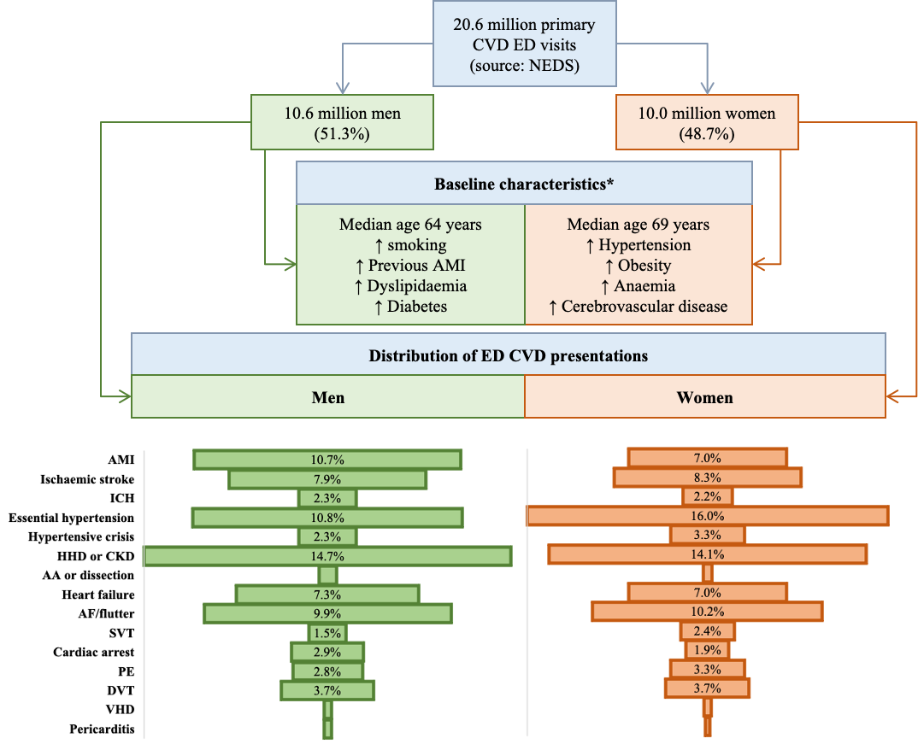

Figure 1. AA: aortic aneurysm; AF: atrial fibrillation; AMI: acute myocardial infarction; CKD: chronic kidney disease (hypertensive); DVT: deep vein thrombosis; HHD: hypertensive heart disease; ICH: intracranial haemorrhage; NEDS: Nationwide Emergency Department Sample; PE: pulmonary embolism; VHD: valvular heart disease. *Arrows indicate relative frequency of risk factor (e.g., there were more smokers amongst men, than women).
Figure 2. Emergency department encounters grouped into disease-specific categories expressed as percentages of all cardiovascular encounters separately for men (green) and women (orange)
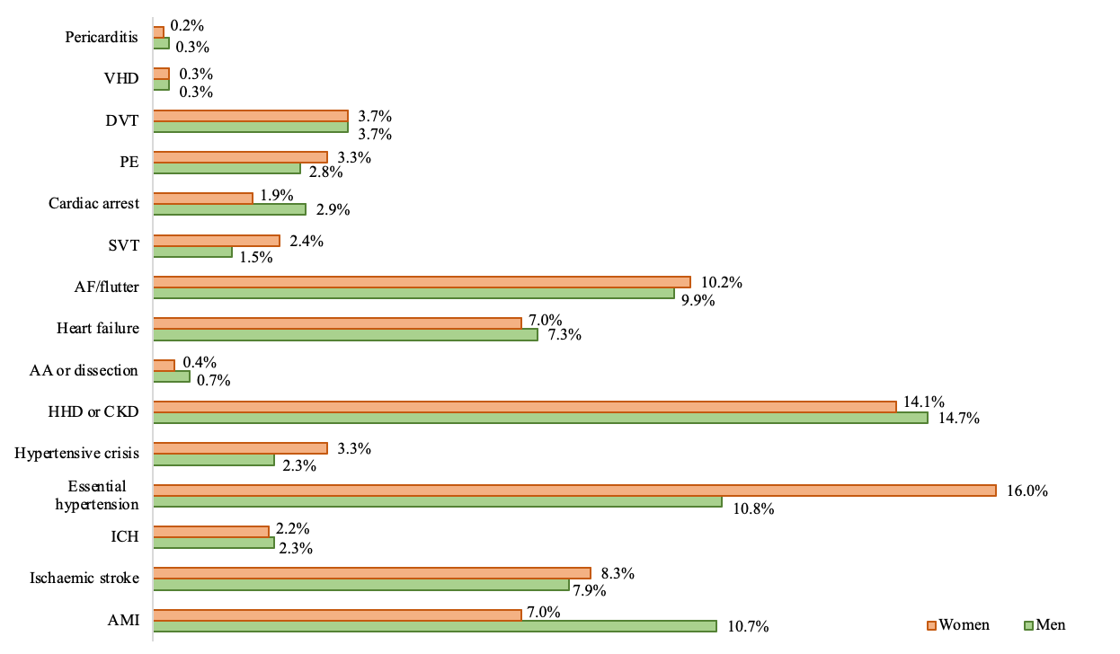
Figure 2 footnote. AA: aortic aneurysm; AF: atrial fibrillation; AMI: acute myocardial infarction; CKD: chronic kidney disease (hypertensive); DVT: deep vein thrombosis; HHD: hypertensive heart disease; ICH: intracranial haemorrhage; PE: pulmonary embolism; VHD: valvular heart disease.

Figure 3. The percentage of cardiovascular encounters followed by hospitalisation (Panel A) or death (Panel B) stratified by disease in men (green) and women (orange)
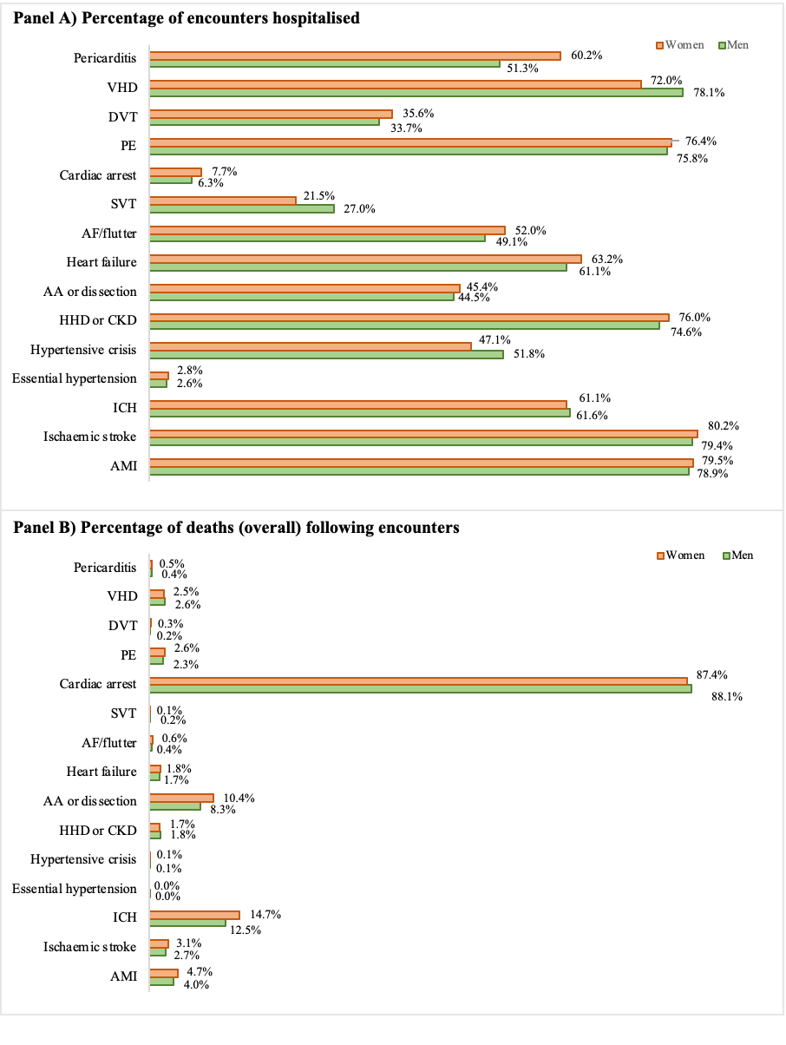
Figure 3 footnote. AA: aortic aneurysm; AF: atrial fibrillation; AMI: acute myocardial infarction; CKD: chronic kidney disease (hypertensive); DVT: deep vein thrombosis; HHD: hypertensive heart disease; ICH: intracranial haemorrhage; PE: pulmonary embolism; VHD: valvular heart disease

