Supplement Material
Figures:

Supplement Figure 1: Consort diagram to show all participants inclusion and exclusion

Total patients received PCI in UK from 2007-2014: 669,279

Total patients received PCI in England & Wales from 2007-2014: 593,098

Total PCI in Grafts: 22,684

No use of Patients with missing data for age n = 8, sex n = 60, Mortality follow up after discharge n = 825 and EPD use n = 1,149

Data for final analysis: 20,642
- No EPD use: 17,730 (86%)
- EPD use: 2,912 (14%)

Legend: Illustrative diagram to explain inclusion and exclusion criteria of all participants in study
PCI; Percutaneous Coronary Intervention, n ; Number, EPD; Embolic protection devices

Supplement Figure 2: EPD use in different age categories

Legend: Graphical presentation of EPD use by age groups in SVG PCI
PCI; Percutaneous Coronary Intervention, EPD; Embolic protection devices
Supplement Figure 3: EPD use by Gender

Legend: Graphical presentation of EPD use by gender in SVG PCI
PCI; Percutaneous Coronary Intervention, EPD; Embolic protection devices

Supplement Figure 4: EPD use by Indication

Legend: Graphical presentation of EPD use by clinical presentation in SVG PCI
PCI; Percutaneous Coronary Intervention, EPD; Embolic protection devices, SVG; Saphenous Vein grafts

Supplement Figure 5: Geographical pattern of EPD use

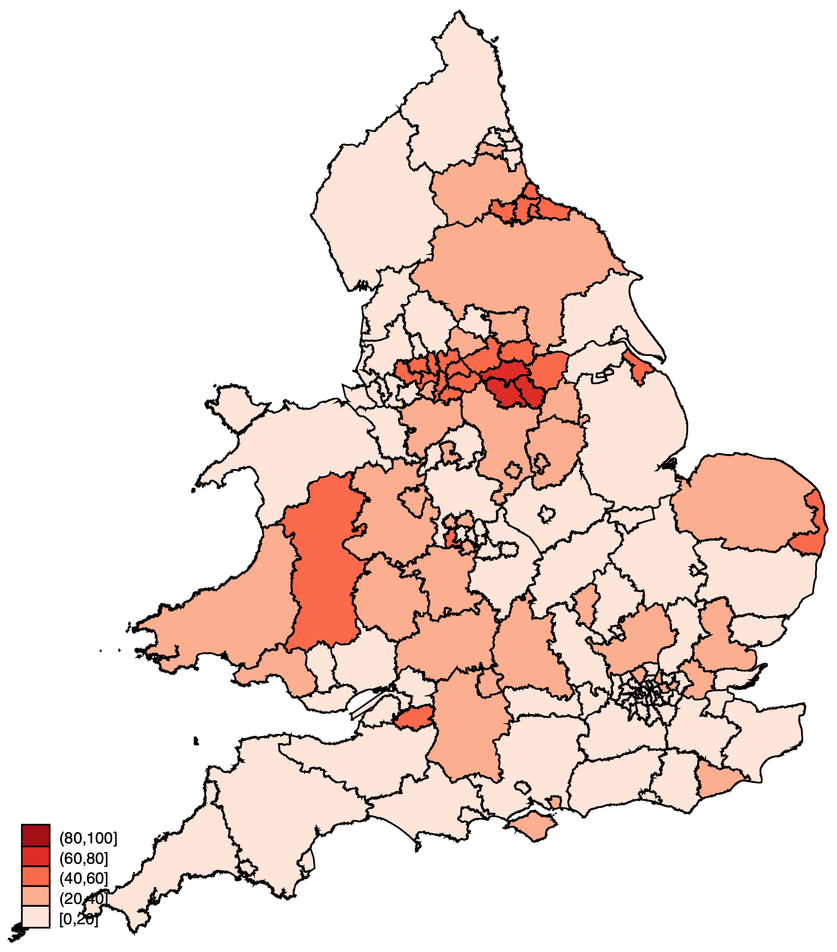

Legend: Geographical pattern of EPD use during SVG PCI in England and Wales

PCI; Percutaneous Coronary Intervention, EPD; Embolic protection devices, SVG; Saphenous Vein grafts

Supplement table 1: Type of Embolic Protection Devices

Type of Device | Number (Total:2,912) | Proportion
Embo-Shield | 58 | 2%
Filter Wire | 1,208 | 41%
Spider | 1,310 | 45%
Unlisted/Others | 336 | 12%

Supplement table 2: Risk of Adverse Outcomes following multivariate adjustment after excluding those patients who had PCI to SVG and native arteries during index procedure

Variable | Adjusted OR/HR as compare to reference (No EPD use) | P-value | 95% CI
In-hospital mortality (number for analysis = 16, 325)
Adjusted OR∗ | 0.73 | 0.27 | 0.41 – 1.28
30-day mortality (number for analysis = 16, 325)
Adjusted OR∗ | 0.81 | 0.33 | 0.54 – 1.23
1-year mortality (number for analysis = 16, 325)
Adjusted OR∗ | 0.89 | 0.28 | 0.73 – 1.09
No reflow/ slow flow phenomenon (number for analysis = 16, 562)
Adjusted OR∗ | 2.14 | <0.001 | 1.64 – 2.80
In-hospital MACE (number for analysis = 16, 562)
Adjusted OR∗ | 1.31 | 0.14 | .92 – 1.88
In-hospital stroke (number for analysis = 16, 562)
Adjusted OR∗ | 0.96 | 0.95 | 0.27 – 3.41

EPD; Embolic protection devices, CI; Confidence interval, OR; Odds ratio, MACE; Major adverse cardiovascular event, PCI; Percutaneous coronary intervention, SVG; Saphenous vein grafts

∗ Variables in model included age, sex, smoking status, diabetes mellitus, hypertension, hyperlipidemia, previous myocardial infarction, previous stroke, peripheral vascular disease, family history of coronary artery disease, Left Ventricular systolic dysfunction, radial access site, glycoprotein IIb/IIIa inhibitor, Multiple territories attempted, Ventilatory Support, Circulatory support, Drug eluting stent use, number of stents, thrombus aspiration on imputed data

Supplement table 3: Unadjusted Clinical outcomes according to total volume of EPD usage in hospitals from 2007-2014
 | EPD usage volume 0-57 (N=1,080) | EPD usage volume 58-114  (N=1,092) | EPD usage volume 115-171  (N=136) | EPD usage volume 172-229  (N=604) | P-Value
In-hospital mortality | 10/1,041 (0.97%) | 7/1,089 (0.65%) | 1/125  (0.8%) | 2/602 (0.33%) | 0.52
30-day mortality | 17/1,080 (1.57%) | 18/1,092  (1.65%) | 1/136  (0.73%) | 6/604  (1%) | 0.62
1-year mortality | 73/1,080  (6.75%) | 69/1,092  (6.31%) | 12/136  (8.82%) | 27/604  (4.47%) | 0.15
No reflow/ slow flow phenomenon | 31/985  (3.14%) | 49/989  (4.95%) | 3/24  (12%) | 51/602  (8.47%) | <0.001
In-hospital MACE | 21/1,053  (2%) | 10/1,076  (0.93%) | 3/136  (2.21%) | 16/582  (2.75%) | 0.04
In-hospital stroke | 3/1,053  (0.28%) | 0 | 0 | 1/582  (0.17%) | 0.35

EPD; Embolic protection devices, MACE; Major adverse cardiovascular event

Supplement table 4: Multivariate analyses for relation between EPD use, number of procedures in hospital and in-patient mortality on imputed data of patients, (N = 19,763)
 | Odds Ratio | 95% Confidence interval |  | P- value
Use of EPD devices | 0.58 | 0.34 | 1 | 0.05
Number of EPD Procedures in Hospital
0-58 | Ref
58-114 | 0.74 | 0.53 | 1.05 | 0.09
115-171 | 2.47 | 1.01 | 6.10 | 0.05
172-229 | 1.08 | 0.60 | 1.94 | 0.79
Age | 1.05 | 1.03 | 1.07 | <0.001
H/O MI | 1.10 | 0.77 | 1.58 | 0.58
Left Ventricular systolic dysfunction
LVEF >50% | Ref
LVEF 30-50% | 3.62 | 1.39 | 9.4 | 0.01
LVEF <30% | 8.04 | 3.74 | 17.32 | <0.001
Family H/O CAD | 0.85 | 0.57 | 1.27 | 0.43
Use of GP2b3a inhibitor | 1.34 | 0.94 | 1.91 | 0.10
Use of Rotational atherectomy devices | 1.47 | 0.98 | 2.19 | 0.06
H/O hypercholesterolaemia | 0.73 | 0.49 | 1.09 | 0.12
H/O hypertension | 0.90 | 0.61 | 1.32 | 0.59
H/O Peripheral vascular disease | 1.25 | 0.80 | 1.95 | 0.32
H/O Cerebrovascular accident | 1.49 | 0.90 | 2.45 | 0.12
H/O Renal disease | 1.67 | 0.77 | 3.62 | 0.19
Radial access | 0.99 | 0.69 | 1.42 | 0.97
Multiple territories attempted | 1.41 | 0.96 | 2.08 | 0.08
H/O Diabetes mellitus | 1.17 | 0.83 | 1.65 | 0.38
Female gender | 1.48 | 1.01 | 2.15 | 0.04
H/O smoking | 0.99 | 0.57 | 1.73 | 0.98
Drug eluting stent use | 0.62 | 0.43 | 0.88 | 0.009
Acute Coronary syndrome | 3.49 | 2.03 | 6.02 | <0.001
Number of Stents used
No stent use | Ref
1 Stent use | 0.39 | 0.25 | 0.62 | <0.001
2 stents use | 0.46 | 0.27 | 0.79 | 0.004
> 3 Stents use | 0.53 | 0.30 | 0.96 | 0.04
Ventilator use | 7.15 | 4.36 | 11.71 | <0.001
Cardiogenic shock | 6.91 | 4.35 | 11 | <0.001
Circulatory support | 5.55 | 3.60 | 8.58 | <0.001

EPD; Embolic protection devices, MI; Myocardial Infarction, CAD; Coronary artery diseases, GP2b3a; Glycoprotein 2b3a inhibitor, LVEF; Left Ventricular ejection fraction, H/O; History of

Supplement table 5: Multivariate analyses for relation between EPD use, number of procedures in hospital and 30-days mortality on imputed data of patients, (N = 19,763)
 | Odds Ratio | 95% Confidence interval |  | P- value
Use of EPD devices | 0.75 | 0.51 | 1.08 | 0.12
Number of EPD Procedures in Hospital
0-58 | Ref
58-114 | 1.16 | 0.90 | 1.50 | 0.24
115-171 | 1.75 | 0.77 | 3.98 | 0.18
172-229 | 1.06 | 0.66 | 1.70 | 0.80
Age | 1.07 | 1.05 | 1.08 | <0.001
H/O MI | 0.79 | 0.60 | 1.04 | 0.09
Left Ventricular systolic dysfunction
LVEF >50% | Ref
LVEF 30-50% | 2.70 | 1.43 | 5.08 | 0.004
LVEF <30% | 5.48 | 3.19 | 9.40 | <0.001
Family H/O CAD | 0.98 | 0.72 | 1.34 | 0.92
Use of GP2b3a inhibitor | 1.49 | 1.13 | 1.96 | 0.005
Use of Rotational atherectomy devices | 1.19 | 0.85 | 1.65 | 0.31
H/O hypercholesterolaemia | 0.66 | 0.49 | 0.89 | 0.007
H/O hypertension | 0.88 | 0.66 | 1.18 | 0.40
H/O Peripheral vascular disease | 1.30 | 0.91 | 1.86 | 0.15
H/O Cerebrovascular accident | 1.30 | 0.86 | 1.96 | 0.21
H/O Renal disease | 2.30 | 1.31 | 4.01 | 0.004
Radial access | 0.79 | 0.60 | 1.05 | 0.1
Multiple territories attempted | 1.17 | 0.87 | 1.58 | 0.30
H/O Diabetes mellitus | 1.28 | 0.97 | 1.69 | 0.08
Female gender | 1.26 | 0.94 | 1.68 | 0.12
H/O smoking | 1.09 | 0.73 | 1.63 | 0.66
Drug eluting stent use | 0.71 | 0.53 | 0.94 | 0.02
Acute Coronary syndrome | 3.45 | 2.38 | 5 | <0.001
Number of Stents used
No stent use | Ref
1 Stent use | 0.35 | 0.24 | 0.51 | <0.001
2 stents use | 0.49 | 0.33 | 0.74 | 0.001
> 3 Stents use | 0.61 | 0.39 | 0.96 | 0.03
Ventilator use | 6.29 | 4.05 | 9.76 | <0.001
Cardiogenic shock | 6.10 | 3.99 | 9.31 | <0.001
Circulatory support | 4.55 | 3.08 | 6.71 | <0.001

EPD; Embolic protection devices, MI; Myocardial Infarction, CAD; Coronary artery diseases, GP2b3a; Glycoprotein 2b3a inhibitor, LVEF; Left Ventricular ejection fraction, H/O; History of

Supplement table 6: Multivariate analyses for relation between EPD use, number of procedures in hospital and 1-year mortality on imputed data of patients, (N = 19,763)
 | Odds Ratio | 95% Confidence interval |  | P- value
Use of EPD devices | 0.88 | 0.73 | 1.06 | 0.20
Number of EPD Procedures in Hospital
0-58 | Ref
58-114 | 0.91 | 0.80 | 1.05 | 0.21
115-171 | 1.30 | 0.80 | 2.13 | 0.29
172-229 | 0.95 | 0.73 | 1.23 | 0.7
Age | 1.06 | 1.05 | 1.07 | <0.001
H/O MI | 0.98 | 0.85 | 1.14 | 0.85
Left Ventricular systolic dysfunction
LVEF >50% | Ref
LVEF 30-50% | 1.78 | 1.39 | 2.27 | <0.001
LVEF <30% | 3.64 | 2.85 | 4.65 | <0.001
Family H/O CAD | 0.97 | 0.83 | 1.13 | 1.13
Use of GP2b3a inhibitor | 0.86 | 0.73 | 1.01 | 0.07
Use of Rotational atherectomy devices | 1.02 | 0.81 | 1.27 | 0.87
H/O hypercholesterolaemia | 0.94 | 0.80 | 1.10 | 0.42
H/O hypertension | 1.02 | 0.87 | 1.20 | 0.76
H/O Peripheral vascular disease | 1.56 | 1.28 | 1.89 | <0.001
H/O Cerebrovascular accident | 1.18 | 0.93 | 1.49 | 0.17
H/O Renal disease | 2.50 | 1.82 | 3.43 | <0.001
Radial access | 0.89 | 0.77 | 1.02 | 0.10
Multiple territories attempted | 1.11 | 0.94 | 1.32 | 0.21
H/O Diabetes mellitus | 1.26 | 1.09 | 1.45 | 0.001
Female gender | 1.06 | 0.90 | 1.26 | 0.47
H/O smoking | 1.09 | 0.89 | 1.35 | 0.39
Drug eluting stent use | 0.71 | 0.61 | 0.83 | <0.001
Acute Coronary Syndrome | 1.98 | 1.69 | 2.31 | <0.001
Number of Stents used
No stent use | Ref
1 Stent use | 0.71 | 0.57 | 0.88 | 0.002
2 stents use | 0.81 | 0.63 | 1.03 | 0.08
> 3 Stents use | 0.80 | 0.61 | 1.06 | 0.12
Ventilator use | 2.95 | 2 | 4.35 | <0.001
Cardiogenic shock | 3.85 | 2.67 | 5.56 | <0.001
Circulatory support | 3.15 | 2.31 | 4.29 | <0.001

EPD; Embolic protection devices, MI; Myocardial Infarction, CAD; Coronary artery diseases, GP2b3a; Glycoprotein 2b3a inhibitor, LVEF; Left Ventricular ejection fraction, H/O; History of

Supplement table 7: Multivariate analyses for relation between EPD use, number of procedures in hospital and in-hospital stroke on imputed data of patients, (N = 19,510)

 | Odds Ratio | 95% Confidence interval |  | P- value
Use of EPD devices | 0.85 | 0.24 | 3 | 0.81
Number of EPD Procedures in Hospital
0-58 | Ref
58-114 | 0.29 | 0.1 | 0.86 | 0.03
115-171 | 1
172-229 | 0.34 | 0.04 | 2.7 | 0.31
Age | 1.03 | 0.98 | 1.07 | 0.24
H/O MI | 0.63 | 0.26 | 1.50 | 0.30
Left Ventricular systolic dysfunction
LVEF >50% | Ref
LVEF 30-50% | 0.44 | 0.11 | 1.73 | 0.23
LVEF <30% | 0.63 | 0.06 | 6.55 | 0.7
Family H/O CAD | 1.77 | 0.75 | 4.21 | 0.19
Use of GP2b3a inhibitor | 1.15 | 0.43 | 3.06 | 0.78
Use of Rotational atherectomy devices | 1.46 | 0.44 | 4.81 | 0.53
H/O hypercholesterolaemia | 1.14 | 0.43 | 3.02 | 0.79
H/O hypertension | 0.77 | 0.31 | 1.95 | 0.59
H/O Peripheral vascular disease | 2.01 | 0.62 | 6.47 | 0.24
H/O Cerebrovascular accident | 1.07 | 0.24 | 4.78 | 0.92
Radial access | 1.13 | 0.48 | 2.68 | 0.77
Multiple territories attempted | 1.30 | 0.46 | 3.64 | 0.62
H/O Diabetes mellitus | 0.77 | 0.30 | 2 | 0.60
Female gender | 0.52 | 0.15 | 1.78 | 0.30
H/O smoking | 0.36 | 0.05 | 2.64 | 0.31
Drug eluting stent use | 0.57 | 0.24 | 1.38 | 0.21
Acute Coronary syndrome | 2.52 | 0.89 | 7.15 | 0.08
Number of Stents used
No stent use | Ref
1 Stent use | 1.76 | 0.36 | 8.5 | 0.48
2 stents use | 1.71 | 0.31 | 9.54 | 0.54
> 3 Stents use | 1.36 | 0.20 | 9.45 | 0.75
Ventilator use | 1.60 | 0.16 | 15.67 | 0.68
Cardiogenic shock | 0.46 | 0.04 | 5.25 | 0.53
Circulatory support | 7.01 | 1.42 | 34.66 | 0.03

EPD; Embolic protection devices, MI; Myocardial Infarction, CAD; Coronary artery diseases, GP2b3a; Glycoprotein 2b3a inhibitor, LVEF; Left Ventricular ejection fraction, H/O; History of

Supplement table 8: Multivariate analyses for relation between EPD use, number of procedures in hospital and in-hospital MACE on imputed data of patients, (N = 19,763)
 | Odds Ratio | 95% Confidence interval |  | P- value
Use of EPD devices | 1.04 | 0.73 | 1.47 | 0.83
Number of EPD Procedures in Hospital
0-58 | Ref
58-114 | 0.60 | 0.46 | 0.79 | <0.001
115-171 | 1.57 | 0.74 | 3.35 | 0.24
172-229 | 1.22 | 0.81 | 1.83 | 0.34
Age | 1.03 | 1.01 | 1.04 | <0.001
H/O MI | 1.11 | 0.85 | 1.45 | 0.45
Left Ventricular systolic dysfunction
LVEF >50% | Ref
LVEF 30-50% | 1.55 | 1.01 | 2.38 | 0.04
LVEF <30% | 2.35 | 1.48 | 3.74 | 0.001
Family H/O CAD | 0.73 | 0.56 | 0.95 | 0.02
Use of GP2b3a inhibitor | 1.68 | 1.29 | 2.20 | <0.001
Use of Rotational atherectomy devices | 1.75 | 1.29 | 2.39 | <0.001
H/O hypercholesterolaemia | 1.07 | 0.79 | 1.44 | 0.65
H/O hypertension | 0.99 | 0.74 | 1.33 | 0.95
H/O Peripheral vascular disease | 1.15 | 0.81 | 1.64 | 0.43
H/O Cerebrovascular accident | 1.10 | 0.70 | 1.71 | 0.68
H/O Renal disease | 1.22 | 0.60 | 2.47 | 0.59
Radial access | 1.17 | 0.90 | 1.52 | 0.23
Multiple territories attempted | 1.34 | 0.99 | 1.80 | 0.05
H/O Diabetes mellitus | 1.08 | 0.83 | 1.41 | 0.55
Female gender | 0.91 | 0.66 | 1.26 | 0.59
H/O smoking | 1.27 | 0.85 | 1.90 | 0.23
Drug eluting stent use | 0.63 | 0.47 | 0.83 | 0.001
Acute Coronary syndrome | 1.21 | 0.89 | 1.64 | 0.22
Number of Stents used
No stent use | Ref
1 Stent use | 0.33 | 0.23 | 0.47 | <0.001
2 stents use | 0.44 | 0.30 | 0.66 | <0.001
> 3 Stents use | 0.65 | 0.42 | 0.99 | 0.04
Ventilator use | 3.31 | 2.06 | 5.29 | <0.001
Cardiogenic shock | 4.25 | 2.73 | 6.63 | <0.001
Circulatory support | 6.20 | 4.18 | 9.19 | <0.001

EPD; Embolic protection devices, MI; Myocardial Infarction, CAD; Coronary artery diseases, GP2b3a; Glycoprotein 2b3a inhibitor, LVEF; Left Ventricular ejection fraction, H/O; History of

Supplement table 9: Multivariate analyses for relation between EPD use, number of procedures in hospital and No-flow/slow flow on imputed data of patients, (N = 19,763)
 | Odds Ratio | 95% Confidence interval |  | P- value
Use of EPD devices | 1.81 | 1.41 | 2.31 | <0.001
Number of EPD Procedures in Hospital
0-58 | Ref
58-114 | 0.88 | 0.69 | 1.14 | 0.35
115-171 | 1.71 | 0.81 | 3.62 | 0.16
172-229 | 1.86 | 1.38 | 2.52 | <0.001
Age | 1.01 | 1.002 | 1.02 | 0.02
H/O MI | 1.17 | 0.91 | 1.51 | 0.22
Left Ventricular systolic dysfunction
LVEF >50% | Ref
LVEF 30-50% | 1.50 | 1.08 | 2.07 | 0.02
LVEF <30% | 1.21 | 0.71 | 2.07 | 0.47
Family H/O CAD | 1.05 | 0.82 | 1.35 | 0.68
Use of GP2b3a inhibitor | 4.23 | 3.33 | 5.36 | <0.001
Use of Rotational atherectomy devices | 2.57 | 1.99 | 3.30 | <0.001
H/O hypercholesterolaemia | 1.61 | 1.22 | 2.14 | 0.001
H/O hypertension | 1.17 | 0.90 | 1.52 | 0.24
H/O Peripheral vascular disease | 0.95 | 0.68 | 1.34 | 0.78
H/O Cerebrovascular accident | 1.12 | 0.76 | 1.63 | 0.57
H/O Renal disease | 1.06 | 0.48 | 2.34 | 0.88
Radial access | 1.32 | 1.05 | 1.66 | 0.02
Multiple territories attempted | 0.95 | 0.71 | 1.28 | 0.74
H/O Diabetes mellitus | 0.96 | 0.76 | 1.21 | 0.73
Female gender | 0.68 | 0.49 | 0.94 | 0.02
H/O smoking | 0.92 | 0.66 | 1.28 | 0.63
Drug eluting stent use | 0.71 | 0.56 | 0.90 | 0.005
Acute Coronary syndrome | 1.42 | 1.08 | 1.87 | 0.01
Number of Stents used
No stent use | Ref
1 Stent use | 1.35 | 0.83 | 2.19 | 0.22
2 stents use | 2.38 | 1.45 | 3.9 | 0.001
> 3 Stents use | 2.91 | 1.76 | 4.8 | <0.001
Ventilator use | 0.77 | 0.28 | 2.11 | 0.62
Cardiogenic shock | 0.20 | 0.06 | 0.62 | 0.006
Circulatory support | 3.90 | 2.33 | 6.51 | <0.001

EPD; Embolic protection devices, MI; Myocardial Infarction, CAD; Coronary artery diseases, GP2b3a; Glycoprotein 2b3a inhibitor, LVEF; Left Ventricular ejection fraction, H/O; History of

