Online-Only Supplement material

List of included elements:

eTable 1 Event rate and time at risk overall and by sex
eFigure 1. Area under the receiver-operating characteristic curves at 1 year of follow up, in the a) female Ontario internal validation cohort, b) male Ontario internal validation cohort, c) female UK external validation cohort, and d) male UK external validation cohort.
eFigure 2. Area under the receiver-operating characteristic curves at 5 years of follow up, in the a) female Ontario internal validation cohort, b) male Ontario internal validation cohort, c) female UK external validation cohort, and d) male UK external validation cohort.
eFigure 3. Area under the receiver-operating characteristic curves at 9 years of follow up, in the a) female Ontario internal validation cohort, b) male Ontario internal validation cohort, c) female UK external validation cohort, and d) male UK external validation cohort.

eTable 1. Event rate and time at risk overall and by sex

 | No. incident  diabetes cases | No. heart failure  events | No. competing  events | Person-years at risk | Rate per 10,000 py  (95% CI)
Ontario
Female | 191455 | 8,272 | 8654 | 921,656 | 89.8 (87.8-91.7)
Male | 156572 | 5,769 | 5789 | 766,610 | 75.3 (73.3-77.2)
UK
Female | 24,664 | 1,107 | 2,362 | 118,807 | 93.2 (87.9-98.8)
Male | 29,819 | 1,494 | 2,711 | 144,466 | 103.4 (98.3-108.8)

Abbreviations: py = person years; CI = confidence interval
eFigure 1. Area under the receiver-operating characteristic curves at 1 year of follow up, in the a) female Ontario internal validation cohort, b) male Ontario internal validation cohort, c) female UK external validation cohort, and d) male UK external validation cohort.

a) Ontario internal validation (Female)  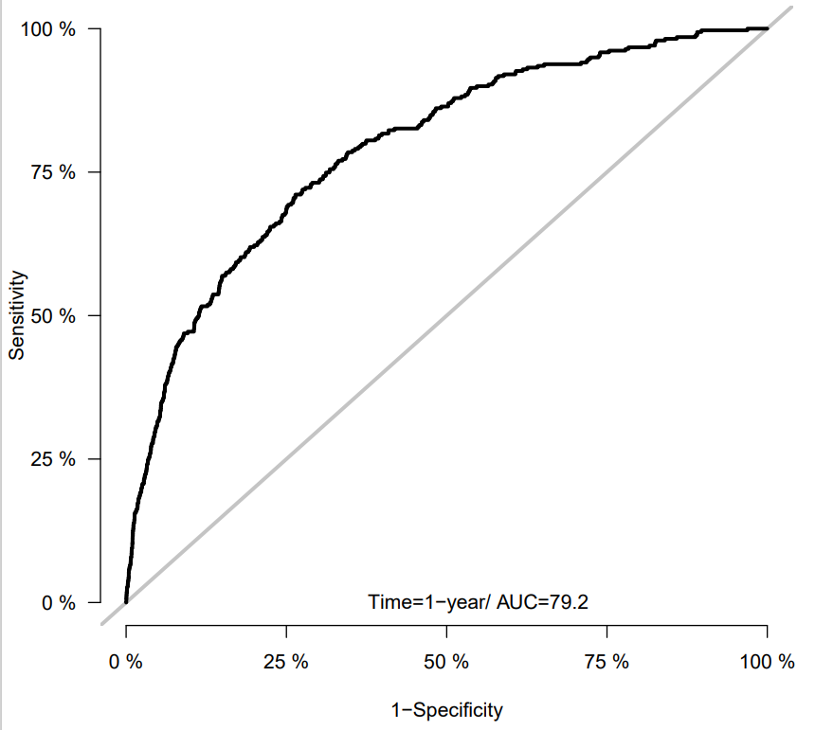 | b) Ontario internal validation (Male)  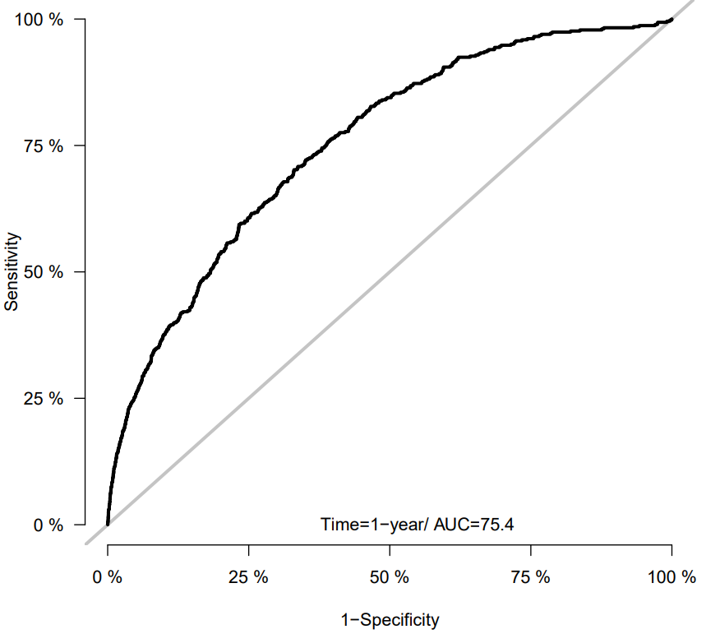
c) UK external validation (Female)  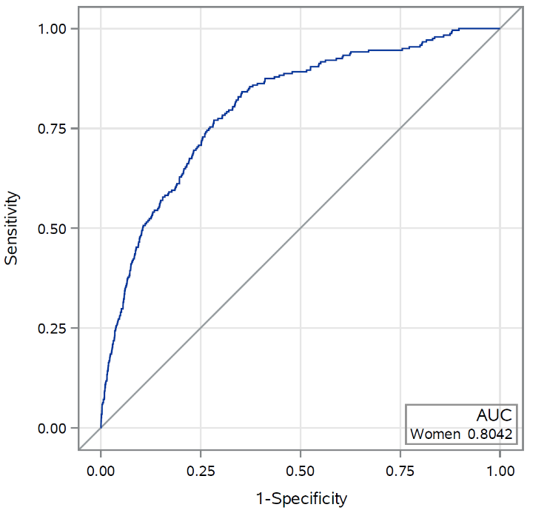 | d) UK external validation (Male)  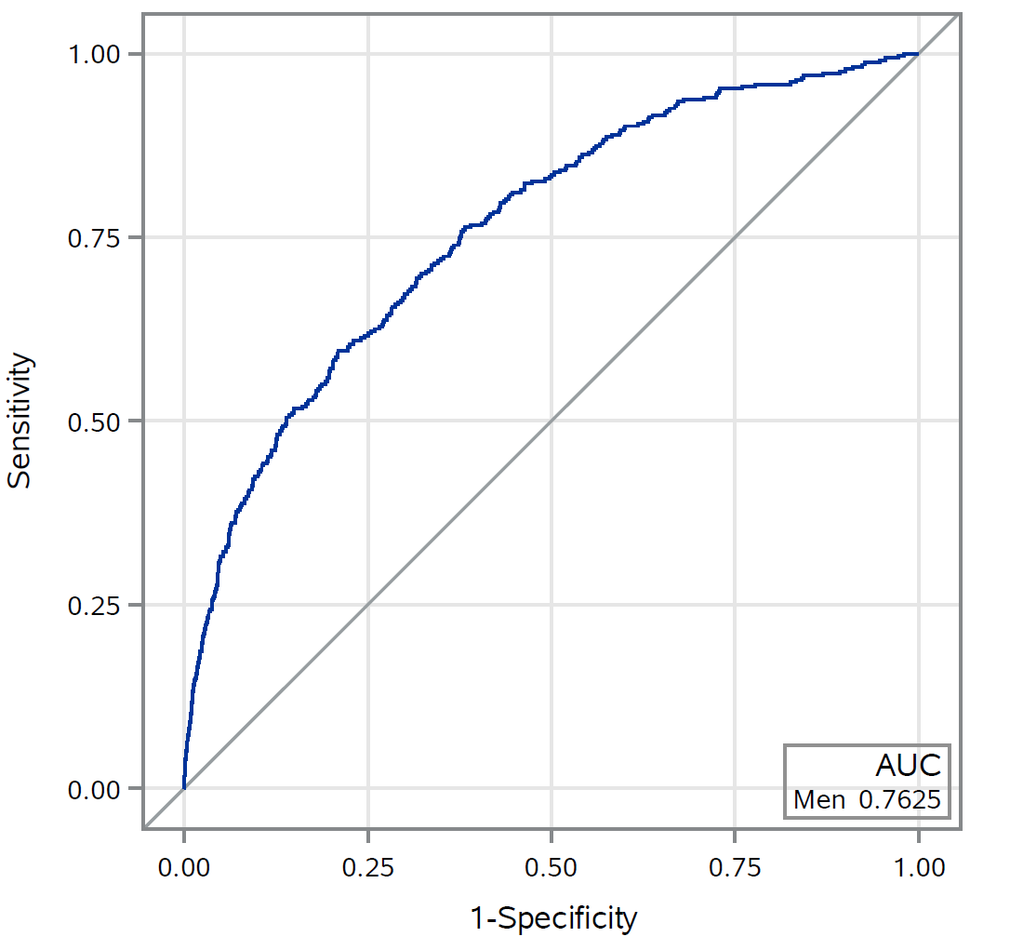

eFigure 2. Area under the receiver-operating characteristic curves at 5 years of follow up, in the a) female Ontario internal validation cohort, b) male Ontario internal validation cohort, c) female UK external validation cohort, and d) male UK external validation cohort.

a) Ontario internal validation (Female)  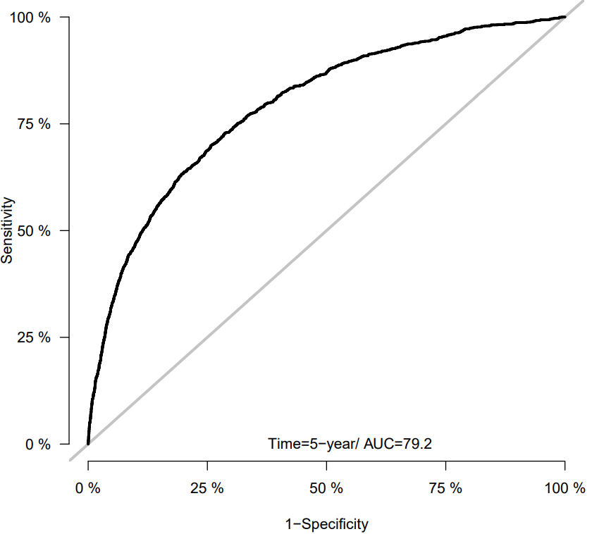 | b) Ontario internal validation (Male)  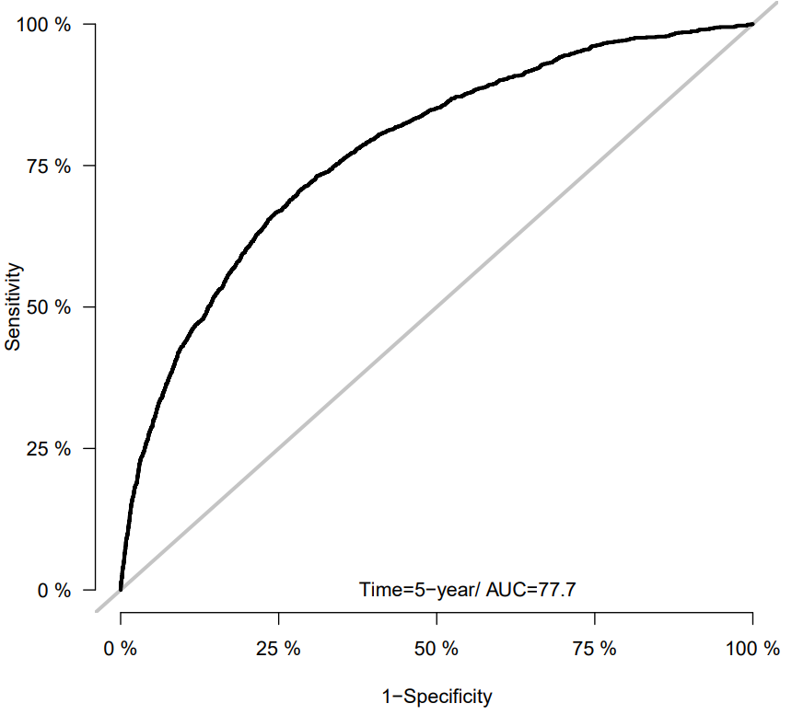
c) UK external validation (Female)  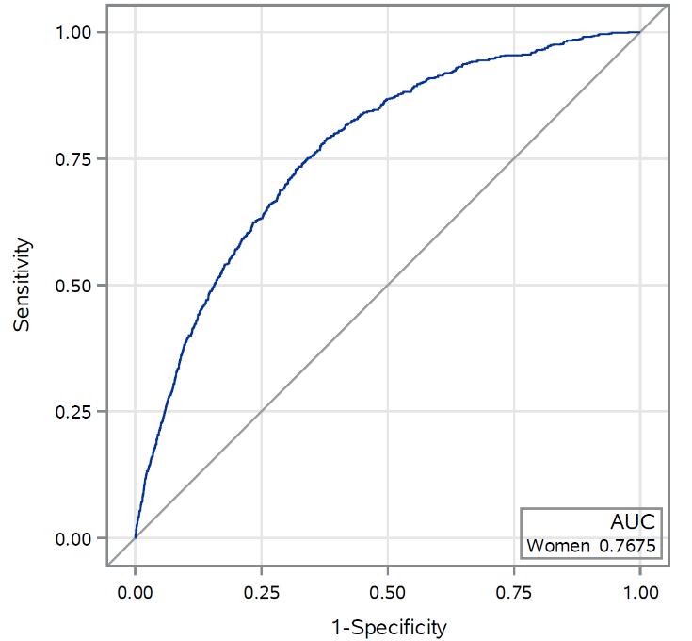 | d) UK external validation (Male)  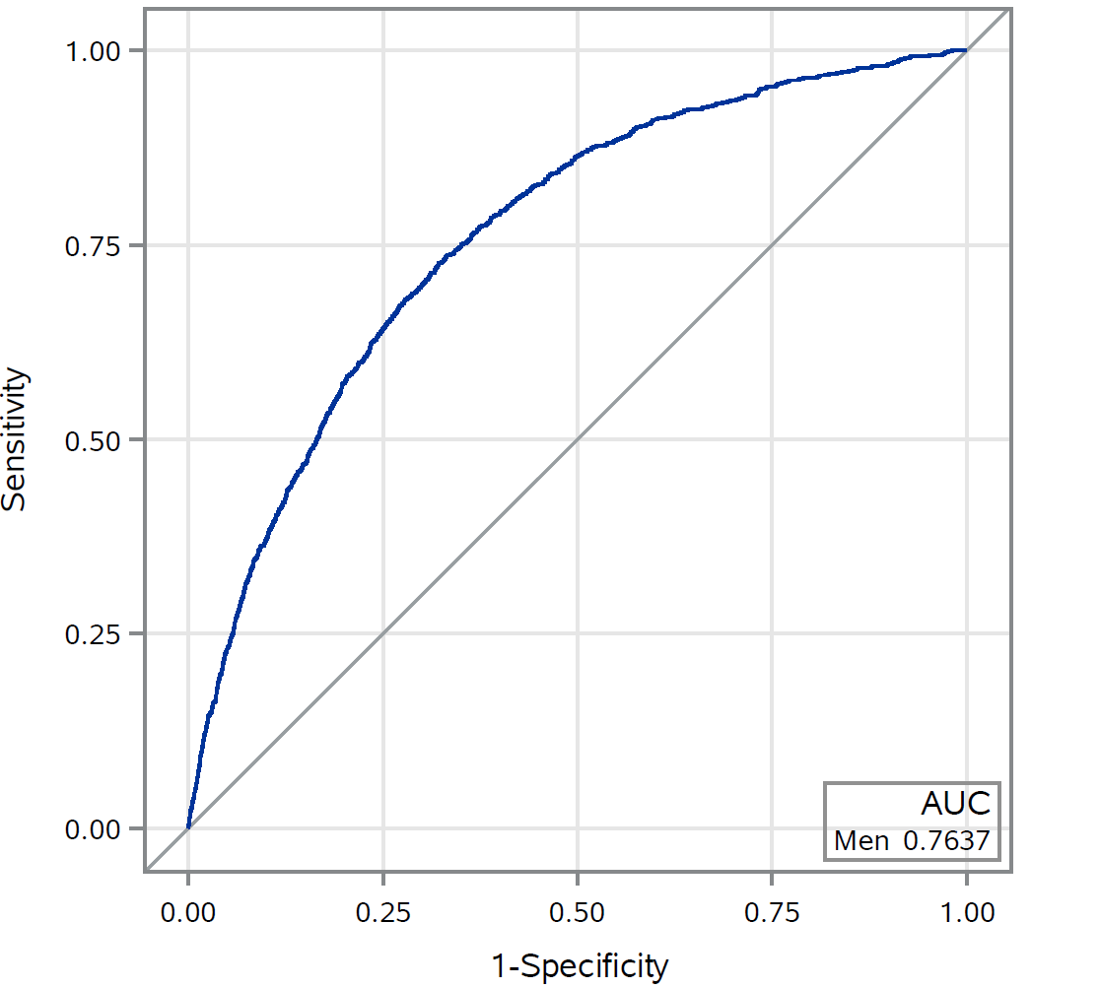

eFigure 3. Area under the receiver-operating characteristic curves at 9 years of follow up, in the a) female Ontario internal validation cohort, b) male Ontario internal validation cohort, c) female UK external validation cohort, and d) male UK external validation cohort.

a) Ontario internal validation (Female)  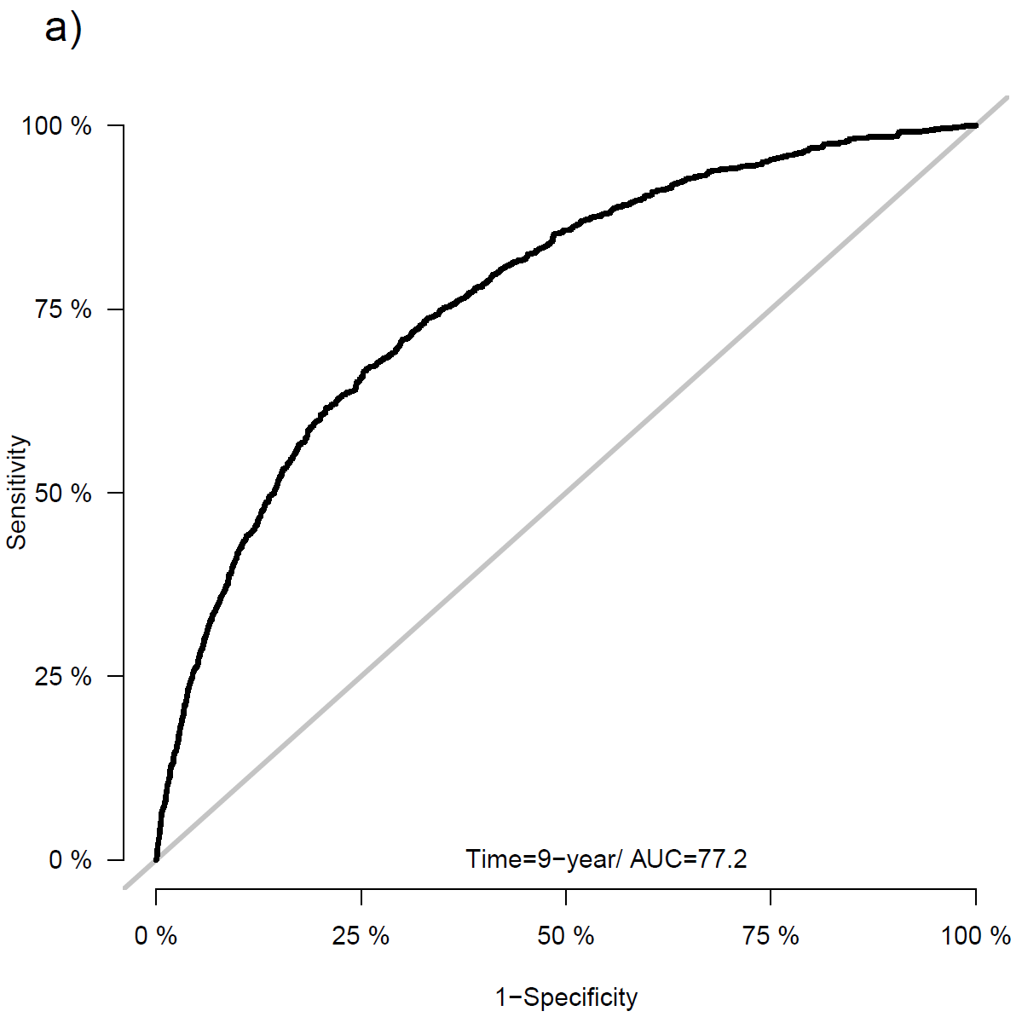 | b) Ontario internal validation (Male)  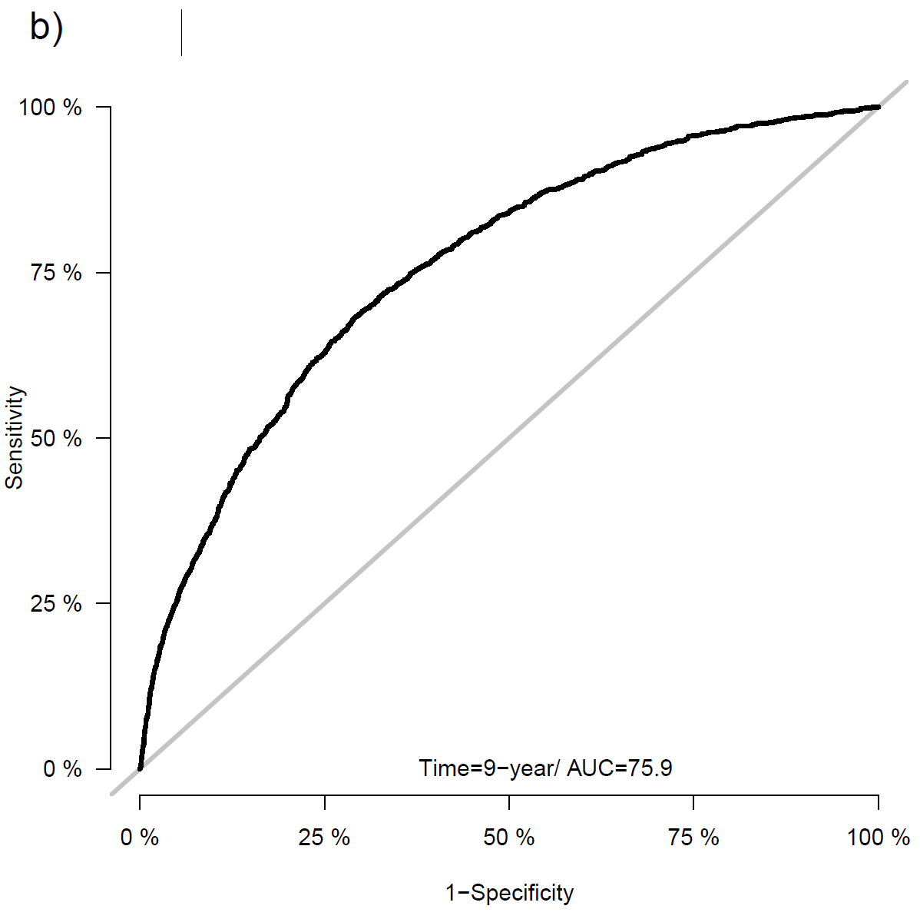
c) UK external validation (Female)  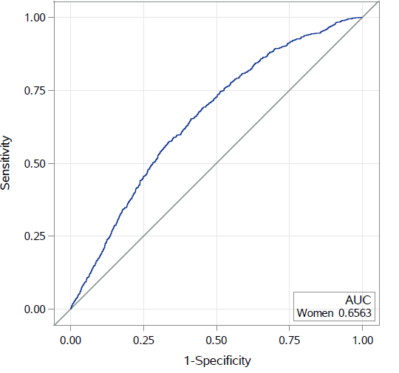 | d) UK external validation (Male)  