Are all online hotel prices created dynamic? An empirical assessment.

Giuseppe Melis Claudio A. Piga* (corresponding author)
Department of Economics and Business Keele Management School,
University of Cagliari Keele University
Viale Sant’Ignazio, 09123 Cagliari (Italy). Keele, Staffordshire, ST5 5BG (United Kingdom)
gemelis@unica.it c.piga@keele.ac.uk

Abstract:
Understanding how tourist firms set their online prices is important given their growing reliance on Online Travel Agencies (OTA). The article investigates whether the narrative of a pervasive presence of dynamic pricing provides a realistic description of hotels’ online pricing behavior and thus challenges the view that dynamic pricing should be considered the prevailing norm for the industry. The evidence suggests a heterogeneous attitude across hotels, with uniform pricing being more widespread in most hotels of our sample, namely, the 3-star or less, while dynamic pricing is more likely applied in higher quality hotels
Keywords: Revenue Management; Online travel agents; dynamic pricing.

Word Count (including this Title page and all references, Tables and Figures): 9352.
Acknowledgements
We are extremely grateful to Marcello Mariani and Adrian Palmer for helpful comments and suggestions. The usual disclaimer applies. Piga gratefully acknowledges receipt of the Visiting Scientist scholarship offered by the Sardinian Regional Government, L.R.7/07.

Introduction
Online Travel Agents (OTAs) have become a key distribution channel for many hospitality firms; nonetheless, very little is known about the way such firms set and manage their prices on the OTAs’ platforms. From a firm’s perspective, a platform enhances price transparency and lowers menu costs, i.e., the cost incurred by a firm when it modifies its price, thereby contributing to the creation of a frictionless market (Bryniolfsson and Smith, 2000). From an economic perspective, companies that use OTAs as distribution channels must set their prices in a context where competition is intensified on both the supply side (more firms against which to compete) and on the demand side, with consumers better informed and potentially capable to choose among alternative destinations located afar from each other (Andrés-Martínez et al., 2014: 172).
Prima facie, both perspectives call for a somewhat sophisticated pricing approach enabling firms to adapt to the varying market conditions that prevail on the platform. Indeed, as Noone and Mattila (2009: 272) observe “... the growth of the Internet as a channel of distribution has significantly increased customer exposure to revenue management pricing practices”. This work aims to better qualify such a statement by investigating whether the propensity to apply such techniques is widespread in the universe of firms, or is instead largely heterogeneous and thus can be related to specific firms and market attributes (Dolnicar and Ring, 2014).
Revenue Management (RM) denotes a broad set of price-setting techniques that are profitably used by such companies as airlines, hotels, cruise shipping (Kimes, 1989). The academic literature has mostly focused on the theoretical reasons why the adoption of RM manifest itself in price variation over time (Talluri and van Ryzin, 2004). The empirical studies based on the airline industry robustly support the notion of an intense intertemporal dynamism in the fares set by both low-cost carriers (Alderighi et al., 2016) and full-service carriers (Bilotkach et al., 2010). In hotel markets, intertemporal pricing also represents an empirical regularity, although little attention has been given to whether it characterizes the price setting behavior of all the firms in the sample (Abrate et al., 2012; Fleischer, 2012). An exception in the literature is Abrate and Viglia (2016), whose approach, which explicitly controls for the presence of heterogeneous behavior in the use of intertemporal pricing across hotel operators, is in line with the findings from a survey carried out by the Global Business Travel Association (GBTA) in 2014, where it emerged that although 75% of the respondents declared to be aware of the possibility to use Dynamic Pricing (DP) to manage their hotel rates, only 22% made active use of it (GBTA, 2014). Such evidence casts doubts on whether a generalized definition of RM as a system aimed at increasing “revenue per transaction through systematic and continuous manipulation of rates”, as found for example in Solnet et al. (2016:120), can describe adequately the price setting behavior of hospitality firms in general, and of those selling via an OTA in particular.
Indeed, there is a growing literature focusing on the relative merits of uniform pricing. Constant manipulation of rates may lead either to discounts that reduce the reference price that customers are willing to pay for the service (Viglia et al., 2016) or to price hikes that can be perceived as unfair (Orbach and Einav, 2007). Ultimately, the tension between dynamic and uniform pricing can only be resolved via an empirical examination of their relative presence.
To assess the extent by which DP is applied in a wide sample of online hotels in four large Mediterranean macro-destinations, this study tests whether the use of an online platform is, as often stated in the literature and the media, accompanied by a frequent change in a hotel room’s posted price. Furthermore, it empirically investigates whether the intertemporal pricing behaviour of hospitality firms operating on an OTA is, when present, more prevalent in some clusters of firms. To strengthen the robustness of the analysis, this study is based on a sample period covering two consecutive Summer seasons (2014 and 2015) and finds similar results in both years; it thus complements other studies focussing on the estimation of the hedonic value of certain sites and establishment’s characteristics in similar geographic areas with a predominant share of leisure customers (Fleischer A., 2012.; Rigall-I-Torrent et al., 2011)

Literature review and main research questions
The existing literature has highlighted a set of major drivers that are expected to enhance or hinder price variation over time in travel and tourism markets (Chen and Schwartz, 2008; Mauri, 2012). We will consider them in the two subsequent subsections.

2.1 Factors expected to boost dynamic pricing.
Intertemporal price variation can be revealed by either upward or downward price adjustments during the booking period preceding the date of the service’s consumption. We therefore consider those factors that are expected to lead to, respectively, price increases and decreases.
First, because consumers may be heterogeneous along such relevant dimensions as their willingness to pay for the service or the uncertainty on whether they need to travel, firms may want to segment the market and price discriminate the business travellers' segment from other lower demand travellers, e.g., those travelling for leisure or for visiting friends and family. The temporal effect arises because business-people are more likely to discover whether they need to travel only a few days before the consumption date and their choice of travelling dates is therefore very inflexible; therefore, it should be expected that the prices increase a few days before the day of travel (Alderighi et. al. 2016).
Abrate et al. (2012) study whether the temporal structure of hotel prices depends on the composition of customers’ type, defined by the motivation of stay, that is, leisure vs. business. They argue that on weekdays the hotels serve a larger proportion of business customers, while on weekends hotels serve predominantly leisure ones. Based on the price of a single room posted online between three months and one day before the stay by about 1000 hotels in eight European capitals, their evidence reveals that over 90% of prices changed during the period, and that the intertemporal price profile varies depending mainly on the mix of customers the hotels anticipate they will be serving.
Second, firms may respond to the online presence of strategic customers, i.e., those who may postpone the purchase in anticipation of last-minute discounts, by committing to raise prices over time to discourage such behaviour (Li et al., 2014). Such a strategy may nonetheless be compatible with price reductions, if these occur randomly and do not disrupt the overall increasing temporal trend of prices (Sweeting, 2012).
Thirdly, “inventory control” is a central aspect of RM in airline markets. It consists in i) setting ticket classes, i.e., fare levels and associated restrictions (refundability, advance purchase, business vs. economy) and ii) defining the number of seats available at each fare. The equivalent in hotel markets would be, assuming identical room characteristics, deciding i) the relevant booking classes and ii) the number of rooms to sell in each class. Dana (1999) demonstrates that it is optimal for firms to divide their capacity into “buckets”, each characterised by a varying number of seats or rooms and by a monotonically increasing price level. The units in a bucket are all sold at the same price, and once they sell out, the price moves automatically upwards to the next bucket’s price level. Alderighi et al. (2016) test the implications of Dana’s model for the case of the airline industry; they find that the fare goes up as the plane fills up. The findings in Alderighi et al. (2016) suggest that having information on the load factor of an aircraft or hotel at the time a price is posted, is necessary to disentangle an intertemporal price discrimination motive from cost-based pricing. In this work, we do not have information of the number of rooms available in the hotel at the time a price was posted; this is not a limitation, because both intertemporal price discrimination and cost-based pricing related to inventory control are expected to operate in the same direction to produce a variation in room prices, which is the focus of our empirical strategy.
Prices may be dropped for two main theoretical reasons. One, hotels and airlines offer a highly perishable product. Because an unsold seat or room carries no value for the firm, there is a strong incentive to lower prices, which are therefore expected to fall as the consumption date nears (Talluri and van Ryzin, 2004). Two, a price reduction is the simplest method to stimulate a sluggish demand. To reduce learning effects that enhance strategic behaviour by consumers, the literature has revealed that European low-cost airlines offer secret discounts (Bachis and Piga, 2011) or generally apply price reductions randomly to reduce their predictability and enhance a flight’s load factor (Bilotkach et al., 2014).

2.2 Reasons favouring uniform pricing.
There are both cost-based and strategic reasons why firms may choose a uniform pricing approach. Zbaracki et al. (2004) show that, for the case of industrial products and services, managerial and customer costs to change prices are relevant. Among managerial costs they include those related to the managers’ effort to gather the information, those associated to the time and attention to make the decision and, finally, the communication costs inside the firm, to explain the logic of the change. Customer costs include those incurred to inform customers. Their estimates indicate managerial costs are more than 6 times, and customer costs are more than 20 times, the simple cost of changing nominal prices, the so called “menu costs” (Bryniolfsson and Smith, 2000).
As far as the strategic reasons favoring a uniform pricing approach are concerned, perceived (un)fairness, uninformed customers and demand uncertainty are often cited factors (Orbach and Einav, 2007).
The (un)fairness of a price is a very controversial issue for several reasons but above all because the perception of (un)fairness of a price is always a matter of judgment that depends on such factors as the context of past purchases, product knowledge and brand communication strategies both formal (advertising) and informal (word of mouth, online reviews). Thus, the decision to purchase is not only based on the price quoted by the company, but on its comparison with the customer’s singular idea of the current price (Kotler et al., 2015). Specifically, posted price's unfairness (or attractiveness) may arise from its relative evaluation with a regular price, a reference, or a standard (Nieto-García et al., 2017). Viglia et al (2016) distinguish between memory-based reference prices, those associated with past purchasing experience, from stimulus-based ones, which are based on the observation of the current distribution of prices offered by equivalent suppliers of the product/service. They argue that reference prices are a strong element to the moderation of price changes dynamics, and that hotels should be very cautious in lowering their prices, because doing so affects the reference price formation, especially if discounts are offered for longer periods. Furthermore, loyal customers dislike price changes induced by RM more intensely (Sahut et al., 2016).
In the travel and tourism industry, the high variability of prices over time can therefore be perceived as "unfair" by consumers who have paid a higher price than other customers. The perception of price equity/iniquity plays an important role in customer satisfaction and subsequent behavior (Oliver and Swan 1989). If hotel clients perceive RM practices as unfair, the increase in revenues resulting from such practices may be only short-term, lead to a decrease in customer satisfaction and, ultimately, to the reduction of their loyalty (Kimes 2002). This is important for online markets due to the growing reliance of customers on reviews and ratings issued by past customers (Leung et al., 2013). In particular, the reference prices play a very negative role in the cases of price changes made by the hotels that compete in the same destination (Viglia et al., 2016: 52-53).
Because hotel services are typical examples of “experience goods” (Nelson, 1970), i.e., goods whose quality can only be properly assessed after consumption, customers could perceive the price as a quality signal; any price drop below the uniform price could lead to a sharp decrease in demand. That is, if the hotel manager drops its price during the booking period, the potential customers may think something is less than ideal in either the hotel or the destination, and be deterred from buying (Orbach and Einav, 2007). Using experimental methods, Nieto-García et al. (2017) investigate the impact of the electronic Word-of-Mouth generated by customers’ ratings on willingness to pay for a hotel room, and find a positive interaction with customers’ internal reference price, that is, customers value positive ratings more when they have a high reference price. This is consistent with the finding in Sahut et al. (2016) that business customers perceive RM practices as less unfair than leisure consumers do.
Demand uncertainty may favor price uniformity; if hotel managers are unable to predict the demand for specific dates, arguably because their relative prospective appeal is unknown, they may decide to treat all dates of stay in a period (say, in August or June) identically (Orbach and Einav, 2007).
The above discussion has highlighted drivers of both price change and uniformity; these are summarized in Table 1. Due to lack of data, we cannot test the relevance of each driver individually, but only assess their net impact in terms of firms’ actual engagement in DP:
Research Question (RQ) 1: How widespread is the adoption of DP strategies among the hotels that operate using an OTA’s platform?

2.3 The importance of the organizational design and other characteristics.
The application of RM techniques becomes a capability that enhances a firm’s competitive advantage only if an organizational architecture supports it by integrating the dispersed knowledge available in various hotel’s functions (marketing, front-office, sales, etc.) into adequate pricing methods (Aubke et al., 2014). This means that hotels differ in their degree of organizational complexity, which in turn may impact on the way they design and implement their pricing schemes. Selmi and Dornier (2011) emphasize the role of the human factor in the establishment and development of an effective RM system. Their qualitative analysis based on interviews to both general and specific revenue managers highlights several relevant points. First, both types of managers must work together to determine the hotel's strategy. Second, RM personnel must be properly trained but an understanding of RM concepts is also a requisite for hotel managers. Third, the IT infrastructure constitutes an invaluable source of information but it does not take away a revenue manager's autonomy of decision and the associated ability to integrate the different departments of the firm (Pinchuk, 2008).
Aubke et al. (2014) argue that RM needs to be well integrated into the overall business structure. Using a sample of international 4* and 5* hotels employing a specific RM team, they conclude that effective RM is principally a result of the RM team’s coordinated knowledge exchange and communication both among its members as well as with other functional managers across the firm’s organizational architecture. Along similar lines, Solnet et al. (2016) argue that the choice to supply a higher quality service (4* and 5*) hotels implies the adoption of a corporate culture that is more receptive to the implementation of new pricing techniques. Furthermore, Israeli (2002) carries out an analysis considering both star rating and corporate affiliation for a sample of 215 hotel stars from 2 to 5 stars. He found that 1) much of the price variation in room prices can be explained by the hotels quality measure of star rating; 2) the impact of corporate affiliation is not as consistent as the star rating but is a factor that explain the application of some premium price in the industry (Israeli, 2002: 419).
Precisely because a RM system needs to be consistently amalgamated with the rest of the hotel’s organizational processes, practitioners often state that its set-up costs operate as a barrier to implementation (see, for instance, http://ideas.com/four-myths-revenue-management/). In other words, the initial investment, both in terms of IT infrastructure and dedicated workforce, is too expensive and generates economies of scale that can only be profitably enjoyed by large hotels. This argument, however, neglects the fact that modern online and cloud technology reduces the need to own an in-house IT server fully dedicated to RM. Similarly, hotel’s proprietary software needs not be developed, given the presence of several RM providers, which offer personalized platforms specifically designed for budget and midscale hotels (see, for instance, https://www.easybookonline.com/). Similarly, hotels affiliated to such OTAs as Booking.com or Expedia, can choose between several customizable options to use the platform not only as a distribution channel but also as a RM tool (see https://www.booking.com/affiliate-program/v2/index.html).
Overall, the foregoing discussion suggests that the pricing scheme which a hotel applies is the outcome of a complex interaction between an internal organization’s characteristics, its culture, the processes linking the operations of the various functions (marketing, RM), and the way in which information derived from the external environment (customers and competitors) is perceived and processed. Financial barriers may also play a role. Because such aspects are generally unobserved by the researcher, it is impossible to establish a direct causation between the way an organization is managed, and the pricing scheme it adopts. However, hotel size captures the role of economies of scale, while organizational complexity is positively correlated with such observable characteristics as the star classification or chain membership, which we adopt in this study to address our:
RQ 2a: How is the propensity to engage in DP correlated with a hotel’s star category, size and chain membership?
The analysis in Fleischer (2012) focuses on whether the hotels charge higher prices for a room with a sea view, after controlling for other possible price shifters. The findings, which are based on only two specific days of stay, indicate a statistically significant “price premium” just above 10% in both days, and no significant variation of such a premium across the sampled Mediterranean areas.
Abrate and Viglia (2016) find empirical support to the hypothesis of a positive impact of online customer’s ratings on prices. Their empirical model also includes the booking time. There is, at least to our knowledge, no study that looks at the relationships between customers’ ratings or the booking time and a firms’ propensity to engage in DP, within a sample that also includes multiple spatial contexts and contiguous dates of stay across a full tourist season. Similarly, there are no studies that analyze price changes at different times of the season and between different seasons. We therefore extend the RQ 2a to include geographical, reputational and seasonality factors:
RQ 2b: How is the propensity to engage in DP correlated with the area in which a hotel is located, the number of days separating the room booking from the “day of stay”, the customers’ ratings and the period of stay during the season?
It is worth stressing that the focus on correlation is due to the impossibility to establish causation effects in our research design. The straightforward implication is that while we cannot state that any of the factors mentioned in RQ 2a and 2b, “determines” a firm’s propensity towards DP, we can evaluate the extent to which such a propensity co-moves with those factors.

Data Collection
We collected primary data using an "electronic web-crawler", a programme designed to connect directly to Booking.com. The crawler was designed to automatically launch the online queries necessary to book an accommodation in a specific locality, and subsequently retrieve the posted prices together with information on the characteristics of the rooms offered and the establishment's name and rating resulting from the past customers' evaluation. Separately, the programme also retrieved other establishment's characteristics, including its type, its size measured by the number of rooms, if it is part of a chain and its star classification. In this work, to simplify the comparisons and provide a more direct link with the existing literature, the analysis uses data only from establishments classified as Hotels, if they state a star classification on their Booking.com website. Furthermore, the study includes only double or twin rooms.
The queries specified the most important tourist seaside localities (62 overall) in four renowned islands in the western part of the Mediterranean Sea, denoted as macro-destinations: Sardinia, Sicily, Corsica, and the Balearics. The period covered in our sample runs from 1st April until the 30th September. These denote the days of stay, which, for analytical purposes, were further divided into three sub-periods: April-June, July-August, and September. The first and the third correspond to periods of medium demand, while the second one identifies the peak-season. The data collection was repeated in two consecutive years, 2014 and 2015.
As in many airline studies (Alderighi et. al., 2015; Bilotkach et al., 2010), the crawler operated daily and issued queries specifying the intervals separating the dates of stay from the query date. For a "hotel/day of stay" combination, the crawler requested prices 70, 65, 60, 55, 50, 45, 40, 35, 30, 25, 20, 14, 7, 4 and 1 day prior to the date of stay, which henceforth we denote as the booking time. For a given date of stay, booking time and consequently prices may not have been collected for the whole booking period if an establishment reached full capacity utilization early in the booking period (or decided to stop posting prices on Booking.com on specific dates of stay). Thus, only combinations of "hotel/day of stay" with at least 5 prices retrieved on different booking times, were considered. Prices were in British Sterling.
The sample presents the following characteristics in terms of number of hotels in each macro-destination: i) the number of hotels in each star classification remains quite stable across periods; ii) at least seventy percent of hotels are classified as either 3- or 4-star, a proportion that reaches ninety percent in Sardinia; iii) in Sardinia and Sicily, the incidence of 5-star hotels is about seven percent, slightly higher than in Corsica and Balearics (slightly less than five percent), where, however, we record a larger presence of 1- and 2-star hotels; iv) the maximum number of hotels ranges from 387 in the Balearics to 155 in Corsica, with intermediate values in Sardinia (218) and Sicily (181).
The number of hotels in the sample reflects the relative tourist demand in the four macro-regions, as also exemplified in Table 2 by the number of passengers using the airports located in each macro-region. The Table indicates that the yearly number of total passengers slightly increased everywhere in 2015, but that the share of passengers in each period remained stable and similar in all macro-regions, with about 32% of passenger in each year in Apr-Jun, 36% in Jul-Aug and 13% in September. The same shares at each airport level are also stable over each period in the two years.
Table 3 clearly shows that, holding the star classification fixed, prices vary across the season in both years, with higher prices for stays in July-August, followed by those in September and in April-June. Note that in this work, seasonal adjustments of price are not considered as evidence of DP, which we identify only in terms of price variations across the booking times, holding the date of stay fixed.

Descriptive evidence
Table 4 sheds some light on the extent by which DP is widespread in each geographical area. The row “Total” reports, for each macro-destination, the proportion of observations denoting a price variation (either an increase or a decrease) between two consecutive booking times, holding the date of stay fixed. Values are generally below 20% in most periods, with a peak of about 24% in July-August 2015; they are always the lowest in the April-June period in both years, although more price dynamism seems to characterize the year 2015. Overall, the evidence indicates that less than one hotels in five, in every macro-destination, changed its online room prices during two consecutive sample observations of the booking times.
Table 4 also reports the same values broken down by star classification, and highlights important differences between types of hotels. In all periods, those classified as 3-star or less exhibit a much smaller propensity to change their online prices; the likelihood of a price variation in such establishments is below the 20% threshold. Notably, even for higher quality hotels the propensity to vary price dynamically hardly exceeds the 30% value in 2014, except for Sicily; it increases in 2015, especially for 5-star hotels in Sardinia and Corsica during the July-August period, where it surpasses the 50% level. For 4-star hotels the proportion of observations with price changes, even in 2015, tends to stay around the 30% value, with only a peak of about 44% in Corsica in July-September 2015. Overall, the analysis based on the star classification points toward a heterogeneous propensity to change room prices dynamically, which is stronger for 4- and 5-star hotels.
We also investigate the possibility that price variations occur asymmetrically during the booking times’ period. Table 5 reports the same statistic of Table 4, broken down by different booking times. In all macro-destinations and across all the stay periods, the probability to observe a price change rises as the booking times decrease (i.e., as the date of stay nears), with marked differences across years. In 2014, the difference between the values in early booking times (45-70) and late booking times (1-4) is generally much smaller than in 2015, in each period of stay. Nonetheless, even in the July-August 2015 period, which records the largest incidence of price variation, our data indicate that no more than 40% of observations (that is, about four hotels out of ten) denote a price change in the 1-4 booking period.
To sum up, the descriptive statistical analysis suggests three main aspects with regards to the incidence of DP in our data: a) in all macro-destinations and years, only a small proportion of hotels have varied their prices over two consecutive booking times, suggesting that DP appears to be on average a rather sporadic phenomenon; b) there seems to be some heterogeneity among hotels, with some, possibly higher quality hotels, actively involved in managing their prices over the booking period, while others choosing to maintain their prices fixed; c) the intensity with which price variations are observed appears to be stronger during the last days of the booking period.

Econometric methodology
In the previous Section, a dummy variable equal to 1 identifies a DP treatment as a change in a room’s price over two consecutive booking times. That is, $Y_{2}^{jt}=1 \text{ if} \left|P_{t}^{j}-P_{t-1}^{j}\right|>0$, where j denotes a “hotel/room type/date of stay” combination, and $\left|P_{t}^{j}-P_{t-1}^{j}\right|$ is the absolute difference of prices in two consecutive booking times t. Such a specification for the treatment variable $Y_{2}^{jt}$ is useful for the investigation of when, during the booking period, the hotels are more likely to engage in DP.
However, the descriptive analysis in the previous section has highlighted that the probability that this may happen is indeed rather small at each point in time, although this does not rule out the possibility that all or most “hotel/room type/date of stay” combinations receive a DP treatment at least once during the booking period. If this were the case, then this would imply that most hotels manage the dates of stay dynamically, even if the treatment occurs sporadically over the booking period. The following treatment variable captures this possibility: $Y_{1}^{j}=1 \text{if} \sum_{t}{Y_{2}^{jt}}>0$. The main difference between the two treatments is that $Y_{1}^{j}$ is independent of the booking time and can be estimated by considering a smaller sample which includes only one observation for each “hotel/room type/date of stay” combination.
Both treatment variables are binary and are therefore estimated using a probit model (Wooldridge 2002): $P\left(Y_{n}^{j}=1 | X\right)=G\left(Xβ\right),$where $P\left(Y_{n}^{j}=1 | X\right)$ denotes the probability that the treatment is administered, given a set of contributing factors X and G is the standard normal cumulative distribution function, which we will use to calculate the estimated probabilities after the coefficients $β$ are estimated. The set of factors X include: a dummy for each macro-destination, interacted separately with the customers’ Ratings, with the six periods of stay (April-June, July-August and September) in each year and also with three dummies identifying Small, Medium and Large size hotels; a dummy for each star classification, interacted with the booking times’ dummies only in the regression using $Y_{2}^{jt}$ as treatment; a dummy for each Town where the hotels are located. The hotel size dummies were constructed using the threshold of 25 rooms to denote Small hotels; Large hotels have more than 70 rooms, while Medium hotels defined accordingly.
The use of many categorical factors aims at generating pre-defined clusters within which we calculate the probability to observe a DP treatment. For instance, although the previous section has indicated a smaller probability of the treatment $Y_{2}^{jt}$ in, say, 3-star hotels, it might be possible that after controlling for such factors as Ratings or hotel size, we might be able to find no difference between 3-star and higher class hotels.
Note that the variable Ratings may be simultaneously determined with our dependent variables, an aspect which prevents an interpretation of the econometric estimates in terms of causality but that does not prevent one in terms of correlation with the treatment (Wooldridge 2002). Indeed, on the one hand, the price discrimination due to a strong price variations is likely to affect an establishment's rating negatively, and may thus act as a deterrent to price fluctuations (Xia et al. 2004; Bolton et al. 2003); on the other, if a firm's competitive advantage arises from a high service quality, or if price fluctuations are perceived to be an industry's common practice, then a firm can freely adjust its prices dynamically without fearing to attract criticism from its customers (Ferguson 2014). Nonetheless, it is also likely that the simultaneity bias induced by the Ratings variable is rather negligible: indeed, the value of Ratings in each establishment is largely invariant over the sample period. It is thus generally pre-determined when the hotel managers make their observed DP decisions.
We choose, nevertheless, to discuss the impact of each factor in terms of their correlation with the treatment because some, e.g., star or size, cannot, by themselves, be associated with a causality effect. For instance, 4 or 5-star and/or large hotels are more likely to employ both a more complex organizational design and higher quality human capital; both unobserved factors are likely to be ultimately responsible for the observed price dynamism. Star classification and/or size may well operate as their proxy, and profitably be used to investigate the second research question of whether different clusters exhibit a stronger than average propensity to DP.

Results
Because the estimation of both types of treatment includes a high number of interacted factors, reporting the list of all their coefficients would be uninformative, difficult to read and space consuming. Furthermore, probit models involve a non-linear estimation process, resulting in estimates that do not have a direct clear interpretation in terms of the factor’s impact on observing the treatment, a problem which is here exacerbated by the need to omit several base categories to avoid the dummy trap. Therefore, all results are reported only in graphical form. We first run the probit models. Then, using the command “Margins” in Stata14, we calculate the predicted probability, based on the probit estimated coefficients, of observing the DP treatment in clusters created by considering one fixed (i.e., the macro-destination), and two variable factors, for instance, the star classification and the hotel size. The estimated probabilities are then reported on a graph, to provide a clear image of differences between clusters.

6.1 Treatment independent of the booking time
Figures 1 to 3 report the estimated probability of $Y_{1}^{j}$, that is, the predicted proportion of dates of stay in which a hotel cluster changed its prices at least once during the booking period. The two variable factors in Figure 1 are the star classification and the Rating, whose values in the predictions’ calculation correspond to the 25th, median and 90th percentile of its distribution (i.e., Low, Medium, High). The reported values suggest a direct answer to the first and the second research questions. Indeed, in all macro-destinations, it appears clear that 4- and 5-star hotels exhibit a stronger propensity to vary their prices dynamically. To explain how to interpret the graphed values, consider Corsica, where clearly Rating has no distinguishing impact. The model estimates that out of 100 dates of stay, 5-star hotels have on average applied the DP treatment in about 80 days; the proportion falls to 70 for 4-star hotels, it is about 50 for 3-star hotels, and slightly above 30 for 2-star ones. Similar values are found for the Balearics. The high-quality hotels in Sardinia and Sicily again show a stronger propensity to adjust prices over the booking period, which also varies in terms of Ratings within each star category. The model’s prediction indicates a mild tendency for establishments with higher Rating to adopt DP more frequently, holding the star classification fixed. Such a difference is not, however, statistically significant, as estimates from the Margins command reveal (these are not reported to save space).
Replacing Rating with hotel size in Figure 2 confirms the previous finding that the propensity to engage in DP tend to increase with the star classification, while size, like Rating, does not seem to be a correlated factor. Most importantly, this finding suggests that the financial cost of setting-up a RM system does not seem to operate as a constraint because within each star category the propensity towards DP does not vary significantly with the scale of the hotel.
Figure 3 investigates whether hotels in the same star category (and macro-destination) are more or less likely to apply DP in different periods of the season, and in different years. In all macro-destinations, the lines for the April-June stay periods in both years lie below all the other lines, that is, the proportion of days in this period with $Y_{1}^{j}=1$ is the lowest within each star category. For example, in Sardinia’s 2-star hotels, only about 20%-25% of stay days in April-June receive the treatment, but this proportion increases to about 35%-40% in all the other periods. Interestingly, for 4- and 5-star hotels the percentage of treated days ranges between 70% and 80% in the period of July-Sept 2015. Such high values are found in all macro-destinations.
Finally, the correlation between chain membership and propensity to DP is investigated in Figure 4. We note two effects. First, 2-, 3- and 4-star hotels in a chain show similar patterns of DP; second, for 2- and 3-star hotels in a chain, the percentage of treated days is significantly higher relative to hotels in the same categories but not in a chain.
To sum up, the probability that DP is applied at least once during the booking period varies extensively and it is particularly low for 1- and 2-star hotels in all periods, and for the 3-star hotels not part of a chain. The estimates confirm the low probability of observing the treatment for many hotels in the sample; in terms of the Research question 1, this implies that DP is not very widespread across the universe of hotels using the Booking.com platform and that such hotels show at least an equal, if not stronger, propensity towards uniform pricing. As far as the Research Question 2a is concerned, the star classification and chain membership appear to be the factors that best correlate with the probability to observe the treatment of DP. In terms of Research Question 2b, a more intense DP activity is recorded for the stay periods of July-August and September, especially in the year 2015.

The treatment varies with the booking time
Relative to $Y_{1}^{j}$, the investigation of $Y_{2}^{j}$ should yield insights on when, during the booking period, price variations are more likely to occur across clusters. Figure 5 reports, on the horizontal axis, the booking times, while each line corresponds to a star category. The values in the Figure complement well those reported in Table 4, which do not differentiate for the star category; once this is added, it appears clear that high quality hotels, and especially 5-star ones, tend to have a higher than average propensity to vary their prices dynamically. Indeed, the probability to observe a price variation between two consecutive booking times is much higher in 5- and 4-star hotels: in these clusters, it fluctuates between 20% and 30% for 4-star hotels, and between 35% and 47% for 5-star ones. In all other categories, it stays well below 20%. Quite interestingly, over the last three weeks before the stay, the difference between categories tends to reduce drastically, due mostly to a strong drop in the propensity of high quality hotels to vary their prices, but also partly to an increase in the same propensity by lower quality hotels.
Figure 6 shows, in every sub-period, a growing probability of observing a price variation between two consecutive booking time which is due to a composite effect of the two opposing trends in Figure 5. The higher probabilities just a few days before the date of stay capture the larger weight of 3-star or less hotels, which are more numerous in every macro-destination. More importantly, the analysis of $Y_{2}^{j}$ confirms the previous finding that DP is applied with a different intensity across different periods of the Summer season, with the lowest probability of observing the treatment reported in April-June.
Overall, the use of $Y_{2}^{j}$ confirms the robustness of the previous findings: DP is prevalent only in higher quality hotels, which however are less numerous in every locality. Therefore, our work suggests that although DP is a relevant phenomenon in the hotel industry, its application is on average rather sporadic, with many firms choosing its mirror image, i.e., uniform pricing. Thus, our findings are consistent with the survey results published in GBTA (2014).

Price increases and decreases
We now consider a third type of DP treatment, which can shed some light on whether DP is related to possible “last-minute discounts”:
$Y_{3}^{jt}=1 \text{if } P_{t-1}^{j}-P_{t}^{j}>0 \text{conditional on} \left|P_{t}^{j}-P_{t-1}^{j}\right|>0$. That is, we only consider the observations in which we record a variation between two consecutive booking times, and flag those corresponding to a price increase. Thus, we can address:
RQ 3. Conditional on a price variation taking place, which factors are more correlated with the probability to observe a price increase?
Figure 7 reports the predicted probability of an increase, broken down by star category and booking times. In all macro-destinations except Corsica, between 65 and 30 days prior to the date of stay the increases make up most of price variation in all star categories. Starting 25 days and up to 7 days before the stay, the incidence of price increases falls, and therefore that of decreases becomes predominant, especially within the clusters including the 3- and 2-star hotels in Sardinia, and all star categories in Corsica. During the last 7 days of the booking period, the proportion of price increases rises again, a finding which provides some support to the notion that prices posted in the final part of the booking period are the result of two conflicting forces. On the one hand, the perishable nature of hotel rooms tends to drive prices down; on the other, if prices were consistently dropped within two weeks of the stay date, potential buyers would soon learn to postpone their purchases, thereby exacerbating the need for hotels to lower the price. As suggested in Li et al. (2014), hotels should therefore commit to an increasing price profile. Indeed, whenever a price variation is observed, such a variation is more likely to be an increase during the early part of the booking period (i.e., at least until 30 days before the stay date). Furthermore, although the proportion of decreases dominate in the final part of the booking period, these are overall not very likely to be observed. For instance, consider the Balearics in Figure 7, where on average 55% of variations in the last 14 days of the booking period are decreases. As previous findings in Table 4 and Figure 6 indicate, the probability of observing a variation during the same period is about 20% on average; therefore, the probability of a price decrease is about 11%, corresponding to one hotel in nine dropping its room price.

Discussion and concluding remarks
The study analyses the propensity to engage in DP of hotels on Booking.com. From a theoretical viewpoint, the study’s novel comparison of intertemporal pricing’s differences in data covering a six months’ period of two consecutive tourist seasons (2015 and 2016) is complemented by an analysis of its variations across different geographical macro-regions. Overall, the evidence suggests that the propensity to engage in DP is not as widespread as often the literature implies.
We indeed find no compelling evidence in support of the view that most hotels are constantly reprogramming their yields by frequently adjusting their rooms’ prices. Although “menu costs” are low for online postings, changing prices entail managerial costs that may enhance price stickiness (Zbaracki et al. 2004). Furthermore, the implicit cost of risking to antagonize customers favours uniform pricing and is consistent with the theory of reference prices, which play a moderating function relative to the amplitude of the variability of rates gap (Sahut et al., 2016; Viglia et al, 2016).
Furthermore, findings highlight a heterogeneous, and previously unreported, propensity towards online DP across hotels. Star classification appears to be the strongest discriminant factor, with higher quality hotels (i.e., 4 and 5 star) always showing to be the most active in terms of DP. Although our data collection is similar to that in Abrate and Viglia (2016), we cover different periods and geographical areas, and reach a rather different conclusion, in so far as their findings suggest more price dynamism, i.e., a larger coefficient of variation, in lower quality firms. If, as argued in Aubke et al. (2014), effective RM is principally due to the coordinated knowledge exchange and communication between various organizational functions, then our findings shed some light on the link between the more complex organizational design of high quality hotels and dynamic pricing as a by-product of RM activities.
Another factor that appear to play a role in explaining the heterogeneous propensity to vary prices over time is the period during the season. Because price dynamism is stronger in high demand periods, the evidence suggests that the cost of antagonizing customers is lower, the higher the probability that a hotel is sold out. Finally, the third RQ investigates whether the price variation corresponds to an increase or a decrease. In all macro-destinations, between 25 and 7 days before the day of stay, the probability of a price drop weakly dominates and is slightly more pronounced in hotels with a lower star classification. While this finding supports the common belief that last-minute discounts are offered by hotels to improve their load factors (Mauri, 2012), it should also be viewed against the generally low propensity that the same hotels exhibit to engage in DP.
The overall analysis suggests a set of managerial implications. First, our findings do not point towards a deterrent effect resulting from the cost of running a RM system, given the lack of difference in the propensity towards DP across hotels of different size but same star classification. This suggests that technological and financial constraints do not constitute an insurmountable barrier to operate a RM system, whose implementation and possible success appears to be driven by the dominant corporate culture, the organizational design and the availability of skilled workforce. Second, because active dynamic RM is more likely observed for firms that are vertically differentiated (that is, the 4- and 5-star hotels), those that are not may need to be incentivized by the Destination Management Organization (DMO) to develop a local management culture that emphasizes the necessary redesign of lower quality firms’ internal organizational architecture to accommodate the appropriate pricing approach when implementing new marketing strategies aimed at revamping their products and the expansion of the set of ancillary services they offer (Crouch, 2011).

REFERENCES
Abrate, G., Fraquelli, G., and Viglia, G. (2012). “Dynamic pricing strategies: Evidence from European hotels”. International Journal of Hospitality Management, 31(1): 160-168.
Abrate, G., and Viglia, G. (2016). “Strategic and tactical price decisions in hotel revenue management.”, Tourism Management, 55: 123--132.
Alderighi M, Nicolini M, Piga CA. (2016). “Targeting leisure and business passengers with unsegmented pricing”. Tourism Management, 54: 502-512.
Andrés-Martínez, M. E., Gómez-Borja, M. Á., and Mondéjar-Jiménez, J. A. (2014). “A model to evaluate the effects of price fairness perception in online hotel booking”. Electronic Commerce Research, 14(2): 171-187.
Aubke, F., Wöber, K., Scott, N., and Baggio R. (2014). Knowledge sharing in revenue management teams: Antecedents and consequences of group cohesion. International Journal of Hospitality Management, 41:149-157.
Bachis, E., Piga, C.A. (2011). “Low-cost airlines and online price dispersion”. International Journal of Industrial Organization, 26(6): 655-667.
Bilotkach, V., Gaggero, A., and Piga, C.A. (2014). “Airline Pricing under Different Market Conditions: evidence from European Low Cost Carriers”. Tourism Management, 47:152-163.
Bilotkach, V., Gorodnichenko, Y. and Talavera O. (2010). Are airlines’ price-setting strategies different Journal of Air Transport Management, 2010,1-6, 16
Bolton L. E., Warlop L., and Alba J.W. (2003). “Consumer Perceptions of Price (Un)Fairness.”, Journal of Consumer Research 29:474-491.
Brynjolfsson, E. and Smith, MD. (2000). “Frictionless Commerce? A comparison of Internet and conventional retailers”, Management Science, 46(4):563—58As Figure 5
Chen, C. C., & Schwartz, Z. (2008). “Timing matters: Travellers' advanced-booking expectations and decisions”. Journal of Travel Research, 47(1), 35-42.
Choi, S., Mattila, A.S. (2004). “Hotel revenue management and its impact on customers' perceptions of fairness.” Journal of Revenue and Pricing Management, 2(4): 303-314.
Crouch, G. I. (2011). Destination competitiveness: An analysis of determinant attributes. Journal of Travel Research, 50(1), 27-45.
Dana Jr, J. D. (1999). “Equilibrium price dispersion under demand uncertainty: the roles of costly capacity and market structure”. Rand Journal of Economics, 30(3), 632-660.
Dolnicar S., Ring A. (2014). “Tourism marketing research: Past, present and future”. Annals of Tourism Research, 47:31-47.
Ferguson JL. (2014). “Implementing price increases in turbulent economies: Pricing approaches for reducing perceptions of price unfairness”. Journal of Business Research, 67(1): 2732-2737.
Fleischer A. (2012). “A room with a view—A valuation of the Mediterranean Sea view.” Tourism Management, 33(3): 598-602.
GBTA (2014). Dynamic Hotel Pricing – Has its Time come?, available at http://www.gbta.org/pressreleases/pages/rls_100114.aspx
Heo C.Y., Lee S. (2011). “Influences of consumer characteristics on fairness perceptions of revenue management pricing in the hotel industry.” International Journal of Hospitality Management, 30:243–251.
Kimes S. E. (1989). “The Basics of Yield Management”. The Cornell Hotel and Restaurant Administration Quarterly 30(6): 14-19.
Kimes, S. E. (2002). Perceived fairness of yield management. Cornell Hospitality Quarterly, 43(1), 21.
Kotler, P., Burton, S., Deans, K., Brown, L., and Armstrong, G. (2015). Marketing. Pearson Higher Education, AU.
Israeli, A. A. (2002). Star rating and corporate affiliation: their influence on room price and performance of hotels in Israel. International Journal of Hospitality Management, 21(4), 405-424.
Leung, D., Law, R., Van Hoof, H., and Buhalis, D. (2013). “Social media in tourism and hospitality: A literature review”. Journal of Travel & Tourism Marketing, 30(1-2): 3-22.
Li, J., Granados, N. and Netessine, S. (2014). “Are Consumers Strategic? Structural Estimation from the Air-Travel Industry”, Management Science, 60: 2114-2137.
Mauri A.G. (2012). Hotel Revenue Management. Principles and Practices. Pearson Italia.
Nelson, P. (1970). “Information and consumer behavior”. Journal of Political Economy, 78(2), 311-329.
Nieto-García, M., Muñoz-Gallego, P. A., & González-Benito, Ó. (2017). Tourists’ willingness to pay for an accommodation: The effect of eWOM and internal reference price. International Journal of Hospitality Management, 62, 67-77.
Noone, B. M., & Mattila, A. S. (2009). “Hotel revenue management and the Internet: The effect of price presentation strategies on customers’ willingness to book”. International Journal of Hospitality Management, 28(2), 272-279.
Oliver, R.L., Swan, J.E. (1989). “Consumer perceptions of interpersonal equity and satisfaction in transactions: a field survey approach”. Journal of Marketing, 53(2): 21–35.
Orbach, B. Y., & Einav, L. (2007). “Uniform prices for differentiated goods: The case of the movie-theater industry”. International Review of Law and Economics, 27(2), 129-153.
Pinchuk, S. (2008). A system profit optimisation. Journal of Revenue and Pricing Management, 7(1), 106-109.
Rigall-I-Torrent, R., Fluvià, M., Ballester, R., Saló, A., Ariza, E., & Espinet, J. M. (2011). The effects of beach characteristics and location with respect to hotel prices. Tourism Management, 32(5), 1150-1158.
Sahut, J. M., Hikkerova, L., and Pupion, P. C. (2016). Perceived unfairness of prices resulting from yield management practices in hotels. Journal of Business Research, 69(11), 4901-4906.
Selmi N, Dornier R. 2011. “Yield Management in the French Hotel Business: an Assessment of the Importance of the Human Factor”. International Business Research. 4(2):58-66.
Solnet, D., Boztug, Y. and Dolnicar, S. (2016). An untapped gold mine? Exploring the potential of market basket analysis to grow hotel revenue. International Journal of Hospitality Management, 56, 119-125.
Sweeting, A. (2012). “Dynamic Pricing Behavior in Perishable Goods Markets: Evidence from Secondary Markets for Major League Baseball Tickets”. Journal of Political Economy. 120(6):1133-1172
Talluri KT, van Ryzin G. (2004). Theory and Practice of Revenue Management. Springer: New York.
Viglia, G., Mauri, A., and Carricano, M. (2016). The exploration of hotel reference prices under dynamic pricing scenarios and different forms of competition. International Journal of Hospitality Management, 52, 46-55.
Wooldridge, J. M. (2002). Econometric Analysis of Cross Section and Panel Data. 1st Ed., MIT Press, Cambridge MA.
Xia L., Monroe K.B., Cox J.L. (2004). “The Price is Unfair! A conceptual framework of Price Fairness Perceptions”. Journal of Marketing, 68 (October):1-15.
Zbaracki MJ, Ritson M, Levy D, Dutta S, and Bergen M. (2004). “Managerial and customer costs of price adjustment: Direct evidence from industrial markets”. The Review of Economics and Statistics, 86(2): 514-533

Table 1 – Economic drivers of dynamic and uniform pricing
Factors likely to induce price
Increases | Decreases | Uniformity
Customer Heterogeneity:  Leisure vs Business | Product  Perishability | Menu Costs
Strategic Consumers | Demand stimulus | Managerial Costs
Occupancy/inventory |  | Perceived unfairness:  Reference price
 |  | Price as a quality signal
 |  | Demand uncertainty

Table 2 – Number of total passengers (both domestic and international) in the macro-regions’ airports, by period.
Airport | Apr-Jun14 | Jul-Aug14 | Sep-14 | All 2014 | Apr-Jun15 | Jul-Aug15 | Sep-15 | All 2015
Alghero | 467,992 | 450,724 | 187353 | 1,432,020 | 492,295 | 452,174 | 191503 | 1,677,967
Cagliari | 970,851 | 982,023 | 397381 | 3,072,868 | 1,013,185 | 966,467 | 414617 | 3,719,289
Olbia | 563,820 | 914,642 | 292122 | 1,993,110 | 580,117 | 985,409 | 313467 | 2,240,016
Total Sardinia | 2,002,663 | 2,347,389 | 876856 | 6,497,998 | 2,085,597 | 2,404,050 | 919587 | 7,637,272
Catania | 2,079,123 | 1,682,692 | 766113 | 6,060,759 | 2,002,753 | 1,544,113 | 724177 | 7,105,487
Palermo | 1,266,039 | 1,071,511 | 484810 | 3,795,716 | 1,334,638 | 1,135,577 | 518033 | 4,910,791
Trapani | 479,493 | 376,526 | 176075 | 1,364,251 | 480,366 | 358,282 | 172499 | 1,586,992
Total Sicily | 1,745,532 | 1,448,037 | 660885 | 5,159,967 | 1,815,004 | 1,493,859 | 690532 | 6,497,783
Ajaccio | 403,450 | 433,958 | 153,860 | 1,205,103 | 402,350 | 427,668 | 157,372 | 1,362,353
Bastia | 321,466 | 362,653 | 121,664 | 1,007,739 | 329,212 | 369,097 | 139,625 | 1,191,273
Figari | 137,515 | 213,481 | 58,622 | 472,569 | 165,863 | 248,351 | 68,371 | 586,046
Calvi | 98,521 | 130,419 | 38,618 | 305,062 | 92,800 | 130,011 | 36,195 | 317,175
Total Corsica | 960,952 | 1,140,511 | 372,764 | 2,990,473 | 990,225 | 1,175,127 | 401,563 | 3,456,847
Mallorca | 7,246,256 | 7,194,751 | 3,061,013 | 21,087,942 | 7,399,767 | 7,278,878 | 3,114,934 | 23,745,131
Ibiza | 1,796,084 | 2,401,736 | 971,857 | 5,869,053 | 1,863,695 | 2,483,197 | 980,867 | 6,477,283
Minorca | 707,225 | 1,094,848 | 394,227 | 2,468,998 | 778,835 | 1,186,566 | 425,298 | 2,867,482
Total Balearics | 9,749,565 | 10,691,335 | 4,427,097 | 29,425,993 | 10,042,297 | 10,948,641 | 4,521,099 | 33,089,896

Table 3 – Mean price of a double room in hotel by period of stay and star classification- Total N=1,358,697
 |  | Period of Stay
 | Stars | Apr-Jun14 | Jul-Aug14 | Sep14 | Apr-Jun15 | Jul-Aug15 | Sep15
Sardinia | 1 | 79.5 | 82.5 | 65.3 | 58.6 | 61.6 | 56.2
 | 2 | 56.6 | 60.8 | 59.2 | 51.3 | 57.0 | 55.8
 | 3 | 63.5 | 84.0 | 66.2 | 55.4 | 80.5 | 59.8
 | 4 | 99.3 | 153.4 | 122.1 | 96.0 | 141.3 | 111.7
 | 5 | 173.5 | 395.0 | 280.1 | 227.4 | 440.3 | 234.5
 | N | 97,434 | 73,965 | 42,242 | 47,005 | 60,500 | 27,260
Sicily | 1 | 45.6 | 49.2 | 39.9 | 36.9 | 40.2 | 38.3
 | 2 | 56.0 | 59.1 | 59.9 | 45.8 | 52.2 | 50.6
 | 3 | 72.6 | 75.1 | 71.6 | 59.9 | 66.3 | 63.8
 | 4 | 111.2 | 106.0 | 109.2 | 94.8 | 92.8 | 99.8
 | 5 | 249.5 | 218.1 | 237.4 | 187.2 | 193.7 | 200.8
 | N | 82,275 | 119,523 | 36,914 | 51,052 | 92,039 | 33,888
Corsica | 2 | 65.5 | 74.8 | 63.1 | 52.9 | 65.7 | 57.6
 | 3 | 95.2 | 107.9 | 93.7 | 78.0 | 98.4 | 84.5
 | 4 | 188.9 | 207.4 | 185.4 | 146.5 | 209.1 | 158.1
 | 5 | 311.0 | 395.5 | 317.6 | 241.0 | 277.5 | 243.9
 | N | 23,279 | 43,809 | 26,001 | 30,709 | 39,423 | 16,232
Balearics | 1 | 42.0 | 65.3 | 45.2 | 30.7 | 55.5 | 41.2
 | 2 | 46.5 | 68.9 | 55.9 | 37.2 | 57.8 | 44.5
 | 3 | 71.7 | 102.4 | 96.9 | 55.4 | 85.5 | 73.3
 | 4 | 113.5 | 143.5 | 133.5 | 98.0 | 127.0 | 117.2
 | 5 | 222.7 | 264.4 | 235.7 | 175.6 | 249.7 | 215.9
 | N | 90,313 | 122,354 | 50,323 | 71,724 | 81,138 | 41,537

Table 4 – Percentage of observations with price variation between two consecutive booking days, by period of stay and star classification
 |  | Period of Stay
 | Stars | Apr-Jun14 | Jul-Aug14 | Sep14 | Apr-Jun15 | Jul-Aug15 | Sep15
Sardinia | 1 | 10.7% | 10.9% | 4.0% | 6.0% | 9.6% | 6.2%
 | 2 | 10.0% | 10.7% | 15.4% | 3.5% | 6.3% | 8.0%
 | 3 | 8.0% | 11.0% | 14.6% | 8.1% | 13.0% | 12.3%
 | 4 | 13.4% | 20.0% | 23.6% | 18.6% | 29.9% | 26.0%
 | 5 | 9.5% | 25.6% | 19.8% | 42.2% | 58.5% | 40.2%
 | Total | 10.2% | 16.2% | 18.9% | 13.9% | 23.2% | 19.5%
Sicily | 1 | 8.7% | 7.4% | 9.9% | 6.6% | 7.3% | 11.8%
 | 2 | 9.5% | 7.8% | 14.0% | 7.2% | 10.4% | 8.7%
 | 3 | 11.1% | 14.0% | 16.0% | 10.0% | 14.4% | 13.2%
 | 4 | 16.3% | 19.6% | 24.1% | 22.5% | 23.5% | 24.4%
 | 5 | 28.9% | 35.7% | 37.0% | 39.0% | 37.4% | 43.5%
 | Total | 14.2% | 17.2% | 20.6% | 15.0% | 18.9% | 18.8%
Corsica | 2 | 5.7% | 9.8% | 9.2% | 5.0% | 10.4% | 14.5%
 | 3 | 8.9% | 12.6% | 12.4% | 12.8% | 19.5% | 17.4%
 | 4 | 12.1% | 19.5% | 18.1% | 30.5% | 43.9% | 33.9%
 | 5 | 17.7% | 27.3% | 22.9% | 38.2% | 53.0% | 43.1%
 | Total | 9.7% | 14.1% | 13.7% | 15.7% | 24.1% | 21.9%
Balearics | 1 | 5.2% | 8.9% | 9.7% | 3.3% | 8.1% | 9.3%
 | 2 | 7.8% | 10.2% | 14.6% | 5.9% | 12.0% | 12.2%
 | 3 | 11.7% | 15.5% | 20.2% | 10.3% | 14.7% | 14.2%
 | 4 | 17.3% | 21.7% | 21.4% | 20.4% | 25.1% | 23.4%
 | 5 | 22.1% | 27.0% | 22.5% | 33.3% | 45.6% | 40.0%
 | Total | 13.3% | 18.4% | 19.2% | 14.3% | 20.8% | 18.7%

Table 5 – Percentage of observations with price variation between two consecutive booking days, by period of stay and booking time
 | Booking | Period of Stay
 | time | Apr-Jun14 | Jul-Aug14 | Sep14 | Apr-Jun15 | Jul-Aug15 | Sep15
Sardinia | 1-4 | 10.6% | 18.6% | 18.6% | 22.1% | 38.5% | 26.3%
 | 7-20 | 10.2% | 15.0% | 19.5% | 16.5% | 27.3% | 24.9%
 | 25-40 | 10.3% | 17.0% | 22.0% | 13.4% | 21.6% | 22.0%
 | 45-70 | 8.2% | 15.4% | 10.6% | 8.0% | 18.7% | 13.6%
Sicily | 1-4 | 16.1% | 20.1% | 21.3% | 27.1% | 37.2% | 32.7%
 | 7-20 | 13.9% | 18.3% | 21.3% | 18.3% | 23.8% | 24.6%
 | 25-40 | 12.3% | 15.2% | 22.9% | 13.2% | 16.9% | 20.3%
 | 45-70 | 9.7% | 13.1% | 11.3% | 8.1% | 12.6% | 11.8%
Corsica | 1-4 | 9.1% | 17.7% | 14.4% | 22.5% | 40.4% | 33.2%
 | 7-20 | 9.1% | 13.8% | 14.4% | 20.0% | 29.3% | 28.9%
 | 25-40 | 15.7% | 12.4% | 12.6% | 15.0% | 22.5% | 24.1%
 | 45-70 | 5.7% | 11.8% | 3.4% | 8.6% | 18.9% | 14.9%
Balearics | 1-4 | 12.3% | 19.2% | 19.2% | 23.3% | 35.3% | 31.0%
 | 7-20 | 13.1% | 18.4% | 19.8% | 17.1% | 25.1% | 22.6%
 | 25-40 | 16.0% | 18.6% | 22.6% | 13.7% | 18.8% | 21.7%
 | 45-70 | 18.8% | 16.0% | 9.0% | 9.2% | 15.9% | 12.4%

Figure 1 – Estimated Probability of observing, for each day of stay, at least a price variation over the booking period - by star classification and customer rating clusters.
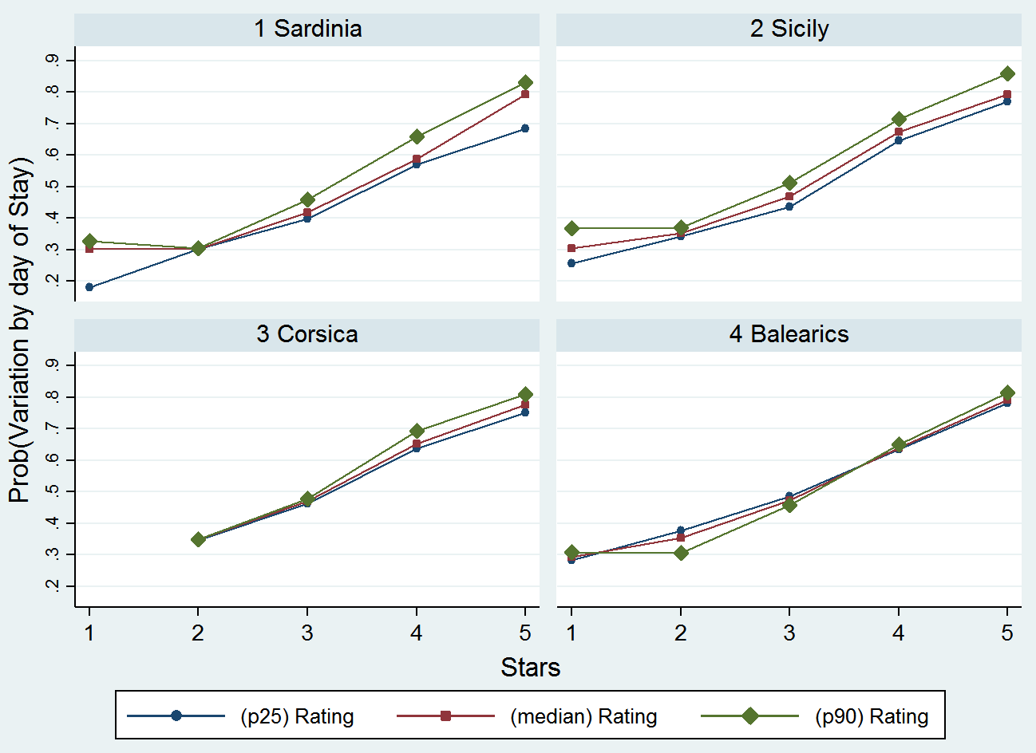

Figure 2 – Estimated Probability of observing, for each day of stay, at least a price variation over the booking period - by star classification and size clusters.
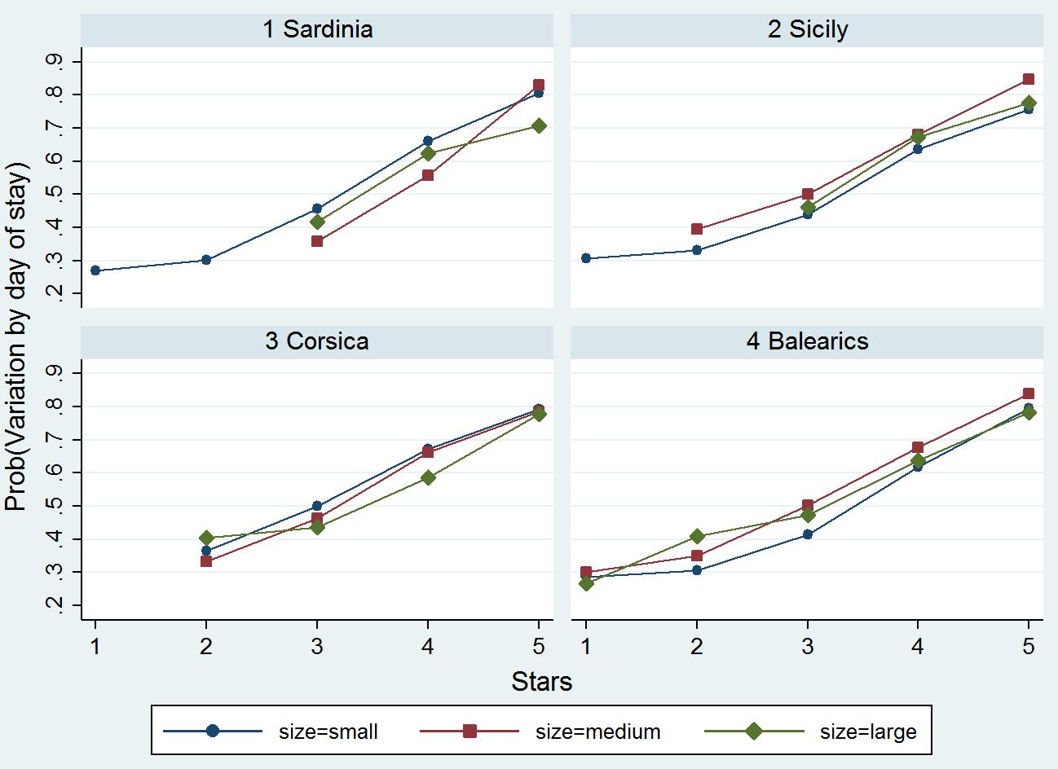

Figure 3– Estimated Probability of observing, for each day of stay, at least a price variation over the booking period - by star classification and seasonal period.
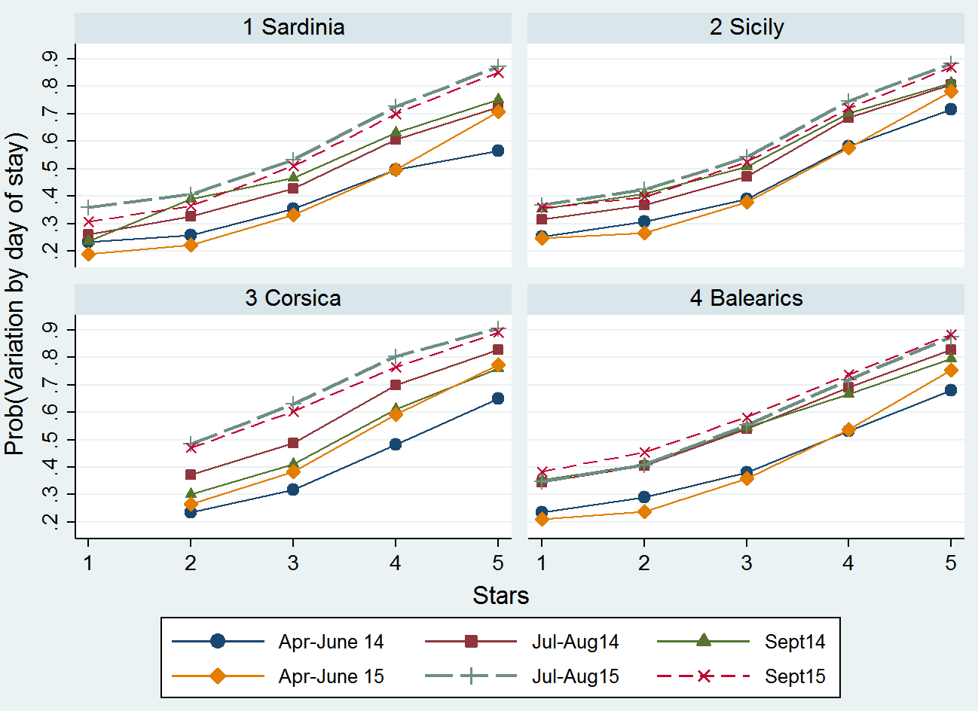

Figure 4 – Estimated Probability of observing, for each day of stay, at least a price variation over the booking period - by star classification and chain membership.
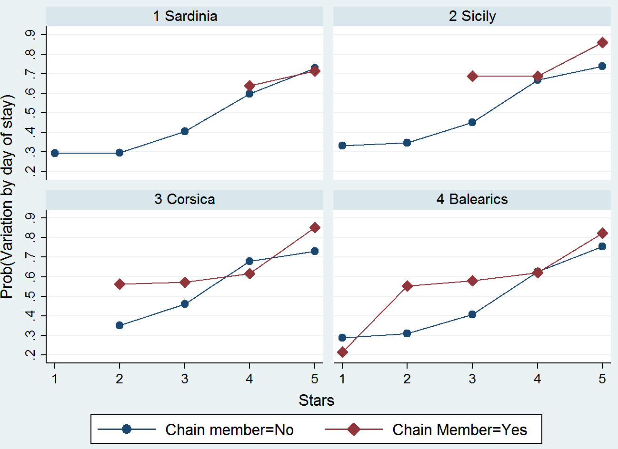

Figure 5 - Estimated Probability of a price change over any day of the booking period – by star classification and number of days from query to stay.
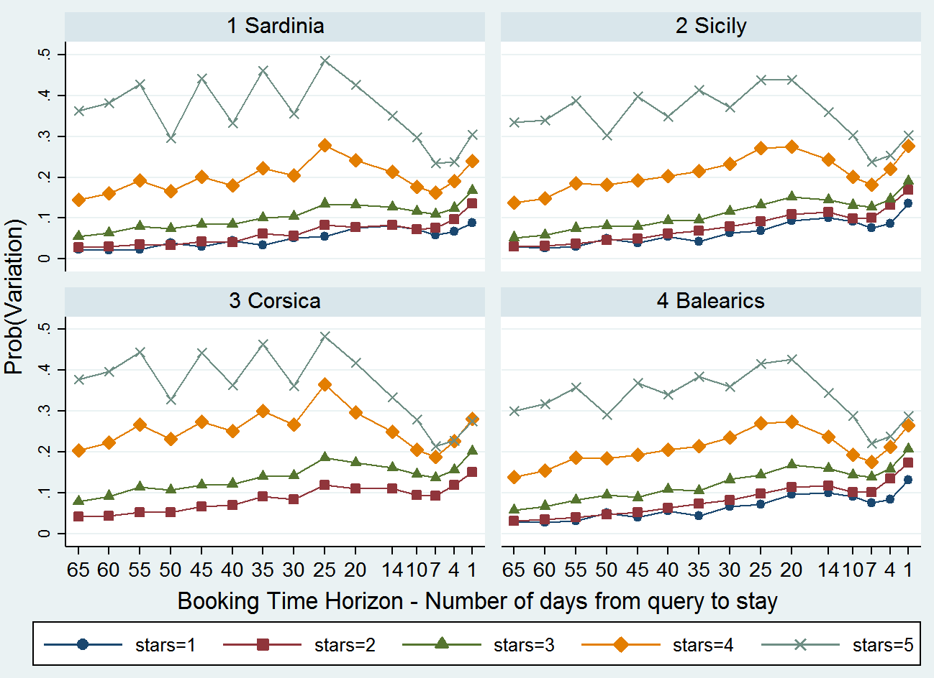

Figure 6 – Estimated Probability of a price change over any day of the booking period – by seasonal period and number of days from query to stay.
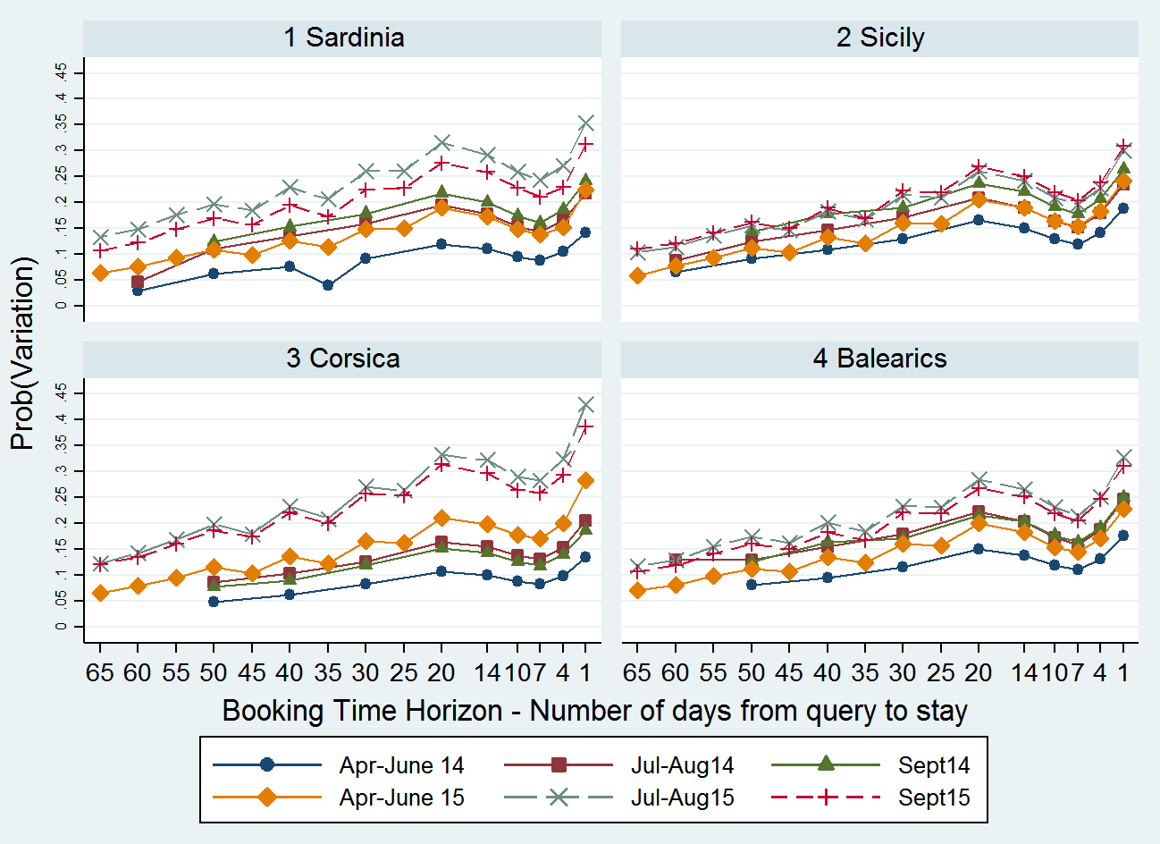

Figure 7 – Estimated Probability of a price increase given that a price variation is observed during the booking period. – by star classification and number of days from query to stay.
