**Tracking Sustainability Concepts in Geology and Earth Science Teaching and Learning, Keele University, UK**

Dr Steven L. Rogers, Dr Stuart S. Egan and Dr Ian G. Stimpson

Contact: s.l.rogers@keele.ac.uk

School of Geography, Geology and the Environment, Faculty of Natural Sciences, Keele University.

**Abstract**

Sustainability of the planet is fundamental to our common future, and geologists and geoscientists are key stakeholders in this process. Better understanding of the Earth, its processes and utilisation of its resources, through successful science communication, is necessary for the effective creation of sustainability policy. Whilst the synergy between geoscience and sustainability is often obvious, the framing of the links is often neglected or downplayed within the UK Higher Education setting. This results in geoscientists lacking in familiarity with sustainability issues, including the ability to communicate geoscience issues to non-specialists effectively. Using the United Nations Sustainable Development Goals, the inclusion and embedding of sustainability issues within Geology and Geoscience modules (offered by the School of Geography, Geology and the Environment, Keele University, UK) is framed in an effort to consolidate and enhance our current standing on sustainability issues. Further tracking of the emphasis and positioning of sustainability issues within these modules will enable a better articulation of the importance between geology and society.

**Keywords:** Sustainable Development Goals, Geology, Earth Science, Sustainability Tracking.

**Introduction**

Sustainability as a science (Kates *et al*., 2001) is essentially the study of our social and economic positions (including our ideologies, activities and practices) and their effects on our physical environment. In return, the consequences of a changing physical environment can be gauged in order to predict how our future options regarding social and economic situations may change. Sustainability concepts and the support of sustainable development as a potential solution to many global environmental issues, are associated with both international and national endorsements (e.g. the World Commission on Environment and Development, 1987; the International Environmental Education Programme, 1975-1995; the Earth Summit Declaration, 1992; the United Nations Decade for Education for Sustainable Development 2005-2014 *etc.*). The embedding of sustainability concepts, and the analysis of sustainability practice in higher education, as well as organisations outside of a an educational setting, has been highlighted in a number of recent publications (e.g. Holmberg *et al*., 2008; Mata-Perelló *et al*., 2012 and Christie *et al*., 2013). Universities have mostly “signed up” to the sustainability agenda and many businesses have tangible sustainability policies in place. Within the UK, the House of Commons (2017) report on “Sustainable Development Goals in the UK” highlighted some of these efforts, including Standard Chartered partnering with Liverpool Football Club to display the United Nations (UNs) Sustainable Development Goals (SDGs) on the club’s kit for a match in 2015. The report also highlighted the need to engage “university age people” with SDGs.

Geological and Earth Science practice, be that research, resource exploration and extraction, ground engineering or monitoring *etc.*, places geologists as key stakeholders to the sustainability process. Explicit examples of geological interactions with global development are highlighted by Gill (2016) and include geohazard and environmental management, energy supply, global climate change, access to clean water, agrogeology (agriculture and food security), natural resources *etc.* Several institutes and organisations, both government and non-government affiliated, such as the Association of Geoscientists for International Development, International Association for Promoting Geoethics, UNESCO, the American Geosciences Institute, the British Geological Survey and The Geological Society of London have all supported and encouraged the integration and importance of sustainability concepts within the geosciences.

Despite the obvious links, and the work of many organisations, it has recently become apparent that Geology and Earth Science teaching in the UK Higher Education system has been reluctant to integrate sustainability into the geoscience curricula. Stewart and Gill (2017), suggest that of the top 20 Earth Science Departments (according to University Subject Tables), there is only one course that has ‘Sustainability’ in the title of a module, and just two courses that specifically refer to sustainability in their module descriptions. This was in comparison to educational practice in the USA where sustainability issues are commonly embedded in geology teaching, and scientists working on sustainability issues are housed within Earth Science departments. Emphasis is also given to the collaboration of individuals from a range of disciplines, from both the social and physical sciences (Gosselin *et al*., 2013).

The slow integration of sustainability issues within geoscience courses has led to the call for geoscientists to introduce modules or overt sustainability material within their taught courses (Gill & Smith, 2017; Stewart & Gill, 2017). The reasoning for this stems from research which suggests that individuals are unlikely to change their opinions even when presented with scientific data that suggests contrary to a held opinion (e.g. Wachinger *et al*., 2013; Rapley and De Meyer, 2014). The introduction of key sustainability issues is a way of introducing geoscientists to the problems they may face, and allow them to associate themselves, and their knowledge, with individuals from other disciplines toward a greater goal. In essence, to become transdisciplinary and interdisciplinary (Blättel-Mink & Hans Kastenholz, 2005). As key stakeholders in the sustainability process, and for the betterment of dissemination of sustainability issues, geoscientists need to understand how they fit into the process, how their expertise can be best utilised, and some of the potential barriers they may face. An example of a barrier between geoscience and sustainability was given by Mackenzie (2017). He highlights that some UK wind farms (which he argues pollute foreign environments via there construction) have been placed on mineral resources “sterilising” the resource, this will result in further exploitation of these resources from parts of the world where no environmental policies are in place, geologists (here, the British Geological Survey) have had no say in this (with the UK government). It could be argued that with geological input, the local exploitation of needed resources would be more sustainable (less polluting etc.) than the shift of this exploitation to areas of the world with poor environmental regulations. Many of these points have been neglected by non-geoscientists, and the wind farms blindly regarded as “green” and therefore “a good thing”. With enhanced knowledge of the SDG’s geoscientists should be better equipped to negotiate with non-specialists in these situations.

It should be noted that it is most certainly not solely geoscientists and Earth Scientists in Higher Education settings that have been called out on this issue, Lozano *et al*. (2013) highlighted that although many universities had become engaged with sustainable development, most had fallen behind companies in creating an environment which nurtures a sustainable culture.

This paper investigates the links to sustainability concepts (in the guise of Sustainable Development Goals, as defined by the UN, see *Sustainability Concepts in the Keele Geology Courses*, below) within the undergraduate Geology and Geoscience courses taught at Keele University (UK). The aim of this work is to consolidate our current position in terms of sustainability science engagement and commitment, and to identify areas where we can improve this; be that with new modules or the better embedding and dissemination of current teaching practice.

**Sustainability Concepts in the Keele Geology Courses**

The tracking of sustainable development has become an important objective for many policy makers in many sectors (e.g. Ramachandran, 2000; Azapagic, 2004; Krajnc and Glavic, 2005; Singh *et al*., 2009 etc.). Indicators for tracking, and the methodologies applied vary between sectors, Singh *et al*. (2009) provides an overview of these concepts, which highlights the complexity of identifying indicators which are meaningful to a particular industry or sector. Some previous studies examining the embedding of sustainability concepts across university courses have used the “triple bottom line” approach (Saeudy, 2014 and 2015), this involves classifying sustainability development into three main categories: economic, social and environmental. Whilst these three categories are intrinsically linked to sustainability, we have used what we believe is a more comprehensive and integrated approach based on the UN’s 17 Sustainable Development Goals, similar to the method of Gill (2016).Gill (2016) used a visual matrix to explore the links between the UN’s 17 SDGs (Fig. 1 and Table 1) and 11 aspects of geology which he deemed key. A similar visual matrix is used here. However, in place of key geological aspects, modules which are run and coordinated by members of the geology teaching team (at Keele Uni.) are listed; these modules are briefly described; in subsequent columns links between these modules and the SDGs are given (represented by numbers corresponding to the SDGs (Fig. 1 and Table 1) as either Explicit, Moderate or Vague. Explicit links are those that are obvious or explicit within a module’s themes or teaching, Moderate links are those that provide knowledge and experience that can be clearly linked to the SDGs, but might not be immediately recognisable. Vague links are those which take some additional application to reach.

The visual matrix used here is much less streamlined than that of Gill (2016), however the number of aspects considered (in this case modules) is far higher. Of course, not all modules or teaching within modules are going to correspond to any of the SDGs, and that is to be expected. It should also be highlighted that the association of part of a module with an SDG, and the level to which it links, are likely to be transitory. In some cases, the association will also be debatable, we feel that our judgement in this matter has been fair, and that the introduction of a scale of linkage (Explicit, Moderate and Vague) reduces the potential for contentious matters. This methodology is less complex than most used within other sectors (Singh *et al*., 2009). For example, we don’t need to go into the economic complexities that most industries need to take into account (supply, demand, transport of goods *etc.*). We have modified this visual matrix as a way of tracking sustainability as a set of individual goals, which will allow us to summarise our overall sustainable development through these individual links; both in terms of the relationship between goals and how goals relate through the levels of our teaching. This development tracking is similar to how Warhurst (2002) considered the measurement of sustainability development.

(FIGURE 1 AROUND HERE, TABLE 1 DIRECTLY AFTER.)

As suggested in the introduction, there is a strong link between Geology and Earth Sciences, and sustainability concepts, so it is no surprise that most of our modules have some aspect or theme that can be linked to a UN SDG (Table 2). Only two modules have no identified links; these are both method driven modules. There are several modules which have Explicit links, for example ESC-10036 Planet Earth is explicitly linked with SDG13 (Climate Action); within the module the Earth's formation and evolution is introduced, providing students with a solid background of what climate change is, and some of the causes and effects associated with it. The visual matrix also highlights that there is a module in each FHEQ level (4-6) that could be considered as a “flagship” module: ESC-10048 The Earth System, ESC-20037 Geoscience and Society and ESC-30038 Geological Communication Skills; indeed, the two later modules explicitly include reference to sustainability in their module descriptions. The number of Moderate and Vague links are quite high for a number of modules, these links include topics such as global mineral distribution, reservoir quality of rocks and sea level change. Whilst these (and many more topics) are taught, their links with society, culture and economics are often neglected, not through any conscious effort, but by the nature of the subject being taught. Case studies are provided below for ESC-10048 The Earth System and ESC-20037 Geoscience and Society. These case studies highlight the synergies between subject material and the SDGs, some insight into their design, and student perception (for ESC-10048).

(TABLE 2 AROUND HERE)

**Module ESC-10048, The Earth System: An example of embedding sustainability in the geology curriculum.**

The Earth System is the title of a bespoke module belonging to the first year of the Single Honours Geology course offered at Keele. It is concerned with studying the Earth using an Earth System Science approach (e.g. Skinner and Murck, 2011), which is an interdisciplinary concept that is new to most, if not all, students taking the module. The Earth System is often represented by interacting "spheres" representing the four basic elements of the planet, the solid earth (geosphere), life on the planet (the biosphere), the Earth’s water reservoirs (the hydrosphere) and the atmosphere (Fig. 2). The module also places emphasis on how these systems interact in terms of physical, geochemical and environmental processes as well as how Society (the anthroposphere) is interacting with parts of the Earth System, which, in turn, is closely linked to sustainability issues.

(FIGURE 2 AROUND HERE)

The module was introduced in the 2009-10 academic year as part of the new Single Honours Geoscience programme (now renamed to Single Honours Geology). The main rationale for introducing the module was to add some interdisciplinarity to the Single Honours Geoscience programme, pulling in aspects from other disciplines such as Biology, Chemistry, Environmental Science, Oceanography, Physical Geography, *etc.* In addition, the QAA’s Subject Benchmark Statement for the Earth Sciences, Environmental Sciences and Environmental Studies (ES3; QAA 2007) emphasised the need for ES3 degree programmes to “focus on understanding Earth systems in order to learn from the past, understand the present and influence the future”, as well as to include “examination of the implications of sustainability and sustainable development”. The revised version of ES3 published in 2014 (QAA 2014) places even greater emphasis on sustainability and sustainable development. The accreditation requirements of the Geological Society of London also state that “an awareness of the essential contributions of geoscience to the economic, environmental and cultural needs of Society” is embedded within the curricula for all accredited programmes (Geological Society, 2012). Given all of these drivers, it was considered essential that geology students at Keele acquire some knowledge of other disciplines in order to understand the causes of global environmental change phenomena (e.g. mass extinctions, climate change, etc.) as well as have an appreciation of the need for the sustainable use of natural resources so that society can survive into the future. Table 3 summarises the content of the module and how it relates to the UN’s SDGs.

Student feedback on the module has been very positive with module evaluation scores of 90% in 2009/10, 97% in 2010/11, 99% in 2011/12 and 100% in 2014/15. Anecdotal evidence from informal discussion with the module cohort indicates that the students are aware of the need to broaden their knowledge outside of Geology in order to understand causes of global environmental change and the need to mitigate the predicted effects. There are, however, a minority of students who clearly view this module as “not geology” and, therefore, it is not worth engaging with, indicating that there is still progress to be made on embedding sustainability and sustainable development within the curricula of the Keele Geology programmes.

(TABLE 3 AROUND HERE)

**Module ESC-20037, Geoscience and Society: Putting sustainability in the heart of the geoscience curriculum.**

This module was designed to directly address issues of sustainability from the start. The aim of this module was taken directly from the accreditation guidelines of the Geological Society of London: “To develop an awareness of the essential contributions of geoscience to the economic, environmental and cultural needs of Society" (GSL 2008), and its Intended Learning Outcomes from the QAA ES3 benchmarking statement: “to demonstrate, critically evaluate, communicate effectively and apply awareness and informed concern of Earth science challenges [in] the exploration for, and the development and exploitation of, Earth resources,  geological aspects of human impacts on the environment, geohazards and their impacts on human societies, earth science perspectives on sustainability and social awareness, environmental challenges [in] [geo]diversity; demand and scarcity; demand for, and consequences of, water resource utilisation, energy and material production and use, including alternatives; air, land and water pollution; approaches to, and limitations of environmental management systems; role of institutions in regulation and management of the environment; environmental policy formulation, legislation and decision making” (QAA 2007). The module covers a wide range of topics from geoscience and health (SDG3), geohazards and mitigation such as earthquake resilience of buildings (SDG11), geodiversity including conservation strategies (SDGs4,14-17), agriculture (SDG1 & 2) and water (SDG6). It looks at the future of oil, gas and coal, clean energy such as geothermal (SDG7) and the technologies of carbon capture and storage (SDG9), as well as nuclear waste management (SDG13), the solutions to which are almost entirely geological. The students research and present on the occurrence, reserves and sustainability of mineral resources (SDG8 & 12) and work in the field on the practical aspects of geoconservation and how to communicate these issues to the public.

**Future Work**

This sustainability audit has been a catalyst for the further embedding and tracking of sustainability concepts into our courses, as well as the appropriate linkages being formed between SDGs. Whilst it is positive that we can link so much of our teaching to the SDGs, it is necessary that we continue to strive to create students that can understand and appreciate these concepts, and the need for them. Our students should have the skills to interact with individuals and groups from other disciplines, understand their arguments, and deliver Geological sciences in an accessible and understandable manner. In order to align our teaching with the SDGs further we plan on taking the following steps:

1. Include a “Sustainability Statement” (outlining major themes, issues and linking SDGs) to each FHEQ level module handbook;
2. Emphasise the links to SDGs module descriptions and in available module teaching activities and materials;
3. Explore the possibility of a “Social Geology” (or similarly named) route through our degree structure;
4. Reflect on these implementations, particularly on how the embedding of individual SDGs link to one another throughout the duration of our degree courses, and disseminate as necessary.
5. Encourage students to establish a Geology for Global Development university group as part of the wider GfGD network.

**Acknowledgements:** The authors would like to thank the rest of the ‘geology team’ at Keele for their support of this ongoing project. We would also like to thank our students for module feedback.

**References**

Azapagic, A., 2004. Developing a framework for sustainable development indicators for the mining and minerals industry. Journal of cleaner production, 12, pp.639-662.

Blättel-Mink, B. and Kastenholz, H., 2005. Transdisciplinarity in sustainability research – diffusion conditions of an institutional innovation. In: The International Journal of Sustainable Development and World Ecology. Vol 12. Pg. 1-12.

Christie, B.A., Miller, K.K., Cooke, R. and White, J.G., 2013. Environmental sustainability in higher education: how do academics teach?. Environmental Education Research, 19, pp.385-414.

Gill, J.C., 2016. Geology and the sustainable development goals. Episodes. Vol 40. pg 70-76

Gill, J.C. and Smith, M., 2017. Sustainable Futures. Geoscientist. Vol 27. Pg 10-15

Geological Society Requirements for Accreditation of 1st Degree Programmes, 2012. (Online). Available at: https://www.geolsoc.org.uk/Education-and-Careers/Universities/Degree-Accreditation/Aims-and-Requirements-for-Accreditation Accessed 22/02/2018

Gosselin, D., Manduca, C., Bralower, T., Mogk, D., 2013. Transforming the teaching of geoscience and sustainability. *Eos.* Vol 94. Pg 221–222.

Holmberg, J., Svanström, M., Peet, D.-J., Mulder, K., Ferrer-Balas, D. &  
Segalàs, J., 2008 Embedding sustainability in higher education through interaction with lecturers: Case studies from three European technical universities. *European Journal of Engineering Education*. Vol 33. Pg 271-282.

House of Commons Environmental Audit Committee, 2017. Sustainable Development Goals in the UK. Ninth Report of Session 2016–17 (Online). Available at: https://publications.parliament.uk/pa/cm201617/cmselect/cmenvaud/596/596.pdf

Accessed 12/12/2017

Kates, R.W., Clark, W.C., Corell, R., Hall, J.M., Jaeger, C.C., Lowe, I., McCarthy, J.J., Schellnhuber, H.J., Bolin, B., Dickson, N.M. and Faucheux, S., 2001. Sustainability science. Science, 292, pp.641-642.

Krajnc, D. and Glavič, P., 2005. A model for integrated assessment of sustainable development. Resources, Conservation and Recycling, 43, pp.189-208.

Lozano, R., Lukman, R., Lozano, F., Huisingh, D., & Lambrechts, W., 2011. Declarations for sustainability in higher education: Becoming better leaders, through addressing the university system. *Journal of Cleaner Production*. Vol 48. Pg 10-19.

Mackenzie, C., 2017. They Hate Us. *Geoscientist*. Vol. 27 (No 8). Pg. 9.

Mata-Perelló, J.M., Mata-Lleonart, R., Vintró-Sánchez, C. and Restrepo-Martínez, C. 2012. Social geology: a new perspective on geology. *Dyna*. Vol 79. Pg 158–166.

QAA (The Quality Assurance Agency for Higher Education) 2007. Subject Benchmark Statement: Earth Sciences, Environmental Sciences and Environmental Studie, QAA, Gloucester (Online). Available at: http://www.qaa.ac.uk/en/Publications/Documents/Subject-benchmark-statement-Earth-sciences-environmental-sciences-and-environmental-studies.pdf              Accessed 22/02/2018

QAA (The Quality Assurance Agency for Higher Education). 2014. Benchmark statement for Earth sciences, environmental sciences and environmental studies, QAA, Gloucester (Online). Available at: http://www.qaa.ac.uk/en/Publications/Documents/SBS-earth-sciences-14.pdf

Accessed 22/02/2018

Ramachandran, N., 2000. Monitoring sustainability: Indices and techniques of analysis. Concept Publishing Company.

Rapley, C., De Meyer, K., 2014. Climate science reconsidered. *Nature Climate Change*. Vol 4. Pg 745–746.

Saeudy, M. 2014. Sustainable practices in the academic workplace. *Journal of Academic Development* *and Education*. Vol 1. Pg. 29–40.

Saeudy, M. 2015. Triple Bottom Line: An Academic Perspective on Sustainability Practices and Accountability. In: Leal Filho, W. (ed) Transformative Approaches to Sustainable Development at Universities. World Sustainability Series. Springer.

Singh, R.K., Murty, H.R., Gupta, S.K. and Dikshit, A.K., 2009. An overview of sustainability assessment methodologies. Ecological indicators, 9, pp.189-212.

Skinner, B.J. and Murck, B.W. 2011. The blue planet: an introduction to earth system science (Third Edition). Wiley.

Stewart, I. S. and Gill, J. C. 2017. Social geology — integrating sustainability concepts into Earth sciences.Proceedings of the Geologists’ Association. Vol 128. Pg 165-172.

UNESCO. 2005. United Nations decade of education for sustainable development (2005-2014): International implementation scheme. Paris: UNESCO.

UNESCO-UNEP. 1987.  International Environmental Education Programme (1975-1987). International Congress on Environmental Education and Training (Moscow, USSR). Pp 17-21.

United Nations. 1992. The Rio Declaration On Environment And Development (Online). Available at: www.unesco.org/education/pdf/RIO_E.PDF

Accessed 7/11/2017

United Nations. 2015. Sustainable Development Goals (Online). Available at:  
www.un.org/sustainabledevelopment/sustainable-development-goals/

Accessed 06/11/2017

Wachinger, G., Renn, O., Begg, C., Kuhlicke, C., 2013. The risk perception paradox -  implications for governance and communication of natural hazards. Risk  
Analysis. Vol 33. Pg 1049–1065.

Warhurst, A., 2002. Sustainability indicators and sustainability performance management. Mining, Minerals and Sustainable Development [MMSD] project report, 43.

World Commission on Environment and Development (WCED). 1987. Our common future. Oxford University Press.

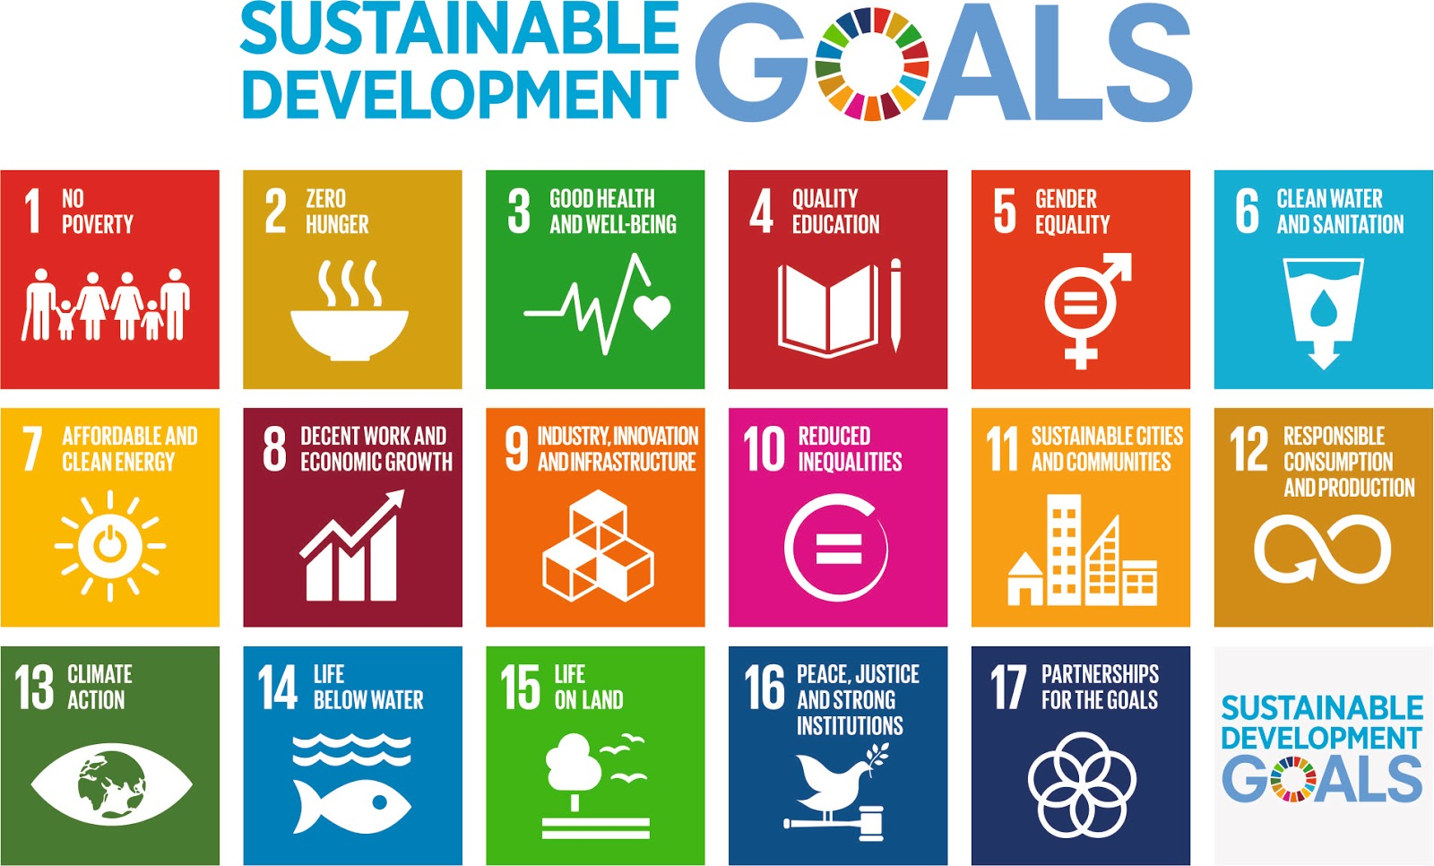

**Figure 1.** The United Nations Sustainable Development Goals (From United Nations, 2015). These are the seventeen goals which form the SDGs, each goal has specific targets to be achieved by 2030 with the aim of ending poverty, protecting the planet and providing prosperity for all. Each goal is expanded in Table 1.

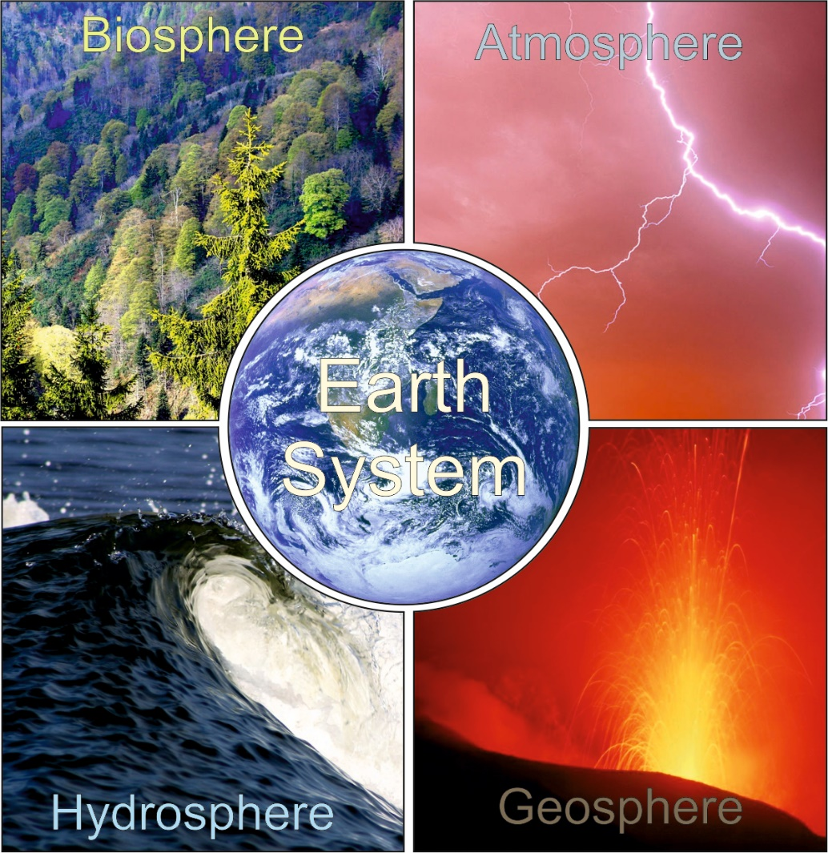

**Figure 2.** The Earth System is underpinned by four basic components, the atmosphere, the hydrosphere, the geosphere and the biosphere. There is continuous interaction between these components in terms of the flow of energy and matter that controls climatic and environmental conditions on Earth.

|  |  |
| --- | --- |
| 1 | No Poverty: End poverty in all its forms everywhere |
| 2 | Zero Hunger: End hunger, achieve food security and improved  nutrition, and promote sustainable agriculture |
| 3 | Good Health and Well-Being: Ensure healthy lives and promote well-being for all at all ages |
| 4 | Quality Education: Ensure inclusive and equitable quality education and promote life-long learning opportunities for all |
| 5 | Gender Equality: Achieve gender equality and empower all women and girls |
| 6 | Clean Water and Sanitation: Ensure availability and sustainable management of water for all |
| 7 | Affordable and Clean Energy: Ensure access to affordable, reliable, sustainable, and modern energy for all |
| 8 | Decent Work and Economic Growth: Promote sustained, inclusive and sustainable economic growth, full and productive employment and decent work for all |
| 9 | Industry, Innovation and Infrastructure: Build resilient infrastructure, promote inclusive and sustainable industrialisation and foster innovation |
| 10 | Reduce Inequalities: Reduce inequality within and among countries |
| 11 | Sustainable Cities and Communities: Make cities and human settlements inclusive, safe, resilient and sustainable |
| 12 | Responsible Consumption and Production: Ensure sustainable consumption and  production patterns |
| 13 | Climate Action: Take urgent action to combat climate change and its impacts |
| 14 | Life Below Water: Conserve and sustainably use the oceans, sea and marine resources for sustainable development |
| 15 | Life on Land: Protect, restore and promote sustainable use of terrestrial ecosystems,  sustainably manage forests, combat desertification, and halt and reverse land  degradation and halt biodiversity loss |
| 16 | Peace, Justice and Strong Institutions: Promote peaceful and inclusive societies for sustainable development, provide access to justice for all and build effective, accountable and inclusive institutions at all levels |
| 17 | Partnerships for the Goals: Strengthen the means of implementation and revitalise  the global partnership for sustainable development |

**Table 1**. A brief description of each Sustainable Development Goal (United Nations, 2015)

|  |  |  |  |  |
| --- | --- | --- | --- | --- |
| **Module Title** | **Brief Description of Module Content** | **Explicit Links with Sustainable Development Goals:** | **Moderate links with Sustainable Development Goals:** | **Vague Links with Sustainable Development Goals:** |
| ESC-10034 Time and Space | Principles of stratigraphy, geodynamic development of Earth and of life on Earth through time |  | 13, 14, 15 | 1, 2, |
| ESC-10036 Planet Earth | Earth as a planet, large scale geological processes ( e.g. volcanoes, earthquakes, tsunamis). | 13, | 6, 7, 9, 11,14, 15 | 1,2, |
| ESC-10045 Introductory Geology for the  Environmental Sciences | Introduction of geoscience as an essential cornerstone of environmental and sustainability science. Covers a wide spectrum of geological topics (the formation and evolution of Earth, life on Earth, rock types, natural hazards etc.) | 7, 12, 13, | 1, 3, 6, 9, 11, 14, 15, | 2, 17 |
| ESC-10047 - Geoscience  Data Interpretation,  Analysis and Visualisation | Introduction to geophysical, remote sensing, geographical/geological informations system techniques. |  |  | 9, 13, 15 |
| ESC-10048 The Earth System | Geosphere, biosphere, atmosphere and hydrosphere interactions. | 1, 2, 3, 6, 7, 11, 13, 14, 15, 17 |  |  |
| ESC-10054 Introduction to Mineralogy  and Petrology | Igneous and Metamorphic mineral identification and formation. |  |  |  |
| ESC-10055 Introduction to Sediment- ology and Palaeontology | Theoretical and practical introductions to sedimentological and palaeontological principles (evolution, extinction, sediment types, environments of deposition) |  |  | 13, 14, 15 |
| ESC-20001 Igneous and Metamorphic  Petrology | The application of geochemistry and experimental models to the formation of igneous and metamorphic rocks. |  | 7 | 13 |
| ESC-20002 Reconstructing Past  Environments | How ancient sediments can be used to reconstruct their environment (and environmental factors such as climate) of deposition. Modern examples are used as a template. |  |  | 13, 14, 15 |
| ESC-20036 Palaeoclimatology and  Quaternary Studies | The occurrence, evidence for and plausible causes of climate change over geological time. | 13, 14, 15 | 1, 2, 3, 6, | 17 |
| ESC-20037 Geoscience and Society | Develops an awareness of contributions of geoscience to economics, environmental and cultural needs of society. | 1, 2, 3, 4, 6, 7, 8, 9, 11, 12, 13, 14, 15 | 16, 17 |  |
| ESC-20039 - Advanced  Structural Geology and  Geological Mapping Training | Basic training in geological map making. The investigation of deformation of rocks |  |  | 7, 9, 11 |
| ESC-20040 Geoscience Field Training | Advanced geophysics and geological field techniques, first aid training, career preparation and independent research skills. |  |  | 4, 9, 11 |
| ESC-20054 Forensic and Historical  Geoscience | Forensic techniques with focus on law enforcement. The historical and modern uses of geoscience for applied purposes (ranging from water resources to warfare) | 6, 11,17 | 1, 2, 3 | 10,16 |
| ESC-20064 Geochemistry | Introduction to basic principles, applications and analytical techniques used in geochemistry. |  |  | 13 |
| ESC-30032 Geoscience: Independent  Field Project | Independent field project including significant geological mapping. |  |  |  |
| ESC-30008 Structure and Geodynamics | Structural and geodynamic effects associated with continental tectonics. |  | 9 | 1, |
| ESC-30009 Natural Hazards | Examines the causes and characteristics of a wide range of natural hazards (with both environmental and anthropogenic triggers) and their impact on society. | 1, 2, 3 | 6, 8, 13, 14, 15 | 17 |
| ESC-30022 Hydrological and  Engineering Geology | Geological factors influence on availability of water resources and the design and construction of engineered infrastructure. | 6, 9, 11 | 7, 14, 15 | 1, 2, 12, 13 |
| ESC-30025 Micropalaeontology: Principles and Applications | The study of major microfossil groups and their palaeogeographical, palaeoecological and biostratigraphical potential. |  | 13 | 7, 14, 15 |
| ESC-30028 Economic Geology | Process and mechanisms of ore body formation. Includes coal and aggregate material. | 1, 6, 7 | 8 | 10 |
| ESC-30030  Advanced  Petrology and Structural  Geology Field Course | Igneous and metamorphic rocks in the field with an emphasis on crustal evolution and associated geological structures. |  |  | 4, 9, 11 |
| ESC-30033 Volcanic and magmatic  processes | Volcanic and magmatic processes in the field (e.g. physical volcanology, volcanic hazards, global environmental change). | 13, 15 | 1, 2, 3 |  |
| ESC-30034 Advanced Topics in  Sedimentology | Analytical methods of seismic and sequence stratigraphy, relating sediments to regional tectonic and eustatic controls. |  | 13, 14, 15 | 8 |
| ESC-30036 Exploration Geophysics  for the Hydrocarbon Industry | Geophysical techniques used in the hydrocarbon exploration industry are investigated. Career preparation for those wishing to enter hydrocarbon exploration. |  | 1, 7, | 8, 12 |
| ESC-30038 Geological Communication  Skills | The communication of complex geological issues, including and awareness of  Earth science, sustainability and social awareness. | 1, 2, 3, 4, 6, 7, 8, 9, 11, 12, 13, 14, 15 |  | 16, 17 |

**Table 2**. A visual matrix of links between modules currently run as part of the by Geology and Geoscience degree programmes and the UN’s SDGs. Brief descriptions of the module content are provided, these are summarised from the respective module descriptions available to current and prospective students. Numbers in the “Link” columns correspond to the individual SDGs: 1, No Poverty. 2, Zero Hunger. 3, Good Health and Well-Being. 4, Quality Education. 5, Gender Equality. 6, Clean Water and Sanitation. 7, Affordable and Clean Energy. 8, Decent Work and Economic Growth. 9, Industry, Innovation and Infrastructure. 10, Reduce Inequalities. 11, Sustainable Cities and Communities. 12, Responsible Consumption and Production. 13, Climate Action. 14, Life Below Water. 15, Life on Land. 16, Peace, Justice and Strong Institutions. 17, Partnerships for the Goals.

|  |  |  |  |
| --- | --- | --- | --- |
| **Wk.** | **Topic** | **Links with UN SDGs** | **Examples** |
| **Module Introduction** | | | |
| 1 | Introduction to Earth System Science (Lecture)  Earth System Interactions:Modelling Biogeochemical cycles (Practical) | 12, 13, 14, 15  12, 13 | The role of Society in causing global environmental change.  Modelling the  effects of Society on the Carbon cycle. |
| **The Oceans** | | | |
| 2 | Structure of the Ocean Floor (Lecture)  Ocean Composition (Lecture) | 14  13, 14 | Importance of the oceans within the Earth System.  Phytoplankton - important role played in influencing global climate as well as  indicators of oceanic health. |
| 3 | Ocean circulation (Lecture)  The World’s Oceans (Practical) | 1, 2, 13, 14, 15  13, 14 | The El Niño Southern Oscillation and it effects on the economy of Chile and Peru.  The links between climate change and oceanic circulation and effects on society. |
| 4 | Waves and Tides (Lecture)  Coastal and Deep Marine Dynamics in Response to Sea Level Change (Online/virtual Lecture) | 14, 15  13, 14, 15,  11, 13, 14, 15 | Coastal erosion.  Effects of sea level rise on coastal populations. |
| **The Atmosphere** | | | |
| 4 | Atmospheric Composition (Lecture) | 12, 13, 15 | Source of aerosols due to pollution (e.g. historically associated with combustion of coal). |
| 5 | Atmospheric Energy (Lecture)  Atmospheric Moisture (Lecture) | 13, 15  6, 13 | Anthropogenic radiative forcings associated with changes in the main greenhouse gases and aerosols.  Links between cloud formation and precipitation and water supply. |
| 6 | Atmospheric Motion (Lecture)  Climatology and Geoscience (Lecture) | 13  11, 13, 15 | Links between climate change and the jet stream, and possible implications for air travel.  Urban Modification of Climate. |
| 7 | Acquiring meteorological data: The Keele Weather Station (Visit)  Analysis of Keele weather data: Global warming – fact or fiction? (Practical) | 13  13 | Analysis of meteorological data for evidence of climate change. |
| **The Biosphere** | | | |
| 8 | The Earth-Life System I (Lecture)  The Earth-Life System II (Lecture)  Mass Extinctions (Online/virtual Lecture) | 14, 15  14, 15  14, 15 | Overview of the biosphere and how it relies on other components of the Earth System.  Evidence for and against a current (sixth) Extinction Level Event. |
| 9 | Global Biogeography and Biomes (Lecture)  Soils: the link between geology and the living skin (Lecture) | 2, 15  2, 6, 15 | The effects of human intervention on global patterns in the biosphere.  Soil as a reservoir for water and its controls on water quality. |
| **The Anthroposphere** | | | |
| 10 | Climate Change (Lecture)  Ozone Depletion (Lecture) | 1, 2, 3, 6, 12, 13, 14, 3, 15 17 | Perspectives on natural versus anthropogenic climate forcing factors.  Links between ozone depletion and health. |
| 11 | Natural Resources (Lecture)  Resource Depletion: Causes, implications and Solutions (Lecture) | 8, 9, 14, 15  1, 2, 3, 6, 7, 11, 12, 14, 15 | Overview of physical, biological and environmental resources.  The Peak Oil Theory. |
| 12 | Revision workshop |  |  |

**Table 3**. A week-by-week overview of the content of the Earth System module with links to the UN’s SDGs summarised in Table 1.