Craft skills

Dr Colin Rigby
Senior Lecturer
Keele Management School
Keele University
Keele, Staffordshire ST5 5BG, UK
Email: c.a.rigby@keele.ac.uk

Dr Gordon Rugg
Senior Lecturer
School of Computing and Mathematics
Keele University
Keele, Staffordshire ST5 5BG, UK
Email: g.rugg@keele.ac.uk

Gavin Taylor
Head of Computing and IT
Countesthorpe Leysland Community College,
Winchester Road,
Countesthorpe,
Leicestershire LE8 5PR, UK
Email: gavint321@gmail.com

Biographies

Dr Colin Rigby is a Senior Lecturer in Management and leads on knowledge exchange for Keele Management School at Keele University in Staffordshire, UK. He has degrees from UMIST (BSc) Physics, Manchester (MSc, Mphil) in Engineering and a Phd from Keele University in Manufacturing Systems. His main interests are in knowledge modelling and how it applies to management theory and practice, along with critical approaches to entrepreneurship and practical methodologies for applied research. He has published in a number of International Journals including International Journal of Production Economics. His funded applied work and consulting have been in the areas of strategic development, sustainability and operational strategy.

Dr Gordon Rugg has a multidisciplinary background, which includes a first degree in French and Linguistics and a PhD in Experimental Social Psychology, both from Reading University UK. His research is mainly focused on the theory and practical applications of knowledge modelling. This includes elicitation methods for expert systems and for software requirements; representation of knowledge; detecting errors in expert reasoning about difficult problems; and selection of appropriate teaching and learning methods in education and training. He is a Senior Lecturer in Computing at Keele University, where he is head of the Knowledge Modelling Group. He is also a founding director of Hyde & Rugg Associates, a consultancy specialising in solving hard problems.

Gavin Taylor is Head of Computing and IT at Countesthorpe Leysland Community College, Countesthorpe, UK. He has a first degree in Computing with Mathematics from Keele University UK, followed by a PGCE in Secondary Education, also from Keele University. His research interests include deep structure analysis, particularly focusing on craft skills and computational modelling. He has worked on various projects, including producing a set of resources on the D’Agapeyeff Cipher and co-authoring a paper on the Voynich Manuscript. His work is featured in the book Unsolved! The History and Mystery of the World's Greatest Ciphers from Ancient Egypt to Online Secret Societies by Craig Bauer.

Acknowledgements

The case study described in this article was funded by a grant from Keele University RSF4 acorn seeding fund arrangement.

The case study was approved by the Keele University ethics process.

We are deeply grateful to Sam Shepherd and his colleagues at the British Ironwork Centre in Oswestry UK for their generous help in the case study.

Abstract

This paper will argue that craft skills, although well established in practice since antiquity, have received little formal academic attention until fairly recently. They are, however, an important and under-researched area of understanding. This paper locates them within a grounded knowledge modelling framework, which includes a description of how methods such as task analysis and cognitive task analysis can be used to elicit and describe craft skills systematically.

We conclude that systematic analysis of craft skills in this manner can be used to improve integration of craft skills within formal education policy and provision, as well as within training. We also identify scope for improving support for managers via systematic use of physical aides-memoires to provide cognitive support, in a manner that is derived from practices within physical craft skills.

Keywords:
Craft skills, knowledge modelling, tacit knowledge, semi-tacit knowledge, instantiated knowledge, gulf of instantiation, muscle memory, workplace layout, aides-memoires

Introduction

The traditional meaning of craft involves a pastime or an occupation that requires particular skills and knowledge. In a historical sense, particularly the Middle Ages and earlier, the term is usually applied to people occupied in small-scale production of goods, or their maintenance, for example by tinkers. The traditional terms craftsman and craftswoman are nowadays often replaced by artisan and occasionally by craftsperson. Within this context of skilled manual labour, the term craft skills has become associated with skills typically viewed as too informal and low-level to merit inclusion in a formal education, system of knowledge, or syllabus. It has become apparent via recent research, however, that craft skills are more important than had previously been thought, and that systematically identifying and teaching key craft skills can make a significant difference to performance of experts and of early career practitioners.

Within the literature, the term “craft skills” has been used in different ways, creating potential for confusion and misunderstanding. One well-established use relates to the skills associated with a (usually manual) craft such as woodworking or metalworking. This is the sense used by e.g. Sennett (2009) in his thoughtful analysis of attitudes toward craft, both within society as a whole, and in how craftspeople view their chosen craft. (Though c.f. Lamont (2002) for a discussion of how pride in craft and work can become interwoven with socially divisive attitudes towards other groups).

Within this usage, it is perfectly sensible to refer to formal qualifications for craft skills (e.g. Briscoe et al, 2001). However, a second and equally well-established use relates to skills which are tacit in the broad sense of not being formally codified, and which involve low-level practical skills as opposed to formally codified abstract academic skills (e.g. Cantrall, 1954). Within this usage, the concept of formal qualifications for craft skills would be a contradiction in terms.

There is also the issue of low-level practical skills which are explicitly taught as part of a formal academic course, such as brushwork within a fine arts course on painting. Many academic disciplines routinely use lab sessions or practical sessions for teaching such skills through to the deployment of students on to in work placements as part of degree courses. In this context, the lab and practical sessions are used for teaching craft skills, though whether this is an explicitly stated use tends to depend on the individual institution and/or instructor.

Although craft skills have been recognised since antiquity as important for working practice, they have received comparatively little formal theoretical analysis. In this article, we use a knowledge modelling framework to analyse craft skills and to locate them in relation to traditionally codified academic skills. The framework suggested includes several components – taxonomy, representation and a number of distinguishing factors determining craft skill types. This approach is similar to that taken by Cross (2011), who also uses a cross-disciplinary approach to study the skills and practices of designers.

In this article, we use the term craft skill in a sense which is broad as regards disciplines, but narrow as regards definition. Our definition locates craft skills as occurring at the point where generic, abstract, often academic, information and guidance are applied to specific, instantiated cases. We unpack these concepts in detail later in this article. An example of an academic craft skill is turning the guideline “Show advanced critical reading” into the specific actions required to produce a suitable piece of written text. An example of a manual craft skill is turning the instruction “Clean up the sawn end of the silver strip” into the specific actions required.

We argue below that the underlying issues involved in both abstract craft skills (e.g. in academic writing, or management, or design) and in physical craft skills are essentially the same, which is why we use the term craft skill in a broad sense as regards discipline. Toward the end of this article, we discuss the implications for managers.

The approach taken in this study is located within the sociotechnical tradition (e.g. Trist and Bamforth, 1957) and within the distributed cognition tradition (Sutton, 2006). Within both these traditions, there is an emphasis on the interaction between cognition and physical context; this emphasis underpins the study described here, which applies a richer framework for modelling cognition than is used by those previous approaches, and examines the insights provided by this richer framework.

A taxonomy of types of knowledge, skill and communication, with particular reference to semi-tacit and tacit knowledge is available within the ACRE framework (Maiden & Rugg, 1996) which synthesises a range of literatures on explicit, tacit and semi-tacit knowledge, ranging from Miller’s seminal work on short term memory (Miller, 1956) to Polanyi’s work on tacit knowledge (Polanyi, 1958) and to work in knowledge elicitation, (Cordingley, 1989), requirements engineering (Thayer et al, 1997) and cognitive psychology (Neisser, 1967).

Another component involves knowledge representation (e.g. Reichgelt 1991), in particular graph theory (Euler, 1741). This component draws heavily on concepts from Artificial Intelligence; in particular, the concept of instance versus class, which is discussed in more detail later in this article.

A cleaner and more powerful way of codifying the relevant concepts is to use a knowledge modelling approach. The types of knowledge involved can first be differentiated in terms of instantiation skills versus abstract skills, as follows.

Instantiation skills versus abstract skills

Formal taxonomic and knowledge representation systems generally distinguish between instances (e.g. “this cat”) and classes (e.g. “cats”). The instance is a particular, specific individual specimen; the class is an abstraction which lumps together a number of instances on the basis of a stated criterion. In most representation systems, this process continues across multiple levels of abstraction. An example is zoological classification, which uses about seven levels. The core concept is illustrated in Figure 1 below, which uses a small number of instances and levels for clarity.

FIGURE 1 ABOUT HERE

Figure 1: Schematised model of levels of abstraction of knowledge

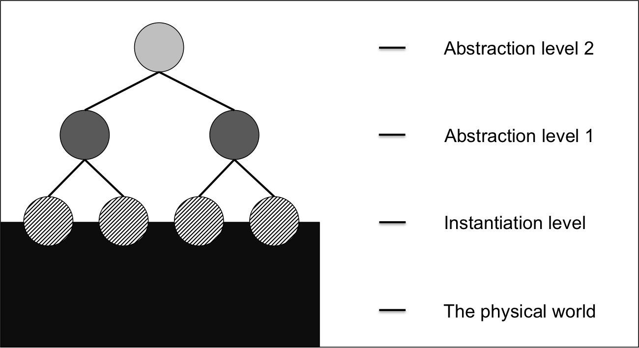

When we apply these concepts to knowledge, we can differentiate between various degrees of instantiation.

Figure 2 shows a schematised example of uninstantiated academic knowledge. This is a common cause of problems in education, where the lecturers assume that the students will be able to work out how to instantiate the abstract knowledge. In reality, this “gulf of instantiation” is often a significant source of problems, with students unable to see what form the instantiation should take, or mistaking the form that it should take. For instance, in the case of a physical craft such as silversmithing, an instruction such as “hit the silver fairly hard” is almost meaningless without instantiation showing how hard “fairly hard” is.

FIGURE 2 ABOUT HERE:

Figure 2: Uninstantiated knowledge at two levels of abstraction

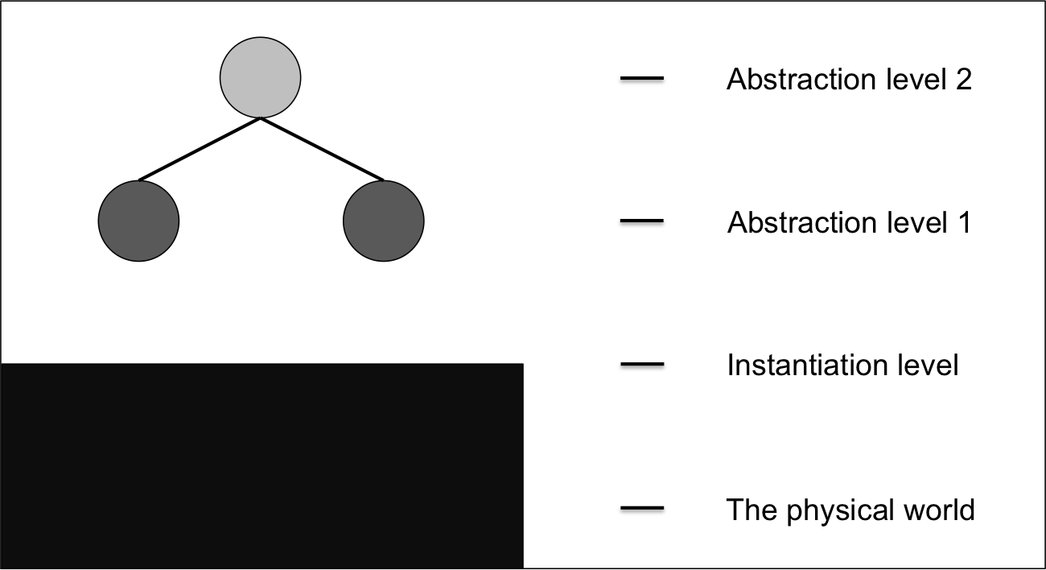

Figure 3 shows a schematised model of “free standing” craft skills which only rise to the lowest level of abstraction. An example would be craft skills involving ways to reduce the risk of accidents and injury, such as “if you are using an acid bath while doing silversmithing, do not reach over it, in case the acid bubbles and burns your arm”. The instantiations are “acid bath” and “reach over it” and the higher-level issue to avoid is “burning your arm” which is higher-level because it can also be reached via different instantiations, such as making a mistake with a soldering iron.

The traditional implicit academic view has been that craft skills are limited in depth and content, but experience with experts in physical crafts shows that their craft skills can be rich and well organised, as illustrated in the case study described later in this article.

FIGURE 3 ABOUT HERE:

Figure 3: Schematised model of craft skills with low levels of abstraction

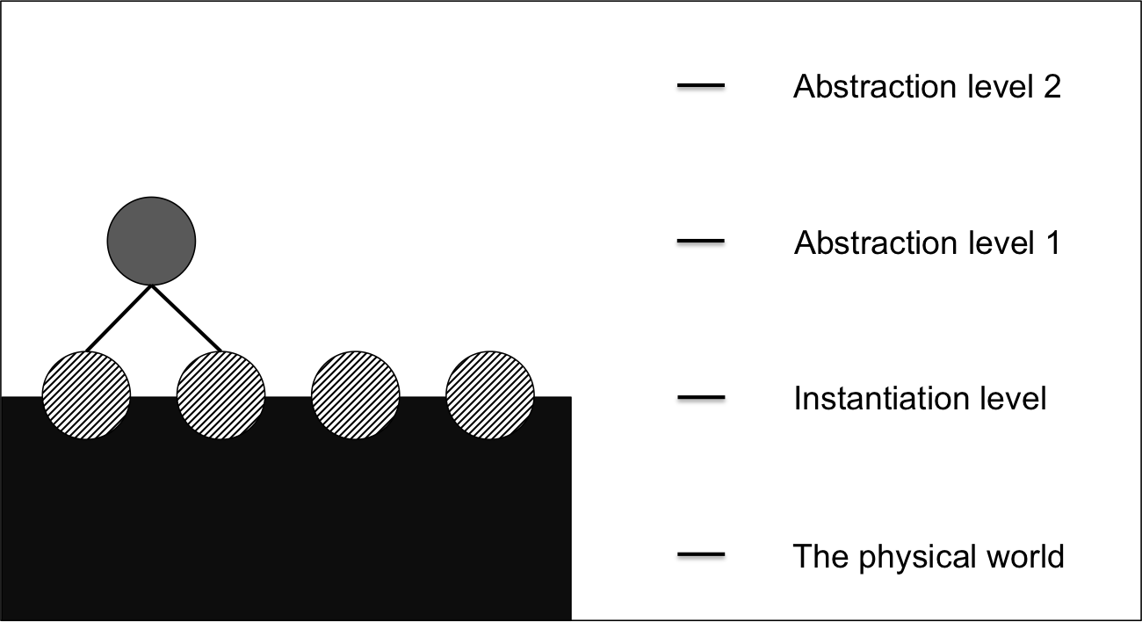

Most academic disciplines include at least some instantiation of the academic content, as shown in Figure 4 below. Examples include programming practicals in computing, and lab classes in physical sciences.

FIGURE 4 ABOUT HERE:
Figure 4: Schematised model of partially instantiated academic knowledge

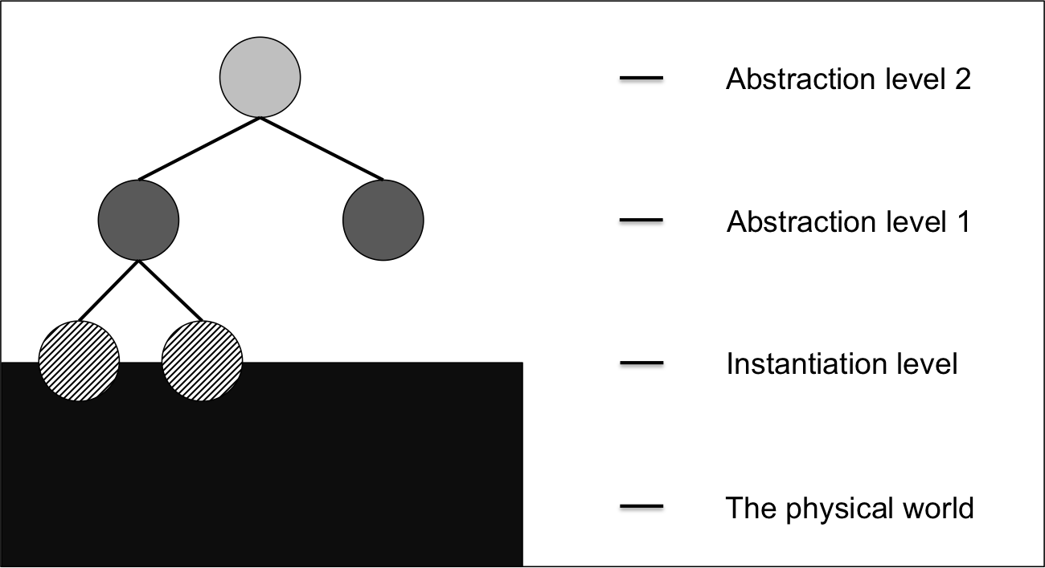

There are other ways in which a knowledge modelling perspective provides a more rigorous way to make sense of craft skills. These are illustrated by a case study conducted by the first two authors, described below.

Case study:

Taking this theoretical construction as a basis, we investigated a craft skill based practice. The case study involved participant observation in a silversmithing class for novices. During the first session, lasting about two hours, the first author learned how to make a silver ring with hammered decoration, using traditional methods. During the second session, lasting about the same time, the second author learned how to make a silver ring with stamped decoration, using a mixture of traditional and modern methods. The two sessions blended in with the instructor giving general overviews and discussing background principles with both authors, hence the approximate nature of the figures for duration.

In both sessions, the authors carried out the silversmithing under instruction, going through the whole process from measuring silver strip through to producing a finished ring.

The recording of the sessions was kept deliberately low key and as unobtrusive as possible, so as not to interfere with the sessions themselves. The author who was not being instructed took written notes, with permission from the instructor and assistants, during the session. We also took photos of the workshop environment, and in a few cases paused the session to photograph points of particular interest. We deliberately did not audio or video record, to reduce the risk of observer effects.

The instructor and assistants are used to giving short training courses to people with no previous experience of silversmithing, and appeared completely comfortable with being photographed and being asked questions.

The analysis below is thematic, rather than chronological, for clarity.

Muscle memory, memory types, and sensory types

As might be expected, “muscle memory” was a significant feature of the work. This involved learning the motor skills required for a particular task, such as hammering a texture into the silver. Muscle memory is well recognised as an issue in many fields, such as sports and manual crafts, so encountering it in silversmithing was no surprise.

Although muscle memory is a well-established concept, and there is little doubt about its reality, it tends to be viewed in most fields as enigmatic, and little understood. It can, however, be fairly easily located in terms of background theory from a knowledge modelling perspective. An example is Shusterman’s (2011) location of muscle memory in relation to six different types of implicit memory.

In terms of the type of memory involved, there is a well established distinction in psychology between episodic memory and semantic memory, where episodic memory relates to specific events that the person has experienced, and semantic memory relates to pieces of information which are known, but not related to specific events (Tulving, 1972). An example of episodic memory is “The time I went to the Louvre” and an example of semantic memory is “The Louvre is a museum in Paris”.

There is a similar distinction in knowledge elicitation between procedural knowledge (“knowing how”) and declarative knowledge (“knowing that…”). Distinctions along these lines date back at least to Polanyi’s seminal work on tacit knowledge (Polanyi, 1958). An important point to note here is that the term “tacit memory” is used in the literature with several different meanings, some of which are mutually incompatible (e.g Schusterman, 2011, op.cit.). The distinction is explicitly made by Maiden & Rugg (Maiden & Rugg, 1996), who differentiate between semi-tacit knowledge and strictly tacit knowledge. “Strictly tacit” in their framework is knowledge to which the individual has no privileged introspective access; the individual knows how to do something, but is unable to articulate that knowledge verbally. “Semi-tacit” in the same framework covers a range of types of knowledge which the individual can access, but may either omit to mention, or deliberately choose not to mention. In this article, we use “tacit” in the sense just described, to refer to knowledge which the individual with that knowledge cannot verbally articulate.

Human senses: Beyond the Visual, Auditory and Kinaesthetic model

Muscle memory can also be understood in relation to the categorisation of human senses. Human beings have considerably more than the five senses recognised in popular culture. For example. McGlone et al (2007) distinguish four separate types of touch (tactile, thermal, painful, and pruritic [itching]) and relate each of these to the corresponding neurophysiology. Another sense well established in the literature, and with significant implications for muscle memory, is proprioception. This is the sense which tells us where each part of our body is in relation to the others, even when we cannot see them (e.g. Riemann & Lephart, 2002). This is separate from the vestibular sensory system which provides information about balance and movement (e.g. Allum and Honegger, 1998). Another sense described in the literature is detection of electromagnetic fields, which appears to be present to some extent in humans and is well attested in some other animals (e.g. Kirschvink et al, 1992). Depending on purpose, different researchers may make finer-grained divisions within a sense, for instance by distinguishing between visual signals from rod cells and cone cells within the human eye, so there is no fixed definitive number for the human senses; the key point is that understanding craft skills requires going beyond the traditional five sense model.

This also goes well beyond the much-criticised Visual, Auditory, Kinaesthetic model which is still widely used in education (Dekker et al, 2012). For instance, in our case study, there was a large quantity of spoken instruction, which would be classed as “Auditory” under that model, but also a range of other uses of sounds for various purposes, which require a more sophisticated categorisation.

One example is pinging, which occurs across numerous crafts. This involves striking a material and listening to the tone that it produces. A clear tone signals that the material is homogeneous and free of internal flaws; a dull tone signals that there may be internal flaws, cracks, etc. This technique is used in making flint artefacts in experimental archaeology; in timber working, to assess whether a tree trunk has inner cracks or rot; in primitive bronze working, to assess the quality of scrap metal with regard to potential re-use; in dentistry, to check whether a tooth or a filling is cracked; and in a wide range of other fields.

Another example is the pattern of sounds when hammering a material, where the regularity and pace of the rhythm, and the sound of the material, give a rich body of information about factors such as whether the student has acquired thorough muscle memory for the activity, whether the student is hammering with the right force, whether the student is pausing to inspect the material sufficiently often, and whether the material has reached a point of work hardening which requires treatment.

An important feature of this non-verbal auditory information is that is not dependent on language, which has significant implications both for cross-cultural transmission of knowledge, and also for the development of tool use in the archaeological record for early hominins. There has, for example, been significant debate in the literature for decades about whether the extreme conservatism of early stone tool technologies was due to stone working skills being transmitted by direct observation and imitation, without the use of language (eg. Isaac, 1972; Livingstone, 1973; Uomini, 2011; McNabb, 2012).

One obvious role for language in this context is for transmission of information about new methods (e.g. “I’ll tell you how the people over the hill make stone tools”). However, language also plays an important role in transmission of craft skills knowledge because of a separate factor, namely rationale.

Rationale in craft skills

A prominent feature of the case study was the quantity of spoken instruction relating to rationale, i.e. the reasons for doing something. The rationales took two main forms. We describe these as aims rationale and avoidance rationale.

Aims rationale involves desired outcomes; for instance, “You raise the file from the metal on the back stroke so that you can see how much more you need to do”.

Avoidance rationale involves avoiding undesired outcomes; for instance, “You only have a small length of metal protruding above the wood of the holder so that the metal doesn’t vibrate and make it difficult to work accurately”.

For all the activities that we performed, we were given detailed rationales by the silversmith and his assistants. For example, Figure 3 shows the silversmith demonstrating how to file the end of a piece of silver bar. This demonstration was accompanied by detailed rationales for how to hold the file (e.g. the index finger extended along the file, with the aim of giving greater control) and of how much of the bar should protrude beyond the wooden holder (enough to reduce the risk of the file snagging on the wood, but as little as possible beyond that, so that the silver bar didn’t vibrate too much). The silversmith also explained the design rationale for the key features of the wooden holder, such as why the slot was V-shaped. This continued throughout the two sessions, each about two hours long; there was clearly a huge quantity of explicit knowledge about craft skill rationale.

Figure 3: The silversmith filing a length of silver bar.

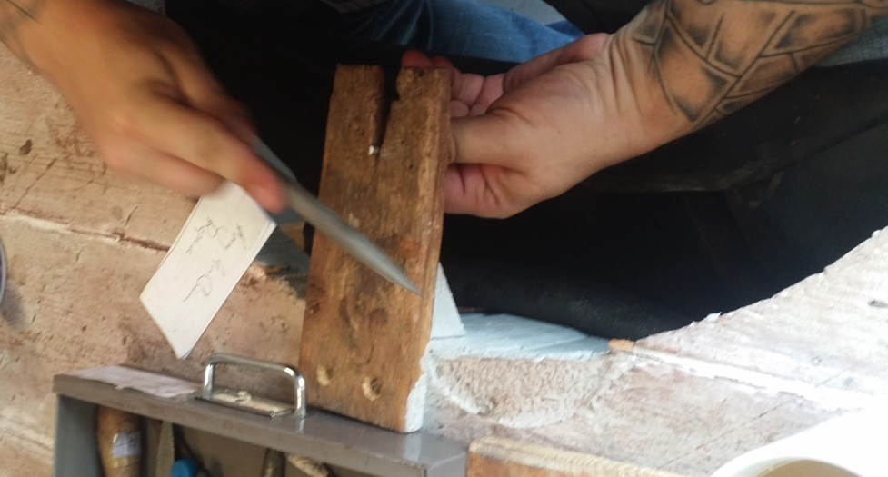

Physical layout as support for cognition

Our previous work on academic craft skills had demonstrated that skilled academics have considerable quantities of knowledge about academic craft skills. These skills, however, are largely abstract and unobservable. We conducted the study reported here on a physical craft to see whether there were significant physical features that related to the nature and structure of the craft skills. This was indeed the case.

Figure 4 shows part of the silversmith’s workshop during the data collection session.

Figure 4: Tools in the silversmith’s workshop

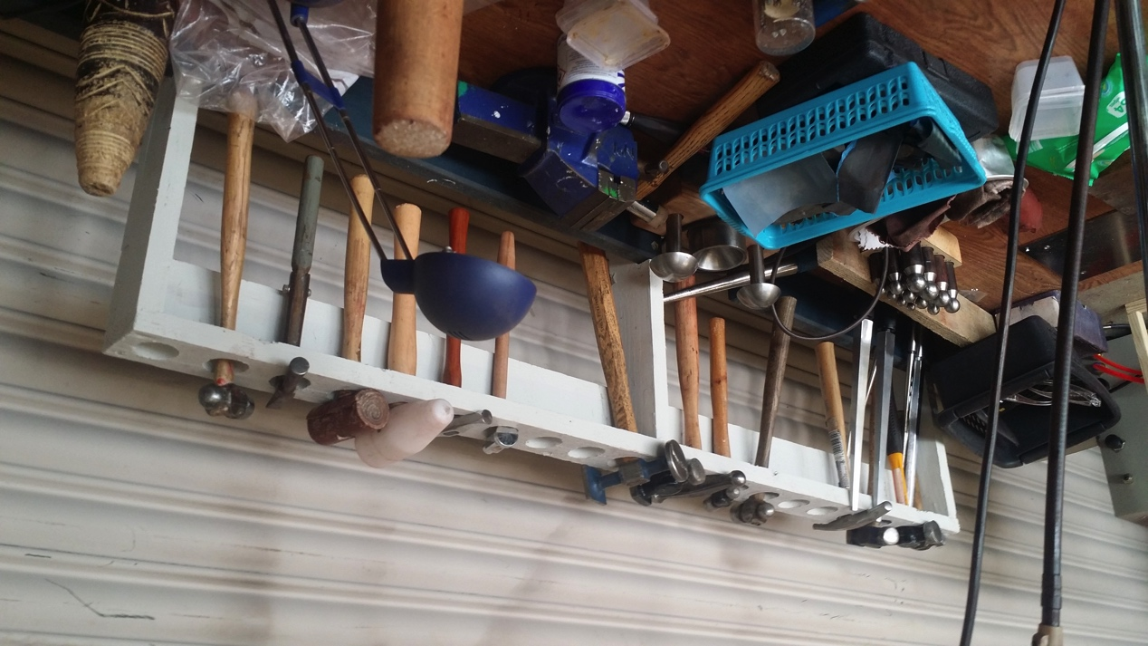

At first sight, this layout might appear untidy and unstructured. From a knowledge modelling perspective, however, there are interesting regularities and structures which have implications for non-manual craft skills, such as those involved in management.

One obvious structure is the rack of hammers. It contains eighteen holes, of which thirteen are occupied, one hammer per hole. This number is well beyond the capacity of human short term memory, namely about seven plus or minus two (Miller, 1956). Having the hammers visible in this way makes it easy for the silversmith to find a particular hammer via recognition (passive memory) rather than via slower and error-prone recall (active memory).

The locations of the hammers and the holes also suggest that the hammers have been laid out on the basis of some form of deliberate categorisation. For instance, there are two hammers with non-metal heads next to each other toward the right of the rack, and two hammers with textured faces next to each other near the middle of the rack. This is consistent with the literature on expertise, where experts typically have richer and more structured knowledge categorisation than novices in the same field (e.g. de Groot, 1965; Chi et al, 1988).

Another possible feature of the rack is the use of significant absence. Gaps can be deliberately left between groups of hammers, to make it easier to tell the groups apart. Gaps within a group of hammers can also be used as an aide-memoire, showing where a tool is missing from its proper place. Many workshops have tool boards with painted silhouettes for each tool, so that absences can be seen at a glance, and so that the correct place for each tool can be easily seen.

More subtly, the apparent clutter in front of the hammer rack can also be related to reduction of cognitive load. Clutter is a common feature across many, but not all, manual crafts. There are several common reasons for this. One is when the nature of the work means that replacing tools in their normal storage place is not feasible; for instance, if the task involves working on material within a tight timescale, such as working with hot metal before it cools, or with wet paint before it dries. Another, as in this case study, is when a range of tools are used particularly often; in this situation, it makes more ergonomic sense to have the tools within reach, and easily visible, so that they can be swiftly recognised via passive memory.

Workshops typically have huge quantities of tools and materials; efficient use of layout can greatly reduce the cognitive load for the workshop user.

This may appear obvious, but when we compare this situation with the situation of a typical manager, the differences are stark. Management theories and concepts are typically intangible, unlike the very tangible tools and materials of physical crafts. How, then, can managers organise the considerable range of methods and conceptual tools that are available to them, in a way that will reduce cognitive load and cognitive limitations?

The answer is that usually managers have considerable difficulty with this. This has been recognised within the management literature via e.g. the development of the “garbage can” model of management, in which a manager faced by a problem scrabbles through the set of solutions that they have most recently used (Cohen et al, 1972). The same issue was addressed by Cross (2011) in the context of design, with regard to methods and physical materials to support the design process.

An obvious solution is to put the relevant knowledge online in some form. That idea, however, has numerous drawbacks. For a start, it has been recognised since Mintzberg’s pioneering studies of managers’ actual behaviour (Mintzberg, 1973) that a high proportion of managers’ time is spent on firefighting, i.e. responding swiftly to unexpected problems that need immediate action. In such situations, searching an online repository may require time that isn’t available.

Another problem with putting relevant knowledge online is that much of the relevant knowledge cannot or will not, by its very nature, be put online. This includes a range of forms of semi-tacit knowledge, such as back versions of behaviour (Goffman, 1959). By definition, back versions are not intended for public view, and any sensible organisation would be very reluctant to have its back versions stored as hard information, with the accompanying risk of that information being leaked and causing damage to the organisation’s reputation. A related issue is that having a standard set of documentation online will usually diminish the status of the manager, whose authority derives in part from knowing methods and facts that subordinates do not know.

This means that other forms of physical support for cognition are required. Usually, however, these are lacking. We return to this issue in the discussion section of this article.

Methods for studying craft skills

Because craft skills frequently involve semi-tacit or tacit knowledge, eliciting information about them will by definition have to involve techniques other than interviews, questionnaires and focus groups. Most of these methods are well established, often with a substantial literature on their use and their theoretical foundations.

One obvious and sensible place to start is with observation, whether direct or indirect observation. This can include techniques such as STROBE (STRuctured OBservation of the Environment) (Kendall & Kendall, 1984) and various forms of task analysis. A classic form of task analysis was the Therblig method developed by the Gilbreths in the early years of the 20th century; this approach is still very much in use today (Ferguson, 2000).

Although task analysis can be extremely useful for codifying the activities involved, it needs to be used with care, because of the risk of wrongly lumping together different categories of activity if the observer is unfamiliar with the domain of expertise. For example, the activities of texturing a surface and of raising a bowl in silversmithing both involve hitting the metal with a hammer, but lumping them together into the same category of “hitting with a hammer” would obscure the important differences between them. This is one reason that the original Therblig method was deliberately left open-ended, so that new symbols could be used where appropriate, to let the observer record at the appropriate level of granularity.

Similarly, cognitive task analysis methods such as GOMS (Card, Moran & Newell, 1983) and subsequent methods need to be used with care, since they are heavily grounded in the explicit, front versions that are provided by the individual being studied. This leads to several risks to validity. Explicit knowledge is subject to a range of memory biases and distortions (e.g. Loftus & Palmer, 1974) and needs to be treated with caution. Back versions of what actually happens in normal situations may be very different from the front versions presented to a researcher (Goffmann 1959). There is also the risk that the individual is producing an account which they believe to be true, but which is actually a confabulation about procedures which are actually tacit (Hirstein 2006) and bear little or no relation to the confabulated account. In addition, verbal accounts are inherently sequential in nature, whereas a high proportion of physical tasks involve parallel processing, often both cognitively and physically. Although formal notations for cognitive task analysis such as GOMS (Card, Moran & Newell, 1983) take account of parallel processing, this is a notoriously difficult problem to represent.

Think-aloud technique is a very useful complement to observation, since it gives a concurrent trace of the participant’s thought processes (Ericsson & Simon, 1980). It is particularly useful because it gives access to working memory, which only has a duration of a few seconds (Miller, 1956), and whose contents can therefore only be accessed using real-time elicitation methods.

This approach overlaps with reflective approaches, as described by e.g. Schon (1983). However, reflective approaches should be used with care, since they are prone to various biases associated with introspection, such as attribution error (Heider, 1958). For example, Repenning and Sterman (2002), discuss how such errors can affect reflection-based approaches to process improvement.

Both observation and think-aloud technique can be complemented by upward laddering on goals and values (Hinkle, 1965; Reynolds & Gutman, 1988; Rugg & McGeorge, 1997), and by downward laddering for explanations of subjective and of technical terms until this “bottoms out” in observable attributes and actions (Rugg & McGeorge, 1997).

All of the techniques above can be used either directly or projectively. Projective elicitation involves asking the participant to behave and/or respond as if they were a specified other person, such as a lazy or an unscrupulous practitioner. This can be particularly valuable for gaining access to beliefs about back versions and about improper practices.

Our methodological findings in this case study are very similar to those in our previous work on academic craft skills (Rugg et al, 2008). This suggests that the set of methods described here should be appropriate for study both of physical and of cognitive craft skills, both within and outside a formal academic setting.

Discussion

Theoretical issues

One significant feature of this case study was that categorisation of different types of knowledge and skill provided powerful insights into the craft skills being studied. Having a rich taxonomy which distinguished numerous types of semi-tacit and tacit knowledge enabled the choice of appropriate elicitation method for each type; for instance, the use of think-aloud technique to capture knowledge during the very short time when it is in working memory. Similarly, the semi-tacit categories of recall and recognition made sense of the apparent clutter in the working environment, and identified a feature of this physical craft which provided cognitive support to the practitioner in a way that is not readily available to groups such as managers, who deal largely with intangible methods.

Another significant theoretical issue raised in this article is the concept of instantiation level, which allows cleaner and more powerful analysis of the craft skills involved in a particular case. This is consistent with our findings about academic craft skills, where unpacking a participant’s knowledge down to the level of instantiation enabled us to identify the point where key misunderstandings arose, and where instruction was falling short (Rugg et al, 2008). This is closely linked to the use of laddering, and to the inclusion of taken for granted knowledge (Grice, 1975) in our knowledge modelling framework.

What we often observed in our work on academic craft skills was that a gulf of instantiation arose when both instructor and student believed that the instructor had unpacked a concept down to a level where the student could fill in the remaining levels to instantiation from their existing knowledge. Digging into this level systematically via laddering made it clear that in some cases, the students had a very different model from the instructor about the remaining levels, and that in others, the students realised that they were mistaken in their belief that they could fill in the remaining levels (Rugg et al, 2008).

Methodological issues

In this case study, the expert provided richly detailed guidance and rationales throughout the tuition sessions. This, however, is not the only pattern of behaviour that occurs when studying craft skills. Often, the expert’s knowledge is strictly tacit, in the sense that the expert is unable to verbalise their knowledge because it is inaccessible to mental introspections.

For both this study and our previous work on academic craft skills, observation provided valuable insights. For the work on academic craft skills, think-aloud technique and laddering provided rich, powerful insights which had been missed by previous methods. Any systematic research into craft skills should use these techniques to improve the chances of detecting the full range of semi-tacit and tacit knowledge involved.

Practice and policy issues

The craft skills that we observed in this case study drew on a wide range of knowledge types and of sensory modalities. This is in contrast with the craft skills of disciplines such as management, which are typically restricted to a very narrow set of knowledge types and sensory modalities.

In addition, the nature of silversmithing was well suited to the use of external aids to cognition, such as physical layout of tools.

Both of these areas offer considerable potential for future research.

In the case of modalities, some issues have been well addressed in various literatures. For instance, the invention of mechanical printing and of woodcut illustrations had major implications for the dissemination of technical knowledge, by facilitating the spread both of verbal and of visual hard information. For various reasons, management practice is still heavily dominated by these two modalities for hard information, and by the spoken word for soft information. This has significant implications for cognitive load.

The issue of cognitive load on managers has been known since at least the 1970s, when Mintzberg noted the constraints placed on managers by the nature of their work (Mintzberg, 1973). Managers tend to make heavy use of soft information, which has significant strengths in terms of immediacy and its usefulness for handling the back versions of problems. However, this soft information tends to be verbal, thereby reducing the scope for cognitive support that is offered by hard information media such as checklists, schematics, etc. There are some non-verbal soft information options such as sketching out a possible solution on a whiteboard and then erasing it, but common options such as whiteboards have obvious practical limitations as regards portability etc.

The result is that when managers try to think of solutions to a problem, they tend to depend on unaided recall from memory. This exposes them to a wide range of biases that are well documented in the Judgment/Decision Making (J/DM) literature (e.g. Kahneman, Slovic & Tversky, 1982) such as recency bias towards solutions that they have used recently, vividness bias towards colourful solutions, and primacy bias towards the first solutions that they learned. There are also numerous classes of predictable error to which unsupported human cognition is prone, such as “strong but wrong” errors, where the person slips into the most familiar action, rather than the correct action.

Some of these biases are recognised in the management literature; for instance, the “garbage can” model of management (Cohen, March & Olsen, 1972), based on the metaphor of the manager rootling through the garbage can of recently discarded experiences to see whether there is something useful there, is a colourful way of describing recency bias.

Implications for managers

How best to tackle the problems described above is an interesting question.

For design of workplace layout for physical tasks, there is a well-established body of knowledge going back for over a century. For routine managerial tasks, such as report writing, there are well-established support tools such as spreadsheets, databases, and automated report generators. For choosing the most appropriate solution to a new problem, however, the situation is different. This is a particular issue because of the amount of time most managers spend firefighting unexpected problems, where supports such as customised spreadsheets or personalised dashboards are often irrelevant to the problem in hand.

There are some examples of cognitive supports within the management literature. For instance, Malone’s classic study of desktop organisation (Malone, 1983) describes a similar phenomenon to the spatial layout of tools that we observed in the silversmithing case study, with the layout and structure of documents in the manager’s office (e.g. which documents were in the same pile, or filed in the same drawer) providing cues to the nature and content of those documents. For cognitive support in choosing the most appropriate solution, however, managers face some difficult constraints.

One obvious source of cognitive support is online documentation accessible via portable devices such as tablets and mobile phones, but the inherently serial nature of text means that it takes time and effort to work through the set of possible solutions. Formats such as graphical wall charts can reduce cognitive load by allowing the manager to use visual pattern-matching, which is much swifter than reading text, but any public display of material runs the risk of making the manager appear less expert and skilled than if they have the solution immediately available in their head.

Interestingly, Malone (op.cit) noted that the spatial organization of the documents was often used informally as a reminder about tasks that needed to be done.

One elegant variation on this approach is to make deliberate use of aide-memoires that are based on the manager’s previous episodic experience, such as physical mementoes of previous cases, displayed as ornaments on the manager’s desk or shelves. Such mementoes are semantically opaque to visitors, who do not know the associations that go with each memento; they can also act as useful props for conversations in which the manager displays expertise by telling the story behind a particular item, should the manager choose to do so.

Another traditional approach is to use mnemonics based on spatial imagery to help organise the manager’s memory of possible solutions into groups and sub groups. This is consistent with the literature on expertise, which consistently finds that experts have well-organised structures for their explicit knowledge (e.g. Chi, Glaser & Farr, 1988); such structures lend themselves readily to being mapped onto spatial metaphors.

Implications for education and training

There are also significant implications for education policy with regard to craft skills. The approach outlined in this case study can be scaled up to allow systematic elicitation and modelling of craft skills in a given field, in a way that fits well with systematic curriculum and assessment design.

Brown and McIntyre’s 1993 study focused upon “good teaching” of 6 primary schools and 12 secondary schools, and demonstrated how teaching practitioners would “choose actions…with several goals in mind. “.

The study as mentioned did not distinguish for example the difference between
expert teachers and trainee teachers. A study by Hagger and McIntyre, 2006,
noted this and started to look at “professional craft knowledge”. This, however needs to be addressed properly, as Tom and Valli (1990) warn that there is little consensus about what ”craft knowledge” means. The approach above however would allow assessment and curriculum to be refined based on key skills and knowledge which are not explicitly taught and support in identifying “craft knowledge”. This could be extended to refining apprenticeship courses as well as identifying a cohesive assessment system within education, focusing on knowledge rather than recall.

The implications would mean a refined trainee teacher program as well as a standardised assessment system, which is already starting to be integrated within education through PiXL Personal Learning Checklists, in which these focus on key knowledge for a qualification, but not necessarily key knowledge or skills needed. One example would be research skills and the difference in an expert researcher and an undergraduate student.

Conclusion and further work

Using a formal framework for knowledge representation and knowledge types provides crucial insights into some key issues which had previously been unclear within the literature on craft skills. In particular, the concept of the “gulf of instantiation” was invaluable for making sense of how formal academic course content relates to the application of concepts from that course, and for making sense of some common misunderstandings when students tried putting course content into practice.

This framework offers a way of systematically evaluating academic courses with regard to how completely they ensure that knowledge on the course is instantiated. The implications for applied disciplines, such as vocational courses for physical crafts, are far-reaching.

Similarly, this framework helped make sense of numerous features of the silversmithing case study, some of which have practical implications for more abstract skills such as management. In particular, physical cues to support cognition were significantly present in the silversmithing case, and are significantly lacking in management practice. There is considerable scope for improving the situation in management by identifying suitable types of physical cue in other fields, and then importing or adopting them for use in management. We will explore this further in our future work.

References

Allum, J.H.J. and Honegger, F. (1998), ‘Interactions between vestibular and proprioceptive inputs triggering and modulating human balance-correcting responces differ across muscles,’ Experimental Brain Research, Vol.121, No.4, pp478-494.

Barbe, W. B., Swassing, R.H., Milone, M.N. (1979) Teaching through modality strengths: concepts practices, Zaner-Bloser, Columbus, Ohio.

Briscoe, G., Dainty, R.J., and Millett, S. (2001) ‘Construction supply chain partnerships: skills, knowledge and attitudinal requirements’, European Journal of Purchasing & Supply Management, Vol.7 No.4 pp243-255.

Cantrall, A.M. (1954) ‘Practical skills can and must be taught in law schools’, Journal of Legal Education, Vol. 6 No.3, pp316-323.

Card, S., Moran, T.P. and Newell, A. (1983) The Psychology of Human Computer Interaction, Lawrence Erlbaum Associates, Hillsdale NJ.

Chi, M.T.H., Glaser, R. and Farr, M.J. (Eds.), (1988) The Nature of Expertise, Lawrence Erlbaum Associates, Hillsdale NJ.

Cohen, M.D., March, J.G. and Olsen, J.P. (1972) ‘A Garbage Can Model of Organizational Choice’, Administrative Science Quarterly, Vol. 17 No.1, pp.1-25.

Cordingley, E. S. (1989) ‘Knowledge elicitation techniques for knowledge-based systems’, in Diaper, D. (Ed.), Knowledge elicitation: Principles, techniques and applications, Ellis Horwood, Chichester UK.

Cross, N. (2011), Design Thinking: Understanding How Designers Think and Work, Bloomsbury Academic, London.

Dekker, S., Lee, N.C., Howard-Jones, P. and Jolles, J. (2012) ‘Neuromyths in education: Prevalence and predictors of misconceptions among teachers’, Frontiers in Psychology, Vol. 3, pp1-8.

Ericsson, K. and Simon, H. (1980) ‘Verbal reports as data’, Psychological Review, Vol. 87 No.3, pp.215–251

Euler, L. (1741) (facsimile of original paper) ‘Solutio problematis ad geometriam situs pertinentis’, Commentarii academiae scientiarum Petropolitanae Vol. 8, pp.128–140.
http://eulerarchive.maa.org//docs/originals/E053.pdf
(Accessed 8 November 2017).

Ferguson, D. (2000) Therbligs: The Keys to Simplifying Work.
http://gilbrethnetwork.tripod.com/therbligs.html
(Accessed 8 November 2017).
Goffmann, E. (1959) The Presentation of Self in Everyday Life, Doubleday, New York.

Grice, H. P. (1975) ‘Logic and Conversation’, in Cole, P. and Morgan J.L. (Eds.) Syntax and Semantics 3, Academic Press, New York.

de Groot, A.D. (1965) Thought and Choice in Chess, Mouton, the Hague.

Hagger, D. and McIntyre, D. (2006) Learning teaching from teachers: Realising the potential of school-based teacher education, Open University Press, Maidenhead UK.

Heider, E. (1958), The Psychology of Interpersonal Relations, Wiley, New York.

Hinkle, D. (1965) The change of personal constructs from the viewpoint of a theory of construct implications. Unpublished PhD thesis, Ohio State University, Ohio, USA.

Hirstein, W. (2006) Brain Fiction: Self-Deception and the Riddle of Confabulation, MIT Press, London.

Isaac, G.L. (1972), ‘Early phases in human behaviour: models in Lower Palaeolithic archaeology’.
In Clarke, D.L. (ed.) (1972) Models in Archaeology, Routledge, London.

Kahneman, D, Slovic, P. and Tversky, A. (1982) Judgment under uncertainty:
Heuristics and biases, Cambridge University Press, Cambridge UK.

Kendall, K.E. and Kendall, J.E. (1984) ‘STROBE: A structured approach to observation of the decision-making environment’, Information & Management, Vol. 7 No. 1, pp1-11.

Kirschvink, J.L., Kobayashi-Kirschvink, A., Diaz-Ricci, J.C. and Kirschvink, S.J. ‘Magnetite in human tissues: A mechanism for the biological effects of weak ELF magnetic fields’ Bio Electric Magnetics, Vol.13, No.S1, (supplement) pp.101-113.

Lamont, M. (2002), The Dignity of Working Men: Morality and the Boundaries of Race, Class and Immigration, Harvard University Press, Harvard.

Livingstone, B.F. (1973), "Did the Australopithecines Sing?," Current Anthropology, Vol.14, No.1/2, pp.25-29.

Loftus, E.F. and Palmer, J.C. (1974) ‘Reconstruction of automobile destruction: An example of the interaction between language and memory’, Journal of Verbal Learning and Verbal Behaviour, Vol. 13, pp.585-589.

McNabb, J. (2012). ‘The Importance of Conveying Visual Information in Acheulian Society. The Background to the Visual Display Hypothesis.’
In: Cole, J. and Ruebens, K. (eds.), (2012), Human Origins (volume 1), University of Southampton, UK.
http://eprints.brighton.ac.uk/13528/1/HumanOriginsV1.pdf
Accessed June 6, 2018.

Maiden, N.A.M. and Rugg, G. (1996) ‘ACRE: a framework for acquisition of requirements’, Software Engineering Journal, Vol. 11 No.3, pp.183-192.

Malone, T.W. (1983). ‘How do people organize their desks? Implications for the design of office information systems’, ACM Transactions on Information Systems, Vol. 1 No.1, pp.99–112.

Miller, G.A. (1956) ‘The magic number seven, plus or minus two: Some limits on our capacity for processing information’, Psychological Review, Vol. 63, pp.81-93.

Mintzberg, H. (1973) The Nature of Managerial Work, Harper & Row, New York.

Neisser, U. (1967) Cognitive Psychology, Prentice Hall, Englewood Cliffs, NJ.

Polanyi, M. (1958) Personal Knowledge: Towards a Post-Critical Philosophy, University of Chicago Press, Chicago.

Reichgelt, H. (1991) Knowledge Representation, Ablex Publishing Corp., Norwood NJ.

Repenning, N.R. and Sterman, J.D. (2002), ‘Capability Traps and Self-Confirming Attribution Errors in the Dynamics of Process Improvement,’ Administrative Science Quarterly, Vol.47, No.2, pp.265-295.

Reynolds, T.J. and Gutman, J. (1988) ‘ Laddering Theory, Method, Analysis, and Interpretation’, Journal of Advertising Research, February-March 1988, pp.11-31.

Rugg, G., D’Cruz, B., Foreman-Peck, L., Grimshaw, E., Guilford, S., Roberts, S. and Tonglet, M. (2008) ‘Selection and use of elicitation techniques for education research’, International Journal of Information and Operations Management Education, Vol. 2 No.3, pp.235–254.

Rugg, G. and McGeorge, P. (1995) ‘Laddering’, Expert Systems, Vol. 12 No.4, pp.339-346.

Schon, D.A. (1983) The Reflective Practitioner: How Professionals Think in Action, Basic Books.

Sennett, R. (2009) The Craftsman, Penguin, London.

Shusterman, R. (2011), ‘Muscle Memory and the Somaesthetic Pathologies of Everyday Life,’ Human Movement, Vol.12, No.1, pp4-15.

Sutton, J. (2006), ‘Distributed cognition: Domains and dimensions,’ Pragmatics and Cognition, Vol.14, No.2, pp.235-247.

Thayer, R.H. and Dorfman, M., eds. (1997) Software Requirements Engineering, 2nd ed., IEEE Computer Society Press.

Tom, A.R. and Valli, L. (1987) ‘Foundations of education in teacher education’, in Houston, W.R., Haberman, M. and Sikula, J. (Eds), Handbook of Research on Teacher Education, Macmillan, USA.

Trist, E. and Bamforth, W. (1957), ‘Some Social and Psychological Consequences of the Long Wall Method of Coal-Getting,’ Human Relations, Vol.4, pp.3-38.

Tulving, E. (1972) ‘Episodic and Semantic Memory’.
In: Tulving, E. and Donaldson, W. (1972) Organization of memory, Academic Press, London.

Uomini, N.T. (2011), ‘Handedness in Neanderthals’.
In: Conard, N.J. and Richter, J. (Eds.) (2011) Neanderthal lifeways, subsistence and technology, Springer, Heidelberg.

