LIST OF FIGURES
Figure 1 – anonymised photo of an interview at the Beef Expo, 2017. Interviewer, Nick Evans.

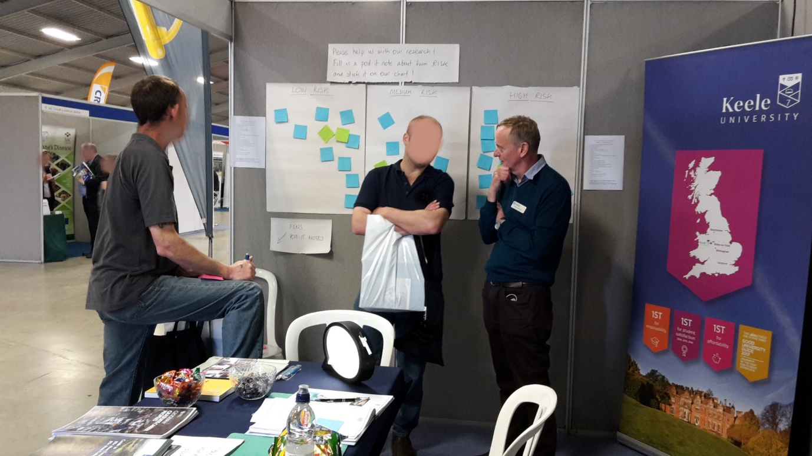

Figure 2 – Flipchart papers to be covered in post-it notes, filled in either at the start or end of an interview. The idea of framing this around risk is useful as an idea generator.

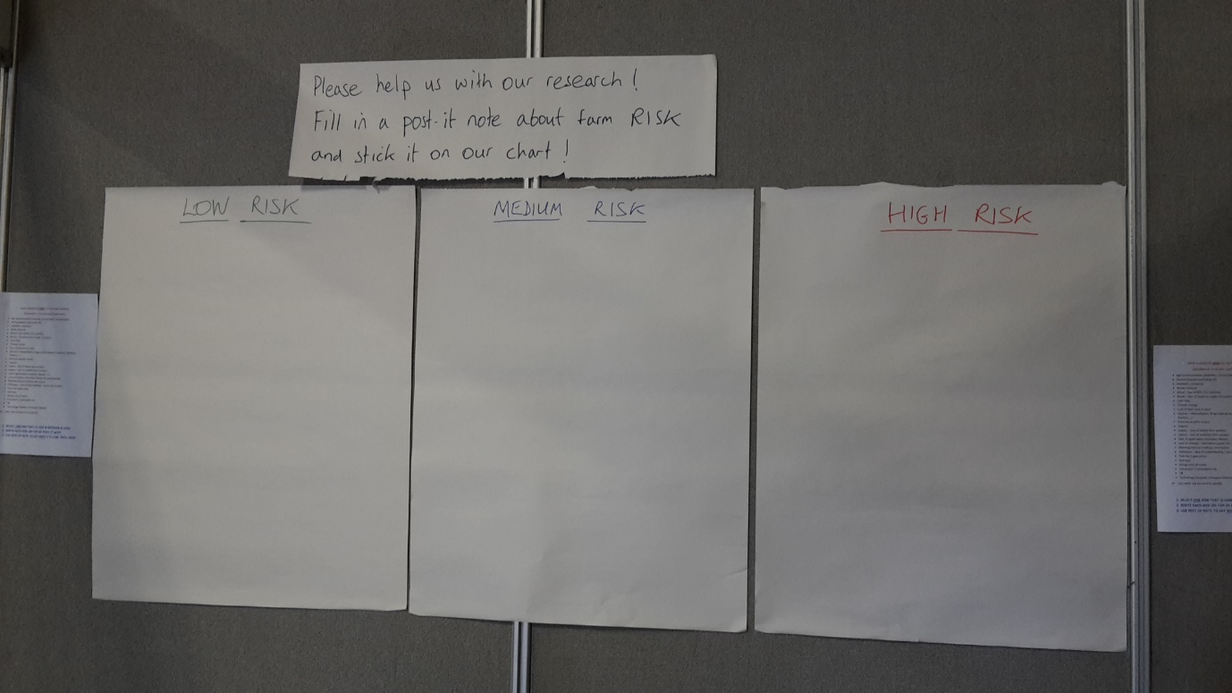

Figure 3 – photograph of show stand visitor at the Dairy Day, 2017: Interviewer Nick Evans

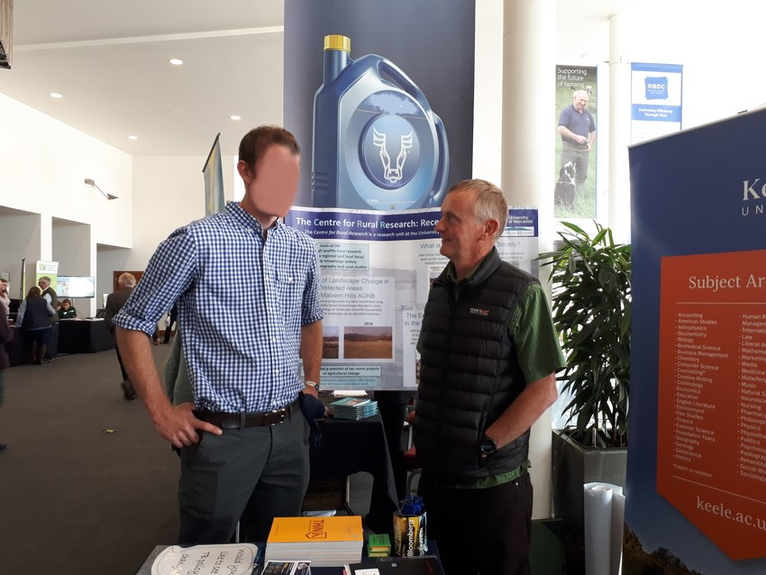

Figure 4 – Piechart showing the typology of feelings, coded from the interview material and post-it notes.

