**Ln3+ doping in CaYAl3O7 and luminescence concentration quenching studied via a new computer modelling strategy.**

**Giordano F. da C Bispo.**1,\***, Robert A. Jackson** 2 **, Zélia Soares Macedo¹ and Mário E. G. Valerio** 1

*1 Physics Department, Federal University of Sergipe, 49100-000, São Cristovão-SE, Brazil*

*²Lennard-Jones Laboratories, School of Chemical and Physical Sciences, Keele University, ST5 5BG, Keele, Staffordshire, UK*

[*\*gfredericoc@gmail.com*](mailto:*gfredericoc@gmail.com)

**Abstract**

Ln-doped CaYAl3O7 (CYAM) has several applications due to its optical properties. This crystal matrix belongs to the melilite family, where Ca2+/Y3+ ions are randomly distributed at the same crystallographic site keeping a composition ratio of 1:1. This natural disorder represents a problem to traditional modelling strategies because it is not possible to determine experimentally which ion is actually substituted when a Ln3+ ion is incorporated. To overcome this problem and to be able to use a static computer modelling approach based on energy minimisation, a supercell was built and Ca2+/Y3+ ions were distributed randomly in the crystallographic positions keeping the composition ratio at 1:1. The substitution of any Ln3+ at cation sites could be successfully simulated. The energetic cost for the extrinsic defect creation were calculated using two different approaches. The first one was the well-established Mott-Littleton method, where the defect of interest is created in the centre of an explicit region and the position of all species were allowed to relax until a minimum potential energy is reached, with more distant regions being treated as a dielectric continuum. The second approach was based on a direct incorporation into a supercell by just redefining the supercell structure with the defect of interest as part of the supercell itself. The results from both approaches demonstrated that substitution at Ca site with charge compensation by Ca displaced to Y site, forming a kind of anti-site defect, was the most probable configuration. Analysis of the defect region showed that presence of mostly Ca ions in the next neighbour cation site to the dopant site reduced the solution energies. This latter result can explain the high Ln doping concentration limit observed for Ln3+ - doped CYAM, as compared to Ln3+ doping in other host materials, without any appreciable photoluminescence concentration quenching.

Keywords: CaYAl3O7, Lanthanides doping, Static Computer Modelling, Extrinsic defect

1. **Introduction**

Materials doped with lanthanide (Ln) ions are well known and widely explored due to having several optical applications. CaYAl3O7 (CYAM) is one such system where interesting luminescent properties when doped with Ln, were observed. Experimental work has suggested several possible uses, including sensing structural damage, solid-state light sources for white LEDs and temperature sensors [1-3]. These potential applications are linked to the type of Ln-doping as well as the way that the Ln3+ ion interacts with the surrounding neighbourhood and that is a direct effect of the first neighbour distances and the Ln3+ site symmetry. Furthermore, the relative position of the rare-earth 5d orbitals with respect to the conduction band of material also can influence the luminescence properties[ref]. This happen because when the excited-state 5d orbitals are located close enough to the conduction band of the host crystal structure the photoionization or charge transfer can occur[ref]. Recently, an alternative approach using DFT band gap predictions and Debye temperature has been published[ref], but these cases are not treated in this work.

CYAM is a member of the melilite family with a tetragonal crystalline structure, belonging to the space group P421m [4]. The crystal structure is formed of a sheet-like arrangement with five membered rings in (AlO4)-5 tetrahedra perpendicular to the c-axis. The Ca2+ and Y3+ ions are distributed randomly in the same six coordinated sites with Cs symmetry between the layers. This shared site has been suggested as the most probable substitutional site for Ln3+ and other cation dopants by experimental work [5], but it is not possible to determine experimentally which ion is substituted owing to intrinsic disorder of the Ca/Y shared site. This characteristic of the CYAM structure is one of the challenges for defect modelling calculations [6, 5].

This problem was treated previously using computer modelling based on interatomic potential using a strategy, away from the traditional mean field approach. This strategy was based on building up supercells with Ca/Y ions randomly distributed, keeping the composition ratio of 1:1 and using the quality of the simulated XRD pattern as compared to the standard pattern deposited in the crystallographic database as a criterion for choosing the best supercell size and the Ca/Y distribution. [6]. Results for intrinsic defect calculations predicted successfully an oxygen Frenkel defect as the most probable form of disorder [6], in line with experimental work reported in literature [7]. The present paper applies such a strategy to simulate the doping process of CYAM by Ln ions. The calculations enabled predictions of the sites occupied by dopant ions and possible forms of charge compensation defects, when required. Results can be used to explain features found in the luminescence properties of this materials observed by experimental works.

1. **Methodology**

The calculations used in this work are based on an atomistic model and energy minimisation. This allows the atomic configuration with minimum total energy to be obtained [8]. The interactions between ions present in the material were described through a set of pairwise interatomic potentials derived previously [6]. An important fact about CaYAl3O7 modelling is that Ca2+ and Y3+ ions are distributed randomly at the same crystallographic site with a composition ratio of 1:1 [3, 6]. Several studies have suggested the Y3+/Ca2+ shared crystallographic site as the most probable substitution site for trivalent lanthanide (Ln3+) dopants due to ionic radii similarity [3, 5, 9].

The intrinsic disorder does not present a problem for general structure methods, such as X-ray diﬀraction (XRD) [6], however for computer modelling aiming to calculate energetic cost of defect formation, it presents a huge problem. Firstly, it is impossible to determine which ion is substituted, Ca2+ or Y3+, when a dopant is placed in the Ca/Y shared site and a possible charge compensation mechanism could be necessary for an aliovalent substitution, when a Ca ion is substituted for the dopant. In a previous paper, we proposed as a solution to construct a supercell large enough and with enough Ca/Y sites within the supercell that a certain random distribution of Ca and Y produced a calculated diﬀraction pattern with a good agreement with standard diﬀraction patterns. The defects are calculated within such supercell considering all possible site combinations. Such methodology was applied to calculate the intrinsic defects in CYAM and it showed that oxygen Frenkel defects have the lowest energetic cost of all possible intrinsic defects and this is, thus, the predicted intrinsic disorder that would be found in the material [6]. This result was in line with experimental results that showed the presence of F-centres, an oxygen vacancy that captures electrons, and a possible emission related to an interstitial oxygen defect [7].

For Ln-doping in CYAM calculations this was performed using a 3 x 3 x 3 supercell that followed the criteria previously reported and is still within the size that is reasonably treatable with smaller computer costs [6]. The same set of pair-potential parameters used successfully for intrinsic defect calculations were used in the present work supplemented by the Ln3+ interactions that were provided by pairwise potentials from reference [12].

The Ln3+ defects were calculated with the above supercell following two different approaches. The first one is based on the well-establish Mott-Littleton strategy [11] that consists of the division of crystal lattice in two regions, a first where interaction between atoms are treated explicitly and another treated as a continuum dielectric. Consistent regions size of 22 and 26 Ǻ were used in calculations. These will be called Mott-Littleton results from now on. In the second approach the energetic cost associated with the creation of the defects of interest was obtained from the diﬀerence between the defective and perfect supercell lattice energies [6, 10], where the perfect supercell should be understood as the 3x3x3 supercell generated according to the previous description and considering only the ions that are part of the CYAM structure, and the defective supercell is the one where the defect of interest is produced inside the supercell. As an example, suppose that the defect of interest is Eu substituting for a Ca ion. One of the Ca2+ ions of the perfect supercell is removed, and the Eu is allocated to that site. Since there are 54 Ca sites in the 3 x 3 x 3 supercell, this calculation has to be repeated for all of them and an average of all energies is found. When bound defects are to be considered, i.e., a charged defect generated by the doping effect and its accompanying charge compensation defect, all parts of the defect are arranged inside the supercell and again, since the number of possible configurations are quite high, the energies quoted are those which represent the configuration with lower energetic cost.

In order to determine the most probable substitution site for Ln3+ substitution, in the CYAM matrix, some considerations must be made. Firstly, it is unlikely that a cation would substitution for O2- site because there is a very large chemical difference between the two species. Secondly, each Ca2+ and Y3+ site in the supercell must be considered as a possible substitutional site and all calculations and defect equations must take that into account. Lastly, since Ca and Y have now their own site in the superlattice, an anti-site defect is now meaningful and can be considered as one possible charge compensation defect. Although these considerations may sound quite obvious, it is necessary to keep them in mind so the model can come close to what actually happens in a real crystal. Furthermore, it is possible chemically induced ${Ca}_{Y}^{'}$ defects in material as a compensation of incorporation of Eu3+ ions in Ca sites [reference].

Table 1 presents the mechanisms considered that involve doping CYAM by Ln3+. For each mechanism a solid state reaction is devised and respective solution energy equations can be obtained. The mechanism considered the substitution of Ln3+ ions at the Al3+, Y3+ and Ca2+ sites. For aliovalent substitution at Ca2+ sites the charge compensation mechanisms can be provided by cation vacancies or anti-site defects. The solution energies were calculated based on these reactions. The solution energy calculations for the Mott-Littleton approach were calculated using the dilute limit approximation [13], where each defect is considered as an isolated defect embedded in a perfect matrix that relax as a consequence of the defect in the centre of the explicit region, and the final energies presented in figures 1a and 1b were normalized by the molar quantities of dopant.

Table 1: Reaction schemes and solution energy defect equations for extrinsic defects in CYAM

|  |  |
| --- | --- |
| Scheme | *Substitutions without charge compensation* |
| (1) | |
|  | |
| (2) | |
|  | |
|  | *Substitutions with charge compensation* |
| (3) | |
|  | |
| (4) | |
|  | |
| (5) | |
|  | |
| (6) | |
|  | |
| (7) | |
|  | |
| (8) | |
|  | |

In these expressions Esol, Edef and Elatt are solution, formation defect and lattice energies respectively. It should be noted that mechanism (7) is only possible because each Ca2+ and Y3+ site were considered as a possible substitutional sites. In fact, such a defect type represents a situation where the Ln3+ occupies a Ca2+ site and this ion is “kicked out” to a Y-site nearby.

3. **Results**

Solution energies are present in Figure 1a and 1b for both Mott-Littleton and supercell approaches. Both approaches gave the same overall trend that qualitatively agreed, despite the fact that they are obtained from two conceptually diﬀerent approaches. Such a result was already obtained by Jackson et al [10] for the system UO2-PO2 using a 2 x 2 x 2 supercell. In the defect calculations using the supercell approach, the defects may interact among themselves since there is one of such defects per supercell and the supercell was replicated periodically. If the defect itself has a net charge, Coulombic interactions will occur. If the defect has a net dipole or higher order electrical moment, there will be dipolar, quadrupolar, etc interactions among them. But that is explicitly included in this approach when the supercell is replicated. One of the consequences is that, if the defect is big, i.e., involves many species within the supercell and the supercell is not big enough, these interactions may be quite large and the model will describe interacting defects, that can be quite different form the infinite dilution approximation. But if the defect involves very few ions and the supercell is big enough the effect of the defect interaction could be quite low and the values will be closer to the infinite dilution values obtained by the Mott-Littleton approach. Therefore, the fact that the solution energies obtained by both strategies are close is an indication that the size of 3 x 3 x 3 supercell is enough to keep the interaction among the defects low enough so that they are may be considered isolated and non-interacting, as for the infinite dilution approximation.

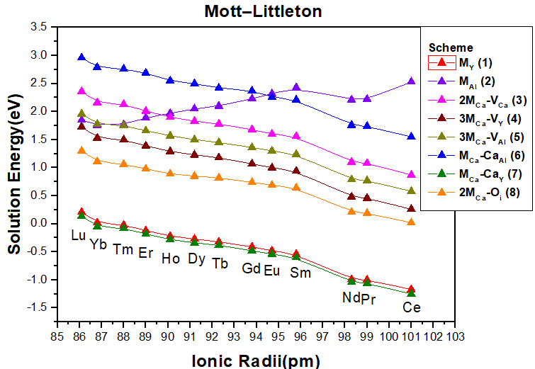

(a)

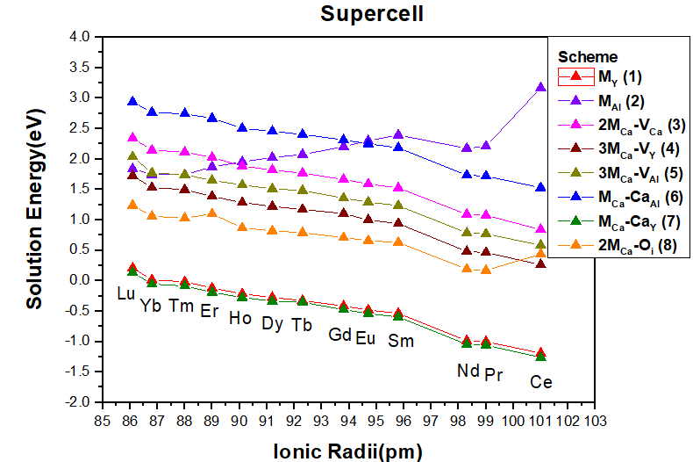

(b)

Figure 1: Solution energy as function of ionic radius calculated by (a) Mott-Littleton and (b) supercell approaches.

As a rule, defects involving Al sites have a higher energetic cost than the other sites. It is interesting to note that for all schemes involving substitution at Ca or Y site (schemes 1,3-7), the solution energy decreases with increase of Ln3+ ionic radii while the opposite behaviour can be observed for isovalent substitution at the Al-site (scheme 2), and this can be viewed as a feature related to similarity of ionic radii between ions involved in the defect schemes. For all schemes involving substitution at Y3+ ( , in CN-Coordination Number = 6) or Ca2+ (, CN=6) sites, Ce3+ ion (with ionic radii of 101 pm, CN=6) these always gave the lowest solution energies, while Lu3+ (, CN=6) always gave the highest solution energies. Typically, aliovalent substitutions tend to cause more distortion in the lattice because it is necessary to create a defect to compensate the excess of charge.

The schemes that are clearly preferable (having lowest energetic costs) are the ones involving the substitution of Y3+ ions by the Ln3+ dopant or the substitution at the Ca2+ site with Ca2+ being displaced to the Y3+ site forming a kind of anti-site defect.

From the point of view of the CYAM structure one could argue that ${Ln}_{(Y)}$ or ${Ln}_{(Ca)}^{•}$ is not different since Ca and Y shares the same site. Nevertheless, one should consider that while ${Ln}_{(Y)}$ is a neutral defect, ${Ln}_{(Ca)}^{•}$ is a positively charged one and this will produce different effects in the lattice. This is one of the key reasons why one should use a supercell as a starting structure for modelling the defects, and not just the normal unit cell of CYAM. The use of the supercell allowed the distinction between both substitutions and additionally allowed the discussion of the mechanism of charge compensation in the case of the ${Ln}_{(Ca)}^{•}$ type substitution. As pointed out earlier, figures 1(a) and (b) indicates that the lowest solution energy for this type of Ln3+ incorporation is via ${Ca}_{(Y)}^{'}$ anti-site and this again just possible to calculate because a supercell with individual sites for Ca and Y was used.

The results shown in figure 1 also demonstrated that substitution of Ln3+ at an Al3+ site are almost impossible and there is a possibility that Ln3+ may replace all Y3+ present in the matrix. The distortion caused by the introduction of Ln3+ in a substitutional site can be seen in figure 2, which shows the average bond length in the site occupied by Ln3+ as a function of ionic radii for Ln(Ca/Y) and Ln(Al). This figure also explains why Ce3+ - based defects have always the lowest solution energies among the lanthanide trivalent ions. Ce3+ based defects always produce the smallest distortion in the lattice as compared to the cation – oxygen bond length.

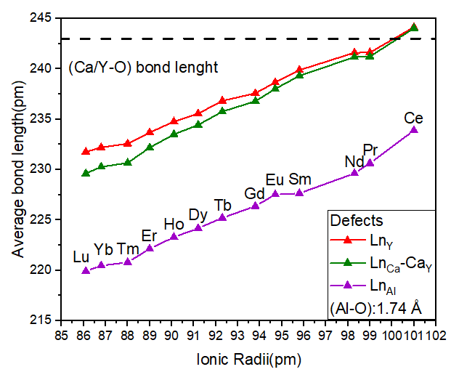

Figure 2: Average bond length in site occupyed by Ln3+ as a function of ionic radii after relaxation using Mott-Littleton strategy.

All three types of defects shown in figure 3 presented the same behaviour with smallest average bond length for Lu3+ and biggest for Ce3+ following the increasing of ionic radii. For LnCa/Y defects there is a compression for all dopant ions except for Ce3+, where the lattice displayed a small contraction, and that is an effect of the ionic radii of Ce3+ of 101 pm, bigger than the one for Ca2+ (90 pm) and Y3+ (100 pm) ions. The maximum lattice distortion occurs for Lu3+ (86.1 pm) with a lattice contraction around 6 %. In the case of the defect all dopants produced a distortion bigger than 26 % and this is one of the reasons why this defect is the one with higher solution energy, as shown in figures 1 (a) and (b). Another interesting feature revealed by the results in figure 2 is that the average bond length is slightly higher for ${Ln}_{(Ca)}^{•}-{Ca}_{(Y)}^{'}$ then for ${Ln}_{(Y)}$ and the difference between them increased as the size of the dopant increased; there is almost no difference for Ce3+ dopant and this difference is around 0.02Å for Lu3+.

Figures 1 and 2 showed that both ${Ln}_{(Y)}$ and ${Ln}_{(Ca)}^{•}-{Ca}_{(Y)}^{'}$ defects presented the same general behaviour and energy costs using both approaches, Mott-Littleton or supercell, with the ${Ln}_{(Ca)}^{•}-{Ca}_{(Y)}^{'}$ defect being the most probable one with the lowest energetic costs among all investigated defects. This feature could only be seen because the CYAM structure was modelled as a supercell. This result also indicated that there may be a trend that the Ln3+ dopants prefer to have Ca2+ in the first cationic coordination shell, and not a random distribution of Ca2+ and Y3+.



1. (b)

Figure 3: Neighbour region of dopant in a (a) LnY and (b) LnCa-CaY defect.

Figure 3 shows the configuration of the neighbouring region of the Eu3+ dopant for the case of the both ${Eu}_{(Y)}$ and ${Eu}_{(Ca)}^{•}-{Ca}_{(Y)}^{'}$ defects. The essential difference is in the number of Ca2+ ions as the nearest cationic neighbour of the dopant. While the Eu(Y) (figure 3a) have 3 Ca2+ atoms in the second coordination shell, for ${Ln}_{(Ca)}^{•}-{Ca}_{(Y)}^{'}$ defect there is one extra Ca2+ ion. This particular diﬀerence seems to be the cause for the smaller energetic cost for the ${Ln}_{(Ca)}^{•}-{Ca}_{(Y)}^{'}$ in comparison to the energetics for the Ln(Y) ones.

This interesting feature can be tested comparing different configurations of the ${Ln}_{(Ca)}^{•}-{Ca}_{(Y)}^{'}$ but allocating increasing number of Ca ions in the first cation coordination shell, from 1 up to 6, that is the maximum number of nearest Ca/Y sites to the dopant, while keeping the stoichiometry of the material within the supercell. All different configurations were treated as new defects and the energetic cost for each one of them was calculated within the Mott-Littleton approach.

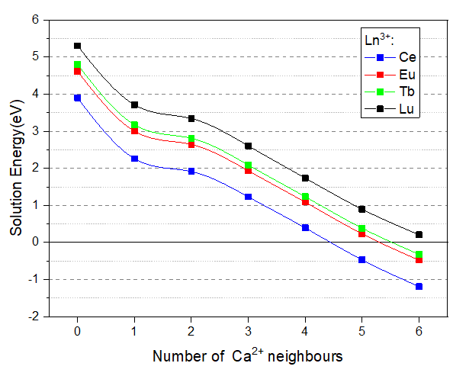

Figure 4: Solution energies versus number of Ca2+ ions neighbours using Mott-Littleton strategy.

Figure 4 shows the solution energies versus the number of neighbouring Ca2+ ions for Ce3+, Eu3+, Tb3+ and Lu3+. The first conclusion is that the energetic costs of the ${Ln}_{(Ca)}^{•}-{Ca}_{(Y)}^{'}$ decreased as the number of Ca2+ increased and for a cationic neighbour fully occupied with Ca2+ ions, the solution energies become close to zero or even negative, for the case of Ce3+, Eu3+ and Tb3+. This surprising result is a clear indication that the Ln3+ dopant would create a kind of “shielding” of Ca2+ ions pushing away Y3+ (or any other Ln3+) ions.

Results in the literature have shown that the photoluminescence yield of Ln3+-doped CYAM exhibited a much higher Ln3+ concentration limit for photoluminescence concentration quenching, when compared to other host materials [1]. The quenching in materials has been largely studied taking account not only concentration of dopant as also the effect of temperature on emission[reference]. The concentration quenching occurs when there is an overdoping of the material which increases the possibility of a non-radiative energy transfer from one activator ion to another. In general, this eﬀect is measured by testing several dopant concentrations until emission intensity started decreasing. The critical distance for energy transfer can be estimated using equation 1 from Blasse’s theory [15]:

 (1)

Here RC is the critical distance, V is the unit cell volume, N is the number of total available sites for dopants and xc is the measured critical concentration. A number of papers have demonstrated that a typical value for the critical concentration is xc =0.35 mol, which implies a critical distance of about 9Ǻ [1, 16].

For all cases of Ln3+ doping in the CYAM structure the distances from the dopant to the Ca/Y site is around 5Å and the second distance is bigger than 10Å. If the closest Ca/Y site to the dopant was available for doping, there would be a possibility that a second Ln3+ would be in this first shell increasing the possibility of luminescence quenching. Since the defect configuration with smallest solution energy is the one where this first site was fully occupied by Ca2+, the chance that another Ln3+ ion can get close is decreased due to this Ca2+ shielding and the closest distance a second Ln3+ can get, as the Ln3+ concentration increases, is in the second shell of Ca/Y sites that lies more than 10Å further apart from the original dopant, decreasing the possibility of luminescence quenching and, as a consequence, increasing the critical concentration limit.

4. **Conclusions**

CaYAl3O7 doped with lanthanide ions was studied via computer modelling. We used a previously developed methodology considering the Ca/Y ions distributed randomly in a 3x3x3 supercell that was able to give a good agreement between standard XRD patterns of CYAM and the calculated supercell one. Two different approaches were then used to calculate extrinsic defects, starting with the same supercell. One of the approaches was using the Mott-Littleton method where a defect of interest is constructed close to the centre of the supercell and an explicit region where all species are allowed to relax in order to obtain the minimum potential energy for the defective system. In the second approach the defect is built within the supercell and this defective supercell is replicated periodically. The energy difference between the periodic defective supercell and the periodic perfect supercell is defined as the energy cost for the defect. The results from both approaches showed perfect agreement and the same trend for energetic costs of different defects were obtained. The most probable defects, with lowest energetic costs, were direct substitution at Y-site and a substitution at Ca-site with Ca being displaced to a neighbouring Y site. A more detailed study of energetic competition between Ln(Y) and ${Ln}_{(Ca)}^{•}-{Ca}_{(Y)}^{'}$ defects showed that the presence of Ca2+ ions in the first Ca/Y coordination shell with respect of the dopant reduced considerably the solution energy, producing a Ca2+ shield for the Ln3+ ions that prevents Y3+ or another dopant ion to be closer to the Ln3+ dopant. This latter result explains why Ln3+-doped CYAM showed a much higher critical concentration limit for luminescence quenching than a number of other hosts.

5. Acknowledgments

The authors gratefully acknowledge the CNPq, CAPES, FINEP and FAPITEC-SE, Brazilian funding agencies, for financial support. We acknowledge the computer facilities of the Centro Nacional de Processamento de Alto Desempenho (CENAPAD-SP) and Centro Nacional de Supercomputação (CESUP-RS).

1. References
   1. S. H. Park, K. H. Lee, S. Unithrattil, H. S. Yoon, H. G. Jang, W. B. Im, Melilite-Structure CaYAl3O7:Eu3+ Phosphor: Structural and Optical Characteristics for Near-UV LED-Based White Light, The Journal of Physical Chemistry C 116 (2012) 26850–26856. doi:10.1021/jp307192y.
   2. H. Zhang, H. Yamada, N. Terasaki, C.-N. Xu, Blue Light Emission from Stress-Activated CaYAl3O7:Eu, Journal of The Electrochemical Society (5) (2008) J128. doi:10.1149/1.2890856.
   3. NIR to visible upconversion in Er3+/Yb3+ co-doped CaYAl3O7 phosphor obtained by solution combustion process, Journal of Luminescence (12) (2011) 2679–2682. doi:10.1016/j.jlumin.2011.06.055.
   4. Y. Li, Z. Jia, Y. Yin, Q. Hu, W. Mu, J. Zhang, X. Yu, X. Tao, Optimizing growth, structure, and elastic-electrical properties of acentric melilite CaYAl3O7 crystal, Journal of Alloys and Compounds 748 (2018) 57 – 62 doi:10.1016/j.jallcom.2018.03.089.
   5. G. F. da Cunha Bispo, S. M. V. Novais, V. C. Teixeira, Z. S. Macedo, M. E. G. Valerio, Luminescence characterization and the energy level scheme for lanthanide doped CaYAl3O7 203 (2018) 486 – 491. doi:10.1016/j.jlumin.2018.06.073.
   6. G. F. da C. Bispo, R. A. Jackson, M. E. G. Valerio, Modelling of Intrinsic Defects in CaYAl3O7, Acta Physica Polonica A 133 (4) (2018) 781–784. doi:10.12693/APhysPolA.133.781.
   7. G. F. Bispo, A. B. Andrade, C. dos S Bezerra, V. C. Teixeira, D. Galante, M. E. Valerio, Luminescence in undoped CaYAl3O7 produced via the Pechini method, Physica B: Condensed Matter 507 (2017) 119–130. doi:10.1016/j.physb.2016.12.002.
   8. M. V. dos S. Rezende, D. J. Santos, R. A. Jackson, M. E. G. Valerio, Z. S. Macedo, Atomistic simulation and XAS investigation of Mn induced defects in Bi12TiO20, Journal of Solid State Chemistry-doi:10.1016/j.jssc.2016.03.029.
2. S. Unithrattil, K. H. Lee, W. J. Chung, W. B. Im, Full-color-emitting CaYAl3O7:Pr3+,Ce3+ phosphor for near-UV LED-based white light, Journal of Luminescence 152 (2014) 176 – 181. doi:10.1016/j.jlumin.2013.11.039.
3. R. A. Jackson, J. E. Huntingdon, R. G. J. Ball, Defect calculations in solids beyond the dilute limit, Journal of Materials Chemistry 1 (1991) 1079–1080. doi:10.1039/jm9910101079.
4. N. F. Mott, M. J. Littleton, Conduction in polar crystals. I. Electrolytic conduction in solid salts, Transactions of the Faraday Society 34 (1938) 485–499. doi:10.1039/TF9383400485.
5. R. M. Araujo, K. Lengyel, R. A. Jackson, L. Kovács, M. E. G. Valerio, A computer study of intrinsic and extrinsic defects in LiNbO3, Journal of Physics: Condensed Matter 19 (2007) 046211. doi:10.1088/0953-8984/19/4/046211.
6. M. V. dos S. Rezende, M. E. Valerio, R. A. Jackson, Modelling the concentration dependence of rare earth doping in inorganic materials for optical applications: Application to rare earth doped barium aluminate, Optical Materials 34 (2011) 109 – 118. doi:10.1016/j.optmat.2011.07.025.
7. V. Singh, S. Watanabe, T. K. G. Rao, H.-Y. Kwak, Synthesis, characterization, luminescence and defect centres in CaYAl3O7:Eu3+ red phosphor., Journal of fluorescence 21 (2011) 313–20. doi:10.1007/s10895-010-0718-x.
8. G. Blasse, Energy transfer in oxidic phosphors, Physics Letters A 28 (1968) 444 – 445. doi:10.1016/0375-9601(68)90486-6.
9. Z. Lei, X. Zhang, D. Wang, J. Chen, L. Cong, D. Meng, Y. Wang, Sol–gel synthesis and photoluminescence properties of a novel Dy3+ activated CaYAl3O7 phosphor, Journal of Materials Science: Materials in Electronics 27 (2016) 7089–7094. doi:10.1007/s10854-016-4668-1.

Y. Zhuo, A.M. Tehrani, A.O. Oliynyk, A.C. Duke, J. Brgoch, Identifying an efficient, thermally robust inorganic phosphor host via machine learning, Nat. Commun. 9 (2018) 4377. doi:10.1038/s41467-018-06625-z.