Michael G. Evans^{1†*}, Arwa Al-Shakli^{2†}, Stuart I. Jenkins² and Divya M. Chari²  ¹School of Life Sciences, Keele University, Keele, Staffordshire ST5 5BG, UK  ²Institute for Science and Technology in Medicine, Keele University, Keele, Staffordshire, ST5 5BG, UK  †Both authors contributed equally to the manuscript. | 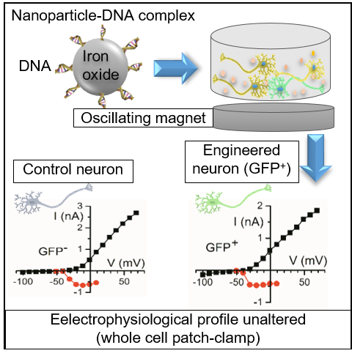
 | An electrophysiological study of neurons genetically engineered using iron oxide nanoparticles reveals the high safety of the approach.

Michael G. Evans, www.keele.ac.uk/lifesci/people/mikeevans/
Arwa Al-Shakli, www.keele.ac.uk/lifesci/people/postgraduates/
Stuart I. Jenkins, www.researchgate.net/profile/Stuart_Jenkins
Divya M. Chari , www.keele.ac.uk/istm/staff/divyachari/

Nano Res
DOI (automatically inserted by the publisher)
Research Article

Electrophysiological Assessment of Primary Cortical Neurons Genetically Engineered using Iron Oxide Nanoparticles

Michael G. Evans^{1†*}, Arwa Al-Shakli^{2†}, Stuart I. Jenkins² and Divya M. Chari² ()
¹School of Life Sciences, Keele University, Keele, Staffordshire ST5 5BG, UK
²Institute for Science and Technology in Medicine, Keele University, Keele, Staffordshire, ST5 5BG, UK
†Both authors contributed equally to the manuscript.
Received: day month year / Revised: day month year / Accepted: day month year (automatically inserted by the publisher)
© Tsinghua University Press and Springer-Verlag Berlin Heidelberg 2011

ABSTRACT
The development of safe technologies to genetically modify neurons is of high interest in regenerative neurology, for both translational and basic science applications. Such approaches have conventionally been heavily reliant on viral transduction methods which have safety and production limitations. Magnetofection (magnet-assisted gene transfer using iron oxide nanoparticles as vectors) has emerged as a highly promising non-viral alternative for safe and reproducible genetic modification of neurons. Despite the high promise of this technology, there is an important gap in our knowledge of the safety of this approach, namely, whether it alters neuronal function in adverse ways such as by altering neuronal excitability and signalling. We have investigated the effects of magnetofection in primary cortical neurons by examining neuronal excitability using the whole cell patch clamp technique. We found no evidence that magnetofection alters the voltage-dependent sodium and potassium ionic currents that underpin excitability. Our study provides important new data supporting the concept that magnetofection is a safe technology for bioengineering of neuronal cell populations.

KEYWORDS
Transfection, magnetic nanoparticle, GFP, whole-cell patch clamp, fluorescence microscopy

- Introduction
————————————
Address correspondence to Divya M. Chari: d.chari@keele.ac.uk
The endogenous repair capacity of the central nervous system (CNS) following injury or disease is limited; the low capacity of neurons to regenerate is a major contributor to this phenomenon [1]. Accordingly, extensive basic scientific research has been directed towards gaining an enhanced understanding of neuronal biology, including the roles of key genes and proteins that can improve neuronal survival and function, in order to inform the development of novel therapeutic interventions [2]. A major technical issue to consider in this context, is the ability to safely and successfully deliver genetic material to target neuronal populations. Post-mitotic neurons are challenging in this regard, being both hard to transfect and showing high sensitivity to alterations in their microenvironment, necessitating minimal cell manipulation during the genetic modification procedures [3]. To this end, both viral and non-viral approaches have been used for targeted neuronal gene delivery [4]. The key factors that determine the suitability of a methodology for genetic engineering include (i) transfection efficiency achieved, (ii) reproducibility for a given cell type, (iii) cost, (iv) technical complexity, (v) production scalability and (vi) cytotoxicity. In this regard, non-viral gene delivery systems such as electroporation, lipofection, and nucleofection can be associated with membrane damage and high cell loss, considerable expense and low transfection [4,5]. Viral methods such as adenoviruses, lentiviruses and herpes simplex virus can achieve high transfection levels but can be associated with insertional mutagenesis, contaminant related toxicity, and expensive and time consuming production procedures [5].
A promising non-viral alternative for neuronal gene transfer that has emerged in recent years, involves the use of iron oxide magnetic nanoparticles (MNPs) with chemically adaptable surfaces, allowing bound genetic material to be targeted to cells by application of static or oscillating magnetic fields (Magnetofection) [6]. This approach is rapid, technically simple, safe and low cost. It has been used extensively for genetic modification of both neuronal cell lines and primary neurons, including for delivery of physiologically relevant biomolecules. For example, reporter genes (such as GFP) have been delivered in transfection studies of neurons derived from stem cells [7], as well as in embryonic primary motor neurons [8], in order to test the suitability of this method at different developmental stages. The approach has also been used to study the localization and axonal transport of the spinal muscular atrophy protein (SMN) in motor neurons [8]. Other studies have successfully utilised magnetofection to overexpress the gene encoding scaffolding protein RanBP9 in primary cortical neurons, with a resultant reduction in dendritic spine density [9]. Further, this technique has been applied in gene knockdown studies to decrease the synaptic GTPase activating protein (SynGAP) expression via the sustained expression of short hairpin RNA (shRNA) in neurons for up to six days [10].
This bioengineering strategy has now been successfully used for a wide range of neuronal transfection applications by laboratories worldwide. Despite its high utility, it should be noted that investigations into the potential adverse effects of this technology on neuron biology rely almost exclusively on relatively simple histological readouts such as cell adherence, phenotypic evaluation, live/dead staining, viable cell counts using flow cytometry, mitochondrial toxicity assays and lactate dehydrogenase (LDH) activity [11]. However, a crucial knowledge gap currently exists in relation to magnetofection technology for neuronal applications, namely, whether this bioengineering approach alters neuronal excitability. This is a critical issue to address as nanoparticles such as carbon black (CB), hematite (Fe₂O₃), and titanium dioxide (TiO₂) were found to alter spiking patterns in primary cortical neurons cultured on microelectrode array neuro-chips in a concentration dependent manner [12]. Silver nanoparticles were also found to reduce sodium current size and action potential amplitude in a concentration-dependent manner in whole-cell recordings from hippocampal CA1 neurons in brain slices [13].
To address this important issue we have conducted for the first time an electrophysiological analysis (using single cell patch clamp recordings) into the effect of magnetofection on the voltage-dependent ion channels that underpin excitability in primary cortical neurons.

- Materials and methods

The care and use of animals was in accordance with the Animals (Scientific Procedures) Act of 1986 (United Kingdom) with approval by the local ethics committee.

2.1 Equipment and reagents

Cell culture-grade plastics, Hanks Balanced salt solution (HBSS; calcium and magnesium free), B27 serum-free supplement [14], glutaMAX-I, penicillin and streptomycin (P/S) and TrypLE (synthetic trypsin, with phenol) were obtained from Fisher (Loughborough, UK). Chemicals for electrophysiology, phosphate buffer saline (PBS) and N-2-hydroxyethylpiperazine-N-2-ethane sulfonic acid (HEPES) were from Sigma-Aldrich (Poole, Dorset, UK). Neurobasal, Dulbecco's Modified Eagle's medium (DMEM) and F12 media were from Invitrogen (Paisley, Scotland, UK). Deoxyribonuclease I (DNase I) was from Roche (Welwyn, UK). Antibodies: rabbit anti-glial fibrillary acidic protein (GFAP; Z0334; Dako Cytomation, Ely, UK), rabbit anti-β-tubulin (Tuj-1; MRB-435P; Covance, Princeton, USA). Cy3- and fluorescein isothiocyanate (FITC)-conjugated secondary antibodies were from Jackson Immunoresearch Laboratories Ltd (West grove, PA, USA). Vectashield mounting medium with 4, 6-diamidino-2-phenylindole (DAPI, nuclear marker) was from Vector Laboratories (Peterborough, UK). Fetal bovine serum (FBS) and normal donkey serum were from Dutscher Scientific (UK) and Stratech Scientific (UK) respectively. The magnefect-nano system, comprising an array of NdFeB magnets (grade N42; field strength of 421 ± 20 mT) matching the wells of culture plates, was from nanoTherics Ltd (Stoke-on-Trent, UK [15]). This array oscillates horizontally beneath the culture plate, with programmable frequency and oscillation. Neuromag MNPs were from Oz Biosciences (Marseilles, France). pMAXGFP plasmid [size 3.5 kb; encodes green fluorescent protein (GFP)] was from Amaxa Biosciences (Cologne, Germany). Tetrodotoxin (TTX) was from Tocris (UK), borosilicate glass for patch electrodes from Harvard Instruments, blue excitation LED from Cairn Instruments, Optimos camera from Q Imaging, patch clamp amplifier from HEKA and the Signal software and computer interface (Power 1401) was from CED.

2.2 Culture of primary cortical neurons
Neuronal cells were derived from embryonic day 18 (E18) CD1 mouse cortex. Pregnant mice were killed by cervical dislocation and the uterus was exposed by cutting the abdominal cavity using scissors sterilized with 70% ethanol. The uterus was placed in a petri dish containing ice-cold dissection medium (97.5% HBSS, 15 mM HEPES, 50 U mL⁻¹ penicillin, 50 µg mL⁻¹ streptomycin). The embryos were decapitated very quickly into ice-cold HBSS. Cortical tissue was extracted and minced using a sterile scalpel blade and incubated with 250 µl of TrypLE and incubated for 20 min with shaking at 37°C. The digestion was stopped by adding 1 ml of FBS and cells were dissociated mechanically for 1-2 min and then strained (70 µm followed by 40 µm). Cells were seeded at 1x10⁵ cells ml⁻¹ in 24 well plates with 400 µL growth medium (96% Neurobasal medium, 2% B-27, 2 mM glutaMAX-I, 50 U mL⁻¹ penicillin, 50 µg mL⁻¹ streptomycin) placed in standard humidified incubator (37°C, 95% air/5% CO₂), and the cells allowed to adhere to the coverslip (<1 h). Then the medium was replaced with 600 µL fresh growth medium, with a 50% medium change every 2-3 days.

2.3 Transfection (magnetofection)
At 7 days in vitro (DIV), medium was replaced with 225 µL antibiotic-free growth medium. MNP-plasmid complexes were formed by diluting (per well) 178 ng pMAXGFP plasmid in 75 µL 1:1 DMEM: F12 and adding 0.62 µL Neuromag (20 min, room temperature). This mixture was added to the cells dropwise with gentle swirling of the plate. 75 µL DMEM: F12 medium free of complex were added to the controls. Plates were then incubated for 30 min on the magnefect-nano array system [24 magnets, matching the culture plate; frequency (F) = 4 Hz; amplitude = 200 nm], then incubated for 24-72 h in the absence of the magnetic field [7].

2.4 Viability (live/dead staining)
Viability was assessed at 48 h post-magnetofection. Cultures were washed gently with PBS, then exposed to 4 mM calcein-AM (fluorescent green; indicates live cells) and 2 mM ethidium homodimer-1 (fluorescent red; indicates dead cells) for 5 min (37°C), washed twice with PBS, then imaged immediately. Magnetofection-induced toxicity was assessed by determining the percentage of viable (calcein positive) cells.

2.5 Immunocytochemistry
Samples were fixed 48 h post-magnetofection (4% paraformaldehyde in PBS; 20 min; room temperature) before incubation with blocking solution (5% normal donkey serum, 0.3% Triton-X in PBS; 30 min), then primary antibodies in blocking solution (Tuj1 1:1000; anti-GFAP 1:500; 4°C; overnight). Samples were then washed three times with PBS, blocked (30 min) and incubated with secondary antibodies in blocking solution (1:200). Samples were washed three times in PBS, then mounted with the nuclear stain DAPI.

2.6 Whole-cell electrophysiological recording
Whole-cell recordings were made at room temperature, using patch pipette electrodes pulled with shanks coated with wax to reduce pipette capacitance. Neurons cultured on circular coverslips were secured, using a small drop of Sylgard, in the center of the lid of a 35 mm cell culture dish that acted as a chamber. The chamber was filled with Neurobasal medium and placed on the stage of an Olympus BX51 microscope fitted with an x40 water-immersion objective (Olympus, NA = 0.8). Neurons were identified as GFP positive / negative by the presence / absence of GFP fluorescence under appropriate epi-fluorescence illumination. Images were taken with a Watec 902B camera or Optimos camera mounted on the microscope. Voltage-clamp protocols were run using Signal software with a Power 1401 interface, a patch clamp amplifier (EPC7) and a standard laboratory computer. The patch pipette filling solution contained (mM): KCl 140, Na₂ATP 2.5, MgCl₂ 3.5, EGTA 1, and HEPES 10, buffered to pH 7.4 with KOH. The large end of the pipette was gently fire polished before filling and attachment to the head stage. Pipettes had a resistance of 4 MΩ when filled. TTX was prepared as a 1 mM stock solution in citrate buffer, frozen in aliquots, and dissolved in Neurobasal medium on the day of use. It was applied to the neuron from a second pipette positioned about 10 µm from the cell body and ejected using a picopump (PV820, WPI) either manually or via a trigger pulse.

2.7 Fluorescence microscopy and image analysis
Fluorescence micrographs were taken using an Axio Scope A1 (equipped with an Axio Cam ICc1 digital camera and AxioVision software, release 4.7.1; Carl Zeiss Micro Imaging GmbH, Goettingen, Germany), then merged using Photoshop (Adobe, USA). To evaluate transfection levels, each DAPI-positive nucleus was identified as neuronal (Tuj1⁺), astrocytic (GFAP⁺), or undetermined (Tuj1⁻/GFAP⁻), and scored as ‘transfected’ if GFP⁺. Pyknotic nuclei (indicative of necrotic or apoptotic cells) were identified by chromosomal condensation, and reported as a percentage of all (healthy plus pyknotic) nuclei.

2.8 Data analysis
For the toxicity assays (live/dead and percentage pyknotic nuclei), three sets of micrographs (two from the edges and one from the centre of each coverslip; each set comprised of counterpart red, green, blue and phase contrast images) were captured and merged. Values are presented as mean ± standard error of the mean. For culture data, n indicates the number of cultures (each obtained from different pregnant females); for electrophysiological data, n indicates the number of cells recorded (derived from eight separate litters). Data were analyzed by two-tailed t-tests (p<0.05 considered significant) using either Prism (version 6.0; GraphPad, USA) or Origin 2016 (Origin Labs). Electrophysiological recordings were analysed using Signal and Origin software. Leak subtraction and capacitive transient reduction was performed where indicated by the addition of currents recorded in response to positive (depolarizing) voltage clamp steps to currents recorded in response to small (10-40 mV) negative voltage clamp steps, scaled and averaged if necessary.

- Results

3.1 Culture characterization
The proportion of neurons (Tuj1⁺) and astrocytes (GFAP⁺) was consistent across cultures (25.6 ± 3.2% Tuj1⁺, 58.0 ± 4.5 % GFAP⁺; n = 3) with 16.3 ± 7.7% of nuclei being undetermined (Tuj1⁻/GFAP⁻). Neurons showed well-defined spherical somata with long processes that formed a complex network with adjacent neurons. Astrocytes were morphologically distinguished as (flat, membranous, unbranched or star-shaped; Figure 1).

3.2 Transfection (magnetofection) efficiency
After magnetofection, 3.2 ± 1.2% of viable cells were transfected neurons (GFP⁺/Tuj1⁺), and a further 6.3 ± 3.3% expressed GFP but not Tuj1. These latter cells exhibited astrocytic morphologies (Figure 1a and d). Statistical analysis demonstrated no significant differences between these values.

3.3 Safety assessments of particle toxicity in cortical neuronal culture
No differences were noted between neurons in magnetofected and control cultures with respect to morphology, percentage of live cells (59.3 ± 9.2%, 53.0 ± 2.0% respectively), number of neurons per micrograph (36.3 ± 16.5, 35.6 ± 10.7), or percentage of pyknotic nuclei (38.6 ± 3.0%, 35.3 ± 7.8%; Figure 1).

3.4 Electrophysiological characterization
Neurons for whole cell recording were identified under normal light conditions by a bulb-shaped soma with long processes often forming a complex network, and under blue light (excitation wavelength 495 nm), by the fluorescence associated with GFP protein expression (Figure 2).
10µm
10µm
In voltage-clamp experiments, depolarising voltage-clamp steps produced biphasic currents comprising an early inward current, reaching a peak at around 2 ms after the step, followed by a late outward current that activated over 5-10 ms (Figure 2 a and b). The early inward current was found to be rapidly blocked by TTX (25 µM) suggesting that it was a voltage-dependent Na⁺ current (Figure 2d). The late outward current, which was maintained for the duration of the voltage step, was likely to be carried by K⁺ since its reversal potential was negative to -60 mV, based on outward tail current polarity at -60 mV (Figure 2a). Currents carried by K⁺ would be expected have a reversal potential of -83 mV (the calculated K⁺ equilibrium potential under our recording conditions). From a holding potential of -60 mV or -70 mV, the Na⁺ and K⁺ currents were first seen, in response to depolarising steps, at around -40 mV. The Na⁺ current activated rapidly (1-3 ms) and was maximal at about -20 mV (Figure 2c). A comparison between GFP⁺ and GFP⁻ neurons revealed no differences between current amplitudes or membrane potential (Student’s t test; Table 1).
In current clamp, most neurons exhibited a small spike following a step depolarising current injection (Figure 3a and b). The spikes were 15-30 mV in amplitude and did not reach or exceed 0 mV. We also noticed in a few cells spontaneous depolarisations that increased in amplitude with hyperpolarisation (Figure 3a and b).These presumably reflect excitatory synaptic activity.

- Discussion

To our knowledge, this is the first study investigating the electrophysiological properties of magnetofected primary neurons. We find no evidence for any functional influence of magnetofection in these relatively immature cortical neurons, based on our experiments demonstrating similar amplitudes and kinetics of the voltage-dependent Na⁺ and K⁺ currents. These findings are corroborated by our histological observations that did not reveal adverse effects of the genetic modification protocols on key parameters of cell health. Our use of primary neurons has the advantage of eliminating possible confounding issues associated with cell lines such as their relative homogeneity and clonal nature and resistance to nano-toxicity along with genetic drift [16-18], enabling a more physiologically relevant study to be undertaken.

Our observation that magnetofection did not affect the Na⁺ and K⁺ channels in cortical neurons is clearly an encouraging result in terms of its potential use in clinical applications employing cell or tissue transplants. It also provides an encouraging platform for basic science applications, where the effects of transgenes on neuronal function could be investigated in the absence of confounding issues, such as the decreased cell viability associated with some transfection techniques. Clearly, normal ion channel function is a prerequisite for normal neuronal function in any environment, including transplantation into a host. Even in the absence of functional synaptic contacts, a transplanted neuron’s membrane potential, and ability to spike (all functions of ion channels), would be important for the health of the neuron and its ability to secrete chemicals or neurotransmitters. Our observation of apparently spontaneous excitatory synaptic potentials is significant since it implies that synaptic contacts are functional in these neurons. These factors are suggestive of a healthy and maturing cell culture amenable to gene manipulation by magnetofection. Future studies should assess more completely the signalling and synaptic properties of such bioengineered neurons. This would require both single neuron recordings and recordings of neuronal populations in order to build up a picture of function and signalling at the single cell and multi-cell levels. Given that ion channel dysfunction or channelopathy can lead to epileptic seizures and a myriad of other problems [19], such information is vital before any type of clinical intervention using magnetofected neurons or glia can be successfully undertaken.

However, cellular uptake of metal or carbon-based nanoparticles has been associated with changes in spiking frequency and bursting patterns, based on neurochip extracellular recordings [12], and with alterations in Na⁺ current amplitude and activation range in whole-cell patch recordings [13]. These effects are clearly concentration-dependent and are subtle at low concentrations of nanoparticles, including iron oxide core MNPs [12]. Comparison between studies in terms of metal or particle concentration is difficult in as much as uptake into the cells is highly dependent on particle size and cell type. The MNPs employed here, at ~160 nm diameter [20], and with an additional chemical envelope for plasmid attachment, are relatively large, but these and similar particles have a well-documented safety profile across a range of neural cell types [7, 15-18, 20]. Further investigation should be directed towards more mature cells and to track changes post-transfection over longer time periods.

Transfection-based bioengineering strategies for neural repair will require both efficient and safe protocols. Our electrophysiological analysis of magnetofected cells was restricted to neurons clearly identified as expressing the reporter protein, hence the transfection levels obtained do not impact on the findings of our study. The overall culture transfection efficiency reported here (ca. 10%) is lower than that reported for various neuronal types including primary cortical neuronal cultures (up to 46%, using non-viral approaches combined with high DNA concentrations [8]). It should also be noted that the protocol employed here was safe over the time course of our experiments in terms of cell survival and an apparent absence of pathological changes. Multiple factors can be predicted to influence transfection efficiency, including: developmental stage, conditions of cell culture (e.g. type of media used, physicochemical structure of vectors, and vector:DNA ratio) [8-10, 21]. These factors are likely to account for the differences in observations between studies.

It is well established that astrocytes show high levels of endocytotic activity in line with their homeostatic functions in the nervous system, resulting in documented ‘competitive uptake dynamics’ for nanoparticle uptake which in co-cultures would limit neuronal transfection [15, 16, 22]. Because of this, we chose cell culture conditions that would limit astrocyte numbers and proliferation. First, by deriving cultures from embryonic tissue, astrocyte numbers can be kept low, as it is estimated that >90% of cells at this developmental time point are neurons [23]. Second, the use of serum free medium can (i) enhance the purity of neuronal cultures by reducing astrocyte proliferation and (ii) provide greater definition of experimental conditions by removing confounding variation in serum composition [24-26] and eliminating the need to use chemical inhibitors of astrocytes such as arabinosylcytosine C (AraC) [27, 28]. Nevertheless, in our hands it proved difficult to eliminate the issue of astrocyte contamination completely; approximately 35% of the astrocyte population can re-enter the cell cycle after serum deprivation, likely accounting for the high proportions of astrocytes in these cultures [23].

In summary, we provide the first complementary electrophysiological and histological analyses supporting the concept that iron oxide nanoparticles and applied magnetic fields can be safely deployed for genetic modification of primary neurons for basic research and translational applications.

Acknowledgements

This work has funded by Iraqi ministry of higher education (Baghdad University). SJ was funded by an Engineering and Physical Sciences Research Council (EPSRC; UK) Engineering Tissue Engineering and Regenerative Medicine (E-TERM) Landscape Fellowship (EP/I017801/1).

References

[1] Biorklund, A.; Stenevi, U. Regeneration of monoaminergic and cholinergic neurons in the mammalian central nervous system. Physiol. Rev. 1979, 59, 62-100.
[2] Tuszynski, M. H.; Steward O. Concepts and methods for the study of axonal regeneration in the CNS. Neuron 2012, 74, 777–791.
[3] Karra, D.; Dahm, R. Transfection techniques for neuronal cells. J. Neurosci. 2010, 30, 6171-6177.
[4] Washbourne, P.; McAllister, A. K. Techniques for gene transfer into neurons. Curr. Opin. Neurobiol. 2002, 12, 566-573.
[5] Lentz, T. B.; Gray, S. J.; Samulski, R. J. Viral vectors for gene delivery to the central nervous system. Neurobiol. Dis. 2012, 48, 179-188.
[6] Schwerdt, J. I.; Goya G. F.; Calatayud, P.; Hereñú C. B.; Reggiani P. C.; Goya R. G. Magnetic field-assisted gene delivery: achievements and therapeutic potential. Curr. Gene Ther. 2012, 12, 116-126.
[7] Fernandes, A.; Chari, D. Part II: Functional delivery of a neurotherapeutic gene to neural stem cells using minicircle DNA and nanoparticles: translational advantages for regenerative neurology. J. Control. Release. 2016, Epub ahead of print, 300-310.
[8] Fallini, C.; Bassell, G. J.; Rossoll, W. High-efficiency transfection of cultured primary motor neurons to study protein localization, trafficking, and function. Mol. Neurodegener. 2010, 5, 17.
[9] Wang, R.; Palavicini, J. P.; Wang, H.; Maiti, P.; Bianchi, E.; Xu, S.; Lloyd, B.; Dawson-Scully, K.; Kang, D. E.; Lakshmana, M. K. RanBP9 overexpression accelerates loss of dendritic spines in a mouse model of Alzheimer's disease. Neurobiol. Dis. 2014, 69, 169-179.
[10] Buerli, T.; Pellegrino, C.; Baer, K.; Lardi-Studler, B.; Chudotvorova, I.; Fritschy, J.-M.; Medina, I.; Fuhrer, C. Efficient transfection of DNA or shRNA vectors into neurons using magnetofection. Nat. Protoc. 2007, 2, 3090-3101.
[11] Petters, C.; Dringen, R. Accumulation of iron oxide nanoparticles by cultured primary neurons. Neurochem. Int. 2015, 81, 1-9.
[12] Gramowski, A.; Flossdorf, J.; Bhattacharya, K.; Jonas, L.; Lantow, M.; Rahman, Q.; Schiffmann, D.; Weiss, D. G.; Dopp, E. Nanoparticles induce changes of the electrical activity of neuronal networks on microelectrode array neurochips. Environ. Health Perspect. 2010, 118, 1363-1369.
[13] Liu, Z.; Ren, G.; Zhang, T.; Yang, Z. Action potential changes associated with the inhibitory effects on voltage-gated sodium current of hippocampal CA1 neurons by silver nanoparticles. Toxicology. 2009, 264, 179-184.
[14] Brewer, G. J. Serum-free B27/neurobasal medium supports differentiated growth of neurons from the striatum, substantia nigra, septum, cerebral cortex, cerebellum, and dentate gyrus. J. Neurosci. Res. 1995, 42, 674–683.
[15] Jenkins, S. I.; Weinberg, D.; Al-Shakli, A. F.; Fernandes, A. R.; Yiu, H. H.; Telling, N. D.; Roach, P.; Chari, D. M. 'Stealth' nanoparticles evade neural immune cells but also evade major brain cell populations: Implications for PEG-based neurotherapeutics. J. Control. Release. 2016, 224, 136-145.
[16] Jenkins, S. I.; Pickard, M. R.; Furness, D. N.; Yiu, H. H.; Chari, D. M. Differences in magnetic particle uptake by CNS neuroglial subclasses: implications for neural tissue engineering. Nanomedicine (Lond.). 2013, 8, 951-968.
[17] Jenkins, S. I.; Yiu, H. H. P.; Rosseinsky, M. J.; Chari, D. M. Magnetic nanoparticles for oligodendrocyte precursor cell transplantation therapies: progress and challenges. Mol. Cell. Ther. 2014, 2, 23.
[18] Pinkernelle, J.; Calatayud, P.; Goya, G. F.; Fansa, H.; Keilhoff, G. Magnetic nanoparticles in primary neural cell cultures are mainly taken up by microglia. BMC Neurosci. 2012, 13, 32.
[19] Steinlein, O. K. Genetic mechanisms that underlie epilepsy. Nat. Rev. Neurosci. 2004, 5, 400-408.
[20] Pickard, M. R.; Adams, C. F.; Barraud, P.; Chari, D. M. Using magnetic nanoparticles for gene transfer to neural stem cells: stem cell propagation method influences outcomes. J. Funct. Biomater. 2015, 6, 259-276.
[21] Jenkins, S. I.; Pickard, M. R.; Chari, D. M. Magnetic nanoparticle mediated gene delivery in oligodendroglial cells: A comparison of differentiated cells versus precursor forms. Nano Life. 2013, 3, 1243001.
[22] Jenkins, S. I.; Roach, P.; Chari, D. M. Development of a nanomaterial bio-screening platform for neurological applications. Nanomedicine NBM. 2014, 11, 77–87.
[23] Murphy, S. Generation of astrocyte cultures from normal and neoplastic central nervous system. In: Methods in Neurosciences. Conn, P. M. (Ed); Academic Press, 1990; vol 2, pp 33-47.
[24] Evans, M. S.; Collings, M. A.; Brewer, G. J. Electrophysiology of embryonic, adult and aged rat hippocampal neurons in serum-free culture. J. Neurosci. Methods 1998, 79, 37-46.
[25] Kivell, B. M.; McDonald, F. J.; Miller, J. H. Serum-free culture of rat post-natal and fetal brainstem neurons. Brain Res. Dev. Brain Res. 2000, 120, 199-210.
[26] Langan, T. J.; Slater, M. C.; Kelly, K. Novel relationships of growth factors to the G1/S transition in cultured astrocytes from rat forebrain. Glia 1994, 10, 30-39.
[27] Ahlemeyer, B.; Kölker, S.; Zhu, Y.; Hoffmann, G. F.; Krieglstein, J. Cytosine arabinofuranoside-induced activation of astrocytes increases the susceptibility of neurons to glutamate due to the release of soluble factors. Neurochem. Int. 2003, 42, 567-581.
[28] Geller, H. M.; Cheng, K. Y.; Goldsmith, N. K.; Romero, A. A.; Zhang, A. L.; Morris, E. J.; Grandison, L. Oxidative stress mediates neuronal DNA damage and apoptosis in response to cytosine arabinoside. J. Neurochem. 2001, 78, 265-75.

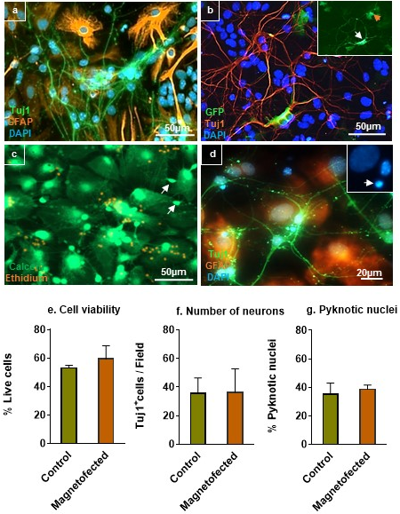
Figure 1. Magnetofection is safe for transfecting primary cortical neuronal cultures. Fluorescence micrographs of cortical cultures after 7 days in vitro. (a) Neurons (Tuj1⁺) display small rounded soma with long processes, astrocytes (GFAP⁺) are flat, membranous and unbranched. (b) Neurons after magnetofection co-express Tuj1 and GFP. The inset shows a GFP⁺ astrocyte (orange arrow) and a Tuj1⁺/GFP⁺ neuron (white arrow). (c) Cell viability assay showing viable cells in culture (green) and dead cells (orange). (d) Pyknotic nuclei show condensed chromatin (white arrow, inset) in cortical co-culture. The inset shows the same arrowed neuron showing the condensed chromatin more clearly. Graphs (e, f and g) show no alteration in cell viability, neuronal number and percentage of pyknotic nuclei (n = 3).
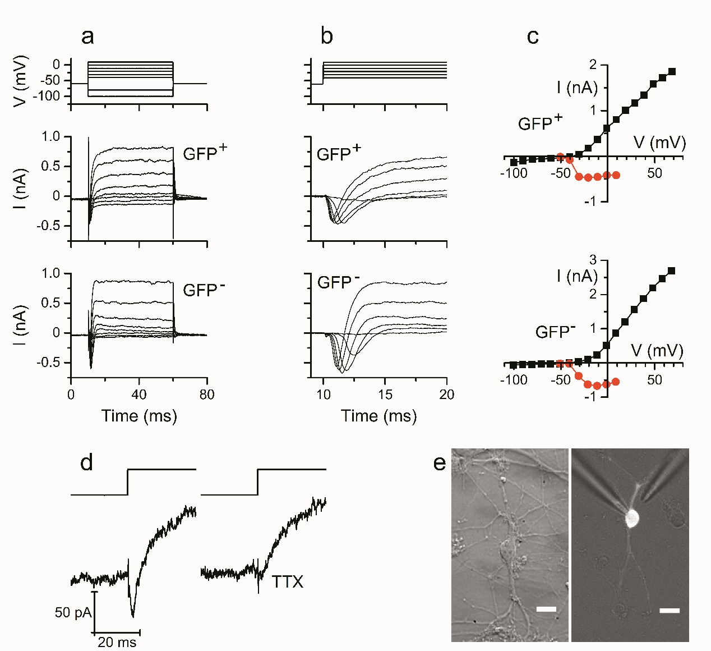
Figure 2. Representative ionic currents seen in response to voltage steps from a holding potential of -60 mV from both magnetofected (GFP⁺) and non-magnetofected (GFP⁻) neurons. (a) Voltage steps (top) and corresponding ionic currents are shown for GFP⁺ and GFP⁻ neurons as indicated (bottom two rows). (b) Leak-subtracted records shown on a faster time scale to reveal early inward (Na⁺) currents followed by late outward (K⁺) currents. Holding currents have been subtracted. Same cells as (a). In (a) and (b) the horizontal (time) and vertical scales are shown at the bottom and on the left respectively. (c) I-V plots of early inward and late outward currents from GFP⁺ (top) and GFP⁻ neurons (bottom). The late currents (squares) were measured from the records shown in (a) at the 40ms time point, the early currents (circles) were measured as peak inward currents from the records in (b). (d) The inward (Na⁺) current seen in response to a 40 mV depolarising voltage-clamp step from a holding potential of -70 mV (left) is blocked by TTX (25 µM, right). The voltage steps are shown above the current records. (e) Micrographs of magnetofected neurons (GFP⁺) used for whole-cell recording taken under normal transmitted light conditions (left) and a combination of low transmitted light and fluorescence excitation (right), also showing the recording and drug-application pipettes. Scale bars = 10 µm.

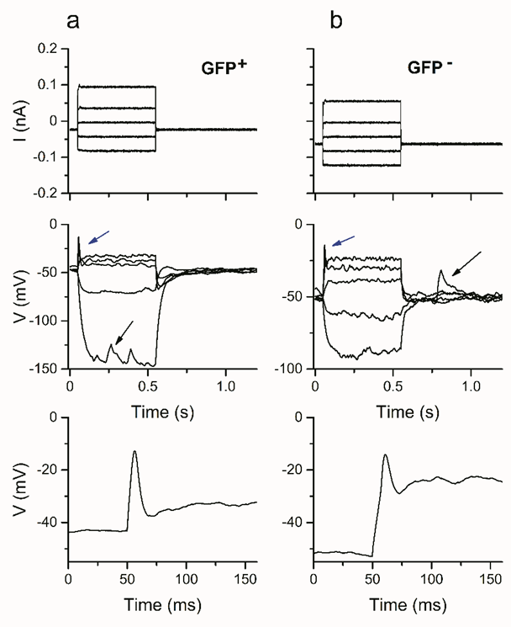
Figure 3. Representative current clamp recordings from magnetofected (GFP⁺) and non-magnetofected (GFP⁻) neurons showing spike-like activity. (a) Current steps (top) and corresponding voltage responses (middle) from a GFP⁺ neuron. The arrows indicate spike-like voltage transients (blue arrows) and spontaneous depolarisations, probably reflecting synaptic activity (black arrows). The bottom panel shows the response to the largest depolarising current injection on an expanded scale. A negative holding current was applied to hyperpolarise the neuron, the injection begins at 50 ms. (b). An equivalent recording from a GFP⁻ neuron.
TABLES.

Table 1. Comparison of voltage-dependent Na⁺ and K⁺ currents in GFP⁺ and GFP⁻ (control) neurons in voltage-clamp.
 | GFP positive  (n = 8) | GFP negative  (n = 6)
E_{m} (mV) | -38 ± 1 | -32 ± 3
I_{Na} at -30 mV (pA) | -271 ± 88 | -385 ± 144
I_{K} at -30 mV (pA) | 70 ± 20 | 33 ± 9
I_{K} at 0 mV (pA) | 806 ± 235 | 807 ± 257
Table 1. Comparison of voltage-dependent Na⁺ and K⁺ currents in GFP⁺ and GFP⁻ neurons in voltage-clamp. Current amplitudes were measured at the voltages indicated. For the measurements made at -30 mV, records were made using leak subtracted records. Membrane potential (E_{m}) measurements are also shown, measured by linear interpolation of I-V curves at I = 0. There were no significant differences between the means for GFP⁺ and GFP⁻ neurons (Student’s t test). Values are mean ± SEM, given to the nearest whole number.

