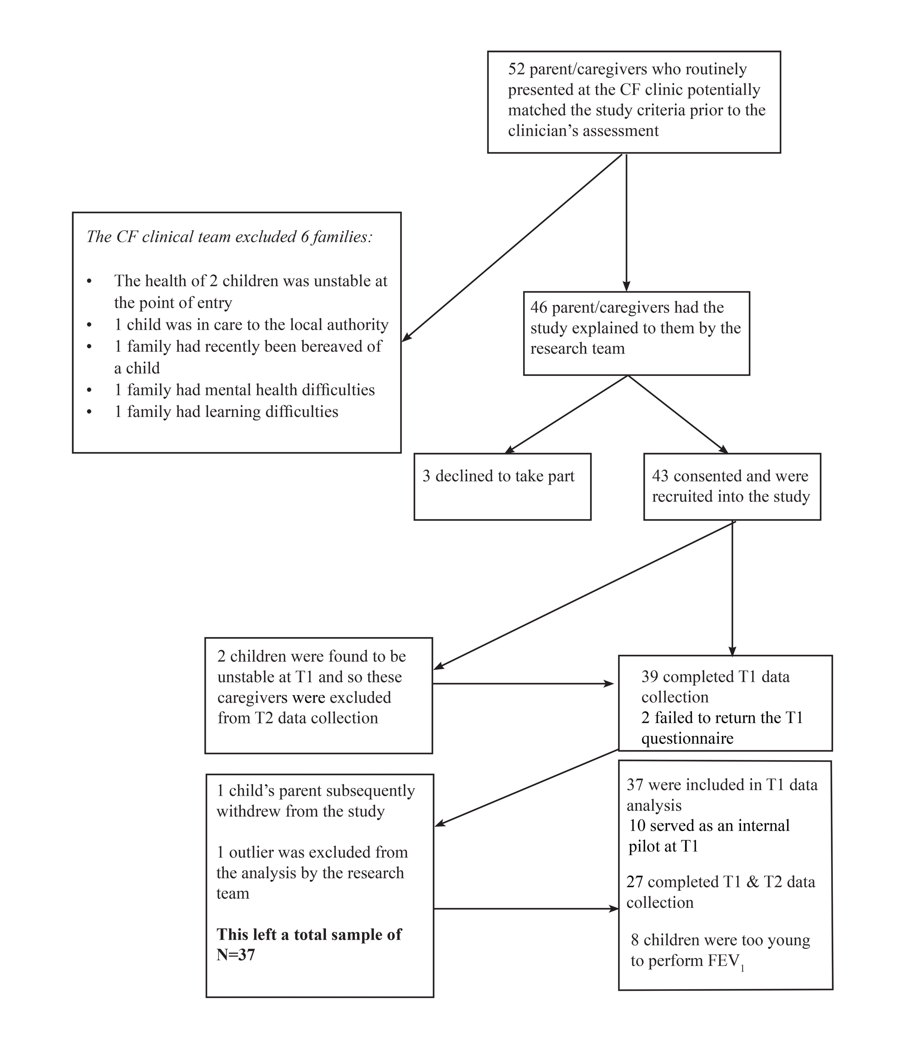Appendix 2. Recruitment Flow Chart for Phase 3 of the Study

