The Use of Liquid Chromatography Quadrupole Time-of-Flight Mass Spectrometry and Metabonomic Profiling to Differentiate Between Normally Slaughtered and Dead On Arrival Poultry Meat
Kate L. Sidwickª, Amy E. Johnsonª, Craig D. Adamª, Luisa Pereira^{b}, and David F. Thompson*ª
ª School of Chemical and Physical Sciences, Keele University, Keele, Staffordshire, United Kingdom, ST5 5BG
^{b} Thermo Fisher Scientific, Manor Park, Tudor Road, Runcorn, United Kingdom, WA7 1TA

ABSTRACT: Metabonomic profiling techniques, with established quality control methods, have been used to detect subtle metabolic differences in tissue that could aid in the discovery of fraud within the food industry. Liquid chromatography quadrupole time-of-flight mass spectrometry (LC-Q-TOF-MS) was utilized to acquire metabolic profiles of muscle, heart and liver tissue from normally slaughtered and dead on arrival chickens. A workflow including XCMS Online for data processing and robust confirmatory statistics was used in order to differentiate between the two sample types. It was found that normally slaughtered and dead on arrival chicken can be differentiated based on the metabolic profile and multivariate analysis. Markers were found to be significantly different between the two sample types in all samples. With the use of the METLIN database and MS/MS analysis of chemical standards, sphingosine was identified as a marker in the muscle tissue samples which may offer potential for the detection of fraudulently processed chicken meat. The approach taken in this work has shown that it is possible to apply the described workflows to food fraud problems, with a view to identifying key markers that could be investigated further to determine their usefulness for fraud detection.

Food fraud is a global issue that became more apparent when horse meat was found in beef products in the UK in 2013¹. Ever since this incident, consumers’ trust in the meat industry has decreased substantially, and it has become evident that there are weaknesses in the authentication of meat products. Many techniques have been developed to combat adulteration, bulking and misrepresentation of food products^{2,3,4}, however little has been done to investigate the subtler and more complex issues that cannot be detected by these methods, specifically fraud that involves the same tissue of the same species.
Metabonomics can be defined as ‘the quantitative measurement of the dynamic multiparametric metabolic response of living systems to pathophysiological stimuli or genetic modification’⁵. It focusses on the changes in metabolic profile caused by disease or environmental influences. Metabolites are the low molecular weight compounds (< 1000 Da) that are the products of metabolism, and collectively they are known as the metabolome. Metabonomics has been utilized in a variety of research areas, including environmental sciences^{6,7}, toxicology^{8,9}, nutrition¹⁰, and medicine and diagnosis^{11,12}. It has also been exploited in detecting metabolic changes after death¹³, as well as within the food industry for the detection of fraudulent activities^{14,15}. Specifically, metabonomics has been used to verify meat products, including the quality of meat¹⁶, and adulteration of meat¹⁷. This technique could be employed further within this research field by determining the metabolic differences in the subtler authentication issues that, as of yet, are unable to be detected.
Metabonomics can be used in both a targeted and untargeted manner; targeted metabonomics focusses on the presence of a specific class of compounds, whereas untargeted metabonomics aims to detect as many metabolites as possible within a sample, in order to gain a metabolic fingerprint that can show slight differences in metabolites between sample types. The presence or concentration of these metabolites can then be used as markers to indicate the difference. Due to the nature of untargeted metabonomics, vast datasets are produced that require complex software to process, and sophisticated chemometrics for interpretation of the results. This approach, however, is very beneficial in initial investigations as it gives a plethora of information without prior knowledge of the sample in question¹⁸. The identification of the markers that appear to be significantly different between sample types is widely acknowledged as a major issue in metabonomics¹⁹. There is a limited availability of authentic chemical standards for many metabolites, which makes confirmatory identification difficult, and is an area that requires crucial development²⁰. In this research, metabolite identification was performed manually by following previously published criteria²¹, and for the marker identified, this was confirmed with a standard.
According to The Animal By-Products (Enforcement) (England) Regulations 2013, “whole poultry bodies where animals are dead on arrival at the slaughterhouse” must be stained with a coloring agent in order to distinguish it as a product not fit for human consumption²². Most poultry batches contain some dead on arrival (DOA) animals, which impacts the profit gained for the supplier. The detection of this complex fraud relies solely on documentation and the cooperation of the slaughterhouse. This type of mislabeling has not been previously detected with analytical techniques. The difference between DOA and normally slaughtered chickens may only be a couple of hours, or minutes, in the time of death, and the way in which they died, creating the need for a robust technique to be developed that can target these extremely small differences. Metabonomic techniques could be utilized to detect this subtle food fraud by finding the differences in metabolic content in chicken that has been slaughtered conventionally and chicken that was dead on arrival to the slaughterhouse, leading to the identification of markers that could discover this fraud.
This work aimed to investigate the potential of using established metabonomic protocols to differentiate between DOA and normally slaughtered chicken. It strived to show that the workflow used within this study is capable of reducing large and complex datasets to a small number of significant features. These can then be identified, to provide a direction for larger studies in developing a targeted assay for this type of food fraud.

MATERIALS AND METHODS
Materials Methanol, dichloromethane and formic acid was purchased from Fisher Scientific (Loughborough, UK). Ultrapure water (18.2 MΩ) was purified using a Milli-Q system from Elga (High Wycombe, UK). Acetonitrile was purchased from VWR (East Grinstead, UK). ESI-L low concentration tuning mix and API-TOF reference mass solution were purchased from Agilent Technologies (California, USA).
Sample collection and storage Chicken samples were collected from a certified poultry processor. Five DOA and ten normally slaughtered chickens were obtained on the day of slaughter. The number of DOA animals chosen was limited by the number of animals that were lost in transit on the day of collection. All chickens originated from the same farm, were the same age and had been fed the same diet. The heart, liver and muscle tissue was removed from each carcass and placed in individual polythene bags. These were immediately transported in a refrigerated van at 4°C to the laboratory, where they were stored at -80°C prior to extraction. The tissue type selected for this study was based on what was available on the day of collection, as well as the consideration of what would be available during a fraud investigation. Blood was not collected as it is unlikely to be available during such an investigation.
Metabolite extraction In order to extract the maximum number of polar and non-polar metabolites from the tissue, sequential aqueous and organic extractions were carried out^{23,24}. All extractions were carried out in the fume cupboard to avoid inhalation of solvents. Tissue samples (~100 mg) were homogenized in Eppendorf tubes using surgical scissors, and methanol/water (1:1) was added (1 mL per 100 mg sample). To avoid carryover, the scissors were thoroughly cleaned with methanol between each sample. The sample was then sonicated for 10 minutes and centrifuged at 16100 rcf for 20 minutes. The supernatant was removed and retained as an aqueous extract, and the remaining tissue pellet was broken up with a clean pipette tip and dichloromethane/methanol (3:1) was added (1 mL per 100 mg). The sample was sonicated for 10 minutes and centrifuged at 16100 rcf for 20 minutes. The supernatant was moved to a glass vial and allowed to evaporate overnight in a fume cupboard. The sample was resuspended in methanol to the same volume, and retained as an organic extract. All extracts were stored at -25°C before analysis.
Quality control Quality control (QC) samples were created as described in previous studies²⁵. An equal aliquot of each sample within each analytical run was pooled. A QC sample was analyzed every 3 injections to monitor the reproducibility and stability of the analyses, and used to condition the column prior to each analysis. The coefficient of variance percentage (CV%) was calculated from peak areas for each marker within the QC samples throughout the analytical run to monitor the precision of the data. All markers that had a CV% of more than 10% in the QC samples were removed, which is below the threshold in suggested guidance²⁶. The reduced CV% value was chosen to provide the most robust dataset once the data had been normalized, and still provided sufficient markers to enable a meaningful analysis.
Conditioning of column To ensure the stability of the baseline and retention time throughout each analytical run, a number of QC samples were injected at the beginning, as done in other studies^{24,27,28}. It was found that more QC samples than in other studies were required before the system became stable, so 10 QC samples with an injection volume of 10 µL were first run through the column, then 20 QC samples with an injection volume of 3 µL were injected to condition the system. This produced reproducible results with minimal baseline and retention time drift within the run.
Chromatographic parameters Each tissue type was analyzed in a separate analytical run. The sample running order was randomized and analyzed using an Agilent 6530 Accurate Mass Q-TOF LC/MS. The system was calibrated before each run to ensure a high level of mass accuracy. The chromatography was carried out using a Thermo Scientific Hypersil GOLD aQ column (100 mm x 2.1 mm, particle size of 1.9 µm). The column was maintained at 40°C and the injection volume was 3 µL. The flow rate of the mobile phase was 0.3 mL/min and consisted of (A) 0.1% formic acid and (B) acetonitrile with 0.1% formic acid. After extensive method development, the optimal solvent gradient percentages were found for both positive and negative ionization mode. The solvent gradient for positive ionization mode started at 5% B, increased to 52.5% B in 1 minute, increased to 100% B in 27 minutes, held for 10 minutes, then returned to starting conditions. The solvent gradient for negative ionization mode started at 5% B, increased to 60% in 1 minute, increased to 65% in 10 minutes, increased to 80% in 12 minutes, increased to 100% in 3 minutes, held for 7 minutes, then returned to starting conditions. After every injection, three needle washes with 100 µL of methanol were included to reduce any potential carryover.
Mass spectrometry parameters An electrospray ionization source was used, and all samples were analyzed in positive and negative mode. The parameters were set as follows: drying gas temperature of 320°C, drying gas flow of 11 L/min, capillary voltage of 4000 V, nebulizer pressure of 40 psi, fragmentor voltage of 125 V, skimmer voltage of 65 V, and a mass range of 100-1000 m/z. The reference mass solution used purine (121.0509 m/z) and hexakis (1H, 1H, 3H-tetrafluoropropoxy)phosphazine (922.0098 m/z) for positive ionization, and ammonium trifluoroacetate (112.9856 m/z) for negative ionization as internal reference masses to ensure mass accuracy.
Statistical analysis The data were processed using XCMS Online. This platform carried out feature detection, retention time correction, and chromatogram alignment¹⁹. The data were normalized, and a feature table, each feature represented by the m/z value and retention time with the peak areas for these features in each sample, was transferred to Excel. The peak areas were used to perform multivariate analysis (principal component analysis (PCA)) and t-tests (assuming unequal variance, α = 0.05).
The coefficient of variance was calculated from peak areas for the QC samples for each feature throughout each analytical run to monitor the precision of the data. Due to the vast data sets generated in untargeted metabonomic studies, the coefficient of variance was used to reduce the number of features. All features that had a CV% of more than 10% were removed, within the threshold in published guidance²⁶, in order to only look at the most robust features. When producing PCA plots, only significantly different markers with a CV% of less than 10% in the QC samples were used in order to maximize any separation of groups more clearly. This reduced the sample set considerably (approximately 95% of data was removed), but still left enough features for further statistical analysis. Markers were found to be significantly different if the statistical tests gave a p-value of less than 0.05. Principal components 1-4 were compared in all combinations in order to find the components that best represented the separation of the sample types. The top 25 markers in each analytical run that were found to be the most significantly different with the use of XCMS Online were then verified by looking at the original raw data in Masshunter Qualitative Analysis software (Agilent Technologies). Extracted ion chromatograms were obtained for the significant markers, and t-tests were conducted on the peak areas to check the significance against the raw data. The CV% of the QC samples was also checked. This had a threshold of up to 30% as this was calculated on the raw data that had not been normalized. These additional steps identified the more robust markers that could be used to distinguish between the two sample types.
For clarity, throughout this work, the term ‘feature’ is for a m/z and retention time ion pair the instrument has detected, and the term ‘marker’ is for any of these features that have shown to be significantly different (p-value < 0.05) between normally slaughtered and DOA samples.
Identification using MS/MS The chemical reference standard for D-sphingosine purchased from Sigma-Aldrich, UK, was analyzed using MS/MS mode on an Agilent 6530 Accurate Mass Q-TOF LC/MS. All parameters were the same as described in the chromatographic and mass spectrometry parameters, and the MS/MS parameters were set to the specific mass of the standard. The MS spectra were compared for the standard and the sample to confirm the identity of the marker. A sample was also spiked with the standard and analyzed using a LC-MS in order to compare the chromatographic properties.

RESULTS AND DISCUSSION
Metabolite profiling by LC-Q-TOF-MS In positive mode, as shown in Figure 1, the muscle extracts (A) were very similar, the liver extracts (B) had a higher abundance in some peaks for the DOA samples compared to the normally slaughtered, and finally, the heart extracts (C) showed a higher abundance in some peaks for the normally slaughtered chickens compared to DOA. For the negative mode, the overlaid chromatograms (Figure S-1) for each tissue type showed a similar pattern as in the positive mode. Specifically, the liver extracts (B) appeared to have a higher abundance in most peaks for the DOA samples, and the heart extracts (C) had a higher abundance in most peaks for the normally slaughtered chickens.
Using the equipment described in this manuscript, it was not possible to create satisfactory chromatographic separation for the aqueous extracts that would ensure meaningful statistical analysis to take place. Therefore no further work on these extracts were undertaken.

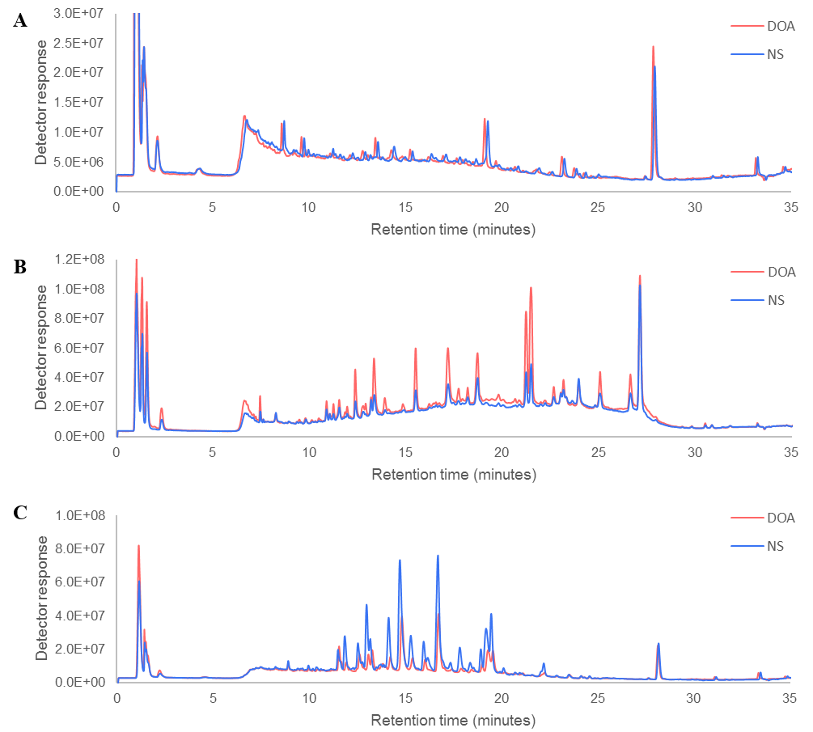
Figure 1. Example chromatograms of organic extracts from normally slaughtered (NS) and dead on arrival (DOA) chickens in positive ionization mode, A) muscle, B) liver, C) heart.

Multivariate statistics The PCA plots show good separation for the heart extracts in both positive and negative mode, as shown in Figure 2. The QC samples are very tightly clustered, showing high precision in the data set. The separation between these two groups is greater than the spread of the QC points, signifying the hearts from DOA and normally slaughtered chickens are distinguishable. The PCA plots for the liver and muscle extracts (Figures S-2 and S-3) did show two groups for the normally slaughtered and DOA samples, but there was some overlap. Whilst there are a wide spread of data points for both sample groups in all tissue types, it is important to note that any differences between the two groups is extremely subtle; all chickens originated from the same batch, so the age, diet and handling prior to death was identical. The only difference is the manner in which they died, and the time of death. The DOA poultry died in transport to the slaughterhouse, where they are subjected to a range of stressors including vibration, motion, heat, and noise²⁹. These animals would have all died at different times during the handling and transportation, and in a variety of ways such as suffocation, injury, congestive heart failure²⁹, heart and circulation disorders, and trauma³⁰, lung congestion, and nephropathy accompanied by dehydration³¹. This allows there to be a greater diversity of metabolic profiles within these chickens compared to the normally slaughtered chickens, which were all slaughtered in the same manner. The metabolic profiling implemented in this research was powerful enough to detect these subtle differences.
Potential markers All markers in Tables S-1, S-2, and S-3 were found to be significantly different in XCMS Online. These were manually confirmed with t-tests in Excel, using the peak areas obtained from the EIC data in MassHunter Qualitative Analysis. All QCs had a CV% of less than 30% in the normalized data analysis and raw data analysis, showing the marker was stable throughout. The heart extracts contained the greatest number of significantly different markers, with 15 markers in positive mode and 23 markers in negative mode. The liver and muscle extracts contained 10 and 7 markers in positive mode and 4 and 3 markers in negative mode respectively. The markers found in the heart extracts were all higher in abundance in the normally slaughtered samples, and the markers found in the liver were nearly all higher in abundance in the DOA samples. This is in accordance with the difference in chromatograms in these two tissue types.
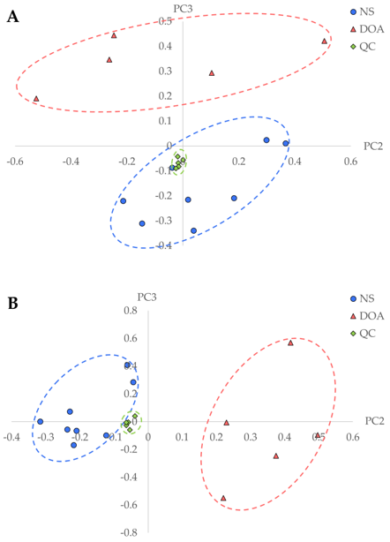
Figure 2. PCA score plots of PC2 and PC3 of organic extracts from heart tissue in positive (A) and negative (B) ionization mode (DOA = dead on arrival, NS = normally slaughtered, QC = quality control).

Identification of markers As part of the XCMS Online processing, the METLIN database was used to give an indication to the possible identification of the markers. MassHunter Qualitative Analysis is able to predict the formula of a compound from the mass spectrum based on monoisotopic mass, isotope abundances and spacing between isotope peaks³². This feature also gives a score indicating how closely this formula matches the experimental data. Time-of-flight instruments have high mass resolution and mass accuracy, therefore the number of potential molecular formula matches are reduced²¹. The tentative identification of some markers was obtained by a combination of these two features, using MassHunter Qualitative Analysis to predict potential formulae and comparing the m/z value and fragmentation pattern to metabolites in the METLIN database. The markers in the heart and liver extracts could not be identified, however the marker found in the muscle extracts in positive mode with a m/z value of 300.2893 at 12.37 minutes gave a predicted formula of C₁₈H₃₇NO₂, with a score of 98.91%. The METLIN database suggested this molecule could be sphingosine, and the mass spectrum from the experimental data matched the mass spectrum on the database, increasing the likelihood of this identification. Following criteria outlined in previous work²¹, this marker was potentially identified as sphingosine, and after the MS/MS analysis of the chemical reference standard for this molecule, this identification was confirmed. The fragmentation patterns were the same in a normally slaughtered sample and in the standard, at 10, 20 and 40 V collision energy. The retention time was also compared on an LC-MS, where a normally slaughtered sample, the standard, and a spiked sample all had an identical retention time.
Sphingosine is a sphingolipid found endogenously in cells, and is the backbone to many sphingolipids, including ceramide. These sphingolipids are involved in a variety of cell signaling and pathological functions, specifically in the process of apoptosis^{33,34} and stress responses³⁵. Sphingosine synthesis begins with the condensation of serine and palmitoyl CoA, producing 3-ketodihydrosphingosine. This is then reduced to dihydrosphingosine and acylated to dihydroceramide. Ceramide is then formed through a dehydrogenation reaction. This is deacylated to form sphingosine, where it can either be phosphorylated to sphingosine-1-phosphate, which is key in the generation of glycerolipids, or it can be recycled back to ceramide following the reutilization pathway, maintaining sphingolipid homeostasis³⁶. It has been found that ceramide production is induced by stress stimuli including hypoxia³⁷. It is therefore possible that the presence of sphingosine in the chicken muscle is a result of the breakdown of ceramide, which accumulated in the muscle during the transport and slaughter of the chicken where there may have been a deficiency in oxygen reaching the muscle tissue. This marker was found to be upregulated in the normally slaughtered chicken muscle compared to the DOA chicken muscle, which could be because the DOA chickens have been dead for longer so the sphingosine was recycled back to ceramide in the time between death and sampling, or it has continued to form sphingosine-1-phosphate, and further broken down to hexadecenal and phosphoethanolamine³⁸.

CONCLUSION
This work has shown that it is possible to use established metabonomic profiling methods to differentiate between animals that have died in transit and those that were subjected to the normal slaughter process. Using this approach has also shown that it is possible to generate a large dataset of metabolites that can be statistically analyzed to determine potential markers that could be useful for the detection of this type of fraud. In this work, sphingosine intensity was found to be statistically significant between DOA and normally slaughtered animals. Due to the number of samples available for this study, it is clear that further work is required to validate this marker for this purpose. However, this work highlights the potential of this approach to provide markers that could be used in targeted assays to detect frauds of this nature.

ASSOCIATED CONTENT
Supporting Information Available:

Table of significantly different markers in organic extracts between normally slaughtered and dead on arrival chicken heart, muscle and liver, including p-value and CV%.

PCA score plots of the organic extracts from liver and muscle tissue in positive and negative ionization mode.
AUTHOR INFORMATION
Corresponding Author
* d.f.thompson@keele.ac.uk
Author Contributions
All authors have given approval to the final version of the manuscript.
ACKNOWLEDGMENT
This work was supported by the BBSRC iCASE studentship BB/L015439/1 and Thermo Fisher Scientific. The authors declare no competing financial interest.

REFERENCES
- Premanandh, J. Food Control 2013, 34, 568-569.
- Sentandreu, M. A.; Sentandreu, E. Food Res. Int. 2014, 60, 19-29.
- Ballin, N. Z. Meat Sci. 2010, 86, 577-587.
- Primrose, S.; Woolfe, M.; Rollinson, S. Trends Food Sci. Technol. 2010, 21, 582-590.
- Nicholson, J. K.; Lindon, J. C.; Holmes, E. Xenobiotica. 1999, 29, 1181-1189.
- Bundy, J. G.; Davey, M. P.; Viant, M. R. Metabolomics 2008, 5, 3021.
- Samuelsson, L. M.; Förlin, L.; Karlsson, G.; Adolfsson-Erici, M.; Larsson, D. G. J. Aquat. Toxicol. 2006, 78, 341-349.
- Robertson, D. G. Toxicol. 2005, 85, 809-822.
- Mattes, W.; Davis, K.; Fabian, E.; Greenhaw, J.; Herold, M.; Looser, R.; Mellert, W.; Groeters, S.; Marxfeld, H.; Moeller, N.; Montoya-Parra, G.; Prokoudine, A.; van Ravenzwaay, B.; Strauss, V.; Walk, T.; Kamp, H. Toxicol. Lett. 2014, 230, 467-478.
- Wishart, D. S. Trends Food Sci. Technol. 2008, 19, 482-493.
- Ke. C.; Hou, Y.; Zhang, H.; Fan, L.; Ge, T.; Guo, B.; Zhang, F.; Yang, K.; Wang, J.; Lou, G.; Li, K. Int. J. Cancer, 2015, 136, 516-526.
- Brindle, J.T.; Antti, H.; Holmes, E.; Tranter, G.; Nicholson, J. K.; Bethell, H. W. L.; Clarke, S.; Schofield, P. M.; McKilligin, E.; Mosedale, D. E.; Grainger, D. J. Nat. Med. 2002, 8, 1439-1444.
- Donaldson, A. E.; Lamont, I. L. PLoS One, 2013, 8, 1-10.
- Cevallos-Cevallos, J. M.; Reyes-De-Corcuera, J. I.; Etxeberria, E.; Danyluk, M. D.; Rodrick, G. E. Trends Food Sci. Technol. 2009, 20, 557-566.
- Cubero-Leon, E.; Peñalver, R.; Maquet, A. Food Res. Int. 2014, 60, 95-107.
- Liu, C.; Pan, D.; Ye, Y.; Cao, J. Food Chem. 2013, 141, 1281-1286.
- Trivedi, D. K.; Hollywood, K. A.; Rattray, N. J. W.; Ward, H.; Trivedi, D. K.; Greenwood, J.; Ellis, D. I.; Goodacre, R. Analyst 2016, 141, 2155-2164.
- Cook, D. W.; Rutan, S. C. J. Chemom. 2014, 28, 681-687.
- Benton, H. P.; Ivanisevic, J.; Mahieu, N. G.; Kurczy, M. E.; Johnson, C. H.; Franco, L.; Rinehart, D.; Valentine, E.; Gowda, H; Ubhi, B. K.; Tautenhahn, R.; Gieschen, A.; Fields, M. W.; Patti, G. J.; Siuzdak, G. Anal. Chem. 2015, 87, 884-891.
- Dunn, W. B.; Broadhurst, D. I.; Atherton, H. J.; Goodacre, R.; Griffin, J. L. Chem. Soc. Rev. 2011, 40, 387-426.
- Dunn, W. B.; Erban, A.; Weber, R. J. M.; Creek, D. J.; Brown, M.; Breitling, R.; Hankemeier, T.; Goodacre, R.; Neumann, S.; Kopka, J.; Viant, M. R. Metabolomics 2013, 9, 44-66.
- Statutory Instruments 2013 No. 2952. Public Health, England, Part 3, paragraph (3b) and (4), page 6.
- Thompson, D. F.; Michopoulos, F.; Smith, C. J.; Duckett, C.J.; Wilkinson, R. W.; Jarvis, P.; Wilson, I. D. Rapid Commun. Mass Spectrom. 2013, 27, 2539-2545.
- Masson, P.; Alves, A. C.; Ebbels, T. M. D.; Nicholson, J. K.; Want, E. J. Anal. Chem. 2010, 82, 7779-7786.
- Want, E. J.; Wilson, I. D.; Gika, H.; Theodoridis, G.; Plumb, R. S.; Shockcor, J.; Holmes, E.; Nicholson, J. K. Nat. Protoc. 2010, 5, 1005-1018.
- Michopoulos, F.; Lai, L.; Gika, H.; Theodoridis, G.; Wilson, I. J. Proteome Res. 2009, 8, 2114-2121.
- Lai, L.; Michopoulos, F.; Gika, H.; Theodoridis, G.; Wilkinson, R. W.; Odedra, R.; Wingate, J; Bonner, R.; Tate, S.; Wilson, I. D. Mol. Biosyst. 2010, 6, 108-120.
- Theodoridis, G. A.; Gika, H. G.; Want, E. J.; Wilson, I. D. Anal. Chim. Acta 2012, 711, 7-16.
- Nilipour, B. A. H.; Melo, G. World Poult. 2002, 18, 30-32.
- Nijdam, E. Zailan, A. R. M.; van Eck, J. H. H.; Decuypere, E.; Stegeman, J. A. Poult. Sci. 2006, 85, 1303-1308.
- Lund, V. P.; Kyvsgaard, N. C.; Christensen, J. P.; Bisgaard, M. Br. Poult. Sci. 2013, 54, 430-440.
- Sana, T. R.; Roark, J. C.; Li, X.; Waddell, K.; Fischer, S. M. J. Biomol. Tech. 2008, 19, 258-266.
- Cuvillier, O. Biochim. Biophys. Acta, Mol. Cell Biol. Lipids 2002, 1585, 153-162.
- Woodcock, J. IUBMB Life 2006, 58, 462-466.
- Spiegel, S.; Milstien, S. FEBS Lett. 2000, 476, 55-57.
- Maceyka, M. Spiegel, S. Nature 2014, 510, 58-67.
- Levade, T.; Malagarie-Cazenave, S.; Gouazé, V.; Ségui, B.; Tardy, C.; Betito, S.; Andrieu-Abadie, N.; Cuvillier, O. Neurochem. Res. 2002, 27, 601-607.
- Gault, C.; Obeid, L.; Hannun, Y. Adv. Exp. Med. Biol. 2010, 688, 1-23.

Supporting Information

The Use of Liquid Chromatography Quadrupole Time-of-Flight Mass Spectrometry and Metabonomic Profiling to Differentiate Between Normally Slaughtered and Dead On Arrival Poultry Meat
Kate L. Sidwickª, Amy E. Johnsonª, Craig D. Adamª, Luisa Pereira^{b}, and David F. Thompson*ª
ª School of Chemical and Physical Sciences, Keele University, Keele, Staffordshire, United Kingdom, ST5 5BG
^{b} Thermo Fisher Scientific, Manor Park, Tudor Road, Runcorn, United Kingdom, WA7 1TA

* Corresponding author:
d.f.thompson@keele.ac.uk

Page Information
S-2 Figure S-1. Example chromatograms of organic extracts from normally slaughtered (NS) and dead on arrival (DOA) chickens in negative ionization mode, A) muscle, B) liver, C) heart.
S-3 Figure S-2. PCA score plots of PC2 and PC3 of organic extracts from liver tissue in positive (A) and negative (B) ionization mode.
Figure S-3. PCA score plots of PC2 and PC3 of organic extracts from muscle tissue in positive (A) and negative (B) ionization mode.
S-4 Table S-1. Significantly different markers in organic extracts between normally slaughtered and dead on arrival chicken heart.
S-5 Table S-2. Significantly different markers in organic extracts between normally slaughtered and dead on arrival chicken liver.
Table S-3. Significantly different markers in organic extracts between normally slaughtered and dead on arrival chicken muscle.

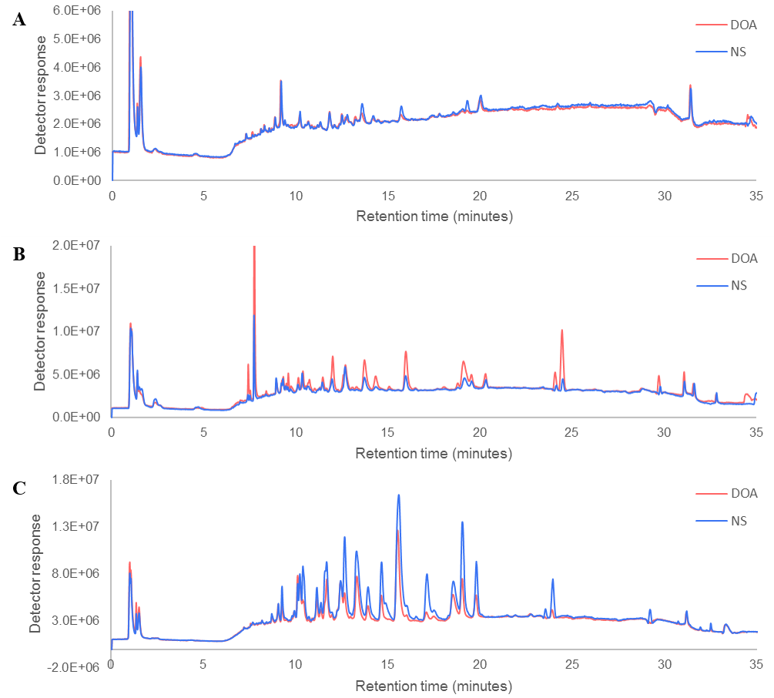
Figure S-1. Example chromatograms of organic extracts from normally slaughtered (NS) and dead on arrival (DOA) chickens in negative ionization mode, A) muscle, B) liver, C) heart.

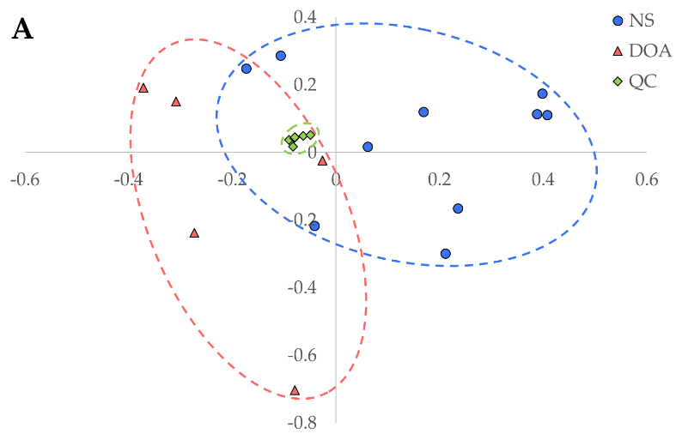
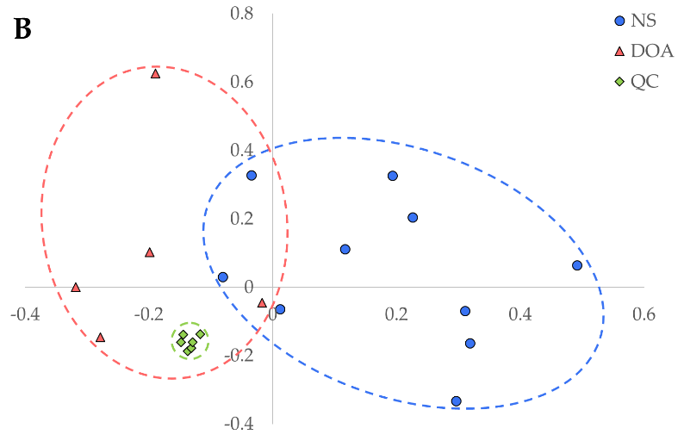
Figure S-2. PCA score plots of PC2 and PC3 of organic extracts from liver tissue in positive (A) and negative (B) ionization mode (DOA = dead on arrival, NS = normally slaughtered, QC = quality control).

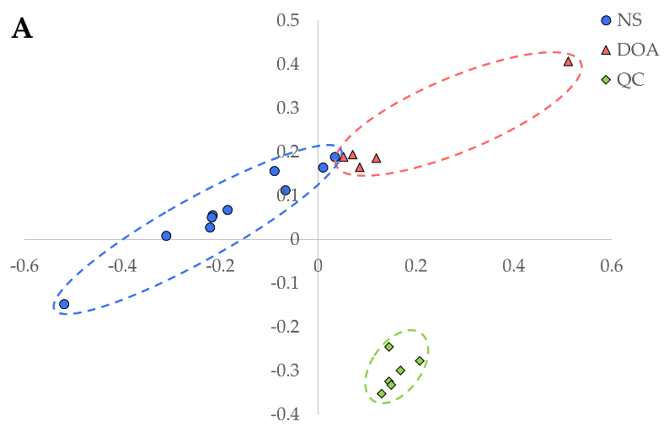
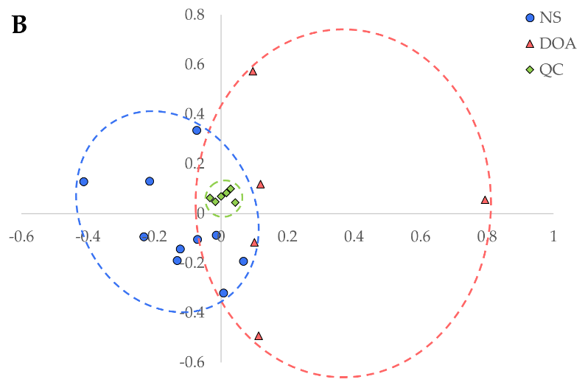
Figure S-3. PCA score plots of PC2 and PC3 of organic extracts from muscle tissue in positive (A) and negative (B) ionization mode (DOA = dead on arrival, NS = normally slaughtered, QC = quality control).

Table S-1. Significantly different markers in organic extracts between normally slaughtered and dead on arrival chicken heart. CV% calculated from peak areas of QC samples, p-value based on 95% confidence level. All markers were higher in normally slaughtered chickens.
Polarity | m/z | Retention time median (minutes) | P-value from t-test (peak areas from XCMS) | P-value from t-test (peak areas from EICs) | CV% (XCMS) | CV% (Qual)
+ | 216.0630 | 16.68 | < 0.001 | < 0.001 | 4.82 | 11.03
+ | 238.6263 | 14.16 | < 0.001 | 0.002 | 5.34 | 7.51
+ | 261.6288 | 17.83 | < 0.001 | < 0.001 | 2.89 | 4.40
+ | 268.1302 | 14.16 | < 0.001 | 0.009 | 8.79 | 29.28
+ | 270.1278 | 16.67 | < 0.001 | 0.001 | 4.22 | 11.08
+ | 282.1428 | 17.83 | < 0.001 | 0.006 | 8.44 | 21.34
+ | 290.1398 | 16.68 | < 0.001 | < 0.001 | 4.96 | 5.12
+ | 467.3261 | 14.74 | < 0.001 | < 0.001 | 2.72 | 25.26
+ | 482.3266 | 16.68 | < 0.001 | < 0.001 | 0.66 | 4.52
+ | 501.8004 | 16.67 | < 0.001 | 0.001 | 4.47 | 24.88
+ | 539.2375 | 14.18 | < 0.001 | < 0.001 | 8.74 | 28.34
+ | 741.9572 | 16.68 | < 0.001 | < 0.001 | 4.00 | 6.95
+ | 747.9430 | 16.68 | < 0.001 | 0.001 | 9.91 | 25.79
+ | 982.6152 | 16.68 | < 0.001 | < 0.001 | 7.27 | 25.04
+ | 988.1003 | 16.68 | < 0.001 | < 0.001 | 6.24 | 11.40
- | 436.2792 | 12.65 | < 0.001 | 0.001 | 1.98 | 2.65
- | 462.2929 | 13.96 | < 0.001 | < 0.001 | 4.34 | 3.14
- | 462.2937 | 13.23 | < 0.001 | < 0.001 | 2.18 | 2.30
- | 482.3097 | 15.54 | < 0.001 | 0.038 | 1.99 | 1.38
- | 494.2358 | 12.66 | < 0.001 | 0.001 | 5.62 | 1.84
- | 504.2655 | 12.65 | < 0.001 | < 0.001 | 1.84 | 3.22
- | 521.2542 | 12.65 | < 0.001 | 0.011 | 1.89 | 20.24
- | 522.2672 | 17.08 | < 0.001 | < 0.001 | 3.19 | 6.62
- | 549.2846 | 17.08 | < 0.001 | 0.001 | 3.36 | 10.58
- | 572.2515 | 12.65 | < 0.001 | 0.010 | 3.32 | 29.00
- | 600.2811 | 17.08 | < 0.001 | 0.004 | 3.58 | 1.14
- | 617.2718 | 17.08 | < 0.001 | < 0.001 | 3.90 | 6.46
- | 668.2685 | 17.09 | < 0.001 | < 0.001 | 2.38 | 1.99
- | 895.5412 | 12.65 | < 0.001 | < 0.001 | 2.18 | 4.09
- | 925.5891 | 13.23 | < 0.001 | < 0.001 | 4.93 | 6.07
- | 947.5698 | 13.21 | < 0.001 | < 0.001 | 4.39 | 6.81
- | 959.6218 | 13.28 | < 0.001 | < 0.001 | 2.44 | 23.50
- | 961.6116 | 15.54 | < 0.001 | 0.006 | 1.22 | 21.51
- | 963.5288 | 12.65 | < 0.001 | < 0.001 | 2.52 | 6.31
- | 965.6203 | 15.54 | < 0.001 | 0.001 | 3.73 | 21.09
- | 980.5186 | 12.65 | < 0.001 | < 0.001 | 4.22 | 4.31
- | 988.6422 | 15.93 | < 0.001 | < 0.001 | 6.19 | 25.70
- | 999.5758 | 13.43 | < 0.001 | < 0.001 | 9.11 | 11.04

Polarity | m/z | Retention time median (minutes) | P-value from t-test (peak areas from XCMS) | P-value from t-test (peak areas from EICs) | CV% (XCMS) | CV% (Qual)
+ | 106.0501 | 1.03 | 0.014 | 0.042 | 1.54 | 1.33
+ | *282.6343 | 14.11 | 0.001 | 0.004 | 3.41 | 8.36
+ | *291.6224 | 14.11 | 0.004 | 0.001 | 5.05 | 29.87
+ | *312.1370 | 14.11 | 0.005 | < 0.001 | 9.32 | 9.45
+ | *333.2389 | 15.24 | 0.023 | 0.024 | 5.38 | 8.93
+ | *498.2808 | 11.39 | 0.008 | 0.015 | 0.45 | 0.88
+ | *508.3065 | 14.11 | 0.003 | 0.028 | 3.54 | 24.17
+ | *524.3002 | 11.92 | 0.001 | < 0.001 | 6.97 | 6.93
+ | *526.3129 | 14.11 | 0.002 | 0.003 | 0.78 | 1.58
+ | *548.2953 | 14.11 | < 0.001 | 0.002 | 9.41 | 22.41
- | *296.2258 | 11.02 | 0.037 | 0.004 | 5.27 | 26.76
- | *319.2214 | 11.23 | 0.036 | 0.042 | 2.79 | 29.57
- | *485.2729 | 13.33 | 0.006 | 0.003 | 1.08 | 28.83
- | *614.2536 | 14.30 | 0.019 | 0.005 | 5.27 | 10.63
Table S-2. Significantly different markers in organic extracts between normally slaughtered and dead on arrival chicken liver. CV% calculated from peak areas of QC samples, p-value based on 95% confidence level. Asterisk indicates marker was higher in DOA chickens.

Table S-3. Significantly different markers in organic extracts between normally slaughtered and dead on arrival chicken muscle. CV% calculated from peak areas of QC samples, p-value based on 95% confidence level. Asterisk indicates marker was higher in DOA chickens.
Polarity | m/z | Retention time median (minutes) | P-value from t-test (peak areas from XCMS) | P-value from t-test (peak areas from EICs) | CV% (XCMS) | CV% (Qual)
+ | 130.1570 | 6.47 | 0.003 | 0.005 | 6.04 | 8.34
+ | *178.5856 | 1.01 | 0.006 | 0.004 | 5.65 | 4.89
+ | *216.1944 | 7.78 | 0.002 | < 0.001 | 6.62 | 3.57
+ | 300.2893 | 12.37 | 0.009 | 0.015 | 6.61 | 7.08
+ | 421.2538 | 19.09 | 0.010 | 0.028 | 6.95 | 15.55
+ | *509.2041 | 1.49 | 0.014 | 0.009 | 9.55 | 5.67
+ | *708.1774 | 1.02 | 0.006 | 0.045 | 9.56 | 6.73
- | *180.0669 | 1.12 | 0.037 | 0.041 | 2.23 | 3.79
- | *297.2461 | 11.78 | 0.030 | 0.031 | 4.85 | 27.15
- | *371.1599 | 1.05 | 0.006 | 0.002 | 3.70 | 27.03

