Supplementary information

Bogdziewicz et al. Climate warming disrupts mast seeding and its fitness benefits in European beech.

Supplementary Table 1. Abiotic drivers of beech seed production. Seed production (yearly records per tree) was modelled using the zero-inflated negative binomial mixed model with tree ID and site used as random intercepts and temporal autoregressive order-1 autocorrelation structure. The logit part of the model included the same set of variables, but only count model results are presented. Significant predictors are given in bold. The model AIC equalled 26578.87 (df = 18), while one in which the temperature and precipitation was replaced with ΔT equalled 26709.4 (df = 12). Thus, the AIC indicated that ΔT model provided worse fit (ΔAIC = 130.5). The model is based on seeding records of 139 trees spaced across 12 sites in England monitored since 1980 till 2018.

|  |  |  |  |  |
| --- | --- | --- | --- | --- |
| Predictor | Effect size | SE | z-value | p |
| Mean Jun-July max temperature in the year prior seedfall | **0.57** | **0.13** | **4.68** | **< 0.001** |
| Mean Jun-July max temperature two years prior seedfall | **-1.07** | **0.12** | **-8.71** | **< 0.001** |
| Jun-July summed precipitation in the year prior seed dispersal | 0.004 | 0.003 | 1.35 | 0.18 |
| Jun-July summed precipitation two years prior seed dispersal | -0.0003 | 0.003 | -0.11 | 0.91 |
| Summed nitrogen deposition in the past 5 years | **0.01** | **0.004** | **2.55** | **0.01** |
| Growing season mean temperature (May-August) | **0.46** | **0.16** | **2.84** | **0.004** |

Supplementary Table 2. Economies of scale and their temporal change. Proportion of predated seeds (a, b) or (c) proportion of pollinated seeds (yearly records per tree) were modelled using the binomial mixed models with tree ID and site used as random intercepts and temporal autoregressive order-1 autocorrelation structure. Models included also observation-level random effect to account for overdispersion. Not significant interaction terms were dropped from the final models.

1. Starvation (response: yearly proportion of predated nuts per tree)

|  |  |  |  |  |
| --- | --- | --- | --- | --- |
| Predictor | Effect size | SE | z-value | p |
| Ln ratio (seed production in year T to that in year T-1) | -0.24 | 0.03 | -8.90 | < 0.001 |
| Ln ratio^2 | 0.02 | 0.008 | 2.95 | 0.003 |
| Year | 0.13 | 0.01 | 9.72 | < 0.001 |

1. Satiation (response: yearly proportion of predated nuts per tree)

|  |  |  |  |  |
| --- | --- | --- | --- | --- |
| Predictor | Effect size | SE | z-value | p |
| Ln nut production | -0.11 | 0.19 | -0.58 | 0.56 |
| Year | 0.09 | 0.02 | 4.18 | < 0.001 |
| Ln nut production^2 | -0.11 | 0.02 | -4.75 | < 0.001 |
| Ln nut production × year | 0.01 | 0.004 | 2.66 | 0.008 |

1. Pollination efficiency

|  |  |  |  |  |
| --- | --- | --- | --- | --- |
| Predictor | Effect size | SE | z-value | p |
| Ln summed nut production of conspecifics | 0.55 | 0.09 | 5.94 | < 0.001 |
| Within-site synchrony of flowering (CV) | 0.89 | 0.31 | 2.85 | 0.004 |
| Summed nut production × synchrony | -0.33 | 0.05 | -6.45 | < 0.001 |
| Year | -0.02 | 0.01 | -1.83 | 0.07 |

Supplementary Figure 1.



Supplementary Figure 1. Map of study sites. Numbers in the circles are the total number of trees sampled at each site across the study site. Locations of Buckholt, Painswick, Killerton and Woodbury were adjusted slightly to prevent overplotting.

Supplementary Figure 2.

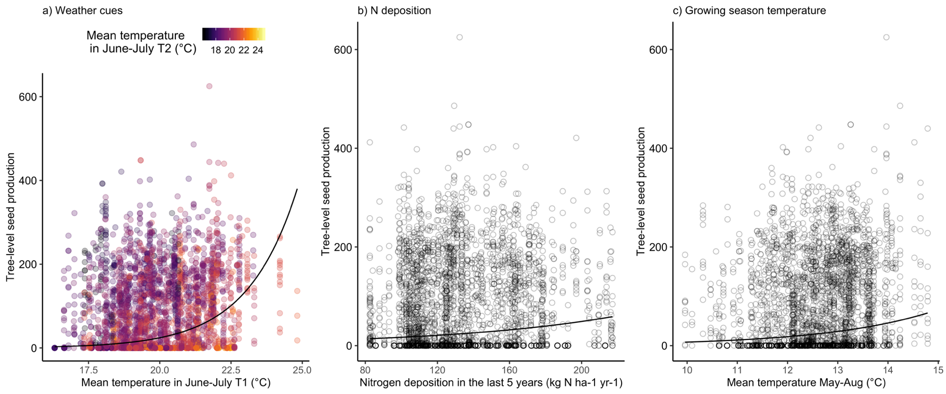

Supplementary Figure 2. The relationship between beech seed production and the abiotic variables. A) Summer temperature in the year prior seedfall. Colors of points show summer temperature two years before seedfall. B) Nitrogen deposition in the last 5 years. C) Growing season mean temperature (May-August). The lines are based on the significant GLMM predictions, see Table S1, and are given for the mean values of other variables included in the model. Points are the per-tree, per-year observations, based on 39-yr data set of 139 beech trees spaced across 12 forest sites in England.