Fig. 1
Shaded area represnts 95% confidence interval

Fig. 2
For Both: age-sex and length-of-data standardized rate; Men and Women: age and length of data standardized rate; Shaded area represents 95% confidence interval
Trends are age-sex and length of data standardized using 2017 CPRD population

Fig. 3
A) Incidence B) Prevalence
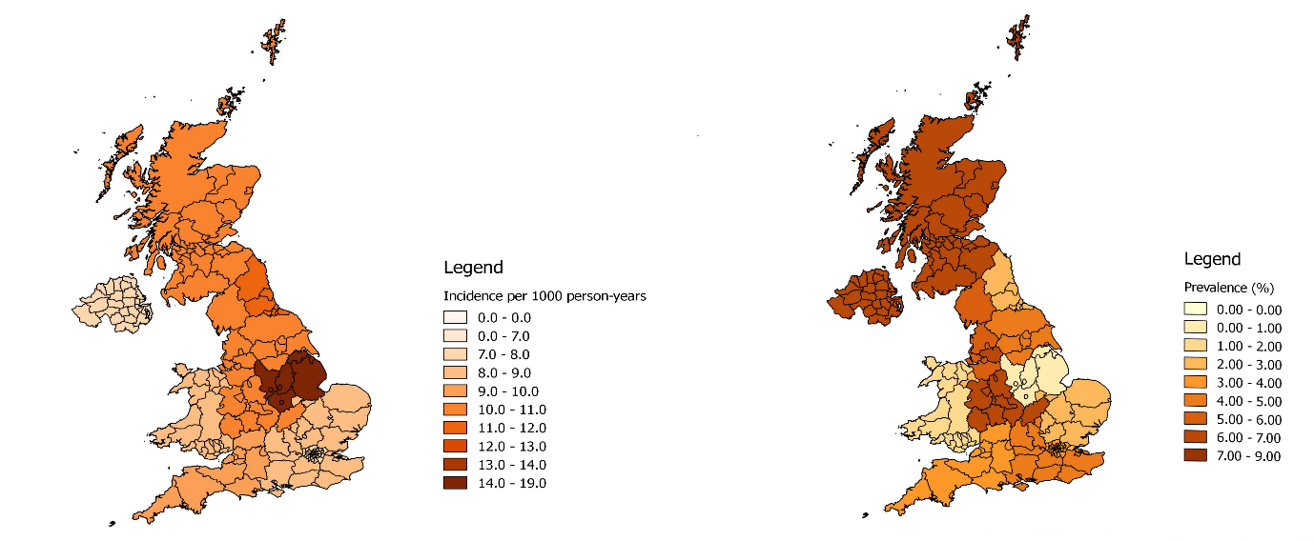

Fig. 4
A) Incidence B) Prevalence
