Supplementary Figures

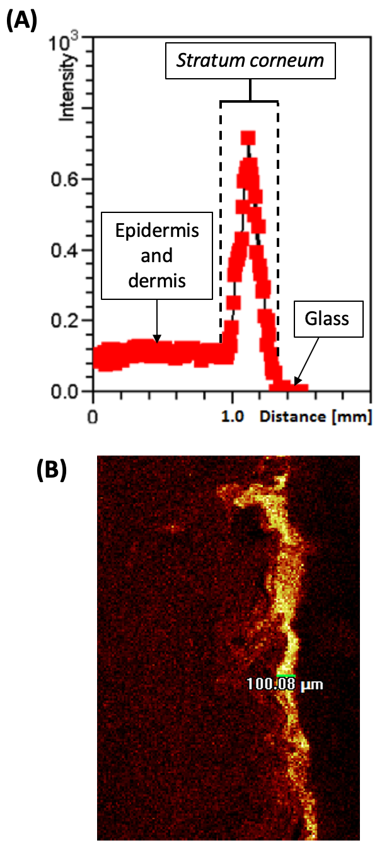

Figure S1. Illustration of the “Measurement Editor” feature using the IONTOF software. Cross sections are measured manually and are illustrated by the green line in (B). (A) Illustration of the change in C₇H₄N₂Cl⁻ ion intensity across the entirety of the tape strip. (B) Quantitative depth permeation measurement of C₇H₄N₂Cl⁻ ion distribution within porcine skin.

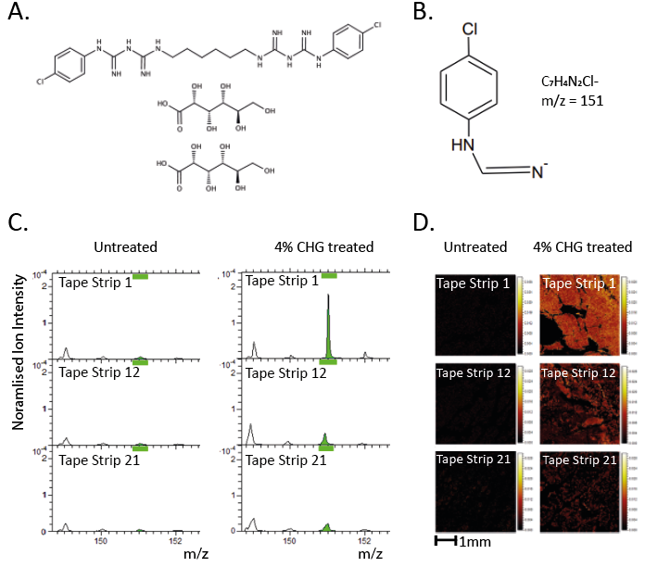
Figure S2. A. Chemical structure of CHG. B. Structure and m/z of CHG fragment used to map drug depth permeation using ToF-SIMS, previously discovered by Holmes et al.¹. C. Mass spectra indicating specificity of C₇H₄N₂Cl⁻ion to CHG (green peak) which is only present on tape strips taken from skin treated with CHG formulation. D. Tape strip images indicating specificity of C₇H₄N₂Cl⁻ ion to CHG. Each image represents a 4 mm × 4 mm area.

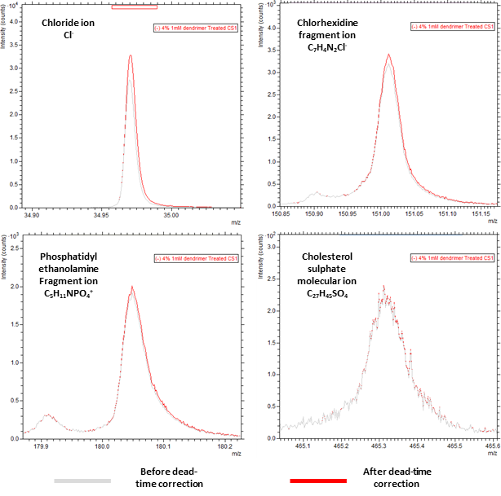

Figure S3. Changes in peak shape before (grey line) and after (red line) dead-time correction. Changes to Cl⁻ peak before and after deadtime correction highlights the presence of peak saturation. However, for the peak of interest C₇H₄N₂Cl⁻ (m/z 151); C₅H₁₁NPO₄⁻ (m/z 180) and C₂₇H₄₅SO₄⁻, (m/z 465.3), there were minimal changes to the peak before and after deadtime correction, suggesting there were minimal to no peak saturation.

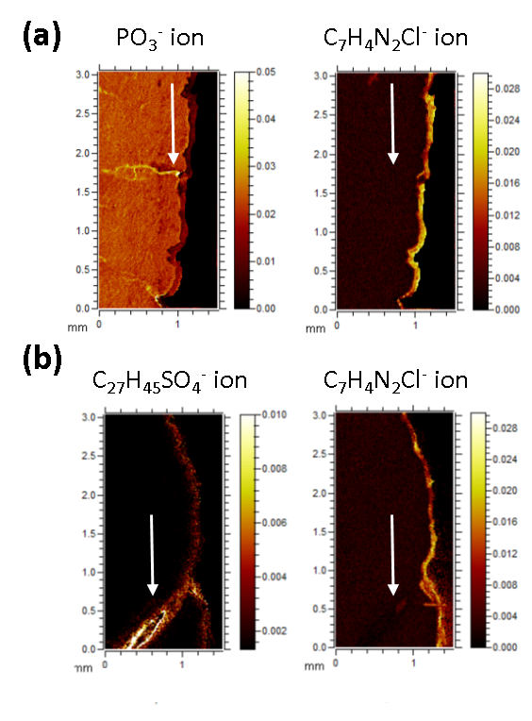
Figure S4. A. Suggestion of a sweat gland (PO₃⁻) with lack of CHG permeation (indicated by white arrows). B. Suggestion of a hair follicle (C₂₇H₄₅SO₄⁻) with lack of CHG permeation (indicated by white arrows).

