Establishing forensic search methodologies and geophysical surveying for the detection of clandestine graves in coastal beach environments

Pringle, J.K.^{1*}, Holland, C.¹, Szkornik, K.¹ & Harrison, M.^{2,3}

¹School of Physical Sciences & Geography, Keele University, Keele, Staffordshire, ST5 5BG, UK.
²National Search Advisor, National Policing Improvement Agency, Knowledge Centre, Wyboston Lakes, Bedfordshire, MK45 3JS, UK
³now National Coordinator Crime Scene Sciences, Australian Federal Police

E-mail addresses; j.k.pringle@esci.keele.ac.uk (J.K. Pringle), k.szkornik@esci.keele.ac.uk (K. Szkornik) & mark.harrison@afp.gov.au (M. Harrison)

*corresponding author. Tel: +44 (0)1782 733163. Fax: +44 (0)1782 733737

Abstract

A 2010 UK police search for a clandestine burial highlighted the need for more information and quantitative data to aid coastal beach searches. This study aimed to address this by establishing relevant forensic search methodologies to aid the search for clandestine coastal burial sites, using the North West English coastline as a search area. A set of parameters were established, including criteria such as tidal range, proximity to vehicular access points and distance from inhabited areas, which may inform forensic searches by prioritising likely locations of clandestine burials. Three prioritised coastal locations were subsequently identified: (1) coastal dunes at Formby, (2) coastal dunes and (3) beach foreshore at Southport, all sites part of the Liverpool City Region in the United Kingdom. At all locations, simulated clandestine graves were created in which a naked adult-sized, metal-jointed fiberglass mannequin was hand-dug by spades and buried at 0.5m below ground level. Trial geophysical surveys were then undertaken with the aim of identifying the optimal geophysical instrumentation and technique to deploy in such environments. GPR data showed 450 MHz frequency antennae to be optimal, with significantly poor data obtained from the foreshore area due to saline seawater. Electrical resistivity and magnetic susceptibility surveys were successful in coastal environments in target detection (albeit not in non-vegetated sand dunes), with resistivity fixed-offset configurations deemed optimal. The latter survey successes may be due to the recent disturbed ‘grave’ rather than the target, which itself is of interest in terms of identifying the most recent clandestine burials.

Keywords: forensic geoscience; clandestine grave; coastal; beach; intertidal zone; geophysics

1. Introduction

The World’s coastline extends for some 440,000 km and more than half of the global human population live less than 100 km from the coast ([1] Davis & Fitzgerald, 2004), making such environments easily accessible for clandestine burials of homicide victims. However, the burial of homicide victims within the coastal environment is relatively infrequent compared to other terrestrial environments ([2] Harrison, 2011). Globally, there is limited published data on clandestine burials within coastal environments however, some examples include the homicide of Father Patrick Heslin in 1921 in the US ([3] Murray & Tedrow, 1991; [4] Murray, 2004) and searches for burial sites of dismembered body parts in Lincolnshire coastal marshes, UK ([5] Saye & Pye, 2004). Forensic trace evidence from coastal sediments have been used in, for example, a U.S. attempted homicide in 1999 ([6] Stam, 2004), the forensic investigation of Italy’s ex-Prime Minister Aldo Moro homicide in 1978 ([7] Lombardi, 1999), and criminal beach investigations in both Japan ([8] Sugita & Marumo, 2004) and the UK ([9] Ruffell & McKinley, 2008, p.229-230). .

The UK coastline is estimated to be around 7,700 km in length with coastal sand dunes in England and Wales covering ~200 km² ([5] Saye and Pye, 2004). In the UK, and other European countries such as Portugal ([10] Guedes et al., 2009), there has been some progress to generate coastal dune sediment databases for forensic searches ([5] Saye & Pye, 2004). However, these have primarily been used to narrow down potential beaches once initial forensic trace evidence has been found. In 2010 a UK police search for a clandestine burial of a murder victim revealed a limited understanding of relevant factors enabling the successful discovery of clandestine burials within coastal environments and in particular on coastal beaches. This search also highlighted a lack of knowledge of optimum search detection technique(s) and methodologies in coastal environments.

Common practice in forensic searches for clandestine burial site(s) can include a variety of conventional and geoforensic search methods as [9] Ruffell & McKinley (2008) review, e.g.; remote sensing ([11-12] Brilis et al., 2000a.b), site walk-overs ([13] Hunter & Cox, 2005), trained victim recovery dogs ([14] Lasseter et al. 2003), methane ([9] Ruffell & McKinley, 2008) and soil probes ([15-16] Owsley, 1995; Ruffell, 2005a), near-surface geophysics, which includes metal detectors ([9] Ruffell & McKinley, 2008), GPR surveys ([17] Ellwood 1994; [18] Witten et al. 2000; [19] Ruffell, 2005b; [20] Novo et al. 2011), electrical resistivity surveys ([21] Cheetham, 2005; [22] Pringle & Jervis, 2010), electro-magnetic ([23] Nobes, 2000) and magnetic surveys ([18] Witten et al. 2000), geochemical surveys ([9] Ruffell & McKinley, 2008) and mass excavations ([13] Hunter & Cox 2005). Current UK search best practice suggests creating a conceptual target (and geological) model of the suspected burial site, using available geological maps, imagery, intelligence and other information, prior to undertaking fieldwork to maximise the chances of detection (see [24] Harrison & Donnelly, 2009). Diggability surveys have also been used to estimate burial viability of a search site.

It has been found by various simulated clandestine grave studies (e.g. [25] France et al. 1992; [26] Schultz et al. 2004; [21] Cheetham, 2005; [27] Schultz, 2008; [28] Pringle et al. 2008; [29] Jervis et al. 2009; [30] Juerges et al. 2010) that optimum search technique(s) can vary due to a variety of factors, for example, time since burial, depth below ground level (or bgl), evidence of scavenging, burial style (wrapped/unclothed), soil type and water content, local climate and environmental factors.

This study aimed to contribute to existing knowledge and data on forensic searches in coastal beach environments using the North West English coastline as a case study. The objectives of this project were therefore to: (1) establish initial forensic beach search methodologies via a desk study designed to migrate from macro- to micro-search sites; (2) undertake pilot studies to create simulated clandestine burials to discover the variant burial viabilities; (3) collect geophysical data over simulated burials to determine optimum geophysical surveying and imaging technique(s) in beach environments and discover their variability.

2. Method

2.1 Preliminary beach classification search protocols

Due to the significant size of the UK coastline, the limited time frame of this study and it’s proximity to Keele University, the North West coastline of England was chosen as the case study area (Fig. 1a). Digital Ordnance Survey of Great Britain (OSGB) and British Geological Survey (BGS) data were downloaded and analysed, 51 potential beach search areas were identified. To reduce this number and following discussions with forensic search practitioners, a set of parameters were identified that may influence an offenders choice of grave location. These parameters included measuring beach lengths, identifying the main sediment type, measuring distance from inhabited areas, vehicular access points, tidal ranges and cliff heights (Table 1). These parameters aimed to identify the ‘most likely’ suitable locations for clandestine burials and thus reduced the number of potential beach search locations along the NW coastline. The [5] Saye & Pye (2004) case study highlighted the relevance of both direct vehicular access and a covert location in the choice of clandestine burial sites.

Of the 51 search areas initially identified along the NW coastline, only one was classified as ‘rocky’, one was classified as a salt marsh and the other 49 were comprised predominately of sand. 49 of the search areas were backed by cliffs, ranging in height from 1 – 5 m, averaging 1.5 m. Beaches ranged in length from 0.6 km to 9 km with an average of ~2.5 km. Ten of these beaches were adjacent to built up urban areas, the remaining thirty-nine were situated between 0.5 km and 3 km from the nearest urban area, divided into; a) isolated dwellings (2%); b) hamlets (8%); villages (51%) and; (d) major urban areas (37%). All investigated beaches had macro-tidal ranges of > 4 m.

Several beach search areas were initially ruled out as likely locations for a clandestine burial due to: (1) lack of direct vehicle access, (2) distance from nearest main roads (3) proximity to built-up and urban areas, and, (4), unsuitable burial ground. The remaining 34 beaches were then prioritised depending upon their proximity to built up areas, levels of vehicular access, their covert nature and sediment composition (Table 1). Two of the top four-ranked priority beach areas were then chosen to be used for field trial burials, Formby Point and Southport, both in the Sefton area of NW England (Fig. 1b-d).

2.2 Geographic location-description of test sites

The coastal Sefton area in NW England, north of the city of Liverpool, has an extensive sand dune-fronted shoreline that has and continues to undergo significant longshore drift and coastal erosion ([31] Pye & Neal, 1994; [32] Esteves et al. 2011). The coastal Sefton dune system is predominantly composed of fine to medium grained, very well sorted sands ([5] Saye & Pye, 2004), comprising over 95% of quartz, with the remainder comprising either carbonates and/or fine silts and muds. The granular uniformity has been suggested to be due to the homogeneity of the sediment source (reworked glacial deposits from the eastern Irish Sea), and the efficiency of marine wave action, tidal currents and aeolian processes at this location ([31] Pye & Neal 1994). The bedrock geology beneath the Sefton area is the Triassic Sidmouth Mudstone Formation ([5] Saye & Pye 2004).

The 3 km long Formby Point beach has an extensive network of dominantly barchan sand dunes as a strip ~1 km wide parallel to the coast, with access roads and multiple car parks for leisure visitors (Fig. 1c). Formby Point is situated ~1.2 km from the village of Formby. The 2.1 km long Southport beach has a ~200 m wide, marram grass-topped sand dune system parallel to the coast and one major car park ~0.6 km from the town of Southport (Fig. 1d). The Southport foreshore also comprises of a mixture of sand and organic-rich silt sediments. [5] Saye & Pye (2004) undertook a detailed study of the coastal sediments in this region, finding Formby Point Beach dune sediments at least 6 m thick and comprised 94-97% sand in size, with the remainder predominantly silt. Sand grains were well sorted and rounded, with three sample (SEFB3A-C) grain sizes averaging 198-247 μm. At Southport, one beach dune sample (SEFB8) comprised 100% quartz sand, with grains well sorted and rounded and averaged 281 μm in size. There was no sample taken at the final Southport foreshore test site. [33] Croft & Pye (2004) document an environmental forensics case study in Sefton sand dunes and quantified the sediment colours to be 0.0Y 4.2/2.5 and 0.1Y 4.3/2.4 Munsell soil colours at two sites respectively.

2.3 Field trials at Formby Point

Initial site reconnaissance at Formby revealed a network of car parks with nearby extensive sand dune systems (Fig. 1c). One dune was chosen as the test site (1) due to it’s proximity to the car park (100 m) and its covert nature (Fig. 2a). A hand-dug ‘grave’ was very easily created at 0.5 m below ground level (bgl), the naked adult-sized, metal-jointed fiberglass mannequin was added as the target and the grave was re-filled with the excavated sand in a total time of ~20 minutes. A 0.5 m burial depth was chosen as this has been shown to be the average depth bgl for discovered clandestine burials ([34] Manhein, 1995; [13] Hunter & Cox, 2005). The digging tools used were a standard wooden-handled spade 1 m long, with a 25 cm wide, 40 cm long stainless steel head and a wooden-handled shovel 1 m long, with a 40 cm wide, 40 cm long steel head. The spade was initially used to create the ‘grave’ dimensions and sides, with the shovel being judged optimal to rapidly remove sand from the grave. It was also straightforward to use nearby dry surface sand to disguise the burial position. The sub-surface sand was also sufficiently saturated to allow easy digging and prevent ‘grave’ side-wall collapse.

Using a fibreglass mannequin was not ideal as a human analogue but was used in this study due to the limited time frame and, more importantly, the potential environmental contamination concerns with using a soft tissue target (e.g. pig cadaver). A 5 m long ‘grave’ survey line was marked with the grave situated centrally, as this line length was judged sufficient to record background data that was not associated with the ‘grave’. In addition, another 5 m long survey line was also marked 5 m away from the ‘grave’ survey line to provide additional control data for comparison purposes (Fig. 2a).

A BloodHound™ IV metal detector was then immediately used to try and locate the burial but this was unsuccessful; somewhat unusual given that metal components were present within the mannequin. However, it should be noted that had a minimum mine detector been available; this may have given success. Initial bulk ground electrical resistivity trials with Geoscan™ RM15-D equipment, using both fixed-offset and square-array electrode probe configurations (see [28] Pringle et al. 2008), were also trialled but could not obtain readings due to very high resistance values, thought to be due to the very dry nature of the sand substrate at this location.

Ground Penetrating Radar (GPR) PulseEKKO™ 1000 equipment were used to collect fixed-offset, bi-static, 225 MHz, 450 MHz and 900 MHz dominant frequency 2D repeat profiles along both survey lines (Fig. 2a). Radar trace spacings (and time windows) were 0.1 m (80 ns), 0.05 m (60 ns) and 0.025 m (40 ns) for the 225, 450 and 900 MHz frequency data respectively, using 32 ‘stacks’ to increase the signal-to-noise ratio and for all datasets for consistency purposes. The GPR surveys took ~1 h to collect. It was evaluated that 110 MHz and 1200 MHz dominant frequency GPR data would not be collected in such a forensic search due to the poor resolution and penetration respectively. Once the 2D GPR profiles for each dominant frequency antennae were acquired, they were downloaded and imported into REFLEX-Win™ v.3.0 processing software. Processing steps were applied in order to filter out non-target ‘noise’ and optimise image quality. These steps were: (1) trace editing; (2) subtracting trace mean (‘dewowing’); (3) picking first arrivals and applying static correction where necessary; (4) band-pass gain filter to boost deeper reflection events whilst retaining relative signal amplitudes (see [35] Milsom, 2007).

2.4 Field trials at Southport

Initial site reconnaissance at Southport revealed one major car park with nearby sand dune systems to the south and an extensive foreshore to the west (Fig. 1d). One dune site was chosen as test site (2) due to it’s proximity to the car park (<100 m) and its covert nature (Fig. 2b/c). Test site (3) was situated on the foreshore due to its proximity to the car park and being a quite different environment compared to the previous test sites (Fig. 2d). A hand-dug ‘grave’ was again easily created in the dune test site (2) using the same parameters as for test site (1), although the test site (3) foreshore burial took ~30 minutes to complete as the organic-rich sediment were more difficult to dig (Fig. 2e). The ‘grave’ side-walls in the foreshore regularly collapsed when being dug, with the very saturated, mixed sediments also not being easy to extract to the required depth of 0.5 m bgl. It was also difficult to disguise the burial in the foreshore due to the mixed nature of the sediments. For consistency purposes and for comparison, 5 m long ‘grave’ survey lines were again marked at these test sites with the grave situated centrally, as well as 5 m control survey lines (Fig. 2b-e).

A BloodHound™ IV metal detector was again used to try and locate both ‘graves’ but again this was unsuccessful. Bulk ground electrical resistivity data were collected at test sites (2) and (3) every 0.25 m over respective ‘grave’ and control profiles (Fig. 2), with Geoscan™ RM15-D equipment using both fixed-offset and square array probe configurations. 0.1 m long, stainless steel electrode probe separations were all 0.5 m, except for the remote probes used for the fixed-offset resistivity surveys that had to be 1.5 m separated in order to sufficiently reduce resistivity readings to gain usable measurements. The square array surveys had both square (needing a geometric correction factor) and diagonal measurements (which did need correction) taken. The geometric correction factor is given in [35] Milsom (2007) and is thus:

ρ = (2πa/2-√2)*V¹/V²

where a = electrode spacing, and V¹ and V² are the first and second measurement respectively.

A Bartington MS.1™ susceptibility instrument (Bartington Instruments Ltd., Oxford, UK) with a 30 cm diameter probe was also available for these surveys and was used to collect 0.25 m spaced, magnetic susceptibility data over both survey lines. GPR 2D profiles were also collected over both test sites using the same antennae frequencies, configuration, trace spacings and data processing as used for the Formby Point study (1) for consistency purposes.

3. Results

The Formby Point test site (1) sand dune (Fig. 2a) GPR datasets showed the ‘grave’ could be detected using all frequencies, but the 450 MHz frequency antennae was found to be optimal (Fig.3). Point source velocities identified in the 2D profiles varied from 0.05 – 0.08 ns/m. Typical penetration depths were ~3.25 m (65 ns), ~2.25 m (45 ns) and ~1 m (20 ns) for the 225 MHz, 450 MHz and 900 MHz frequency antennae respectively. There were no non-target anomalies present. Blank traces identified in the 2D ‘grave’ profile were due to a malfunctioning cable that was subsequently fixed before other GPR data were collected.

The Southport test site (2) sand dune (Fig. 2b-c) GPR datasets showed the ‘grave’ could be detected using all frequencies, but the 225 MHz frequency antennae is optimal as there were fewer non-target anomalies (Fig.3). Point source velocities identified in the 2D profiles varied from 0.07 – 0.1 ns/m. Typical penetration depths were ~5 m (65 ns), ~2.4 m (30 ns) and ~1.5 m (20 ns) for the 225 MHz, 450 MHz and 900 MHz frequency antennae respectively. Non-target anomalies were also resolved, especially in the 900 MHz 2D profiles.

The Southport test site (3) foreshore (Fig. 2d-e) GPR datasets showed the ‘grave’ was poorly resolved using all frequencies, but the 450 MHz frequency antennae is optimal as this gave the clearest anomaly (Fig.3). Point source velocities identified in the 2D profiles varied from 0.06 – 0.07 ns/m. Typical penetration depths were ~1.5 m (25 ns), ~0.9 m (15 ns) and ~0.5 m (8 ns) for the 225 MHz, 450 MHz and 900 MHz frequency antennae respectively. There were non-target anomalies resolved, especially in both the 450 MHz and 900 MHz 2D profiles. GPR profiles needed to have at least twice as much gain filter applied during data processing, when compared to the other test sites, to resolve deeper reflection events in 2D profiles.

The Southport electrical resistivity survey results were varied; for test site (2) in the sand dunes, average resistivity values were 183 Ω.m, 188 Ω.m and 41 Ω.m for the fixed-offset, raw and diagonal square array configurations respectively, whereas for test site (3) on the foreshore, average resistivity values were 10 Ω.m, 1.5 Ω.m and 0.3 Ω.m for the fixed-offset, raw and diagonal square array configurations respectively. In the fixed-offset resistivity surveys, the ‘grave’ position was very obvious in the sand dunes with resistivity values of ~107 Ω.m compared to a 183 Ω.m average (Fig. 4a), whereas on the foreshore the ‘grave’ position was ~9.25 Ω.m compared to a 10 Ω.m average (Fig. 4b). In the geometrically corrected, square array resistivity surveys, the ‘grave’ was still identifiable if less obvious compared to the fixed-offset data at test site (2) in the sand dunes (Fig. 4c), whereas it could not be identified in test site (3) on the foreshore (Fig. 4d). In the diagonal square array resistivity surveys, the ‘grave’ was identifiable at test site (2) in the sand dunes at ~150 Ω.m compared to a 40 Ω.m average (Fig. 4e), and was ~0.8 Ω.m compared to a ~0.2 Ω.m average in test site (3) on the foreshore (Fig. 4f).

The Southport magnetic susceptibility results at test site (2) in the sand dunes showed the ‘grave’ had readings of ~17 ms which were very identifiable compared to an average reading of 5 ms (Fig. 4g). At test site (3) on the foreshore, the ‘grave’ readings of ~110 ms did contrast with an average reading of 37 ms, albeit another significant peak of ~150 ms was also measured on the profile that was not associated with the ‘grave’ (Fig. 4h).

4. Discussion

Initial project outcomes suggest narrowing down potential beach sites is difficult given the protocols suggested (Table 1). However, these may be useful in terms of providing initial guidance for identifying the most likely potential burial locations. The literature also suggests the importance of covert coastal sites ([5] Saye & Paye, 2004), proximity to vehicle access ([9] Ruffell & McKinley, 2008; [22] Pringle & Jervis, 2010) and perpetrator burial area familiarity and hence these are important case specific parameters to consider in any coastal forensic search.

The pilot field studies showed burials could be excavated surprisingly quickly in the coastal environments investigated, typically less than 30 minutes, although the foreshore burial (test site 3) had seawater-saturated sediments that would have prevented burial much deeper than 0.5 m bgl due to ‘grave’ wall instability and saturated sediments. Burial depths of 1+ m would be achievable in less than 1 hour, even in dry sand environments such as the sand dunes investigated here. It was also found that ‘graves’ could be fairly easily disguised with no surface expression remaining; even with the foreshore ‘grave’ if more time had elapsed between burial and the surveying search phase. This has also been found by the Police co-author in ‘live’ forensic beach searches with an increased reliance on search dog teams that were not investigated in this study. It was also unforeseen that the metal detector used did not detect the burials, for reasons that are presently unexplained. However, had an alternative device such as a minimum mine detector been available, this may have achieved success.

The GPR results from both sand dunes (test sites 2 and 3) located the target well; lower frequency GPR antennae could be therefore be used in these environments for forensic searches which would significantly decrease survey time. However, the foreshore test site (3) GPR data showed poor target resolution, significant signal attenuation and shallow penetration depths, when compared to the sand dune study (2 and 3) datasets, which was most probably due to the presence of seawater. It is important to note that a mannequin is not an ideal human analogue. Although humanoid in shape and presenting an excellent reflective radar surface, the dielectric permittivity contrast of human remains compared to background material will be quite different. In this study it was not deemed suitable to use, for example, a soft tissue target (e.g. pig cadaver) due to the potential environmental impacts.

The bulk ground resistivity results suggested that this may be a technique that would be useful in forensic coastal searches, with the fixed-offset probe configuration deemed optimal (cf. Fig.2a-f). This has been found in other environments (e.g. [21] Cheetham, 2005; [22] Pringle & Jervis, 2010). However, note that the very dry sand dunes in test site (1) precluded resistivity data being collected here; emphasising the importance of trial surveys using different equipment configurations before a full search is conducted. Although the buried mannequin target presented a solid barrier to electrical current (as would be expected with a wrapped or clothed human victim), the resulting anomalies were only high in the diagonal square array resistivity data, with respect to background values; the other anomalies were low. This is surprising; other simulated studies of wrapped targets provide a high resistivity anomaly with respect to background values, although this has been shown to change over time (see [29] Jervis et al. 2009). Other authors (e.g. [21] Cheetham, 2005) have suggested that the disturbed ground in the ‘grave’ area itself may be causing a resistivity anomaly, although this is judged unlikely here as the sand dune itself will be actively moving. More likely it may be due to the limited time frame between burial and subsequent geophysical surveys being undertaken. This is in itself is an important consideration for forensic surveys as often the clandestine burial may be fairly recent. The square array probe configuration has been under-utilised in all fields of near-surface investigations and this study shows it has merit for forensic searches.

Magnetic susceptibility surveys showed surprisingly good results in test sites (2) and (3) with clear anomalies present over the respective ‘graves’; this technique is, however, laborious to collect and thus only recommended for a modest-sized forensic search area. More advanced magnetic survey equipment (for example, using a fluxgate gradiometer or alkali vapour gradiometer) is suggested to be worthwhile investigating in this environment as they have been shown useful at target location in other studies ([18] Witten, 2000; [28] Pringle et al. 2008). Again the magnetic susceptibility results may be due to the disturbed ground in the ‘grave’ with respect to background values, rather than the target in this study due to the limited time frame between burial and geophysical survey. This is reinforced by the metal detector not being successful at locating the mannequin.

5. Conclusions

Initial beach classifications for forensic searches have highlighted the importance of covert locations away from urban areas and direct vehicular access in determining potential clandestine burial sites. Initial field trials showed hand-dug, 0.5m bgl sand dune burials to be surprisingly easy to create within small time frames (<0.5 hours) in the test sites, albeit the foreshore test site took longer and was harder to dig due to saturated mixed sediments.

GPR datasets acquired in the sand dune study sites were able to locate the target ‘grave’, with 450 MHz frequency antennae deemed optimal for burial target detection. However, GPR data collected from the foreshore showed poor data resolution, significant signal attenuation and reduced penetration depths. Bulk ground resistivity results generally showed good results in the coastal study sites investigated; although resistivity values were very low in the foreshore area; the target ‘grave’ could still be resolved. Results showed that such techniques are not, however, recommended in very dry sand survey sites. Magnetic susceptibility results were successful in locating the ‘target grave’ in both sand dunes and foreshore areas but current equipment used would only be recommended when surveying a relatively small area. Caution should be used noting the resistivity and magnetic results as these may be due to the disturbed ground present in the ‘grave’ rather than the mannequin itself.

Clearly a significant larger-scale desk study should be initiated for the UK and elsewhere, with contributory factors from unpublished and specific case investigations used to refine the suggested forensic search methodologies. More robust field trials should also be undertaken, with control (empty) graves and simulated clandestine graves using soft tissue targets repeatedly surveyed over time should be undertaken if the necessary field permissions could be obtained. Specialist search dog teams and mine detector equipment should also be utilised as these are standard Police search team tools. Lastly handheld thermal cameras should also be utilised as these and GPR proved successful for the forensic search that instigated this research.

6. Acknowledgements

The Nuffield Foundation is thanked for providing summer undergraduate placement funding (URB/37969) for Claire Holland. Connor Wheeldon is thanked for field work assistance. John Jervis and Jamie Hansen are thanked for improving an early version of this manuscript. Alastair Ruffell is acknowledged for advice on operational experience on forensic beach searches. Fairytales bridal shop in Newcastle-under-lyme, Staffordshire, UK, is thanked for mannequin donation.

7. Role of the funding source

The Nuffield Foundation had no involvement with the project.

8. References

[1] Davis R, Fitzgerald, DM, Beaches and coasts, Blackwell Publishing, Malden, MA, 2003.

[2] Classified information provided by the UK Police homicide body disposal database, Harrison personal communication, 2011.

[3] Murray RC, Tedrow JCF, Forensic geology, Prentice Hall, Englewood Cliffs, NJ, 1991.

[4] Murray RC, Evidence from the earth: forensic geology and criminal investigation, Mountain Press Publishing, Missoula, MT, 2004.

[5] Saye SE, Pye K, Development of a coastal dune sediment database for England and Wales: forensic applications, in: K Pye, DJ Croft, (Eds.), Forensic Geoscience: Principles, Techniques and Applications, Geol. Soc. London Spec. Pub., 232, 2004, 75-95.

[6] Stam M, Soil as significant evidence in a sexual assault/attempted homicide case, in: K Pye, DJ Croft, (Eds.), Forensic Geoscience: Principles, Techniques and Applications, Geol. Soc. London Spec. Pub., 232, 2004, 295-299.

[7] Lombardi G, The contribution of forensic geology and other trace evidence analysis to the investigation of the killing of Italian Prime Minister Aldo Moro, J. For. Sci. 44 (1999) 634-642.

[8] Sugita R, Marumo Y, ‘Unique’ particles in soil evidence, in: K Pye, DJ Croft, (Eds.), Forensic Geoscience: Principles, Techniques and Applications, Geol. Soc. London Spec. Pub., 232, 2004, 97-102.

[9] Ruffell A, McKinley J, Geoforensics, Wiley, Chichester, 2008.

[10] Guedes A, Ribeiro H, Valentim B, Noronha F, Quantitative colour analysis of beach and dune sediments for forensic applications: a Portuguese example, For. Sci. Int. 190 (2009) 42-51.

[11] Brilis GM, Gerlach CL, van Waasbergen RJ, Remote sensing tools assist in environmental forensics, Part I, Digital tools—traditional methods, Env. For. 1 (2000a) 63–67.

[12] Brilis GM, van Waasbergen RJ, Stokely PM, Gerlach CL, Remote sensing tools assist in environmental forensics, Part II, Digital tools, Env. For. 1 (2000b) 1–7.

[13] Hunter J, Cox M, Forensic archaeology: advances in theory and practice, Routledge, Abingdon, 2005.

[14] Lasseter A, Jacobi KP, Farley R, Hensel L, Cadaver dog and handler team capabilities in the recovery of buried human remains in the Southeastern United States, J. For. Sci. 48 (2003) 1–5.

[15] Owsley DW, Techniques for locating burials, with emphasis on the probe, J. For. Sci. 40 (1995) 735–740.

[16] Ruffell, A, Burial location using cheap and reliable quantitative probe measurements, For. Sci. Int. 151 (2005a) 207-211.

[17] Ellwood BB, Owsley DW, Ellwood SH, Mercado-Allinger PA, Search for the grave of the hanged Texas gunfighter, William Preston Longley, Hist. Arch. 28 (1994) 94-112.

[18] Witten A, Brooks R, Fenner T, The Tulsa Race Riot of 1921: a geophysical study to locate a mass grave, Leading Edge 20 (2000) 655–660.

[19] Ruffell A, Searching for the IRA “disappeared”: Ground Penetrating radar investigation of a churchyard burial site, J. For. Sci. 50 (2005b) 1430-1435.

[20] Novo A, Lorenzo H, Ria F, Solla M, 3D GPR in forensics: finding a clandestine grave in a mountainous environment, For. Sci. Int. 204 (2011) 134-138.

[21] Cheetham P, Forensic geophysical survey, in: J Hunter, M Cox, (Eds.), Forensic Archaeology: Advances in Theory and Practice, Routledge, Abingdon, 2005, pp. 62–95.

[22] Pringle JK, Jervis JR, Electrical resistivity survey to search for a recent clandestine burial of a homicide victim, UK, For. Sci. Int. 202 (2010) e1-e7.

[23] Nobes DC, The search for ‘‘Yvonne’’: a case example of the delineation of a grave using near-surface geophysical methods, J. For. Sci. 45 (2000) 715–721.

[24] Harrison M, Donnelly LJ, Locating concealed homicide victims: developing the role of geoforensics, in: K Ritz, L Dawson, D Miller, (Eds.), Criminal and Environmental Soil Forensics, Springer, Dordrecht, 2009, pp. 197–219.

[25] France D L, Griffin TJ, Swanburg JG, Lindemann JW, et al., Necrosearch revisited: further multidisciplinary approaches to the detection of clandestine graves, in: W.D. Haglund, M.H. Sorg (Eds.), Forensic taphonomy: the postmortem fate of human remains, CRC Press, Boca Raton, FL, 1997, pp. 497–509.

[26] Schultz JJ, Collins ME, Falsetti AB, Sequential monitoring of burials containing large pig cadavers using ground-penetrating radar, J. For. Sci. 51 (2006) 607–616.

[27] Schultz JJ, Sequential monitoring of burials containing small pig cadavers using ground-penetrating radar, J. For. Sci. 53 (2008) 279–287.

[28] Pringle JK, Jervis J, Cassella JP, Cassidy NJ, Time-lapse geophysical investigations over a simulated urban clandestine grave, J. For. Sci. 53 (2008) 1405-1417.

[29] Jervis JR, Pringle JK Tuckwell GT, Time-lapse resistivity surveys over simulated clandestine burials, For. Sci. Int. 192 (2009) 7-13.

[30] Juerges A, Pringle JK, Jervis JR, Masters P, Comparisons of magnetic surveys over simulated clandestine graves in contrasting burial environments, Near Surf. Geophys. 8 (2010) 529-539.

[31] Pye K, Neal A, Coastal dune erosion at Formby Point, north Merseyside, England: causes and mechanisms, Marine Geol. 119 (1994) 39-56.

[32] Esteves L, Brown JM, Williams JJ, Lymbery G, Quantifying thresholds for significant dune erosion along the Sefton Coast, Northwest England, Geomorph. doi:10.1016/j.geomorph.2011.02.029 (2011).

[33] Croft D, Pye K, Colour theory and the evaluation of an instrumental method of measurement using geological samples for forensic applications, in: K Pye, DJ Croft, (Eds.), Forensic Geoscience: Principles, Techniques and Applications, Geol. Soc. London Spec. Pub. London, 232, 2004, 49-62.

[34] Manhein MH, Decomposition rates of deliberate burials: a case study of preservation, in: WD Haglund, MH Sorg, (Eds.), Forensic taphonomy: the post-mortem fate of human remains, CRC Press, Boca Raton, FL, 1996, pp. 469–481.

[35] Milsom J, Field Geophysics, 3rd edn. John Wiley & Sons, 2007.
9. Figures

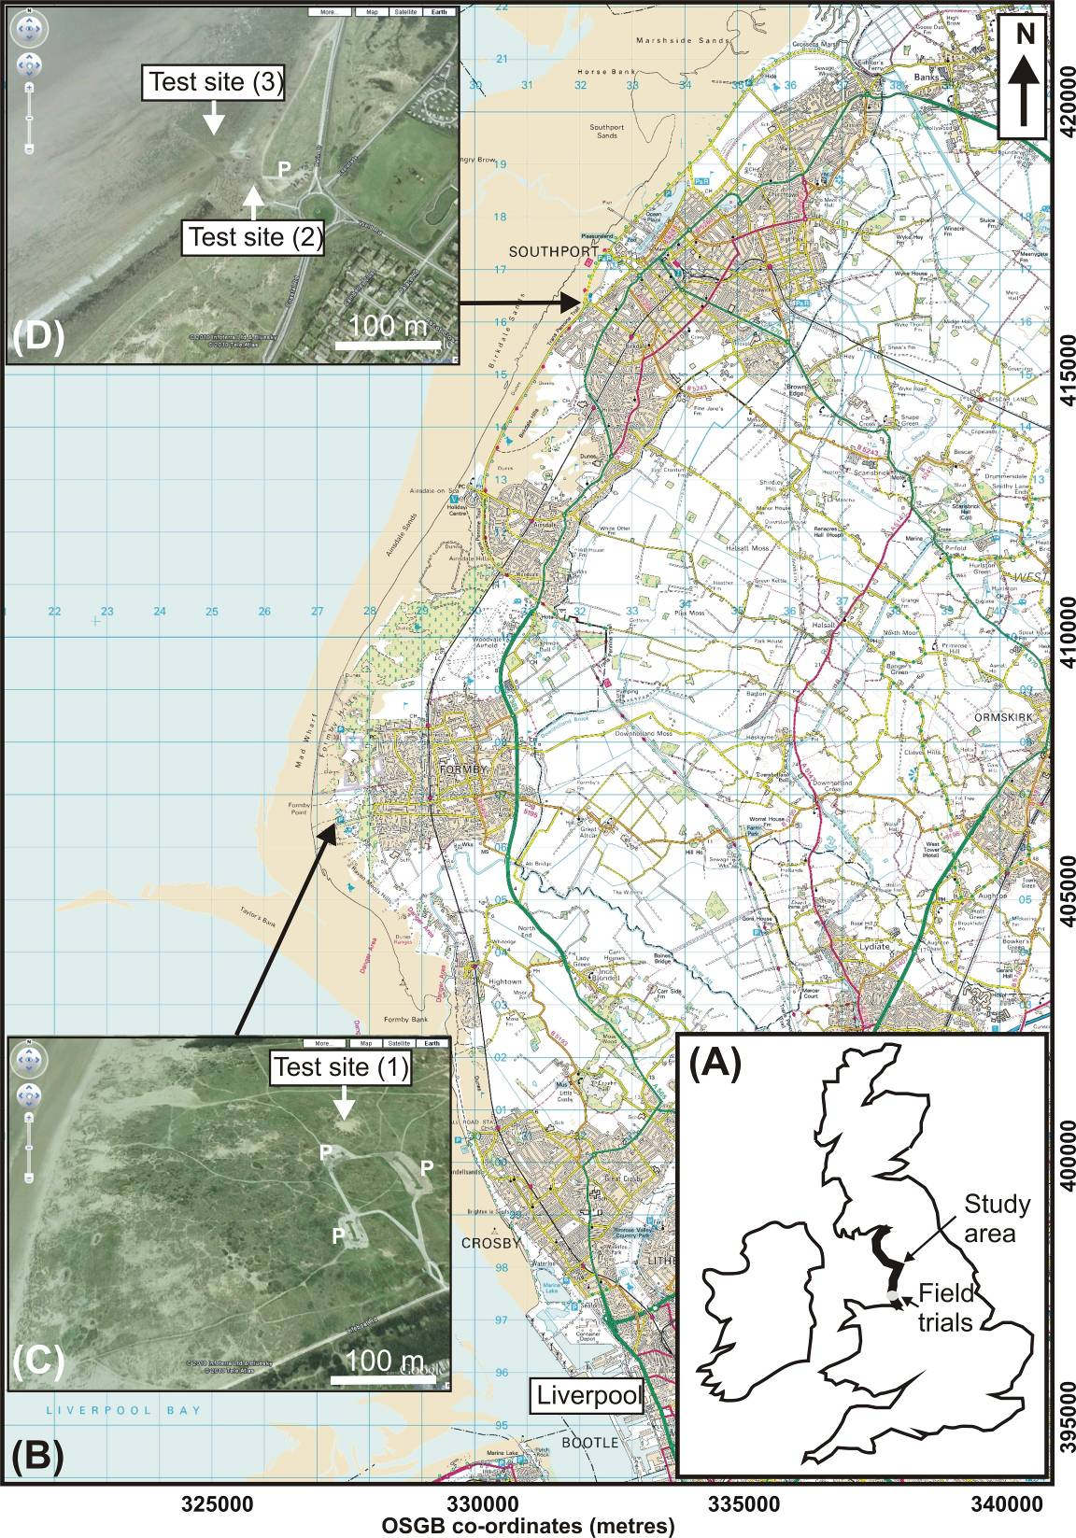

Fig. 1. Overview of study. (a) Location map of NW England area investigated; (b) Location map of priority study areas (1-3) showing; (C) Formby Point and (D) Southport aerial views. (B) Image supplied by Ordnance Survey/EDINA service ©Crown Copyright Database 2007 and (C/D) ©Googlemaps.

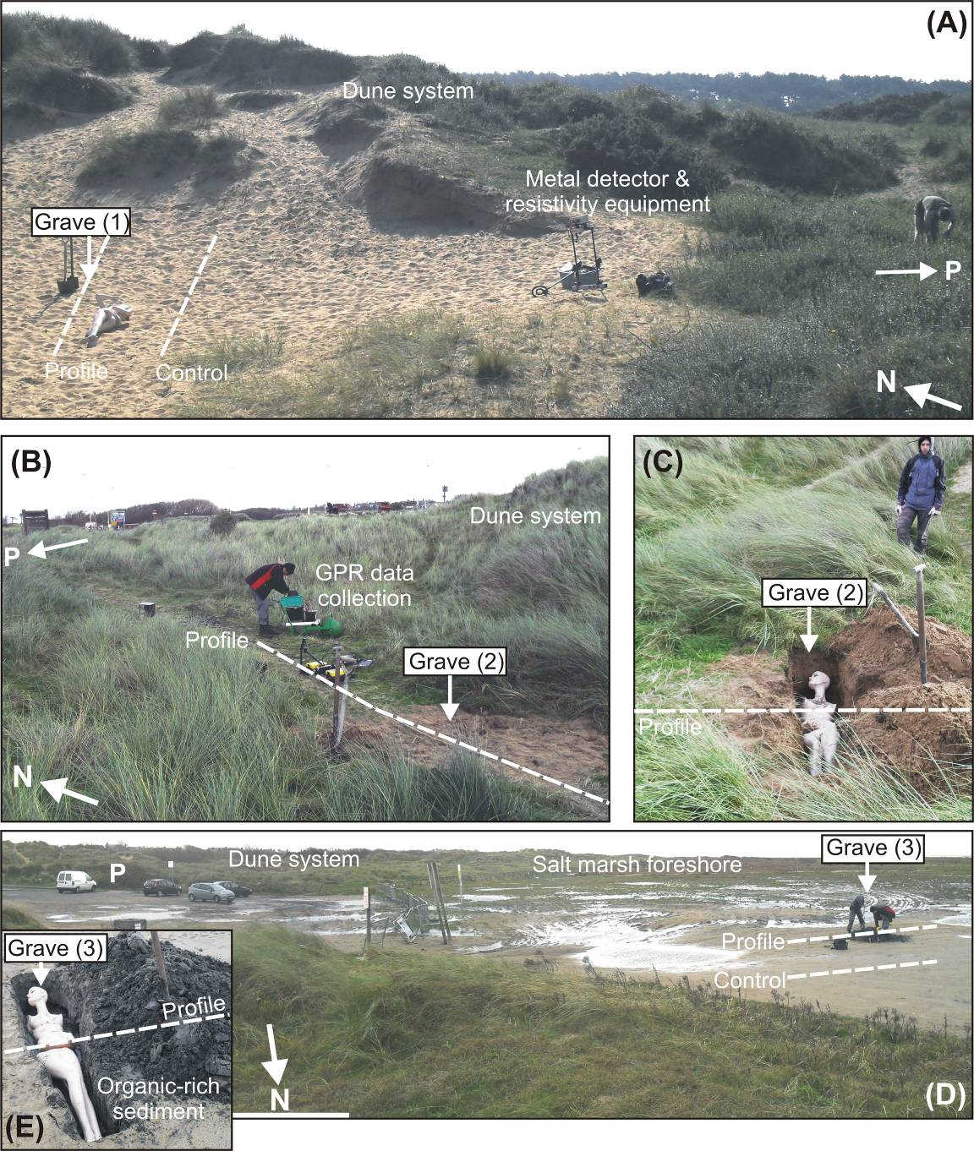

Fig. 2. Photographs of Formby and Southport field study sites. (A) Formby study site (1) with ‘grave’, GPR 2D profile and car park (P) positions marked. (B/C) Southport sand dune study site (2) with ‘grave’, geophysics 2D profile and car park (P) position marked. (D/E) Southport foreshore study site (3) with ‘grave’, geophysics 2D profiles and car park position (P) marked.
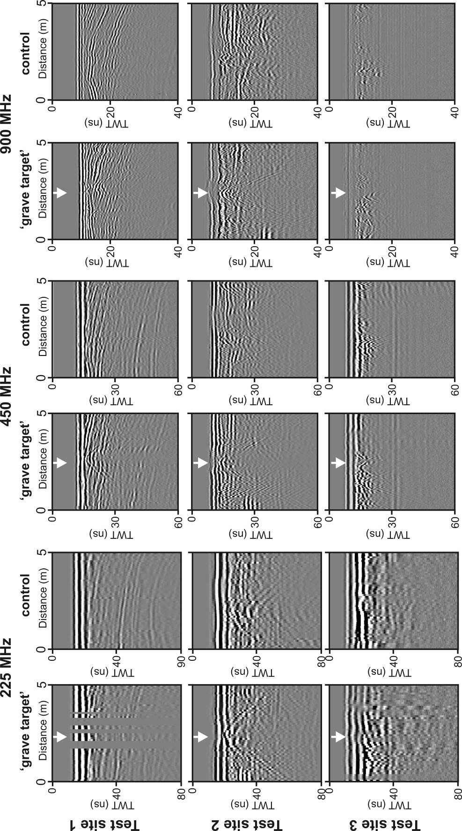
Fig. 3. 2D GPR processed profiles from test sites (1) Formby Point, (2) sand dunes and (3) foreshore at Southport (see text). Respective 2D ‘grave’ (marked by arrow) and control profiles at 225 MHz, 450 MHz and 900 MHz dominant frequencies are shown (see Fig. 2 for location).
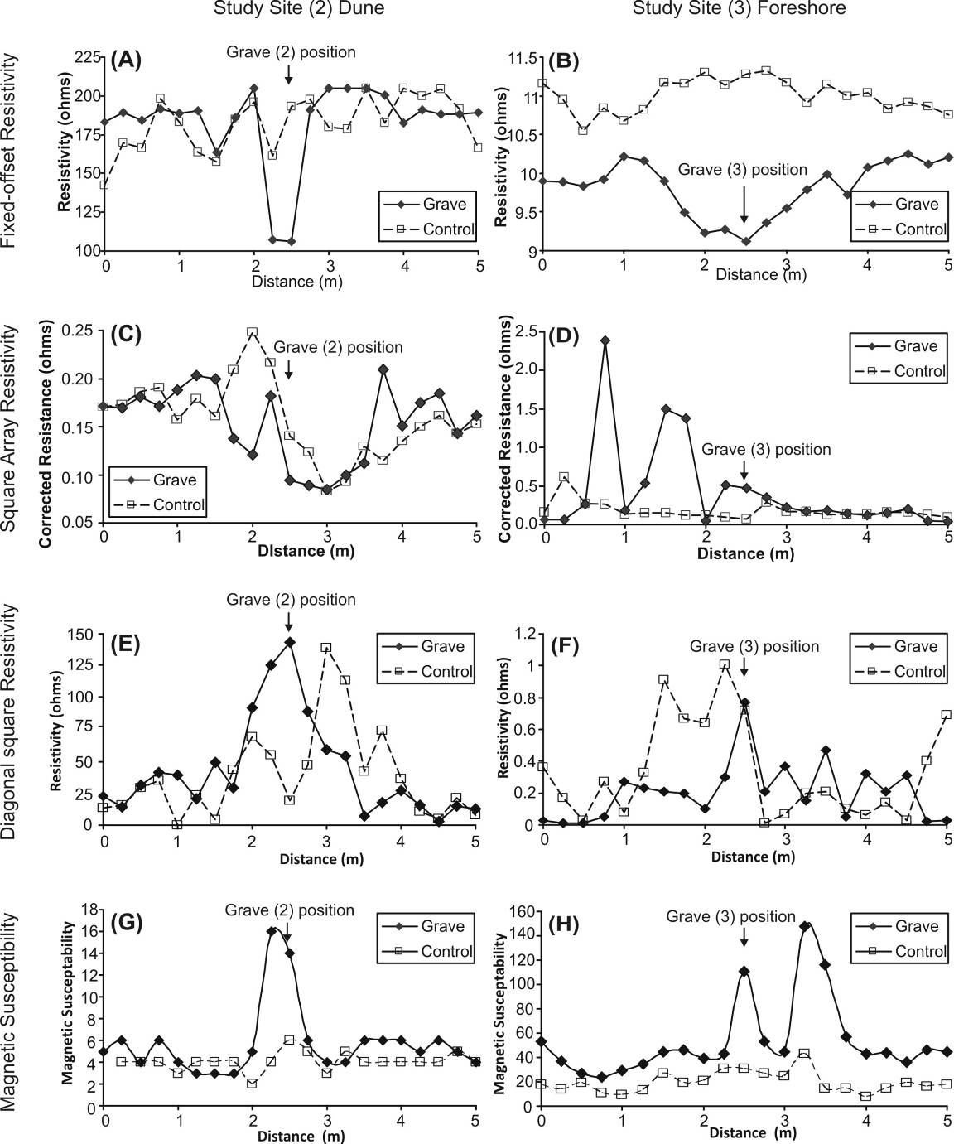
Fig. 4. Southport field test sites 2 and 3 electrical resistivity (A-F) and magnetic susceptibility (G-H) data respectively (see text). Approximate profile positions are shown in Fig. 2. Respective ‘grave’ positions on profiles are marked.
10. Tables

Step | Detail
1. Compile beach list. | List of North West England study site beaches identified.
2. Digital data acquisition. | Digital data (OSGB topography & BGS geology) sourced & combined in ArcMap™ v.9.3.1 software.
3. Beach limits & co-ordinates identified. | Digital data & Google Maps used to identify upper / lower limits of each beach plus OSGB positional co-ordinates. This produced 51 beaches in the study site.
4. Brief beach description. | Included beach length (measured), bedrock geology, sediment type (sandy (49), rocky (1), marsh (1)), adjacent to built up area (10), coastal defences (1), etc.
5. Vehicle access. | If direct vehicular road access was achievable (>200 m), road name noted (32). If not (19), shortest distance to road measured. If other roads close with footpaths, distance also measured. Lastly potential access obstacles (e.g. railway lines, rivers etc.) also noted (3).
6. Built-up areas. | Distance measured from beach to built up area (41). Built up areas classified as: (a) isolated dwellings (1); (b) hamlets (>10 dwellings) (4); (c) villages (21) and; (d) built-up urban areas (15).
11. Beach tidal ranges. | 14 beaches had tidal data available, allowing sub-divisions of macro- (4m+), meso- (2m - 4m) and micro-tidal (<2m) ranges to be calculated. All were macro-tidal. This was assigned to the remaining (37) beaches.
7. Cliff height (if any). | Used topographic elevation data to calculate (41).

Table 1. Description of beach classification steps used in this study for potential forensic burials searches. Ordnance Survey of Great Britain (OSGB) and British Geology Survey (BGS) digital maps used for data interrogation in ArcMap™ software.

