Two cases of spinal muscular atrophy type II with eosinophilic oesophagitis.

Heidi R Fuller^{1,2*}, Hannah K Shorrock³, Thomas H Gillingwater³, Anna Pigott⁴, Victoria Smith⁵, Richa Kulshrestha¹, Caroline S Sewry¹ and Tracey A Willis^{1*}.

¹Wolfson Centre for Inherited Neuromuscular Disease, RJAH Orthopaedic Hospital, Oswestry, SY10 7AG, UK; ²Institute for Science and Technology in Medicine, Keele University, Staffordshire, ST5 5BG, UK; ³Centre for Integrative Physiology, University of Edinburgh, UK; Euan MacDonald Centre for Motor Neurone Disease Research, University of Edinburgh, UK; ⁴Children’s Centre, University Hospital of North Midlands NHS Trust, Royal Stoke University Hospital, Newcastle Road, Stoke-on-Trent, ST4 6QG; ⁵Pathology Department, University Hospital of North Midlands NHS Trust, Royal Stoke University Hospital, Newcastle Road, Stoke-on-Trent, ST4 6QG,

*Corresponding authors

Email: Tracey.Willis@rjah.nhs.uk
Telephone: +44(0)1691 404047
Fax: +44(0)1691 404065

Email: h.r.fuller@keele.ac.uk
Telephone: +44(0)1691 404693
Fax: +44(0)1691 404065
Running title: SMA type II with eosinophilic oesophagitis.

Abstract
Although primarily characterised by loss of motor neurons from the anterior horn of spinal cord and muscle atrophy, spinal muscular atrophy (SMA) is now recognised as a multi-systemic disorder. Here, we report two SMA Type II patients with eosinophilic oesophagitis (EoE), a rare, chronic immune/antigen-mediated condition. One patient presented with dysphagia and poor weight gain, and the second patient had symptoms of gastro-oesophageal reflux (GOR) and poor weight gain. In both patients, macroscopic observations during gastroscopy indicated typical signs of EoE, which were verified during histological examination of oesophageal biopsies. Given that there is a specific treatment strategy for EoE, these cases highlight the importance of considering this condition in clinical investigations - especially for patients with SMA - who have GOR, discomfort, and oral aversion.

Key words
Spinal muscular atrophy; SMA; SMN; eosinophilic oesophagitis; dysphagia; gastro-oesophageal reflux; immune dysfunction.
1. Introduction
The inherited neuromuscular disease, spinal muscular atrophy (SMA), is primarily characterised by loss of lower motor neurons from the anterior horn of spinal cord and subsequent atrophy of skeletal muscle. The cause of SMA for >95% of patients is a loss-of-function defect in the SMN1 gene, resulting in reduced levels of the survival of motor neuron (SMN) protein [1]. Most humans possess at least one copy of an additional - and almost identical - SMN2 gene, but protein translated from SMN2 is much less stable and unable to fully compensate for loss of SMN1 [2, 3]. The severity of the disease is largely dependent upon the number of SMN2 copies that are present, and as such, patients with the most severe phenotypes typically – but not always - have a lower copy number of SMN2 [4]. The disease is broadly subdivided into four clinical sub-types, depending on the developmental milestones that are reached: type I (severe), type II (intermediate), type III (mild) and type IV (adult-onset) [5].

Although lower motor neurons appear to be particularly vulnerable to low levels of SMN [6], numerous reports of symptoms extending far beyond the motor neuron in SMA patients and mouse models have resulted in SMA being recognised, in recent years, as a multi-systemic disorder [7, 8]. In patients with Type I SMA, for example, there have been reports of congenital heart defects, vascular defects, sensory neuronopathy, various pathologies of the spleen, abnormalities associated with the autonomic nervous system, and widespread metabolic abnormalities, including hyperglycemia, hyperlipidemia, and abnormal fatty acid metabolism [reviewed in 7, 8].

Here, we report on two SMA Type II patients presenting with a rare condition known as eosinophilic oesophagitis (EoE), and discuss the findings in context with what is known about the aetiology of EoE.

2. Case reports
Full parental consent was given for both patients described, before the drafting of this paper.

2.1. Patient 1
A male child with Type II SMA presented with persistent food aversion, poor weight gain, and apparent pain with eating at the age of three years. His weight had remained static on the 2nd centile at 12kg and was complicated by hypoglycaemic episodes. A gastroscopy (OGD) examination revealed signs of reflux oesophagitis but no features of EoE were noted at the time. A gastrostomy was subsequently arranged for supplementary feeding, and adlib oral intake was encouraged. At five years of age he underwent a second OGD examination with a percutaneous endoscopic gastrostomy (PEG) change, and analysis of his oesophageal biopsy taken during the examination revealed signs consistent with EoE (Figure 1a). This was characterised by the presence of 37 eosinophils per high power field (phpf); in line with the North American Society for Pediatric Gastroenterology, Hepatology and Nutrition (NASPGHAN) consensus guidelines for diagnosis of EoE (i.e. >20phpf) [9]. Macroscopic observation at OGD indicated typical signs of EoE, characterised by a furrowed and thickened oesophagus. The patient was subsequently treated with esomeprazole at 10mg daily and Budesonide at 500mg, given twice daily as Budesonide nebules mixed with Candorel sweetener. He was switched to PediaSure Peptide-based feed (400mls overnight and 200mls in day), and cow’s milk protein was excluded from his oral diet (this should continue to be the case, assuming patient compliance). His oral intake subsequently improved, and he crossed the centile charts with a weight gain of 6kg in three years since presentation. At six years of age, it was noted that the patient no longer had symptoms of EoE and a third OGD examination appeared normal. The biopsies taken during this time also appeared normal, though only distal biopsies were taken instead of throughout oesophagus, as per recommendations [9]). Whilst he had been tested for allergens and was not overtly atopic, it was reported, previous to the EoE diagnosis, that he had excessive abdominal rumbling noises when given milk or cheese.

2.2. Patient 2
A female, also with Type II SMA, presented with persistent gastro-oesophageal reflux and poor weight gain at the age of 7 years and 6 months. Upon presentation, her weight was only 14kg, and treatment with 40mg of esomeprazole once daily was started empirically. An endoscopy investigation was undertaken when the patient was 10 years of age, whilst undergoing a PEG insertion for supplementary nutrition with adlib oral intake (initially, the formula was Osmolite, but this was later changed to the higher fibre formula, Ensure TwoCal). Though some scattered eosinophils were noted in the oesophagus biopsy, the number did not meet the criteria for diagnosis of EoE, and the oesophagus had a normal macroscopic appearance. Shortly after, the patient underwent scoliosis surgery, but despite this, continued to suffer gastro-oesphageal reflux (GOR) symptoms.

At 14 years of age, another endoscopy investigation during PEG change revealed furrowing of the oesophagus with friable mucosa. Up to 20 eosinophils phfp were detected in sections taken from her oesophageal biopsy, and though not conclusive, the finding indicated the possibility of EoE as differential diagnosis to explain the symptoms of GOR. A follow-up endoscopy, 4 months later, revealed thickening of the oesophagus and microscopic changes, including eosinophillic degranulation and a count of 50 eosinophils phpf, both of which were consistent with a diagnosis of EoE (Figure 1b). The possibility of switching to a milk-free diet was discussed with the patient, but she declined on the basis that her oral intake was so limited. Ten weeks following diagnosis, the patient presented with symptoms of dysphagia, and subsequently commenced topical steroid treatment in the form of viscous Budesonide at 1mg, twice daily. Following a ten-week trial, however, the patient and her family reported that it had resulted in little perceived benefit, so Budesonide treatment was halted. Three months following this, an OGD examination revealed further thickening of the oesophagus, though the eosinophil count had reduced slightly, to 20 phpf, since the previous investigation. One year later, the patient reported that there had been a slight improvement in symptoms. Whilst not overtly atopic, she had been taking antihistamines for hay fever, and when she stopped them taking them, reported a return of her GOR symptoms and halitosis.

3. Histological analysis of oesophagi from severe SMA mice
To determine whether EoE could be concomitant with SMA, histological analyses were performed on a series of oesophageal sections from late-symptomatic (postnatal day 8) mice with a severe SMA phenotype and age-matched controls. Taiwanese (Smn-/-; SMN2tg/0) SMA mice [10, 11], on a congenic FVB background, were generated from stocks originally obtained from Jackson Laboratories, maintained according to established breeding protocols [11, 12]. Phenotypically normal heterozygous (Smn+/-; SMN2tg/0) littermates were used for controls. Mice were genotyped using standard PCR methods. Animal breeding was performed in accordance with institutional guidelines and under appropriate UK Home Office personal and project licenses. All mice were maintained under standard specific pathogen-free conditions in animal care facilities at the University of Edinburgh.

Oesophagi from late-symptomatic (P8) SMA (n=3) and control mice (n=3) were removed immediately following sacrifice by cutting transversely through the base of skull and at the level of the L1 vertebrae. The neck, spinal column, dorsal ribcage and diaphragm were kept attached to the oesophagus to provide structural support. Specimens were fixed in 4% paraformaldehyde, transferred to 30% sucrose and then embedded in optimal cutting temperature compound (OCT). The oesophaus, with supporting structures, was sectioned at 10μm on a cryostat and sections from the cervical, proximal thoracic and distal thoracic regions were collected onto slides. Five sections from each of these areas (from each mouse) were stained with haematoxylin and eosin using a standard protocol. Images were captured using a Nikon Eclipse 80i microscope, fitted with Nikon camera, and operated with the NiS Elements computer software.

The captured images were analysed by two independent assessors; neither of whom positively identified the presence of eosinophils in any of the oesophageal sections examined from SMA or age-matched control mice. In addition, there were no apparent morphological differences seen between the oesophagi of SMA and control mice (Figure 2).

4. Discussion
To the best of our knowledge, these are the first formally reported cases of EoE coexisting with SMA. EoE is considered to represent a chronic immune/antigen-mediated oesophageal disease, characterised by symptoms of oesophageal dysfunction in subjects who typically have indicators of an atopic tendency [13]. With an incidence of EoE currently estimated at 0.16-4 per 10,000 [13-15], coupled with an incidence of Type II SMA within a similar range [16], it is very surprising to observe the two conditions presenting concurrently within a small geographically-defined patient cohort.

Symptoms of gastrointestinal (GI) dysfunction in SMA patients, including oesophageal reflux, are widely reported and are a major contributor to mortality and morbidity [17]. It is generally accepted that there is an anatomical association between scoliosis and GI problems [18], evidenced by the fact that patients with inherited connective tissue disorders (CTDs) for whom scoliosis is a common condition, for example, also have a high rate of gastroesophageal reflux disease [19]. It has been suggested that CTD patients are at an 8-fold risk of EoE compared with the general population [19], raising the possibility that EoE may simply represent a symptom in a spectrum of “normal reflux”. Intriguingly, however, the same study also reported that 15 out of 42 patients with EoE-CTD responded to dietary-based interventions, thus indicating that their EoE was allergen-mediated rather than a consequence of primary reflux [19]. This therefore raises the possibility that EoE may, at least in some circumstances, be a consequence of immune / molecular dysfunction.

There is no evidence at this stage to suggest a concomitant association of EoE with SMA, but the finding that some GI symptoms in SMA patients have been attributed to molecular dysfunction [20], coupled with reports of immune dysregulation in SMA patients and mouse models [21, 22], clearly justifies the need for further research. When doing so, however, it will be important to consider that laboratory mice are unlikely to have been exposed to the type of environmental or food-based antigens that may be necessary to trigger immune/antigen-mediated oesophageal disease [23]. (In this study, for example, the mice were still feeding on milk from their mother who was fed a standard milk-free pellet feed, RM3, from Special Diets Services).

In conclusion, the cases described above highlight the importance of considering EoE in clinical investigations of patients who have GOR, discomfort, and oral aversion, even when neurological reasons may appear to explain symptoms.

Author contributions
HRF participated in the animal study design and analysed data. HS and TG participated in the animal study design and provided the samples for histology analysis. VS supplied images for Figure 1. All authors contributed to the preparation of the written manuscript, and have given approval to the final version.

Acknowledgments
Research in HF’s laboratory is supported by the Newlife Foundation for Disabled Children. Research in THG’s laboratory is support by the UK SMA Research Consortium (SMA Trust) and the Euan MacDonald Centre for Motor Neurone Disease Research (PhD studentship award to HKS).

Conflict of interest
The authors have no conflict of interest to report.

References
[1] Lefebvre S, Bürglen L, Reboullet S, et al. Identification and characterization of a spinal muscular atrophy-determining gene. Cell 1995;80:155-65.

[2] Lorson CL, Strasswimmer J, Yao JM, et al. SMN oligomerization defect correlates with spinal muscular atrophy severity. Nat Genet 1998;19:63-6.
[3] Pellizzoni L, Charroux B, Dreyfuss G. SMN mutants of spinal muscular atrophy patients are defective in binding to snRNP proteins. Proc Natl Acad Sci U S 1999;96:11167-72.

[4] Swoboda KJ, Prior TW, Scott CB, et al. Natural history of denervation in SMA: relation to age, SMN2 copy number, and function. Ann Neurol 2005;57:704-12.

[5] Dubowitz V. Chaos in the classification of SMA: a possible resolution. Neuromuscul Disord 1995;5:3-5.

[6] Powis RA and Gillingwater TH. Selective loss of alpha motor neurons with sparing of gamma motor neurons and spinal cord cholinergic neurons in a mouse model of spinal muscular atrophy. J Anat 2016;228:443-51.

[7] Nash LA, Burns JK, Chardon JW, Kothary R, Parks RJ. Spinal Muscular Atrophy: More than a Disease of Motor Neurons? Curr Mol Med 2016;16:779-92.

[8] Hamilton G and Gillingwater TH. Spinal muscular atrophy: going beyond the motor neuron. Trends Mol Med 2013;19:40-50.

[9] Furuta GT, Liacouras CA, Collins MH, Gupta SK, Justinich C, Putnam PE, Bonis P, Hassall E, Straumann A, Rothenberg ME; First International Gastrointestinal Eosinophil Research Symposium (FIGERS) Subcommittees. Eosinophilic esophagitis in children and adults: a systematic review and consensus recommendations for diagnosis and treatment. Gastroenterology 2007;133:1342-63.
[10] Hsieh-li HM, Chang JG, Jong YJ, Wu MH, Wang NM, Tsai CH, Li H. A mouse model for spinal muscular atrophy. Nature genetics 2000;24:66–70.

[11] Riessland M, Ackermann B, Förster A, Jakubik M, Hauke J, Garbes L, Fritzsche I, Mende Y, Blumcke I, Hahnen E, Wirth B. SAHA ameliorates the SMA phenotype in two mouse models for spinal muscular atrophy. Human molecular genetics 2010;19:1492–506.

[12] Powis RA, Karyka E, Boyd P, Côme J, Jones RA, Zheng Y, Szunyogova E, Groen EJ, Hunter G, Thomson D, Wishart TM, Becker CG, Parson SH, Martinat C, Azzouz M, Gillingwater TH. Systemic restoration of UBA1 ameliorates disease in spinal muscular atrophy. JCI Insight 2016;1:409–13.

[13] Liacouras CA, Furuta GT, Hirano I, et al. Eosinophilc Oesophagitis updated consensus recommendations for children and adults. J Allergy Clin Immunol 2011;128:3-20.

[14] Noel RJ, Putnam PE, Rothenberg ME. Eosinophilic oesophagitis. N Engl J Med 2004;351:940-1.

[15] Cherian S, Smith NM, Forbes DA. Rapidly increasing prevalence of eosinophilic oesophagitis in Western Australia. Arch Dis Child 2006;91:1000-4.

[16] Ogino S, Wilson RB, Gold B. New insights on the evolution of the SMN1 and SMN2 region: simulation and meta-analysis for allele and haplotype frequency calculations. Eur J Hum Genet 2004;12:1015-23.
[17] Wang CH, Finkel RS, Bertini ES, Schroth M, Simonds A, Wong B, Aloysius A, Morrison L, Main M, Crawford TO, Trela A; Participants of the International Conference on SMA Standard of Care. Consensus statement for standard of care in spinal muscular atrophy. J Child Neurol 2007;22:1027-49.

[18] Hoeffel JC, Lascombes P, Schmitt M, Galloy MA. Peptic esophagitis and scoliosis in children. Ann Pediatr (Paris) 1992;39:561-5.

[19] Abonia JP, Wen T, Stucke EM, Grotjan T, Griffith MS, Kemme KA, Collins MH, Putnam PE, Franciosi JP, von Tiehl KF, Tinkle BT, Marsolo KA, Martin LJ, Ware SM, Rothenberg ME. High prevalence of eosinophilic esophagitis in patients with inherited connective tissue disorders. J Allergy Clin Immunol 2013;132:378-86.

[20] Gombash SE, Cowley CJ, Fitzgerald JA, Iyer CC, Fried D, McGovern VL, Williams KC, Burghes AH, Christofi FL, Gulbransen BD, Foust KD. SMN deficiency disrupts gastrointestinal and enteric nervous system function in mice. Hum Mol Genet 2015;24:3847-60.

[21] Thomson AK, Somers E, Powis RA, Shorrock HK, Murphy K, Swoboda KJ, Gillingwater TH, Parson SH. Survival of motor neurone protein is required for normal postnatal development of the spleen. J Anat 2017;230:337-46.

[22] Deguise MO, De Repentigny Y, McFall E, Auclair N, Sad S, Kothary R. Immune dysregulation may contribute to disease pathogenesis in spinal muscular atrophy mice. Hum Mol Genet 2017;26:801-19.
[23] Akei HS, Mishra A, Blanchard C, Rothenberg ME. Epicutaneous antigen exposure primes for experimental eosinophilic esophagitis in mice. Gastroenterology 2005;129:985-94.

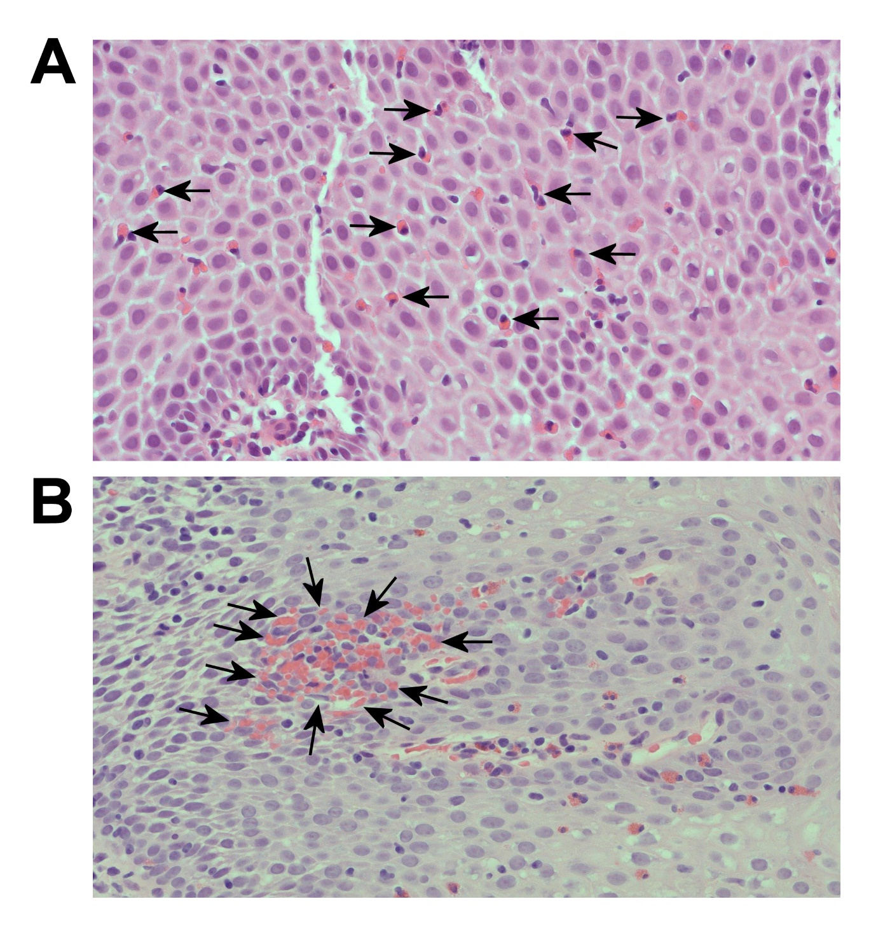
Figures and figure legends
Figure 1: Intraepithelial eosinophils in the oesophageal squamous epithelium of two SMA patients. Representative haematoxylin and eosin stained images of oesophageal biopsy sections from patient 1 (A) and patient 2 (B), both showing signs consistent with EoE. This was characterised by the presence of 37 eosinophils per high power field (in line with the NASPGHAN guidelines for diagnosis of EoE (i.e. >20phpf) [3]). Arrows point to some of the eosinophils that were present. Images were captured on a Nikon eclipse 80i microscope.

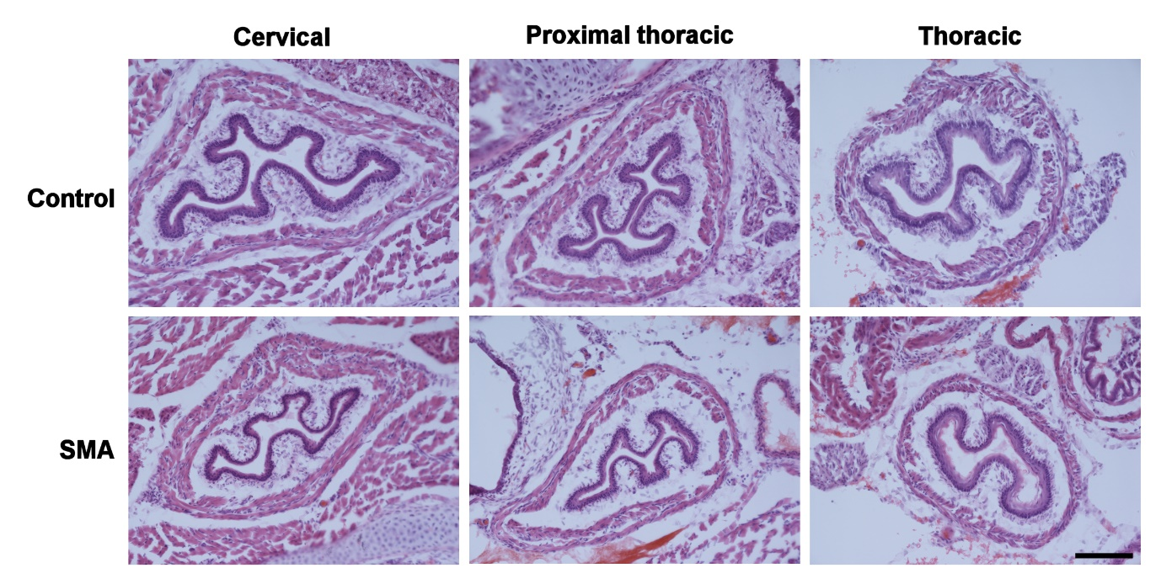
Figure 2: Eosinophils were not detected in oesophageal sections from severe SMA mice. Representative haematoxylin and eosin stained images of each region of the oesophagus (i.e. cervical, proximal thoracic and thoracic) are shown. (Five sections per region were analysed from three SMA mice and three age-matched control mice). Scale bar = 10µm.

