EAHP Statements Survey 2016

Petr Horák, Nicholas Gibbons, Juraj Sýkora, Aida Batista, Jonathan Underhill

Abstract

Objectives
The 2016 EAHP European Statements survey was related to sections 1, 3 and 4 of the European Statements of Hospital Pharmacy (Statements). In addition to the collection of statistical data about the level of implementation of the Statements, it was also intended to identify important barriers to their implementation.

Methods
The online questionnaire was sent to all hospital pharmacies in EAHP member countries. Data were analysed by researchers from Keele University School of Pharmacy, UK and the EAHP Survey Group.

Results
The overall response rate was 16% with 730 complete responses. In the first part of the survey, data was collected on the hospital pharmacy setting. While almost half of hospital pharmacies served over 500 beds, 77% of hospital pharmacies had 10 or less pharmacists. In section B, we gathered evidence about the degree of implementation of sections 1, 3 and 4 of the Statements and the main barriers to and drivers of implementation. The questions related to production and compounding (Section 3) received very positive responses (all questions from this section received at least a 70% positive response rate) indicating that responders are having less difficulty complying in these areas compared to others. The Introductory statements and governance questions (Section 1) received a more mixed response. Only 46% of responses indicated that the pharmacists worked routinely as part of multidisciplinary team. Many of the questions relating to clinical pharmacy services (Section 4) received a more negative response overall, with 6 questions receiving fewer than 50% positive responses.

Conclusions
EAHP has gained an informative overview of the implementation level as well as the barriers to and drivers of implementation in sections 1, 3 and 4. This is essential to inform the plans for EAHP to best support their implementation.

Introduction
EAHP Statements Survey 2016 represented the final step in the first cycle of modernised line of EAHP Surveys. After the EAHP General Assembly 2014 decision, the EAHP Survey changed the tool for measuring current level and progress of implementation of European Statements of Hospital Pharmacy, which were adopted in 2014[1, 2]. In this model, the Baseline Survey was followed by two alternating annual surveys covering 3 of 6 European Statements Sections. While the results of the Baseline and 2015 EAHP Statements Survey, describing the status for Sections 2, 5 and 6, were already published[3, 4], this article brings the results of 2016 Survey aimed to Section 1, 3 and 4. With this Survey, the first cycle is closed and we are expecting that repeating the surveys in future will bring us an opportunity to measure progress in implementation and an update in information about the main barriers in the implementation process. This will serve not just to the implementation project, currently one of the most important EAHP activities, but also for a potential update of the European Statements.

Methods

The survey was drafted following a meeting of the EAHP Survey Group and was conducted between October and December 2016, spanning 35 EAHP member countries.

- Section 1: Introductory Statements and Governance
- Section 3: Production and Compounding
- Section 4: Clinical Pharmacy Services

As with previous surveys, the 2016 EAHP Statements Survey consisted of three sections:

- Section A: general questions about the participant’s hospital pharmacy, such as workforce skill-mix and number of beds served
- Section B: questions about the current activity of pharmacists around each statement
- Section C: questions about the hospital’s readiness and ability to implement the statements

Questions in section A were designed to allow further analysis of dependencies between main implementation barriers and hospital type, level of staffing, etc.
In section B, a value was allocated to each response to rate the degree to which they were able to comply with each statement (where 1=never able to comply, 5=always complied. In section C, they were asked to what degree they agreed with the question (1 for strongly disagree, 5 for strongly agree). A response of 3, 4 or 5 was deemed to indicate less difficulty in complying with that statement – a ‘positive response’. Where this was not the case, the participant was asked the reasons for their difficulty for complying with the statement.
In section C, they were asked to what degree they agreed with the question, and the same Likert scale was used (1 for strongly disagree, 5 for strongly agree).
For the purposes of identifying those Statements where the barriers to implementation were greatest, a response of 3, 4 or 5 was deemed to indicate less difficulty in complying with that statement—a 'positive response'. A response of 1 or 2 was deemed to indicate some difficulty in complying with that statement—a 'negative response'. Where this was the case, the participant was asked a follow-up question to identify the barriers to implementing the Statement.
Five standard preselected options were used for every question, with some questions having additional specific options. The five main options were:
- We are prevented by national policy and/or legislation
- Not considered to be a priority by my managers
- Not considered to be a priority by me
- We would like to do this but we have limited capacity
- We would like to do this but we have limited capability.
There was also an 'other' option field, where the respondent could still give a free text response if they had a unique answer. Respondents were given the ability to select multiple options. Having identified the level of implementation of the Statements, and any barriers to implementation, participants were also asked for specific information to deepen the understanding of the topic. For example, in addition to asking a participant if medication errors are reported in their hospital, and then if not why not, they are also asked how many medication errors were reported in the last year and what they had done with the results of any medication error reports.
SurveyMonkey™ was used as the software tool for the survey. The EAHP General Assembly decided to use English as the only language for the survey to facilitate data assessment and to avoid additional costs and possible mistakes hidden in the translation of questions and answers. The survey was conducted from October 2016 to mid-November 2016. National coordinators were involved in tracking response rates in their country. In some countries, the national coordinators were also responsible for dissemination of the survey links. When the survey closed, there were a total of 903 responses, the results of which were exported from SurveyMonkey for further analysis and reporting.
At a glance, it would appear that the number of responses is down from the 2015 EAHP Statements Survey, which had 952 replies. However, this year’s survey had more complete responses (that is, people who made it to the end of the survey) than last year (730 this year, 697 last year)[4]. 81% of participants completed the 2016 survey, compared to 73% of participants in 2015.

Results

Response rates
The response rates for 2016 EAHP Statements Survey are listed in the table 1, broken down by country. The response rates from the baseline survey are given in the final column for comparison.

Country | Responses | Requests | Percentage | Percentage (baseline)
Austria | 27 | 48 | 56% | 47%
Belgium | 45 | 172 | 26% | 22%
Bosnia | 12 | 23 | 52% | 33%
Bulgaria | 17 | 73 | 23% | 14%
Croatia | 16 | 36 | 44% | 79%
Czech Republic | 42 | 104 | 40% | 63%
Denmark | 7 | 8 | 88% | 88%
Estonia | 10 | 25 | 40% | 64%
Finland | 16 | 82 | 20% | 17%
France | 50 | 1835 | 3% | 7%
FYROM | 13 | 31 | 42% | 22%
Germany | 82 | 383 | 21% | 31%
Greece | 32 | 106 | 30% | 62%
Hungary | 54 | 111 | 49% | 100%
Iceland | 2 | 2 | 100% | 48%
Ireland | 32 | 73 | 44% | 5%
Italy | 36 | 609 | 6% | 11%
Latvia | 6 | 45 | 13% | 7%
Lithuania | 9 | 39 | 23% | 50%
Luxembourg | 3 | 6 | 50% | 58%
Malta | 3 | 5 | 60% | 50%
Montenegro | 4 | 6 | 67% | n/a
Netherlands | 18 | 108 | 17% | 35%
Norway | 20 | 32 | 63% | 56%
Poland | 21 | 38 | 55% | 7%
Portugal | 38 | 89 | 43% | 22%
Romania | 14 | 66 | 21% | 41%
Serbia | 45 | 65 | 69% | 78%
Slovakia | 33 | 76 | 43% | 52%
Slovenia | 22 | 31 | 71% | 57%
Spain* | 39 | 250 | 16% | 17%
Sweden | 19 | 37 | 51% | 24%
Switzerland | 17 | 60 | 28% | 43%
Turkey | 70 | 821 | 9% | 6%
UK | 30 | 216 | 14% | 36%
Total | 904 | 5,711 | 16% | 18%
Table 1: Response rates by country

Section A
The results showed that 46% of responders worked in teaching hospitals. These numbers are only slightly higher than those in the baseline survey (42%)[3] and 2015 Statements survey (43%)[4]. Hence the sample can be considered similar to this survey from this point of view.
75% of responders represented hospital pharmacies based in general hospitals. 38% of participants (N=279) indicated that their hospital pharmacy regularly provides service to more than one hospital. 233 (84%) of them indicated that they provide services to 2 to 5 hospitals, 23 to 6-10 and 23 (8%) to more than 10 hospitals.
A total of 47% of hospital pharmacies served hospitals with 100–500 beds, 25% served hospitals with 500–1000 beds, 21% served hospitals with >1000 beds while 7% served hospitals with <100 beds (figure 1). This also confirms that the sample was very similar to 2015 Survey (45, 24, 22 and 9% respectively).[4]

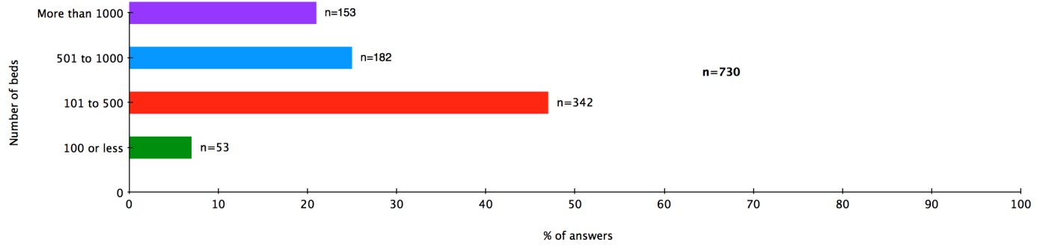
Figure 1: Number of beds served by hospital pharmacies.
Based on the results of previous EAHP Surveys, insufficient staffing (capacity) appeared to be one of the most important barriers in the implementation process. In our sample, 77% of hospital pharmacies employed less than 10 pharmacists (n=564), 20% between 11 and 50, and only 3% employed 51 or more pharmacists (figure 2). We found similar numbers for the pharmacy technicians – 71% of responders reported that their hospital pharmacy employed up to 10 pharmacy technicians.

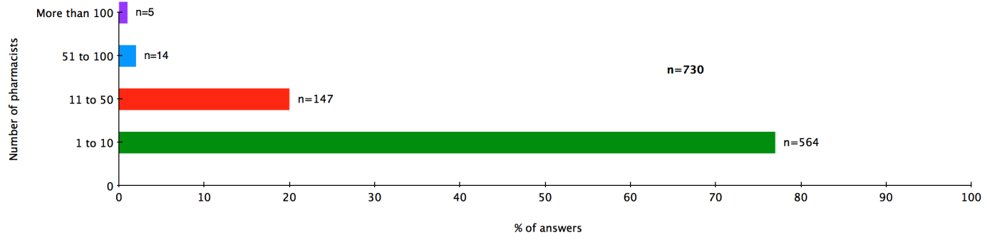
Figure 2: Staffing per hospital pharmacies: pharmacists.

Section B
Table 2 shows all questions asked in the survey regarding the 21 European Statements of Hospital Pharmacy from Sections 1, 3 and 4, and where applicable, the overall percentage of participants who gave a ‘positive response’ to the question. Whenever a participant gave a negative response to a question, there was usually a follow up question of ‘What is preventing this?’

Questions where less than 50% of participants gave a positive response have been highlighted in orange, and questions where more than 75% of participants gave a positive response have been highlighted in grey. The table shows generally the highest level of implementation in Section 3 (production and compounding), where all questions got over two thirds of positive responses. The results in Section 1 (Introductory Statements and Governance) showed mixed results. The lowest number of positive responses appeared in Section 4 (Clinical Pharmacy Services), where most first level questions got around 50% positive responses or less.

EAHP Survey Questions
Section 1: Introductory Statements and Governance
S11 The pharmacists in our hospital work routinely as part of multidisciplinary team (46% of responses were positive.)
S13 Our hospital is able prioritise hospital pharmacy activities according to agreed criteria (66% of all responses were positive.)
S15 The pharmacists in our hospital are engaged in the supervision of all steps of all medicine use processes (67% of all responses were positive.)
S152 Do you have an approved human resource plan in place to address this? (22% of all responses were positive.)
S16 At least one pharmacist from our team is a full member of the Drug & Therapeutics Committee or equivalent (86% of all responses were positive.)
S162 The pharmacists in our hospital take the lead or have an active role in coordinating the activities of the Drug & Therapeutics Committees or equivalent (88% of all responses were positive.)
S17 The pharmacists in our hospital are involved in the design, specification of parameters and evaluation of ICT used within medicines processes (64% of all responses were positive.)
Section 3: Production and Compounding
S31 The pharmacists in our hospital check if a suitable product is commercially available before we manufacture or prepare a medicine (89% of all responses were positive.)
S32 When medicines require manufacture or compounding, we either produce them in our hospital pharmacy or we outsource to an approved provider (85% of all responses were positive.)
S33 The pharmacists in our hospital undertake a risk assessment to determine the best practice quality requirements before making a pharmacy preparation (81% of all responses were positive.)

S34 The pharmacy in our hospital has an appropriate system in place for the quality assurance of pharmacy prepared and compounded medicines (73% of all responses were positive.)
S342 The pharmacy in our hospital has an appropriate system in place for the traceability of pharmacy prepared and compounded medicines (81% of all responses were positive.)
S35 Our hospital has appropriate systems in place for the preparation and supply of hazardous medicines (67% of all responses were positive.)
S352 Our hospital has appropriate systems in place to minimise the risk of exposing hospital personnel, patients and the environment to harm from hazardous medicines (76% of all responses were positive.)
S36 Our hospital has written procedures that ensure staff are appropriately trained to reconstitute or mix medicines in a patient care area (67% of all responses were positive.)
S362 Were pharmacists involved in approving these procedures? (78% of all responses were positive.)
Section 4: Clinical Pharmacy Services
S41 The pharmacists in our hospital play a full part in shared decision making on medicines, including advising, implementing and monitoring medication changes (52% of all responses were positive.)
S42 All prescriptions in our hospital are reviewed and validated as soon as possible by a pharmacist (51% of all responses were positive.)
S422 Does this review and validation by a pharmacist take place prior to the administration of medicines? (88% of responses were positive.)
S43 The pharmacists in our hospital have access to the patients’ health record (59% of responses were positive.)
S432 The pharmacists in our hospital document their clinical interventions into the patients’ health record (56% of responses were positive.)
S434 We analyse these clinical pharmacy interventions to inform quality improvement plans (80% of responses were positive.)
S44 The pharmacists in our hospital enter all medicines used onto the patient’s medical record on admission (24% of responses were positive.)
S442 The pharmacists in our hospital reconcile medicines on admission (39% of all responses were positive.)

S444 When reconciling medicines, the pharmacists in our hospital assess the appropriateness of all patients’ medicines, including herbal and dietary supplements (40% of all responses were positive.)

S45 The pharmacists in our hospital contribute to the transfer of information about medicines when patients move between and within healthcare settings (39% of all responses were positive.)

S46 The pharmacists in our hospital ensure patients and carers are offered information about their medicines in terms they can understand (51% of all responses were positive.)

S463 Have the pharmacists in your hospital received appropriate education and support to help them explain the risks and benefits of medicines, in terms patients/carers can understand? (65% of all responses were positive.)

S47 The patients in our hospital are informed when medicines are used outside of their marketing authorisation (57% of all responses were positive.)

S472 Do hospital pharmacists do this? (40% of all responses were positive.)

S48 Do you have an agreed strategic plan for the development of clinical pharmacy services in your hospital? (42% of all responses were positive.)

Table 2: Survey questions and percentage of positive answers
The five first level questions which received the least positive responses were identified (table 3), and were subjected to a more in-depth analysis. These five questions were related the Statements: 4.4, 4.5, 4.8, 1.1 and 4.6.
Question |  | Mean* (2016 survey) | Mean* (baseline survey)
S4.4 | The pharmacists in our hospital enter all medicines used onto the patient’s medical record on admission | 24% | 29%
S4.5 | The pharmacists in our hospital contribute to the transfer of information about medicines when patients move between and within healthcare settings | 39% | 44%
S4.8 | Do you have an agreed strategic plan for the development of clinical pharmacy services in your hospital? | 42% | n/a
S1.1 | The pharmacists in our hospital work routinely as part of multidisciplinary team | 46% | 59%
S4.6 | The pharmacists in our hospital ensure patients and carers are offered information about their medicines in terms they can understand | 51% | 64%
Table 3: Five questions with the lowest mean percentage of positive responses across the different countries
Questions related to Statement 4.4: All the medicines used by patients should be entered on the patient’s medical record and reconciled by the hospital pharmacist on admission. Hospital pharmacists should assess the appropriateness of all patients’ medicines, including herbal and dietary supplements.

Figure 3 shows the percentage of respondents who gave a positive response when asked if pharmacists enter all medicines used onto the patient’s medical record on admission. Overall, only 29% of responses were positive to this question. With the exception of Spain, Turkey, the Netherlands and the UK, in every country surveyed less than half of the respondents gave a positive response.
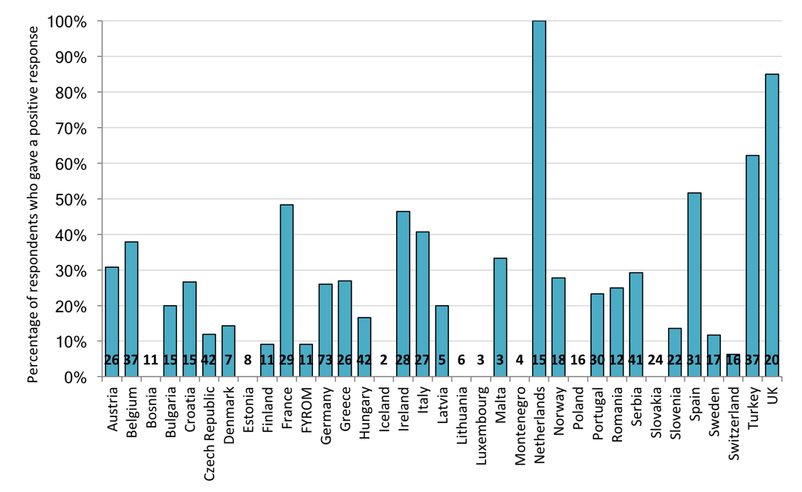
Figure 3: Percentage of respondents who gave a positive response to the statement ‘The pharmacists in our hospital enter all medicines used onto the patient’s medical record on admission’.

When this question was originally asked in the 2015 baseline survey it had a similarly negative response (29% responses positive) indicating that many pharmacists do not perform this activity and little progress overall has been made towards implementing it.

To further understand this, respondents were asked what is preventing pharmacists from entering medicines onto patient’s medical records, the overall results of which are shown in Figure 4. The most frequent overall response was that other healthcare professionals do this, with 314 responses in total. This was also the main reason given in the free text responses to the same question in the 2015 baseline survey.

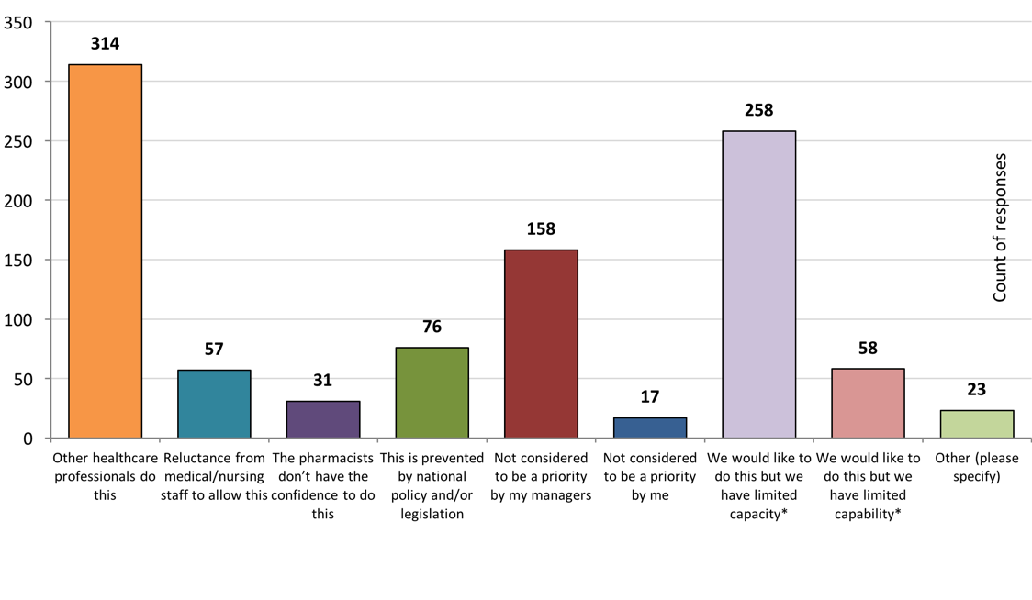
Figure 4: Overall results of the question 'What is preventing pharmacists from entering medicines onto patients records on admission?

Another major barrier identified was lack of capacity, with 258 responses, suggesting many pharmacists do not have time to perform this activity. Not being considered to be a priority by managers was also raised as a large barrier with 158 responses. Since so many responses say other healthcare professionals do this activity already, it may be that managers do not see the value in implementing any changes to a system already in place, especially if the existing pharmacists are at capacity already.
It is encouraging that there were few responses saying the pharmacist did not consider it to be a priority (17), the pharmacists don’t have the confidence to do this (31) and reluctance from the medical staff to support/allow this (57). There were also comments in the ‘Other’ section from Germany and Portugal saying it is their intention to implement this soon. ¨

Questions related to Statement 4.5: Hospital pharmacists should promote seamless care by contributing to transfer of information about medicines whenever patients move between and within healthcare settings.

The responses to the question 'The pharmacists in our hospital contribute to the transfer of information about medicines when patients move between and within healthcare settings' are shown below in Figure 5. The mean response for countries was 39% positive, showing this statement is not currently implemented widely across European hospitals. This response is actually slightly lower than the result from the pilot survey, which was 44%, indicating that progress has not been made on a large scale to implement change. As with other questions regarding clinical pharmacy services, the positive response rate between countries was very variable, and it can be seen that some countries have focused more on developing their clinical pharmacy services.
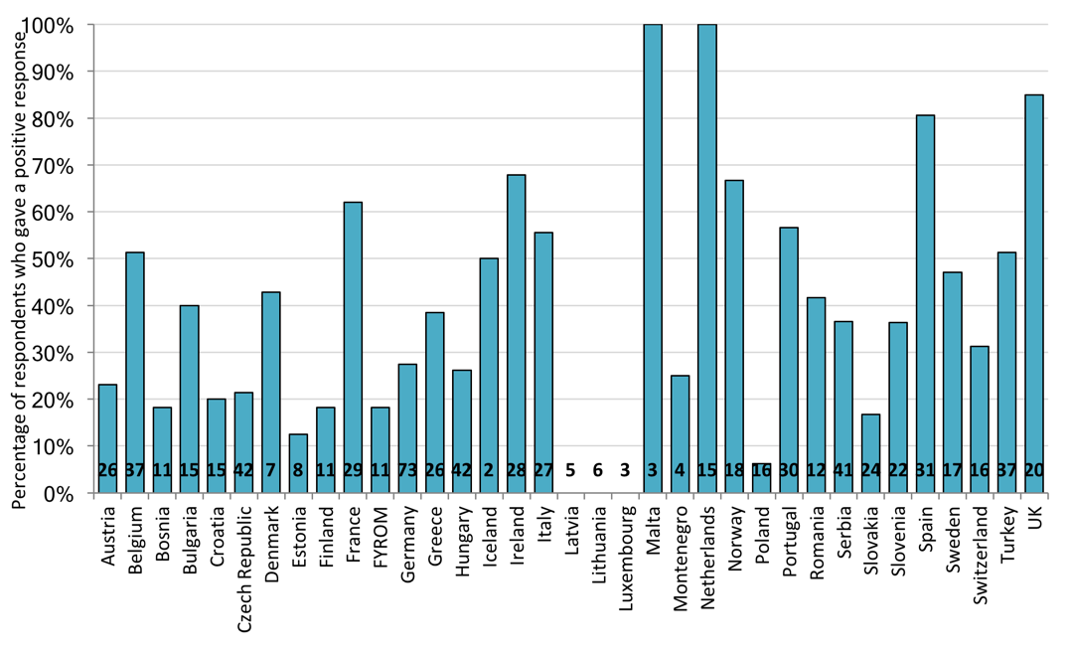
Figure 5: Percentage of respondents who gave a positive response to the statement ‘the pharmacists in our hospital contribute to the transfer of information about medicines when patients move between and within healthcare settings’.

When asked what are the barriers to pharmacists contributing to the transfer of information about medicines when patients move between and within healthcare settings, the most frequent response was other professionals doing this already (242 responses) and lack of capacity (207 responses), as seen in Figure 6. Not considered to be a priority by my managers also had 126 responses. From the ‘Other’ category are several comments from different countries saying they have electronic systems and records in place that automatically do this task without needing the pharmacists’ intervention.

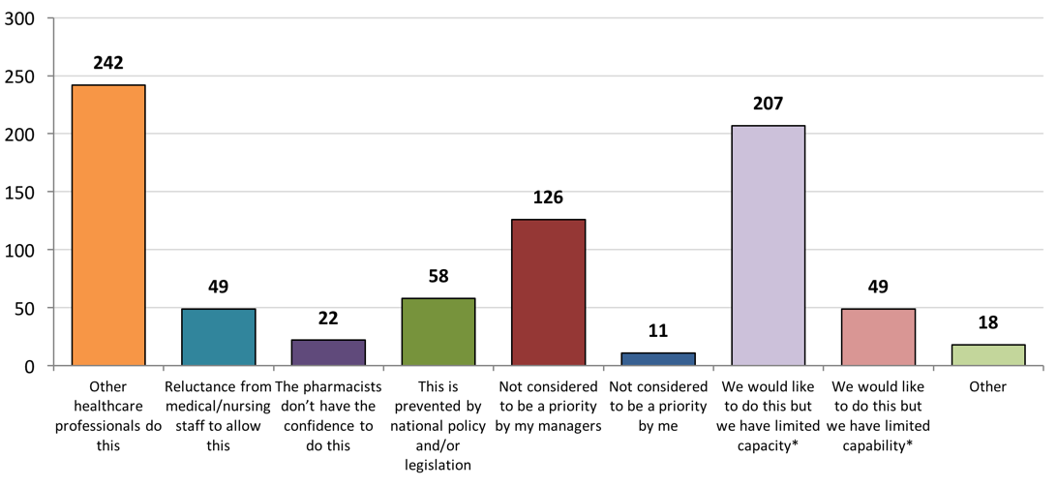
Figure 6: Overall results of the question ‘What is preventing the pharmacists in your hospital from contributing to the transfer of information about medicines when patients move between and within healthcare settings’.

Questions related to Statement 4.8: Clinical pharmacy services should continuously evolve to optimise patients’ outcomes.

Figure 7 shows the percentage of respondents who gave a positive response when asked ‘Do you have an agreed strategic plan for the development of clinical pharmacy services in your hospital?’. The mean positive response rate for this question was 42%, and aside from a few outliers, this result is fairly consistent across countries. This question was not asked in the pilot survey, so there are no baseline data to compare against.

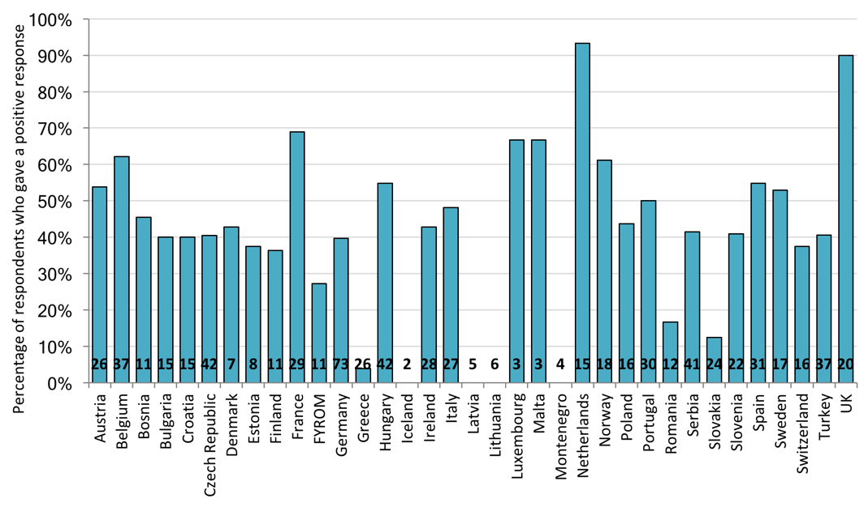
Figure 7: Percentage of respondents who gave a positive response to the statement ‘Do you have an agreed strategic plan for the development of clinical pharmacy services in your hospital?’

The main barriers to implementing this statement were identified to be ‘not being considered a priority by managers/clinicians’ (257 responses) and ‘limited capacity’ (221 responses), as seen in Figure 8. Again it can be seen that there are very few responses for ‘not considered to be a priority by me’, suggesting many pharmacists see being involved in more clinical pharmacy services to be important.
Of the 39 freetext responses from the ‘Other’ category, 11 responses say they are currently working on a strategic plan. 10 responses say they have a strategic plan, but are not able to implement it due to lack of capacity or lack of interest from managers.
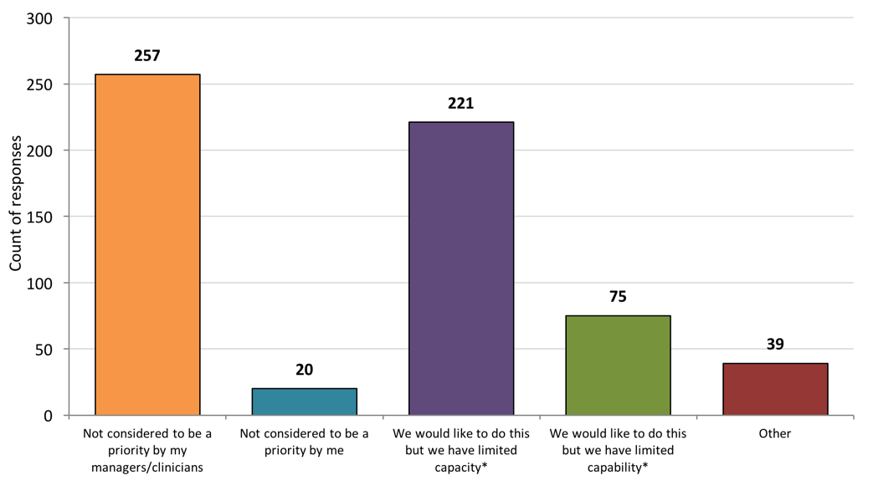
Figure 8: Overall results of the question 'Do you have an agreed strategic plan for the development of clinical pharmacy services in your hospital?’

Questions related to Statement 1.1: The overarching goal of the hospital pharmacy service is to optimise patient outcomes through working collaboratively within multidisciplinary teams in order to achieve the responsible use of medicines across all settings.

Figure 9 shows the percentage of respondents who gave a positive response when asked ‘The pharmacists in our hospital work routinely as part of multidisciplinary team’. From this it can be seen that the pharmacists from many countries say they do not work as part of a multidisciplinary team, which was also identified to be a major issue in the 2015 baseline survey. The mean positive response rate for countries was 46%, which is lower than the result from the 2015 baseline survey, which was 59%.

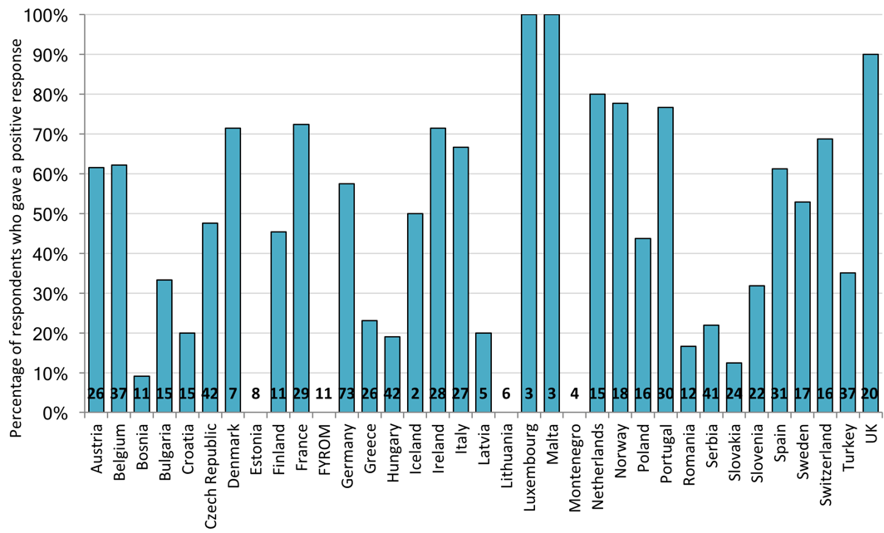
Figure 9: Percentage of respondents who gave a positive response to the statement ‘The pharmacists in our hospital work routinely as part of multidisciplinary team’

Respondents who gave a positive response to the question were asked ‘What type of multidisciplinary activities are you involved with?’, the overall results of which are shown in. Figure 10. Membership of multidisciplinary committees, specific therapeutic subgroups and educational activities all received many responses. It is interesting to note that the activities involving interaction with patients (multidisciplinary ward rounds and consulting with patients about medicines) received fewer responses. The 37 ‘Other’ freetext responses offered a wide range of activities, but responses regarding patient safety were raised several times.

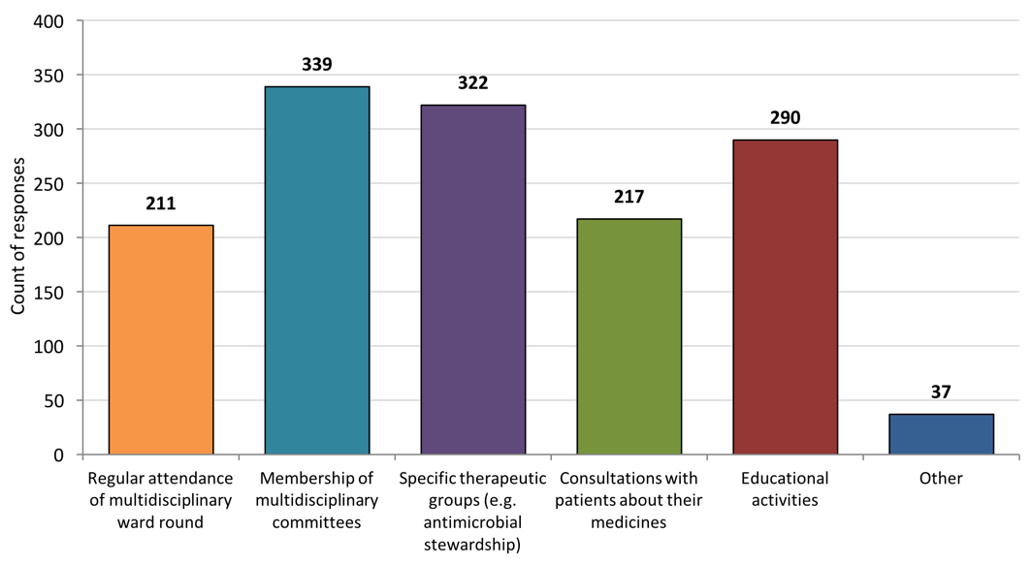
Figure 10: Overall results of the question 'What type of multidisciplinary activities are you involved with?’

Respondents who gave a negative response to the initial question were asked ‘What is preventing you or your pharmacists from routinely working as part of multidisciplinary team?’, the overall results of which are shown in Figure 11. Limited capacity is the main barrier identified by a large margin with 278 responses. The responses from the baseline survey also identified limited capacity (specifically lack of funding and availability of clinical pharmacists) as the main barrier.
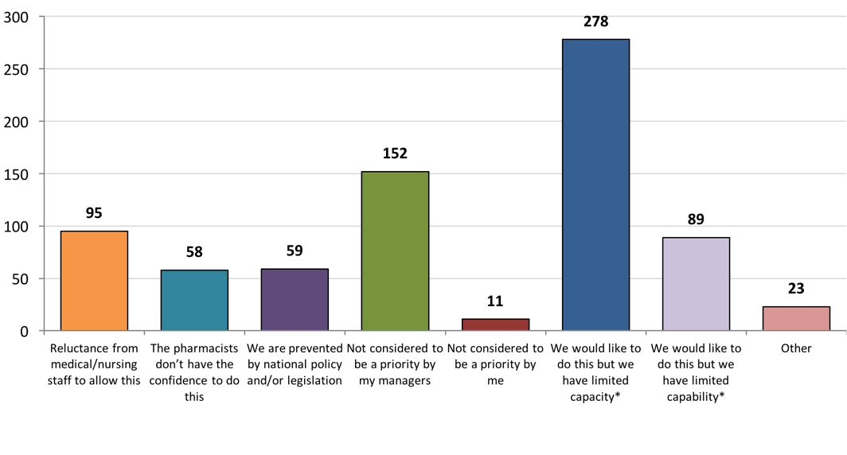
Figure 11: Overall results of the question 'What is preventing you or your pharmacists from routinely working as part of multidisciplinary team’
Not being considered a priority by managers and reluctance from other medical/nursing to allow this also received a lot of responses (152 and 95 respectively). From the ‘Other’ freetext comments, and from comments from the baseline survey, it is suggested this could be because managers and other medical staff are not aware of the skills that pharmacists may bring to the table. The remaining freetext comments refer to not having enough clinical pharmacists available to perform any multidisciplinary activities.

Questions related to Statement 4.6: Hospital pharmacists, as an integral part of all patient care teams, should ensure that patients and carers are offered information about their clinical management options, and especially about the use of their medicines, in terms they can understand.
When asked if hospital pharmacists ensure patients and carers are offered information about their medicines in terms they can understand, the mean percentage of positive responses for a country was 51%. This is a much less positive response from when the question was asked two years ago in the baseline survey (64% positive). Figure 12 shows the results broken down by country, which shows that the response between countries is very mixed, with a very large range between results.

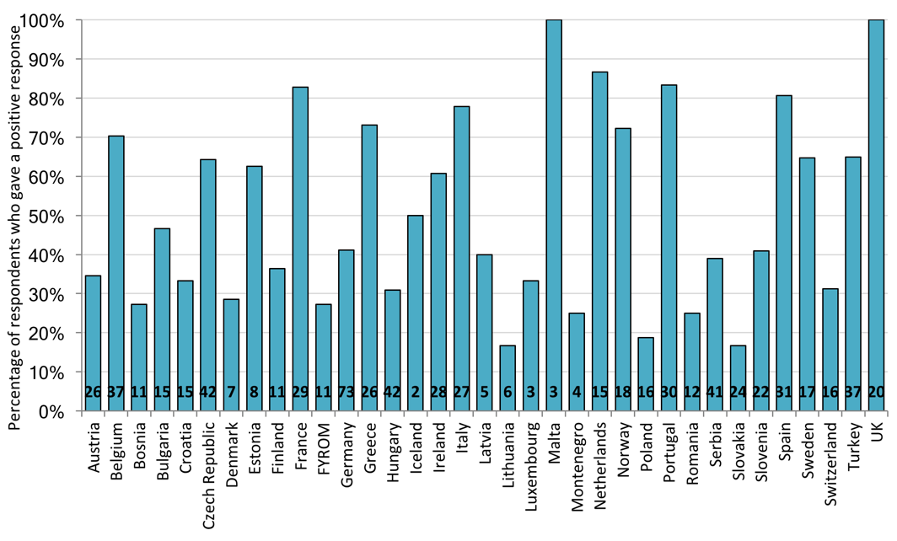
Figure 12: Percentage of respondents who gave a positive response to the statement ‘The pharmacists in our hospital ensure patients and carers are offered information about their medicines in terms they can understand’
Participants who said they had offered patients information about their medicines in terms they can understand were then asked who they did this for mostly. The most common response was doing this for all patients, with 165 responses. However, a large number of respondents say they mainly do this only for inpatients (132 responses) or outpatients (100 responses).

The participants who indicated that they do not offer patients information about their medicines in terms they can understand were asked to identify what barriers were preventing this from happening. Figure 13 shows that as with the other questions looked at in this report, the most frequent barrier listed was a lack of capacity (192 comments), followed by ‘other healthcare professionals do this’ (179 comments). Only 6 people selected ‘not considered to be a priority by me’ as an option. The majority of the ‘other’ freetext comments refer to pharmacists saying they have no contact with patients in their roles.
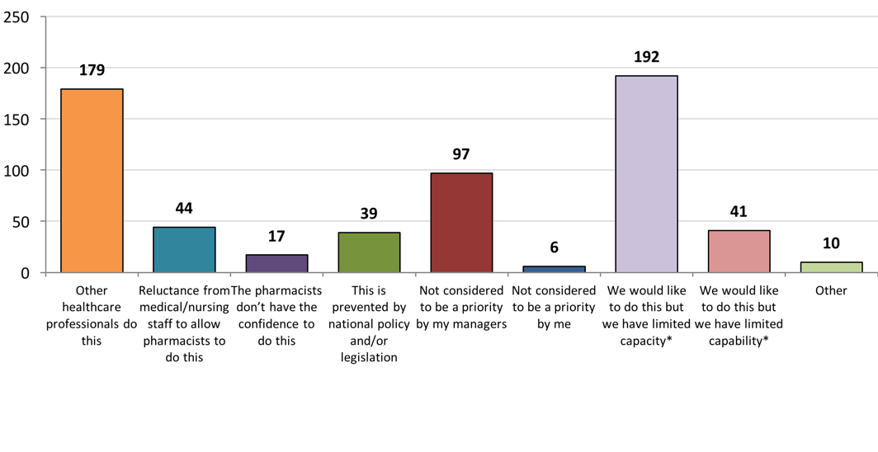
Figure 13: Overall results of the question 'What is preventing ensuring that patients and carers are offered information about their medicines in terms they can understand?’
Participants were also asked ‘Have the pharmacists in your hospital received appropriate education and support to help them explain the risks and benefits of medicines, in terms patients/carers can understand?’, the results of which are seen in Figure 14. It is interesting to compare this graph with Figure 12, as a simple assumption might be that the countries saying pharmacists in their hospital are not offering information medicines to patients might not have received any training to perform this activity. However, this is not the case as the mean positive response rate for countries was 65%. From this and Figure 12, pharmacists have the confidence and feel capable of performing this activity, but other barriers such as limited capacity are preventing it.

DISCUSSION
The 2016 EAHP Statements survey was the closing survey of the first 2 year cycle of the EAHP survey related to the European Statements of Hospital Pharmacy. This survey was related to three of the six sections of the Statements and, in addition to collecting basic statistical data about the current level of implementation of the Statements, it was also intended to identify the most important barriers to and drivers of implementation.
There are several limitations to this study. The first and most important limitation was that the number of responses from some member countries was very small, and hence did not allow a precise statistical evaluation on country level. The reason for this is that some countries have a much smaller population and therefore a much smaller number of hospitals. The second limitation was the necessity to find a balance between the length of the questionnaire (and the workload for responders) and level of detail sought in identification of the main implementation barriers.
Despite these limitations, the survey results provide an up to date picture of the current state of our profession in Europe in relation to the Statements. The most challenging Statements in sections 1, 3 and 4 for implementation remain those related to clinical pharmacy services, and participation of hospital pharmacists in multidisciplinary teams.
The main barrier identified was insufficient capacity to undertake the services, and the results of this survey confirm the finding from the EAHP baseline survey. The numbers of hospital pharmacists and pharmacy technicians remain quite low in many European countries. 46% of hospitals in this survey had 500 beds, but 77% of hospitals had up to 10 pharmacists.
While significant improvement in staffing levels cannot be a short term goal, EAHP will provide education on the development of business cases and the self-assessment tool will enable head pharmacists to have real time information to discuss with hospital and health system managers. The answer 'not being considered priority by my managers' was quite often mentioned, and here we see even greater opportunities in speeding up implementation and raising awareness about the Statements and their impact on patients and healthcare systems. The level of awareness, implementation readiness and willingness was also measured in this survey (more details in report) showing clear increase in awareness.
The next surveys, in autumn 2017 and 2018, focusing on sections 1, 3 and 4, and 2, 5, 6 respectively, will revisit the sections described first cycle of surveys. We will then be able to compare the results and track any progress.

CONCLUSION
The main objective of the 2016 EAHP Statements survey was to provide an assessment of the level of implementation of sections 1, 3 and 4 of the Statements throughout European countries and to identify the main barriers to and drivers of implementation. This enables the EAHP to prioritise efforts in our implementation and educational activities. This objective has been reached, thanks to the enormous efforts of national coordinators and all of our members who responded to the survey. The data will now be used to inform the EAHP Statements implementation project as well as other major projects of EAHP.

Key messages

What is already known on this subject
The 2014/2015 European Association of Hospital Pharmacists (EAHP) baseline survey, the first survey of the new EAHP line, provided general knowledge of the baseline level of implementation of the Statements in all six sections of the European Statements.

What this study adds
This paper deepens our knowledge of the level of implementation of sections 1, 3 and 4 of the Statements together with identification of the main barriers to and drivers of implementation.
The most challenging Statements for implementation in hospital pharmacies in Sections listed above are:
- clinical pharmacy services
- participation in multidiciplinary teams.
The most important barrier to implementation is insufficient capacity and different priorities of hospital and health system managers

1. Frontini, R., The European Summit on Hospital Pharmacy. European Journal of Hospital Pharmacy, 2014. 21(5): p. 255.
2. Horák, P., et al., EAHP survey and European Statements of Hospital Pharmacy – can we achieve a perfect match? European Journal of Hospital Pharmacy, 2014. 21(5): p. 291-293.
3. Horák, P., et al., EAHP European Statements baseline survey 2015: results. European Journal of Hospital Pharmacy, 2016. 23(2): p. 69-75.
4. Horák, P., et al., EAHP European Statements survey 2015. European Journal of Hospital Pharmacy, 2017. 24(3): p. 138-146.

