**Outcomes Following Percutaneous Coronary Intervention (PCI) in Non-ST-segment Elevation Myocardial Infarction Patients with Coronary Artery Bypass Grafts**

Ahmad Shoaib1 MD, Tim Kinnaird2 MD, Nick Curzen3 PhD, Evangelos Kontopantelis4 PhD, Peter Ludman5 MD, Mark de Belder6 MD, Muhammed Rashid1 MBBS, Chun Shing Kwok1 MBBS, James Nolan1 MD, Azfar Zaman7 MD, Mamas A Mamas1 DPhil

On behalf of the British Cardiovascular Intervention Society (BCIS) and the National Institute for Cardiovascular Outcomes Research (NICOR)

1. Keele Cardiovascular Research Group, Centre for Prognosis Research, Institute for Primary Care and Health Sciences, Keele University

2. University Hospital of Wales, Cardiff, United Kingdom

3. University of Southampton, Southampton, United Kingdom

4. Institute for Primary Care Sciences, University of Manchester

5. Queen Elizabeth Hospital Birmingham, Birmingham, United Kingdom

6. James Cook University Hospital, Middlesbrough, United Kingdom

1. Newcastle University, Newcastle Upon Tyne, United Kingdom

## **Corresponding author:**

Mamas A. Mamas

Professor of Cardiology

Keele Cardiovascular Research Group,

Centre for Prognosis Research,

Institute for Primary Care and Health Sciences,

Keele University, UK

Fax number: +44 1782 734719

[mamasmamas1@yahoo.co.uk](mailto:a.shoaib@keele.ac.uk)

## **Abstract**

**Background**: There are limited data on outcomes of patients with previous CABG presenting with NSTEMI undergoing PCI. We compare clinical characteristics and outcomes in NSTEMI patients undergoing PCI with or without prior CABG surgery in a national cohort.

**Methods & Results**: We identified 205,039 patients with NSTEMI who underwent PCI between 2007-2014 in the British Cardiovascular Intervention Society (BCIS) database. Clinical, demographical, procedural and outcome data were analysed by dividing into three groups; Group 1- PCI in native coronary arteries and no prior CABG (n= 186,670), Group 2- PCI in native arteries with prior CABG (n= 8,825), Group 3- PCI in Grafts (n= 9,544). Patients in Group 2 & 3 were older, had more comorbidities and higher mortality at 30 days (group 2 -2.6%, group 3 – 1.9%) and 1 year (group 2 – 8.29%, group 3 – 7.08%) as compared to Group 1 (1.7% & 4.87%). Following multivariable analysis, no significant difference in outcomes were observed in 30 days mortality (OR: group 2 = 0.87 (CI 0.69-1.80, P-0.20), group 3 = 0.91 (CI 0.71-1.17, P-0.46)), in-hospital MACE (OR: group 2 = 1.08 (CI 0.88-1.34, P- 0.45), group 3 0.97 (CI 0.77-1.23, P- 0.82)) and in-hospital stroke (OR: group 2 = 1.37 (CI 0.71-2.69, P - 0.35), group 3 = 1.13 (CI 0.55-2.34, P- 0.73))(group 1= reference).

**Conclusion**: Patients with prior CABG presenting with NSTEMI and treated with PCI had more co-morbid illnesses but once these differences were adjusted for, prior CABG did not independently confer additional risk of mortality and MACE.

Keywords: PCI, NSTEMI, Mortality, Complications

**Introduction**

In the United States, more than 300,000 patients undergo Coronary Artery Bypass Grafts (CABG) surgery each year.1 Despite achieving complete revascularization with CABG, only 85% of internal mammary artery (IMA) and 60% of saphenous vein grafts (SVG) remained patent after 10 years.2 Occlusion of grafts may result in an acute coronary syndrome (ACS) and current European Society of Cardiology and North American guidelines recommend an invasive approach (Class 1-A) in the management of appropriately selected patients with a previous history of CABG.3, 4

Several contemporary clinical studies report worse long-term outcomes of patients presenting with NSTEMI with prior CABG as compared to those without previous CABG 5-8, although data are inconsistent9,10 It is consistently reported in many clinical studies that patients with prior CABG are generally older, with worse demographic profiles and more complex and extensive coronary artery disease which may contribute to the higher mortality observed.10-12

Data that examines the outcomes of PCI separately in grafts and in native vessels in patients with prior CABG presenting with NSTEMI are limited. In an unselected cohort of 11,118 patients (including STEMI, NSTEMI, and stable angina patients) with prior CABG, PCI to grafts was associated with significantly higher mortality and MACE (MI, repeat revascularization) as compared to those who underwent PCI in native vessels at median 3 years follow up.13 By contrast, in another study of 47,557 patients with NSTEMI (8,790 had prior CABG), the adjusted risk of bleeding and in-hospital mortality did not differ significantly between the 2 groups (with and without prior CABG).14 However, no large contemporary study has compared outcomes after PCI in NSTEMI patients with and without previous CABG and in the latter, outcomes after PCI in native arteries against PCI to grafts. We therefore sought to describe the early (in-patient and 30 days) and late (1-year) outcomes of PCI in patients with and without a history of prior CABG presenting with NSTEMI in a large contemporary unselected national cohort from the database of the British Cardiovascular Intervention Society (BCIS). Outcomes were compared to the population with no history of prior CABG undergoing PCI for NSTEMI during the same study period.

## **Methods**

This study was a retrospective analysis of prospectively recorded national data for all patients that underwent PCI for NSTEMI in England & Wales from January 2007 to December 2014. The British Cardiovascular Intervention Society (BCIS) collects data on all PCI procedures undertaken in the United Kingdom (UK) with data collection managed by the National Institute of Cardiovascular Outcomes Research (NICOR). Data input is mandatory, as part of the formal revalidation process, for all independent operators in the UK. The BCIS database consists of 113 clinical, procedural and outcome variables with approximately 80,000 new reports added each year.15-18 We used data from the Office of National Statistics (ONS) for mortality tracking in all patients of England & Wales by using their unique National Health Service number. We excluded patients from Scotland and Northern Ireland because of the absence of the ONS-linked mortality data. Institutional research and ethical board approval were not required for this study as all data were anonymized and routinely collected as part of the national audit, but the project was approved by a national Data and Monitoring Advisory Group on behalf of NICOR & BCIS.

Data were collected on patients’ clinical characteristics, risk factors and comorbid conditions as well as aspects of interventional treatment and adjunctive drug therapy. We collected all-cause mortality during index admission and at 30 days and 1-year follow up. In addition, we assessed temporal changes in interventional practice for these patients from 2007-2014. We also analysed in-hospital major adverse cardiovascular events (MACE; defined as a composite of in-hospital mortality, in-hospital myocardial reinfarction, and target vessel revascularization), in-hospital major bleeding (described as arterial access site complication requiring surgery, gastrointestinal bleed, intracerebral bleed, retroperitoneal haematoma and blood or platelets transfusion), and in-hospital stroke which included ischaemic or haemorrhagic stroke or transient ischaemic attack (TIA).

The study participants were divided into 3 groups: (Group 1) no prior CABG, (Group 2) previous CABG with PCI to native coronary arteries, and (Group 3) previous CABG with PCI to bypass grafts. Patients with missing data for mortality, sex, and age were excluded. We compared clinical characteristics across the three groups of interest and these comparisons were undertaken using Fisher’s exact tests for categorical and analysis of variance for continuous variables. We used multiple imputations with chained equations to impute data for all variables with missing information. We registered age, sex, group of participants, and study outcomes as complete variables in imputation models and these were used to produce 10 datasets on which we ran the analysis. Incomplete and imputed variables were smoking status, diabetes mellitus (DM), hypertension, hyperlipidaemia, previous MI, previous stroke, peripheral vascular disease, renal disease, family history of CAD, radial access site, glycoprotein IIb/IIIa inhibitors use, shock, circulatory support, number of stents, thrombus aspiration, mechanical ventilation and left ventricular systolic dysfunction.

We applied multivariable logistic regression analysis to estimate the risk of adverse outcomes among groups. In multivariable analysis, we adjusted different covariates in the models included age, sex, smoking history, DM, hypertension, hypercholesterolemia, previous MI, peripheral vascular disease, renal insufficiency, family history of premature coronary disease, radial access site, glycoprotein IIb/IIIa inhibitor use, multivessel PCI, shock, circulatory support, number of stents, thrombus aspiration, mechanical ventilation, left ventricular systolic dysfunction, PCI to left main stem (LMS), PCI to left anterior descending artery (LAD) and use of distal protection devices.

Almost 48% of data were missed in variable of Left Ventricular ejection fraction, 14% in family history of coronary artery disease, 10% in prior history of smoking and Myocardial infarction and less than 10% in all remaining variables (Table 1). Missing data can impair the ability to make correct inferences from observational studies. Complete case analysis is commonly applied but it reduces sample size and may lead to reduced statistical power. However, by using multiple imputation methods, sample size is preserved and they are generally regarded as preferred analysis technique. We used Multiple imputations with chained equations to impute missing data. It is already well reported in literature that Multiple imputation is the best technique among all missing-ness mechanisms and works well even very high level of data is missing.19 For more clarity, we reported statistical models with complete case analysis as well as with multiple imputations. We also applied Multiple imputations with propensity score matching statistical techniques (miestimate: teffects psmatch) to estimate the average treatment effects for adjustment of baseline differences across the groups of patients. We applied two different multiple imputation logistic regressions models to calculate propensity score for each group member: (1) PCI to native coronary arteries without prior CABG (group 0) versus PCI to native arteries in patient with prior CABG (group 1); and PCI to native arteries without prior CABG (group 0) versus PCI to grafts (group 2). These scores were then applied to perform the matching, and simple logistic regression analysis was run (the sole predictor being group membership) to gain the average treatment effect.

We also performed Kaplan-Meier survival analysis and Cox proportional hazards regression analysis for 30-days and 1-year mortality by patients group. Stata 13.1 statistical package was used for statistical analysis.

## **Results**

### *Study Cohort*

Our study cohort comprised of 205,039 patients who had PCI during admission for NSTEMI in England and Wales from January 2007 to December 2014 and did not have missing data for mortality, follow up, gender and age. The process of patients’ inclusion and exclusion is presented in Figure 1. A total 186,670 (91%) patients had no history of prior CABG, whereas 18,369 (9%) had a history of previous CABG. In those patients with a history of prior CABG, 48% (n=8,825) underwent PCI to native coronary arteries, and 52% (n=9,544) had PCI to bypass grafts. The mean follow-up of these patients was 3.84 years (Standard deviation 2.3), and 94% were followed up for a minimum of 1 year (or until death, if occurring within this period).

## ***Clinical characteristics***

Significant differences in demographic, clinical and procedural characteristics of the 3 groups (Table 1) were observed. Specifically, patients with prior CABG were significantly older, less likely to be female, had a higher prevalence of DM, hypertension, hyperlipidaemia, PVD and previous MI or stroke (Table 1). Patients with prior CABG were also more likely to have moderate-severe left ventricle systolic dysfunction as compared to those without previous CABG. A steady increase in use of Drug eluting stents (DES) was observed among all three groups from 2007 – 2014 (Supplement figure 1). In 2007, 54%, 60% & 57% DES were used in Group 1, 2 & 3 which increased to 88%, 84% and 83% respectively in 2014. More patients in Group 3 (25%) received Glycoprotein IIb IIIa inhibitor as compare to others (Group 2: 16%, Group 1: 21%), which may indicate higher adverse clinical profile of this cohort, and the greater thrombotic environment encountered in SVGs. In group 2, a higher proportion of patients received LMS and multivessel PCI (group 2 = 26% & 19%, group 1 = 3 & 16 %, group 3 = 1.55% & 17%), presented with cardiogenic shock (group 2 = 1.5%, group 1= 1.2%, group 3 = 1%) and received circulatory support (group 2 = 2.7%, group 1 = 1.6%, group 3= 1.8%). In group 3, more patients were treated with thrombus aspiration (group 3 = 7.4%, group 1 = 4.6%, group 2 = 2.4%) and distal protection devices (group 3 = 18%, group 1= 0.4, group 2 = 1.3%). Overall, patients in group 2 & 3 had higher risk clinical and procedural profile as compared to those patients in group 1. Figure 2 demonstrates temporal patterns of interventional practice from 2007-14.

## ***Unadjusted outcomes***

There were significant differences in unadjusted clinical outcomes (mortality and in-hospital MACE) among the three groups (Table 2). Unadjusted Kaplan-Meier survival estimates for all three groups at 30 days and one year are shown in figures 3-A and 3-B. Group 2 patients (Patients with previous CABG and PCI to native coronary arteries) had the highest mortality at 30 days (2.6%) and at 365 days (8.29%) as compared to those who had Group 3 (PCI to grafts) (1.9% & 7.08%) (P- 0.001 & 0.002) and Group 1 (PCI to native coronary arteries without prior CABG) (1.7% and 4.8%) (P-<0.0001) respectively (Table 2). In-hospital MACE rates showed similar patterns.

## ***Outcomes After Risk Adjustment***

The adjusted risk of mortality, MACE, major bleeding, and stroke outcomes are presented in Table 3. As big age difference was observed among three groups and we also undertook statistical analysis just controlling for age to compare the impact of the other risk factors (Supplement table 2). This analysis showed higher mortality during index admission (OR 1.28, CI 1.07-1.53, P=0.007), 30 days (OR 1.23, CI 1.07-1.42, P=0.003) in Group 2 and 1 year both in Group 2 (OR 1.41, CI 1.30-1.53, P=<0.0001) and Group 3 (OR 1.19, CI 1.10-1.30, P = <0.0001) as compare to Group 1. However, this difference in mortality lost its significance when we control other risk factors in statistical model (Table 3 & 4). In multivariate analysis, after adjustment of baseline dissimilarities, no significant differences were observed for in-patient mortality between Group 2 (for those who received PCI in native coronary arteries with prior CABG) (OR: 0.90, CI 0.73-1.11, P- 0.32) or Group 3 (PCI in Grafts) (OR: 0.90, CI 0.71-1.15, P-0.42) as compared to Group 1 (PCI in native vessels without previous CABG). Interestingly, PCI in Group 3 & 2 were associated with slightly better survival in Multivariable analysis on imputed data at 30 days as compare to Group 1. However, no significant difference in mortality was observed at follow up of one year for group 2 (OR: 0.92, CI 0.84-1.01, P – 0.09) and group 3 (OR: 0.99, CI 0.89-1.09, P-0.78) as compared to group 1 (Table 3). Likewise, for MACE during index admission, there were no significant differences in outcomes between group 2 versus group 1 (OR 1.08 (CI 0.88-1.34) and group 3 versus group 1 (OR 0.97 (CI 0.77-1.23) P= 0.82) after adjustment of baseline covariates. Similar findings were recorded for other in-hospital endpoints, with similar results observed irrespective of whether a complete case analysis was undertaken or multiple imputation for missing data was used.

## ***Analysis with Propensity Score-Matching***

Finally, we undertook a propensity score matching analysis. We did not observe any difference in outcomes among patients with or without prior CABG where PCI was performed in either the native coronary arteries or in the grafts (Table 4). Propensity score matching diagnostics success is presented in Supplement table 1, supplement Figures 2 A & B and it show that groups are balanced across all covariates after matching.

## **Discussion**

To the best of our knowledge, this is the largest study to examine temporal trends, baseline clinical and procedural characteristics and outcomes in patients with a history of prior CABG presenting with NSTEMI and undergoing PCI. Our study demonstrates that patients with prior CABG are older with a greater comorbid burden and more complex procedural characteristics, but after adjustment of these differences, clinical outcomes were similar to patients undergoing PCI for NSTEMI without prior CABG.

In our unadjusted analysis, patients with a history of CABG who underwent PCI to native coronary arteries (Group 2) had the highest in-patient, 30 days and 1-year mortality and in-patient MACE as compared to those patients who had PCI in grafts (Group 3), or in native arteries without the prior history of CABG (Group 1). We observe that patients with prior CABG are a higher-risk cohort, with a greater burden of comorbidities and adverse clinical profile, which might contribute to the unfavourable outcomes observed in unadjusted analyses. For example, patients with prior CABG were more likely to present with cardiogenic shock, undergo PCI to the left main stem (LMS), or multivessel PCI and were more often in receipt of circulatory support. After adjustment of such confounding factors, no statistically significant differences in clinical outcomes were observed in patients with or without previous CABG, regardless whether the PCI was performed in a native vessel or a graft, in the majority of the analyses although we did observe a reduced risk of 30-day mortality in some of the analyses that we undertook in the cohort of patients that had PCI in grafts (Group 3). Whilst this is statistically significant, whether this observation is clinically significant is unclear, and may relate to selection bias in that PCI is undertaken with a much higher threshold in patients with lesions in the SVG (undertaken in relatively “healthier” patients) compared to those with lesions in coronary native vessels.

Indeed, previous studies have suggested that patients with prior CABG presenting with NSTEMI are less likely to receive early invasive treatment.20 For example, Kim et al reported in a study of 47,557 NSTEMI patients, that prior CABG surgery was independently associated with a lower likelihood of early invasive coronary angiography (adjusted OR 0.88, CI 0.83-0.92).14 Similar findings were reported in the CRUSADE Quality Improvement Initiative, where high-risk patients were paradoxically less likely to receive invasive therapies despite having greater potential to get more benefit from a more aggressive approach.21 Such clinical practices might be driven by the paucity of data in NSTEMI patients with previous CABG undergoing PCI, or the perceived greater risk of adverse outcomes in such patients due to their higher risk clinical profile.

Despite current guidelines recommending the use of distal protection devices (DPD) in PCI to Vein Grafts, we observed a relatively small proportion of patients (18%) receiving this adjunctive intervention. However, this finding is consistent with other observational studies. For instance, in US, use of DPD was limited to 21% of patients in National Cardiovascular Data registry. 22 Similar findings were reported by Brennan et al in a study of 49,325 patients with SVG lesions, when one third of the centres in US did not use DPD at all and only 5.6% used DPD in > 50% of SVG PCI. 23 There are several possible explanations for less use of these adjunctive devices in Vein Grafts PCI. For example, current devices are still bulky and add complexity to procedure. Secondly, they are not feasible for every case because of diverse anatomic profile and they are also not complication free. Furthermore, a recent meta-analysis of 52, 893 patients suggests no significant benefit in the routine use of DPD in contemporary real world practice (all-cause mortality (OR, 0.79; 95% CI 0.55-1.12; P=0.19), major adverse cardiovascular events (OR, 0.73; 95% CI 0.51-1.05; P=0.09), periprocedural MI (OR, 1.12; 95% CI, 0.65-1.90, P=0.69)). Most importantly, over time, relatively simpler techniques have been adopted to prevent distal embolization, including use of direct stenting and use of stents with nitinol mesh to reduce embolization and laser atherectomy.24-26 However these techniques have not been studied in well designed randomised controlled clinical trials. 27 Nevertheless, more compelling data is needed which can evaluate the performance of DPD and other modern Interventional techniques in randomised clinical trials to prevent distal embolization in Vein Grafts PCI.

Studies describing outcomes in patients presenting with NSTEMI and a prior history of CABG have reported variable findings, although such prior studies have not focussed specifically according to whether the PCI was undertaken in a native vessel or graft vessel in this cohort of patients with prior CABG. In a study of 47,557 patients presenting with NSTEMI, in which 8,790 patients had prior CABG, the adjusted risk of bleeding and in-hospital mortality did not differ significantly between the prior CABG and no CABG group, although this study included patients managed both medically and invasively with PCI 14 and reported no long-term follow-up data. Data from the CathPCI Registry reported that in patients with prior CABG, most PCI was performed in native coronary arteries and PCI of a bypass graft was independently associated with in-hospital mortality,11 although outcome data was not reported specifically for NSTEMI patients. In another study of 4,193 patients presenting with ACS, higher in-patient cardiac mortality (6.6% versus 3.3%), 30 days mortality (14.3% versus 8.4%), one-year MACE (36.8% versus 24.5%) and one-year mortality (29.8 versus 16.4%) were reported in those who underwent PCI to SVG compared to those who had PCI in native coronary arteries. Mortality at 30 days (HR 2.13, CI 1.06 -4.26) and 1-year MACE (HR 1.87, CI 1.22 – 2.87) remained significant in the multivariable analysis. However, the data were derived from over a decade ago and included only 192 patients with prior CABG, with no outcome data presented specifically for NSTEMI.28 Data derived from the National Cardiovascular Data Registry of 11,118 patients with prior CABG showed that the majority of PCI procedures in this cohort of patients were performed in native coronary arteries (73%) and rest in bypass grafts. In the Multivariable analysis, significantly higher mortality (HR 1.3, CI 1.18-1.42), MI (HR 1.61, CI 1.43-1.82) and repeat revascularization (HR 1.60, CI 1.5-1.7) were observed in patients who received PCI in grafts at a median follow up of 3.1 years. However, this study didn’t report outcomes specifically for NSTEMI.11

## ***Strengths & Limitations***

This study has several strengths. The BCIS dataset comprises of almost complete record of all PCI procedures undertaken in the UK which represent unselected real-world experience, containing high-risk patients with multiple comorbidities often not included in clinical trials, and represents the largest analysis of PCI for NSTEMI patients with prior CABG to be published. 29 To the best of our knowledge, no national cohort study has examined clinical outcomes in NSTEMI patients with the previous history of CABG who undergo PCI to grafts or native arteries and compared with those who did not have CABG. Our large sample size gives us sufficient statistical power to capture differences in clinical outcomes between the patient grouped studied. Furthermore, given patients with prior CABG are often excluded or under-represented in landmark PCI trials, and so our data represents best available current evidence in this cohort.

A major inherent limitation of our study was that it was based on retrospective analysis of national registry data and hence was subject to all the limitations of observational studies. Secondly, whilst mortality tracking within England & Wales is well structured, all other clinical outcomes and post procedural complication are self-reported without official adjudication. Therefore, such outcomes are vulnerable to reporting biases, and complications may be under-reported, although it is unlikely that there will be differences in such reporting biases in the three groups studied. Thirdly, this data set does not contain information about patients who were admitted with NSTEMI but who were managed medically or underwent cardiac catheterisation and no PCI was performed. Therefore, our findings are only applicable to patients who undergo PCI and cannot be used to inform around outcomes in the wider cohort of NSTEMI patients. Finally, BCIS dataset does not record information about the nature of Grafts (Arterial or Venous), although it is likely that the majority of PCI were performed in saphenous vein grafts, as previous data derived from the National Cardiovascular Data Registry (NCDR) reported that arterial grafts represented only 2.5% of all PCI procedures undertaken in bypass grafts in the US.11

**Conclusion**

Our study demonstrates that close to one in eleven patients who present with NSTEMI and undergo PCI are patients with prior CABG. These patients are a higher risk group that are older, have more comorbid conditions and present with more haemodynamic compromise. However, after adjustment of differences in baseline clinical and procedural characteristics, we report that clinical outcomes are not significantly different in patients who undergo PCI to the grafts or native vessels, when compared with those patients that have not had prior CABG. Whilst PCI to bypass grafts is technically more demanding and complex, our study demonstrates reassuring data for short and medium term clinical outcomes- the presence of prior CABG should not be a factor in deciding on invasive management after presentation with NSTEMI. Our study suggests that the excess of cardiac events and death seen in patients with prior CABG relates more to the comorbid burden of the patients than to the fact that coronary intervention itself increases risk of these events.

# **Figures & Tables**

**Figure 1: Flow chart of participant inclusion. PCI indicates percutaneous coronary intervention**

Figure 2 A & B: Temporal Pattern of PCI practice from 2007-2014

Total cohort: 205,039

Group 1: PCI to Native coronary arteries: 186,670 (91.04 %)

Group 2: PCI to Native coronary arteries in previous CABG patients: 8,825 (4.30%)

Group 3: PCI to Grafts: 9,544 (4.65%)

Total NSTEMI patients received PCI in England and Wales from 2007-2014 = 220,592

Patients with missing data for age n = 151, sex n = 391, Mortality follow up n = 12,745 and for PCI records n = 2,266

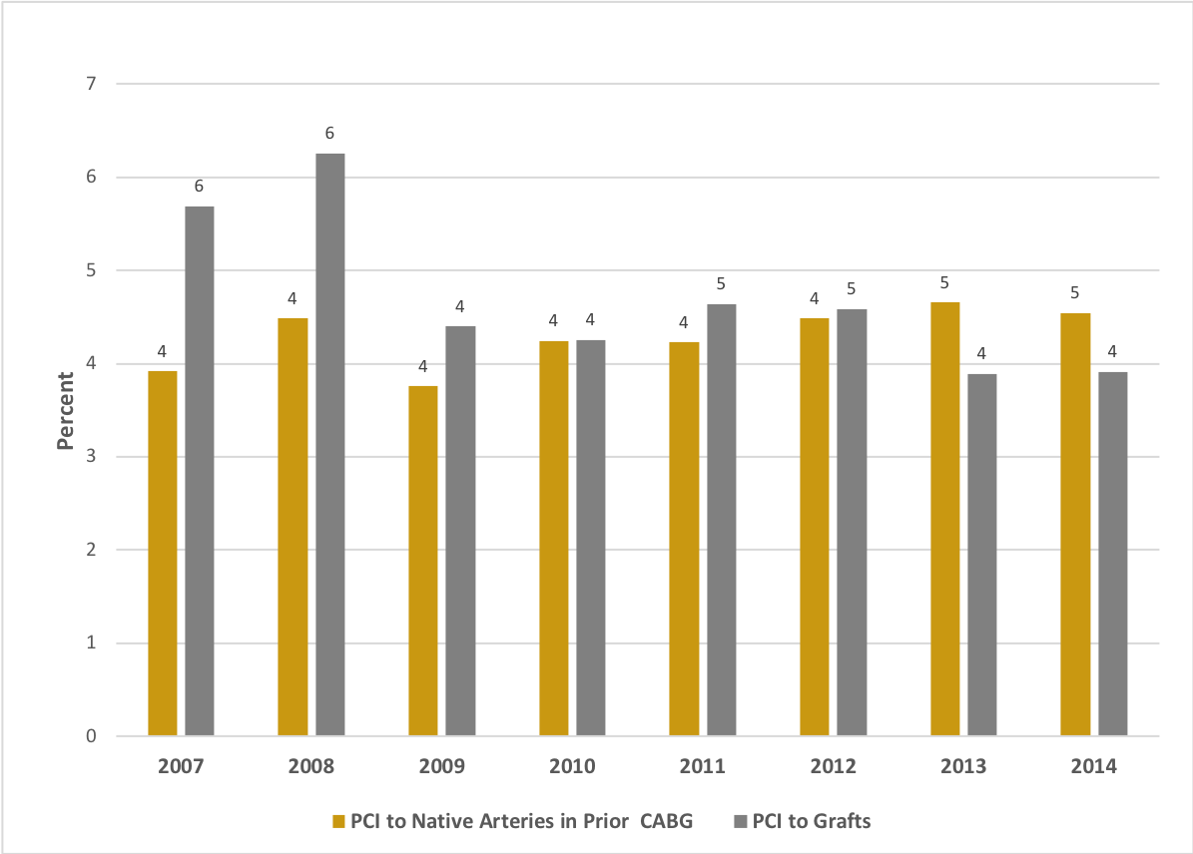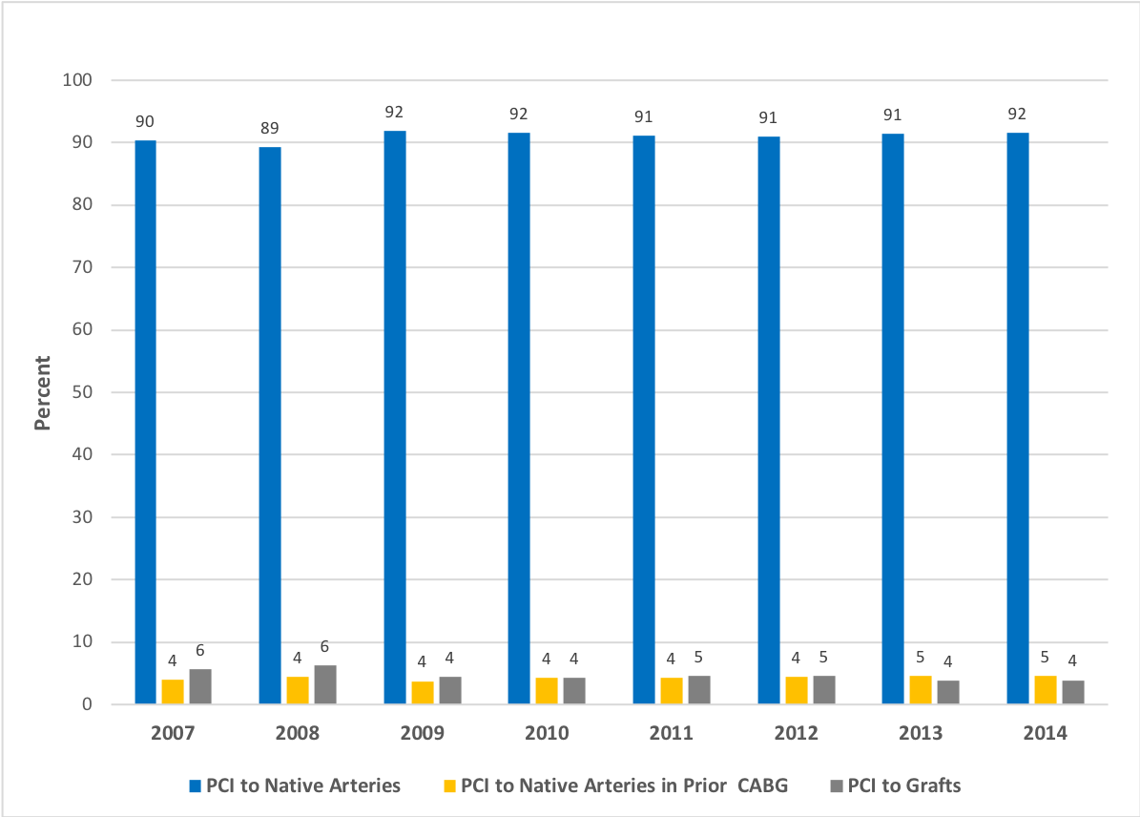

PCI: Percutaneous Coronary Intervention

Figure 3-A & B: Kaplan-Meier Survival estimates at 30 and 365 days

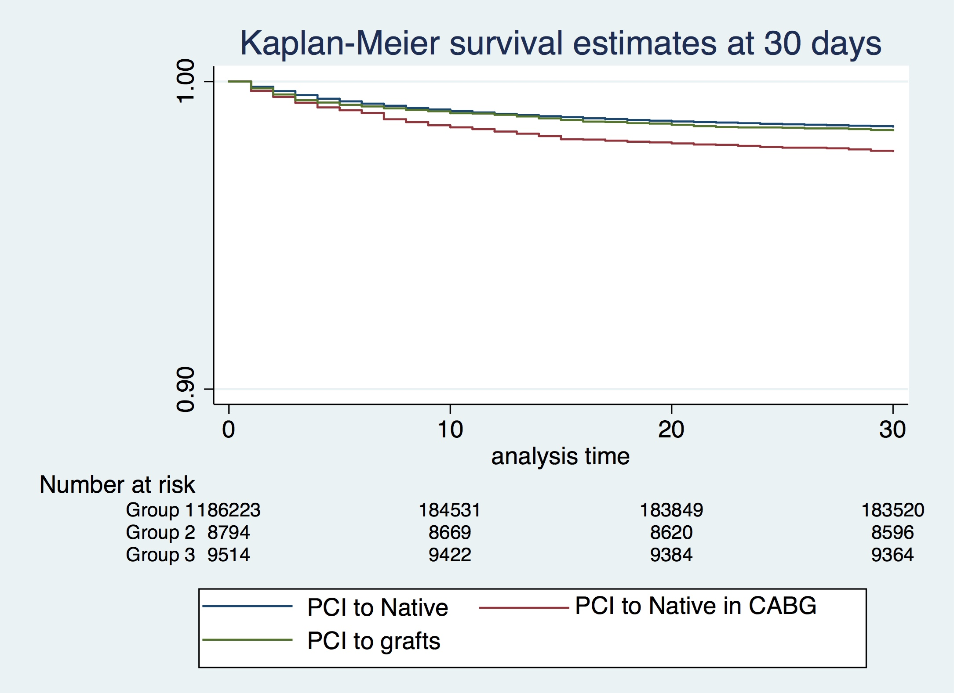

Log rank P <0.001



Log rank P <0.001

PCI: Percutaneous Coronary Intervention

Group 1: PCI to Native Arteries

Group 2: PCI to Native Arteries in Prior Coronary Artery Bypass Grafts   
Group 3: PCI to GRAFTS

Table 1: Baseline Clinical Characteristics

|  |  |  |  |  |  |
| --- | --- | --- | --- | --- | --- |
| Variable | Missing data | Group 1 (n=186,670)  PCI to Native arteries | Group 2 (n=8,825)  PCI to Natives with prior CASBG | Group 3 (n=9,544)  PCI to Grafts | P- Value |
| Age (IQR) | 0 | 65 (55-74) | 70 (63-77) | 71 (63-77) | <0.0001 |
| Female sex | 0 | 52,758/186,670(28%) | 1,932/8,825 (22%) | 1,755/9,544 (18%) | <0.0001 |
| Smoking | 20,828 (10%) | 112,222/167,988 (67%) | 5,108/7,846 (65%) | 5,470/8,377 (65%) | <0.0001 |
| Diabetes mellitus | 7,110 (3%) | 34,794/180,252 (19%) | 2,939/8,489 (35%) | 2,967/9,188 (32%) | <0.0001 |
| Hypertension | 7,320 (4%) | 98,239/179,992 (55%) | 6,005/8,556 (70%) | 5,989/9,171 (65%) | <0.0001 |
| Hyperlipidaemia | 7,320 (4%) | 102,611/179,992 (57%) | 5,851/8,556 (68%) | 5,998/9,171 (65%) | <0.0001 |
| Previous MI | 19,876 (10%) | 43,596/168,578 (26%) | 5,003/7,968 (63%) | 5,425/8,617 (63%) | <0.0001 |
| Previous CVA | 7,320 (4%) | 7,873/179,992 (4%) | 657/8,556  (8%) | 665/9,171  (7%) | <0.0001 |
| Peripheral vascular disease | 7,320 (4%) | 9,263/179,992 (5%) | 941/8,556  (11%) | 1,004/9,171 (11%) | <0.0001 |
| Previous renal disease | 11,448 (6%) | 2,613/176,673 (1.48%) | 248/8,071 (3.07%) | 199/8,847 (2.25%) | <0.0001 |
| Family history of heart disease | 27,931  (14%) | 72,721/161,514 (45%) | 3,582/7,485 (48%) | 3,693/8,109 (46%) | <0.0001 |
| Glycoprotein IIb/IIIa inhibitor | 13,574 (7%) | 37,338/174,244 (21%) | 1,294/8,310 (16%) | 2,213/8,911 (25%) | <0.0001 |
| **LVEF** | 98,598 (48%) |  |  |  |  |
| *Good (EF >50%)* |  | 66,422/97,022 (69%) | 2,442/4,855 (50%) | 2,274/4,564 (50%) | <0.0001 |
| *Moderate (EF 30-50%)* |  | 24,392/97,022 (25%) | 1,819/4,855 (38%) | 1,741/4,564 (38%) | <0.0001 |
| *Poor (EF <30%)* |  | 6,208/97,022 (6%) | 594/4,855  (12%) | 549/4,564  (12%) | <0.0001 |
| **Access site** | 4,583 (2%) |  |  |  |  |
| *Femoral* |  | 77,540/182,551 (43%) | 6,032/8,684 (70%) | 6,304/9,221 (68%) | <0.0001 |
| *Radial* |  | 100,938/182,551 (55%) | 2,452/8,684 (28%) | 2,707/9,221 (29%) | <0.0001 |
| *Multiple* |  | 3,675/182,551 (2%) | 164/8,684  (2%) | 183/9,221  (2%) | <0.0001 |
| **Target vessel** | 0 |  |  |  |  |
| *LAD* | 0 | 93,949/186,670 (50%) | 2,539/8,825 (29%) | 593/9,544  (6%) | <0.0001 |
| *Left main stem* | 0 | 5,938/186,670 (3%) | 2,301/8,825 (26%) | 148/9,544 (1.55%) | <0.0001 |
| *Left Circumflex* | 0 | 53,250/186,670 (29%) | 3,412/8,825 (39%) | 609/9,544  (6%) | <0.0001 |
| *Right coronary artery* | 0 | 67,037/186,670 (36%) | 2,542/8,825 (29%) | 551/9,544  (6%) | <0.0001 |
| *Graft* | 0 | 0 | 0 | 9,544  (100%) | <0.0001 |
| *Multivessel PCI* | 0 | 29,871/186,670 (16%) | 1,693/8,825 (19%) | 1,646/9,544 (17%) | <0.0001 |
| Cardiogenic shock | 4,004 (2%) | 2,247/182,969 (1.2%) | 134/8,721 (1.5%) | 93/9,345  (1%) | 0.004 |
| Circulatory support | 11,723 (6%) | 2,716/175,671 (1.6%) | 226/8,516 (2.7%) | 164/9,129  (1.8%) | <0.0001 |
| DES use | 8,742 (4%) | 129,878/178,601 (73%) | 6,269/8,574 (73%) | 6,195/9,122 (68%) | <0.0001 |
| **Number of stents** | 2,680 (1%) |  |  |  |  |
| *0* |  | 11,218/184,156 (6%) | 914/8,774 (10.4%) | 758/9,429  (8%) | <0.0001 |
| *1* |  | 101,047/184,156 (55%) | 4,313/8,774 (49%) | 5,096/9,429 (54%) | <0.0001 |
| *2* |  | 46,415/184,156 (25%) | 2,165/8,774 (25%) | 2,230/9,429 (24%) | <0.0001 |
| *≥3* |  | 25,476/184,156 (14%) | 1,382/8,774 (16%) | 1,345/9,429 (14%) | <0.0001 |
| Thrombus aspiration | 11,303 (6%) | 8,134/176,172 (4.6%) | 203/8,449 (2.4%) | 678/9,115  (7.4%) | <0.0001 |
| Mechanical ventilator support | 24,013 (12%) | 1,741/164,823 (1.1%) | 119/7,991 (1.5%) | 128/8,212  (1.6%) | <0.0001 |
| Use of distal protection device | 11,464 (6%) | 660/175,980 (0.4%) | 113/8,448 (1.3%) | 1,676/9,147 (18%) | <0.0001 |
| Median follow up time (IQR) | 0 | 1,333 (665-2,104) | 1,141 (551-1,929) | 1,332 (667-2,191) | 0.0001 |
| Mean follow up time (SD) | 0 | 1,406 (850) | 1,275 (845) | 1,422 (876) | 0.0001 |

PCI: Percutaneous Coronary Intervention

Group 1: PCI in native coronary arteries; Group 2: PCI in native coronary arteries in patient with CABG; Group 3: PCI in bypass grafts. CVA indicates cerebrovascular accident; DES, drug-eluting stent; LAD, left anterior descending; LVEF, left ventricular ejection fraction;, EF; Ejection Fraction, MI, myocardial infarction; and PCI, percutaneous coronary intervention, IQR; Interquartile range, SD: Standard deviation, CABG; Coronary Artery Bypass Grafts

Table 2: Unadjusted Clinical Outcomes

|  |  |  |  |  |
| --- | --- | --- | --- | --- |
| Outcome | Group 1 (n=186,670)  PCI to Native | Group 2 (n=8,825)  PCI to Native in CABG | Group 3 (n=9,544)  PCI to GRAFTS | *P-value comparing in all groups\** |
| In-hospital mortality | 1,812/186,670 (0.97%) | 136/8,825 (1.54%) | 105/9,544 (1.1%) | <0.0001 |
| 30-day mortality | 3,182/186,670 (1.7%) | 230/8,825 (2.6%) | 181/9,544 (1.9%) | <0.0001 |
| 1-year mortality | 9,090/186,670 (4.87%) | 732/8,825 (8.29%) | 676/9,544 (7.08%) | <0.0001 |
| In-hospital MACE | 2,542/183,311 (1.39%) | 184/8,645 (2.13%) | 143/9,386 (1.52%) | <0.0001 |
| In-hospital reinfarction | 664/183,311 (0.36%) | 47/8,645 (0.54%) | 39/9,386 (0.42%) | 0.02 |
| In-hospital reintervention | 644/183,311 (0.35%) | 49/8,645 (0.57%) | 30/9,386 (0.32%) | <0.0001 |
| In-hospital emergency cardiac surgery | 447/183,311 (0.24%) | 12/8,645 (0.14%) | 4/9,386 (0.04%) | <0.0001 |
| In-hospital Stroke | 205/183,311 (0.11%) | 12/8,645 (0.14%) | 16/9,386 (0.17%) | 0.22 |
| In-hospital bleeding | 1,575/183,323 (0.86%) | 83/8,646 (0.96) | 85/9,388 (0.91%) | 0.56 |

Group 1: Primary PCI in native coronary arteries; Group 2: Primary PCI in native coronary arteries in patient with CABG; Group 3: Primary PCI in bypass grafts. CABG indicates coronary artery bypass graft; MACE, major adverse cardiovascular events; PCI, percutaneous coronary intervention; and TIA, transient ischemic attack.

\**P* value determined by Chi Square test with two degree of freedom

Table 3: Risk of Adverse Outcomes following multivariate adjustment

|  |  |  |  |
| --- | --- | --- | --- |
| Variable | Group 1: PCI in Native Coronary Arteries | Group 2: PCI in Native Coronary Arteries in Patient with prior CABG | Group 3: PCI in Bypass Grafts |
| In-hospital mortality | | | |
| Adjusted OR*  (N for analysis= 129,103) | Reference | OR 0.94 (CI 0.70-1.26) P = 0.67 | 0.88 (CI 0.62- 1.23) P = 0.49 |
| Adjusted OR†  (N for analysis= 201,329) | Reference | OR 0.90 (CI 0.73-1.11) P = 0.32 | OR 0.90 (CI 0.71-1.15) P = 0.42 |
| 30-day mortality | | | |
| Adjusted OR*  (N for analysis= 129,103) | Reference | OR 0.87 (CI 0.69-1.80) P = 0.20 | OR 0.91 (CI 0.71-1.17) P = 0.46 |
| Adjusted HR*  (N for analysis= 128,855) | Reference | HR 0.96 (CI 0.74-1.25), P = 0.77 | HR 0.73 (CI 0.51-1.06) P = 0.09 |
| Adjusted OR†  (N for analysis= 201,329) | Reference | OR 0.85 (CI 0.72-0.99) P = 0.04 | OR 0.84 (CI 0.70-1.007) P = 0.06 |
| Adjusted HR†  (N for analysis= 201,329) | Reference | HR 0.94 (CI 0.88-0.99) P = 0.04 | HR 0.78 (CI 0.72-0.84) P = <0.0001 |
| 1-y mortality | | | |
| Adjusted OR *  (N for analysis= 129,103) | Reference | OR 0.95 (CI 0.84-1.07) P = 0.37 | OR 1.02 (CI 0.90 – 1.17) P = 0.72 |
| Adjusted HR*  (N for analysis= 128,855) | Reference | HR 0.98 (CI 0.85-1.13) P = 0.80 | HR 0.90 (CI 0.76-1.06) P = 0.21 |
| AdjustedOR†  (N for analysis= 201,329) | Reference | OR 0.92 (CI 0.84-1.01) P = 0.09 | OR 0.99 (CI 0.89-1.09) P = 0.78 |
| AdjustedHR†  (N for analysis= 201,329) | Reference | HR 0.96 (CI 0.92-0.99) P = 0.02 | HR 0.96 (CI 0.92-0.99) P = 0.03 |
| In-hospital MACE | | | |
| AdjustedOR*  (N for analysis= 125,889) | Reference | OR 1.08 (CI 0.88-1.34) P = 0.45 | OR 0.97 (CI 0.77-1.23) P = 0.82 |
| AdjustedOR†  (N for analysis= 201,329) | Reference | OR 1.01 (CI 0.84-1.19) P = 0.99 | OR 0.86 (CI 0.71-1.05) P = 0.13 |
| In-hospital stroke | | | |
| Adjusted OR*  (N for analysis= 125,889) | Reference | OR 1.37 (CI 0.71-2.69) P = 0.35 | OR 1.13 (CI 0.55-2.34) P = 0.73 |
| Adjusted OR†  (N for analysis= 201,329) | Reference | OR 1.01 (CI 0.54-1.84) P = 0.99 | OR 1.21 (0.68 – 2.13) P = 0.52 |
| In-hospital bleeding | | | |
| Adjusted OR*  (N for analysis= 127,690) | Reference | OR 0.68 (CI 0.51-0.92) P = 0.01 | OR 0.99 (CI 0.75-1.33) P = 0.98 |
| Adjusted OR†  (N for analysis= 201,329) | Reference | OR 0.78 (CI 0.62-0.98) P = 0.04 | OR 0.91 (CI 0.71-1.16) P = 0.46 |

OR; Odds Ratio, HR; Hazard Ratio, CABG indicates coronary artery bypass graft; MACE, major adverse cardiovascular events; and PCI, percutaneous coronary intervention, N; Number

* Adjusted on Non-Imputed data (Complete case analysis)

† Adjusted on Imputed data

Variables for Statistical models: age, sex, smoking status, diabetes mellitus, hypertension, hyperlipidemia, previous myocardial infarction, previous stroke, peripheral vascular disease, renal disease, family history, radial access site, glycoprotein IIb/IIIa inhibitor, multivessel, PCI to left anterior descending artery, PCI to left main artery, shock, circulatory support, number of stents, thrombus aspiration, ventilation and distal protection device

*Table 4:* Propensity Score-Matched Analysis with Average Treatment Effects & Odds Ratio on imputed data

|  |  |  |  |  |
| --- | --- | --- | --- | --- |
| Analysis | Group | Coefficient (95% CI) | OR  (95% CI) | *P* Value |
| In-hospital mortality | Group 1: PCI in native coronary arteries | Reference |  |  |
| Group 2: PCI in native coronary arteries in patient with CABG (N=122,265) | 0.0048  (-0.002 to  0.012) | 1.50  (0.79-2.26) | 0.17 |
| Group 3: PCI in bypass grafts (N= 122,434) | -0.0032  (-0.0068 to 0.0003) | 0.67  (0.30-1.03) | 0.08 |
| 30-day mortality | Group 1: PCI in native coronary arteries | Reference |  |  |
| Group 2: PCI in native coronary arteries in patient with CABG (N=122,265) | 0.0041  (-0.0044 to 0.0125) | 1.25  (0.74-1.76) | 0.34 |
| Group 3: PCI in bypass grafts (N=122,434) | - 0.0064  (-0.0106 to -0.0021) | 0.62  (0.37-0.88) | 0.003 |
| 1-y mortality | Group 1: PCI in native coronary arteries | Reference |  |  |
| Group 2: PCI in native coronary arteries in patient with CABG (N=122,265) | 0.0109  (-0.0016 to 0.0234) | 1.24  (0.97-1.52) | 0.09 |
| Group 3: PCI in bypass grafts (N=122,434) | -0.0032  (-0.0315 to 0.025) | 0.93  (0.34-1.55) | 0.81 |
| In-hospital MACE | Group 1: PCI in native coronary arteries | Reference |  |  |
| Group 2: PCI in native coronary arteries in patient with CABG (N=122,265) | 0.0091  (-0.0002 to 0.0185) | 1.67  (0.98-2.38) | 0.055 |
| Group 3: PCI in bypass grafts (N=122,434) | -0.0038  (-0.0094 to 0.0017) | 0.72  (0.32-1.12) | 0.18 |

PCI; percutaneous coronary intervention, CABG; indicates coronary artery bypass graft, MACE; major adverse cardiovascular events, CI; confidence interval, OR: Odds ratio

N: Number of observations

**Supplement**

# Patients selection

* Total Number of Records: 669,279
* Data available from England & Wales: 593,058
* NSTEMI: 220,592
* Age Data
* Missing: 151 (Dropped)
* available data after excluding missing data: 220,441
* Gender data
* Not specified: 29 (Dropped)
* Missing data: 362 (Dropped)
* Available data after excluding missing data: 220,050
* In Patient Mortality Follow up
* Missing data for inpatient Mortality: 4,049
* Remaining data after excluding missing data for in-patient Mortality: 216,001
* 30 Days Mortality Data
* Missing data for 30 days Mortality: 8,622
* Remaining data after excluding missing data for 30 days Mortality: 207,379
* 90 Days Mortality Data
* Missing data for 90 days Mortality: 0
* Remaining data after excluding missing data for 90 days Mortality: 207,379
* 365 Days Mortality Data
  + Missing data for 365 days Mortality: 27
  + Remaining data after excluding missing data for 365 days Mortality: 207,352
* Final Censorship Days Mortality Data
  + Missing data for Mortality at final censorship date: 47
  + Remaining data after excluding missing data for final censorship Mortality: 207,305
* PCI Data
* Missing data for PCI Records: 2,266
* Remaining data after excluding missing data for PCI records: 205,039
* Total cohort available for final analysis: 205,039
* PCI to Native coronary arteries: 186,670 (91.04 %)
* PCI to Native coronary arteries in previous CABG patients: 8,825 (4.30%)
* PCI to Grafts: 9,544 (4.65%)

*Supplement Figure 1: Temporal Pattern of use of Drug eluting stent from 2007-2014*

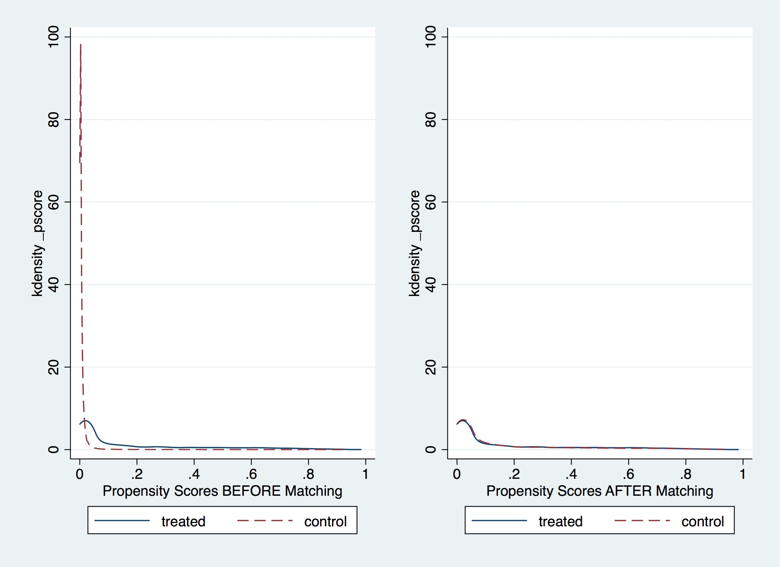

Supplement Figure 2-A: Propensity score before and after Matching in Group 1 vs Group 2

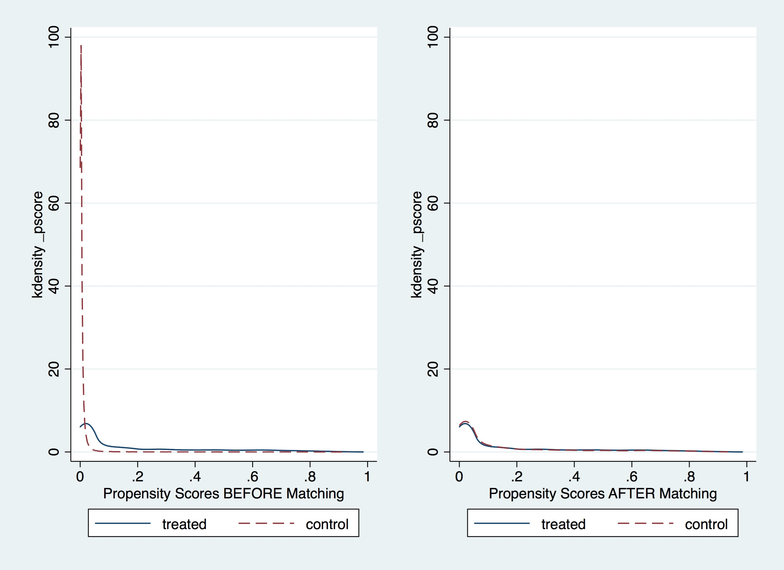

Supplement Figure 2-B: Propensity score before and after Matching in Group 1 versus Group 3

Group 1; PCI to Native coronary arteries

Group 2: PCI to Native coronary arteries in previous Coronary Artery Bypass Grafts (CABG) patients

Group 3: PCI to Grafts

Supplement table 1: Matching success diagnostics for propensity model

|  |  |  |  |  |
| --- | --- | --- | --- | --- |
| Analysis | Group | Group | Mean (SD) | Median (IQR) |
| In Patient Mortality | PCI in native coronary arteries in patients with CABG versus PCI in native | Case 1(PCI in native with CABG) | 0.9549 (0.0769) | 0.9797 (0.9538-0.9898) |
| Control (PCI in Native) | 0.9549 (0.0768) | 0.9797 (0.9538-0.9898) |
| Abs (Case-Control) | 0.0000208(0.000597) | 0.0000066 (0.0000019-0.0000151) |
| PCI in GRAFTS versus PCI in native | Case 1(PCI in GRAFTS) | 0.9512 (0.1049) | 0.9856 (0.9527-0.9971) |
| Control (PCI in Native) | 0.9512 (0.1048) | 0.9856 (0.9526-0.9971) |
| Abs (Case-Control) | 0.0000423 (0.00019) | 0.0000114 (0.0000029-0.0000298 |
| 30-day mortality | PCI in native coronary arteries in patients with CABG versus PCI in native | Case 1(PCI in native with CABG) | 0.9549 (0.7696) | 0.9797 (0.9538-0.9898) |
| Control (PCI in Native) | 0.9549 (0.7689) | 0.9797 (0.9538-0.9898) |
| Abs (Case-Control) | 0.0000208 (0.000597) | 0.00000668 (0.00000191-0.0000151) |
| PCI in GRAFTS versus PCI in native | Case 1(PCI in GRAFTS) | 0.9512 (0.1049) | 0.9856 (0.9527-0.9971) |
| Control (PCI in Native) | 0.9512 (0.1048) | 0.9856 (0.9526-0.9971) |
| Abs (Case-Control) | 0.0000423  (0.0001904) | 0.0000114 (0.00000298-0.0000298) |
| 1-y mortality | PCI in native coronary arteries in patients with CABG versus PCI in native | Case 1(PCI in native with CABG) | 0.9549 (0.7696) | 0.9797 (0.9538-0.9898) |
| Control (PCI in Native) | 0.9549 (0.7689) | 0.9797 (0.9538-0.9898) |
| Abs (Case-Control) | 0.0000208 (0.000597) | 0.00000668 (0.00000191-0.0000151) |
| PCI in GRAFTS versus PCI in native | Case 1(PCI in GRAFTS) | 0.9512 (0.1049) | 0.9856 (0.9527-0.9971) |
| Control (PCI in Native) | 0.9512 (0.1048) | 0.9856 (0.9526-0.9971) |
| Abs (Case-Control) | 0.0000423 (0.0001904) | 0.0000114 (0.00000298-0.0000298) |
| MACE | PCI in native coronary arteries in patients with CABG versus PCI in native | Case 1(PCI in native with CABG) | 0.9549 (0.7696) | 0.9797 (0.9538-0.9898) |
| Control (PCI in Native) | 0.9549 (0.7689) | 0.9797 (0.9538-0.9898) |
| Abs (Case-Control) | 0.0000208 (0.000597) | 0.00000668 (0.00000191-0.0000151) |
| PCI in GRAFTS versus PCI in native | Case 1(PCI in native with CABG) | 0.9512 (0.1049) | 0.9856 (0.9527-0.9971) |
| Control (PCI in Native) | 0.9512 (0.1048) | 0.9856 (0.9526-0.9971) |
| Abs (Case-Control) | 0.0000423 (0.0001904) | 0.0000114 (0.00000298-0.0000298) |

PCI; percutaneous coronary intervention, CABG; indicates coronary artery bypass graft, MACE; major adverse cardiovascular events

Supplement Table 2: Analysis controlling for age only

|  |  |  |  |  |
| --- | --- | --- | --- | --- |
| Analysis | Group | OR | 95% Confidence Interval | *P* Value |
| In-hospital mortality | Group 1: PCI in native coronary arteries | Reference |  |  |
| Group 2: PCI in native coronary arteries in patient with CABG | 1.28 | 1.07-1.53 | **0.007** |
| Group 3: PCI in bypass grafts( | 0.92 | 0.75-1.12 | 0.39 |
| 30-day mortality | Group 1: PCI in native coronary arteries | Reference |  |  |
| Group 2: PCI in native coronary arteries in patient with CABG (n=191,943) | 1.23 | 1.07-1.42 | **0.003** |
| Group 3: PCI in bypass grafts(n=192,689) | 0.92 | 0.79-1.07 | 0.29 |
| 1-y mortality | Group 1: PCI in native coronary arteries | Reference |  |  |
| Group 2: PCI in native coronary arteries in patient with CABG (n=191,943) | 1.41 | 1.30-1.53 | **<0.0001** |
| Group 3: PCI in bypass grafts (192,689) | 1.19 | 1.10-1.30 | **<0.0001** |
| In-hospital MACE | Group 1: PCI in native coronary arteries | Reference |  |  |
| Group 2: PCI in native coronary arteries in patient with CABG (n=191,943) | 1.32 | 1.14-1.54 | **<0.0001** |
| Group 3: PCI in bypass grafts (n= 192,689) | 0.95 | 0.80-1.13 | 0.56 |

PCI; percutaneous coronary intervention, CABG; indicates coronary artery bypass graft, MACE; major adverse cardiovascular events

# References

1. Epstein AJ, Polsky D, Yang F, Yang L and Groeneveld PW. Coronary revascularization trends in the United States, 2001-2008. *JAMA*. 2011;305:1769-76.

2. Goldman S, Zadina K, Moritz T, Ovitt T, Sethi G, Copeland JG, Thottapurathu L, Krasnicka B, Ellis N, Anderson RJ and Henderson W. Long-term patency of saphenous vein and left internal mammary artery grafts after coronary artery bypass surgery: results from a Department of Veterans Affairs Cooperative Study. *Journal of the American College of Cardiology*. 2004;44:2149-56.

3. Hamm CW, Bassand J-P, Agewall S, Bax J, Boersma E, Bueno H, Caso P, Dudek D, Gielen S, Huber K, Ohman M, Petrie MC, Sonntag F, Uva MS, Storey RF, Wijns W, Zahger D, Bax JJ, Auricchio A, Baumgartner H, Ceconi C, Dean V, Deaton C, Fagard R, Funck-Brentano C, Hasdai D, Hoes A, Knuuti J, Kolh P, McDonagh T, Moulin C, Poldermans D, Popescu BA, Reiner Ž, Sechtem U, Sirnes PA, Torbicki A, Vahanian A, Windecker S, Windecker S, Achenbach S, Badimon L, Bertrand M, Bøtker HE, Collet J-P, Crea F, Danchin N, Falk E, Goudevenos J, Gulba D, Hambrecht R, Herrmann J, Kastrati A, Kjeldsen K, Kristensen SD, Lancellotti P, Mehilli J, Merkely B, Montalescot G, Neumann F-J, Neyses L, Perk J, Roffi M, Romeo F, Ruda M, Swahn E, Valgimigli M, Vrints CJM and Widimsky P. ESC Guidelines for the management of acute coronary syndromes in patients presenting without persistent ST-segment elevationThe Task Force for the management of acute coronary syndromes (ACS) in patients presenting without persistent ST-segment elevation of the European Society of Cardiology (ESC). *European heart journal*. 2011;32:2999-3054.

4. Amsterdam EA, Wenger NK, Brindis RG, Casey DE, Ganiats TG, Holmes DR, Jaffe AS, Jneid H, Kelly RF, Kontos MC, Levine GN, Liebson PR, Mukherjee D, Peterson ED, Sabatine MS, Smalling RW and Zieman SJ. 2014 AHA/ACC Guideline for the Management of Patients With Non-ST-Elevation Acute Coronary Syndromes. *A Report of the American College of Cardiology/American Heart Association Task Force on Practice Guidelines*. 2014.

5. Kleiman NS, Anderson HV, Rogers WJ, Theroux P, Thompson B and Stone PH. Comparison of outcome of patients with unstable angina and non-Q-wave acute myocardial infarction with and without prior coronary artery bypass grafting (Thrombolysis in Myocardial Ischemia III Registry). *The American journal of cardiology*. 1996;77:227-31.

6. Kugelmass AD, Sadanandan S, Lakkis N, Dibattiste PM, Robertson DH, Demopoulos LA, Gibson CM, Weintraub WS, Murphy SA and Cannon CP. Early invasive strategy improves outcomes in patients with acute coronary syndrome with previous coronary artery bypass graft surgery: a report from TACTICS-TIMI 18. *Crit Pathw Cardiol*. 2006;5:167-72.

7. Labinaz M, Kilaru R, Pieper K, Marso SP, Kitt MM, Simoons ML, Califf RM, Topol EJ, Armstrong PW and Harrington RA. Outcomes of patients with acute coronary syndromes and prior coronary artery bypass grafting: results from the platelet glycoprotein IIb/IIIa in unstable angina: receptor suppression using integrilin therapy (PURSUIT) trial. *Circulation*. 2002;105:322-7.

8. Ketonen M, Pajunen P, Koukkunen H, Immonen-Raiha P, Mustonen J, Mahonen M, Niemela M, Kuulasmaa K, Palomaki P, Arstila M, Vuorenmaa T, Lehtonen A, Lehto S, Miettinen H, Torppa J, Tuomilehto J, Airaksinen J, Pyorala K and Salomaa V. Long-term prognosis after coronary artery bypass surgery. *International journal of cardiology*. 2008;124:72-9.

9. Mathew V, Gersh B, Barron H, Every N, Tiefenbrunn A, Frederick P and Malmgren J. Inhospital outcome of acute myocardial infarction in patients with prior coronary artery bypass surgery. *Am Heart J*. 2002;144:463-9.

10. Nikolsky E, McLaurin BT, Cox DA, Manoukian SV, Xu K, Mehran R and Stone GW. Outcomes of patients with prior coronary artery bypass grafting and acute coronary syndromes: analysis from the ACUITY (Acute Catheterization and Urgent Intervention Triage Strategy) trial. *JACC Cardiovascular interventions*. 2012;5:919-26.

11. Brilakis ES, Rao SV, Banerjee S, Goldman S, Shunk KA, Holmes DR, Jr., Honeycutt E and Roe MT. Percutaneous coronary intervention in native arteries versus bypass grafts in prior coronary artery bypass grafting patients: a report from the National Cardiovascular Data Registry. *JACC Cardiovasc Interv*. 2011;4:844-50.

12. Gyenes G, Norris CM and Graham MM. Percutaneous revascularization improves outcomes in patients with prior coronary artery bypass surgery. *Catheterization and cardiovascular interventions : official journal of the Society for Cardiac Angiography & Interventions*. 2013;82:E148-54.

13. Brilakis ES, O'Donnell CI, Penny W, Armstrong EJ, Tsai T, Maddox TM, Plomondon ME, Banerjee S, Rao SV, Garcia S, Nallamothu B, Shunk KA, Mavromatis K, Grunwald GK and Bhatt DL. Percutaneous Coronary Intervention in Native Coronary Arteries Versus Bypass Grafts in Patients With Prior Coronary Artery Bypass Graft Surgery: Insights From the Veterans Affairs Clinical Assessment, Reporting, and Tracking Program. *JACC Cardiovascular interventions*. 2016;9:884-93.

14. Kim MS, Wang TY, Ou FS, Klein AJ, Hudson PA, Messenger JC, Masoudi FA, Rumsfeld JS and Ho PM. Association of prior coronary artery bypass graft surgery with quality of care of patients with non-ST-segment elevation myocardial infarction: a report from the National Cardiovascular Data Registry Acute Coronary Treatment and Intervention Outcomes Network Registry-Get With the Guidelines. *Am Heart J*. 2010;160:951-7.

15. Kwok CS, Kontopantelis E, Kinnaird T, Potts J, Rashid M, Shoaib A, Nolan J, Bagur R, de Belder MA, Ludman P and Mamas MA. Retroperitoneal Hemorrhage After Percutaneous Coronary Intervention: Incidence, Determinants, and Outcomes as Recorded by the British Cardiovascular Intervention Society. *Circulation Cardiovascular interventions*. 2018;11:e005866.

16. Sirker A, Kwok CS, Kontopantelis E, Johnson T, Freeman P, de Belder MA, Ludman P, Zaman A and Mamas MA. Antiplatelet drug selection in PCI to vein grafts in patients with acute coronary syndrome and adverse clinical outcomes: Insights from the British Cardiovascular Intervention Society database. *Catheterization and cardiovascular interventions : official journal of the Society for Cardiac Angiography & Interventions*. 2018.

17. Rashid M, Rushton CA, Kwok CS, Kinnaird T, Kontopantelis E, Olier I, Ludman P, De Belder MA, Nolan J and Mamas MA. Impact of Access Site Practice on Clinical Outcomes in Patients Undergoing Percutaneous Coronary Intervention Following Thrombolysis for ST-Segment Elevation Myocardial Infarction in the United Kingdom: An Insight From the British Cardiovascular Intervention Society Dataset. *JACC Cardiovascular interventions*. 2017;10:2258-2265.

18. Kinnaird T, Anderson R, Ossei-Gerning N, Cockburn J, Sirker A, Ludman P, de Belder M, Johnson TW, Copt S, Zaman A and Mamas MA. Coronary Perforation Complicating Percutaneous Coronary Intervention in Patients With a History of Coronary Artery Bypass Surgery: An Analysis of 309 Perforation Cases From the British Cardiovascular Intervention Society Database. *Circulation Cardiovascular interventions*. 2017;10.

19. Kontopantelis E, White IR, Sperrin M and Buchan I. Outcome-sensitive multiple imputation: a simulation study. *BMC Medical Research Methodology*. 2017;17:2.

20. Khera S, Kolte D, Aronow WS, Palaniswamy C, Subramanian KS, Hashim T, Mujib M, Jain D, Paudel R, Ahmed A, Frishman WH, Bhatt DL, Panza JA and Fonarow GC. Non-ST-elevation myocardial infarction in the United States: contemporary trends in incidence, utilization of the early invasive strategy, and in-hospital outcomes. *Journal of the American Heart Association*. 2014;3.

21. Bhatt DL, Roe MT, Peterson ED, Li Y, Chen AY, Harrington RA, Greenbaum AB, Berger PB, Cannon CP, Cohen DJ, Gibson CM, Saucedo JF, Kleiman NS, Hochman JS, Boden WE, Brindis RG, Peacock WF, Smith SC, Jr., Pollack CV, Jr., Gibler WB and Ohman EM. Utilization of early invasive management strategies for high-risk patients with non-ST-segment elevation acute coronary syndromes: results from the CRUSADE Quality Improvement Initiative. *JAMA : the journal of the American Medical Association*. 2004;292:2096-104.

22. Mehta SK, Frutkin AD, Milford-Beland S, Klein LW, Shaw RE, Weintraub WS, Krone RJ, Anderson HV, Kutcher MA and Marso SP. Utilization of distal embolic protection in saphenous vein graft interventions (an analysis of 19,546 patients in the American College of Cardiology-National Cardiovascular Data Registry). *The American journal of cardiology*. 2007;100:1114-8.

23. Brennan JM, Al-Hejily W, Dai D, Shaw RE, Trilesskaya M, Rao SV, Brilakis ES, Anstrom KJ, Messenger JC, Peterson ED, Douglas PS and Sketch MH, Jr. Three-year outcomes associated with embolic protection in saphenous vein graft intervention: results in 49 325 senior patients in the Medicare-linked National Cardiovascular Data Registry CathPCI Registry. *Circulation Cardiovascular interventions*. 2015;8:e001403.

24. Paul TK, Bhatheja S, Panchal HB, Zheng S, Banerjee S, Rao SV, Guzman L, Beohar N, Zhao D, Mehran R and Mukherjee D. Outcomes of Saphenous Vein Graft Intervention With and Without Embolic Protection Device: A Comprehensive Review and Meta-Analysis. *Circulation Cardiovascular interventions*. 2017;10.

25. Okabe T, Lindsay J, Torguson R, Steinberg DH, Roy P, Slottow TL, Kaneshige K, Xue Z, Satler LF, Kent KM, Pichard AD and Waksman R. Can direct stenting in selected saphenous vein graft lesions be considered an alternative to percutaneous intervention with a distal protection device? *Catheterization and cardiovascular interventions : official journal of the Society for Cardiac Angiography & Interventions*. 2008;72:799-803.

26. Niccoli G, Belloni F, Cosentino N, Fracassi F, Falcioni E, Roberto M, Panico RA, Mongiardo R, Porto I, Leone AM, Burzotta F, Trani C and Crea F. Case-control registry of excimer laser coronary angioplasty versus distal protection devices in patients with acute coronary syndromes due to saphenous vein graft disease. *The American journal of cardiology*. 2013;112:1586-91.

27. Waksman R and Koifman E. Embolic protection device for saphenous vein graft intervention: too early to take off the seat belt. *Circulation Cardiovascular interventions*. 2015;8:e002371.

28. Gaglia MA, Jr., Torguson R, Xue Z, Gonzalez MA, Ben-Dor I, Suddath WO, Kent KM, Satler LF, Pichard AD and Waksman R. Outcomes of patients with acute myocardial infarction from a saphenous vein graft culprit undergoing percutaneous coronary intervention. *Catheterization and cardiovascular interventions : official journal of the Society for Cardiac Angiography & Interventions*. 2011;78:23-9.

29. Iqbal J, Kwok CS, Kontopantelis E, de Belder MA, Ludman PF, Giannoudi M, Gunning M, Zaman A and Mamas MA. Outcomes Following Primary Percutaneous Coronary Intervention in Patients With Previous Coronary Artery Bypass Surgery. *Circ Cardiovasc Interv*. 2016;9:e003151.